Response to an OME Storage Proposal at Swansea Waterfront
  - OME Safety and Legislation Assignment
Silas Blevins | ACDA6022 | December 2025

Abstract
Big Bang Storage Solutions Ltd have proposed the construction of a large-scale explosives storage facility at Swansea Waterfront. This report discusses the safety and licensing aspects of this facility and determines that construction would not be feasible. A number of recommendations including alternative sites for a facility are presented.

Table of Contents
Abstract 1
List of Tables 3
Table of Figures 3
1 Introduction 5
1.1 Summary of Proposal 5
1.2 Methodology 5
2 Analysis of Proposal 6
2.1 Compatibility Group Mixing 6
2.2 Aggregation Rules 8
2.3 Derivation of Quantity Distances 9
2.4 Identification of Specific Exposed Sites 16
3 Proposed Alterations 21
3.1 Overview 21
3.2 NATO Standard ECMs 21
3.3 Alternative Sites 21
4 Conclusions and Recommendations 27
4.1 Conclusions 27
4.2 Recommendations 27
5 References 28

List of Tables
Table 1: Compatibility Group Matrix for Storage of Explosives [2] 5
Table 2: Aggregation Rules for Quantity Distance Calculations [3] 8
Table 3: Extract from a QD Matrix taken from the IATG guidance [3]showing how values of D are determined 8
Table 4: D Values derived from the QD Matrix [3] for a range of Exposed Sites 10
Table 5: Quantity Distances for ESH A 11
Table 6: Quantity Distances for ESH B 11
Table 7: Quantity Distances for ESH C 12
Table 8: Quantity Distances for ESH D 13
Table 9: Quantity Distances for ESH E 14

Table of Figures
Figure 1: Distance from Facility to Langdon Road at Closest Point [4] 17
Figure 2: Distance from Facility to Langdon Road at Furthest Point [4] 17
Figure 3: Distance from the Facility to Fabian Way [4] 18
Figure 4: Distance from the Facility to UWTSD IQ [4] 19
Figure 5: Distance from the Facility to Yr Hafran [4] 19
Figure 6: Shortest Distance between the facility and HMT Sancta Maria [4] 20
Figure 7: Longest Distance between the facility and HMT Sancta Maria [4] 20
Figure 8: Overview of Quantity Distances for the proposed facility 21
Figure 9: Approximate perimeter of a potential alternative site at Swansea Bay Golf Club [4] 23
Figure 10: The line along which the magazines could be built at the potential alternative Swansea Bay Golf Club Site [4] 23
Figure 11: Approximate IBD from the proposed construction location at Swansea Bay Golf Course [4] 24
Figure 12: Approximate PTRD from the proposed construction location at Swansea Bay Golf Course [4] 24
Figure 13: Position of proposed alternative site (Penllergaer Woods) relative to initial proposal [4] 25
Figure 14: Approximate line along which a facility could be constructed at the second alternative site [4] 26
Figure 15: Distance from the second proposed site to the nearest high-density Public Traffic Route [4] 26
Figure 16: Approximate distance between the nearest inhabited buildings and the second proposed alternative site [4] 27
Figure 17: Approximate distance between the nearest Vulnerable Buildings (Cemetery) and the second proposed alternative site [4] 27

1 Introduction

Summary of Proposal
This report is prepared as an exercise in response to a proposal to store a number of OME articles at a location in Swansea. The proposal [1] describes the construction of a facility composing of five Explosive Storehouses (ESH) at a location on Swansea waterfront, GPS coordinates 51°37’5,45’’N, 3°55’7.90’’W.
(Un-Annotated Image Placeholder)
The proposal describes the explosives to be stored as follows:
- Hazard Division 1.1, 5000kg divided as follows:
  - 50kg 1.1B
  - 3200kg 1.1D
  - 1250kg 1.1E
  - 500kg 1.1F
- Hazard Division 1.2, 500kg divided as follows:
  - 350kg 1.2C
  - 100kg 1.2D
  - 50kg 1.2F
- Hazard Division 1.3, 1000kg, all 1.3C
- Hazard Division 1.4, 1000kg, all 1.4S
The proposal document also provides the following information about the storage facilities:
- “Each ESH will be able to hold up to 1000kg of each type of hazard division (pallets stacked 3 high), thereby requiring no more than 5 x ESH built east to west along the waste land.”
- “The Vulnerable Building Distance is no more than 300m for each ESH”
- “The Inhabited Building Distance is no more than 125m for each ESH”
- “The Public Traffic Route Distance is 270m for each ESH”

Methodology
In order to assess the above proposal, the information provided shall be assessed against the criteria laid out for licensing and safety in the International Ammunition Technical Guidelines (IATG). The stated quantity distances (QDs) shall be compared to those calculated using the IATG formulae to ensure their accuracy. The local geography and position of the proposed depot relative to housing and other facilities shall be considered when determining the feasibility of the proposal. The conclusion shall state whether the facility could be: licensed as per the proposal, licensed subject to a modified proposal, or unable to be licensed for storage.

Analysis of Proposal

Compatibility Group Mixing
The Proposal [1] describes how explosives of a variety of compatibility groups would be present at the depot at any one time, and therefore consideration needs to be given to the allowed mixing of these stores in order to determine how they could be distributed between ESHs. The IATG provide a matrix [2] which shows which explosive compatibility groups can be stored alongside one another.
Compatibility Group | A | B | C | D | E | F | G | H | J | K | L | N | S
A | X
B |  | X | - | - | - | - | - |  |  |  |  |  | X
C |  | - | X | X | X | - | - |  |  |  |  | - | X
D |  | - | X | X | X | - | - |  |  |  |  | - | X
E |  | - | X | X | X | - | - |  |  |  |  | - | X
F |  | - | - | - | - | X | - |  |  |  |  |  | X
G |  | - | - | - | - | - | X |  |  |  |  |  | X
H |  |  |  |  |  |  |  | X |  |  |  |  | X
J |  |  |  |  |  |  |  |  | X |  |  |  | X
K |  |  |  |  |  |  |  |  |  | X
L |  |  |  |  |  |  |  |  |  |  | -
N |  |  | - | - | - |  |  |  |  |  |  | - | -
S |  | X | X | X | X | X | X | X | X |  |  | - | X
Table 1: Compatibility Group Matrix for Storage of Explosives [2]
In the above matrix, a green box marked with an X indicates that the explosives can be stored together, an amber box marked with a dash indicates that the explosives can be stored together only if certain conditions are met, and a red box indicates that the explosives cannot be stored together under any circumstances. The specific conditions relevant to the explosives discussed in the proposal are:
- “Note 1: Compatibility Group B Fuzes may be stored with the articles to which they shall be assembled, but the Net Explosive Quantity (NEQ) shall be aggregated and treated as Compatibility Group F”
- “Note 2: Storage in the same building may be permitted if effectively segregated to prevent propagation”
Note 1 applies to the 50kg of 1.1B which are proposed to be stored, and Note 2 applies to the storage of compatibility groups C, D, and E with compatibility group F.
Given the proposal’s statement that “Each ESH can hold up to 1000kg of each type of Hazard Division” [1], and the compatibility rules described above, it is assessed that the explosives could be divided up in the following way to comply with both of these statements:

- ESH A (General Storage):
  - 250kg 1.1D, if and only if it can be segregated from the 1.1F and 1.2F
  - 250kg 1.1E, if and only if it can be segregated from the 1.1F and 1.2F
  - 500kg 1.1F
  - 50kg 1.2F
  - 200kg 1.4S
- ESH B (General Storage):
  - 1000kg 1.1D
  - 500kg 1.3C
  - 200kg 1.4S
- ESH C (General Storage)
  - 500kg 1.1D
  - 500kg 1.1E
  - 500kg 1.3C
  - 200kg 1.4S
- ESH D (General Storage):
  - 500kg 1.1D
  - 500kg 1.1E
  - 350kg 1.2C
  - 200kg 1.4S
- ESH E (Munition and Fuze Storage):
  - 50kg 1.1B
  - 950kg 1.1D, if and only if it consists of munitions fuzed with the 1.1B articles
  - 100kg 1.2D, if and only if it consists of munitions fuzed with the 1.1B articles
  - 200kg 1.4S
This arrangement allows up to 1000kg of each hazard division to be stored in each ESH whilst complying with the compatibility restrictions laid out in the mixing matrix. The overall NEQ of each ESH by hazard division is:
- ESH A
  - 1000kg HD 1.1
  - 50kg HD 1.2
  - 200kg HD 1.4
- ESH B
  - 1000kg HD 1.1
  - 500kg HD 1.3
  - 200kg HD 1.4
- ESH C
  - 1000kg HD 1.1
  - 500kg HD 1.3
  - 200kg HD 1.4
- ESH D
  - 1000kg HD 1.1
  - 350kg HD 1.2
  - 200kg HD 1.4
- ESH E
  - 1000kg HD 1.1
  - 100kg HD 1.2
  - 200kg HD 1.4

Aggregation Rules
In order to calculate the QDs, the aggregation rules for the hazard divisions must be taken into account. These rules describe how different hazard divisions are considered when stored alongside each other in order to calculate the QDs from the storage facility. The IATG provide a table summarising these rules, which is reproduced below.
Serial | Hazard Divisions |  |  | Storage Requirement
Serial | 1.1 | 1.2 | 1.3 | Storage Requirement
1 | Yes | No | No | - Use HD 1.1 Quantity Distance.
2 | Yes | Yes | No | - Aggregate the HD 1.1 and 1.2 NEQ.  - Evaluate aggregate as HD 1.1 then as HD 1.2 and use the greater Quantity Distance.
3 | Yes | Yes | Yes | - Aggregate the HD 1.1, 1.2 and 1.3 NEQ.  - Evaluate aggregate as HD 1.1 then as HD 1.2 and use the greater Quantity Distance
4 | Yes | No | Yes | - Aggregate the HD 1.1 and 1.3 NEQ  - Use HD 1.1 Quantity Distance for the aggregated NEQ total
5 | No | Yes | No | - Use HD 1.2 Quantity Distance.
6 | No | Yes | Yes | - Assess QD for the NEQ of each HD  - Use the greatest Quantity Distance
7 | No | No | Yes | - Use HD 1.3 Quantity Distance
Table 2: Aggregation Rules for Quantity Distance Calculations [3]
From these rules, the ESHs can be assigned serials to be used in the calculation of quantity distances:
- ESH A: Serial 2
- ESH B: Serial 4
- ESH C: Serial 4
- ESH D: Serial 2
- ESH E: Serial 2

Derivation of Quantity Distances
Quantity Distances (QDs) describe the minimum permissible distance between a Potential Explosive Site (PES) and an Exposed Site (ES) for a given quantity of explosive [3]. The IATG provide tables which provide the quantity distances for a given pairing of PES and ES.
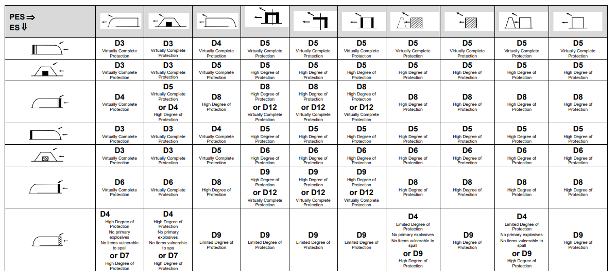
Table 3: Extract from a QD Matrix taken from the IATG guidance [3]showing how values of D are determined
All storage facilities proposed are of the same ‘Earth Covered Magazine’ construction. Quantity distances are given in the IATG Guidance [3]. For determining the internal QDs (the distance between magazines), the magazines will be considered to be ‘Undefined ECM’ exposed sites, as the proposal does not state whether or not the magazines will be built to the NATO standard. The proposal does state that the magazines will be constructed in a single line, so the internal QDs will be determined by treating the PES as the side of the magazine, and the ES as the side of the adjacent magazine. As all magazines are of the same construction, the same values of D can be taken from the tables for each magazine and then compared to the relevant NEQ of each magazine to determine the QD. The values of D for each QD, assuming Hazard Division 1.1, are presented below.
Potential Explosion Site (PES) | Exposed Site (ES) | D (HD 1.1)
Side of Magazine | Side of Adjacent Magazine | D6 (Virtually Complete Protection) or D4 (High Degree of Protection, No Primary Explosives, No items vulnerable to spall)
Side of Magazine | Low Density Public Traffic Route | 0.5 x D12 or 0.5 x D15 (Reduced QD for NATO Standard ECM)
Rear of Magazine | Low Density Public Traffic Route | 0.5 x D12 or 0.5 x D14 (Reduced QD for NATO Standard ECM)
Front of Magazine | Low Density Public Traffic Route | 0.5 x D12
Side of Magazine | Medium Density Public Traffic Route | D11 (>270m) or D17 (Reduced QD for NATO Standard ECM)
Rear of Magazine | Medium Density Public Traffic Route | D11 (>270m) or D16 (Reduced QD for NATO Standard ECM)
Front of Magazine | Medium Density Public Traffic Route | D11 (>270m)
Side of Magazine | High Density Public Traffic Route | D13 (>400m) or D15 (Reduced QD for NATO Standard ECM)
Rear of Magazine | High Density Public Traffic Route | D13 (>400m) or D14(Reduced QD for NATO Standard ECM)
Front of Magazine | High Density Public Traffic Route | D13 (>400m)
Side of Magazine | Inhabited Building | D13 (>400m) or D15 (Reduced QD for Standard ECM)
Rear of Magazine | Inhabited Building | D13 (>400m) or D14(Reduced QD for Standard ECM)
Front of Magazine | Inhabited Building | D13 (>400m)
Side of Magazine | Vulnerable Building | 2 x D12 or 2 x D15 (Reduced QD For NATO Standard ECM)
Rear of Magazine | Vulnerable Building | 2 x D12 or 2 x D14 (Reduced QD for NATO Standard ECM)
Front of Magazine | Vulnerable Building | 2 x D12
Side of Magazine | On-Site Office (<20 Staff) | D11 (>270m) or D17 (Reduced QD for NATO Standard ECM)
Rear of Magazine | On-Site Office (<20 Staff) | D11 (>270m) or D16 (Reduced QD for NATO Standard ECM)
Front of Magazine | On-Site Office (<20 Staff) | D11 (>270m)
Side of Magazine | On-Site Office (>20 Staff) | D13 (>400m) or D15 (Reduced QD for NATO Standard ECM)
Rear of Magazine | On-Site Office (>20 Staff) | D13 (>400m) or D14(Reduced QD for NATO Standard ECM)
Front of Magazine | On-Site Office (>20 Staff) | D13 (>400m)
Table 4: D Values derived from the QD Matrix [3] for a range of Exposed Sites

In order to determine the QDs for each ESH, the aggregation rules described in Section 2.2 shall be applied, as shown in the tables below.
ESH A (1050kg NEQ Excluding HD 1.4, Aggregation Serial 2)
QD Type | Orientation | QD (HD 1.1) | (QD HD 1.2.1) | QD (HD 1.2.2) | QD Per Aggregation Rules
Inter-Magazine Distance | Side | 18m | No QD | No QD | 18m
Distance to Support Office (<20 Staff) | Side | 270m | 40m | 20m | 270m
Distance to Support Office (<20 Staff) | Rear | 270m | 4om | 20m | 270m
Distance to Support Office (<20 Staff) | Front | 270m | 4om | 20m | 270m
Distance to Support Office (>20 Staff) | Side | 400m | 60m | 30m | 400m
Distance to Support Office (>20 Staff) | Rear | 400m | 60m | 30m | 400m
Distance to Support Office (>20 Staff) | Front | 400m | 60m | 30m | 400m
PTR (Low Density) | Side | 200m | No QD | No QD | 200m
PTR (Low Density) | Rear | 200m | No QD | No QD | 200m
PTR (Low Density) | Front | 113m | 130m | 44m | 130m
PTR (Med Density) | Side | 270m | No QD | 20m | 270m
PTR (Med Density) | Rear | 270m | No QD | 20m | 270m
PTR (Med Density) | Front | 270m | 175m | 59m | 270m
PTR (High Density) | Side | 400m | 60m | 30m | 400m
PTR (High Density) | Rear | 400m | 60m | 30m | 400m
PTR (High Density) | Front | 400m | 260m | 88m | 400m
IBD | Side | 400m | 60m | 30m | 400m
IBD | Rear | 400m | 60m | 30m | 400m
IBD | Front | 400m | 260m | 88m | 400m
VBD | Side | 800m | 60m | 30m | 800m
VBD | Rear | 800m | 60m | 30m | 800m
VBD | Front | 451m | 260m | 88m | 451m
Table 5: Quantity Distances for ESH A

ESH B (1500kg NEQ Excluding HD 1.4, Aggregation Serial 4)
QD Type | Orientation | QD (HD 1.1) | QD Per Aggregation Rules
Inter-Magazine Distance | Side | 22m | 22m
Distance to Support Office (<20 Staff) | Side | 270m | 270m
Distance to Support Office (<20 Staff) | Rear | 270m | 270m
Distance to Support Office (<20 Staff) | Front | 270m | 270m
Distance to Support Office (>20 Staff) | Side | 400m | 400m
Distance to Support Office (>20 Staff) | Rear | 400m | 400m
Distance to Support Office (>20 Staff) | Front | 400m | 400m
PTR (Low Density) | Side | 200m | 200m
PTR (Low Density) | Rear | 200m | 200m
PTR (Low Density) | Front | 130m | 130m
PTR (Med Density) | Side | 270m | 270m
PTR (Med Density) | Rear | 270m | 270m
PTR (Med Density) | Front | 270m | 270m
PTR (High Density) | Side | 400m | 400m
PTR (High Density) | Rear | 400m | 400m
PTR (High Density) | Front | 400m | 400m
IBD | Side | 400m | 400m
IBD | Rear | 400m | 400m
IBD | Front | 400m | 400m
VBD | Side | 800m | 800m
VBD | Rear | 800m | 800m
VBD | Front | 520m | 520m
Table 6: Quantity Distances for ESH B

ESH C (1500kg NEQ Excluding HD 1.4, Aggregation Serial 4)
QD Type | Orientation | QD (HD 1.1) | QD Per Aggregation Rules
Inter-Magazine Distance | Side | 22m | 22m
Distance to Support Office (<20 Staff) | Side | 270m | 270m
Distance to Support Office (<20 Staff) | Rear | 270m | 270m
Distance to Support Office (<20 Staff) | Front | 270m | 270m
Distance to Support Office (>20 Staff) | Side | 400m | 400m
Distance to Support Office (>20 Staff) | Rear | 400m | 400m
Distance to Support Office (>20 Staff) | Front | 400m | 400m
PTR (Low Density) | Side | 200m | 200m
PTR (Low Density) | Rear | 200m | 200m
PTR (Low Density) | Front | 130m | 130m
PTR (Med Density) | Side | 270m | 270m
PTR (Med Density) | Rear | 270m | 270m
PTR (Med Density) | Front | 270m | 270m
PTR (High Density) | Side | 400m | 400m
PTR (High Density) | Rear | 400m | 400m
PTR (High Density) | Front | 400m | 400m
IBD | Side | 400m | 400m
IBD | Rear | 400m | 400m
IBD | Front | 400m | 400m
VBD | Side | 800m | 800m
VBD | Rear | 800m | 800m
VBD | Front | 520m | 520m
Table 7: Quantity Distances for ESH C

ESH D (1350kg NEQ Excluding HD 1.4, Aggregation Serial 2)
QD Type | Orientation | QD (HD 1.1) | (QD HD 1.2.1) | QD (HD 1.2.2) | QD Per Aggregation Rules
Inter-Magazine Distance | Side | 21m | No QD | No QD | 21m
Distance to Support Office (<20 Staff) | Side | 270m | 40m | 20m | 270m
Distance to Support Office (<20 Staff) | Rear | 270m | 40m | 20m | 270m
Distance to Support Office (<20 Staff) | Front | 270m | 185m | 63m | 270m
Distance to Support Office (>20 Staff) | Side | 400m | 60m | 30m | 400m
Distance to Support Office (>20 Staff) | Rear | 400m | 60m | 30m | 400m
Distance to Support Office (>20 Staff) | Front | 400m | 275m | 94m | 400m
PTR (Low Density) | Side | 200m | No QD | No QD | 200m
PTR (Low Density) | Rear | 200m | No QD | No QD | 200m
PTR (Low Density) | Front | 125m | 124m | 46m | 125m
PTR (Med Density) | Side | 270m | No QD | No QD | 270m
PTR (Med Density) | Rear | 270m | No QD | No QD | 270m
PTR (Med Density) | Front | 270m | 185m | 63m | 270m
PTR (High Density) | Side | 400m | 60m | 30m | 400m
PTR (High Density) | Rear | 400m | 60m | 30m | 400m
PTR (High Density) | Front | 400m | 275m | 94m | 400m
IBD | Side | 400m | 60m | 30m | 400m
IBD | Rear | 400m | 60m | 30m | 400m
IBD | Front | 400m | 275m | 94m | 400m
VBD | Side | 800m | 60m | 30m | 800m
VBD | Rear | 800m | 60m | 30m | 800m
VBD | Front | 500m | 275m | 94m | 500m
Table 8: Quantity Distances for ESH D

ESH D (1100kg NEQ Excluding HD 1.4, Aggregation Serial 2)
QD Type | Orientation | QD (HD 1.1) | (QD HD 1.2.1) | QD (HD 1.2.2) | QD Per Aggregation Rules
Inter-Magazine Distance | Side | 20m | No QD | No QD | 20m
Distance to Support Office (<20 Staff) | Side | 270m | 40m | 20m | 270m
Distance to Support Office (<20 Staff) | Rear | 270m | 40m | 20m | 270m
Distance to Support Office (<20 Staff) | Front | 270m | 180m | 61m | 270m
Distance to Support Office (>20 Staff) | Side | 400m | 60m | 30m | 400m
Distance to Support Office (>20 Staff) | Rear | 400m | 60m | 30m | 400m
Distance to Support Office (>20 Staff) | Front | 400m | 270m | 91m | 400m
PTR (Low Density) | Side | 200m | No QD | No QD | 200m
PTR (Low Density) | Rear | 200m | No QD | No QD | 200m
PTR (Low Density) | Front | 120m | 135m | 46m | 135m
PTR (Med Density) | Side | 270m | No QD | No QD | 270m
PTR (Med Density) | Rear | 270m | No QD | No QD | 270m
PTR (Med Density) | Front | 270m | 180m | 61m | 270m
PTR (High Density) | Side | 400m | 60m | 30m | 400m
PTR (High Density) | Rear | 400m | 60m | 30m | 400m
PTR (High Density) | Front | 400m | 270m | 91m | 400m
IBD | Side | 400m | 60m | 30m | 400m
IBD | Rear | 400m | 60m | 30m | 400m
IBD | Front | 400m | 270m | 91m | 400m
VBD | Side | 800m | 60m | 30m | 800m
VBD | Rear | 800m | 60m | 30m | 800m
VBD | Front | 480m | 270m | 91m | 480m
Table 9: Quantity Distances for ESH E

Identification of Specific Exposed Sites
The proposed site on Swansea Waterfront is surrounded by a number of other developments including those which would fall into the definitions of ‘Inhabited Buildings’, ‘Vulnerable Buildings’, and ‘Public Traffic Routes’. To determine whether the facility could be licensed, it is necessary to determine whether these sites fall within the relevant quantity distances as determined above.

Langdon Road
Directly north of the proposed site is Langdon Road. The distance between the facility and the road varies between 120 and 293m.
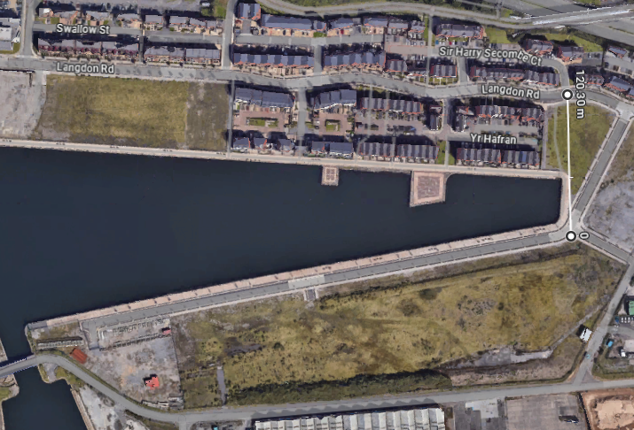
Figure 1: Distance from Facility to Langdon Road at Closest Point [4]
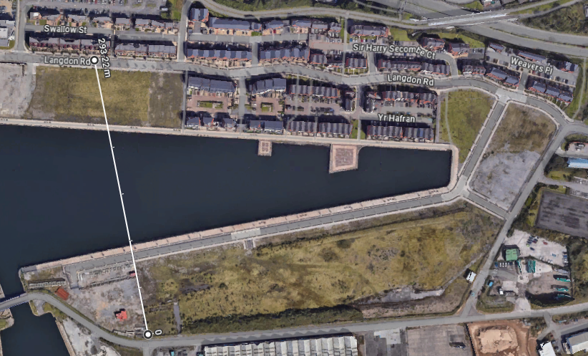
Figure 2: Distance from Facility to Langdon Road at Furthest Point [4]

Given the Public Traffic Route Distances (PTRDs) determined in Tables 5-9 are 400m for a high-density route, 270m for a medium density route, and 200m for a low density route, it can be assumed that there is no construction arrangement wherein all five magazines can be built within the facility and filled to their proposed capacity whilst all keeping Langdon Road outside the PTRD, even if it was treated as a low-density route.

Fabian Way
Further north of the proposed site is Fabian Way. This road would be unambiguously defined as a high-density public traffic route (>5000 vehicles/day) [3]. At its closest to the facility boundary, Fabian Way is 200m from the facility. This is significantly below the PTRD for a high-density route and so it can be assumed that there is no construction arrangement wherein all five magazines can be built within the facility and filled to their proposed capacity whilst all keeping Fabian Way outside the PTRD
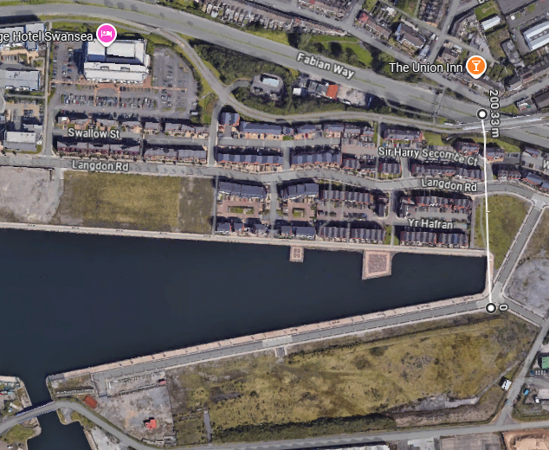
Figure 3: Distance from the Facility to Fabian Way [4]

University of Wales Trinity St David’s (UWTSD)
To the west of the proposed site is the IQ campus of the University of Wales Trinity St David’s. This campus houses multiple teaching facilities and student accommodation and so would be classified as an Inhabited Building. The distance from the western boundary of the facility to the easternmost point of the IQ campus is 255m.
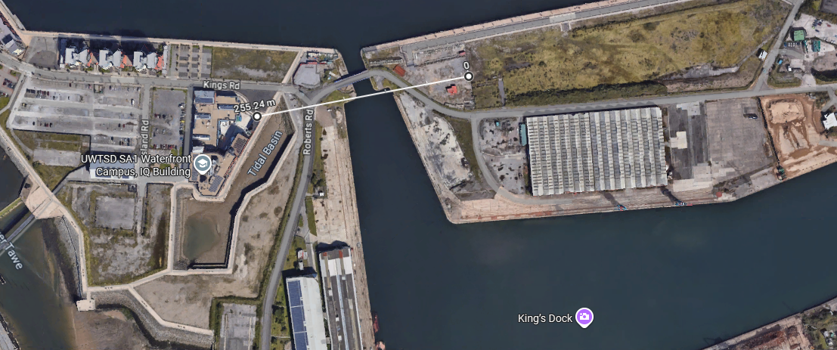
Figure 4: Distance from the Facility to UWTSD IQ [4]
The IBDs given in Tables 5-9 are 400m from the side of the magazine, and whilst it can be assumed that the westernmost magazine would not be built directly adjacent to the boundary, it would have to be built within 400m of the campus, and so it is not possible to build all five magazines within the facility and fill them to their proposed capacity whilst keeping the IQ campus outside the IBD.

Yr Hafran Housing Estate
To the north of the facility, south of Langdon Road, are a series of houses on a housing estate named Yr Hafran. This development would be classified as Inhabited Buildings. At the closest point from the northern boundary of the site to the development, the distance is 74m.
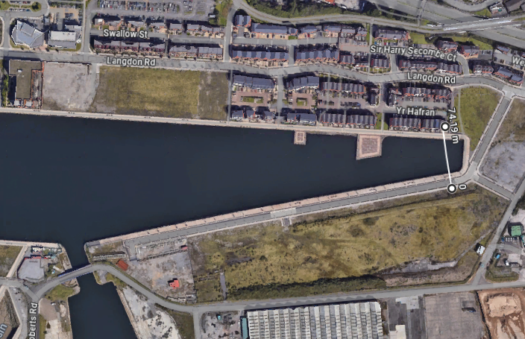
Figure 5: Distance from the Facility to Yr Hafran [4]
The IBDs given in Tables 5-9 are 400m from both the front and rear of the magazine, and so regardless of the orientation of the magazines, there is no construction arrangement which would allow all five magazines to be built and filled to capacity whilst keeping the Yr Hafran development outside the IBD.

HMT Sancta Maria Hospital
To the Northwest of the facility, on Langdon Road, is the HMT Sancta Maria Hospital. As a hospital, this facility would be classed as a Vulnerable Building. The distance between the hospital and the proposed magazines varies between 373m and 675m.
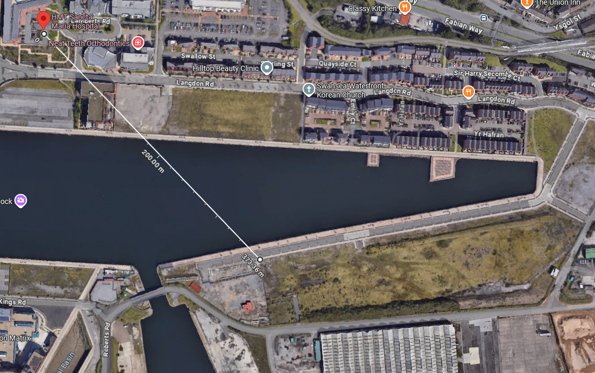
Figure 6: Shortest Distance between the facility and HMT Sancta Maria [4]
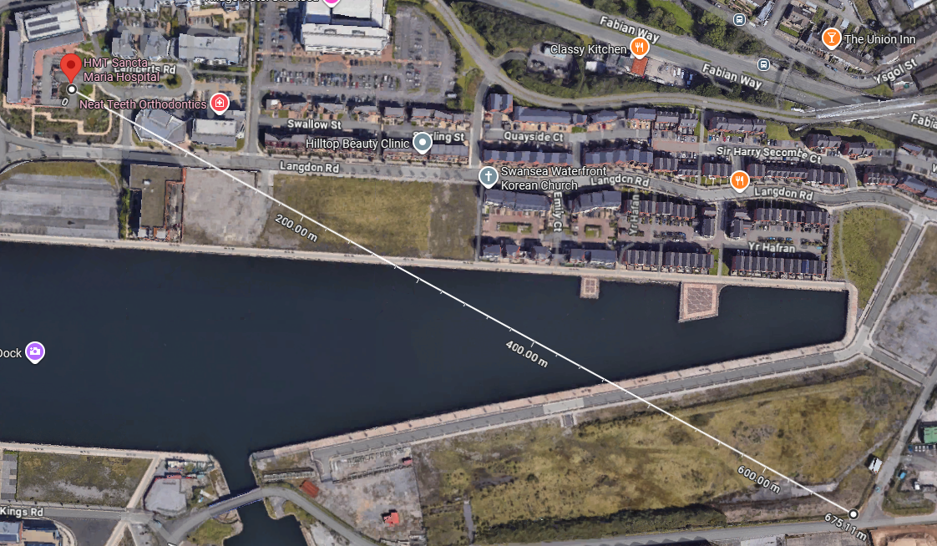
Figure 7: Longest Distance between the facility and HMT Sancta Maria [4]
The VBDs given in Tables 5-9 are 800m from the side of the magazines and 451-520m from the front of the magazines. Regardless of orientation or placement of the magazines, HMT Sancta Maria Hospital falls within these VBDs. Therefore, there is no construction arrangement which would allow all five magazines to be built and filled to capacity whilst keeping the HMT Sancta Maria Hospital.

Overview Map
Below is a map showing an overview of the QDs for the facility. VBD is in Red, IBD in Yellow, and PTRD in Green.
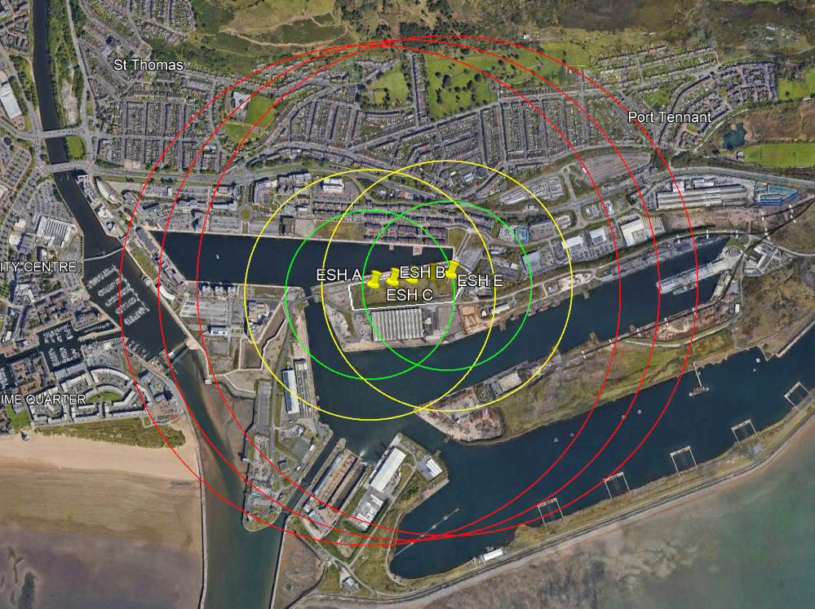
Figure 8: Overview of Quantity Distances for the proposed facility

Proposed Alterations

Overview
From the analysis carried out above, it is clear that it would not be possible to approve the construction of the facility and issue an explosives license in line with the original proposal. To allow any construction or licensing to proceed, alterations to the facility have be explored to identify if it is possible to issue approval and licensing subject to an altered proposal.

NATO Standard ECMs
As the original proposal [1] did not specify whether the magazines would be built to the NATO standard [3], the Quantity Distance figures given in Section 2.3 are for generic ECMs. The QD Tables in the IATG Guidance [3] state that alternative, lower QDs can be used if the magazines are built to the NATO standard. If the construction was altered to ensure compliance with this standard, the QDs would change as follows:
- PTRD (Low Density): Remains at 200m in all aspects
- PTRD (Mid Density): Remains at 270m in all aspects
- PTRD (High Density): Remains at 400m in all aspects
- IBD: Remains at 400m in all aspects
- VBD: Reduced from 800m to 520m (Rear And Side Aspects), remains at 520m for Front Aspect for the largest magazines
From this data, it can be seen that transitioning to NATO standard ECMs alone would not reduce quantity distances sufficiently to exclude any of the identified exposed sites, however it could be used alongside other alterations to allow a facility to be established.

Alternative Sites
Should the construction of an explosives storage facility of the proposed scale in or around Swansea be deemed to be critically important, alternative sites with greater separation distances from surrounding infrastructure have been identified.
The first potential site is Swansea Bay Golf Club, approximately 5km east from the current proposed location.
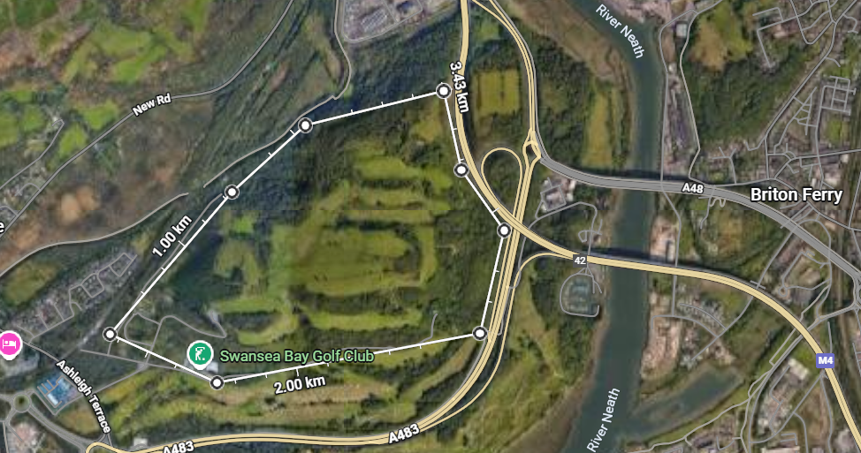
Figure 9: Approximate perimeter of a potential alternative site at Swansea Bay Golf Club [4]
Whilst this proposal would require the purchase, closure, and redevelopment of the golf club, it would allow for 5 magazines to be built near the centre of the proposed perimeter, maintaining a distance of approximately 600m from the nearest inhabited buildings, and over 400m from the nearest high-density Public Traffic Route.
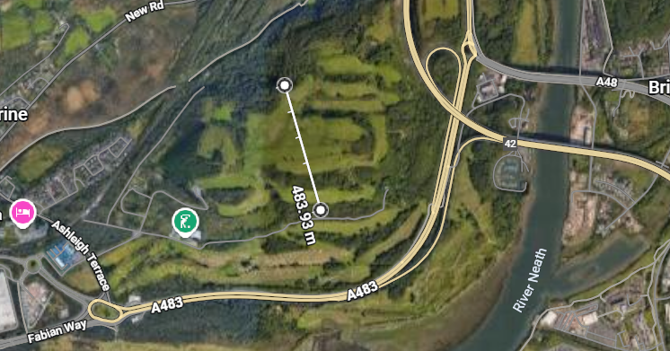
Figure 10: The line along which the magazines could be built at the potential alternative Swansea Bay Golf Club Site [4]
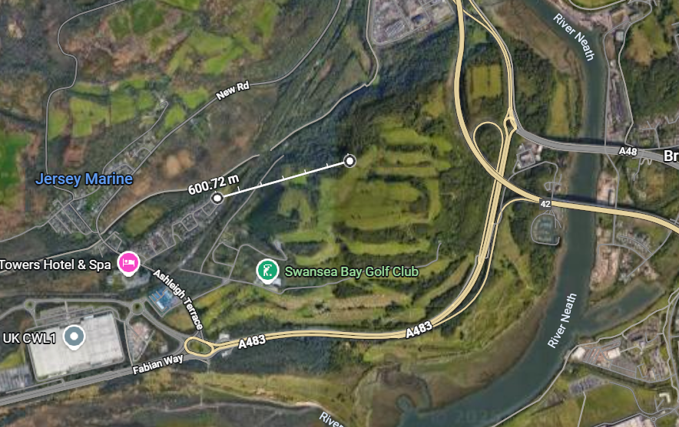
Figure 11: Approximate IBD from the proposed construction location at Swansea Bay Golf Course [4]
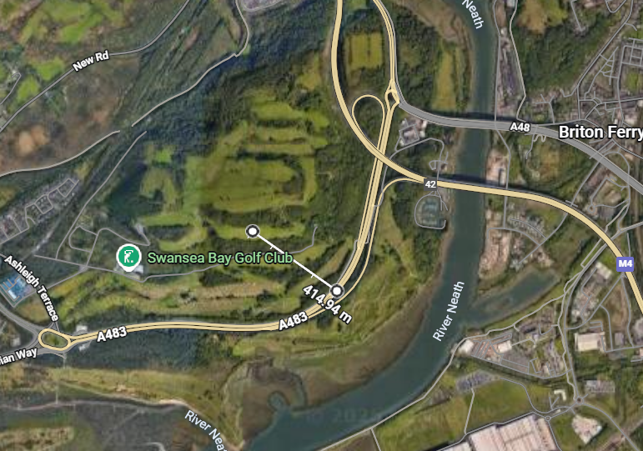
Figure 12: Approximate PTRD from the proposed construction location at Swansea Bay Golf Course [4]

Another possible location is Penllergaer Woods, approximately 6.5km Northwest of the current proposed location.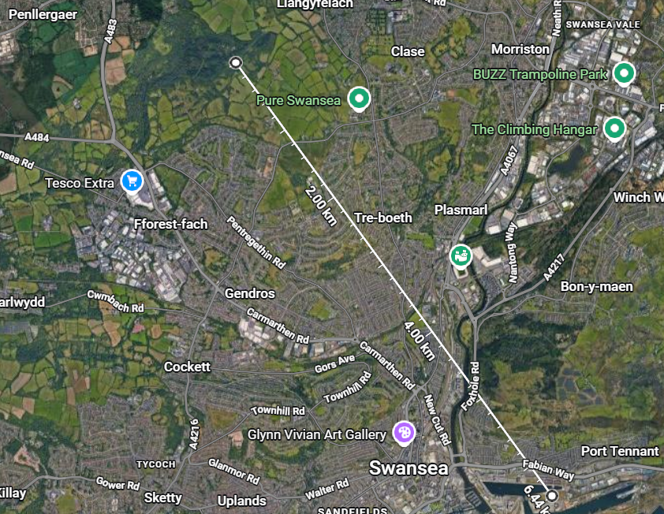
Figure 13: Position of proposed alternative site (Penllergaer Woods) relative to initial proposal [4]
As with the golf course, a degree of land purchase and redevelopment would be needed to allow an ammunition storage facility to be constructed at Penllergaer Woods, however assuming a facility was built roughly in the centre of the uninhabited land, the distances to surrounding infrastructure would fall well outside of the calculated QDs.
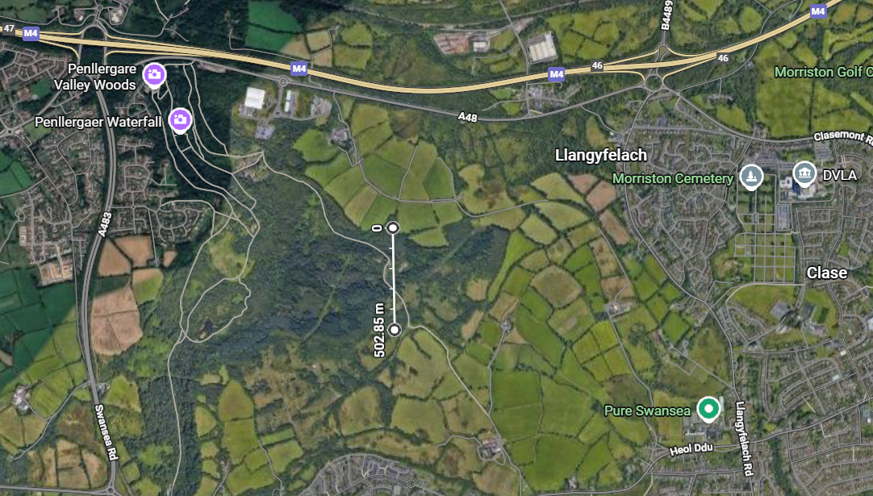
Figure 14: Approximate line along which a facility could be constructed at the second alternative site [4]
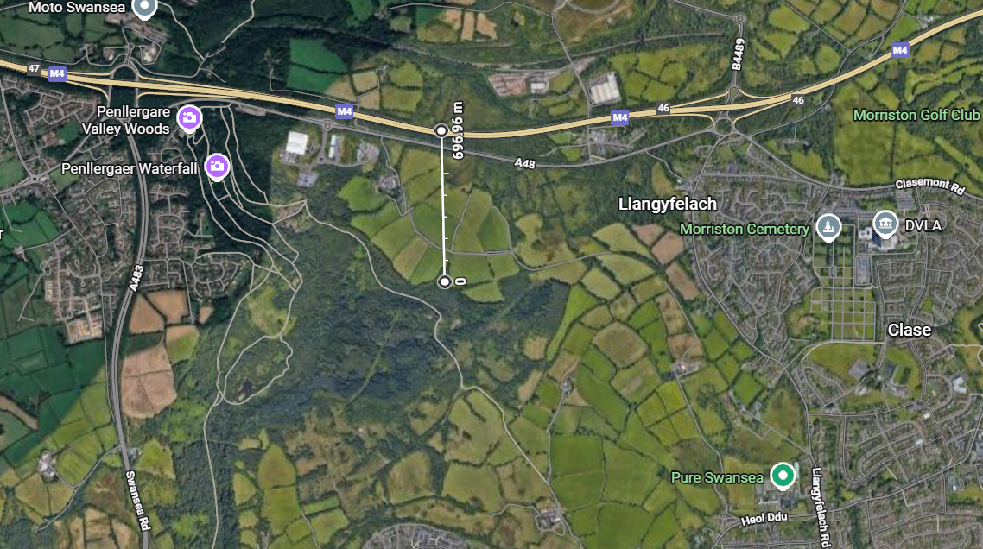Figure 15: Distance from the second proposed site to the nearest high-density Public Traffic Route [4]
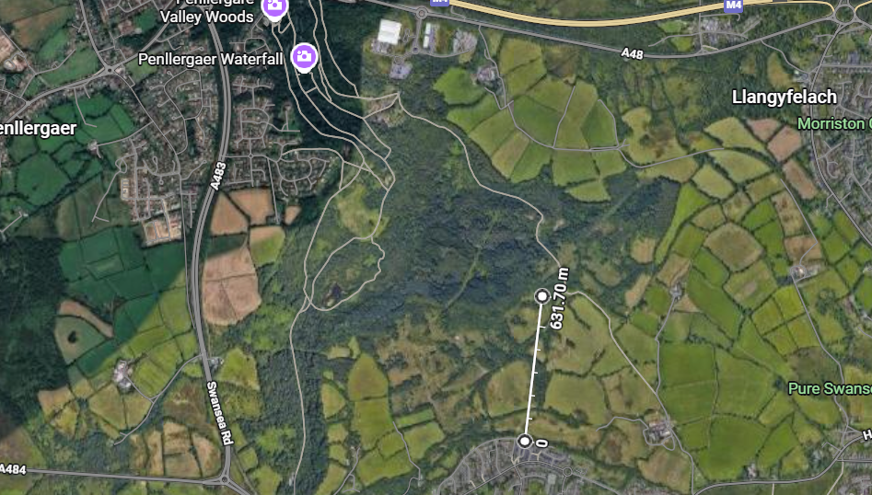
Figure 16: Approximate distance between the nearest inhabited buildings and the second proposed alternative site [4]
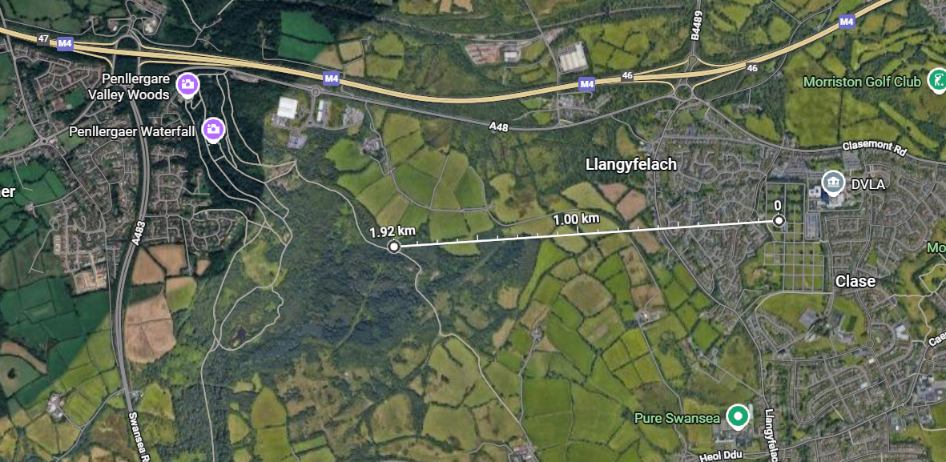
Figure 17: Approximate distance between the nearest Vulnerable Buildings (Cemetery) and the second proposed alternative site [4]
From these measurements it can be seen that there are areas of land in and around Swansea that would allow the construction of an ammunition facility of the desired capacity.

Conclusions and Recommendations

Conclusions
In conclusion, it is not feasible to construct an ammunition storage facility of the proposed capacity at the original proposed location regardless of any modifications to the facility itself such as use of NATO standard magazines or downscaling of the proposed capacity. This is due to the proximity of a large number of inhabited buildings, a high density Public Traffic Route, and the HMT Sancta Maria Hospital to the site. It is possible to identify potential alternative sites in and around Swansea which could allow for the proposed facility to be constructed.

Recommendations
It is recommended that any application to store explosives at the current proposed location is rejected on safety grounds. It is also recommended that the need to store a large quantity of explosives in or around Swansea is carefully considered. If it is judged to be truly necessary, the alternative locations discussed in Section 3.3 should be considered alongside other unused land as potential sites.

References

[1] | UWTSD, ACDA6022 Assignment Specification, Swansea: UWTSD, 2025.
[2] | IATG, IATG 01.50 UN Explosive Hazard Classification System and Codes (Third Edition), New York: United Nations, 2021.
[3] | IATG, IATG 02.20 Quantity and Separation Distances (3rd Edition), New York: United Nations, 2021.
[4] | Google, “Google Maps,” Google, 2025. [Online]. Available: https://www.google.com/maps/@51.6193539,-3.9215258,712m/data=!3m1!1e3?entry=ttu&g_ep=EgoyMDI1MTIwOS4wIKXMDSoKLDEwMDc5MjA2N0gBUAM%3D. [Accessed December 2025].

