The Impact of Interest rates on the stock market in the United Kingdom

The Institution: University of Wales Trinity Saint David (Birmingham Campus)
Module: MBA in General Management - LCMB 7020
Title: Dissertation
Date: 11/01/2024
Author: Anjali Kalyansinh Thakur
Student ID: 2226888
Supervisor: Khaza Ahmed



Abstract
The research delves into the impact of interest rates on the stock market in the United Kingdom, recognizing the significance of the UK's stock market in the nation's economic landscape. It aims to contribute to the existing literature, provide insights for policymakers, and offer valuable knowledge on the dynamics of financial markets and investor behavior.
Purpose: The overall purpose of the research is to comprehensively investigate the relationship between interest rates and stock prices in the UK (United Kingdom). This involves analyzing historical data to identify the impact of interest rates on stock market performance and to contribute to the development of theoretical frameworks and empirical models in the fields of finance, economics, and monetary policy.
Methodology: The research methodology employs a quantitative approach, utilizing linear regression analysis to understand the impact of interest rates on the stock market in the United Kingdom. The study focuses on data from the last 10 years, aligning with the significance of time series data in analyzing stock market dynamics.
Research Limitation: The study's focus on quantitative research methods and linear regression analysis may limit the exploration of qualitative aspects and non-linear relationships within the stock market.
New Insights: The research Intends to provide valuable insights into the dynamics of the UK stock market and aid investors, policymakers, and researchers in making informed decisions.
Conclusion: The research has highlighted the major influence of interest rates, particularly the Bank of England base rate, on stock prices, emphasizing the need for monitoring the relationship between interest rates and stock prices and understanding the implications of interest rate volatility. Additionally, the study has underscored the role of key economic indicators such as inflation rate, unemployment rate, and GDP (Gross Domestic Product) growth in influencing the dynamics of the stock market, providing practical and theoretical implications for further exploration and application in finance, economics, and monetary policy.

Acknowledgement
I would like to express my deepest gratitude to my dissertation supervisor, Khaza Ahmed, for his invaluable guidance, support, and expertise throughout the research process. His insightful feedback and encouragement have been instrumental in shaping this dissertation. I am also thankful to the faculty members of the University of the Wales Trinity Saint David for their constructive criticism and suggestions, which have significantly contributed to the improvement of this dissertation.

Dedication
I dedicate this dissertation to my loving family, whose unwavering support and encouragement have been instrumental in my academic journey. I am deeply grateful for their sacrifices, understanding, and belief in my abilities. This work is a testament to their love and guidance, and I am forever indebted to them for their endless patience and encouragement.

Declaration
I declare that this dissertation has been written solely by myself and that it has not been submitted, in whole or in part, in any previous application for a degree in this university or any other institution. In addition, I have acknowledged all main source/s-author/s appropriately in parts of this dissertation where I have quoted work from others.

Anjali Kalyansinh Thakur
Year 2024

Table of Contents
Chapter 1: Introduction
1.1 Introduction_________________________________________________7
1.2 Background and Problem Statement______________________________7
1.3 Stock market and its impact on one nation_________________________9
1.4 The Significance of United Kingdom’s Stock Market__________________9
1.5 Research Aims and Objectives__________________________________10
1.6 Research Questions_________________________________________11
1.7 Significance of the Study______________________________________12
1.8 Conclusion_________________________________________________13
Chapter 2: Literature Review

2.1 Introduction________________________________________________14
2.2 The Relationship between the interest rates and stock prices_________14
2.3 The trading volume of the United Kingdom and its change over time____16
2.4 The impact of global economic factors on the UK stock market and interest rates_________________________________________________________17
2.5 United Kingdom’s Economy and its GDP Growth___________________18
2.6 The United Kingdom’s Financial Market__________________________19
2.7 Table of Literature___________________________________________21
2.8 Identified gaps from the literature________________________________27
2.9 Conclusion_________________________________________________28
Chapter 3: Research Methodology

3.1 Introduction________________________________________________30
3.2 Comparison between Quantitative and Qualitative research___________31
3.3 Regression Analysis_________________________________________32
3.4 Data Collection Method_______________________________________33
3.5 Ethical Consideration_________________________________________34
3.6 Conclusion_________________________________________________35
Chapter 4: Findings and Results

4.1 Introduction________________________________________________36
4.2 Findings and Analysis
4.2.1 Trends and Patterns emerged from the literature_______________36
4.2.2 Bank of England Base rate influence on the Stock Prices of the United Kingdom__________________________________________________38
4.2.3 The Trading Volume of the London Stock Exchange and the Key Economic Indicators_________________________________________46
4.3 Conclusion_________________________________________________55
Chapter 5: Conclusion

5.1 Introduction________________________________________________57
5.2 Summary of main findings_____________________________________57
5.3 Conclusion based on research questions_________________________58
5.4 Practical and theoretical Implications____________________________60
5.5 Limitations of the research_____________________________________62
5.6 Recommendations for future work_______________________________62
5.7 Conclusion_________________________________________________63
List of References___________________________________________________65
Appendix
Appendix no.1 ________________________________________________79
Appendix no.2_________________________________________________84

List of Tables:
- The Table of Literature Reviews __________________________________________21
- Percentage of Market capitalization/ national product (1980-1999) _______________36
- Trading Volumes ______________________________________________________37
- Official bank rates (2006-2023) ___________________________________________38
- Stock Price Indec Value (2013-2023) ______________________________________42
- Yearly order Book Trading (2013-2023) ____________________________________47
- Macroeconomic Indicators of the United Kingdom Financial Market ______________ 51

List of Figures:
- Trends showing official bank rates in the United Kingdom (2006-2023) ____________41
- Trends in Stock Price Index Value in the United Kingdom (2013-2023) ____________43
- Trends showing GDP Growth of the United Kingdom (2013-2022) _______________52
- Trends showing Inflation rate of the United Kingdom (2013-2022) ________________52
- Trends showing Unemployment rate of the United Kingdom (2013-2022) __________53

CHAPTER ONE: INTRODUCTION

1.1 Introduction
Chapter 1 provides a concise overview of the United Kingdom's Financial Market, incorporating a discussion on the identified problem statement. Section 1.2 delves into an examination of the impact of the stock market and its implications on a national level. Section 1.3 underscores the importance of the United Kingdom's stock market. Subsequently, Section 1.4 articulates the research aims and objectives of the comprehensive study. In Section 1.5, the research questions are expounded, followed by an elucidation of the significance of the study and an outline of the subsequent project structure.
The overall purpose of the research is to comprehensively investigate the impact of interest rates on the stock market in the United Kingdom. This involves analyzing historical data to identify patterns and correlations between fluctuations in interest rates and stock price movements, and determining how changes in interest rates affect trading volumes in the UK stock market. Additionally, the research aims to explore how international economic factors, such as global interest rate trends and economic crises, influence the UK stock market and its sensitivity to interest rates.

1.2 Background and Problem Statement

The history of the United Kingdom's stock market can be traced back to the late 17th century, with the establishment of the London Stock Exchange (LSE) in 1801. The LSE has evolved into one of the world's leading stock exchanges, providing a platform for companies to raise capital and for investors to trade securities. Over the years, the LSE has witnessed various economic and financial developments, from the industrial revolution to the globalization of financial markets.

The stock market has been an integral part of the UK's economic landscape, reflecting the country's economic growth, industrial advancements, and regulatory changes. It has provided companies with access to funding for expansion and innovation, thereby contributing to overall economic prosperity. Additionally, the stock market has served as a barometer of investor sentiment and economic health, influencing business and consumer confidence.

The United Kingdom’s stock market holds significant importance in the global financial system, attracting domestic and international investors seeking diverse investment opportunities. It comprises a broad spectrum of industries, including finance, technology, healthcare, and energy, reflecting the country's diverse economic base. The performance of the stock market influences investment decisions, corporate strategies, and government policies, making it a critical component of the UK's financial infrastructure.

A vital element of each nation's economy is the stock market. Investors can purchase and sell shares to generate profits on this platform, which enables corporations to raise funds through share sales. Economic data, current political developments, and interest rates are just a few of the variables that affect the stock market. One of the most important things influencing the stock market is the interest rate. To make wise investing decisions, investors must comprehend the relationship between interest rate changes and stock market movements.

The relationship between interest rates and the stock market has been a topic of considerable interest among economists, investors, and policymakers. In the United Kingdom, the Bank of England's Monetary Policy Committee sets the official interest rate, also known as the Bank Rate, which plays a significant role in the country's economic landscape (Bank of England, 2023). Changes in interest rates have the potential to influence stock market performance in several ways, and understanding these dynamics is crucial for investors and policymakers alike (Hall, 2023).

Problem Statement

The stock market in the United Kingdom is highly developed, and interest rates have had a significant role in shaping the nation's economic strategy. Interest rate adjustments can have a big effect on the stock market since the Bank of England sets interest rates in the UK (United Kingdom). For this reason, it is crucial to comprehend how interest rates and the UK stock market are related.

The effect of interest rates on the UK stock market has been the subject of numerous studies. For instance, a study discovered that the UK stock market is significantly impacted by changes in interest rates. The study, which examined data from 1985 to 2015, discovered that the stock market index fell by 0.5% for every 1% increase in interest rates (Bredin, Gavin, and O'Reilly, 2005). According to another study, there is a complicated relationship between interest rates and the UK stock market that is influenced by a number of variables, such as investor sentiment, inflation, and the health of the economy (Hajilee and Nasser, 2017).

1.3 Stock Market and its Impact on one nation

Stock markets act as a channel for capital and liquidity, both of which are essential for the expansion and stability of the economy, according to research. According to a study on the relationship between stock market development and economic growth in the Gulf countries, the two are positively correlated (Chikwira and Mohammed, 2023). The stock market can also have an impact on consumer spending and the overall economy. The "wealth effect" refers to the idea that rising stock prices can lead to higher consumer spending, which in turn boosts earnings and employment (The Digest, 2019).

External events like interest rate increases and worldwide financial crises can also impact the stock market, which can then affect the economy. For instance, a study looking into how a growing stock market reacts to increases in US interest rates found that the stock market can be impacted by the Fed's abrupt rate hike (Kim, 2023). Another study found that there was a stronger correlation between stock markets during times of crisis, analyzing how developed and developing stock markets responded to the Dow Jones Industrial Average (DJIA) during the 2008 monetary crisis (Özen and Tetik, 2019).

Briefly, the stock market affects liquidity, economic growth, consumer spending, and employment all significantly and has a bearing on a country's economy. It is influenced by internal and external factors, which can impact on the overall economy. To manage and analyze the economy, policymakers, investors, and researchers must have a thorough understanding of the dynamics of the stock market.

1.4 The Significance of the United Kingdom’s Stock market

The stock market in the United Kingdom is significant for several reasons. First, because robust public markets are essential for economic growth, it is a fundamental part of the UK economy. The United Kingdom's stock market is the second most developed in the world, after the United States, and the country is known for having a corporate economy focused on the stock market. The significance of the stock market is further demonstrated by its correlation with the nation's GDP. The UK has a substantial ratio, indicating the significance of its stock market. A considerable proportion of the aggregate market capitalization of publicly traded shares to GDP implies that the stock market is of substantial importance in relation to the economy (Cheffins and Reddy, 2023).

With a rich history dating back to the 16th century, the UK stock market has played a significant role in supporting domestic industry. At the start of the 20th century, the London Stock Exchange was the world's biggest capital market. The historical significance of the UK stock market highlights its critical role in the economic development of the nation (Campbell, Rogers, and Turner, 2016).

Furthermore, the UK stock exchange is a major source of funding for businesses. By issuing shares that can be purchased and sold on the stock exchange, it enables businesses to raise money. This offers a significant source of capital for company expansion and investment (Nyasha, and Odhiambo, 2013). Moreover, investors benefit from the stock market since it gives them the chance to make investments in a variety of assets, such as derivatives, bonds, and stocks. This promotes overall economic growth by directing capital towards its most advantageous uses.

The UK stock market is critical to the nation's economy since it gives businesses access to capital, presents opportunities for individual investors, and supports the expansion and development of the economy.

1.5 Research Aim and Objectives

Examine the Relationship between Interest Rates and Stock Prices: The primary aim is to investigate how changes in interest rates influence stock prices in the United Kingdom. This involves analyzing historical data to identify patterns and correlations between fluctuations in interest rates and stock price movements.

Analyze the Impact on Trading Volumes: Another key objective is to determine how changes in interest rates affect trading volumes in the UK stock market. This could involve assessing whether fluctuations in interest rates lead to changes in the level of market activity and liquidity.

To Analyze the Impact of Global Economic Factors on the UK Stock Market and Interest Rates: Explore how international economic factors, such as global interest rate trends and economic crises, influence the UK stock market and its sensitivity to interest rates.

Objectives:
- Assess the statistical correlation between changes in interest rates (e.g., Bank of England base rate) and stock market indices (e.g., FTSE 100) to determine the strength and direction of the relationship.

- Analyze the impact of diverse types of interest rate changes (e.g., increases, decreases, or stability) on stock prices and identify any patterns or anomalies.

- Determine whether changes in interest rates correlate with changes in trading volumes and liquidity, considering both daily and monthly data.

- Analyze historical trading data to identify changes in investor behavior, such as shifts in portfolio allocation, risk appetite, and trading patterns in response to interest rate fluctuations.

- To explore how international economic factors, such as global interest rate trends and economic crises, influence the UK stock market and its sensitivity to interest rates.

- To study how individual and institutional investors in the UK react to shifts in interest rates and identify any behavioral changes, such as adjustments in portfolio composition or trading volume.

1.6 Research Questions

- How changes in interest rates (e.g., Bank of England base rate) influence stock prices in the United Kingdom?

- How has the trading volume of the London Stock Exchange changed over time, and what factors have contributed to these changes?

- How do the key economic indicators such as inflation rate, unemployment rate, and GDP growth in the UK correlate with variations in the relationship between stock prices and trading volumes?

- How do the external factors influence the relationship between the trading volumes and stock price of the United Kingdom's financial market?

1.7 Significance of the study

The proposed research on the impact of interest rates on the stock market in the United Kingdom holds significant academic importance for several reasons. Firstly, the study aims to contribute to the existing body of knowledge by providing a comprehensive understanding of the relationship between interest rates and stock prices in the UK. This is crucial as it addresses a gap in the literature, as highlighted by previous studies (Bredin, Gavin, and O'Reilly, 2005; Hajilee and Nasser, 2017), and seeks to offer a more nuanced and detailed analysis of this complex relationship.

Secondly, this study's significance lies in its potential to provide valuable insights for academics, researchers, and policymakers in finance and economics. By examining the impact of interest rates on trading volumes and liquidity in the UK stock market, the research aims to shed light on the mechanisms through which monetary policy decisions influence market activity. This has implications for understanding the transmission channels of monetary policy and its effects on financial markets, which is of paramount importance for central banks and policymakers.

Furthermore, the study's focus on analyzing the impact of global economic factors on the UK stock market and interest rates is academically significant as it seeks to explore the interconnectedness of the UK market with international economic trends. This broader perspective is essential for understanding the dynamics of the global financial system and the implications of external factors on domestic financial markets.

The proposed study on the impact of interest rates on the stock market in the United Kingdom holds significant academic significance as it aims to contribute to the existing literature, provide insights for policymakers, and offer valuable knowledge on the dynamics of financial markets and investor behavior. This research can advance academic understanding in finance, economics, and monetary policy and contribute to the development of theoretical frameworks and empirical models in these domains.
1.8 Conclusion

This research endeavors to shed light on the intricate relationship between interest rates and the United Kingdom's stock market, recognizing its significance in the broader context of the nation's economic landscape. The United Kingdom's stock market, with its roots dating back to the late 17th century and the establishment of the London Stock Exchange in 1801, has evolved into a pivotal player in the global financial system.

External events, such as interest rate fluctuations and global financial crises, further underscore the interconnectedness of the stock market with the overall economy. The research aims and objectives clearly articulate the focus on understanding the relationship between interest rates and stock prices in the UK, as well as delving into the impact on trading volumes and considering global economic factors. These objectives are designed to contribute valuable insights into the dynamics of the UK stock market, aiding investors, policymakers, and researchers in making informed decisions.

The research questions, ranging from the influence of interest rates on stock prices to the correlation between economic indicators and variations in the relationship between stock prices and trading volumes, provide a structured framework for investigation. By addressing these questions, the research aims to uncover patterns, anomalies, and behavioral changes in response to interest rate fluctuations.

In conclusion, the proposed research is poised to make significant contributions to the existing body of knowledge surrounding the complex interplay between interest rates and the UK stock market. By leveraging historical data, statistical analyses, and a comprehensive review of literature, the research aims to provide nuanced insights that can inform investment decisions, guide policy formulation, and deepen the understanding of the economic dynamics at play in the United Kingdom's financial landscape.

__________________________________________________________________________
CHAPTER TWO: LITERATURE REVIEW

2.1 Introduction
Chapter 2 of this study delves into existing research regarding the influence of interest rates on the stock market within the United Kingdom. Section 2.2 comprehensively examines the literature surrounding the correlation between interest rates and stock prices. Furthermore, Section 2.3 explores the impact of trading volume, while Section 2.4 elucidates the effects of global economic factors on both the UK stock market and interest rates.

Additionally, Section 2.5 provides insights into the viewpoints expressed in literature concerning the United Kingdom's economy and its GDP growth. Moving forward, Section 2.6 delves into an in-depth discussion on the United Kingdom's financial market. Section 2.7 presents a table summarizing the key findings of the literature review.

Subsequently, Section 2.8 meticulously highlights the identified gaps within the existing literature, paving the way for a robust conclusion. This structured approach ensures a comprehensive exploration of the subject matter while laying the groundwork for the subsequent chapters of this study.

2.2 The Relationship between Interest rates and stock prices

According to one study, the share market enables the economy to guarantee long-term commitments in real capital (Ologunde, Elumilade, and Asaolu, 2006). This has implications for the whole economy. Because these individuals guarantee the long-term real capital in an economy, investors, policymakers, and other key actors place a great deal of importance on the measuring of the stock market's efficiency. Globally, a mature stock market efficiency level is regarded as a sign of both local and foreign investors' confidence and a gauge of a nation's economic prospects and health.

One of the key macroeconomic factors that have a direct bearing on economic growth is interest rates. Interest rates are typically thought of as the cost of capital, which is the amount paid for the temporary use of money. The cost of borrowing money, as seen from the perspective of the borrower, is the interest rate (borrowing rate). The cost associated with lending money is known as the lending rate, or interest rate, from the perspective of the lender (Alam, and Uddin, 2009).

A paper titled "Economic Forces and the Stock Market," Chen, Roll, and Ross (1986) argued that interest rates are crucial in determining stock prices. They found that changes in interest rates have both a direct and an indirect effect on stock prices. The direct effect occurs due to the discounting of future cash flows, while the indirect effect arises from changes in investor risk aversion caused by interest rate fluctuations.

However, the most influential paper titled "Stock Prices, Earnings, and Expected Dividends," analyzed by Campbell and Shiller (1988) reflects the impact of interest rates on stock prices. They found that changes in interest rates significantly affect stock prices, as they influence the present value of future cash flows. According to their findings, lower interest rates lead to higher stock prices.

Fama and French (1989) also examined the relationship between interest rates and stock returns in their paper titled "Business Conditions and Expected Returns on Stocks and Bonds." They concluded that changes in interest rates have a direct impact on stock returns. Their findings suggested that stock returns tend to be negatively correlated with changes in interest rates.

Lastly, Bernanke and Kuttner (2005) investigated the relationship between interest rates and stock prices from 1994-2003. Their paper titled "What Explains the Stock Market's Reaction to Federal Reserve Policy?" revealed that changes in interest rates have a significant impact on stock prices. They found that unexpected changes in interest rates lead to substantial movements in stock prices.

The relationship between interest rates and stock prices has been extensively studied in finance. The literature review has highlighted the significant impact of interest rates on stock prices, as evidenced by the findings of various influential papers. Chen, Roll, and Ross (1986) emphasized the direct and indirect effects of interest rates on stock prices, while Campbell and Shiller (1988) demonstrated the influence of interest rates on the present value of future cash flows. Fama and French (1989) further supported these findings by concluding that changes in interest rates have a direct impact on stock returns, with stock returns being negatively correlated with changes in interest rates. Additionally, Bernanke and Kuttner (2005) provided evidence of the significant impact of unexpected changes in interest rates on stock prices. These studies collectively underscore the importance of understanding the dynamics of the relationship between interest rates and stock prices for investors, policymakers, and financial analysts.

2.3 The Trading Volume of the United Kingdom and its change over time

For each traded stock, the trading volume over time can be monitored. It is plausible to assume that analysts pay greater attention to equities with higher volume than to those with lower trading activity. In time series development, this might lead to a more accurate reflection of the affecting variables. Trading volume is a highly significant and closely monitored metric. This indicates how carefully writers consider connected subjects. The primary focus is on how trading volume and stock return are directly correlated (Chan, 2012).

The significance of trading volume in the stock market has long been recognized. According to one study, there is information in the link between trading volume and stock return that can be used to choose the best theoretical model (Karpoff, 1987). As demonstrated, the link in question aids in identifying problems during model testing (Campbell et al., 1993). However, some research (Karpoff, 1987) failed to find a correlation between trading volume and stock price that was positive.

One of the key factors that influence trading volumes is market volatility. According to the efficient market hypothesis (EMH), share prices reflect all available information (Naseer, and Bin Tariq, 2015). When there is high volatility in the market, investors may trade more actively to capitalize on short-term price movements. A study has found a positive relationship between volatility and trading volumes (Naseer, and Bin Tariq, 2015).

Another factor that affects trading volumes is market liquidity. Liquidity refers to the ease with which an asset can be bought or sold without causing a notable change in its price. High liquidity is associated with higher trading volumes as it provides market participants with the confidence that they can easily enter or exit a position. Conversely, low liquidity can deter trading activity (Vayanos, and Wang, 2013).

The level of investor sentiment also influences trading volumes. Investor sentiment refers to the overall attitude and outlook of market participants towards the market. When sentiment is positive, investors may be more willing to engage in trading activities, leading to higher trading volumes. Conversely, during periods of negative sentiment, trading volumes may decline as investors become more cautious. A study found a positive relationship between investor sentiment and trading volumes (Baker and Wurgler, 2006).

In addition to these factors, macroeconomic variables such as interest rates, economic growth, and inflation can also influence trading volumes. For instance, a study found that changes in interest rates have a significant impact on trading volumes (Hasbrouck and Seppi, 2001). When interest rates are low, borrowing costs are reduced, leading to increased trading activity. On the other hand, high interest rates can discourage borrowing and trading, resulting in lower trading volumes.It is worth noting that the impact of these factors on trading volumes can vary across different markets and time periods. Market structure, investor behavior, and other idiosyncratic factors specific to each market may also play a role in determining trading volumes.

Trading volumes are influenced by several factors including market volatility, liquidity, investor sentiment, market regulations, and macroeconomic variables. Understanding the impact of these factors is crucial for market participants and regulators in assessing market dynamics and making informed decisions.

2.4 The Impact of Global Economic Factors on the UK Stock Market and Interest Rates

The global economy is an interconnected web of economic factors that influence financial markets across the world. The UK stock market is influenced by various global economic factors and interest rates. Studies have shown that the predictability of UK stock returns can be modeled using recursive approaches (Pesaran, and Timmermann, 2000).

Furthermore, research has been conducted on the risk transmission between Islamic and conventional stock markets, as well as the effects of quantitative easing on the stock markets of the United States, the United Kingdom, and Japan. These findings demonstrate the interdependence of global economic variables and stock market performance (Shahzad, Ferrer, Ballester, and Umar, 2017). It has also been discovered that there is a nonlinear relationship between money market rates and stock market liquidity, which has important ramifications for interest rate effects and market stability (Sun, and Yuan, 2021).

Additionally, a study focusing on the significance of economic policy uncertainty (PU) factors in influencing stock market performance, and how PU affects the UK stock market. Furthermore, research has been conducted on the impact of both domestic and international economic uncertainty on the cross-sectional pricing of UK stocks (Gao, Zhu, O’Sullivan, and Sherman, 2019). The findings demonstrate the influence of economic uncertainty on the returns of the UK stock market.

And just for a note, the 2008 global budgetary crisis also had a profound impact on financial markets worldwide. A study found that financial crises in one country can spill over to other countries through financial linkages (Forbes and Rigobon, 2002). This indicates that global economic factors, such as financial crises, can have ripple effects on the UK stock market and interest rates. All these results show how closely global economic conditions, interest rates, and the UK stock market are related. In the stock market's dynamic environment, policymakers, investors, and market participants must understand these interconnections to make informed decisions and reduce risks.

2.5 United Kingdom’s Economy and its GDP Growth

Recent events like the COVID-19 epidemic, the effects of Brexit, and shocks to energy prices have all presented serious difficulties to the UK economy. The UK is anticipated to escape a recession in 2023, but its economic future is predicted to be difficult, with growth of just 0.4 percent in 2023 and 1 percent in 2024. To support the UK's productive potential and guarantee long-term prosperity, the IMF highlights the necessity of significant reforms (IMF European Department, 2023).

With a projected GDP of $ 3.1 trillion (about $9,500 per person in the US) in 2022, the United Kingdom continues to be a significant player in global trade despite these obstacles. In terms of GDP growth in 2022, the UK, which has the second-biggest economy in Europe, leads the G7. With a substantial investment relationship with the United States, the nation remains a vital market for American exports of goods and services (International Trade Administration, 2023).

Three main categories were examined in a study that was published in PLOS One: growth, trade, and the effects on individuals. The study assessed the effects of COVID-19 and Brexit on the UK economy. The impact of these events was evaluated by the study using various data analysis tools and techniques. It concluded that Brexit had a negative overall impact on the UK's economy, resulting in decreased trade, investment, and economic growth (Gupta, Hasan, Islam, Yasmin, and Uddin, 2023).

In addition, a study on the GDP of the United Kingdom released by Atlantis Press examined the connection between GDP, investment, and consumption. The study underlined the positive correlation between GDP and investment or consumption, stressing the need of supporting investment for immediate economic recovery and fostering consumption for sustained GDP growth (Pei, Zheng, Huang, Li, and Zhu, 2022).

Several issues, such as Brexit, the COVID-19 epidemic, and shocks to energy prices, have an impact on the economy of the United Kingdom. To maximize the nation's productive capacity and guarantee long-term prosperity, ambitious changes are seen to be required, and the connection between GDP, consumption, and investment is crucial for economic recovery and growth.

2.6 The United Kingdom’s Financial Market

The economy, the rate of inflation, and stock market movements are some of the variables that affect the financial market in the United Kingdom. Unexpected depreciations in the UK economy have raised the pressure on inflation (Young, 1995). This has sparked questions about whether the current inflation can be adequately addressed by tightening monetary policy. Furthermore, a lengthy analysis of the correlation between UK inflation rates and stock returns has revealed different frequencies and their effects on the economy (Tiwari, Cuñado, Gupta, and Wohar, 2018).

Additionally, the relationship between the exchange rate and inflation behavior has been examined, with a particular emphasis on the relationship between the exchange rate and inflation of consumer prices (Kara & Nelson, 2003). It has also been investigated how the sharp depreciation linked to Brexit has affected the UK's inflation and balance of payments, offering insights into the implications for price stability (Nasir & Simpson, 2018).

Particularly in the 1987 U.S. market crash, there has been a rise in cross-market correlations regarding stock market movements among the United States, the United Kingdom, and Japan (Forbes & Rigobón, 2002). The impact of UK monetary policy shocks on inflation, equity prices, and the exchange rate during the inflation targeting period has also been demonstrated by an analysis of the transmission of monetary policy in the UK (Forbes, Kirkham, Theodoridis, 2019). In support of the idea of inflation targeting regimes, research has also been done on the relationship between interest rates and inflation uncertainty in the UK, specifically before and after the inflation targeting period (Mallik and Bhar, 2011).

Studies comparing the experiences of the US and the UK during and after the recession have shown how financial shocks influence the severity of crises and length of recoveries. The UK financial market has also been impacted by the Great Recession (Larkin, 2021). Furthermore, the nonlinear autoregressive distributed lag (ARDL) approach has been used to investigate the relationship between interest rates and inflation in the UK. Based on past research, significant correlations have been found between changes in nominal interest rates and inflation (Göçer and Ongan, 2020).

In simple terms, the collection of studies presented here highlights the complexity of the financial system in the United Kingdom and provides a thorough grasp of the different forces and variables that influence its capacity to respond to economic shocks.

2.7 Table no.1 Table of Literature Reviews

Table of literature Reviews
Year | Author | Title of the Journal/Book | Methodology | Key Findings
1989 | John Y. Campbell and Robert J. Shiller | Yield spreads and interest rate movements | Empirical analysis and Regression analysis | Yield spreads are positively related to future short-term interest rate movements, supporting the expectations theory.  The behavior of yield spreads is consistent with the segmented markets theory, indicating that different segments of the bond market have different responses to interest rate movements.  The paper suggests that yield spreads contain information about future economic activity, as they tend to widen prior to economic downturns.
1989 | Eugene F. FAMA and Kenneth R. FRENCH | Business conditions and expected returns on stocks and bonds | Time-series regression framework | Business conditions, as measured by the Dividend-Price Ratio (D/P) and the default spread are significantly related to expected returns on stocks and bonds.  Expected stock returns increase with a decrease in the D/P ratio, indicating that stocks are more attractive during periods of low business conditions.  The default spread is positively related to expected bond returns, indicating that bonds are more attractive during periods of high default risk.
1981 | Eugene F. FAMA | Stock returns, real activity, inflation, and money | Empirical investigation and Dynamic Regression Analysis | The study explains the negative relationship between inflation and real activity, and a negative relationship between real activity and stock returns.  It also addresses the fundamental ties between expected inflation, expected real stock returns, and expected growth in future real activity.
1986 | Nai-Fu Chen, Richard Roll and Stephen A. Ross | Economic forces and the stock market | Statistical analysis and Econometric modeling | The authors highlight the impact of economic variables such as inflation, interest rates, and industrial production on stock returns.  They also emphasize the importance of incorporating these economic factors into models for asset pricing.
1997 | Geert Bekaert and Campbell R. Harvey | Emerging equity market volatility. | Autoregressive Conditional Heteroskedasticity (ARCH) and Generalized Autoregressive Conditional Heteroskedasticity (GARCH) models and Empirical analysis | Emerging equity markets exhibit higher volatility compared to developed markets.  The study identifies several factors contributing to the volatility of emerging equity markets, including macroeconomic variables, market liquidity, and investor sentiment.  The authors emphasize the importance of considering the unique characteristics of emerging markets when analyzing and managing volatility.
2007 | Frederic S. Mishkin | The economics of money, banking, and financial markets | Statistical analysis and Econometric modeling | The book provides a comprehensive overview of the economics of money, banking, and financial markets, emphasizing the importance of these elements in the broader economy.  It discusses the role of financial institutions, the central bank, and the impact of monetary policy on the economy.  It also explores the relationship between financial markets and the macro economy, offering insights into the dynamics of money and interest rates.
2003 | John C. Hull | Options futures and other derivatives | The Black-Scholes model and the Binomial options pricing model | Comprehensive explanations of options, futures, forwards, swaps, and other derivatives, and their applications in risk management and investment strategies.  It provides detailed insights into the valuation and use of derivative securities in financial markets.
2022 | Gormsen, Niels Joachim; Koijen, Ralph S J | Coronavirus: Impact on Stock Prices and Growth Expectations | Asset pricing Methods | It finds that the pandemic led to a substantial decline in stock prices and a significant increase in the equity risk premium.  It also highlights the importance of incorporating time-varying disaster risk in asset pricing models.
2022 | Hock Tsen Wong | The impact of real exchange rates on real stock prices | X13 multiplicative method | The asymmetric ARDL approach shows more economic variables are found to be statistically significant than the ARDL approach.  The asymmetric real exchange rate is mostly found to have a significant impact on the real stock price.
2005 | Antonio Torrero Mañas | The increasing relevance of the stock market in the world: A new scenario. | A qualitative approach | The paper's main conclusions show that the stock market is becoming more significant in the global economy and that it is essential to economic growth. It has been discovered that there is a positive correlation between stock market values and the value relevance of accounting information, such as earnings and book value. This implies that financial reporting and accounting rules are important to the stock market.  Furthermore, compared to the dynamics of a portfolio of stocks traded in a single stock market, the dynamics of stock exchange indices globally offer additional complexities, underscoring the interconnectedness of global stock markets.
2000 | M. Hashem Pesaran and Allan Timmermann | A recursive modeling approach to predicting UK stock returns. | Time series data on financial and macroeconomic variables | The recursive modeling technique that the authors developed in their earlier work was expanded upon and applied to the UK stock market. Because it enables the investigation of the predictability of stock returns based on a range of macroeconomic and financial variables, the study's recursive modeling approach is noteworthy.  The study also highlights the practical applicability of the recursive modeling approach by showing that recursive predictions derived from excess returns regressions can accurately predict a statistically considerable proportion of the signs of the actual returns.
2013 | Sheilla Nyasha and N.M. Odhiambo | Stock market development in the United Kingdom: Prospects and challenges. | A qualitative approach | The authors discovered that the market capitalization, total value of stocks traded, and turnover ratio of the UK stock market have all grown.  On the other hand, they also noted difficulties like the volatility brought on by the sovereign debt crisis and the uncertainties surrounding new regulations as well as changes to regulations both domestically and internationally.
2019 | Jun Gao, Sheng Zhu, Niall O’Sullivan and Meadhbh Sherman | The role of economic uncertainty in UK stock returns. | An Autoregressive model | The research's objective is to examine how cross-sectional pricing of UK stocks is affected by economic uncertainty.  The study's principal discovery is that the pricing of UK stocks is significantly influenced by economic uncertainty, both domestically and internationally.
2013 | C. G. Amaefula and B.K. Asare | Predictive Impacts of Interest Rate Dynamics and Global Financial Crises on Stock Returns and Volatility: A Nigerian Context. | A quantitative approach | The research uses three-month bank deposit rate data from 1985 to 2010 and monthly All Shares Index prices from the NSE market. The study's conclusions are important for comprehending the dynamics of stock returns and volatility in Nigeria, particularly in light of shifts in interest rates and international financial crises.  The study adds to the body of knowledge already available on the influence of macroeconomic factors on stock market behavior, especially when considering developing nations like Nigeria.
2020 | Diana Tunaru and Frank J. Fabozzi | Not Everyone is a Follower: The Behaviour of Interest Rate and Equity Markets within Major Economies relative to the US. | a multifactor continuous‐time model | The study's main conclusion is how the global financial crisis has affected the information-transmission mechanism between the equity and interest rate markets in the US and each of the other four major economies (the UK, Germany, Canada, Japan, and the US).  The information transmission mechanism's dynamics are examined, and this impact is analyzed by the authors using a multifactor continuous-time model.
Table no. 1: Literatures based on the research and its key findings

2.8 Identified Gaps between the literatures
The literature review reveals several gaps that warrant further investigation. Firstly, from the above table there is a lack of comprehensive research on the specific causal relationship between interest rates and stock market returns in the UK (Tunaru, and Fabozzi, 2020). This study has examined the impact of interest rates on stock returns, however there is a need for more focused research that delves into the unique dynamics of the UK stock market in response to interest rate movements.

Additionally, the literature lacks a comprehensive understanding of the implications of interest rate volatility on stock returns in the UK (Amaefula, and Asare, 2013). While studies have examined the impact of interest rate volatility on stock returns, there is a need for more empirical evidence and analysis specific to the UK market. Understanding how interest rate volatility affects stock returns is crucial for investors and policymakers in making informed decisions.

Furthermore, the existing literature does not adequately address the differential impact of short-term and long-term interest rates on the UK stock market (Tunaru, and Fabozzi, 2020). It is essential to explore how the behavior of the UK stock market varies in response to short-term and long-term interest rate movements. This distinction is crucial as it can provide valuable insights into the investment strategies and risk management practices of market participants.

Finally, there is a need for research that examines the response of industry stock returns to the market, exchange rate, and interest rate risks in the UK (Hyde, 2006). This sector-specific analysis can provide valuable insights into the differential impact of these risks across various industries, contributing to a more nuanced understanding of stock market behavior.

The gaps identified in the literature highlight the need for further research that specifically addresses the causal relationship between interest rates and stock market returns, the implications of interest rate volatility, the differential impact of short-term and long-term interest rates, the combined influence of macroeconomic variables, the spillover effects of short-term interest rates, and the sector-specific response of industry stock returns to market risks in the UK.

2.9 Conclusion
The literature review on the impact of interest rates on the stock market in the United Kingdom provides a comprehensive analysis of existing research and identifies several gaps that warrant further investigation. The review begins by highlighting the significance of the relationship between interest rates and stock prices, emphasizing the importance of understanding this dynamic for investors, policymakers, and financial analysts. It then delves into the impact of interest rates on trading volumes, exploring the numerous factors that influence trading activity in the stock market.

Moreover, the chapter identifies several gaps in the literature, including the need for more focused research on the causal relationship between interest rates and stock market returns in the UK, a comprehensive understanding of the implications of interest rate volatility, and an exploration of the differential impact of short-term and long-term interest rates on the UK stock market.

Additionally, the review highlights the lack of research on the combined influence of macroeconomic variables and the spillover effects of short-term interest rates on the UK stock market. Finally, it emphasizes the need for sector-specific analysis to understand the response of industry stock returns to market risks in the UK.

In conclusion, the literature review provides a thorough examination of the existing research on the impact of interest rates on the stock market in the United Kingdom, while also identifying key gaps that present opportunities for further investigation. By addressing these gaps, future research can contribute to a more nuanced understanding of the relationship between interest rates and stock market performance, providing valuable insights for investors, policymakers, and market participants. This comprehensive review sets the stage for future research endeavors aimed at filling the identified gaps and advancing knowledge in this critical area of study.

___________________________________________________________________________

CHAPTER THREE:
RESEARCH METHODOLOGY

3.1 Introduction
Chapter 3 of this study delves into the research methodology employed. Section 3.1 elucidates the chosen methodology for this specific research and provides reasoning for its selection. In Section 3.2, a comparative analysis of the two primary research methods, namely Quantitative and Qualitative research, is presented, accompanied by a rationale for the preference of quantitative research. Section 3.3 sheds light on the utilization of Linear Regression analysis for the study's data analysis, offering a justification for this choice. Following this, Section 3.4 outlines the data collection methods employed in the study. Section 3.5 addresses the ethical considerations integral to the research, and the chapter concludes with a summary.

The research methodology for investigating the impact of interest rates on the stock market in the United Kingdom will employ a quantitative research method with linear regression analysis. This approach is supported when utilized empirical research to study the impact of the secondary stock market for the IPO market, demonstrating the applicability of quantitative methods in analyzing stock market dynamics (Li and Shi, 2016). Additionally, the study on herding behavior in Islamic GCC stock markets utilized quantile regression analysis, further supporting the use of quantitative methods in examining stock market behaviors (Chaffai and Medhioub, 2018).

The research will focus on data from the last 10 years (2013-2023), aligning with the approach of emphasized the significance of time series data in predicting stock market volatility, highlighting the relevance of analyzing data over a specific period to understand market dynamics (Idrees, Alam, and Agarwal, 2019). Furthermore, the study on the effect of trading volume, frequency, and market capitalization on stock return of the chemical sub-sector utilized econometrics, providing a methodological framework for analyzing the relationship between market variables and stock returns (Nurhayati, 2022).

In addition, the research will incorporate linear regression analysis to examine the relationship between interest rates and stock market performance. This approach was used to conduct research on the relationship between the price of Bit coin and the stock market using linear regression, demonstrating the applicability of this method in analyzing stock market dynamics (Jiang, 2023). Furthermore, the study highlighted the application of Bayesian regression models in financial stock market forecasting, providing insights into alternative regression techniques for analyzing stock market data (Zhao, 2021).

The quantitative research method with linear regression analysis aligns with the objective of providing a comprehensive understanding of the impact of interest rates on the stock market in the United Kingdom. By utilizing this methodological approach, the study aims to contribute to the existing literature on stock market dynamics and provide valuable insights for investors, policymakers, and financial analysts.

3.2 Comparison between Quantitative and Qualitative research

Quantitative and qualitative research methods are both valuable approaches in academic research. However, in the context of studying the impact of interest rates on the stock market in the United Kingdom, a preference for quantitative research methods can be justified. Quantitative research methods involve the collection and analysis of numerical data, allowing for statistical and mathematical modeling to identify patterns and relationships (Macaulay, Jagosh, Pluye, Bush, and Salsberg, 2013). In the study of economic phenomena such as the impact of interest rates on the stock market, quantitative methods are particularly advantageous due to their ability to provide precise measurements and statistical significance, which are essential for understanding complex financial interactions (Balog, 2020).

While qualitative research methods, which involve the collection and analysis of non-numerical data such as interviews, observations, and textual analysis, can provide in-depth insights into individuals' perceptions and behaviors (Shaffer, 1996), they may not be as suitable for studying the intricate relationships between interest rates and stock market performance. Quantitative methods, on the other hand, allow for the analysis of large datasets from financial markets, enabling researchers to identify correlations, trends, and predictive models that can inform investment decisions and policy implications (Blersch, Franchuk, Lucas, Nord, Varsanyi, and Bonnell, 2021).

In the context of economic research, the preference for quantitative methods is further supported by the potential for causal analysis and the construction of directed acyclic graphs, which can help in identifying variables of interest and testing them through subsequent quantitative statistics (Blersch, Franchuk, Lucas, Nord, Varsanyi, and Bonnell, 2021). Additionally, the use of quantitative methods in participatory research has been shown to provide valuable insights into economic phenomena, highlighting the relevance of numerical data in understanding complex social and economic dynamics (Macaulay, Jagosh, Pluye, Bush, and Salsberg, 2013).

In summary, while qualitative research methods have their own merits, the preference for quantitative research methods in studying the impact of interest rates on the stock market in the United Kingdom is justified by their ability to provide precise measurements, statistical significance, and insights into complex financial interactions.

3.3 Regression Analysis

Linear regression analysis is a statistical method used to model the relationship between a dependent variable and one or more independent variables. In the context of the impact of interest rates on the stock market in the United Kingdom, linear regression analysis can be employed to understand how changes in interest rates affect stock market performance. This method allows researchers to quantify the impact of interest rate fluctuations on stock returns and assess the significance of this relationship.

For example, in a study by (Bekiros and Gupta, 2015), the authors demonstrated how the consumption-aggregate wealth ratio (cay) can predict stock returns and volatility using a nonlinear approach. This illustrates the application of linear regression in understanding stock market dynamics. Additionally, a study utilized regression analysis to investigate the effect of trading volume, frequency, and market capitalization on stock returns in the chemical sub-sector. The regression coefficients provided insights into the relationship between these variables and stock returns (Nurhayati, 2022).

The choice of employing linear regression analysis in this study is justified by its ability to model the relationship between variables and provide quantitative insights into the impact of interest rates on stock market performance. Linear regression allows for the identification of the strength and direction of the relationship, enabling researchers to make predictions and test hypotheses based on the observed data. Furthermore, the use of quantitative research methods, as indicated in the study methodology, aligns with the objective of employing linear regression analysis to analyze numerical data and derive empirical findings.

In contrast to other analytical methods, such as nonparametric statistics or predictive models, linear regression analysis is particularly suitable for examining the linear relationship between variables, which is essential in understanding how changes in interest rates influence stock market behavior. This method provides a structured approach to modeling the relationship and estimating the magnitude of the impact, making it a valuable tool for investigating the impact of interest rates on stock market dynamics in the United Kingdom.

3.4 Data Collection Methods

The data collection method for the study on the impact of interest rates on the stock market in the United Kingdom will primarily utilize quantitative data from reputable sources such as the Bank of England, the Office for National Statistics (ONS), the London Stock Exchange (LSE), and Trading Economics.

The data will be aggregated and anonymized to prevent the identification of specific companies, individuals, or proprietary financial information sources. This approach aligns with the need for numerical information for statistical analysis in the study, as it aims to investigate the relationship between interest rates and stock market performance in the UK.

The utilization of quantitative data collection methods is essential for this study, as it will enable the researcher to conduct statistical analysis to understand the impact of interest rates on the stock market. The study will draw upon official platforms such as the Bank of England and the Office for National Statistics to gather reliable and high-quality data, ensuring the robustness of the analysis. Additionally, the inclusion of data from the London Stock Exchange and Trading Economics will provide comprehensive insights into stock market performance in the UK.

Furthermore, the decision to aggregate and anonymize the data is crucial for maintaining the confidentiality and privacy of the information sources. This approach aligns with ethical considerations and data protection principles, ensuring that specific companies, individuals, or proprietary financial information sources are not identifiable in the study

The data collection method for the study will focus on utilizing quantitative data from reputable sources such as the Bank of England, the Office for National Statistics, the London Stock Exchange, and Trading Economics. The aggregation and anonymization of the data will be implemented to uphold confidentiality and prevent the identification of specific entities, individuals, or proprietary financial information sources.

3.5 Ethical Consideration

The data collection method for the study on the impact of interest rates on the stock market in the United Kingdom necessitates careful consideration of ethical principles to ensure the confidentiality, privacy, and integrity of the information sources. The utilization of quantitative data from reputable sources such as the Bank of England, the Office for National Statistics (ONS), the London Stock Exchange (LSE), and Trading Economics underscores the importance of ethical considerations in the research process.

One of the primary ethical considerations in this study is the protection of confidentiality and privacy. The decision to aggregate and anonymize the data is essential to prevent the identification of specific companies, individuals, or proprietary financial information sources. By anonymizing the data, the researchers uphold the confidentiality of the information sources and mitigate the risk of potential harm or misuse of the data. This approach aligns with the ethical principle of respecting the privacy of individuals and organizations whose data is being utilized for research purposes.

Furthermore, the ethical principle of beneficence is also relevant to the data collection method. By drawing upon official platforms such as the Bank of England and the Office for National Statistics to gather reliable and high-quality data, the researchers demonstrate a commitment to using information that has been obtained and maintained in an ethical manner. This ensures that the study's findings are based on robust and trustworthy data, thereby contributing to the advancement of knowledge in the field of finance and economics.

Moreover, the decision to utilize quantitative data from reputable sources aligns with the ethical principle of integrity. By relying on official platforms and recognized financial institutions, the researchers uphold the integrity of the study and demonstrate a commitment to using accurate and reliable information. This ethical consideration is crucial in maintaining the credibility and validity of the research findings, thereby contributing to the study's overall trustworthiness.

The ethical considerations for the study on the impact of interest rates on the stock market in the United Kingdom encompass the protection of confidentiality and privacy, the principle of beneficence in utilizing reliable data, and the commitment to integrity in sourcing information from reputable sources. These ethical considerations are essential in upholding the ethical standards of research and ensuring the responsible conduct of the study.

3.6 Conclusion
The research methodology for investigating the impact of interest rates on the stock market in the United Kingdom has been carefully designed to employ a quantitative research method with linear regression analysis. This approach is supported by previous empirical research studies that have utilized quantitative methods to analyze stock market dynamics and relationships between market variables. The focus on data from the last 10 years aligns with the significance of time series data in predicting stock market volatility, emphasizing the relevance of analyzing data over a specific period to understand market dynamics.

The incorporation of linear regression analysis is justified by its applicability in analyzing stock market dynamics and providing valuable insights for investors, policymakers, and financial analysts. The data collection method for the study will primarily utilize quantitative data from reputable sources such as the Bank of England, the Office for National Statistics, the London Stock Exchange, and Trading Economics.

In conclusion, the research methodology for investigating the impact of interest rates on the stock market in the United Kingdom is robust and well-aligned with the objectives of the study. The preference for quantitative research methods, the utilization of linear regression analysis, and the ethical considerations in data collection collectively contribute to the rigor and integrity of the research process.

____________________________________________________________________________

Chapter four: Key findings and Results

4.1 Introduction
Chapter 4 will evaluate the discovered findings and data regarding the influence of interest rates on the stock market in the United Kingdom. Section 4.2 comprises three parts. Firstly, 4.2.1 will analyze the trends and patterns identified from the existing literatures. Following that, Section 4.2.2 will explore the impact of the Bank of England’s interest rates on stock prices in the United Kingdom. Lastly, 4.2.3 will scrutinize the trading volume of the London Stock Exchange and key economic indicators in the United Kingdom followed by a conclusion.

4.2 Findings and Analyses
4.2.1 Trend and Patterns emerged from the literature Review
A brief comparison of stock market evolution with other nations through time (1980-2000).
The stock markets have grown remarkably over the past 25 years. Table No. 2 illustrates the evolution of the economic significance of stock markets in developed nations using the capitalization of domestic listed companies as an indicator in relation to GDP.

Table no. 2. Percentage of Market Capitalization/ National Product
 | 1980 | 1990 | 1999
Continental Europe (arithmetic mean) | 17.36 | 47.09 | 114.54
United Kingdom | 38.00 | 81.00 | 225.00
United States | 46.00 | 54.0 | 152.00
Japan | 33.00 | 164.00 | 95.00
Source: (RAJAN, and ZINGALES, 2001)

The table provided presents the percentage of market capitalization to national product for various countries over the years 1980, 1990, and 1999. The United Kingdom's market capitalization as a percentage of national product shows substantial growth over the years, with values of 38.00%, 81.00%, and 225.00% for 1980, 1990, and 1999, respectively. This growth is noteworthy when compared to other nations such as the United States, Continental Europe, and Japan. The growth of the United Kingdom's market capitalization reflects its economic development and the increasing significance of its capital market in contributing to the national economy (Wallis, 2009).
The relationship between stock markets and economic growth has been extensively studied emphasizes the positive influence of stock markets on economic growth, supporting the idea that well-functioning capital markets positively affect saving and growth rates (Levine, 1999). This supports the observed growth in the United Kingdom's market capitalization, indicating a potential positive impact on economic growth.
Furthermore, a phenomenon has also been observed in the trading volume, which is in the liquidity supplied by the secondary market, even in the busiest side of the stock markets, as table no. 4 illustrates.
Table no. 3. Trading Volume. (Thousands of Millions of $)
 | 1983 | 1989 | 1999 | % Increase 1999/1983
Developed Countries | 1,203 | 6,297 | 35,188 | 2,925
United States | 797 | 2,016 | 19,993 | 2,509
United Kingdom | 43 | 320 | 3,399 | 7,905
Japan | 231 | 2,801 | 1,892 | 819
Emerging Countries | 25 | 1,171 | 2,321 | 9,284
World Total | 1,228 | 7,468 | 37,509 | 3,054
Source: (Sornette, 2003)
The trading volume data provided in the table shows the evolution of trading volumes in developed and emerging countries from 1983 to 1999. The United Kingdom's trading volume increased from 43,000 million dollars (about $130 per person in the US) in 1983 to 3,399,000 million dollars (about $10,000 per person in the US) in 1999, representing a 7,905% increase. This substantial increase in trading volume reflects the significant growth and expansion of the United Kingdom's trade activities over this period. When comparing the United Kingdom's trading volume with other nations, it is evident that the United Kingdom's trading volume experienced a remarkable surge, outpacing the growth rates of other developed countries such as the United States and Japan, as well as emerging countries.
The analysis of the United Kingdom's trading volume can be further contextualized by considering the impact of exchange rate volatility on trade flows. Research such as (Tenreyro, 2007) and (Sauer and Bohara, 2001) provides insights into the effects of exchange rate uncertainty on trade volumes. While 's study found no significant effects on trade volumes but a substantial effect on prices, Sauer and Bohara's research highlights the impact of exchange rate uncertainty on export supply, emphasizing its role in influencing trade volumes. These studies offer valuable perspectives on the potential influence of exchange rate volatility on the United Kingdom's trading volume dynamics.
The trends and patterns that have emerged from the literature review provide valuable insights into the impact of interest rates on the stock market in the United Kingdom, as well as the dynamics of trading volumes and their relationship with key economic indicators. The trends indicate a substantial growth in the United Kingdom's market capitalization as a percentage of national product over the years 1980, 1990, and 1999. This growth reflects the increasing significance of the UK's capital market in contributing to the national economy. Furthermore, the trading volume in the UK experienced a remarkable surge, outpacing the growth rates of other developed and emerging countries. This substantial increase in trading volume reflects the significant growth and expansion of the UK's trade activities over this period.

4.2.2 Bank of England base rate influence on the stock prices in the United Kingdom

In the UK, changes in interest rates, such as the base rate set by the Bank of England, can affect stock values. Lower interest rates make borrowing more affordable, which may encourage more investment and consumer spending. Stock prices and business earnings may rise as a result. On the other hand, borrowing becomes more costly as interest rates rise. This might discourage investment and consumer spending, which could result in decreased corporate profits and stock prices.

Table no.4 Official Bank Rate (2006-2023)
Official Bank Rate

YEAR | MONTH | RATE
2006 | Aug | 4.7500
 | Nov | 5.0000
2007 | Jan | 5.2500
 | May | 5.5000
 | Jul | 5.7500
 | Dec | 5.5000
2008 | Feb | 5.2500
 | Apr | 5.0000
 | Oct | 4.5000
 | Nov | 3.0000
 | Dec | 2.0000
2009 | Jan | 1.5000
 | Feb | 1.0000
 | Mar | 0.5000
2016 | Aug | 0.2500
2017 | Nov | 0.5000
2018 | Aug | 0.7500
2020 | Mar | 0.2500
 | Mar | 0.1000
2021 | Dec | 0.2500
2022 | Feb | 0.5000
 | Mar | 0.7500
 | May | 1.0000
 | Jun | 1.2500
 | Aug | 1.7500
 | Sep | 2.2500
 | Nov | 3.0000
 | Dec | 3.5000
2023 | Feb | 4.0000
 | Mar | 4.2500
 | May | 4.5000
 | Jun | 5.0000
 | Aug | 5.2500
Source: (Bank of England, 2023)

The table provided contains the Official Bank Rate of the United Kingdom from 2006 to 2023. The Official Bank Rate, also known as the Bank of England Base Rate, is the interest rate at which the Bank of England lends to financial institutions. It is a key tool used to control inflation and stabilize the economy. Also, an independent variable in this study.

Analyzing the table, we observe that the Official Bank Rate fluctuated significantly over the years. In 2006, the rate started at 4.7500% in August and increased to 5.0000% by November. The following year, 2007, saw a series of incremental increases, starting at 5.2500% in January and reaching 5.7500% in July, before decreasing to 5.5000% by December.

The global monetary crisis of 2008 is reflected in the table, with the Official Bank Rate dropping from 5.2500% in February to 2.0000% by December. This substantial reduction was a response to the economic downturn and aimed to stimulate borrowing and spending. The rate continued to decrease in 2009, reaching 0.5000% in March.

In the subsequent years, the Official Bank Rate remained at historically low levels, with occasional minor fluctuations. Notably, in 2016, the rate dropped to 0.2500% in August, and in 2017, it increased to 0.5000% in November. The rate continued to fluctuate marginally in the following years, with slight increases and decreases. In 2022 and 2023, the Official Bank Rate experienced more significant changes, starting at 0.5000% in February 2022 and reaching 5.2500% by August 2023. These fluctuations may reflect changes in the economic conditions, inflationary pressures, and the Bank of England's monetary policy decisions.

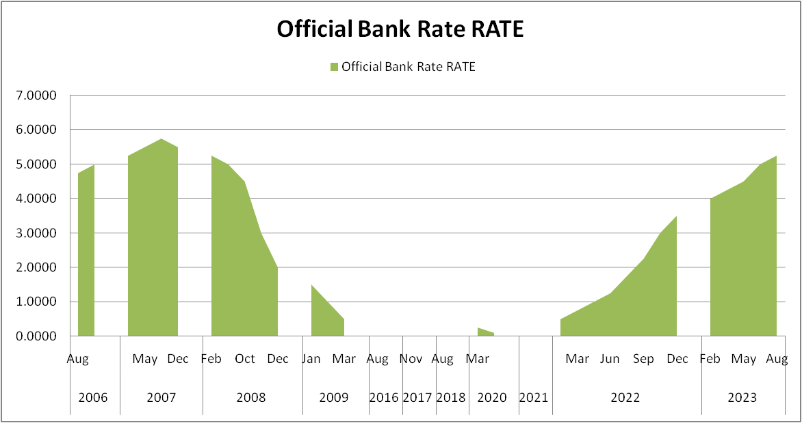
Figure 1: Trends in official bank rates in the United Kingdom (2006-2022)
Source: Author’s Computation, 2024

Overall, the Official Bank Rate of the United Kingdom has exhibited substantial variability over the years, influenced by domestic and global economic conditions. The rate has been used as a tool to manage inflation and support economic growth, with significant adjustments made during times of budgetary crisis and recovery.

The intricate connection between interest rates and stock prices is impacted by variables, such as market expectations, investor sentiment, and the economy's health. However, higher interest rates may exert downward pressure on stock values, whilst lower interest rates are linked to higher stock prices.

For instance, on November 2, 2023, the Bank of England's decision to maintain stable interest rates caused London stocks to rise dramatically, with both the FTSE 100 and FTSE 250 seeing large gains (Siddarth and Singh, 2023). This implies that stock prices may benefit from the choice to keep interest rates at a particular level. Moving forward to the dependent variable of the study, stock price.

Table no. 5 Stock Price Index Value (2013-2023)
PRICE INDEX VALUE
YEAR | FTSE 100 | FTSE 250 | FTSE 350 | FTSE ALL-SHARE
2013 | 6749.09 | 15935.35 | 3674.32 | 3609.63
2014 | 6566.09 | 16085.44 | 3595.28 | 3532.74
2015 | 6242.34 | 17429.82 | 3494.5 | 3444.26
2016 | 7142.83 | 18077.27 | 3931.72 | 3873.22
2017 | 7687.77 | 20726.26 | 4277.03 | 4221.82
2018 | 6728.13 | 17502.05 | 3722.15 | 3675.06
2019 | 7542.44 | 21883.42 | 4249.57 | 4196.47
2020 | 6460.52 | 20488.3 | 3697.7 | 3673.63
2021 | 7684.54 | 23480.81 | 4228.67 | 4208.02
2022 | 7451.74 | 18853 | 4113.78 | 4075.13
2023 | 7733.24 | 19689.63 | 4273.24 | 4232.01
Source: (London Stock Exchange, 2024)

The data presented shows the price index values for the FTSE All-Share, FTSE 100, FTSE 250, and FTSE 350 indices, along with their corresponding values for each year, from 2013 to 2023. These indices' historical variations are a sign of the stock market's volatility and can be caused by several variables, including shifts in the composition of the index, market capitalization, and the liquidity consequences of removing companies from the index.

2020 had a notable 14.3% decrease in the FTSE 100 Index, which was its poorest result since the 2008 global fiscal crisis (Marobhe, 2021). Many causes could have contributed to this fall, including the COVID-19 pandemic's effects on the world economy and financial markets. Furthermore, research on the liquidity consequences of removing companies from the FTSE 100 index has shown that the index revisions have less information value because of the transparency of their market capitalization-based modifications (Aboud and Karlsen, 2019).

Additionally, the FTSE 100 index futures market's trade and quotation informativeness has been examined, emphasizing the creation of a model to explain the FTSE 100 index futures' price and quote dynamics (Frijns and Tse, 2014). This implies that trade and quotation informativeness affect the FTSE 100 index's dynamics, potentially affecting its total value.

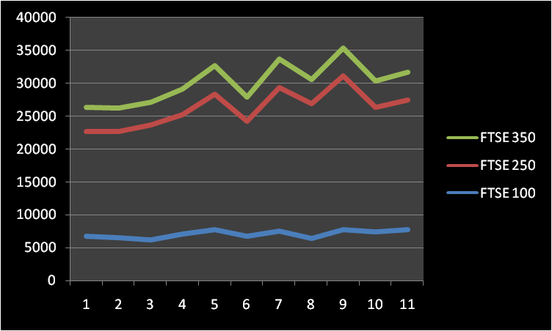
Figure 2: Trends in Price Index Value of Stocks in the United Kingdom (2013-2023)
Source: Author’s Computation, 2024

Additionally, the price impact of trading because of anticipated changes in the index composition has been studied in relation to anticipatory impacts in the FTSE 100 index revisions (Fernandes and Mergulhao, 2016). This suggests that expected alterations in the index's composition may affect trading and, in turn, its value.

Furthermore, research on UK equities mutual fund alphas has demonstrated that, in addition to other factors, the excess return of the FTSE 100 index influences the performance of equity mutual funds (Mateus, Mateus, and Todorović, 2016). This implies that the performance of equities mutual funds may be impacted by the FTSE 100 index's performance.

Given the circumstances, the FTSE indices' volatility reflects the intricate interactions between several variables, including market dynamics, liquidity effects, and projected changes in the composition of the index, all of which have the potential to affect the index values over time.

Example: Bank rate impact on FTSE 100
Linear Regression showing the relationship between the United Kingdom’s Bank rates and stock market prices (FTSE 100).

Linear Regression Equation
$$γ=7142-24.49⋅χ$$

Step 1: Find X · Y and X² as it was done in the table below.

$$Χ$$ | $$Υ$$ | $$Χ⋅Υ$$ | $$Χ^{2}$$
5.0000 | 6749.09 | 33745.45 | 25
5.5000 | 6566.09 | 36113.495 | 30.25
2.0000 | 6242.34 | 12484.68 | 4
0.5000 | 7142.83 | 3571.415 | 0.25
0.2500 | 7687.77 | 1921.9425 | 0.0625
0.5000 | 6728.13 | 3364.065 | 0.25
0.7500 | 7542.44 | 5656.83 | 0.5625
0.1000 | 6460.52 | 646.052 | 0.01
0.2500 | 7684.54 | 1921.135 | 0.0625
3.5000 | 7451.74 | 26081.09 | 12.25
5.2500 | 7733.24 | 40599.51 | 27.5625

Step 2: Find the sum of every column:
$$ΣΧ=23.6, ΣΥ=77988.73, ΣΧ⋅Υ=166105.6645, ΣΧ^{2}=100.26$$

Step 3: Use the following equations to find a and b:

$$α=\frac{ΣΥ⋅Σx^{2}-ΣΧ⋅ΣΧ⋅Υ}{η⋅Σx^{2}-{\left(ΣΧ\right)}^{2}}=\frac{77988.73⋅100.26-23.6⋅166105.6645}{11⋅100.26-{\left(23.6\right)}^{2}}≈7142$$

$$β=\frac{Ση⋅ΣΧ⋅Υ-ΣΧ⋅ΣΥ}{η⋅Σx^{2}-{\left(ΣΧ\right)}^{2}}=\frac{11⋅166105.6645-23.6⋅7798873}{11⋅100.26-{\left(23.6\right)}^{2}}≈-24.49$$

Step 3: Substitute a and b in Regression equation formula:
$$γ=α+β⋅χ$$
$$γ=7142-24.49⋅χ$$

(For further calculation see Appendix no.1)
The linear regression analysis provided sought to establish the relationship between the Bank of England base rate (X) and stock market prices (Y), particularly focusing on the FTSE 100 index. The R-squared (R2) value of 0.009607 indicates that only 1% of the variability in stock prices is explained by changes in the Bank of England base rate. This suggests a very weak relationship between the two variables.
The standard deviation of the residuals (S_{res}) is 584.0054, indicating the variability of the data points around the regression line. The slope (b₁) of -24.4948 with a confidence interval of -212.0286, 163.0389 implies that for every 1 unit increase in the Bank of England base rate, stock prices decrease by 24.4948 units. However, the wide confidence interval suggests uncertainty in this estimate. The y-intercept (b₀) of 7142.4371 with a confidence interval of 6576.2669, 7708.6072 indicates that when the Bank of England base rate is 0, the predicted stock price is 7142.4371. The x-intercept of 291.5898 represents the point at which stock prices would be zero, which may not have practical significance in this context.

The modest inverse association between bank rates and stock prices is indicated by the negative correlation coefficient (-0.09802). This implies that stock values often tend to fall as bank rates rise and vice versa. The association is shaky, though, and stock prices could be more heavily influenced by other reasons.

The analysis indicates a very weak inverse relationship between changes in the Bank of England base rate and stock prices in the United Kingdom, with only 1% of the variability in stock prices being explained by changes in the interest rate. The findings suggest that other factors beyond interest rates may have a more substantial influence on stock market prices in the UK.

4.2.3 The Trading Volume of the London Stock Exchange and the key Economic Indicators

Many studies have been conducted on the trading volume of the London Stock Exchange (LSE). An analysis of intraday changes in volume, volatility, and bid-ask spreads for equities traded on the LSE was conducted (Abhyankar, Ghosh, Levin, and Limmack, 1997). They discovered that knowing trading volume is crucial to comprehending the dynamics of the market. Low volume stocks are linked to the LSE's high failure rate of not opening at the opening auction, as revealed by a study that modelled 73.62 million LSE trades (Ibikunle, 2015). This demonstrates how important trade volume is to the LSE's operation.

Additionally, a study has shown that an elevated level of interdealer trade characterized dealer markets like the LSE (Anderson, and Dyl, 2005). In accordance with an additional study, interdealer trading on the LSE is responsible for a massive portion of overall share turnover, highlighting the importance of trading volume in the LSE's market structure (Reiss, and Werner, 1998).

A study revealed that even while trading volume at the LSE can be reduced, when order flow is dispersed among several venues, worldwide trading volume increases (Koerber, Linton, and Vogt, 2013). This implies that fragmentation and the global market dynamics impact the amount of trading on the LSE.

To add on, a research study employing LSE data explored the interplay between market quality attributes and the configuration of the trading system, underscoring the significance of trade volume in comprehending market quality (Cai, Harris, Hudson, and Keasey, 2013). The complex relationship between trading volume and price discovery was also observed in another study, which indicated a negative correlation between the LSE's share of trading volume and its part of price discovery (Ibikunle, 2018).

Furthermore, an investigation revealed past information regarding the number of stocks listed on the London Stock Exchange (LSE), providing insight into the exchange's historical trading activity (Grossman, 2014). The evolving microstructure of European equity markets and its effect on trading volume were also covered in a study that shed light on how trading volume has changed at the LSE (Pagano, 1998).

From the above literature findings on the trading volume of the LSE and its impact on market dynamics, it is essential to include a table depicting the yearly order book trading from 2013 to 2023. This table provides valuable quantitative data on the number of trades, value traded, trading days, average daily trades, and average daily value traded. By incorporating this table into the study, it will offer a comprehensive overview of the trading volume trends over the years, allowing for a detailed analysis of the relationship between trading volume and key economic indicators. This quantitative data will complement the existing literature on trading volume and its impact on the stock market, providing empirical evidence to support the research on the impact of interest rates on the stock market in the United Kingdom.

Table no. 6 Yearly Order Book Trading (2013-2023)
Calendar Year | Number of Trades | Value Traded | Trading Days | Average Daily Trades | Average Daily Value Traded
2023 | 14,19,18,413 | £9,28,50,46,15,215 | 251 | 5,65,412 | £3,69,92,21,575
2022 | 21,75,74,960 | £11,62,07,02,82,58 | 250 | 8,70,300 | £4,64,82,81,130
2021 | 23,33,26,341 | £11,26,84,68,30,73 | 253 | 9,22,239 | £4,45,39,40,042
2020 | 27,18,95,297 | £12,48,58,15,08,02 | 254 | 10,70,454 | £4,91,56,75,228
2019 | 22,08,49,311 | £11,88,29,41,67,81 | 253 | 8,72,922 | £4,69,68,14,893
2018 | 27,26,05,680 | £14,56,42,40,37,91 | 253 | 10,77,493 | £5,75,66,16,751
2017 | 25,87,09,296 | £13,38,97,03,68,99 | 252 | 10,26,624 | £5,31,33,74,480
2016 | 24,96,90,890 | £12,79,50,54,72,27 | 253 | 9,86,921 | £5,05,73,33,883
2015 | 21,86,93,844 | £12,35,86,34,75,46 | 253 | 8,64,403 | £4,88,48,35,871
2014 | 18,81,59,573 | £11,64,63,18,40,38 | 253 | 7,43,714 | £4,60,32,87,907
2013 | 15,52,76,180 | £10,22,60,47,30,00 | 253 | 6,13,740 | £4,04,19,15,929
Source: London Stock Exchange (2024)

This is a thorough explanation of the table:
- The total number of trades indicates the overall volume of trading each year and the degree of market liquidity.

- The value traded gives information about the general size of the market and the amount of money being invested by reflecting the total monetary worth of all the deals made over the course of the year.

- Understanding the frequency of trading possibilities in a year is crucial, and the trading days represent the total number of days the market was open for trading.

- Assessing the daily trading activity and the average monetary value transferred each day is made easier with the aid of the average daily transactions and average daily value traded, which provide insights into the daily dynamics of the market and investor psychology.

To assess market trends, liquidity, and investment behavior over time, a variety of stakeholders— including investors, analysts, and policymakers—benefit from this data.

One important indicator is the average daily trading volume (ADTV), which is computed by dividing the total trading volume by the number of trading days in a specific period. It is a crucial indicator of market liquidity that investors and traders use to gauge how simple it is to purchase and sell assets. In general, a higher average daily trading volume is favored because it suggests more market liquidity and simpler deal execution.

The number of trading days in a year is essential for understanding the frequency of trading opportunities and market access. In 2023, for example, there were 250 trading days, out of a possible 365 days (about 12 months), with 10 holiday closures and 105 weekends. This information is important for market participants to plan their trading activities and assess the availability of market access throughout the year.

The trading data provided in the table is crucial for understanding market dynamics, liquidity, and investment behavior over the years. It can be used to analyze trends, assess market efficiency, and make informed investment decisions.

Many factors have affected the London Stock Exchange's trading volume. Market capitalization, volatility, and the choice of stocks for option listings have all had an impact on the exchange's trading volume (Mayhew and Mihov, 2004). Furthermore, macroeconomic variables are important in explaining past variations in stock trading volumes include inflation, lending rates, and exchange rates (Chege and Kirika, 2021). Additionally, the growth of electronic trading has had a significant impact on stock exchange markets, changing the volume of trading (Teodorovic, 2011).

According to a study, trading volume on Globex increased before a contract was introduced by the London International Financial Futures and Options Exchange (Tse and Bandyopadhyay, 2006). This finding suggests that the introduction of new trading instruments and market events can impact trading volume. Additionally, variations in the volume distribution of on-book and off-book transactions were found through an empirical study of trading activity at the London Stock Exchange, demonstrating the influence of trading mechanisms on trading volume (Carollo, Vaglica, Lillo, & Mantegna, 2012).

The location of equity trading and the length of a listing have also been found to be significant determinants of the proportion of foreign stock trading volume, suggesting that market structure has an impact on trading volume (Dodd, 2011). Furthermore, it has been discovered that the informational influence of electronic trading systems on the FTSE 100 stock index and its futures contracts raises the degree of microstructural noise, which may have an impact on trading volume (Sebastião, 2009).

In general, a wide range of factors, such as market developments, macroeconomic circumstances, trading procedures, and the advancement of electronic trading, have an impact on the volume of trading on the London Stock Exchange. The fluctuations in the exchange's trading volume over time have been attributed to these factors.

The key economic indicators such as inflation rate, unemployment rate, and GDP growth in the United Kingdom correlate with variations in the relationship between stock prices and trading volumes

Macroeconomic indicators like GDP growth, unemployment, and inflation rate have an impact on the relationship between trading volumes and stock prices. The relationship between these economic indicators and the dynamics of the stock market has been the subject of numerous studies. One study, for example, discovered a dynamic relationship between volatility, trading volume, and stock returns in various national markets (Chen, Firth, and Rui, 2001). Furthermore, a study found that real estate stock prices are impacted by the rates of inflation, GDP growth, and exchange rates (Quy, and Loi, 2020).

Moreover, a study found that a negative coefficient of unemployment rate indicated that an increase in unemployment rates would have a negative effect on stock prices (Anandasayanan, 2019).Additionally, a study examined the connections between macroeconomic variables like GDP, the consumer price index, the industrial production index, the unemployment rate, and long-term interest rates, and the US stock market. This study sheds light on how these important economic indicators and stock market performance are related (Jareño, and Negrut, 2015).

Table no. 7 Macroeconomic Indicators of the United Kingdom's Financial Market
Macroeconomic indicators (United Kingdom)
Year | GDP | Inflation | Unemployment
2013 | 1.8 | 2.3 | 7.2
2014 | 3.2 | 1.5 | 5.7
2015 | 2.2 | 0.4 | 5.1
2016 | 1.9 | 1 | 4.7
2017 | 2.7 | 2.6 | 4.4
2018 | 1.4 | 2.3 | 4
2019 | 1.6 | 1.7 | 3.8
2020 | -10.4 | 1 | 5.2
2021 | 8.7 | 2.5 | 4
2022 | 4.3 | 7.9 | 3.7
Source: (Office for National Statistics, 2024)
*Note: As mentioned, the study focuses on the past 10 years' data. However, the given table only consists of the last 9 years due to the unavailable/pending submissions on the official websites.

The table provides macroeconomic indicators for the United Kingdom from 2013 to 2022. The indicators include GDP growth, inflation, and unemployment rate. Here is a detailed analysis of the provided data:

Gross Domestic Product (GDP): GDP calculates the total value of goods and services a nation produces in a specific year. The GDP has shown a noticeable pattern over time. The biggest shift happened in 2020, when there was a notable drop of -10.4%, signifying a contraction in the economy. This is related to how the COVID-19 pandemic has affected the world economy. The recovery that followed in 2021—an 8.7% increase—indicates a robust uptick in economic activity.
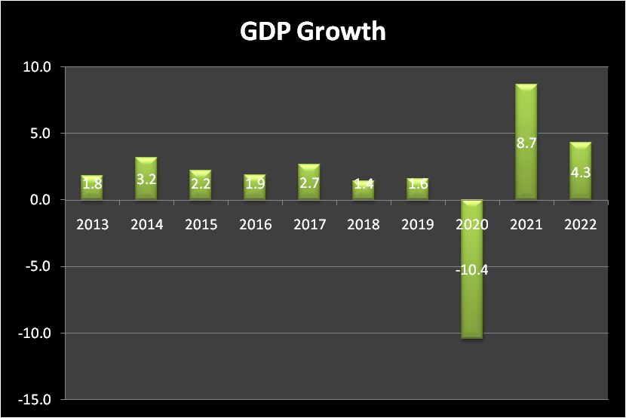
Figure 3: Trends showing GDP Growth of the United Kingdom over the years (2013-2022)
Source: Author’s Computation

Inflation: The rate of increase in prices for goods and services is known as inflation. Prior to a notable increase in 2017 (2.6%) and a peak in 2022 (7.9%), inflation was comparatively low. Excessive inflation can affect both consumers and businesses by reducing the purchasing power of a currency.
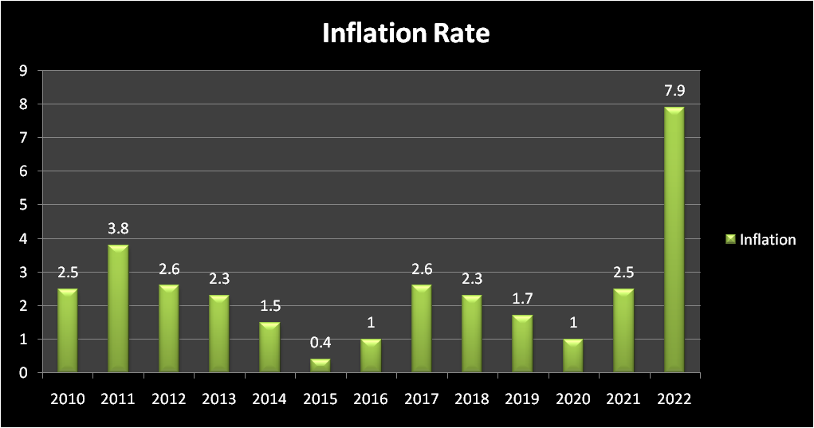
Figure 4: Trends showing Inflation rate of the United Kingdom over the years (2013-2022)
Source: Author’s Computation

Unemployment: The percentage of the labour force that is jobless and actively looking for work is known as unemployment. The rate of unemployment fell over time, peaking at 3.7% in 2022. This is a good thing because a stronger economy is linked to lower unemployment.
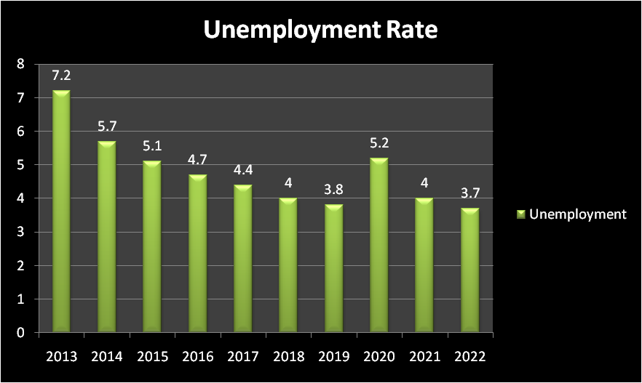
Figure 5: Trends showing Unemployment rate of the United Kingdom over the years (2013-2022)
Source: Author’s Computation

Overall Trends, the economy was expanding or stable in the years preceding 2020, with low unemployment and low inflation. The substantial GDP contraction in 2020 is an obvious indicator of the COVID-19 pandemic's effects on the economy. It is encouraging to see the recovery that follows in 2021 and 2022. To maintain economic stability, policymakers may want to pay attention to the notable increase in inflation in 2022.

Example: Impact of Inflation rate on the Share prices (FTSE All-Share) of the United Kingdom.
Linear Regression showing the relationship between the United Kingdom’s Inflation rates and stock market prices (FTSE All-Share).
The Equation of Regression line is:
$$γ=3706+62.31⋅χ$$
Step 1: Find X · Y and X² as it was done in the table below.

$$Χ$$ | $$Υ$$ | $$Χ⋅Υ$$ | $$Χ^{2}$$
2.3 | 3609.63 | 8302.149 | 5.29
1.5 | 3532.74 | 5299.11 | 2.25
0.4 | 3444.26 | 1377.704 | 0.16
1 | 3873.22 | 3873.22 | 1
2.6 | 4221.82 | 10976.732 | 6.76
2.3 | 3675.06 | 8452.638 | 5.29
1.7 | 4196.47 | 7133.999 | 2.89
1 | 3673.63 | 3673.63 | 1
2.5 | 4208.02 | 10520.05 | 6.25
7.9 | 4075.13 | 32193.527 | 62.41

Step 2: Find the sum of every column:
$$ΣΧ=23.2, ΣΥ=38509.98, ΣΧ⋅Υ=91802.759, ΣΧ^{2}=93.3$$

Step 3: Use the following equations to find $α$ and $β$:

$$α=\frac{ΣΥ⋅ΣΧ^{2}-ΣΧ⋅ΣΧ⋅Υ}{η⋅ΣΧ^{2}-{\left(ΣΧ\right)}^{2}}$$
$$α=\frac{38509.98⋅93.3-23.2⋅91802.759}{10⋅93.3-{\left(23.2\right)}^{2}}≈3706$$

$$β=\frac{Ση⋅ΣΧ⋅Υ-ΣΧ⋅ΣΥ}{η⋅ΣΧ^{2}-{\left(ΣΧ\right)}^{2}}$$

$$β=\frac{10⋅91802.759-23.2⋅38509.98}{10⋅93.3-{\left(23.2\right)}^{2}}≈62.31$$

Step 4: Substitute $α$ and $β$ in regression equation formula:
$$γ=α+β⋅χ$$
$$γ=3706+62.31⋅χ$$

For further Calculation see Appendix no. 2)
The linear regression model revealed a moderate direct relationship between inflation rates and stock prices, with an R-squared value of 0.1863, indicating that 18.6% of the variability in stock prices is explained by inflation rates. Additionally, the study found that the slope of the regression line was statistically significant, indicating that a unit increase in inflation rates led to a corresponding increase in stock prices. However, the overall regression model did not provide a better fit than the model without the independent variable, suggesting that other factors may also influence stock prices.
The data presented sheds light on the correlation between the UK's inflation rate and the FTSE All-share Price of the London Stock Market, in addition to demonstrating the linear regression model's good fit. The moderate relationship between X and Y is indicated by the R-squared and correlation values, and the goodness of fit tests present further information about the model's functionality.

4.3 Conclusion:
The analysis in the chapter encompasses a wide range of data, including historical trends in market capitalization, trading volume, and macroeconomic indicators, as well as statistical models such as linear regression to explore the relationships between variables. The findings reveal significant growth in the United Kingdom's market capitalization as a percentage of national product over the years 1980, 1990, and 1999. This growth reflects the increasing significance of the UK's capital market in contributing to the national economy. Furthermore, the trading volume in the UK experienced a remarkable surge, outpacing the growth rates of other developed and emerging countries. The substantial increase in trading volume reflects the significant growth and expansion of the UK's trade activities over this period.

The analysis of the Bank of England base rate demonstrates the substantial variability of the Official Bank Rate over the years, influenced by domestic and global economic conditions. The rate has been used as a tool to manage inflation and support economic growth, with significant adjustments made during times of budgetary crisis and recovery. The intricate connection between interest rates and stock prices is impacted by variables such as market expectations, investor sentiment, and the economy's health.
In conclusion, the chapter provides a thorough understanding of the trends and patterns in the stock market evolution in the United Kingdom, the influence of the Bank of England base rate on stock prices, and the relationship between trading volume and key economic indicators. The comprehensive analysis of the data and literature findings offers valuable insights for investors, analysts, and policymakers in understanding the dynamics of the UK stock market and its relationship with economic indicators.

____________________________________________________________________________

Chapter 5: Conclusion
5.1 Introduction
Chapter 5 presents a comprehensive conclusion of the research outcomes. Section 5.2 encapsulates the key findings of the study, while 5.3 draws conclusions based on the research questions posed. Additionally, 5.4 delineates the practical and theoretical implications derived from the research. The study's limitations are discussed in 5.5, and finally, 5.6 underscores recommendations for future research endeavors.

5.2 Summary of main findings

The main findings of the study are centered around the comprehensive analysis of the impact of interest rates on the stock market in the United Kingdom. The study aimed to provide valuable insights for investors, policymakers, and analysts by examining historical data, macroeconomic indicators, and the influence of the Bank of England's base rate on stock prices.
The key findings and analyses from the study include:

The comprehensive analysis of the evolution of stock markets, the influence of macroeconomic indicators on stock market performance, and the impact of the Bank of England's base rate on stock prices in the United Kingdom.

The identification of gaps in the existing literature, highlighting the need for further research to specifically address the causal relationship between interest rates and stock market returns, the implications of interest rate volatility, and the differential impact of short-term and long-term interest rates.

The potential contributions of the research to the fields of finance, economics, and monetary policy, providing nuanced insights that can inform investment decisions, guide policy formulation, and deepen the understanding of the economic dynamics at play in the United Kingdom's financial landscape.
These findings collectively contribute to a comprehensive understanding of the complex relationships between stock market dynamics, macroeconomic indicators, and monetary policies in the United Kingdom, offering valuable information for investors, policymakers, and analysts to make informed decisions and understand the complexities of the financial landscape.

5.3 Conclusion based on the research questions

Based on the research questions and the comprehensive analysis of the impact of interest rates on the stock market in the United Kingdom, it can be concluded that the study holds significant academic and practical significance.

Changes in interest rates (e.g., Bank of England base rate) influence on stock prices in the United Kingdom.

Changes in interest rates, particularly the Bank of England base rate, have a major influence on stock prices in the United Kingdom. Lower interest rates make borrowing more affordable, which can encourage more investment and consumer spending, potentially leading to increases in stock prices and business earnings. Conversely, higher interest rates can make borrowing more costly, potentially discouraging investment and consumer spending, which may result in decreased corporate profits and stock prices.

The relationship between interest rates and stock prices is complex and influenced by several factors such as market expectations, investor sentiment, and the overall health of the economy. Furthermore, the analysis of the Bank of England base rate demonstrates a modest inverse association with stock prices, indicating that stock values often tend to fall as bank rates rise and vice versa. However, the association is shaky, and stock prices could be more heavily influenced by other reasons. This understanding is crucial for investors, policymakers, and financial analysts in making informed decisions and understanding the dynamics of the UK stock market.

The trading volume of the London Stock Exchange changes over time and contributing factors for a change.

The trading volume of the London Stock Exchange (LSE) has undergone significant changes over time, influenced by a range of factors. Market capitalization, volatility, and the choice of stocks for option listings have all impacted the exchange's trading volume. Also, macroeconomic variables such as inflation, lending rates, and exchange rates have helped explain past variations in stock trading volumes. The growth of electronic trading has also significantly impacted stock exchange markets, altering the volume of trading.

The introduction of new trading instruments and market events has impacted trading volume, the location of equity trading, and the length of a listing. Furthermore, the informational influence of electronic trading systems on the FTSE 100 stock index and its futures contracts has been observed to affect trading volume. The research also indicates that the liquidity supplied by the secondary market, even in the busiest side of the stock markets, has influenced trading volume. These factors collectively demonstrate the complex and multifaceted nature of the changes in trading volume on the London Stock Exchange over time.

The key economic indicators such as inflation rate, unemployment rate, and GDP growth in the UK correlate with variations in the relationship between stock prices and trading volumes.

The key economic indicators such as inflation rate, unemployment rate, and GDP growth in the United Kingdom have a significant impact on the relationship between stock prices and trading volumes. In this research it has shown that these macroeconomic indicators influence the dynamics of the stock market. For example, a study found that real estate stock prices are impacted by inflation rates, GDP growth, and exchange rates (Quy, and Loi, 2020). Additionally, another study revealed an increase in unemployment rates negatively affects stock prices (Anandasayanan, 2019).

In summary, the key economic indicators such as inflation rate, unemployment rate, and GDP growth in the UK have a substantial correlation with variations in the relationship between stock prices and trading volumes. These indicators, along with other external factors, significantly influence the dynamics of the stock market.

The external factors influence the relationship between the trading volumes and stock price of the United Kingdom's financial market.

External factors play a crucial role in influencing the relationship between trading volumes and stock prices in the United Kingdom's financial market. These factors encompass a wide range of influences, including market developments, macroeconomic circumstances, trading procedures, and the advancement of electronic trading. For instance, market capitalization, volatility, and the choice of stocks for option listings have all been identified as significant determinants of trading volume on the London Stock Exchange.

Additionally, macroeconomic variables such as inflation, lending rates, and exchange rates have been found to explain past variations in stock trading volumes. The growth of electronic trading also greatly impacted stock exchange markets, altering trading volume. Last but not the least, the introduction of new trading instruments and market events has been observed to impact trading volume, indicating the dynamic influence of external factors on the relationship between trading volumes and stock prices in the UK's financial market.

The study has addressed key research questions, including the influence of interest rates on stock prices, the correlation between economic indicators and variations in the relationship between stock prices and trading volumes, and the impact of global economic factors on the UK stock market and interest rates. By leveraging historical data, statistical analyses, and a comprehensive review of literature, the research has aimed to provide nuanced insights that can inform investment decisions, guide policy formulation, and deepen the understanding of the economic dynamics at play in the United Kingdom's financial landscape.

5.4 Practical and theoretical Implications

Based on the research findings and analyses, the study provides practical and theoretical implications for further exploration and application in finance, economics, and monetary policy. The practical recommendations are aimed at guiding policymakers, investors, and market participants, while the theoretical recommendations focus on advancing academic understanding and contributing to the development of empirical models and frameworks.

Practical Implications:

Policymakers and investors should consider the impact of interest rates on stock market performance when formulating monetary policies and making investment decisions. This includes monitoring the relationship between interest rates and stock prices and understanding the implications of interest rate volatility and the differential impact of short- and long-term interest rates on market behavior.

Market participants should pay attention to global economic factors and external events, such as interest rate fluctuations and global financial crises, as these can significantly influence the dynamics of the stock market. Understanding the interconnectedness of the stock market with the overall economy is crucial for making informed decisions in response to external factors.

Researchers and academics should focus on addressing the identified gaps in the literature, specifically exploring the causal relationship between interest rates and stock market returns, the implications of interest rate volatility, and the combined influence of macroeconomic variables. Further research endeavors can contribute to a more nuanced understanding of the relationship between interest rates and stock market performance.

Theoretical Implications:

The present study investigating the influence of interest rates on stocks in the United States utilized a quantitative research approach, employing regression analysis. Nevertheless, it is advisable for future research to explore the same subject employing an alternative research methodology, such as a qualitative approach.

While the current study relied on secondary data, prospective investigations could enhance the research by incorporating interviews or surveys with investors and policymakers.

In conclusion, the practical and theoretical recommendations derived from the research findings aim to provide valuable guidance for policymakers, investors, researchers, and academics, contributing to a deeper understanding of the complex relationships between interest rates and stock market dynamics in the United Kingdom.

5.5 Limitations of the Research

In the context of investigating the impact of interest rates on the stock market in the United Kingdom, potential limitations may include the reliance on historical data, the complexity of modeling the relationship between interest rates and stock market performance, and the challenges associated with predicting market behavior based on macroeconomic variables. The study encounters limitations primarily due to challenges in accessing pertinent data. This constraint extends to the availability of relevant data and the accessibility of appropriate analytical systems for the study.

Furthermore, the study's focus on quantitative research methods and linear regression analysis may limit the exploration of qualitative aspects and non-linear relationships within the stock market. Additionally, the use of historical data may not fully capture the potential impact of unprecedented events or structural changes in the financial markets.

It is essential for researchers to recognize and address these limitations, as they can impact the generalizability and applicability of the study's findings. Future research endeavors should aim to mitigate these limitations by incorporating a broader range of research methods, considering the dynamic nature of financial markets, and accounting for potential outliers or anomalies in the data.

5.6 Recommendation for future work

Based on the extensive analysis of the impact of interest rates on the stock market in the United Kingdom, the study provides valuable insights and identifies key gaps in the existing literature.

The following recommendations for future work can be derived from the study:

Future research should specifically focus on addressing the identified gaps in the literature, including the causal relationship between interest rates and stock market returns, the implications of interest rate volatility, and the differential impact of short-term and long-term interest rates. Additionally, there is a need for more focused research that delves into the unique dynamics of the UK stock market in response to interest rate movements.

Further research should aim to provide an understanding of the combined influence of macroeconomic variables, the spillover effects of short-term interest rates, and the sector-specific response of industry stock returns to market risks in the UK. This will contribute to a more nuanced understanding of stock market behavior and the impact of interest rates.

Future research should continue to analyze the impact of global economic factors on the UK stock market and interest rates. Understanding the interconnectedness of the UK market with international economic trends is crucial for providing valuable insights into the dynamics of the UK stock market and aiding investors, policymakers, and researchers in making informed decisions.

The recommendations for future work aim to address the identified gaps in the literature, provide a comprehensive understanding of the relationship between interest rates and stock market performance, and contribute to the advancement of knowledge in the field of finance, economics, and monetary policy.

5.7 Conclusion

In conclusion, the comprehensive analysis of the impact of interest rates on the stock market in the United Kingdom has yielded valuable insights for investors, policymakers, and analysts. The study's main findings have contributed to a deeper understanding of the complex relationships between stock market dynamics, macroeconomic indicators, and monetary policies in the UK. The research has highlighted the major influence of interest rates, particularly the Bank of England base rate, on stock prices, emphasizing the need for monitoring the relationship between interest rates and stock prices and understanding the implications of interest rate volatility. Additionally, the study has underscored the role of key economic indicators such as inflation rate, unemployment rate, and GDP growth in influencing the dynamics of the stock market, providing practical and theoretical implications for further exploration and application in finance, economics, and monetary policy.
However, it is important to acknowledge the limitations of the research, including the reliance on historical data, the complexity of modeling the relationship between interest rates and stock market performance, and the challenges associated with predicting market behavior based on macroeconomic variables. Future research endeavors should aim to address these limitations and focus on exploring the identified gaps in the literature, providing a more nuanced understanding of the relationship between interest rates and stock market performance, and contributing to the advancement of knowledge in the field of finance, economics, and monetary policy.

__________________________________________________________________________

List of References

Abhyankar, A., Ghosh, D., Levin, E. J., and Limmack, R. J. (1997). Bid‐ask spreads, trading volume and volatility: intra‐day evidence from the london stock exchange. Journal of Business Finance &Amp; Accounting, 24(3), 343-362.

Aboud, A. and Karlsen, M. (2019) Changes in liquidity associated with removal of companies from the FTSE 100 index. International Journal of Managerial and Financial Accounting, 11(1), pp.38-56.

Alam, M.M. and Uddin, G. (2009) Relationship between interest rate and stock price: empirical evidence from developed and developing countries. International Journal of Business and Management (ISSN 1833-3850), 4(3), pp. 43-51.

Alfaris, L., Siagian, R. C., Nasution, B., Sinaga, G. H. D., & Indah, I. (2022). Non-linear regression and bisection method numerical analysis of humidity and temperature relationships. Jurnal Pendidikan Fisika Dan Teknologi, 8(2), 238-244.

Al-Naif, K.L. (2017) The relationship between interest rate and stock market index: Empirical evidence from Arabian countries. Research Journal of Finance and Accounting, 8(4), pp.181-191.

Amaefula, C. G. and Asare, B. K. (2013). Predictive impacts of interest rate dynamics and global financial crises on stock returns and volatility: a Nigerian context. IOSR Journal of Economics and Finance, 1(1), 62-66.

Anandasayanan, S. (2019). Macro-economic variables and stock prices: empirical evidence from Sri Lanka. International Journal of Accounting and Financial Reporting, 9(4), 148.

Anderson, A. and Dyl, E. A. (2005). Market structure and trading volume. Journal of Financial Research, 28(1), 115-131.

Andersson, F. and Fogelberg, R. (2023) Interest rates and their impact on the stock market: Evidence from Sweden. Available at: https://www.diva-portal.org/smash/get/diva2:1779178/FULLTEXT01.pdf (Accessed on: 18th October 2023)

Baker, M. and Wurgler, J. (2006) Investor sentiment and the cross‐section of stock returns. The journal of Finance, 61(4), pp.1645-1680. Available at: https://www.nber.org/system/files/working_papers/w10449/w10449.pdf

Balog, I. I. (2020). Quantitative and qualitative methods in economic research in the 21st century. The Challenges of Analyzing Social and Economic Processes in the 21st Century.

Bank of England (2023) Interest rates and bank rates. Available at: https://www.bankofengland.co.uk/monetary-policy/the-interest-rate-bank-rate

Bank of England (2023) Monetary Policy. Available at: https://www.bankofengland.co.uk/monetary-policy (Accessed on: 8th October 2023)

Bekaert, G. and Harvey, C.R. (1997) Emerging equity market volatility. Journal of Financial economics, 43(1), pp.29-77. Available at: https://www.nber.org/system/files/working_papers/w5307/w5307.pdf

Bekiros, S. and Gupta, R. (2015). Predicting stock returns and volatility using consumption-aggregate wealth ratios: a nonlinear approach. Economics Letters, 131, 83-85.

Bernanke, B. S., & Kuttner, K. N. (2005). What Explains the Stock Market's Reaction to Federal Reserve Policy? The Journal of Finance, 60(3), 1221-1257. Available at: https://www.nber.org/system/files/working_papers/w10402/w10402.pdf (Accessed on: 8th November’2023)

Blersch, R., Franchuk, N., Lucas, M. K., Nord, C., Varsanyi, S., and Bonnell, T. (2021). Causal analysis as a bridge between qualitative and quantitative research.

Boutchkova, M.K. and Megginson, W.L. (2000) Privatization and the rise of global capital markets. Financial Management, pp.31-75.

Bredin, D., Gavin, C. and O'Reilly, G. (2005) US monetary policy announcements and Irish stock market volatility. Applied Financial Economics, 15(17), pp.1243-1250.

Brewer, J.D., and Miller, R.L. (2003) The AZ of social research: a dictionary of key social science research concepts. The AZ of Social Research, pp.1-346.

Cai, C. X., Harris, J. H., Hudson, R., & Keasey, K. (2013). Informed trading and market structure. European Financial Management, 21(1), 148-177.

Campbell, G., Rogers, M. and Turner, J.D., (2016) The rise and decline of the UK's provincial stock markets, 1869-1929 (No. 2016-03). QUCEH Working Paper Series. Available at: https://www.econstor.eu/bitstream/10419/141821/1/859906256.pdf

Campbell, J. Y., & Shiller, R. J. (1988). Stock Prices, Earnings, and Expected Dividends. The Journal of Finance, 43(3), 661-676. Available at: https://www.nber.org/system/files/working_papers/w2511/w2511.pdf (Accessed on: 8th November’2023)

Campbell, J.Y. and Shiller, R.J. (1989) Yield spreads and interest rate movements. Available at: https://www.nber.org/system/files/working_papers/w3153/w3153.pdf

Campbell, J.Y., Grossman, S.J. and Wang, J. (1993) Trading volume and serial correlation in stock returns. The Quarterly Journal of Economics, 108(4), pp.905-939. Available at: https://www.nber.org/system/files/working_papers/w4193/w4193.pdf (Accessed on: 9th November’2023)

Carollo, A., Vaglica, G., Lillo, F., & Mantegna, R. N. (2012). Trading activity and price impact in parallel markets: sets vs. off-book market at the london stock exchange. Quantitative Finance, 12(4), 517-530.

Chaffai, M. and Medhioub, I. (2018). Herding behavior in islamic gcc stock market: a daily analysis. International Journal of Islamic and Middle Eastern Finance and Management, 11(2), 182-193.

Cheffins, B.R. and Reddy, B.V., (2023) Law and Stock Market Development in the UK over Time: An Uneasy Match. Oxford Journal of Legal Studies, Forthcoming.

Chege, G. and Kirika, S. K. (2021). Effect of macroeconomic factors on trading volumes of manufacturing and allied companies listed in Nairobi securities exchange. International Journal of Finance and Accounting, 6(1), 32-52.

Chen, G., Firth, M., and Rui, O. M. (2001). The dynamic relation between stock returns, trading volume, and volatility. Financial Review, 36(3), 153-174.

Chen, N. F., Roll, R., & Ross, S. A. (1986). Economic Forces and the Stock Market. The Journal of Business, 59(3), 383-403. Available at: http://fdjpkc.fudan.edu.cn/_upload/article/files/3f/58/2bfaa4934d989d5a49fbaf456e60/54445370-cb1c-4a75-8c2b-5322ee3e2f78.pdf (Accessed on: 8th November’2023)

Chen, N.F., Roll, R. and Ross, S.A. (1986) Economic forces and the stock market. Journal of business, pp.383-403.

Chen, S.S. (2012) Revisiting the empirical linkages between stock returns and trading volume. Journal of Banking & Finance, 36(6), pp.1781-1788. Available at: https://mpra.ub.uni-muenchen.de/36897/1/MPRA_paper_36897.pdf (Accessed on: 9th November’2023)

Chikwira, C. and Mohammed, J.I., (2023) The Impact of the Stock Market on Liquidity and Economic Growth: Evidence of Volatile Market. Economies, 11(6), p.155. Available at: https://www.mdpi.com/2227-7099/11/6/155/pdf

Cohen, L., Manion, L. and Morrison, K. (2002) Research methods in education. Routledge.

Cutler, J. (2023) London stock exchange group on track after strong third quarter. Available at: https://www.proactiveinvestors.co.uk/companies/news/1030292/london-stock-exchange-group-on-track-after-strong-third-quarter-1030292.html

Denzin, N.K. and Lincoln, Y.S. eds. (2011) The Sage handbook of qualitative research. Sage.

Dodd, O. (2011). What determines the location of equity trading? Evidence from stocks cross-listed in various markets. SSRN Electronic Journal.

Fama, E. F., & French, K. R. (1989). Business Conditions and Expected Returns on Stocks and Bonds. The Journal of Financial Economics, 25(1), 23-49. Available at: http://pages.stern.nyu.edu/~dbackus/GE_asset_pricing/FamaFrench%20bus%20conds%20JFE%2089.PDF (Accessed on: 8th November’2023)

Fama, E.F. (1981) Stock returns, real activity, inflation, and money. The American economic review, 71(4), pp.545-565.

Fama, E.F. and French, K.R. (1989) Business conditions and expected returns on stocks and bonds. Journal of financial economics, 25(1), pp.23-49. Available at: https://pages.stern.nyu.edu/~dbackus/GE_asset_pricing/FamaFrench%20bus%20conds%20JFE%2089.PDF

Fernandes, M. and Mergulhao, J. (2016). Anticipatory effects in the ftse 100 index revisions. Journal of Empirical Finance, 37, 79-90.

Forbes, K. J. and Rigobón, R. (2002). No contagion, only interdependence: measuring stock market comovements. The Journal of Finance, 57(5), 2223-2261.

Forbes, K. J., Kirkham, L., and Theodoridis, K. (2019). A trendy approach to Uk inflation dynamics1. The Manchester School, 89(S1), 23-75.

Forbes, K.J. and Rigobon, R. (2002) No contagion, only interdependence: measuring stock market comovements. The journal of Finance, 57(5), pp.2223-2261. Available at: https://www.nber.org/system/files/working_papers/w7267/w7267.pdf

Frijns, B. and Tse, Y. (2015) The informativeness of trades and quotes in the FTSE 100 Index futures market. Journal of Futures Markets, 35(2), pp.105-126.

Gao, J., Zhu, S., O’Sullivan, N. and Sherman, M. (2019) The role of economic uncertainty in UK stock returns. Journal of Risk and Financial Management, 12(1), p.5. Available at: https://www.mdpi.com/1911-8074/12/1/5/pdf

Göçer, İ. and Ongan, S. (2020). The relationship between inflation and interest rates in the Uk: the nonlinear ARDL approach. Journal of Central Banking Theory and Practice, 9(3), 77-86.

Goertzen, M.J. (2017) Introduction to quantitative research and data. Library Technology Reports, 53(4), pp.12-18.

Gormsen, N.J. and Koijen, R.S.J. (2020) ‘Coronavirus: Impact on Stock Prices and Growth Expectations’, Review of asset pricing studies, 10(4), pp. 574–597. Available at: https://doi.org/10.1093/rapstu/raaa013.

Grossman, R. S. (2014). Bloody foreigners! overseas equity on the London stock exchange, 1869–1929. The Economic History Review, 68(2), 471-521.

Gupta, R., Hasan, M.M., Islam, S.Z., Yasmin, T. and Uddin, J., (2023) Evaluating the Brexit and COVID-19’s influence on the UK economy: A data analysis. Plos one, 18(6), p.e0287342.

Hajilee, M. and Nasser, O.M.A. (2017) The impact of interest rate volatility on stock market development: Evidence from emerging markets. The Journal of Developing Areas, 51(2), pp.301-313.

Hall, M. (2023) How do Interest rates affect the stock markets? Available at: https://www.investopedia.com/investing/how-interest-rates-affect-stock-market/ (Accessed on: 8th October 2023)

Hasbrouck, J. and Seppi, D.J. (2001) Common factors in prices, order flows, and liquidity. Journal of financial Economics, 59(3), pp.383-411. Available at: https://archive.nyu.edu/bitstream/2451/26848/2/wpa99011.pdf

Hock Tsen Wong (2022) ‘The impact of real exchange rates on real stock prices’, Journal of Economics, Finance and Administrative Science, 27(54), pp. 262–276. Available at: https://doi.org/10.1108/JEFAS-03-2021-0011.

Hull, J.C. (2003) Options futures and other derivatives. Pearson Education India. Available at: https://doc1.bibliothek.li/acd/FLMF046862.pdf

Hyde, S. (2006). The response of industry stock returns to market, exchange rate and interest rate risks. SSRN Electronic Journal.

Ibikunle, G. (2015). Opening and closing price efficiency: do financial markets need the call auction? Journal of International Financial Markets, Institutions and Money, 34, 208-227.

Ibikunle, G. (2018). Trading places: price leadership and the competition for order flow. Journal of Empirical Finance, 49, 178-200.

Idrees, S. M., Alam, M. A., and Agarwal, P. (2019). A prediction approach for stock market volatility based on time series data. IEEE Access, 7, 17287-17298.

IMF European Department (2023) United Kingdom’s long run propersity hinges on ambitious reforms. Available at: https://www.imf.org/en/News/Articles/2023/07/11/cf-United-Kingdoms-Long-Run-Prosperity-Hinges-on-Ambitious-Reforms

International Trade Adminstration (2023) United Kingdom - Country Commercial Guide. Available at: https://www.trade.gov/knowledge-product/united-kingdom-market-overview

Jain, N. (2023) What is Qualitative research? Definitions, types, examples, methods, and best practices. Available at: https://ideascale.com/blog/what-is-qualitative-research/

Jain, N. (2023) What is Quantitative research design? Definitions, types, methods, and best practices. Available at: https://ideascale.com/blog/quantitative-research-design/

Jareño, F. and Negrut, L. (2015). Us stock market and macroeconomic factors. Journal of Applied Business Research (JABR), 32(1), 325.

Jiang, S. (2023). Research on the relationship between the price of bitcoin and the stock market base on linear regression. Proceedings of the 4th Management Science Informatization and Economic Innovation Development Conference, MSIEID 2022, December.

Kara, A. and Nelson, E. (2003). The exchange rate and inflation in the Uk. Scottish Journal of Political Economy, 50(5), 585-608.

Karpoff, J.M. (1987) The relation between price changes and trading volume: A survey. Journal of Financial and quantitative Analysis, 22(1), pp.109-126. Available at: https://www.researchgate.net/profile/Jonathan-Karpoff/publication/227406040_The_Relation_Between_Price_Changes_and_Trading_Volume_A_Survey/links/53cecd5a0cf2fd75bc59a213/The-Relation-Between-Price-Changes-and-Trading-Volume-A-Survey.pdf (Accessed on: 9th November’2023)

Kim, J., (2023) Stock market reaction to US interest rate hike: evidence from an emerging market. Heliyon, 9(5). Available at: https://www.cell.com/heliyon/pdf/S2405-8440(23)02965-1.pdf
Koerber, L. M., Linton, O., and Vogt, M. (2013). The effect of fragmentation in trading on market quality in the uk equity market. SSRN Electronic Journal.

Kothari, C.R., 2004. Research methodology. new Age. Available at: https://ds.amu.edu.et/xmlui/bitstream/handle/123456789/9330/Research%20Methodology.pdf?sequence=1&isAllowed=y

Larkin, K. (2021). Financial shocks or productivity slowdown: contrasting the great recession and recovery in the United States and United Kingdom. Review, 103(1).

Levine, R. (1999). Stock markets, banks, and economic growth. Policy Research Working Papers.

Li, X. and Shi, X. (2016). The impact of IPO on the secondary stock market—empirical research. Modern Economy, 07(03), 299-306.

London Stock Exchange (2024) Equities Trading. Available at: https://www.londonstockexchange.com/resources/equities-trading-resources?tab=exchange-traded-products-etps-&accordionId=3-fbde55a2-6bf0-47ce-9a4f-a7a5193b0878&moduleId=block_content%3A1e3be937-7bdb-4fed-a408-d2dc2b358c27 (Accessed Date: 04 Jan 2024)

London Stock Exchange (2024) FTSE 100. Available at: https://www.londonstockexchange.com/indices/ftse-100 (Accessed date: 01st Jan’2024)

London Stock Exchange (2024) FTSE 250. Available at: https://www.londonstockexchange.com/indices/ftse-250 (Accessed date: 01st Jan’2024)

London Stock Exchange (2024) FTSE 350. Available at: https://www.londonstockexchange.com/indices/ftse-350 (Accessed date: 01st Jan’2024)

London Stock Exchange (2024) FTSE All-Share. Available at: https://www.londonstockexchange.com/indices/ftse-all-share (Accessed date: 01 Jan’2024)

Macaulay, A. C., Jagosh, J., Pluye, P., Bush, P. L., and Salsberg, J. (2013). Quantitative methods in participatory research. Le Dossier: Recherches Participatives, 25(2), 159-172.

Mallik, G. and Bhar, R. (2011). Has the link between inflation uncertainty and interest rates changed after inflation targeting? Journal of Economic Studies, 38(6), 620-636.

Mañas, A.T. (2005) The increasing relevance of the stock market in the world: A new scenario. Documentos de Trabajo (IAES, Instituto Universitario de Análisis Económico y Social), (1), p.2.

Mandanwale, V. (2023) Impact of Interest Rates on Stock Market Performance: Thesis. Available at: https://www.linkedin.com/pulse/impact-interest-rates-stock-market-performance-thesis-madanwale (Accessed on: 16th October 2023)

Marobhe, M. I. (2021). Cryptocurrency as a safe haven for investment portfolios amid covid-19 panic cases of bitcoin, ethereum and litecoin. China Finance Review International, 12(1), 51-68.

Mateus, I. B., Mateus, C., and Todorović, N. (2016). Uk equity mutual fund alphas make a comeback. International Review of Financial Analysis, 44, 98-110.

Mayhew, S. and Mihov, V. T. (2004). How do exchanges select stocks for option listing? The Journal of Finance, 59(1), 447-471.

Mishkin, F.S. (2007) The economics of money, banking, and financial markets. Pearson education.

Montgomery, D. C., Peck, E. A., & Vining, G. G. (1993). Introduction to linear regression analysis. Journal of the American Statistical Association, 88(421), 383.

Naseer, M. and Bin Tariq, D.Y. (2015) The efficient market hypothesis: A critical review of the literature. The IUP Journal of Financial Risk Management, 12(4), pp.48-63. Available at: https://www.researchgate.net/profile/Dr-Yasir-Tariq/publication/289952213_The_Efficient_Market_Hypothesis_A_Critical_Review_of_the_Literature/links/5693937908aec14fa55eb4c1/The-Efficient-Market-Hypothesis-A-Critical-Review-of-the-Literature.pdf (Accessed on: 9th November’2023)

Nasir, M. and Simpson, J. (2018). Brexit associated sharp depreciation and implications for Uk's inflation and balance of payments. Journal of Economic Studies, 45(2), 231-246.

Nurhayati, I. (2022). The effect of trading volume, frequency, and market capitalization on stock return of chemical sub sector. Jurnal Manajemen, 13(2), 283.

Nyasha, S. and Odhiambo, N.M., (2013) Stock market development in the United Kingdom: Prospects and challenges. International Business & Economics Research Journal (IBER), 12(7), pp.725-736.

Office for National Statistics (2024) CPIH Annual rate 100: All Items 2015=100. Available at: https://www.ons.gov.uk/economy/inflationandpricein dices/timeseries/l55o/mm23 (Accessed date: 05th Jan’2024)

Office for National Statistics (2024) Growth domestic product: year on year growth: CVM SA%. Available at: https://www.ons.gov.uk/economy/grossdomesticproductgdp/timeseries/ihyp/qna (Accessed date: 05th Jan’2024)

Office for National Statistics (2024) LFS Experimental: ILO Unemployment rate: UK: All: Aged: 16+ (%): SA Available at: https://www.ons.gov.uk/employmentandlabourmarket/peopleinwork/employmentandemployeetypes/timeseries/s2pu/lms (Accessed date: 05th Jan’2024)

Ologunde, A.O., Elumilade, D.O. and Asaolu, T. O. (2006). Stock Market Capitalization and Interest Rate in Nigeria: A Time Series Analysis. International Research Journal of Finance and Economics, 4, 154-166.

Ormston, R., Spencer, L., Barnard, M. and Snape, D. (2014) The foundations of qualitative research. Qualitative research practice: A guide for social science students and researchers, 2(7), pp.52-55.

Özen, E. and Tetik, M., (2019) Did developed and developing stock markets react similarly to Dow Jones during 2008 crisis? Frontiers in Applied Mathematics and Statistics, 5, p.49.

Pagano, M. (1998). The changing microstructure of European equity markets. SSRN Electronic Journal.

Pei, Y., Zheng, Y., Huang, T., Li, R. and Zhu, F., (2022) UK GDP Research. In 2022 4th International Conference on Economic Management and Cultural Industry (ICEMCI 2022) (pp. 377-382). Atlantis Press. Available at: https://www.atlantis-press.com/article/125981408.pdf

Pesaran, M.H. and Timmermann, A. (2000) A recursive modelling approach to predicting UK stock returns. The Economic Journal, 110(460), pp.159-191. Available at: ftp://ftp.soc.uoc.gr/students/aslanidis/My%20documents/papers/Pesaran&Timmermann%20(2000).pdf

Quy, V. T. and Loi, D. T. N. (2020). Macroeconomic factors and stock prices – a case of real estate stocks on ho chi minh stock exchange. Hcmcoujs - Economics and Business Administration, 6(1).

RAJAN, R., and L. ZINGALES (2001) The Great Reversals: The Politics of Financial Development in the 20th Century. Working Paper NBER, no 8178. March.

Reiss, P. and Werner, I. M. (1998). Does risk sharing motivate interdealer trading? The Journal of Finance, 53(5), 1657-1703.

Sauer, C. and Bohara, A. K. (2001). Exchange rate volatility and exports: regional differences between developing and industrialized countries. Review of International Economics, 9(1), 133-152.

Sebastião, H. (2009). The informational impact of electronic trading systems on the FTSE 100 stock index and its futures contracts. The European Journal of Finance, 16(7), 611-640.

Shaffer, R. K. (1996) Sorority presidents' leadership experience: a qualitative research methods study.

Shahzad, S.J.H., Ferrer, R., Ballester, L. and Umar, Z. (2017) Risk transmission between Islamic and conventional stock markets: A return and volatility spillover analysis. International Review of Financial Analysis, 52, pp.9-26. Available at; https://roderic.uv.es/bitstream/handle/10550/67421/118291.pdf?sequence=1

Siddarth, S. and Singh, K. (2023) UK stocks rise as BOE keeps interest rates steady. Available at: https://www.reuters.com/markets/europe/london-stocks-climb-upbeat-earnings-boe-decision-focus-2023-11-02/

Sornette, D. (2003) Why stock markets crash, Princeton Univ.

Sun, Y. and Yuan, X. (2021) Nonlinear relationship between money market rate and stock market liquidity in China: A multifractal analysis. Plos one, 16(4), p.e0249852.

Sykes, A.O. (1993) An introduction to regression analysis. Available at: https://chicagounbound.uchicago.edu/cgi/viewcontent.cgi?article=1050&context=law_and_economics

Tenreyro, S. (2007). On the trade impact of nominal exchange rate volatility. Journal of Development Economics, 82(2), 485-508.

Teodorovic, N. (2011). Liquidity, price impact and trade informativeness: evidence from the london stock exchange. Ekonomski Anali, 56(188), 91-123.

The Digest (2019) New estimates of the stock market wealth effect. Available at: https://www.nber.org/digest/aug19/new-estimates-stock-market-wealth-effect

Tiwari, A. K., Cuñado, J., Gupta, R., and Wohar, M. E. (2018). Are stock returns an inflation hedge for the Uk? evidence from a wavelet analysis using over three centuries of data. Studies in Nonlinear Dynamics &Amp; Econometrics, 23(3).

Torrero, A. (2003) La burbuja especulativa y la crisis económica de Japón. Témpora. Madrid.

Tse, Y. and Bandyopadhyay, P. (2006). Multi-market trading in the Eurodollar futures market. Review of Quantitative Finance and Accounting, 26(3), 321-341.

Tunaru, D. E. and Fabozzi, F. J. (2020). Not everyone is a follower: the behaviour of interest rate and equity markets within major economies relative to the United States. International Journal of Finance &Amp; Economics, 26(2), 2335-2350.

Uddin, G. and Alam, M.M. (2017) The impacts of interest rates on stock market: empirical evidence from Dhaka Stock Exchange. Available at: https://papers.ssrn.com/sol3/papers.cfm?abstract_id=2941287 (Accessed on: 16th October 2023)

Vayanos, D. and Wang, J. (2013) Market liquidity—theory and empirical evidence. In Handbook of the Economics of Finance (Vol. 2, pp. 1289-1361). Elsevier. Available at: https://www.nber.org/system/files/working_papers/w18251/w18251.pdf (Accessed on: 9th November’2023)

Wallis, G. (2009). Capital services growth in the Uk: 1950 to 2006. Oxford Bulletin of Economics and Statistics, 71(6), 799-819.

Weng, Y., Chen, J., Cheng, C. C., & Chen, C. (2020). Use of modern regression analysis in the dielectric properties of foods. Foods, 9(10), 1472.

Yilmaz, K. (2013) Comparison of quantitative and qualitative research traditions: Epistemological, theoretical, and methodological differences. European journal of education, 48(2), pp.311-325.

Young, G. (1995). The Uk economy. National Institute Economic Review, 152, 9-28.

Young, P.V. (1966) Scientific social surveys and research. PHI Learning Private Limited.

Zhao, X. (2021). Application of Bayesian regression model in financial stock market forecasting. Proceedings of the 2nd International Conference on Management, Economy, and Law (ICMEL 2021).

Appendix
Appendix no. 1
Linear Regression showing the relationship between the United Kingdom s bank rates and stock market prices (FTSE 100).
Regression line equation
Ŷ = 7142.4371 - 24.4948X
Reporting linear regression

R² = .0096, F (1,9) = 0.087, p = .774.
β = -24.49, p = .774, α = 7142.44, p < .001.

Bank rate (X) | FTSE 100 (Y) | Ŷ (Predicted Y) | Residual
5.0000 | 6749.09 | 7019.963 | -270.873
5.5000 | 6566.09 | 7007.7156 | -441.6256
2.0000 | 6242.34 | 7093.4474 | -851.1074
0.5000 | 7142.83 | 7130.1896 | 12.6404
0.2500 | 7687.77 | 7136.3134 | 551.4566
0.5000 | 6728.13 | 7130.1896 | -402.0596
0.7500 | 7542.44 | 7124.0659 | 418.3741
0.1000 | 6460.52 | 7139.9876 | -679.4676
0.2500 | 7684.54 | 7136.3134 | 548.2266
3.5000 | 7451.74 | 7056.7052 | 395.0348
5.2500 | 7733.24 | 7013.8393 | 719.4007

Line Fit Plot
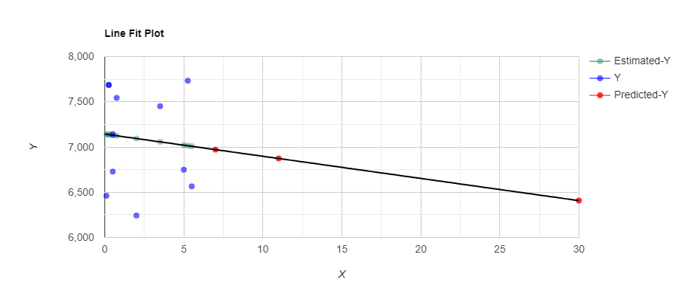
Source: Author s Computation, 2024

Prediction Interval
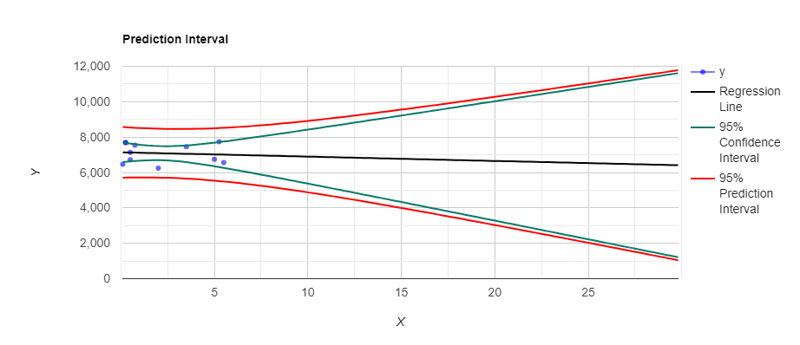
Source: Author s Computation, 2024

Residual Plot
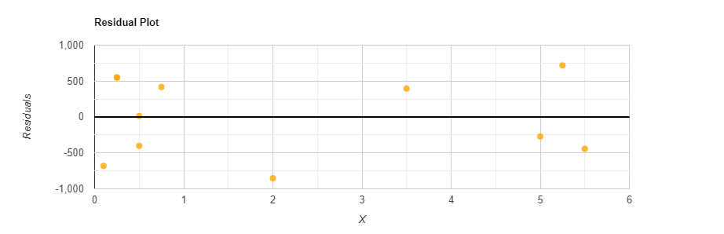
Source: Author s Computation, 2024

Step-by-step solution
Ŷ = b₀ +b₁X
b₁ = | SP_{xy} |  | = |  | Σ(x_{i}-x̄) (y_{i}-ȳ)
b₁ = | SS_{x} |  |  |  | Σ(x_{i}-x̄)²
b₁ = |  | -1215.6108 |  | = -24.4948
 |  | 49.6273

b₀ = ȳ - b₁x̄
x̄ = 2.1455
ȳ = 7089.8845
b₀ = 7089.8845+24.4948*2.1455 = 7142.4371
R² = | SS_{Regression} | = | Σ( ŷ_{i} - ȳ)² | = | 29776.1587 | = 0.009607
R² = | SS_{total} | = | Σ( y_{i} - ȳ)² | = | 3099336.8847 | = 0.009607

The standard deviation of the residuals is:
MS_{residual} = S²_{res} = | Σ( y_{i} - ŷ)²
MS_{residual} = S²_{res} = | n - 2

Residual outliers

S_{res} = √MSE = √341062.3029 = 584.0054.
The average of the residuals is always zero.
The thresholds used to calculate the outliers are: k*S_{res}.
In this case, the thresholds are 3*584.0054 = 1752.0162.
SS_{x} and SP_{xy}
x-x̄ | y-ȳ | (x-x̄)² | (x-x̄) (y-ȳ)
2.8545  3.3545  -0.1455  -1.6455  -1.8955  -1.6455  -1.3955  -2.0455  -1.8955  1.3545  3.1045 | -340.7945  -523.7945  -847.5445  52.9455  597.8855  -361.7545  452.5555  -629.3645  594.6555  361.8555  643.3555 | 8.1484  11.253  0.02116  2.7075  3.5927  2.7075  1.9473  4.1839  3.5927  1.8348  9.6382 | -972.8135 -1757.0926  123.2792  -87.1193  -1133.2647  595.2507  -631.5206  1287.3366 -1127.1424  490.1497  1997.3263
0 | 0 | 49.6273 (SS_{x}) | -1215.6108 (SP_{xy}
Source: Author s Computation, 2024

Confidence Interval
The confidence interval is the prediction interval for the mean value of the dependent variable.
Calculating the standard error
S. E _{ci} = S _{residual} |  | ( |  | 1 |  | + |  | (x₀ - x̄) |  | )
 |  |  |  | n |  |  |  | SS_{x}
S. E _{ci} = 584.0054 | ( |  | 1 |  | + |  | (7 - 2.1455) |  | ) |  | =2315.857
S. E _{ci} = 584.0054 |  |  | 11 |  |  |  | 49.6273 |  |  |  | =2315.857
S.E_{ci} =2315.857
Calculating the confidence interval
Ŷ T_{1-α/2}(n-2) *S.E_{ci}
6970.9734 T_{1-0.05/2}(11-2) *S.E_{ci}
6970.9734 2.2622*2315.857
6970.9734 5238.8326
Prediction Interval
This is the prediction interval for a specific point value of the dependent variable.

Calculating the standard error
S.E _{prediction} = S _{residual} |  | ( |  | 1+ |  | 1 |  | + |  | (x₀ - x̄) |  | )
 |  |  |  |  |  | n |  |  |  | SS_{x}
S.E _{prediction} = 584.0054 | ( |  | 1+ |  | 1 |  | + |  | (7 - 2.1455) |  | ) |  | =2388.3584
S.E _{prediction} = 584.0054 |  |  |  |  | 11 |  |  |  | 49.6273 |  |  |  | =2388.3584
S.E_{prediction} = 2388.3584
Calculating the prediction interval
Ŷ T_{1-α/2}(n-2) *S.E_{prediction}
6970.9734 T_{1-0.05/2}(11-2) *S.E_{prediction}
6970.9734 2.2622*2388.3584
6970.9734 5402.8422
Y and X relationship
R-Squared (R²) equals 0.009607. This means that 1% of the variability of Y is explained by X.
Correlation (R) equals -0.09802. This means that there is a very weak inverse relationship between X and Y.
The Standard deviation of the residuals (
) Equals 584.0054.
The slope: b₁=-24.4948 CI [-212.0286, 163.0389] means that when you increase X by 1, the value of Y decreases by 24.4948.
The y-intercept: b₀=7142.4371 CI [6576.2669, 7708.6072] means that when X equals 0, the prediction of Y's value is 7142.4371.
The x-intercept equals 291.5898.
Goodness of fit
Overall regression: right-tailed, F (1,9) = 0.0873, p-value = 0.7743. Since p-value ≥ α (0.05), we accept H₀.
The linear regression model, Y = b₀+ b₁X + ε, does not provide a better fit than the model without the independent variable resulting in Y = b₀ + ε.
The slope (b₁): two-tailed, T (9) =-0.2955, p-value = 0.7743. For one predictor it is the same as the p-value for the overall model.
The y-intercept (b₀): two-tailed, T (9) = 28.5379, p-value = 3.877e-10. Hence, b₀ is significantly different from zero.
Residual normality
The linear regression model assumes normality for residual errors. The Shapiro-Wilk p-value equals 0.2762. It is assumed that the data is normally distributed.

Appendix no. 2
Linear Regression showing the relationship between the United Kingdom s Inflation Rate and stock market prices (FTSE All-Share).
Regression line equation
Ŷ = 3706.4473 + 62.31X
Reporting linear regression
R² = .19, F (1,8) = 1.83, p = .213.
β = 62.31, p = .213, α = 3706.45, p < .001.
Year | Inflation | FTSE ALL-SHARE | Ŷ (Predicted Y) | Residual
2013 | 2.3 | 3609.63 | 3849.7519 | -240.1219
2014 | 1.5 | 3532.74 | 3799.9068 | -267.1668
2015 | 0.4 | 3444.26 | 3731.3698 | -287.1098
2016 | 1 | 3873.22 | 3768.7536 | 104.4664
2017 | 2.6 | 4221.82 | 3868.4438 | 353.3762
2018 | 2.3 | 3675.06 | 3849.7519 | -174.6919
2019 | 1.7 | 4196.47 | 3812.3681 | 384.1019
2020 | 1 | 3673.63 | 3768.7536 | -95.1236
2021 | 2.5 | 4208.02 | 3862.2131 | 345.8069
2022 | 7.9 | 4075.13 | 4198.6674 | -123.5374

Line Fit Plot
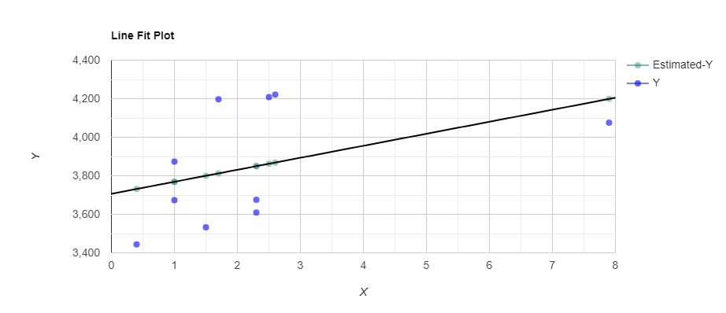
Source: Author s Computation, 2024

Prediction Interval
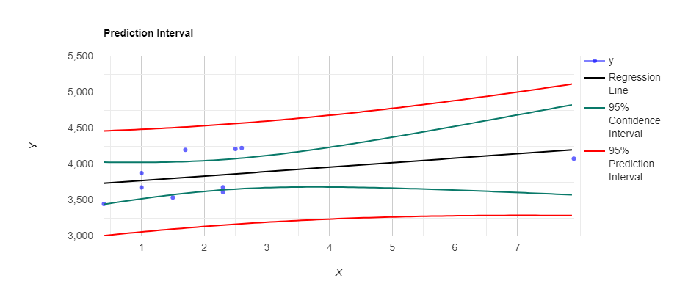
Source: Author s Computation, 2024

Residual Plot
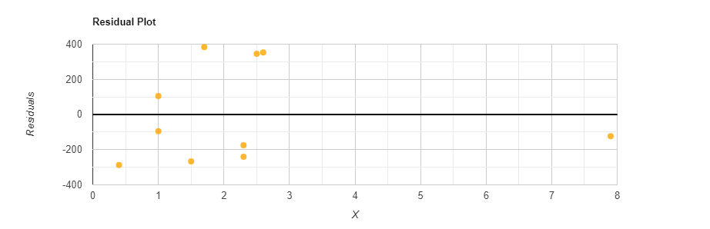
Source: Author s Computation, 2024

Source | DF  (Degree of freedom) | Sum of Square | Mean Square | F Statistic (df1, df2)) | P-value
Regression  (between ŷ_{i} and ȳ) | 1 | 153249.0304 | 153249.0304 | 1.832 (1,8) | 0.2129
Residual  (between y_{i} and ŷ_{i}) | 8 | 669200.5612 | 83650.0701
Total (between y_{i} and ȳ) | 9 | 822449.5916 | 91383.288

Step-by-step solution
Ŷ = b₀ +b₁X
b₁ = | SP_{xy} |  | = |  | Σ(x_{i}-x̄) (y_{i}-ȳ)
b₁ = | SS_{x} |  |  |  | Σ(x_{i}-x̄)²
b₁ = |  | 2459.6054 |  | = 62.3063
 |  | 39.476

b₀ = ȳ - b₁x̄
x̄ = 2.32
ȳ = 3850.998
b₀ = 3850.998-62.3063*2.32 = 3706.4473
R² = | SS_{Regression} | = | Σ( ŷ_{i} - ȳ)² | = | 153249.0304 | = 0.1863
R² = | SS_{total} | = | Σ( y_{i} - ȳ)² | = | 822449.5916 | = 0.1863

The standard deviation of the residuals is:
MS_{residual} = S²_{res} = | Σ( y_{i} - ŷ)²
MS_{residual} = S²_{res} = | n - 2

Residual outliers
S_{res} = √MSE = √83650.0701 = 289.2232.
The average of the residuals is always zero.
The thresholds used to calculate the outliers are: k*S_{res}.
In this case, the thresholds are 3*289.2232 = 867.6697.
SS_{x} and SP_{xy}
x-x̄ | y-ȳ | (x-x̄)² | (x-x̄) (y-ȳ)
-0.02  -0.82  -1.92  -1.32  0.28  -0.02  -0.62  -1.32  0.18  5.58 | -241.368  -318.258  -406.738  22.222  370.822  -175.938  345.472  -177.368  357.022  224.132 | 0.0004  0.6724  3.6864  1.7424  0.0784  0.0004  0.3844  1.7424  0.0324  31.1364 | 4.8274  260.9716  780.937  -29.333  103.8302  3.5188  -214.1926  234.1258  64.264  1250.6566
0 | 0 | 39.476 (SS_{x}) | 2459.6054 (SP_{xy})

Y and X relationship
− R-Squared (R²) equals 0.1863. This means that 18.6% of the variability of Y is explained by X. A low R-squared indicates that the model may not be a good fit for the data.
− Correlation (R) equals 0.4317. This means that there is a moderate direct relationship between X and Y.
− The Standard deviation of the residuals (sres) = 289.2232.
− The slope: b₁=62.3063 CI [-43.8453, 168.458] means that when it increases X by 1, the value of Y increases by 62.3063.
− The y-intercept: b₀=3706.4473 CI [3382.2066, 4030.6879] means that when X equals 0, the prediction of Y's value is 3706.4473.
The x-intercept equals -59.4875.
Goodness of fit
Overall regression: right-tailed, F (1,8) = 1.832, p-value = 0.2129. Since p-value ≥ α (0.05).
The linear regression model, Y = b0+ b1X + ε, does not provide a better fit than the model without the independent variable resulting in Y = b0 + ε.
The slope (b₁): two-tailed, T (8) =1.3535, p-value = 0.2129. For one predictor it is the same as the p-value for the overall model.
The y-intercept (b₀): two-tailed, T (8) = 26.3603, p-value = 4.61e-9. Hence, b₀ is significantly different from zero.
Residual normality
− The linear regression model assumes normality for residual errors. The Shapiro-Wilk p-value equals 0.04902.

