REPORT ON EFFECTIVE TEAMWORK FOR TEAM SUCCESS

BMSW4002 EFFECTIVE TEAM WORKING AND COMMUNICATION
HALEMA KHANOM (2117251)
LECTURER- ABDI RAHMAN

SUMMARY

This is a report on the Module 4003 in Effective team working and communication for the University of Wales Trinity Saint David. This report identifies and understands the importance of team building. It explores different structures and models on how teams can build an effective team to be able to reach a specific target. Models help build successful teams and create strong relationships between leaders and members.

Table of Contents
SUMMARY 1
INTRODUCTION 3
OVERVIEW ON TEAMWORKING 3
MODELS OF TEAM DEVELOPMENT 4
TEAM ROLES 4
DISCUSSION 6
CONCLUSION AND RECOMMENDATION 8
REFERENCES 10

INTRODUCTION
This is a report to the management team for the Pelsall Care Home, Birmingham. The report will explore and advise how an effective team can be established and implemented. Having an effective team can have great impact in the health and social care setting. This report will have findings on how to build a successful and practical team to be able to provide the best quality care. It will suggest solutions on how to overcome barriers and conflicts in the best possible way.
When building an effective team structure is important. This can be applied with various types of models, such as the Tuckman’s Model of Team Development and the Wheelan’s Model of Team Development. The report will suggest which model will be effective for this company. Most commonly within the models 3-5 steps are suggested to be followed to build a functional and practical team.
Team roles will also be discussed and using the Belbin’s Team Roles Model. The appropriate measures will be suggested to take the correct action for team forming.

OVERVIEW ON TEAMWORKING
Team is a diverse group of people and all play part of a role. When building a team every member could express their opinions. Team working is important, effective teamwork can get to the root of the problem and come to the best solution to overcome it. “A team is a number of individuals working as one to achieve a particular goal to which they are mutually committed” Morgan (2017).
Many factors contribute to an effective team. Teams are formed with a limited size. Sizes can be from 4-5 to a larger number 8-10. Smaller groups such as 4-5 can be optimum. Larger groups such as 8-10 will have more benefits as they will have a greater support system.
To establish an effective team, come with problems and hurdles. Most common problems Griffith & Dunham, (2015) have identified are
- Lack of commitment
- Productivity losses
- Poor communication
- Interpersonal conflict
- Poor leadership

MODELS OF TEAM DEVELOPMENT
Choosing the right model to build the best effective team is vital. Maund et al (2017) compared three models below
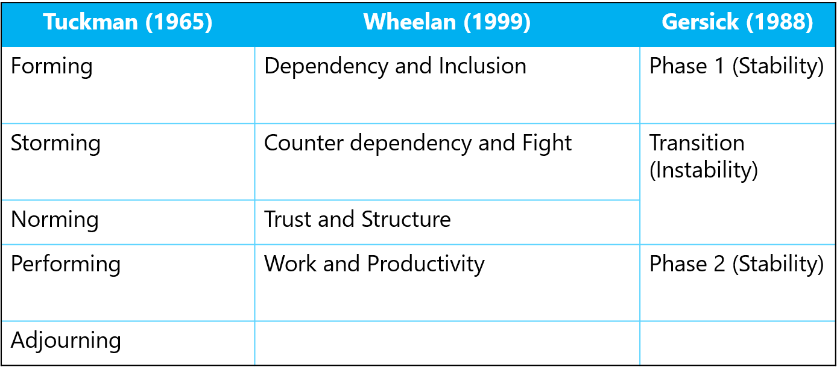
Maund et al (2017)
Comparing the model by creating a table to compare, make it easier on to decide what would be the best model to create an effective team in the establishment. Team development is crucial. Models that are used to establish a team is very effective as perfectly structured team will give the best positive outcome of any problems that needs a solution.
To be able to get the best results and forming an effective team for the care home, the Tuckman’s Model (1965) will be more effective. It has five stages compared to the other two forming, storming, norming, performing and adjourning. Health care is very important and must be carefully monitored and provided. If this is not appropriately structed this can have negative implications. Hence Tuckman’s model can create successful team. In a journal by Natvig (2016) identified that using the Tuckman’s model had resulted in successful outcome. “After the charter was developed and used, it was instrumental in providing focus on the group's work and moving the team forward to project completion”.
Tuckman’s model of stages is structed to be able to create an effective team, this is important in healthcare as people’s health are in question. To be able to provide the best care, teams should be able to be communicate, collaborate and trusting and competent to provide positive results. To have competent team members is essential as Miller (2016) indicates “Being competent is to demonstrate the necessary skills, knowledge and values required to practise to a good standard”

TEAM ROLES
The theory of Belbin’s Team roles (2016) results in good team composition by balancing personalities and roles. Belbin’s model has 3 categories which is then divided into 9 roles.
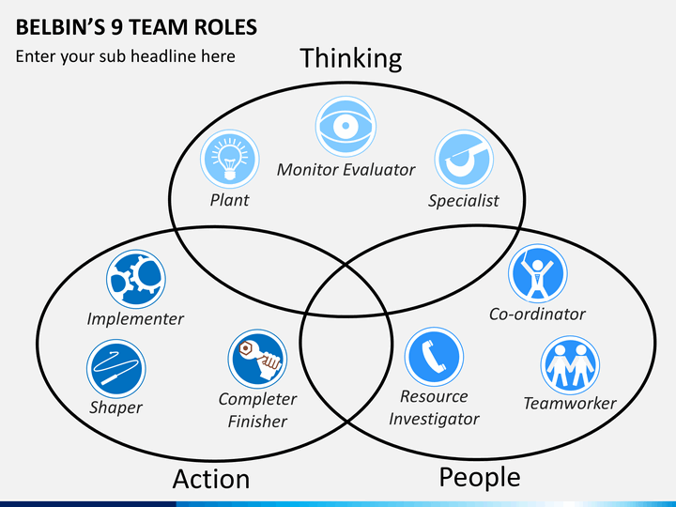Belbin’s team roles (2016)

“Belbin and others argued that the combination of personalities in a team or the combination of individual team member roles could significantly improve or diminish the ability of a team to complete a particular task”. Morgan (2017)
Belbin argued and believed that having team roles can make or break a team. This is because of the differences between the members of the team. Individual differences and characters and personalities can clash and break the team. If individual can see past the differences, then can build a strong team.

The three roles are action orientated, thinking orientated and people orientated. Developing roles will give individuals to work on their strength, participate and give input. Sharing out individual tasks according to their roles will result in the best decision or outcome. The models also point out strengths but also the weaknesses. Although this weakness is allowed, as it can be overcome and dealt with. On the table below shows Belbin’s 9 roles which shows the contribution and allowed weaknesses.
Broomfield (2009) published an article defining the characteristics of the Belbin’s team roles and how roles contribute to teamwork.
- Thinking orientated roles characteristics can bring in new ideas and innovations for a team project. The specialist in that category will have knowledge towards a particular subject.
- People orientated roles can work efficiently with team members and can lead correctly. Members tend to be more outgoing and enthusiastic
- Action orientated roles oversee, rectify, and implement decisions. These roles can identify errors and hurdles.
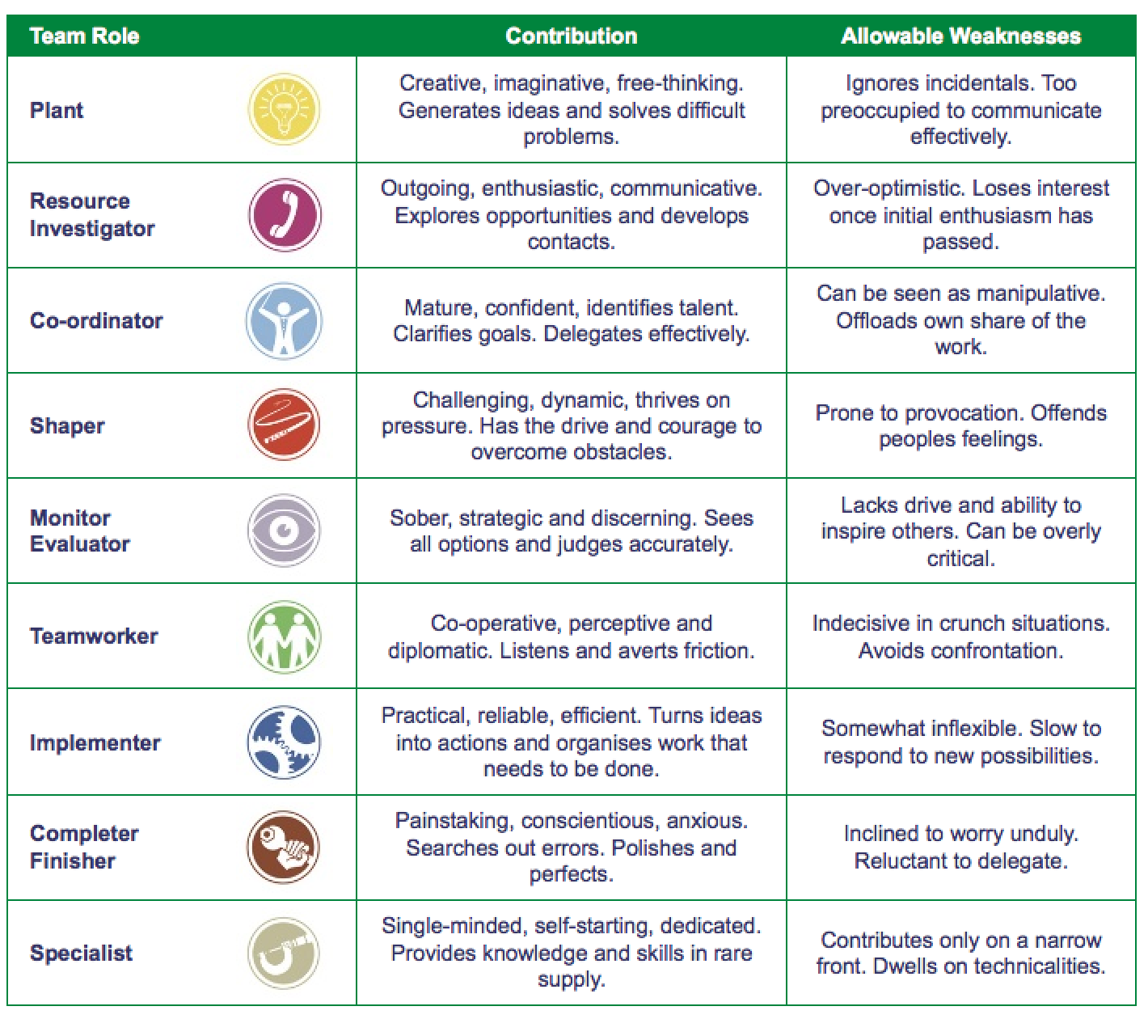 Belbin’s roles (2016)
It is important to carefully sought specific roles for an individual to be able to come to a solution of the problem. Everyone has their own skills and can bring more than one solution to be able to investigate and come with high quality outcome. Oke et al (2016) discusses in a journal on the importance of team roles that when placing members in roles, members are expected to have the knowledge and understanding what the role entitles. Team must communicate and collaborate to achieve goals. Commitment and responsibility are important for members to recognise and accept to execute in projects for outstanding results.

DISCUSSION

There are numerous advantages of team working. Working in teams can create positive outcomes. This can create a successful team in the organisation
- Deliver outstanding results
- Build relationships
- Weigh advantages and disadvantages
- Communicate and collaborate ideas
- Access to more research
- Motivation

Barriers in team working can occur, this is natural as members have different personalities. The barriers that effect teamworking in the care home are
- Lack of communication skills
- Difference of opinions
- No team roles
- Bad management
- Blaming others for problems
Wheelan (2014) outlines the key advice to build an effective team to be able to work through and break barriers. Members should not blame each other when problem arises rather to identify the problem and work through it. Team members should encourage each other to share ideas whether it be correct or incorrect. Most important skill that needs to be prioritised is communication. Communicate in different ways individually and teams.

The Coyle’s code (2018) identifies three skills that create a successful group and develops effective teams. They shared common capabilities and potential. Reginold (2019) reviews the Coyle’s code that is explained in “the secrets of highly successful groups” by Coyle (2019)
Skill 1 – Build safety
To build safety communication is key, communication can be in different ways such as body language and eye contact showing interest and importance. Connecting members and sharing ideas. To accept fallibility acknowledging mistakes and misunderstanding it sooner than later will bring ease and comfort to the teams. Accepting each other’s beliefs make teams stronger.
Skill 2 – Share vulnerability
Negative and cynical ideas should be shared to be able to work and identify to get a positive outcome. Speaking and sharing the truth in difficult times does not necessarily mean anything personal should be shared, it could be accepting a situation that one does not understand or have knowledge of. Reginold (2019) interviews a navy seal and found out that expressing vulnerability within groups can create a trust between team members.
Skill 3 – Establish Purpose
Establishing purpose has two ways one is simply means to be able to set out and hand out tasks correctly. To have a structured approach to reach the common goal. Groups should be set into minimal numbers not more than 5-6 to be able to share and co-operate effectively. Limiting group numbers enables better communication and collaboration. This also enables all members to participate and have a task to carry out.
Second purpose is to be able to set priorities clearly. Leaders to repeat tasks and ask questions to members to identify members knowledge and understanding on the task set out. Priorities should not just be spoke it should be written down on emails and bulletin boards etc.
Using key advice such as Wheelan and Coyle suggests will help enable and identify steps that needs to be undertaken to create a team. Using models such as the Wheelan’s and Tuckman’s model will enable leaders to identify positives and negatives to create a team

CONCLUSION AND RECOMMENDATION
To conclude the report, effective teamwork is vital as without one can result in an unsolved problem. Building an effective team in organisations can help outstanding results. To resolve matter leaders and members of team must liaise to achieve the best outcome. This can be achieved by creating an effective team.
To create an effective team structure is important. To be able to structure and give everyone a role, model such as the Tuckman’s model, Wheelan’s model and the Gersick’s model can be used to carefully sought the groups and members. These models help build relationships with members. It helps team members to communicate and express their ideas. Trust is built through these structures. Ideas such as positive and negative should be expressed to overcome barriers.
Once team is built, roles should be given to each member according to their individual skills. Members have skills in sectors stronger than others, which is important to give correct tasks to get better results. For this task using the Belbin team role model can be used to identify key roles for each member. This model can also identify weaknesses to help leaders decide which member will suit a certain role.
When creating an effective team, it is important to have the knowledge and understanding of structured models. Key advice from the Coyle’s Code (2018) and Wheelan’s (2014) should be acknowledged and used throughout forming a team and overcoming barriers to have successful team and outstanding result.
To conclude this report the management team for Pelsall Care Home should use models discussed in the report to build an effective team. This will have an impact positively to be able to have a successful health and social care setting. Using the Tuckman’s Model (1965) will be the better model to use for the care home to establish a team as this has five steps that is sectioned out to identify the pros and cons and overcome barriers efficiently. Communication and collaboration can create a high-performance team in the organisation.

REFERENCES

Broomfield, D. and Bligh, J. (1997) ‘Curriculum change: the importance of team role’, Medical education. Received 18 January 1996; editorial comments to authors 18 July 1996; accepted for publication 23 August 1996, 31(2), pp. 109–114. doi:10.1111/j.1365-2923. 1997.tb02468.x.
Coyle, D. (2018), The Culture Code, London: Random House Business.
Griffith, B.A., and Dunham, E.B. (2015) Working in teams: moving from high potential to high performance. Los Angeles: SAGE.
Maund, A. et al. (2017) ‘Certificate in higher education : skills for the workplace student yearbook.’ London: Sage.
Morgan, P. (2017) Business student’s guide to study and employability. London: Sage Publications Ltd.
Natvug, D. and Stark, N.L., 2016. A Project Team Analysis Using Tuckman's Model of Small-Group Development. ‘Journal of Nursing Education’, 55(12), pp. 675-681.
Oke, A.E., et al (2016). Importance of team roles composition to success of construction projects. ‘International Journal of Construction Project Management’, 8(2), pp. 141-152.
Regenold, T.A (2019) Review of ‘The Culture Code: The Secrets of Highly Successful Groups’, by Daniel Coyle. https://doi.org/10.1002/pfi.21839
Wheelan, S.A., (2016), ‘Creating Effective Teams’, 5th edn, London: SAGE.

