Ana Maria Morteanu
Module: Cultural Awareness
Student ID: 2127610
Lecturer: Luciana Suardi

Executive Summary
The report focuses on analysing cultural differences between China and Italy. The main aim, in this regard, is to help the staff of Hotel Moresco to understand any differences and requirements of guests from China so that further suitable arrangements can be made. The emphasis on cultural awareness should remain on creating a welcoming environment for guests. For this purpose, dos and don'ts have also been included for the staff to provide a great experience.

Contents
1 Introduction 3
2 First Selected Country – Italy 3
3 Second Selected Country – China 3
4 Analysis 4
5 Dos and Don’ts for the Staff 6
6 Summary and Recommendations 7
7 References 8

Introduction
The report has been prepared for the staff of Hotel Moresco, located in Venice, which offers authentic Italian hospitality. The modern design and technology blend makes the hotel more refined and welcoming (Hotel Moresco, 2023). The purpose is to highlight the necessity of having cultural intelligence and sensitivity for the staff, as guests from China are coming to stay in the hotel. According to Latif et al. (2020), cultural awareness is crucial to ensure service delivery in such a manner that is in accordance with the cultural requirements and norms of guests. For comparing cultural differences between China and Italy, the Hofstede model has been used.

First Selected Country – Italy
The Italian culture, traditions and norms comprise a mixture of cuisine, architecture, fashion and religion. Cultural legacies are deeply influential when considering Western cultural tradition (Latif, 2021). Panno (2020) has stated that with regard to hospitality, Italian culture is mainly known for relations, family and friends. For this purpose, the culture prefers equality as well as decentralisation of decision-making and power. However, at the same time, the overall culture is individualistic in the northern side of the country. Overall, Italy has a masculine society, which is highly success-driven, which further impacts the business mindset (Hofstede Insights, 2023).

Second Selected Country – China
People in China also tend to honour traditions while also embracing Western culture. In this manner, Chinese culture includes a strong sense of family and respect for hierarchy (Hao et al., 2020). However, at the same time, Chinese culture shows acceptance of inequalities among people, with no defence against power, despite having a collectivist culture. Chinese tend to sacrifice their leisure and even families for their work, thereby indicating a masculine society (Latif et al., 2020).

Analysis
Cultural dimensions have been developed by Greet Hofstede for understanding any differences in cultures, preferences and ways of communication (Litvin, 2019). The figure below shows the comparison of the two countries based on Hofstede's dimensions.
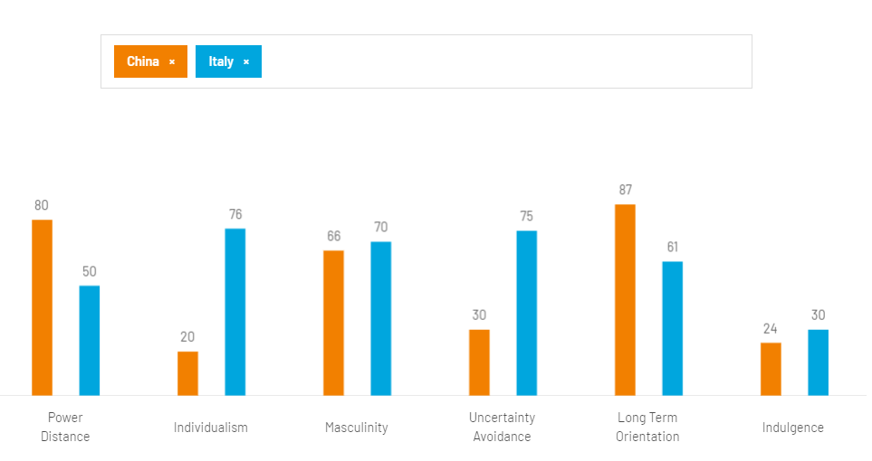
Figure 1: Cultural Dimensions
Source: Hofstede Insights (2023)
As mentioned by the above-illustrated figure, there exists a significant difference between China and Italy in terms of power distance, with China more influenced by formal authority. This, in turn, is further reflected in the priorities of the Chinese, as they are also quite cautious when selecting accommodation. Chinese usually prioritise security and feel comfortable in their chosen accommodation (Khattak et al., 2021). Therefore, it would be crucial for the management department of Hotel Moresco to make some significant changes to adapt to the need of guests from China. The front office department and the security department, in this regard, will play a major role in warmly welcoming and greeting customers upon their arrival. It is undeniable that the Chinese are eager to throw themselves into unique but authentic experiences. However, they also choose hotels based on the perspectives of universal standards and reliability (Eid and Agag, 2020).
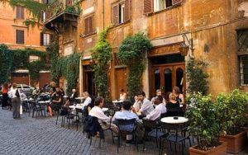
Figure 2: Italian Hospitality
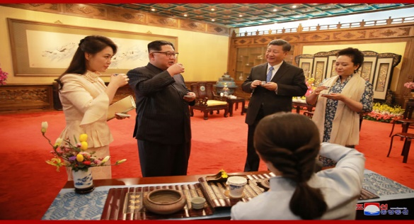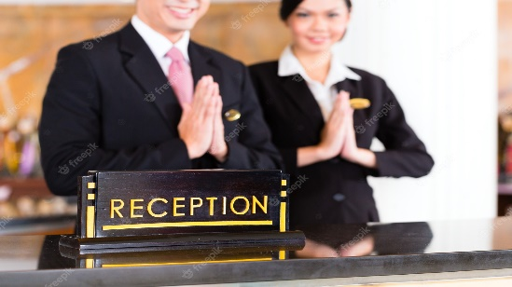
Figure 3: Chinese Hospitality
For the management department, it is crucial to ensure that when talking, the handshakes are standard; however, the grip should be lighter than that preferred in Italy. In addition, family names and suitable titles should be used for addressing. This would not be an issue, as Italians also prefer addressing with sir names (Amicarelli et al., 2022). Chinese also consider truth to be relative through immediate social circles, which further reflects that they do not like taking risks and, at the same time, prefer avoiding any losses. On the other hand, Italians are usually not comfortable in unambiguous situations and, therefore, have certain norms and procedures in place, even if they do not always comply with them (Panno, 2020). Considering this particular difference, all of the employees of the Hotel Moresco, irrespective of the department they are associated with, would be expected to ensure that the differences in how Chinese guests interact with the hotel area are acknowledged. The major emphasis, in this regard, should be on improving communication with potential Chinese customers. The restaurant and room service providers should be aware of the Mandarin language or at least have some guide with them so that any queries can be resolved as required (Sun et al., 2022).
Italy has more of a pragmatic culture and, therefore, shows the ability to adapt traditions to changing conditions as well as perseverance in achieving desired results (Amicarelli et al., 2022). This, in turn, will prove to be useful in being aware of Chinese culture and making necessary arrangements for the guests accordingly.

Dos and Don’ts for the Staff
Dos | Don’ts
Although Chinese do not expect staff to be fluent in speaking Mandarin; however, it is necessary to have familiarity with the language. | Try not to communicate in the Italian language
Be indirect and diplomatic to avoid confrontation | Never be direct when resolving issues
Handshakes are standard, and smile while talking to them | Do not become more formal
Add some Chinese dishes to the menu, with the menu available in Mandarin | Do not only present Italian dishes; Chinese might not like it
Add some Chinese TV programmes | Chinese are more interested in star-rated hotels, so their priorities should not be ignored.
Remember, Chinese prefer rooms with 8 or 9 | Never put Chinese guests on the fourth floor
Keep security the top priority  Make guests comfortable and welcomed | Never compromise on security
Have hotel information booklet in Chinese | Not acknowledging the differences in interactions of Chinese guests could negatively impact their overall travel experience.

Summary and Recommendations
China and Italy have some major differences when it comes to the comparison of the culture of the two countries. For this reason, it would be crucial for the management of Hotel Moresco to make necessary efforts to make guests from China feel welcomed by acknowledging the differences. The following recommendations should also be considered.
- Emphasise improving communications by making information easily available in Mandarin and through technology, such as mobile devices.
- Demonstrate commitment to providing a good welcome by providing complementary, top-quality and trustworthy services.

References
Amicarelli, V., Aluculesei, A.C., Lagioia, G., Pamfilie, R. and Bux, C., 2022. How to manage and minimise food waste in the hotel industry: An exploratory research. International Journal of Culture, Tourism and Hospitality Research, 16(1), pp.152-167.
Eid, R. and Agag, G., 2020. Determinants of innovative behaviour in the hotel industry: a cross-cultural study. International Journal of Hospitality Management, 91, p.102642.
Hao, F., Xiao, Q. and Chon, K., 2020. COVID-19 and China’s hotel industry: Impacts, a disaster management framework, and post-pandemic agenda. International journal of hospitality management, 90, p.102636.
Hofstede Insights, 2023. Country comparison tool. [Online] Hofstede Insights. Available at: <https://www.hofstede-insights.com/country-comparison-tool?countries=china%2Citaly> [Accessed 15 Jun. 2023].
Hotel Moresco, 2023. Home. [Online] Hotel Moresco Venice. Available at: <https://hotelmorescovenice.com/> [Accessed 15 Jun. 2023].
Khattak, S.R., Nouman, M., Fayaz, M., Cismaș, L.M., Negruț, L., Negruț, C.V. and Salem, S., 2021. Corporate social responsibility and green employee behaviour in the hospitality industry: a cross-country study. Sustainability, 13(19), p.10534.
Latif, K.F., 2021. Recipes for customer loyalty: a cross-country study of the hotel industry. International Journal of Contemporary Hospitality Management, 33(5), pp.1892-1916.
Latif, K.F., Pérez, A. and Sahibzada, U.F., 2020. Corporate social responsibility (CSR) and customer loyalty in the hotel industry: A cross-country study. International Journal of Hospitality Management, 89, p.102565.
Latif, K.F., Pérez, A. and Sahibzada, U.F., 2020. Corporate social responsibility (CSR) and customer loyalty in the hotel industry: A cross-country study. International Journal of Hospitality Management, 89, p.102565.
Litvin, S.W., 2019. Hofstede, cultural differences, and TripAdvisor hotel reviews. International Journal of Tourism Research, 21(5), pp.712-717.
Panno, A., 2020. Performance measurement and management in small companies of the service sector; evidence from a sample of Italian hotels. Measuring business excellence, 24(2), pp.133-160.
Sun, S., Jiang, F., Feng, G., Wang, S. and Zhang, C., 2022. The impact of COVID-19 on hotel customer satisfaction: evidence from Beijing and Shanghai in China. International Journal of Contemporary Hospitality Management, 34(1), pp.382-406.

