Name: Emmanuel Itua
Student ID: 2019391
Module Code: BMSW5106
Module Title: Knowledge and Information Management Skills for the workplace
Lecturer’s Name: Amit Naik

Table of Contents
Introduction………………………………………………………………………..3
Knowledge and Information management……………………………………..3
Importance of Knowledge Management……………………………………….4
Knowledge Management theories and Models……………………………….5
Challenges faced by Amazon and suggested solutions……………………..7
Conclusion…………………………………………………………………………8

Introduction
In this report, I will be writing about the organization Amazon. It is one of the biggest online retail companies in the world today. It was started by Jeff Bezos in 1994 from his home garage in Bellevue, Washington USA. Jeff Bezos is currently the CEO of Amazon.
At the time of its inception, it only sold books to its customers in the 50 states of the US and 48 countries worldwide. It first went public on 15th of May 1997. In 2001 it added a feature whereby it was made possible to look inside the book being sold and in 2003 it was possible for customers to search for key words in books.
Amazon Web Services (AWS) was launched in 2002 initially focusing on tools and services for cloud computing. It later in 2004 launched Simple Queue service (SQS) to speed up message sending between customers and companies. AWS launched in 2006 to offer even more such as EC2 and Amazon cloud storage
Today Amazon sells variety of items to its customers online. It has enjoyed heavy sales growth over the past decade increasing net sales from $4billion to $32billion
Its workforce has increased steadily over the years too from less than 200 thousand in 2010 to over 800 thousand in 2020 with signs of hiring more employees in the years to come.
During the recent Covid pandemic while other companies where shutting down, Amazon continued to flourish in its business because demands increased due to lockdowns limited movement.
Knowledge and Information Management
This is an approach whereby knowledge is used, shared, gathered, and distributed within an organization to help manage its customers and also improve staff efficiency from the information gathered. An important part of this is putting together tacit knowledge and being converted into explicit knowledge.
Knowledge Management (KM) involves capturing, sharing and using it in an effective manner.
Capturing knowledge effectively involves how information is being generated, wrapped up and stored for use. Sharing Knowledge in an organization helps to improve employee efficiency and also adds value to the employees. Using the knowledge involves how it is being used to improve decision making and overall improvement of an organization.
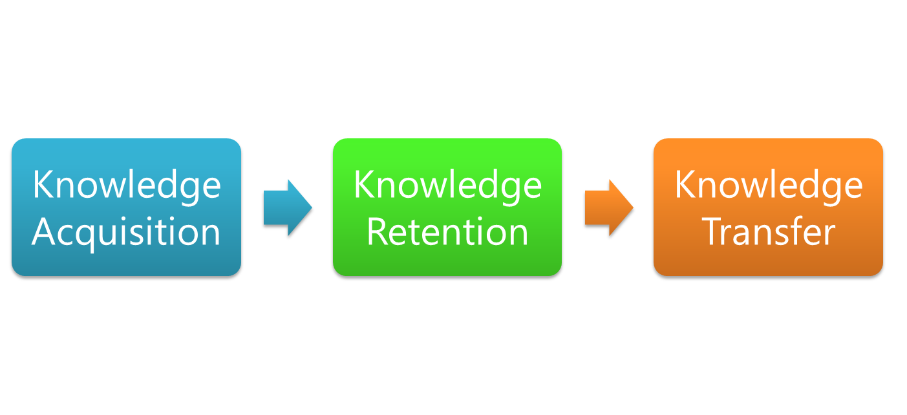
Diagram source: Moodle
The above diagram illustrates the life cycle of Knowledge Management
Importance of Knowledge Management (KM)
Knowledge management is a very important tool that affects the operations of any organization including Amazon. The knowledge held by the employees helps in the management of customer engagement, improvement of its service, its products and services.
It is very important that an organization shares the knowledge available at its disposal for growth and development.
Having a knowledge management system helps in the following ways:
- It makes it easily accessible for use when needed
- Esay access to training materials
- Saves time searching
- Other employees can have access to materials when staff in this department are not around.
Other benefits include:
- It creates a single source of information for an organization as employees leave the organization while new people are employed.
- Prioritizing knowledge management innovates ideas such as external source information of market trends, competitors and helps makes useful decisions ahead of the market.
- It encourages team collaboration by employees being more transparent on available knowledge and how to reach it.
- It makes onboarding of new employees easier as all information needed for a good start are already in place.
- Improves employee wellbeing and makes it easier to add new information to the system and at the same time eliminate old and unwanted information.
Knowledge Management Theories and Models
In my report, l will be writing about the SECI and knowledge conversion and the Bukowitz and William models.
The SECI and knowledge conversion model was introduced by Nonaka and Takeuchi and has become the cornerstone of knowledge creation and transfer theory. They suggested how knowledge can be created and shared within an organization. The four ways are listed below:
- Socialization: This method is tacit to tacit where knowledge can be passed around through practice, limitation, guidance and observation.
- Externalization: This method is tacit to explicit where knowledge is converted into documents for easier use within the organization.
- Combination: this method is explicit to explicit where knowledge kept in documents can be put together to form new knowledge.
- Internalization: This method is explicit to tacit. Where knowledge is internalized thereby changing user’s tacit knowledge that already existed.
The Bukowitz and William model was proposed in 1999 and its central point is on how organization make, keep, stamp out and employ knowledge so its valuable within an organization.
Model overview is illustrated with diagram below.
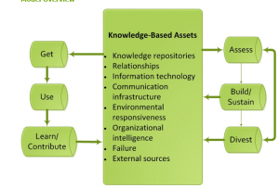
Diagram source: Devolution knowledge Hub, Ministry of Devolution (Knowledge Management)
There are six stages involved in this model. Get, Use, Learn/ Contribute, Assess, Build/Sustain and lastly Divest.
Get: In this stage, knowledge is acquired and used for problem solving and innovational purposes however looking through a large amount of information can be daunting.
Use: This stage involves you have to make a decision on how to make use of the knowledge that has been obtained and how it can be implemented for problem solving.
Learn/Contribute: This stage involves getting knowledge from individual experience and knowledge acquired. Knowledge is acquired collectively for the good of the organization.
Assess: In this stage, already acquired knowledge in an organization needs to be assessed and relationships and competencies with clients and people needs to be checked.
Build/Sustain: In this stage, if a knowledge is seen as valuable, a means needs to be derived to build and sustain the knowledge. Resources needs to be allocated to grow the knowledge and make it more sustainable for the organization.
Divest: In this stage, any knowledge that is deemed unimportant is discarded while resources are put towards knowledge that has value and has the ability to grow the organization positively.
The importance of acquiring, sharing, creating and integration of information at Amazon can not be underestimated. Amazon makes use of advanced management techniques to connect people around the world with product information. It uses KM principles to make life easier for its customers finding products they want by click of a button and its site being very user friendly.
The following are some ways Amazon uses Information management principles to reach its customers:
- Single Porter/Interface: All the products bought from Amazon and business done withem are all through a single page where you can search for anything you want to buy from clothes to computers to even cars there by making it easier for customers to find what they are looking for. Likewise giving its employees a familiar and easy to use gateway to work and also satisfying customer’s needs.
- Consistent Presentation: Products are displayed in the same way for every buy by customers. There is a review section for every product bought by customers. Consistency is the key word here due to outstanding content management procedure. For every product, customer are able to save them for later buy if they don’t feel like buying the it at the very moment.
- Modular Content: Amazon pages are arranged in such a way that they are made in a simplified way to make it easy for customers to read. Access to book pages has also been made possible so customers can have an idea of what they are buying. The idea of combing through elaborate PDF’s have been eliminated for easier access to book content.
- Distributed upstream content creation: Contents are generated by product source though all what we see is controlled by Amazon. They keep to Amazon design standards, way of writing and other policies set by Amazon. In many ways this also empowers the Small Business Enterprises.
- Almost Magical Personalization: Amazon seems to know its customers as a result of their purchase history. It suggests similar products to its customers which they think they would like and also recommends products they think their customers might need. This idea attracts more customers to Amazon.
- Crowd sourcing: Features such as reviews and ratings by customers further helps Amazon to understand its customers better and also improves customer service. Reviews also an advantage to Amazon as customer literally do the marketing for Amazon.
Ratings also improves rankings, and it allows customers to have a voice and create loyalty.
- Easy and consistent transactions: Putting a product on hold and requesting more information about a particular product or products are all the same process thereby making it a lot easier to get used to the system
- Subscriptions, Alerts and Reminders: It is easy to set up reminders to buy a product later or get a subscription for updates on products.
Challenges faced by Amazon and suggested solutions.
In as much as Amazon is flying high in sales and increased revenue, it has its fair share of challenges either from customers or sellers on its site. Below are some of the issues faced by seller on the Amazon site and suggested solution to these problems.
- Sellers complain that Amazon is too complex. They are challenged in areas such as logistics, fee renegotiation, tax issues, review management and more.
Solution: A lot of brands approach Amazon on second thoughts thereby not making full use of its potential and having no idea where to start from. There are lots of videos on YouTube that educates customer on what to do if they having difficulties. Brand should take advantage of this video to solve their problems because it covers a variety of areas where you can find solutions.
- No guarantee in profitability: Depending on factors such as shipping costs and category competition, profit on Amazon by brands can vary. Apart from that Amazon’s reporting don’t make sellers know if they making profits or not and this can be daunting to sellers.
Solution: Using an agency or third party repThe top three amazon challenges, and how to solve them (no date) Adlucent. Available at: https://www.adlucent.com/resources/blog/the-top-three-amazon-challenges-and-how-to-solve-them/ (Accessed: 9 September 2022).orting tool to pull in ones data can be useful.
- Market Competition: Certain sectors can get saturated thereby making it difficult to make a headway in the market.
Solution: Focus on reviews, evaluate product mix and build a paid advertising strategy.
- Politicians calling for breakup of Amazon: Senator Elizabeth Warren in the USA thinks Amazon is too big and power and therefore wants a breakup of the organization. She also thinks Amazon has dominated the playing field thereby edging smaller companies out of the market.
Solution: Amazon should work with law makers and politicians to reach a reasonable compromise that is best for Amazon and for the market in general.
- Global Warming challenge by its employees: Employees of Amazon are pressuring their organization to change how it deals with global warming and its reliance on fossil fuels. Amazon.
Solution: Amazon can reduce its reliance on fossil fuels for more products that are more environmentally friendly and greener.
- Ditching the world’s biggest market, China: Amazon pulled out of China market which means its customers are unable to use the platform to shop for products. This is a serious setback for Amazon as China is one of the biggest world’s markets. This was a result of fierce competition from local competitors.
Solution: Amazon should re-strategize and make its business heard in Chine. Not doing business in China is a huge revenue loss.
Conclusion
In conclusion my report explores Amazon as an ecommerce giant and how it uses Knowledge and Information to give customers a better experience on their website when they buy products. The report also writes about the importance of Knowledge Management
I also highlighted some of the challenges it faces from sellers on its sites as well as general challenges it faces with solutions on how to deal with the challenges.
Applying the correct approaches to Knowledge Management will be key to Amazon making even bigger profits than they already do.

References
Armstrong, C. (no date) ‘The history of Amazon.com’ Available at: https://www.techwalla.com/articles/the-history-of-amazoncom
admin (2019) ‘A brief history of amazon web services’, Green Cloud Hosting, 29 April. Available at: https://greencloudhosting.co.uk/brief-history-of-amazon-web-services/ (Accessed: 9 September 2022).
Amazon UK: annual net sales 2021 (no date) Statista. Available at: https://www.statista.com/statistics/1035592/net-sales-amazon-united-kingdom-uk/ (Accessed: 8 September 2022).
‘Why is knowledge management so important?’ (2022) HRForecast, 23 August. Available at: https://hrforecast.com/what-is-knowledge-management-and-why-its-important/ (Accessed: 9 September 2022).
Hajric, E. (no date) The seci model & knowledge conversion. Available at: http://www.knowledge-management-tools.net/knowledge-conversion.html (Accessed: 9 September 2022).
‘The km process framework(Bukowitz and williams)’ (no date). Available at: https://knowledgehub.devolution.go.ke/lms/courses/knowledge-management/lesson/the-km-process-framework-bukowitz-and-williams/ (Accessed: 9 September 2022).
marc-rosenberg (2014) The knowledge management genius of amazon. Com, Learning Solutions Magazine. Available at: https://learningsolutionsmag.com/articles/1480/the-knowledge-management-genius-of-amazoncom (Accessed: 9 September 2022).
The top three amazon challenges, and how to solve them (no date) Adlucent. Available at: https://www.adlucent.com/resources/blog/the-top-three-amazon-challenges-and-how-to-solve-them/ (Accessed: 9 September 2022).
Valinsky, J. (2019) 9 challenges Amazon faces on its 25th birthday | CNN Business, CNN. Available at: https://www.cnn.com/2019/07/04/business/amazon-25th-birthday-challenges-trnd/index.html (Accessed: 9 September 2022).

