
Programme: BA in Business Management
Module: Project Management
Module code: LCBB5005
Assignment Title: Component 2: Coursework: Essay
Student Name: Yanislav Georgiev
Student ID: 2219323
Submission Date: 30/08/2024
Lecturer Name: Dr Molly Jack

Table of Contents

Introduction……………………………………………………………………3 Discussion……………………………………………………………………..4
Conclusion……………………………………………………………………12
References……………………………………………………………………14

King`s Cross Project
Introduction
The term 'project management' denotes the process of planning, organising, and using the resources for a specific project or undertaking to achieve a specific outcome. Project management incorporates several phases which incorporate initiation, planning, execution, monitoring, control, and closure (García-Madurga and Esteban-Navarro, 2020, p. 8). The business firms accomplish their undertakings by going through these mentioned phases of the project. The entire report is based on a theme of which Google, the multinational tech giant has undertaken the initiative to construct its headquarters in King’s Cross location of London. It was Google's first initiative to construct its headquarters outside the United States of America. Google has focused on upholding environmental sustainability while designing the building and campus. Google used solar panels, and thermal mass for sustainable energy optimisation and preventing the negative environmental impact. It also used a huge area for campus building to accommodate a huge number of employees. The initiative undertaken by Google is a work in progress and is estimated to be completed by the end of 2024. The current report primarily aims to provide an opinion of the Google Headquarters Project. In addition, the report also aims to provide personal opinions on why the project is a success as well. Furthermore, the report will also highlight the lessons from the project and provide sound recommendations for a similar project. Therefore, the central question of the report is to analyse whether this project will be a failure or a success and provide recommendations for it.
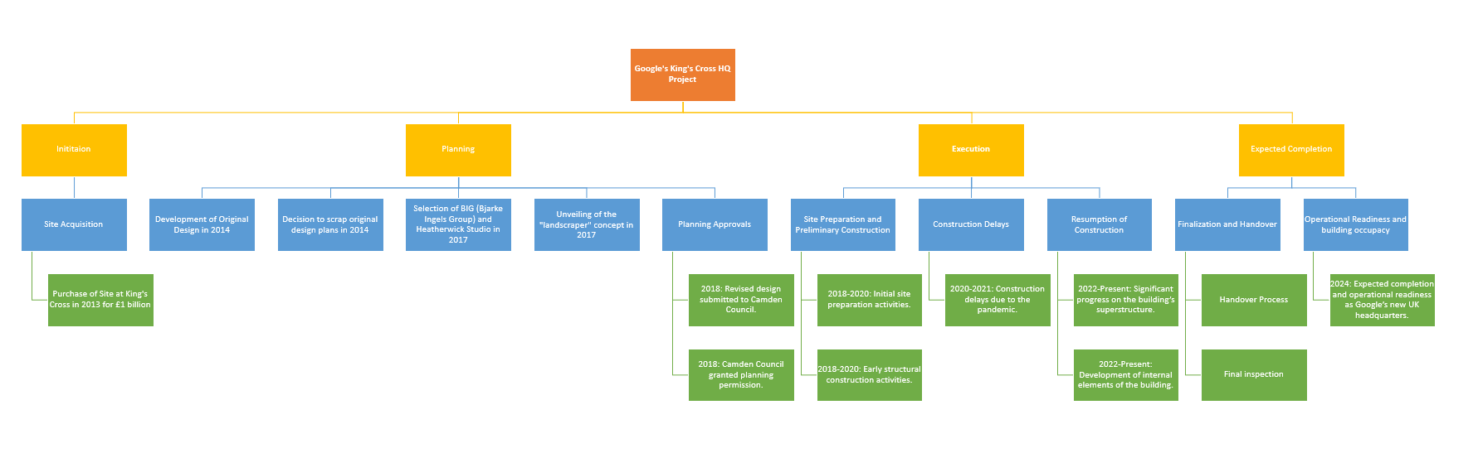
Figure 1: WBS of King’s Cross HQ Project of Google
(Source: Self-created)

Discussion
The King's Cross Campus Project is one of the mega construction projects initiated by Google outside the United States of America for the first time (Trivedi, 2022). One of the most recognised and lucrative technological companies, Google, having its functional origins in the USA is currently constructing its headquarters in London's King's Cross (Partridge, 2022). This is a construction project that will make use of a larger plot of land where Kings Cross Station is located. The headquarters' surface area will be 60400 square metres, occupying a bigger portion of the site (Anderson, 2021). Google, while designing the project, adequately considered the factor of sustainability. The campus area of the building contained a carbon-neutral landscape design. This mega infrastructure developmental project puts a strong emphasis on environmental sustainability. The project employs sustainable and renewable energy sources for the building to prevent the negative environmental impact. Innovative and sustainable design was employed by the project which incorporated the use of solar shadings, thermal mass for artificial air cooling and passive ventilation (King Cross, 2024). Hence, the project not only focused on the design of building construction but also took environmental sustainability maintenance into account to achieve environmental standards.
On the other hand, the project also considered the community impact for which it included several amenities and public places like outlets, parks, and so forth for the betterment psychological wellness of the community. In addition to this, the entire campus will use an area of more than 650,000 square feet of HQ (King Cross HQ, 2024). This high area of campus will house more than 7000 employees (King Cross HQ, 2024). A huge range of employment opportunities will be generated after the completion of the project which will ultimately provide a positive impact on the employment rate of the United Kingdom and strengthen the workforce of Google. Although Google tried to uphold environmental sustainability in designing the building, the construction phase of the building will surely have a negative environmental impact which Google must take into consideration. The critical environmental factors would include possible soil, air and water pollution due to the massive construction project. Social issues that may arise involve the selection of the location itself and clashes with the communities surrounding the mega Hub; a probable political issue may concern employment and wages of the people working on the project. To address all these issues, Google should have conducted and published a risk-benefit analysis of the entire project to dispel any apprehension that different parties may feel about the project. This would also make the entire process more transparent lending it even more credibility. The mega concrete structure at the heart of London will pollute the air of the locality and there is very little that can be done about it. Moreover, the project may also disrupt the natural flow of the neighbouring communities thus exacting a social toll for being in its vicinity. On the other hand, people can be persuaded to tolerate all this if they are told it will benefit the local community in terms of financial and political importance. Google should take special care to ensure that the workers who work at the construction site get a fair wage. However, the development of this project will have a beneficial impact on the operations of Google and will drive organisational success.

Figure 2: Google 1 billion Pound data centre in the UK
(Source: Kaur, 2024)
The project to build a new Google Hub for the first time outside the USA is likely to be a success. The success of a project such as this depends on a wide range of factors related to socio-political and economic dimensions (Khalifeh et al., 2020, p. 453). For a project to be successful it must possess certain attributes such as timeliness, social value, economic value, the correct political landscape and so on. A thorough analysis of these factors in the case of Google’s new project makes it clear why the project is likely to be a success.
Information Technology (IT) is not merely a booming industry but is well on the path to becoming the next key industry after iron and steel. That is because every other business has to rely on the Information Technology (IT) industry in one way or the other (Gemino et al., 2021, p. 162). Google is a massive multinational giant of a corporation and one of, if not the, biggest IT organisation in the world. Being able to work at Google is not merely a career option but one that can launch the career of a young professional in the right direction. Opening a new HQ outside of the USA and that too at the very heart of London, will attract eyeballs. It will also entice talented people from the UK and abroad to come and work there. In other words, this project by Google is a massive opportunity for young talented people to jumpstart their IT careers (Ahmad et al., 2021, p. 45). Moreover, like any other organisation, the new HQ of Google UK will also require staff members who are not strictly related to the core competencies of the organisation, creating a torrent of job opportunities. The success of the project will ultimately depend on its execution; opening a huge data centre is hardly enough and there must be enough importance given to this facility as well. It must be noted that Google must run enough operations through this data centre to justify its existence.
Creating job opportunities is a timely function of this project since the UK is suffering from a significant unemployment and underemployment crisis now. Therefore, by creating job opportunities, the project is likely to accrue support not just from the people of the UK but also from the Government of the UK (Bilir, 2022, p. 55). Therefore, this project has the potential to boost the economy of the UK, which is undergoing a recession as of now and will likely garner support from politicians on all sides and camps. The massive project with a cost of over a billion pounds, will not be a commercial venture but also a marvellous exercise of civil engineering and modern architecture. The way Google has planned this new HQ sets it apart from the stereotypical dull and boring-looking office or residential spaces (Wafa et al., 2022, p.17). Thus, the campus when finished may also attract tourists and excursionists; students pursuing a career in the IT sector may also be willing to visit the place. On the other hand, job opportunities will be limited to mainly engineers, data analysts and other closely related technical fields. Thus, this project does not do much to improve the general condition of unemployment in the UK.
One of the major benefits of building this hub is its ability to nurture young talents in the UK. The hub has a dedicated space encompassing most of its ground floor for training. This will help Google create a skilled workforce in the UK market which can have long-term positive impacts on the economy of the country (Oh et al., 2021, p. 3). Moreover, one of the major strengths of this hub is its attention to employee well-being and nourishment. The hub has a game room, pools, and even a walking path on the roof, which is decorated with green. Thus, employees will be more likely to engage positively in their workplace thereby boosting productivity and quality of work of the entire organisation. Moreover, this huge project by Google will push other large multinational companies to take up similar projects that will be able to drive the economy forward in a good way.

Preparing a report based on a project of Google regarding the development of new headquarters can assist one in acquiring knowledge about project management and relatable contexts. Underscoring the project overview through this report can provide one the opportunity to learn different aspects of the lifecycle of a construction project. It was found that identifying critical success factors (CSF) is the most effective part of the construction project life cycle (Wuni and Shen, 2020, p. 1). Execution of a project plan for the successful compilation of the project can also offer valuable lessons. Outlining different stages of the life cycle can provide one the scope of delving into the insights of the stages of the project life cycle. Apart from that, the project shows the importance of maintaining the quality, budget, timeline and other necessary variables of the project to complete the project successfully. This is because maintaining the stipulated time frame to complete the project is considered one of the most difficult factors for the construction project (Durdyev and Hosseini, 2020, p. 2). Prolonging the period might impact the overall budget of the construction projects. It can cause budget overrun which can hinder the potential of the project by making it a failed project (Asiedu and Adaku, 2020). The example of a failed construction project was also outlined by me in the report which has guided me to compare the drawbacks of the project management process. In-depth knowledge can be gained about the critical success factors that can avoid failure by enhancing the success rate of the project. There is also a lesson in gathering information regarding the involvement of the stakeholders, communities and employees to finish the construction project effectively.

Some recommendations will be provided herein for future projects. Large construction projects usually witness several complexities during the delivery of successful performance as the perception of performance metrics and project management still comprises multifaceted ambiguities (Gunduz and Almuajebh, 2020, p. 01). Therefore, to address pertinent factors of project management and fill the gaps to consider ensuring stakeholders' concerns, the assimilation of an accuracy checklist consisting of critical success factors (CSF) should be prioritised (Gunduz and Almuajebh, 2020, p. 01). Categorisation of success factors for quantifying their impact on project performance can effectuate the overall success of similar future projects like Kings’ Cross Campus of Google. Examples of some Critical Success Factors (CSF) that must be ascertained are the determination of project locations, defining realistic, achievable and transparent goals, adequate planning for resource allocation, prominent tender and procurement methods and so on (Obi et al., 2021, p. 2). In addition to these project-related components, client-based factors, work-related elements, and team and design-related factors should also be emphasised on the CSF checklist by the prospective project managers. This will enable suitable accommodation of equipment, workforce and capital for corroborating effective construction management, similar to Google's new headquarters project.

A transparent comparison between Google and Amazon is illustrated in the following to elaborate on the extant CSF competencies and weaknesses of the King’s Cross Campus Project.
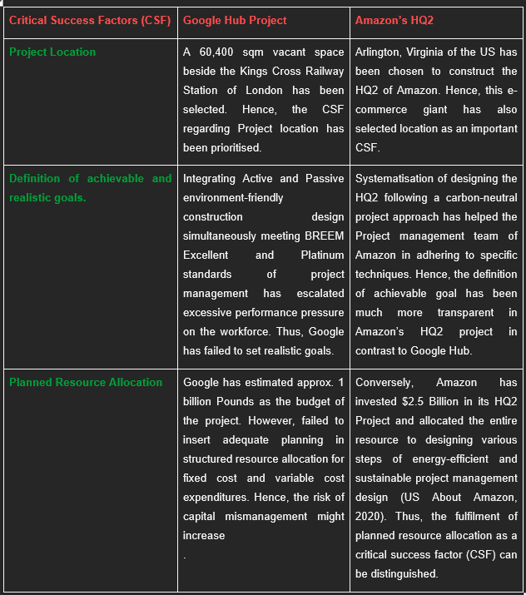

Infrastructure or Construction projects are generally composed of different external and internal stakeholders and extracting sufficient support from them plays a substantial role in demonstrating project success (Waris et al., 2022, p. 189). Apart from that, the gradual transition of conventional project management approaches towards contemporary and agile management has reflected the importance of people-centrism and relationship dynamics between the workforces intertwined in a project (Montenegro et al., 2021, p. 01). Hence, a wide concentration has been laid on the positive interrelation between the Emotional Intelligence (EI) of project managers and successful stakeholder relationships. The engagement of a competent project manager can exemplify the role of a mediator between external and internal stakeholders to accelerate trust and satisfaction (Montenegro et al., 2021, p. 01). Additionally, the proficient leadership style of the project managers can also amplify collaboration and harness team effectiveness. Henceforth, to gain concurrent effects like Google's new headquarters project, the appointment of an adroit project manager, having adeptness in EI, should be focused on. This strategy can work as a driving factor to contemplate the behavioural traits and soft skills of the employees as well as influencing their eminence in hard skills and digital capacities.
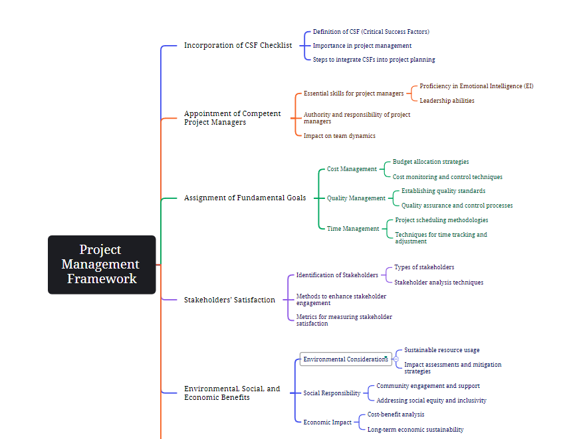
Figure 3: CSF Flowchart
(Source: Self-Created)
A construction project becomes successful when the desired outcomes as per the predetermined objectives are accomplished within a stipulated budget and time (Irfan et al., 2021, p. 01). In addition, success is also considered a multidimensional perception that asserts overall organisational, project and business efficiency alongside consumer satisfaction. Henceforth, the determination of the long-term and short-term goals are elucidated as the antecedent of project management success that fosters the economic, environmental and social well-being of different stakeholders, accommodated with the infrastructure project (Irfan et al., 2021, p. 01). Therefore, for future companies that envision developing indistinguishable projects like Google, systemization of the aforesaid objectives can evolve encompassed and efficacious outcomes. Quality, Cost and Time should be assigned as the primary goals that the potential project managers should include that aim to deliver a project like Kings' Cross Campus of Google. Conversely, the overall impact of those projects on the society, environment and financial benefits of the organisation, their future potential and the satisfaction of stakeholders must be resorted to as long-term goals.
The rapid pace of urbanisation has elevated societal concerns regarding the overexploitation of natural and non-renewable resources by different industries (Goh et al. 2020, p. 02). The Construction and Project management industry is specifically responsible for causing climate change and deterioration of the natural resources (Ahmed Ali et al., 2020, p. 2). Therefore, to construct future projects similar to Google's HQ office, must adopt sustainable construction mechanisms to reduce the environmental impact of infrastructural projects.

Conclusion
Hence, it can be concluded that project management is denoted as a complex procedure that needs to be carefully handled during the construction project like developing the new headquarters of Google. It is found that King's Cross construction projects undertaken by Google to enhance their capacity and offer additional facilities. The aim of this project is also aligned with enabling sustainable development to foster their commitment toward the environment and society. Despite the luxury amenities, carbon-neutral landscape design will be prioritised during this construction project. In addition, renewable energy resources will be the first choice which will also contribute to enhancing the success factors of this King's Cross project. However, the socio-political and economic dimensions of the selected region outside of the USA might be the success factor for this specific project. Apart from that, the market niche such as information technology (IT), skilled workforce, sustainability maintenance and internal policies will be drivers to enhance the success rate of this project. Prioritising the employees by nurturing their mental health and well-being will also increase the competencies of Google to complete this project. This is because employee satisfaction is crucial for the success of any construction project. The main argument of this report relies on the determination of the success factors of the King’s Cross project of Google. The context of this report leverages whether this project holds the potential to be a successful project or not.
However, drawing the overview of this project through a report has provided learning opportunities that might be helpful in the future. Understanding of the success factors of project management and risk management has strengthened through the involvement in preparing the report. However, precautions should be taken by Google and similar project holders to avoid uncertainties and failure. Making investments in developing advanced technological infrastructure might be helpful to accelerate the project management procedure. This is because technological involvement can reduce the chances of man-made errors by automating the process. Similarly, advanced construction technologies can stimulate construction work by identifying the gaps at primary stages to minimise the chances of project delay. Apart from that, focusing on advancing the supply chain management process might be helpful for this kind of construction project. This is because resourcing the materials by selecting trustworthy suppliers and distributors who hold ethical backgrounds is important. Considering these suggestions might be helpful for a similar construction project like Google’s HQ project to deal with probable issues.
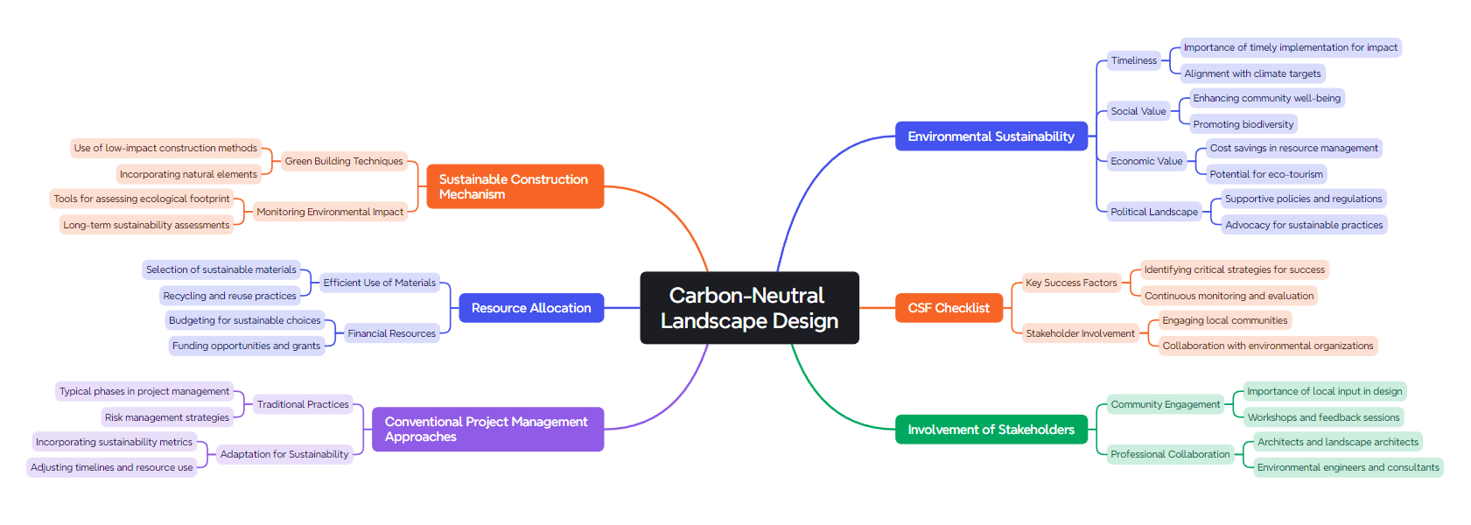
Figure 4: Mindmap
(Source: Self-Created)

Reference List
Ahmad, U., Waqas, H. and Akram, K. (2021) 'Relationship between project success and the success factors in public–private partnership projects: A structural equation model', Cogent Business & Management, 8(1), p. 1927468. Available at: https://www.tandfonline.com/doi/pdf/10.1080/23311975.2021.1927468 (Accessed: 24 August 2024).

Ahmed Ali, K., Ahmad, M.I. and Yusup, Y. (2020) 'Issues, impacts, and mitigations of carbon dioxide emissions in the building sector', Sustainability, 12(18), p. 7427. Available at: http://dx.doi.org/10.3390/su12187427 (Accessed: 24 August 2024).

Anderson, J. (2021) Google HQ, Kings Cross, London - Vareo Blu. [online] Vareo Blu. Available at: https://vareoblu.com/google-hq-kings-cross-london/#:~:text=The%20project%20utilises%20a%20large (Accessed: 23 August 2024).

Asiedu, R.O. and Adaku, E. (2020) 'Cost overruns of public sector construction projects: a developing country perspective', International Journal of Managing Projects in Business, 13(1), pp. 66-84. Available at: https://wlv.openrepository.com/bitstream/handle/2436/623519/Asiedu_et_al_Cost_Overruns_Paper_IJMPB.pdf?sequence=3 (Accessed: 24 August 2024).

Bilir, C. (2022) 'Project success criteria, critical success factors (CSF), and agile projects', in Contemporary challenges for Agile project management, pp. 52-72. Available at: https://openaccess.izu.edu.tr/xmlui/bitstream/handle/20.500.12436/4011/Project-Success-Criteria-Critical-Success-Factors-%28CSF%29-and-Agile-Projects.pdf?sequence=3&isAllowed=y (Accessed: 24 August 2024).

Durdyev, S. and Hosseini, M.R. (2020) 'Causes of delays on construction projects: a comprehensive list', International Journal of Managing Projects in Business, 13(1), pp. 20-46. Available at: https://doi.org/10.1108/IJMPB-09-2018-0178 (Accessed: 24 August 2024).

García-Madurga, M.Á. and Esteban-Navarro, M.Á. (2020) 'A project management approach to competitive intelligence', Journal of Intelligence Studies in Business, 10(3). Available at: https://doi.org/10.37380/jisib.v10i3.636 (Accessed: 24 August 2024).

Gemino, A., Horner Reich, B. and Serrador, P.M. (2021) 'Agile, traditional, and hybrid approaches to project success: is hybrid a poor second choice?', Project Management Journal, 52(2), pp. 161-175. Available at: https://doi.org/10.1177/8756972820973082 (Accessed: 24 August 2024).

Goh, C.S., Chong, H.Y., Jack, L. and Faris, A.F.M. (2020) 'Revisiting triple bottom line within the context of sustainable construction: A systematic review', Journal of Cleaner Production, 252, p. 119884. Available at: https://researchportal.hw.ac.uk/files/27022156/AAM_JCELPRO.pdf (Accessed: 24 August 2024).

Gunduz, M. and Almuajebh, M. (2020) 'Critical success factors for sustainable construction project management', Sustainability, 12(5), p. 1990. Available at: https://doi.org/10.3390/su12051990 (Accessed: 24 August 2024).

Irfan, M., Khan, S.Z., Hassan, N., Hassan, M., Habib, M., Khan, S. and Khan, H.H. (2021) 'Role of project planning and project manager competencies on public sector project success', Sustainability, 13(3), p. 1421. Available at: https://doi.org/10.3390/su13031421 (Accessed: 24 August 2024).

Kaur, D. (2024) 'UK tech revolution: A billion-dollar data center gamble by Google'. [online] Tech Wire Asia. Available at: https://techwireasia.com/2024/01/google-is-making-a-billion-dollar-bet-on-its-first-data-center-in-the-uk/ (Accessed: 24 August 2024).

Khalifeh, A., Farrell, P. and Al-edenat, M. (2020) 'The impact of project sustainability management (PSM) on project success: A systematic literature review', Journal of Management Development, 39(4), pp. 453-474. Available at: https://doi.org/10.1108/JMD-02-2019-0045 (Accessed: 24 August 2024).

King Cross HQ (2024) 'Google will open a new U.K. headquarters with 3,000 employees'. [online] Inc.com. Available at: https://www.inc.com/business-insider/google-uk-london-headquarters.html#:~:text=The%20new%20headquarters%20will%20be,4%2C000%20people%20in%20the%20UK (Accessed: 23 August 2024).

King Cross (2024) 'Sustainable building design at King’s Cross'. [online] King’s Cross. Available at: https://www.kingscross.co.uk/sustainable-buildings (Accessed: 23 August 2024).

Montenegro, A., Dobrota, M., Todorovic, M., Slavinski, T. and Obradovic, V. (2021) 'Impact of construction project managers’ emotional intelligence on project success', Sustainability, 13(19), p. 10804. Available at: https://doi.org/10.3390/su131910804 (Accessed: 24 August 2024).

Obi, L.I., Arif, M., Awuzie, B., Islam, R., Gupta, A.D. and Walton, R. (2021) 'Critical success factors for cost management in public-housing projects', Construction Innovation, 21(4), pp. 625-647. Available at: https://wlv.openrepository.com/bitstream/handle/2436/623810/Critical_success_factors_for_cost_management.pdf?sequence=3 (Accessed: 24 August 2024).

Oh, J., Lee, H. and Zo, H. (2021) 'The effect of leadership and teamwork on ISD project success', Journal of Computer Information Systems. Available at: https://doi.org/10.1080/08874417.2019.1566804 (Accessed: 24 August 2024).

Partridge, J. (2022) 'Behold London’s ‘landscraper’! Google’s new UK HQ – as long as the Shard is tall'. [online] The Guardian. Available at: https://www.theguardian.com/business/2022/jul/01/behold-londons-landscraper-googles-new-uk-hq-as-long-as-the-shard-is-tall (Accessed: 23 August 2024).

Trivedi, A. (2022) 'King’s Cross Graced With Google’s New Headquarters By Heatherwick Studio And Bjarke Ingels Group'. [online] The Decor Journal India. Available at: https://www.thedecorjournalindia.com/google-headquarter-in-kings-cross (Accessed: 23 August 2024).

US About Amazon (2020) 'Amazon selects New York City and Northern Virginia for new headquarters'. [online] Available at: https://www.aboutamazon.com/news/company-news/amazon-selects-new-york-city-and-northern-virginia-for-new-headquarters (Accessed: 24 August 2024).

Wafa, R., Khan, M.Q., Malik, F., Abdusalomov, A.B., Cho, Y.I. and Odarchenko, R. (2022) 'The impact of agile methodology on project success, with a moderating role of Person’s job fit in the IT industry of Pakistan', Applied Sciences, 12(21), p. 10698. Available at: https://www.mdpi.com/2076-3417/12/21/10698/pdf (Accessed: 24 August 2024).

Waris, M., Khan, A., Abideen, A.Z., Sorooshian, S. and Ullah, M. (2022) 'Stakeholder management in public sector infrastructure projects', Journal of Engineering, Project & Production Management, 12(3). Available at: https://doi.org/10.32738/JEPPM-2022-0017 (Accessed: 24 August 2024).

Wuni, I.Y. and Shen, G.Q. (2020) 'Critical success factors for the management of the early stages of prefabricated prefinished volumetric construction project life cycle', Engineering, Construction and Architectural Management, 27(9), pp. 2315-2333. Available at: https://ira.lib.polyu.edu.hk/bitstream/10397/89242/1/Prefabricated_Prefinished_Volumetric.pdf (Accessed: 24 August 2024).

