Managing Enterprise in the 21St Century
Luciana Stafi | 2130653
Business Plan
submision: 03.07.2023
2023
Table of Contents
Task 1a - Business Plan 2
1.0 Company concept. 2
2.0 Company name. 3
3.0 Legal Identity. 3
4.0 Mission statement. 3
5.0 Business Aims and Objectives. 3
5.1 Aims 3
5.2 Objectives (SMART) 4
6.0 Physical 4
7.0. Human Resource. 5
8.0 Marketing Strategy. 7
8.1 Market research 8
9
8.2 Target market 9
8.4 Standing 10
8.5 Market position 10
9.0 7 P's 11
10. SWOT Analysis 12
11. Cash flow 13
Reference List. 14
Task 1b – Reflection 16

Task 1a - Business Plan

1.0 Company concept.

Our company proudly offers a unique and diverse menu of delicious food options from our food truck. We specialise in spiral potatoes, both classic and with exciting twists, as well as a variety of hot and cold drinks, waffles, sandwiches, and traditional Romanian cakes that change daily. Our inspiration for starting a food truck business comes from our love of exploring the country while still providing high-quality food to our customers. We believe that food should taste great and be an experience, which we aim to deliver with every dish we serve. Join us on our journey and enjoy some of the best food on wheels!

2.0 Company name.
The company name will be LUCANTO' S, completed with the message " ARE YOU HUNGRY? "to stimulate the subconscious of potential customers.
The owner chose the company name because it represents the names of the two children, Luca and Antonia and the initial "S" from the sure name.

3.0 Legal Identity.
As a company, we decided to become Sold Trader because we want to be the only owners, but at the same time, we can increase the work team by hiring experienced people.
The advantage of being a Sold Trader is that starting a business does not require a significant investment, and the profit obtained belongs to the owner. The disadvantages of a Sold Trader are that more hours of work must be allocated to succeed, and promotion will be more challenging to achieve (Reach. M, 2019).

4.0 Mission statement.
Discover a tantalising array of unique flavours that will leave a lasting impression on you. With our commitment to quick and convenient ordering, you can savour our delightful dishes on the go. Join us on an unforgettable culinary journey that will make us your go-to food destination.

5.0 Business Aims and Objectives.

5.1 Aims
To establish a food truck service in Caldicot, available from Monday to Friday at the address Pill Way, NP265PU, providing high-quality fries, waffles, hot/cold drinks, and sandwiches from a well-equipped Ford Transit, prioritising exceptional taste and sustainable practices.

5.2 Objectives (SMART)
In establishing our objectives, we use the SMART strategy (Herridge, 2022).

- To secure and outfit a Ford Transit with superior cooking equipment within the next six months.
- To increase our customer base by 20% each quarter by enhancing our marketing efforts and delivering exceptional food and service.
- To pass all health and food safety inspections with a score of at least 95% over the next year.
- To secure prime vending locations at a minimum of 15 major festivals during the peak season (summer and fall weekends).
- To expand our operations by adding at least one more food truck to our fleet each year, aiming for a total of three trucks by the end of three years.

6.0 Physical
- Location: Pill Way, NP265PU (main location). Many warehouses and companies in this area are without a restaurant or food service, and it would be ideal for us to start our business with a food truck.
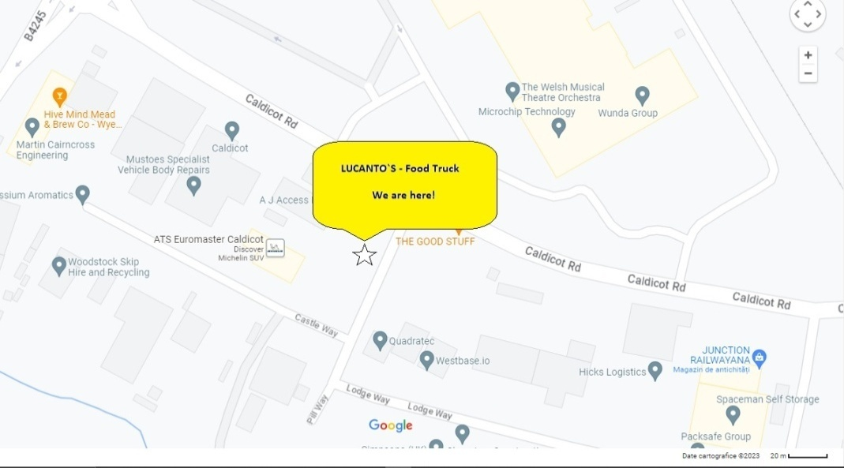

Picture 1
- The equipment needed for spiral fries, waffles, hot/cold drinks, and sandwiches:
Details
Ford Transit from 2016
Spiral Fry Cutter
Deep Fryer
Waffle Maker
Sandwich Prep Table
Panini Press/Grill
Beverage Dispenser
Refrigeration Unit
Hand Wash Sink
Three-Compartment Sink
Cash Register/POS System
Generators

7.0. Human Resource.
In the beginning, the company will need six people after, and we will increase the number of employees if necessary.
- Owner/Founder
- Manager
- Cooker
- Driver
- Marketing and Copywriting Specialist
- Accountant

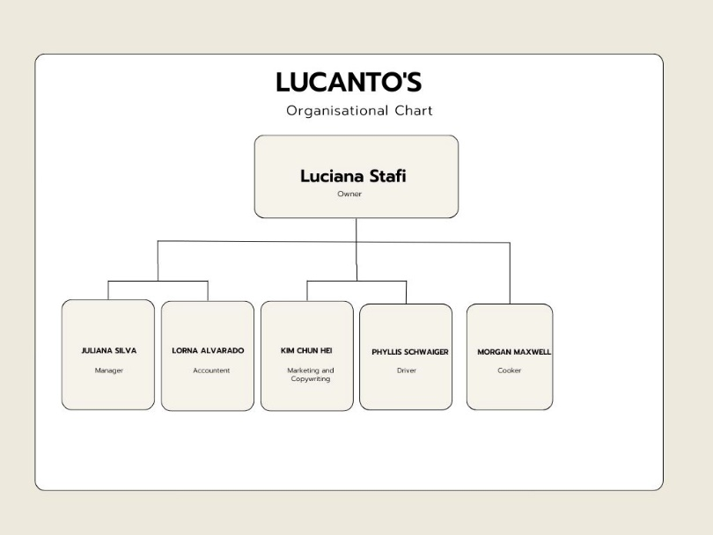

Picture 2

Hiring for a food truck business necessitates specific criteria for different roles:
- Ideally, a Manager should have proven leadership and operational experience in the hospitality industry (Mullins & Walker, 2013).
- Accountants must demonstrate proficiency in financial management and software (Atrill & McLaney, 2011).
- Cooks should demonstrate culinary skills and knowledge of food hygiene standards (National Restaurant Association, 2020).
- Drivers must possess a valid driving license and commercial vehicle knowledge (U.S. Bureau of Labor Statistics, 2019).
- Marketing Specialists require knowledge of local markets and digital marketing skills (Kotler et al., 2017).
- Copywriting Specialists should demonstrate creative writing abilities and SEO knowledge (Killoran, 2013).

When you hire for the first time, you must take into account seven things (Service, 2015):
- Decide how much to pay someone, at least the National Minimum Wage,
- Check if someone has the legal right to work in the UK,
- Get employment insurance,
- Check if you need to apply for a DBS check,
- Send details of the job in writing for employees about the terms and conditions,
- Tell HM Revenue and Customs (HMRC) by registering as an employer,
- Check if we need to enrol the staff into a workplace pension scheme.

8.0 Marketing Strategy.
A marketing Strategy is a business's comprehensive plan to achieve specific goals by effectively utilising its resources in a competitive environment (Kotler et al., 2019).
The marketing strategy for our Food Truck entails identifying the target audience, creating a unique brand identity, utilising social media for promotions, and offering distinct culinary options (Hill et al., 2022). Also, geographic positioning to maximise customer reach is paramount. (Mourdoukoutas, 2017).
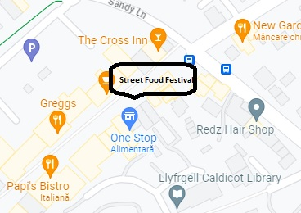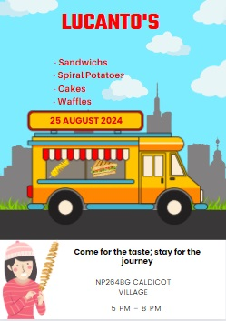
Picture 3 Picture 4
-25.08.2024 - Street Food Festival - Caldicot Village NP24BG

8.1 Market research

After market research, we can identify business opportunities, understand the brand perception and attract a loyal customers base (Zlukova, 2023). As marketing research, we conducted a questionnaire with ten questions. Following the result obtained, we found that around 75% of the ten people who interacted with the questionnaire focused on food quality, hygiene and a well-defined menu. At the same time, promotion on social networks is one of the most indicated due to the percentage obtained in the questionnaire.
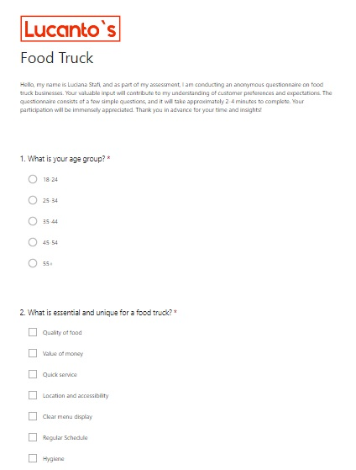

Picture 5

8.2 Target market
Lucanto's marketing strategy integrates traditional (flyer distribution near local businesses in Caldicot) and digital methods (Facebook and Instagram promotions) for broader outreach (Juska, 2017). Furthermore, contacting ASDA (info@asdamediapartnerships.co.uk) and Aldi (aldi.media@umww.com) for banner placements in Caldicot stores will amplify brand visibility (McDonald & Wilson, 2016).
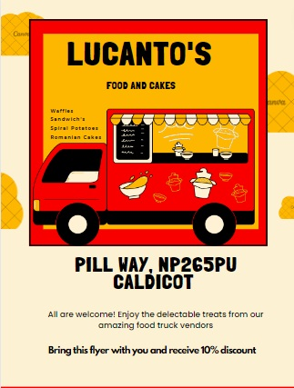

Picture 6

8.4 Standing
Standing refers to a company's reputation or prominence in its industry or marketplace (Deephouse et al., 2016). Lucanto's Food Truck's standing will be enhanced by providing high-quality food, excellent customer service, and effective marketing strategies.

8.5 Market position
Market position, specifically related to pricing strategy, refers to a business's status within its industry based on price, quality, and value relative to its competitors (Kotler et al., 2019).
Four primary competitors exist in the food truck industry within Caldicot and Newport (the closest city to Caldicot), Wales. Prices for key items like fries, waffles, hot/cold drinks, and sandwiches vary:
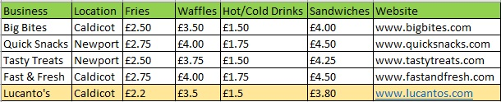

Picture 7
The average prices across all businesses:
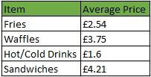
Picture 8
Lucanto's pricing is lower than the average across all categories, suggesting a competitive pricing strategy to offer customers better value.

9.0 7 P's
The "7 P's" of marketing are a well-established framework that can apply to any business. These P's are Product, Price, Place, Promotion, People, Process, and Physical Evidence (Editor, C, 2016). Here is how these 7 P's can be applied to Lucanto's business:
Product: The food offered by Lucanto's is of high quality and always fresh. Our products are different from other competitors on the market because taste makes the difference, and Romanian cakes will bring a new flavour to the food truck field.
Price: Since we also have to consider the competition, our prices will be average, suitable for all types of consumers.
Place: Our location will be Pill Way, NP265PU. In this area, many warehouses and companies have nowhere to get food because there are no food services.
Promotion: Our business will consist of a website but, at the same time, flyers with new locations at various food festivals or other events dedicated to foodies.
People: Employees, thanks to their work skills, have a very important role in the growth and development of the company. That is why the workplace must be friendly for teamwork to excel (Waters, 2022).
Process: LUCANTO' S offers good quality food, always fresh. Customers can order in advance by phone or online to reduce the waiting time.
Physical Evidence: The sweet scent of caramelising waffles, mingling with the savoury aroma of freshly grilled sandwiches and the earthy smell of golden-fried potatoes, wafted through the air, signalling the presence of the beloved food truck.
As physical evidence, we will use our logo (Picture 9) to create a brand in the Food Track industry.
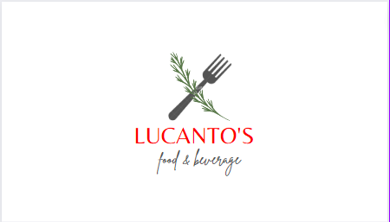

Picture 9
The key to a successful food truck business is effective management and consideration of all the 7 Ps of marketing (Product, Price, Place, Promotion, People, Process, and Physical Evidence) as they are all interlinked, and a weakness in one area can impact the others (Hollensen, 2015).

10. SWOT Analysis

STRENGTHS  - Mobility  - Low starts up costs  - Flexibility in the menu offering | WEAKNESSES  - Limited capacity (Capacity to serve large numbers of customers)  - Regulatory issues (parking restrictions)  - Limited Brand Presence
OPPORTUNITIES  - Catering and Events  - Brand expansion  - Collaborations | THREATS  - Competition  - Climate change  - Fuel price

SWOT Conversion
- To convert the threat of competition into an opportunity, we could differentiate ourselves by innovating our menu, improving customer service, and focusing on a unique branding strategy, attracting a loyal customer base and setting ourselves apart from other food trucks.
- By transforming our weakness of limited capacity into strengths, we could emphasise a unique, personalised customer experience, providing a high-quality, artisanal touch to our food truck service that can effectively cater to small, intimate crowds, setting us apart in a market oversaturated with quantity-focused competitors.

11. Cash flow

Cash flow refers to the net balance that enters and leaves a company at a certain moment in time (Stobierski, 2020).
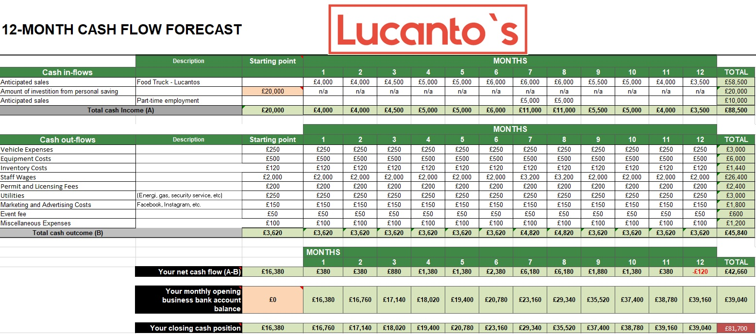

Picture 10

Reference List.
- Atrill, P., & McLaney, E., 2011. Financial Accounting For Decision Makers. 6th ed. Pearson Education.
- Boxsell, M. (2015) Market positioning, Skillmaker. Available at: https://www.skillmaker.edu.au/market-positioning/ (Accessed: 10 June 2023).
- Deephouse, D.L., Bundy, J., Tost, L.P. and Suchman, M.C., 2016. Organisational legitimacy: Six key questions. In The SAGE Handbook of Organisational Institutionalism. SAGE Publications.
- Editor, C. (2016) The 7 PS of Marketing, Caunce O’Hara. Available at: https://www.caunceohara.co.uk/the-7ps-of-marketing/?ppc_keyword=&gclid=CjwKCAjw4ZWkBhA4EiwAVJXwqdjBKaVu75DySeK-0vCJ6GZLaglccXcOGb8llnwElhsyss4T0QM4QhoCJtQQAvD_BwE (Accessed: 11 June 2023).
- Food Truck Equipment Checklist (2021) WebstaurantStore. Available at: https://www.webstaurantstore.com/article/398/food-truck-equipment-list.html (Accessed: 19 May 2023).
- Hannah Grimes Center. 2022. Getting the Most from a SWOT Analysis - Hannah Grimes Center. [online] Available at: <https://www.hannahgrimes.com/544> [Accessed 10 May 2023].
- Herridge, D. (2022) What are smart objectives and how do I apply them? Training Courses & Accredited Qualifications for Professionals. Available at: https://www.professionalacademy.com/blogs/what-are-smart-objectives-and-how-do-i-apply-them/ (Accessed: 08 June 2023).
- Hill, N., Brierley, J. and MacDougall, R., 2022. How to Measure Customer Satisfaction. Routledge.
- Hollensen, S. (2015) 'Marketing Management: A Relationship Approach', 3rd ed. Harlow: Pearson Education.
- Juska, R., 2017. E-Marketing for NGOs. Palgrave Macmillan.
- Killoran, J.B., 2013. How to Use SEO in Your Digital Marketing Strategy. Most of Your Digital Marketing is Useless. University of Lethbridge, pp.113-130.
- Kotler, P., Keller, K.L., Manceau, D. and Hémonnet-Goujot, A., 2019. Marketing Management. 15th ed. Pearson.
- McDonald, M. & Wilson, H., 2016. Marketing Plans: How to prepare them, how to profit from them. 8th ed. Wiley.
- Mourdoukoutas, P., 2017. The Ten Principles Behind Great Customer Experiences. FT Publishing International.
- Mullins, L.J. and Walker, O.R., 2013. Hospitality Management and Organisational Behaviour. Pearson.
- National Restaurant Association, 2020. ServSafe Manager. 7th ed. National Restaurant Association.
- Reach, M. (2019) Enjoy maximum business privacy, Morgan Reach. Available at: https://morganreach.com/the-pros-and-cons-of-being-a-sole-trader (Accessed: 10 May 2023).
- Service, G.D. (2015) Employing staff for the first time, GOV.UK. Available at: https://www.gov.uk/employing-staff (Accessed: 15 May 2023).
- Stobierski, T. (2020) Cash flow vs. profit: What’s the difference?: HBS Online, Business Insights Blog. Available at: https://online.hbs.edu/blog/post/cash-flow-vs-profit (Accessed: 15 June 2023).
- U.S. Bureau of Labor Statistics, 2019. Heavy and Tractor-trailer Truck Drivers: Occupational Outlook Handbook. [online] U.S. Bureau of Labor Statistics. Available at: https://www.bls.gov/ooh/transportation-and-material-moving/heavy-and-tractor-trailer-truck-drivers.htm [Accessed 10 June 2023].
- Waters, S. (2022) What is teamwork and why does it matter? BetterUp. Available at: https://www.betterup.com/blog/what-is-teamwork (Accessed: 09 June 2023).
- Zlukova, N. (2023) ‘Market Research: What It Is &amp; How to Do It’, Semrush blog, 22 March. Available at: https://www.semrush.com/blog/market-research-guide/ (Accessed: 14 June 2023).

Task 1b – Reflection

Taking the first steps towards turning my business idea into reality was an adventure filled with learning and growth. The idea behind my business, LUCANTO's "ARE YOU HUNGRY," came from what I love, what I saw was missing in the market, and what I thought people might need.

The first tool I used to understand my customers better was a questionnaire. The challenge was ensuring it was easy and quick to fill out while giving me valuable insights about what customers want. Each completed questionnaire was like a bit of treasure, full of clues about shaping my business to serve potential customers better.

Alongside the questionnaire, I used a leaflet to spread the word about my business. Designing this leaflet was fun but tricky - it had to look good, share helpful information, and get people excited about LUCANTO's "ARE YOU HUNGRY."

Then, I dived into the world of social media to reach even more people. It was all about understanding my customers' platforms, what type of posts they enjoy, and when they're most likely to be online. It was a lot to take in, but it was also an awesome way to get immediate feedback and connect with people.

As I was doing all of this, I had to ensure my business idea was doable. I looked at the money side of things (expenses, how much to charge, and potential earnings), the practical side (how to source and deliver what we'd be offering), and whether there was enough demand in the market. This was probably the toughest part, but it was also reassuring. It helped confirm that LUCANTO's "ARE YOU HUNGRY" could work as a real business.

Despite some bumps along the way, this journey has shown me that my business idea is exciting and feasible. The questionnaire, the leaflet, and social media have all been great ways to understand and connect with potential customers. They've given me a lot of confidence and made me feel ready to take the next steps towards launching my business.

Turning an idea into a business is a rollercoaster ride with its ups and downs. But with every twist and turn, I've learned something new, and I'm excited to see where this journey takes me next!

