Code Link: https://github.com/Michael7250/smart-device-manager
Michael Ziumbe (2428301) | LECTURER: KOUSHIK MODAK
University of wales trinity saint david | ACCA 5034
Programming Assignment with Associated Documentation
Scripting and Programming Concepts
Table of Contents
Abstract 2
Task 1: Analysis 3
Introduction 3
Requirements Analysis 3
Task 2: Software Design and Development 5
A: Design 5
Flowcharts: 6
Pseudo-code: 7
B: Implementation Decisions 21
C: Source Code 23
Task 3: Testing and Debugging Report 38
Task 4: Evaluation 41
Challenges Faced: 41
Future Improvements: 42
Self-Reflections: 43
Conclusion 44
Appendices 46

Abstract
This report presents the design, development, testing, and evaluation of a Python-based Smart Device Management System developed as part of the Scripting and Programming Concepts module. The purpose of the system is to provide users with an efficient and user-friendly solution for managing information about smart devices through a command-line interface. The application enables users to perform key operations, including, adding, viewing searching updating, and deleting device records while ensuring data integrity through input validation and error handling.
The project follows the Software Development Life Cycle (SDLC), beginning with an analysis of the business requirements and system functionalities. The design stage includes the use of flowcharts and pseudocode to represent the program’s logic before implementation. Appropriate data structures, user-defined functions, control structures, and Python modules are used to develop a modular and maintainable solution that follows good programming practices.
To ensure the reliability of the application, comprehensive testing and debugging activities are conducted using a range of test cases, including normal, boundary, and invalid inputs. The testing process verifies that the implemented validation mechanisms function correctly and that the software behaves as expected under different conditions. Finally, the report evaluates the completed system by reflecting on the challenges encountered during development, the knowledge and programming skills gained throughout the project, and potential enhancements that could be implemented in future versions of the software.
Overall, the project demonstrates the practical application of programming concepts, software design principles, and structured software development techniques to produce a functional Smart Device Management System that satisfies the identified user requirements.

Task 1: Analysis

Introduction
The increasing use of smart devices in homes, workplaces, and educational environments has created a need for efficient methods of managing device information. As the number of connected devices grows, manually tracking details such as device names, types, manufacturers, operating status, and battery levels becomes increasingly time-consuming and prone to human error [1]. Traditional methods, such as paper records or simple spreadsheets, offer limited functionality for searching, updating, and maintaining accurate records, making them unsuitable for managing devices.
To address this problem, this project proposes the development of a Smart Device Management System using Python. The application provides a command-line interface that enables users to manage device records efficiently. The system is designed to store and organise devices, view existing records, search for specific devices, update stored information and delete devices that are no longer required.
The software also incorporates input validation and error handling to improve data accuracy and system reliability. By automating these tasks, the application reduces manual effort and minimises incorrect data entry, providing a more organised approach to managing smart device information. The project follows the Software Development Life Cycle (SDLC), ensuring that the software is developed using a structured process from requirements analysis through to implementation, testing, and evaluation [2].

Requirements Analysis
The Smart Device Management System has been designed to satisfy the functional requirements of users who need an efficient method of organising and maintaining information about smart devices. The system provides a range of features that support the complete management of device records while maintaining data accuracy through appropriate validation.
The main functionalities of the system include:
- Add Device: Users can enter the details of a new smart device, including information such as the device ID, name, type, manufacturer, status, and battery level. The system validates the input before storing the record.

- View Devices: Users can display all device records in a clear and organised format, making it easy to review the information currently held by the system.

- Search Device: Users can search for a device using a unique identifier or device name, allowing specific records to be located quickly.

- Update Device: Existing device information can be modified whenever changes occur, ensuring that stored records remain accurate and up to date.

- Delete Device: Devices that are no longer required can be removed from the system, helping to maintain an accurate database.

- Input Validation: The application validates user input by checking for empty fields, invalid menu selections, duplicate device IDs, incorrect data types, and values outside acceptable ranges. This helps maintain the integrity of the stored data.

- Data Storage: Device information is saved to a file, allowing records to persist after the application has been closed and reopened.
In addition to these functional requirements, the system has been designed with several non-functional requirements in mind. It should be user-friendly, reliable, maintainable, and efficient. The modular structure of the program, achieved using user-defined functions, improves readability and simplifies future maintenance. These requirements ensure that the Smart Device Management System provides a practical, and scalable solution for managing smart device information.

Task 2: Software Design and Development

A: Design
The Smart Device Management System was designed before implementation to provide a clear structure for the application’s functionality and overall workflow. During the design stage, flowcharts and pseudocode were produced to represent the logical sequence of operations performed by the system [3], [4]. These design techniques made it easier to identify decision points, repetition structures, and user interactions before writing the Python source code. As a result, the implementation process became more organised and reduced the likelihood of logical and syntax errors.
The application follows a modular design approach in which each major task is implemented as an individual function. Separate functions were created for adding, viewing, searching, updating, deleting, sorting, and displaying statistics for smart devices. This modular structure improves readability, maintainability, and testing because each function performs one clearly defined responsibility [5]. If modifications are required in the future, changes can be made to a single function without affecting the rest of the program.
The application also follows a menu-driven design. When the program starts, previously saved device records are loaded from a JSON file into memory. The user is then presented with a menu containing all available operations. After a selected task has been completed, the system returns to the main menu, allowing multiple operations to be performed during the same program session. The application continues running until the user chooses the exit option.
Input validation was incorporated into the design to improve data integrity and reduce user errors. Validation ensures that device identifiers remain unique, mandatory fields cannot be left empty, operating status values are restricted to either Online or Offline, and battery levels remain within the permitted range of 0 to 100 percent. Exception handling was also included when processing numeric input and reading the JSON data file to ensure that the application remains stable when unexpected input or file-related errors occur.
Finally, persistent data storage was achieved using JavaScript Object Notation (JSON). Device records are automatically loaded when the program starts and saved whenever a record is added, updated, or deleted. This allows users to retain their data between sessions without requiring a database management system.

Flowcharts:
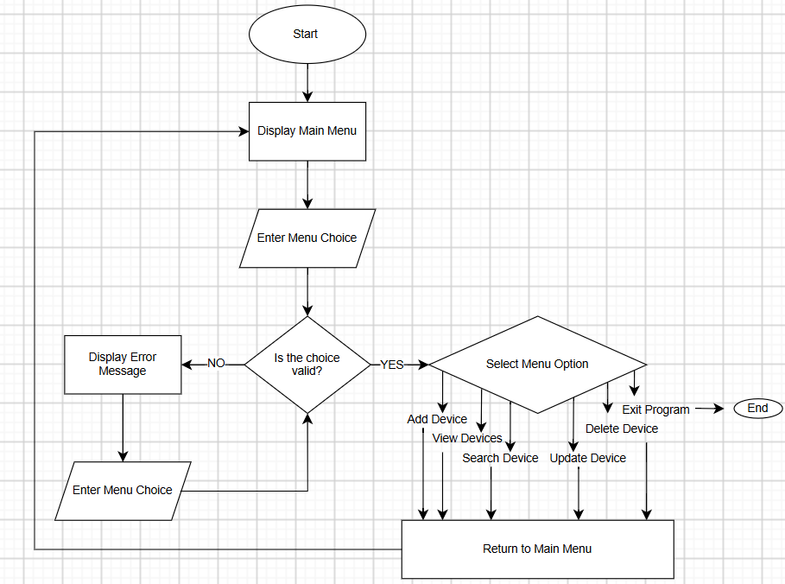
Figure 1: Main Menu Flowchart
Figure 1 illustrates the overall control flow of the Smart Device Management System. When the program starts, the main menu is displayed, allowing the user to enter a menu choice. The entered value is then validated to determine whether it represents an available option. If the input is invalid, an error message is displayed, and the user is prompted to enter another choice. This process continues until valid input is provided, preventing inappropriate menu selections from affecting the operation of the system.
Once a valid choice has been entered, the program determines which menu option the user has selected. The available operations are adding a device, viewing stored devices, searching for a device, updating an existing device, deleting a device, and exiting the program. After completing one of the five device management operations, control returns to the main menu so that the user can perform another task without restarting the application. If the exit option is selected, the program terminates instead of returning to the menu. This design provides a simple navigation structure while using selection and repetition to control the behaviour of the application.
The flowchart illustrates the overall logical structure and operational flow of the Smart Device Management System. It was created during the design stage to provide a visual representation of how the user interacts with the application and how the program responds to different selections. The flowchart also demonstrates the use of sequence, selection, and iteration, which are fundamental programming constructs used throughout the final Python implementation [6].
When the application starts, previously stored device information is loaded from the JSON data file. The program then displays the main menu, which acts as the pivotal point of navigation for the system. From this menu, the user can select an operation such as adding a new device, viewing stored devices, searching for a particular device, updating existing information, deleting a device, displaying statistics, sorting device records, or exiting the application.
Decision points within the flowchart represent the different choices that can be made by the user. Depending on the selected menu option, the program transfers control to the appropriate function. For example, selecting the Add Device option begins the process of collecting and validating information for a new smart device. Selecting Search Device requests a search value and examines the stored records for matching information. Similarly, the Update and Delete options first identify the required device before making changes to the stored data.
Validation is an important part of the design. Where appropriate, the program checks the information entered by the user before continuing. For example, a device ID cannot be empty or duplicated, the device status must be either Online or Offline, and the battery level must be a whole number between 0 and 100. When invalid information is entered, the user is prompted to enter the information again rather than allowing incorrect data to be stored.
After an operation has been completed, control returns to the main menu. This creates a repetition structure that allows the user to perform multiple operations without restarting the application. The loop continues until the Exit option is selected, at which point the application terminates.
Overall, the flowchart provided a useful visual plan for the implementation of the system. It helped establish how the individual functions would connect to the main menu and highlighted where decisions, loops and validation were required. This provided a structured foundation from which the Python implementation could be developed.

Pseudo-code:
Pseudocode was used to represent the logic of the Smart Device Management System in a structured but language-independent format. This allowed the key algorithms to be planned before implementation and made it easier to translate the design into Python. The pseudocode below represents the main menu and the core functions of the final system.
The Main Menu Pseudocode
BEGIN

LOAD device records from JSON file

REPEAT
DISPLAY "Smart Device Management System"
DISPLAY "1. Add Device"
DISPLAY "2. View Devices"
DISPLAY "3. Search Device"
DISPLAY "4. Update Device"
DISPLAY "5. Delete Device"
DISPLAY "6. Device Statistics"
DISPLAY "7. Sort Devices"
DISPLAY "8. Exit"

INPUT menu choice

IF menu choice = 1 THEN
CALL Add_Device

ELSE IF menu choice = 2 THEN
CALL View_Devices

ELSE IF menu choice = 3 THEN
CALL Search_Device

ELSE IF menu choice = 4 THEN
CALL Update_Device

ELSE IF menu choice = 5 THEN
CALL Delete_Device

ELSE IF menu choice = 6 THEN
CALL Show_Statistics

ELSE IF menu choice = 7 THEN
CALL Sort_Devices

ELSE IF menu choice = 8 THEN
DISPLAY "Exiting program"

ELSE
DISPLAY "Invalid choice"
END IF

UNTIL menu choice = 8

END
The main menu pseudocode represents the central control structure of the application. A repetition structure keeps the system active until the user selects the exit option. Selection statements are used to determine which function should be executed, while invalid input results in an error message before the menu is displayed again.
Add Device Pseudocode
BEGIN Add_Device

REPEAT
INPUT device ID

IF device ID is empty THEN
DISPLAY "Device ID cannot be empty"

ELSE
SET duplicate found to FALSE

FOR each device in device list
IF stored device ID = entered device ID THEN
SET duplicate found to TRUE
EXIT loop
END IF
END FOR

IF duplicate found = TRUE THEN
DISPLAY "Device ID already exists"
END IF
END IF

UNTIL device ID is valid and unique

REPEAT
INPUT device name

IF device name is empty THEN
DISPLAY "Device name cannot be empty"
END IF

UNTIL device name is not empty

REPEAT
INPUT device type

IF device type is empty THEN
DISPLAY "Device type cannot be empty"
END IF

UNTIL device type is not empty

REPEAT
INPUT manufacturer

IF manufacturer is empty THEN
DISPLAY "Manufacturer cannot be empty"
END IF

UNTIL manufacturer is not empty

REPEAT
INPUT status

IF status is not Online AND status is not Offline THEN
DISPLAY "Invalid status"
END IF

UNTIL status is Online or Offline

REPEAT
INPUT battery level

IF battery level is not a whole number THEN
DISPLAY "Enter a valid whole number"

ELSE IF battery level < 0 OR battery level > 100 THEN
DISPLAY "Battery must be between 0 and 100"
END IF

UNTIL battery level is valid

CREATE device record using:
device ID
device name
device type
manufacturer
status
battery level

ADD device record to device list

SAVE device list to JSON file

DISPLAY "Device added successfully"

END Add_Device
This algorithm includes several validation checks before a device is stored. The device ID must be unique, required text fields cannot be empty, the status must be valid, and the battery level must fall within the accepted range. These checks help maintain the integrity of the stored device information.
View Devices Pseudocode
BEGIN View_Devices

IF device list is empty THEN
DISPLAY "No devices found"
RETURN
END IF

DISPLAY "Stored Devices"

FOR each device in device list
DISPLAY device ID
DISPLAY device name
DISPLAY device type
DISPLAY manufacturer
DISPLAY status
DISPLAY battery level
END FOR

END View_Devices
The View Devices algorithm checks whether any records exist before attempting to display them. If records are available, a loop is used to display each device and its stored attributes.
Search Device Pseudocode
BEGIN Search_Device

INPUT search value

IF search value is empty THEN
DISPLAY "Search value cannot be empty"
RETURN
END IF

SET matches found to FALSE

FOR each device in device list
IF search value matches:
device ID
OR device name
OR device type
OR manufacturer
THEN
DISPLAY device details
SET matches found to TRUE
END IF
END FOR

IF matches found = FALSE THEN
DISPLAY "No matching devices found"
END IF

END Search_Device
The search algorithm allows records to be located using several different fields rather than requiring only a device ID. This improves usability and allows multiple records to be returned where appropriate.
Update Device Pseudocode
BEGIN Update_Device

INPUT device ID to update

FOR each device in device list
IF device ID matches entered ID THEN

DISPLAY current device information
DISPLAY "Press Enter to keep current value"

INPUT new device name
IF new device name is not empty THEN
UPDATE device name
END IF

INPUT new device type
IF new device type is not empty THEN
UPDATE device type
END IF

INPUT new manufacturer
IF new manufacturer is not empty THEN
UPDATE manufacturer
END IF

REPEAT
INPUT new status

IF new status is empty THEN
KEEP current status
EXIT loop

ELSE IF new status is Online or Offline THEN
UPDATE status
EXIT loop

ELSE
DISPLAY "Invalid status"
END IF
UNTIL valid status entered

REPEAT
INPUT new battery level

IF input is empty THEN
KEEP current battery level
EXIT loop

ELSE IF battery level is not a whole number THEN
DISPLAY numeric error

ELSE IF battery level is outside 0 to 100 THEN
DISPLAY range error

ELSE
UPDATE battery level
EXIT loop
END IF
UNTIL valid value entered

SAVE device list to JSON file
DISPLAY "Device updated successfully"
RETURN

END IF
END FOR

DISPLAY "Device not found"

END Update_Device
The update algorithm allows users to update only the values that need changing. Existing values are retained when the user presses Enter while status and battery level changes are validated before being accepted.
Delete Device Pseudocode
BEGIN Delete_Device

INPUT device ID to delete

FOR each device in device list
IF device ID matches entered ID THEN

DISPLAY device ID
DISPLAY device name

REPEAT
INPUT deletion confirmation

IF confirmation = Y THEN
REMOVE device from device list
SAVE device list to JSON file
DISPLAY "Device deleted successfully"
RETURN

ELSE IF confirmation = N THEN
DISPLAY "Deletion cancelled"
RETURN

ELSE
DISPLAY "Enter Y or N"
END IF

UNTIL valid confirmation entered

END IF
END FOR

DISPLAY "Device not found"

END Delete_Device
The deletion algorithm includes a confirmation step to reduce the risk of accidental data loss. The record is only removed when the user explicitly confirms the action.
Device Statistics Pseudocode
BEGIN Show_Statistics

IF device list is empty THEN
DISPLAY "No devices available for statistics"
RETURN
END IF

SET online count to 0
SET offline count to 0
SET total battery to 0

FOR each device in device list
IF device status = Online THEN
INCREMENT online count

ELSE IF device status = Offline THEN
INCREMENT offline count
END IF

ADD device battery level to total battery
END FOR

CALCULATE average battery
average battery = total battery / number of devices

DISPLAY total number of devices
DISPLAY online count
DISPLAY offline count
DISPLAY average battery level

END Show_Statistics
This algorithm calculates the total number of devices, their Online and Offline status, and the average battery level.
Sort Devices Pseudocode
BEGIN Sort_Devices

IF device list is empty THEN
DISPLAY "No devices available to sort"
RETURN
END IF

DISPLAY sorting options:
1. Name
2. Battery lowest to highest
3. Battery highest to lowest

INPUT sort choice

IF sort choice = 1 THEN
SORT devices alphabetically by device name

ELSE IF sort choice = 2 THEN
SORT devices by battery level ascending

ELSE IF sort choice = 3 THEN
SORT devices by battery level descending

ELSE
DISPLAY "Invalid choice"
RETURN
END IF

FOR each sorted device
DISPLAY device information
END FOR

END Sort_Devices
The Sort Devices algorithm allows users to organise device records by name or battery level. Devices can be sorted alphabetically or by battery level from lowest to highest or highest to lowest, making the records easier to review and compare.

B: Implementation Decisions
The implementation of the Smart Device Management System involved translating the algorithms developed during the design stage into a working Python application. Several implementation decisions were made regarding how device information would be represented, how the program would control user interaction, and how data would be stored permanently. The program was divided into separate functions so that each major operation, such as adding, searching, updating, and deleting a device, could be implemented and evaluated independently. This also made the source code easier to understand and maintain.
Data Structures:
The main data structures used within the Smart Device Management System are lists and dictionaries [7]. These were selected because they provide a simple and effective way of representing multiple smart devices and the different attributes associated with each device.
Each individual device is represented using a Python dictionary. A dictionary was appropriate because every device contains several related pieces of information that can be identified using descriptive keys. The keys used within the program include ID, name, type, manufacturer, status, and battery. For example, the value associated with the status key identifies whether a device is Online or Offline, while the battery key stores its current battery percentage.
Using dictionaries made the program easier to understand because information could be accessed using meaningful key names rather than relying on numerical positions. For example, the program can access a device’s battery level using device [“battery”]. This makes the purpose of the data clearer when reading and maintaining the source code.
A Python list called devices is used to store all of the individual device dictionaries. The list allows the program to hold multiple device records and iterate through them when performing operations. For example, loops are used to examine the list when searching for a device, checking for duplicate IDs, displaying all devices, calculating statistics, and locating records that need to be updated or deleted.
The combination of lists and dictionaries was also suitable for JSON storage because these Python data structures can be represented naturally in JSON format. This simplified the process of saving and loading device information.
Programming Constructs
Several fundamental programming constructs were used to control the behaviour of the application. These include sequence, selection, iteration, functions, and exception handling.
Sequence is demonstrated throughout the application because instructions are performed in a logical order. For example, when adding a device, the program first requests and validates the device ID before collecting the name, type, manufacturer, status, and battery level. Once all information has been validated, a dictionary is created, added to the device list, and saved to the JSON file.
Selection is implemented using if, elif and else statements. These allow the program to make decisions based on user input and stored information. The main menu uses selection to determine which function should be executed. Selection is also used during validation, such as determining whether a battery level falls between 0 and 100 or whether a device’s status is Online or Offline.
Iteration is implemented using while and for loops. While loops are particularly important for validation because they allow the program to repeatedly request information until an acceptable value is entered. For example, if an invalid battery level is supplied the loop continues until the user enters a whole number within the permitted range. For loops are used to process the stored device records, including searching for matching devices and calculating statistics.
Functions were used to divide the program into smaller modules. Functions such as add_device(), view_devices(), search_device(), update_device(), delete_device(), show_statistics(), and sort_devices() each have a specific responsibility. Additional functions are responsible for loading and saving information. This modular approach reduces unnecessary repetition and makes the application easier to assess and modify.
Exception handling was implemented using try and except [7]. When a battery level is entered, the program attempts to convert the input into an integer. If the user enters non-numeric information, a ValueError is overseen and an appropriate message is displayed instead of allowing the application to terminate unexpectedly. Exception handling is also used when loading the JSON file to deal with missing or invalid data files.
Python Modules and Libraries
The main Python module used in the project is the built-in json module. This module was selected to provide persistent storage for the smart-device records. Without persistent storage, the contents of the devices list would disappear whenever the application was closed.
The json.dump() function is used by the save_devices() function to write the current device list to devices.json. The indent parameter is used to format the stored JSON data so that it remains readable. UTF-8 encoding is explicitly specified when opening the file to improve compatibility across different systems.
When the application starts the load_devices() function uses json.load() to read the previously stored information and reconstruct the device list [8]. A FileNotFoundError is managed if the JSON file does not yet exist, allowing the application to start with an empty list instead of crashing. A JSONDecodeError is also overseen in case the file exists but contains invalid JSON data.
JSON was chosen instead of a database because the application manages a small collection of structured records and does not require advanced database functionality [9]. It provides a lightweight solution that is straightforward to implement while still demonstrating file handling and persistent data storage.
The project otherwise relies on Python’s built-in functionality. Methods such as strip(), lower(), title() and upper() are used to normalise user input, while the built-in sorted() function is used to organise device records by name or battery level [10]. Keeping external dependencies to a minimum makes the application easier to run because the user only requires a standard Python installation.

C: Source Code
The completed Smart Device Management System was implemented in Python and uploaded to GitHub to provide version-controlled access to the fully functional source code [11]. The repository link is included on the title page of this report as required.
The source code was organised using separate user-defined functions for each major feature of the application, including adding, viewing, searching, updating, deleting, sorting, and displaying statistics for smart devices. Additional functions were used for saving and loading device records using JSON. This modular structure improves readability and makes the program easier to evaluate, maintain and extend.
Best programming practices were applied throughout the implementation. Meaningful function and variable names were used to make the purpose of each section clear. Comments and docstrings were included to explain important sections of the program, particularly validation, file handling, and data-processing operations. Consistent indentation and spacing were also used to ensure that the code remained readable and followed standard Python conventions [12], [13].
The source code includes validation to prevent inappropriate values from being stored. For example, duplicate device IDs are rejected, mandatory fields cannot be left empty, device status is restricted to Online or Offline, and battery levels must be whole numbers between 0 and 100. Exception handling is also used to prevent invalid numeric input or file-related problems from terminating the application unexpectedly.
The following code listing presents the final implementation of the Smart Device Management System. Comments are included within the listing to annotate important sections and explain their purpose.
Listing 1: Complete Source Code for the Smart Device Management System
import json

def save_devices():
"""Save all device records to a JSON file."""
with open("devices.json", "w", encoding="utf-8") as file:
json.dump(devices, file, indent=4)

def load_devices():
"""Load device records from a JSON file."""
try:
with open("devices.json", "r", encoding="utf-8") as file:
return json.load(file)

except FileNotFoundError:
return []

except json.JSONDecodeError:
print("Warning: The data file is invalid. Starting with no devices.")
return []

devices = load_devices()

def add_device():
"""Collect, validate, and store a new smart-device record."""

while True:
device_id = input("Enter device ID: ").strip()

if device_id == "":
print("Device ID cannot be empty.")
continue

duplicate_found = False

for device in devices:
if device["id"] == device_id:
duplicate_found = True
break

if duplicate_found:
print("That Device ID already exists.")
else:
break

while True:
device_name = input("Enter device name: ").strip()

if device_name == "":
print("Device name cannot be empty.")
else:
break

while True:
device_type = input("Enter device type: ").strip()

if device_type == "":
print("Device type cannot be empty.")
else:
break

while True:
manufacturer = input("Enter manufacturer: ").strip()

if manufacturer == "":
print("Manufacturer cannot be empty.")
else:
break

while True:
status = input("Enter status (Online/Offline): ").strip().title()

if status in ("Online", "Offline"):
break

print("Invalid status. Please enter Online or Offline.")

while True:
try:
battery_level = int(input("Enter battery level (0-100): "))

if 0 <= battery_level <= 100:
break

print("Battery level must be between 0 and 100.")

except ValueError:
print("Please enter a valid whole number.")

device = {
"id": device_id,
"name": device_name,
"type": device_type,
"manufacturer": manufacturer,
"status": status,
"battery": battery_level
}

devices.append(device)
save_devices()
print("Device added successfully.")

def view_devices():
"""Display all stored device records."""

if len(devices) == 0:
print("No devices found.")
return

print("\nStored Devices")

for device in devices:
print("Device ID:", device["id"])
print("Device Name:", device["name"])
print("Device Type:", device["type"])
print("Manufacturer:", device["manufacturer"])
print("Status:", device["status"])
print("Battery Level:", str(device["battery"]) + "%")
print("-------------------------")

def search_device():
"""Search for devices by ID, name, type, or manufacturer."""

search_value = input(
"Enter device ID, name, type, or manufacturer: "
).strip().lower()

if search_value == "":
print("Search value cannot be empty.")
return

matches_found = False

for device in devices:
if (
search_value == device["id"].lower()
or search_value in device["name"].lower()
or search_value in device["type"].lower()
or search_value in device["manufacturer"].lower()
):
matches_found = True

print("\nDevice Found")
print("Device ID:", device["id"])
print("Device Name:", device["name"])
print("Device Type:", device["type"])
print("Manufacturer:", device["manufacturer"])
print("Status:", device["status"])
print("Battery Level:", str(device["battery"]) + "%")
print("-------------------------")

if not matches_found:
print("No matching devices found.")

def update_device():
"""Update an existing device while preserving unchanged values."""

update_id = input("Enter the device ID to update: ").strip()

for device in devices:
if device["id"] == update_id:
print("\nDevice found.")
print("Press Enter to keep the current value.\n")

new_name = input(
f'Current Name ({device["name"]}): '
).strip()

if new_name != "":
device["name"] = new_name

new_type = input(
f'Current Type ({device["type"]}): '
).strip()

if new_type != "":
device["type"] = new_type

new_manufacturer = input(
f'Current Manufacturer ({device["manufacturer"]}): '
).strip()

if new_manufacturer != "":
device["manufacturer"] = new_manufacturer

while True:
new_status = input(
f'Current Status ({device["status"]}) '
"[Online/Offline]: "
).strip().title()

if new_status == "":
break

if new_status in ("Online", "Offline"):
device["status"] = new_status
break

print("Invalid status. Please enter Online or Offline.")

while True:
new_battery = input(
f'Current Battery ({device["battery"]}%): '
).strip()

if new_battery == "":
break

try:
battery = int(new_battery)

if 0 <= battery <= 100:
device["battery"] = battery
break

print("Battery level must be between 0 and 100.")

except ValueError:
print("Please enter a valid whole number.")

save_devices()
print("Device updated successfully.")
return

print("Device not found.")

def delete_device():
"""Delete a device after receiving user confirmation."""

delete_id = input("Enter the device ID to delete: ").strip()

for device in devices:
if device["id"] == delete_id:
print("\nDevice Found")
print("Device ID:", device["id"])
print("Device Name:", device["name"])

while True:
confirmation = input(
"Are you sure you want to delete this device? (Y/N): "
).strip().upper()

if confirmation == "Y":
devices.remove(device)
save_devices()
print("Device deleted successfully.")
return

if confirmation == "N":
print("Deletion cancelled.")
return

print("Invalid choice. Please enter Y or N.")

print("Device not found.")

def show_statistics():
"""Display summary information about stored devices."""

if len(devices) == 0:
print("No devices available for statistics.")
return

online_count = 0
offline_count = 0
total_battery = 0

for device in devices:
if device["status"] == "Online":
online_count += 1
elif device["status"] == "Offline":
offline_count += 1

total_battery += device["battery"]

average_battery = total_battery / len(devices)

print("\n----- Device Statistics -----")
print("Total Devices:", len(devices))
print("Online Devices:", online_count)
print("Offline Devices:", offline_count)
print("Average Battery Level:", round(average_battery, 1), "%")
print("-----------------------------")

def sort_devices():
"""Sort and display devices by name or battery level."""

if len(devices) == 0:
print("No devices available to sort.")
return

print("\nSort Devices")
print("1. Sort by device name")
print("2. Sort by battery level (lowest to highest)")
print("3. Sort by battery level (highest to lowest)")

sort_choice = input("Enter your choice (1-3): ").strip()

if sort_choice == "1":
sorted_devices = sorted(
devices,
key=lambda device: device["name"].lower()
)

elif sort_choice == "2":
sorted_devices = sorted(
devices,
key=lambda device: device["battery"]
)

elif sort_choice == "3":
sorted_devices = sorted(
devices,
key=lambda device: device["battery"],
reverse=True
)

else:
print("Invalid choice. Please enter a number between 1 and 3.")
return

print("\n----- Sorted Devices -----")

for device in sorted_devices:
print("Device ID:", device["id"])
print("Device Name:", device["name"])
print("Device Type:", device["type"])
print("Manufacturer:", device["manufacturer"])
print("Status:", device["status"])
print("Battery Level:", str(device["battery"]) + "%")
print("--------------------------")

def main():
"""Run the main menu until the user chooses to exit."""

while True:
print("\nSmart Device Management System")
print("1. Add Device")
print("2. View Devices")
print("3. Search Device")
print("4. Update Device")
print("5. Delete Device")
print("6. Device Statistics")
print("7. Sort Devices")
print("8. Exit")

choice = input("Enter your choice (1-8): ").strip()

if choice == "1":
add_device()
elif choice == "2":
view_devices()
elif choice == "3":
search_device()
elif choice == "4":
update_device()
elif choice == "5":
delete_device()
elif choice == "6":
show_statistics()
elif choice == "7":
sort_devices()
elif choice == "8":
print("Exiting program...")
break
else:
print("Invalid choice. Please enter a number between 1 and 8.")

if __name__ == "__main__":
main()

Task 3: Testing and Debugging Report
Program testing is an essential stage of software development because it verifies that a system behaves according to its requirements and identifies problems before the software is released to users [14]. Testing involves providing different inputs to the program and comparing the actual output against the expected result [15]. This helps determine whether individual functions operate correctly and whether the complete application remains stable under different circumstances.
Testing was particularly important for the Smart Devices Management System because the application accepts several types of user input. Incorrect information could otherwise result in inaccurate records or unexpected program behaviour. Therefore, both valid and invalid inputs were assessed. For example, the Add Device function prevents empty device IDs, detects duplicate IDs, and validates battery levels before storing a new record. Battery validation also checks that the value is a whole number between 0 and 100.
Testing also helps improve software reliability and user experience. Instead of allowing invalid input to terminate the program, validation loops provide an appropriate error message and allow the user to try again. Assessing each function individually made it possible to identify problems during development before evaluating the complete system.
Several diverse types of errors can occur during software development. A syntax error occurs when the code does not follow the grammatical rules of the programming language. Examples include missing brackets, incorrect indentation, or incorrectly structured statements. During development, indentation errors occurred when some lines inside functions or loops did not contain the correct number of spaces. These were corrected by aligning the affected statements with the appropriate code block and maintain consistent indentation throughout the program.
A runtime error occurs after a program has successfully started but encounters a problem during execution. For example, attempting to convert non-numeric text into an integer using int() can generate a ValueError. The final application prevents this from causing a crash by using try and except when processing battery values. If conversion fails, the user is informed that a valid whole number must be entered.
A logical error occurs when the program runs without crashing but produces an incorrect result [16]. These errors can be more difficult to identify because Python may not display an error message. During development, the Update Device validation required the new status value to be checked rather than an earlier status variable. Evaluating the update process helped identify and correct this issue. The final implementation now validates new_status before changing the stored record.
Debugging was therefore conducted by running individual features, observing their output, reviewing error messages, and correcting the relevant sections of source code before retesting them.
Test Cases
The following test cases were used to verify that both valid and invalid inputs were overseen correctly.
Test | Assess Input | Expected Result | Result
Add valid device | ID 1001, valid details, battery 85 | Device added successfully | Pass
Empty Device ID | Press Enter without ID | Error message and ID requested again | Pass
Duplicate Device ID | Enter existing ID 1001 | Duplicate ID rejected | Pass
Empty Device Name | Press Enter | Name cannot be empty | Pass
Invalid Status | Connected | Status rejected; Online/Offline requested | Pass
Valid lowercase status | online | Converted and accepted as Online | Pass
Battery below range | 150 | Battery range error | Pass
Battery below range | -5 | Battery range error | Pass
Non-numeric battery | hello | Whole-number error message | Pass
Valid search | Existing ID/name/manufacturer | Machine device displayed | Pass
Invalid search | Non-existent value | No matching devices found | Pass
Update valid device | Existing device ID | Selected information updated | Pass
Update invalid battery | 120 | Invalid battery rejected | Pass
Delete – No | N | Deletion cancelled | Pass
Delete – Yes | Y | Device removed and JSON updated | Pass
Invalid menu option | 9 | Invalid choice message | Pass
Sort by battery | Option 2 or 3 | Devices shown in correct battery order | Pass
The final program also saves changes to the JSON file whenever devices are added updated or deleted, allowing persistence to be evaluated by closing and restarting the application.
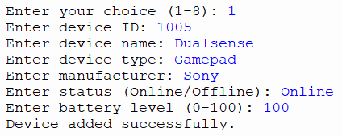
Figure 1: Successful Addition of a Smart Device
Figure 1 demonstrates the successful addition of a new smart device using valid input. The system accepted all of the entered device information and displayed the message “Device added successfully,” confirming that the Add Device function operated correctly.
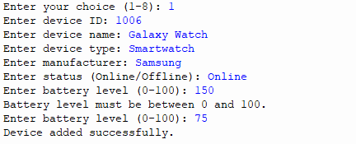
Figure 2: Battery Level Input Validation
Figure 2 demonstrates the battery level validation within the Add Device function. An invalid battery level of 150 was entered and correctly rejected because it exceeded the permitted range 0-100. After entering a valid battery level of 75, the device was successfully added.
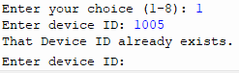
Figure 3: Duplicate Device ID Validation
Figure 3 demonstrates the validation used to prevent duplicate device IDs. The existing ID 1005 was entered and correctly rejected by the system. The program then requested a different device ID, ensuring that each stored device has a unique identifier.
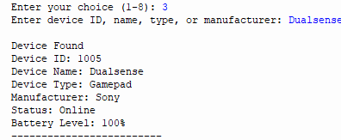
Figure 4: Successful Device Search
This screenshot demonstrates the Search Device function using an existing device name. The system successfully located the matching record and displayed the stored device information, confirming that the search functionality operates correctly.

Task 4: Evaluation

Challenges Faced:
During the development of the Smart Device Management System, several challenges were encountered, particularly while implementing input validation, file handling, and the different device management functions. One of the main challenges was ensuring that user input was correctly validated without causing the application to terminate unexpectedly. For example, the battery level needed to accept only whole numbers between 0 and 100. This required the use of a repetition structure alongside exception handling so that invalid values, including text or numbers outside the permitted range, could be rejected while allowing the user to try again.
Another challenge involved maintaining correct indentation and program structure. Python relies heavily on indentation to identify blocks of code, and during development some indentation errors prevented the program from running. These errors were addressed by examining the error messages, locating the affected lines, and ensuring that statements within functions, loops and selection structures were consistently indented. This experience demonstrated how small formatting errors can have a significant effect on the execution of a Python program.
Implementing persistent data storage was another important challenge. Initially, device information existed only while the application was running. JSON file handling was therefore introduced so that records could be saved and retrieved between sessions. The program was developed to automatically save changes when devices are added, updated, or deleted and load existing information when the application starts. Exception handling was also implemented to deal with situations where the JSON file does not exist or contains invalid data.
Testing was important when addressing these challenges. Features were assessed individually using both valid and invalid inputs, and errors were corrected before the program was evaluated again. This gradual process resulted in a more reliable final application.

Future Improvements:
Although the final application meets its main objectives, several improvements could be introduced in a future version. One significant improvement would be the development of a graphical user interface (GUI). The current application uses a command-line interface, which is functional but requires users to navigate through numbered menu options. A GUI developed using a Python framework such as Tkinter could provide buttons, forms, and tables, making the application more accessible to users who are unfamiliar with command-line applications [17].
Another potential improvement would be replacing JSON storage with a database such as SQLite [18]. JSON is appropriate for the current scale of the project, but a database would provide more efficient management of a much larger collection of devices. It could also support more advanced searching, filtering, and reporting features.
The system could also be expanded to include additional device information, such as location, model number, date added, IP address or last maintenance date. Further statistics could then be generated from this information. Additional filtering options could allow users to display only Online devices, Offline devices, or devices with a low battery level.
A more advanced version could potentially communicate with real smart devices rather than relying on manually entered information [19]. This could allow information such as connectivity status and battery level to be updated automatically. However, this would require networking, APIs and additional security considerations beyond the scope of the current project.

Self-Reflections:
Completing this project improved my understanding of how different programming concepts can be combined to create a complete working application. At the beginning of development, individual concepts such as variables, loops, conditional statements, and functions could be considered separately. During this project, I learned how these concepts interact within a larger program.
One of the most critical areas of development was my understanding of functions and modular programming. Dividing the application into functions for adding, viewing searching, updating, deleting, sorting, and displaying statistics made the program easier to develop and understand. I also developed a stronger understanding of lists and dictionaries and how they can be combined to represent structured information.
Debugging was another valuable part of the learning process. Errors involving indentation, variables and program logic required me to examine error messages and identity the source of the problem rather than simply rewriting large sections of code. Testing incorrect input also helped me understand that a program should not only work when a user enters the expected information; it should also respond appropriately when the user makes mistakes.
The project also introduced me to persistent file storage using JSON. Learning how to save information and reload it when the program restarts made the application feel more complete than a program that loses its information when closed.
Overall, the project has increased my confidence in planning, implementing, assessing, and debugging Python applications. It has also shown me the importance of developing software gradually, testing individual features and improving the program based on the results of those tests.

Conclusion
The Smart Device Management System successfully achieved the main objective of creating a Python application capable of managing smart-device records through a menu-driven interface. The final system allows users to add, view, search, update and delete devices while also providing additional functionality for sorting records and displaying device statistics. Input validation was implemented to improve data accuracy, while JSON file handling ensures that information remains available between program sessions.
The development process demonstrated the importance of planning, structured programming, and systematic testing. Flowcharts and pseudocode provided a foundation for implementation, while testing with valid and invalid inputs helped identify and correct problems throughout development.
Overall, the project provided practical experience in applying Python concepts to a complete software solution rather than using them individually. Although further improvements such as a graphical interface or database integration could expand the application, the current system provides a functional and reliable solution that meets the objectives established during the design stage.

References
[1] Software Engineering, Global Edition, 10th edition, by Ian Sommerville - University of Lancaster, United Kingdom , University of St Andrews, Scotland. Published by Pearson 20 August 2015 https://www.pearson.com/en-gb/subject-catalog/p/software-engineering-global-edition/P200000005464/9781292096131
[2] ISO - Information processing — Documentation symbols and conventions for data, program and system flowcharts, program network charts and system resources charts. 1ST Editon, 1985 https://www.iso.org/standard/11955.html
[3] Python Software Foundation - More Control Flow Tools. Accessed on August 13, 2026. https://docs.python.org/3/tutorial/controlflow.html
[4] Introduction to Algorithms fourth edition by Thomas H. Cormen, Charles E. Leiserson, Ronald L. Rivest and Clifford Stein. Pub date: April 5, 2022. https://mitpress.mit.edu/9780262046305/introduction-to-algorithms/
[5] Python Software Foundation - Data Structures. https://docs.python.org/3/tutorial/datastructures.html
[6] Python Software Foundation – Defining Functions. Accessed on August 13, 2026. https://docs.python.org/3/tutorial/controlflow.html#defining-functions
[7] Python Software Foundation – Sorting Techniques. Accessed on August 13, 2026. https://docs.python.org/3/howto/sorting.html
[8] Python Software Foundation – Errors and Exceptions. Accessed on August 13, 2026. https://docs.python.org/3/tutorial/errors.html
[9] Python Software Foundation - json — JSON encoder and decoder. Accessed on August 13, 2026. https://docs.python.org/3/library/json.html
[10] Internet Engineering Task Force (IETF) - The JavaScript Object Notation (JSON) Data Interchange Format by T. Bray, Ed. December 2017. https://www.rfc-editor.org/info/rfc8259/
[11] Python Software Foundation – Input and Output. Accessed on August 13, 2026. https://docs.python.org/3/tutorial/inputoutput.html
[12] Python Enhancement Proposals - PEP 597 – Add optional EncodingWarning by Inada Naoki. 05-Jun-2019. https://peps.python.org/pep-0597/
[13] Python Enhancement Proposals - PEP 8 – Style Guide for Python Code by
Guido van Rossum, Barry Warsaw & Alyssa Coghlan. 05-Jul-2001. https://peps.python.org/pep-0008/
[14] Clean Code: A Handbook of Agile Software Craftsmanship, 2nd Edition, by Robert C. Martin. Published by Addison-Wesley Professional. 8 October 2025. https://www.pearson.com/en-gb/subject-catalog/p/clean-code-a-handbook-of-agile-software-craftsmanship-2nd-edition/P200000013239/9780135398579
[15] GitHub – “About GitHub”, GitHub Docs. https://docs.github.com/en/get-started/using-git/about-git
[16] GitHub – “Repositories documentation”, GitHub Docs. https://docs.github.com/en/repositories
[17] Introduction to Software Testing by Paul Ammann & Jeff Offutt. Published by Cambridge University Press. https://www.abebooks.co.uk/Introduction-Software-Testing-Ammann-Paul-Offutt/32404717191/bd
[18] ISO/IEC/IEEE 29119-2:2021: Part 2: Test processes - Software and systems engineering — Software testing (2nd Edition, 2021). https://www.iso.org/standard/79428.html
[19] ISO/IEC/IEEE 29119-3:2021: Part 3: Test documentation - Software and systems engineering — Software testing (2nd Edition, 2021). https://www.iso.org/standard/79429.html
[20] ISO/IEC/IEEE 29119-4:2021: Part 4: Test techniques - Software and systems engineering — Software testing (2nd Edition, 2021). https://www.iso.org/standard/79430.html

Appendices
Appendix A – GitHub Repository
The complete source code for the Smart Device Management System is available through the GitHub repository provided on the title page. The repository contains the Python source file and supporting JSON data file used by the application.
Code Link: https://github.com/Michael7250/smart-device-manager
Appendix B – Example JSON Data
This appendix demonstrates the structure used to store smart-device records within the devices.json file.
[
{
"id": "1005",
"name": "Dualsense",
"type": "Gamepad",
"manufacturer": "Sony",
"status": "Online",
"battery": 100
}
]
Appendix C – Development Environment
The Smart Device Management System was developed and evaluated using the Thonny Python IDE. Thonny was used to write, execute and debug the Python source code and to observe the application’s output through the Shell.
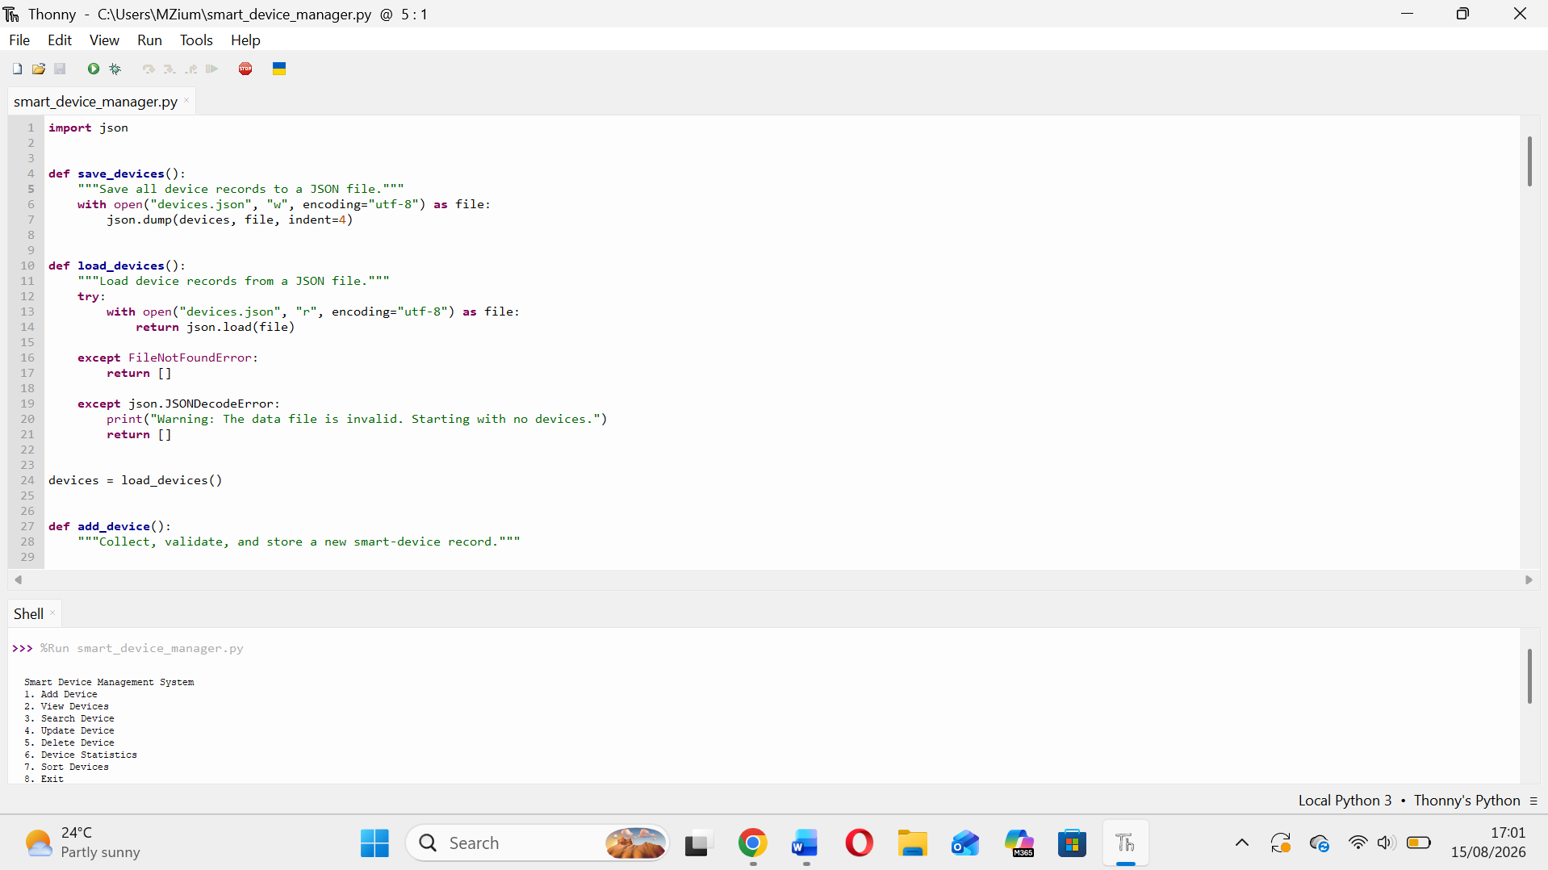
Figure 5: Smart Device Management in the Thonny Python IDE

