  Component One: Student Journal (learning log) 750 words +/- 10%  Contribution to Overall Module Assessment: 25% | Student No: | 2234509
 | Module Title: | Hotel Placement - Operating Hotel Facilities
 | Module Code: | BMIH4006
 | Lecturer: | Natalie Brailsford
This reflective journal aims to identify and analyse key skills necessary for an efficient housekeeper, and the evolution of my understanding of these skills, using Schön’s analysis of reflection. I will reflect on my own skills, linking them to theoretical principles and lived industry examples.
The importance of housekeeping is oftentimes understated. “Customers visit a hotel with a particular idea of the amenities and facilities they want to have access to – high quality is simply expected.” (Carrara, 2018) To maintain such standards, key skills for housekeepers are required:
Attention to Detail: An essential skill, this implies a keen eye for spotting irregularities – like clutter – or uncleanness.
Time-Management: Because work in housekeeping involves respecting deadlines, time-management is paramount, especially as quick turnovers happen daily.
Communication: Is essential for a clear understanding of client expectations, meetings, and checklists.
Teamwork: Housekeeping staff work alone, but teamwork is still important. Reliance on different departments requires dynamic collaboration. “Housekeeping’s coordination with the front desk is essential to the sale of rooms. […] Rooms must be serviced quickly to placate waiting guests and maximize room revenue.” (Vallen and Vallen, 2013, p.69)
Adaptability: Housekeeping is structurally client-based, meaning the work may differ from room to room depending on the client.
Customer Service: “The function of housekeepers has changed over the years, from doing speciﬁc tasks to managing the people, material, and other resources required for task accomplishment.” (Jones, 2007, p. 1) In industries like hospitality, providing excellent customer service involves being courteous and responsive.
Physical Stamina: Housekeeping jobs “entail physical labour such as servicing guest rooms and cleaning public space” (Carrara, 2018), so physical endurance and is an important skill for a housekeeper.
Problem Solving: The ability to solve problems, rather than ask for help, thus delaying results, is essential to running a smooth operation within the hotel.
Pleasant Personality: Housekeeping staff often engage with guests. A pleasant employee is key to guest’s satisfaction. “Housekeeping staffs must show concern for guests, which will make the guests want to return” (Jones, 2007, p. 4).
Schön’s analysis of reflection involves reflection on past actions to get an insight on the situation, but also during the event. Both negative and positive courses of action are analysed, the former for adjusting the course of the action, the latter for helping with keeping the momentum. Informed decisions must be made constantly. Reflection, thus, helps this process.
In my role within housekeeping, I consistently demonstrated attention to detail by ensuring areas were thoroughly cleaned, things on checklists were in place and rooms looked tidy. Real-time reflection on my time-management was linked to the tasks’ deadline. In some situations, my physical endurance was put to the test, as during busy periods tight deadlines could come one after the other. My teamwork skills were a highlight while collaborating with colleagues. I effectively communicated with team members to streamline tasks, which involved further real-time reflection on my actions. While I found satisfaction in maintaining high standards, I faced challenges with my time-management and adaptability, leading to moments of stress. Applying Schön’s analysis of reflection on past actions, these challenges became learning opportunities. I analysed both the situation and my actions: when I had to help clean a non-standard room that had different wardrobes, I realised the need to clean them just when the deadline was due; I got help finishing the job, but later I reflected on how I omitted requesting information before I went into an atypical room.
After reflecting on my actions throughout the placement, I recognized the need for improvement in adapting to unexpected changes. “Using hotel tech to manage housekeeping schedules can save hours of time every week” (SiteMinder, 2023). This translates into understanding the opportunities that can arise in the search for solving problems with the use of technology.
Reflecting on my experiences, I understand the importance of a continuously developing plan to enhance problem-solving skills so I can address challenges more proactively. Recognizing the physical demands of the job, I appreciate the need for continuous improvement in my physical stamina.
Moving forward, I will seek opportunities to enhance my adaptability and problem-solving skills. This may involve seeking guidance from experienced team members and staying updated on industry best practices.

Component Two: Housekeeping cleaning checklist
Contribution to Overall Module Assessment: 25%

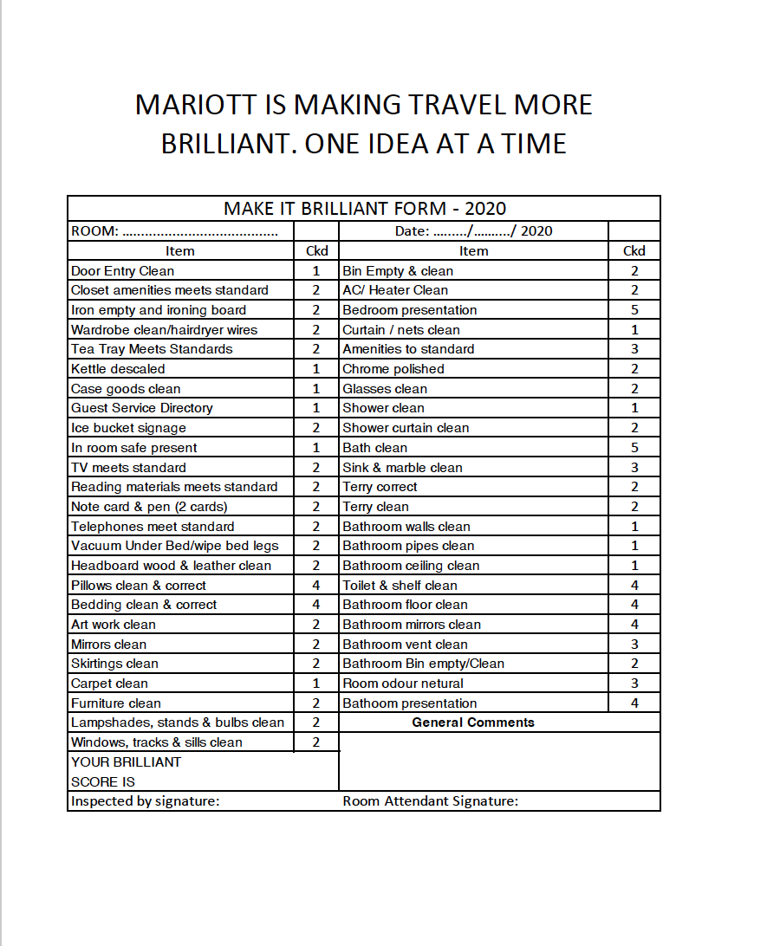
Based on your completed checklist you will need to write 500 words in essay format discussing the following:
- How will you ensure that the rooms are cleaned to brand standards?
- What measures would you introduce to improve team effectiveness?
- Why would you consider your check list to be the most effective?

Within the housekeeping department, consistency is the cornerstone of excellence, as “guests expect the same high level of service quality every time they interact with a hospitality establishment” (Rashid, 2023). This essay outlines a comprehensive room cleaning checklist designed to elevate standards to brand’s expectations, following guestroom complaints reflecting lack of consistency in housekeeping services.

The checklist
To ensure rooms are consistently cleaned to brand standards, this checklist will be tailored to specific requirements of the brand.
Surface Cleaning:
Use approved cleaning agents to ensure surfaces are thoroughly cleaned and sanitized. “By utilizing multipurpose products, […] staff can effectively clean and disinfect in one step, which can […] simplify training.” (Kupneski)
Bathroom Sanitation:
Emphasize the meticulous cleaning of bathroom fixtures and accessories, with special attention to high-touch areas like door handles.
Floor Maintenance:
Specify the appropriate cleaning methods for different flooring types: “Floor cleaning mechanically removes organic soil and dirt that supports bacterial growth.” (Andersen et al, 2009, p. 57-65)
Restocking Amenities:
Establish guidelines for restocking amenities to ensure guests consistently find a well-prepared environment.

Introducing Measures to Improve Team Effectiveness:
To address the issue of consistency within housekeeping, several measures can be introduced:
Training:
Implement regular training sessions to update team on brand standards and the importance of consistency in delivering exceptional guest experiences.
Quality Control:
Introduce a system of regular, thorough inspections conducted by team leaders to identify areas for improvement.
Performance Recognition:
Implement a recognition system to reward housekeepers who consistently meet cleanliness standards, motivating others to excel. “Understanding and addressing factors contributing to job satisfaction for hotel housekeepers is critical for managers.” (Andrade et al, 2020, pp. 90-108)

Why the Checklist is Considered Most Effective:
Comprehensive Coverage:
The checklist covers all critical aspects of room cleanliness, ensuring every room meets the brand’s standards.
Clarity and Detail:
Each item on the checklist is clearly defined, providing specific instructions, which is crucial for maintaining consistency among housekeepers.
Conclusion
Cleanliness and hygiene are of utmost importance in a guest’s decision to return: “Importantly, cleanliness is an essential element considered by hotel customers in their decision-making.” (Shin and Kang, 2020, p. 4) To address the issue of consistency within housekeeping, managers can create a more effective housekeeping team that consistently delivers exceptional guest experiences by implementing regular training sessions, introducing regular quality control inspections, and implement a system to reward team members who meet cleanliness standards is needed.

References

Alessandro Carrara, ‘The importance of good housekeeping’ HotelOwner, 13 December, 2018, Available at: https://www.hotelowner.co.uk/18803-the-importance-of-good-housekeeping/ (Accessed: 10th of November, 2023, 13:15)
Vallen, G. and Vallen, J. (2013) Check-In Check-Out: Managing Hotel Operations, Pearson New International Edition, Pearson Education, Limited, 2013. ProQuest Ebook Central,
Jones, T. J. A. (2007), Professional Management of Housekeeping Operations, John Wiley & Sons, Inc. ProQuest Ebook Central
Alessandro Carrara, ‘The importance of good housekeeping’ HotelOwner, 13 December, 2018, Available at: https://www.hotelowner.co.uk/18803-the-importance-of-good-housekeeping/ (Accessed: 10th of November, 2023, 15:00)
Jones, T. J. A. (2007), Professional Management of Housekeeping Operations, John Wiley & Sons, Inc. ProQuest Ebook Central
Hotel metrics: How to measure performance in the hotel industry, 10 October, 2023, Available at: https://www.siteminder.com/r/hotel-metrics/ (Accessed on the 12th of November, 2023, 18:37).
Rashid, H., (2023) ‘Elevating Customer Satisfaction Through Service Excellence in the Hospitality Industry’, Library & Information Management Academic Blog, 23 September, Available at: https://limbd.org/elevating-customer-satisfaction-through-service-excellence-in-the-hospitality-industry/, (Accessed: 11 November 2023)
Kupneski, M., ‘Cleaning & Disinfecting: The Role of Multipurpose Products in Hotel Cleaning’, Procter & Gamble Blog, Available at: https://pgpro.com/en-us/articles/multipurpose-products-role-hotel-cleaning, (Accessed: 11 November 2023)
Andersen, B.M., Rash, M., Kvist, J., Tollefsen, T., Lukkassen, R., Sandvik, L., Welo, A., (2009) ‘Floor cleaning: effect on bacteria and organic materials in hospital rooms’, Journal of Hospital Infection, (71)1, pp. 57-65. Available at: https://doi.org/10.1016/j.jhin.2008.09.014
Andrade, S.M., Miller, D., Westover, J.H., (2020) ‘Job satisfaction factors for housekeepers in the hotel industry: a global comparative analysis’, International Hospitality Review, (35)1, pp. 90-18 https://doi.org/10.1108/IHR-06-2020-0018
Shin, H. & Kang, J. (2020) ‘Reducing perceived health risk to attract hotel customers in the COVID-19 pandemic era: Focused on technology innovation for social distancing and cleanliness’, International Journal of Hospitality Management, 91, p.4 https://doi.org/10.1016/j.ijhm.2020.102664

