Portfolio.

Ethical Issues.

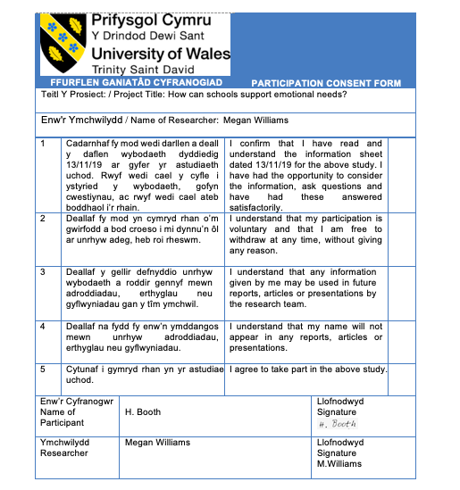
Ethics Form.

Safeguarding Policy and Child Protection Officer.
The Safeguarding Policy is presented below, and it expresses how important safeguarding is viewed by the school. They also list that there are three Child Protection Officer’s (CPO’s), these being the headteacher, the deputy headteacher and a governor. Additionally, as provided in the journal, they have said that there will always be at least one of them there at the school at all times as a safety measure. The leaflet provided states that CPO’s are ‘part of the safeguarding process’ and Lazar (2006, P.1) explains that they are important because they have ‘the authority and the duty to act whenever there is an immediate danger to a minor’ and must ‘use all available means to prevent that danger or provide the treatment’. The leaflet emphasises that CPO’s are a means of promoting the welfare of children and protecting them from any type of harm. Therefore, a researcher must identify the CPO’s within a school setting so that they know who to contact in case they witness anything that causes concern.
According to the Official National Statistics (2019), the proportion of adults in England and Wales aged 18 to 74 who experienced emotional abuse before the age of 16 was 9.3 percent. However, looking at a bigger sample size, the Crime Survey for England and Wales (CSEW cited in ONS, 2019) had ‘estimated that approximately 3.8 million adults aged 18 to 74 years’ within England and Wales ‘had experienced emotional abuse before the age of 16 years’. Furthermore, the ONS (2019) explain that in Wales alone, ‘emotional abuse was the most common category of abuse for the child protection register (CPR)’.

Furthermore, the leaflet provided explains that there is also a School Police Liaison Officer who can be contacted if needed. Quinton and Morris (2008, P.116) explain that they were first ‘introduced as part of the Police Reform Act of 2002’ which was a defining feature of the New Labour Government at the time. As found in Trotman and Thomas’ (2016, P.3) research into School Liaison Officers (SLO), their observations and feedback from interviews shows evidence of the SLO participation in a school environment ‘was perceived as a significant benefit’. This is because, through ‘building mutual trust’ between the officers and the pupils, the relationship enabled the students to ‘feel confident in talking to a ‘known person’ when there was a need to escalate a school issue to police involvement or where advice was needed’ (Trotman and Thomas, 2016, P.3).

Topic Based Information.

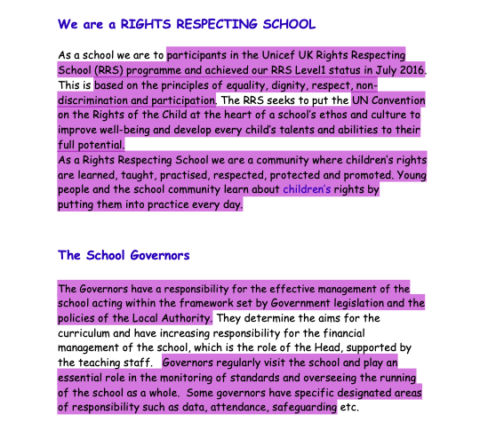
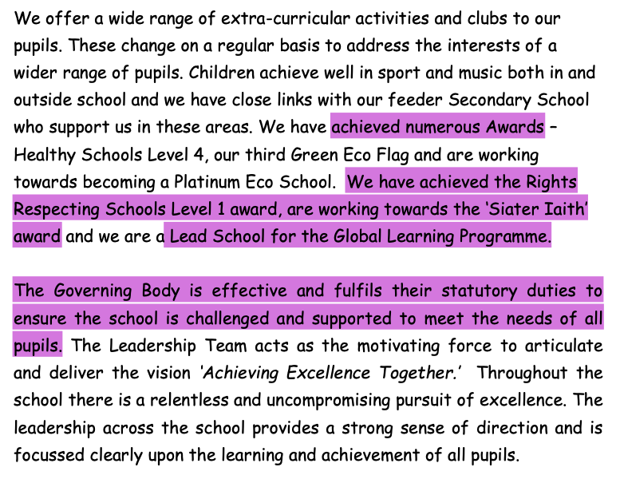
School Prospectus.

Their school prospectus highlights in both pages that they are a Right’s Respecting school and are very proud to have achieved the first level. The United Nations Convention on the Rights of the Child (UNCRC, 2018) created the Rights Respecting School (RRS) programme to encourage children to feel secure and respected at their school so that they can become ‘engaged with their local community’ and ‘enjoy supportive relationships’ with the school staff. The UNCRC (2018, P.2) believe that ‘a rights-based approach underpins school culture, ethos, practice, policy and environment’ and therefore, can have a beneficial impact once implemented. Once completing the bronze, silver and gold awards, the UNCRC (2018, P.2) claim that the pupils will have achieved a range of positive outcomes such as ‘knowing about their rights and support the rights of others locally and globally’ and will be happier and feel safer at school which in turn, results in the children being more ‘engaged in their education’. To add to this, in their research, the UNCRC (2018, P.7) found an increase of five percent in pupils saying they feel happy with themselves since the RRS programme commenced. They believe this increase occurred due to the programme ‘promoting the values of respect, dignity and non-discrimination’ which leads to the pupil’s self-esteem and wellbeing being boosted as ‘their sense of self-worth is strengthened’ (UNCRC, 2018, P.7).

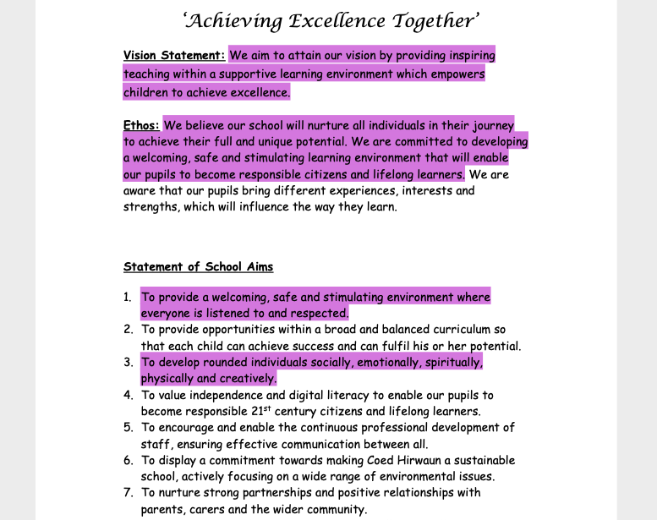
Here is the school’s motto and the description of their school’s ethos in which they emphasise the importance of recognising a child’s emotional wellbeing so that they can achieve their full potential.
As cited in Bragg (2011), Education Minister at the time, Michael Gove expressed ‘for a school what matters is not its intake, but its ethos’ and the reason for this is because an ethos is able to ‘justify greater attention to the emotional climate of schools, to non-cognitive, emotional and social learning and other important aspects of schools work that may not be reflected in test scores’.
Additionally, through the curriculum created by Sir Donaldson (who also created the new Welsh curriculum which will come into effect in 2022), the Scottish Government (2018) found that creating a ‘positive school ethos and culture is essential to developing good relationships and positive behaviour’ not only in the classroom but also the playground as well as the wider community. The Scottish Government (2018) believes there is a ‘strong link between perceptions of ethos and behaviour’ and is a ‘key determent in promoting social and emotional well-being and mental health for all in schools’. The reason for this is because they found that when a child’s ‘achievements and contributions are valued and celebrated’ (Scottish Government, 2018), they felt included, accepted, secure and respected which is why a school’s ethos is essential. To support this, Meece (2003, cited in Bragg, 2011) ‘reported more positive forms of motivation and academic engagement’ when pupils felt their teachers were enforcing child-centred lessons that supported them.

Estyn Report.
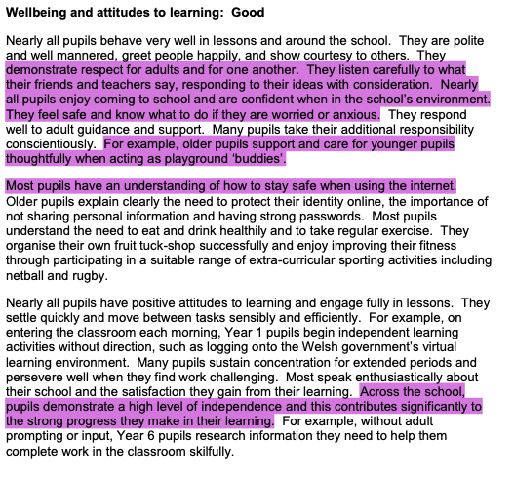
Here it shows that the pupils at the school are confident and understand who to speak to if they feel upset or distressed. For example, Estyn (2018) refers to the use of the school ‘buddie system’ which according to the Derbyshire Community Health Services (2019), is when the older pupils at the school look out for younger pupils who may need help or a friend to play with. The Buddy has a specific role ‘to encourage and lead pupils to play together during breaks’ as well as have the ability to support their peers though ‘mediation skills, peer listening and buddying’. The Buddy will always be supported by a member of staff whose responsibility is to ensure that they receive training and help them raise awareness of the scheme through allowing them to advertise though posters and assemblies. The Better Buddies Foundation (2019) believes the system teaches and provides children opportunities to practise important values such as ‘respect, care, friendship and including others’ as well as developing their emotional well-being. This is because the younger pupils will feel a sense of security and it is likely to help develop their social skills as they begin to feel more confident and content in the playground environment whereas the older children will develop ‘skills associated with empathy and compassion through activities in the classroom and in the playground’ (Better Buddies Foundation, 2019) which in turn, can help combat bullying as a result of the safer environment.
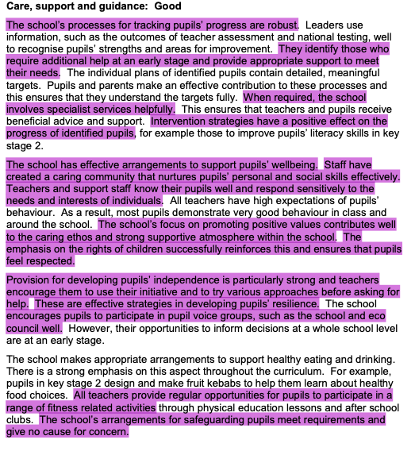
Tracking children to idenitify their needs can be done through niggle notes which is frequently used within this school and was discussed within the journal article created alongside this portfolio.

As a reminder, the Children’s Commissioner (2012) explain that niggle notes is a form used by practitioners to write about any incidents in which they feel there is a concern about a child. The practitioners will then store the notes safely and monitor the child to identify their needs to that there can be ‘early allocation of school resources’ (Children’s Commissioner, 2012) such as councelling.

Clark and Jha (2013, P.2) believe that early allocation is extremely important for students because they claim it ‘has clear links to educational outcomes’. This is agreed by the Welsh Government (2013) who as a result, state in their document that ‘Some local authorities are encouraging greater autonomy’ for schools ‘by delegating services’ so that each school can respond ‘to the needs of individuals’ (Clark and Jha, 2013, P.2) within the school at the given time. Additionally, the National Society for the Prevention of Cruelty to Children (NSPCC, 2020) states that tecahers should be able to identify anything that causes concern, even if the child doesn’t verbally express anhthing as there can ‘be other indicators that something is wrong’. For instance, children may disclose things indirectly through a change in behaviour or drawing pictures. Therefore, this is why the practitioner needs to build a rapport with the child and use the school’s system of niggle notes to refer back to so that they are able to see the bigger picture of what’s going on with the child. If a practitoner fails to notice these incidences, it can result in the child’s mental health being put at risk as they will experience feelings of shame and guilt leading to depression as the child gets older, lessening their chances of achieving their full potential.

Research from Journal Articles; Meditation and Growth Mindset.
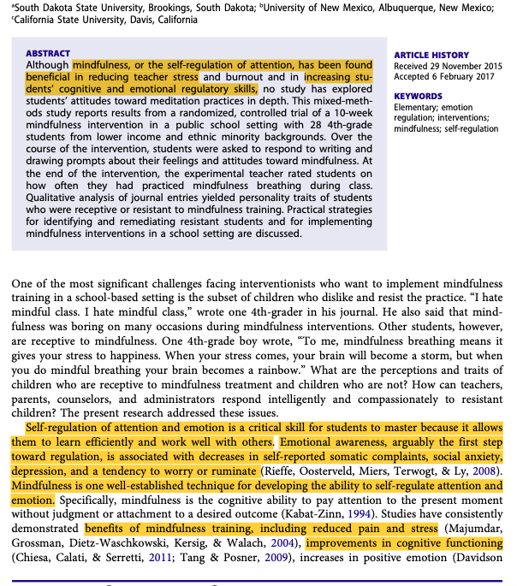
Meditation is also supported by the Welsh Government who plan to use this strategy throughout the new currciculum in 2022. According to the Mindfulness in School Project (MISP, 2019), this is because it will ‘provide a foundation’ for children as they go through changes within the school environment and will also encourage ‘kindness and compassion, to others as well as to self’ which will hopefully result in better ‘communication and collaboration’ throughout the school. Mindfulness will be implemented throughout the Areas of Learning Experiences and also ‘embedded throughout the school ethos to support the four purposes’ (MISP, 2019). For example, it can help with the development of the fourth purpose which is ‘healthy, confident individuals, ready to lead fulfilling lives as valued members of society’ as mindfulness can teach children how to handle challenges they face on a daily basis as it has the potential to have a beneficial impact on the child’s ‘sleep, relationships and anxiety’ (MISP, 2019). It is believed by MISP (2019) that mindfulness can improve mental health and promote wellbeing and resilience’ and should be established through the Welsh curriculum ‘as part of a lifelong toolkit’ to enable children to become confident and emotionally resilient.

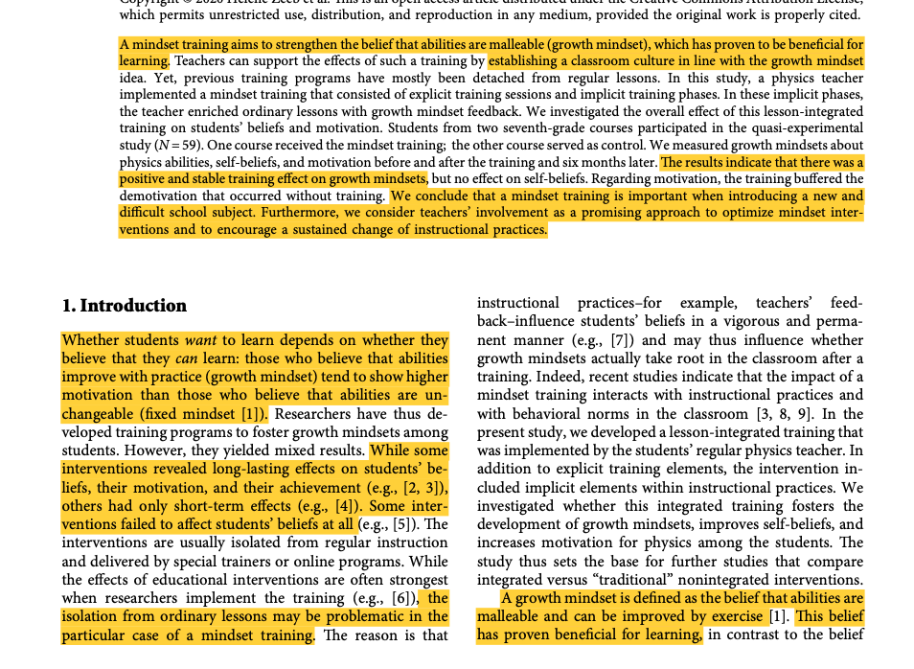
As explained by Romero (2015, P.2), growth mindset is the ‘students’ beliefs about intelligence have important consequences for how they experience school and how they respond to setbacks and adversity’. Many students may feel as through the school environment can be daunting and therefore, hold themselves back due to their anxious thoughts getting in the way. Romero (2015, P.2) states that once a child can achieve a growth mindset, they will view their school experience as a place where they can explore opportunities and embrace challenges. Attaining this mindset can be crucial for students as having a fixed mindset can result in responding through behaviour such as ‘deceased effort’ and feelings of ‘helplessness’ and giving up on their work. Breaking this down further, Romero (2015, P.2) believes that the mindset is the foundation to a child’s future as it leads to a ‘psychological interpretation’ such as feelings of stupidity (fixed) or feeling excited at the opportunity to try new methods (growth), leading to the ‘behavioural response’ such as withdrawal for someone with a fixed mindset which in turn, will affect their ‘academic outcome’. Romero (2015, P.2) states that a really simple way to implement growth mindset is by the practitioner focusing their ‘praise on process rather than ability’ which can be done by congratulating the child when they try a new or a range of methods to get an answer.

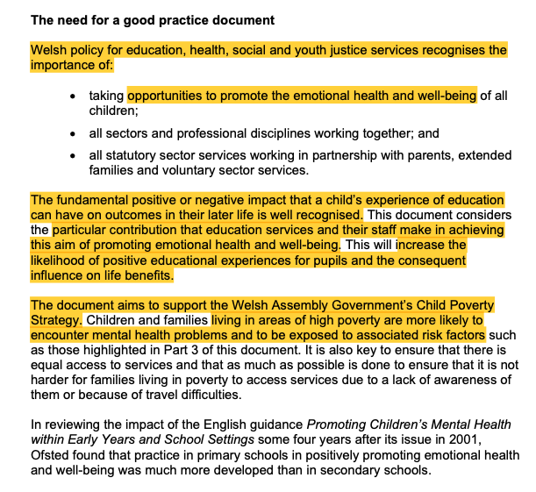
These two strategies have the potential to impact a child’s emotional wellbeing and this is highlighted in the Welsh Assembly Government (2019) document which was featured in the journal article. This Document states that a child’s state of emotional wellbeing can affect them later on in life, especially for vulnerable children such as those who may come from socially disadvantaged backgrounds. This is supported by the report conducted by the ONS (2015) who reveal that ‘one in eight children aged ten-to-fifth-teen’ within the year 2011 to 2012, had symptoms of mental-ill health and the main factor which contributed to this was bullying. ONS (2015) revealed that when this occurred frequently, the child was ‘four times more likely’ to report symptoms of mental-ill health, ranging from anxiety to depression. The reason why these statistics are important is because research conducted by the World Happiness Report (2014) claim that ‘mental health problems such as depression can be more disabling than physical problems such as arthritis or asthma’. Therefore, this is why practitioners such as teachers, have a duty of care to prevent this from happening. Teachers usually see pupils nearly every day of the week making them a very influential person in that pupils’ life which is why having these strategies put in place throughout the curriculum is key to securing a child’s emotional wellbeing.

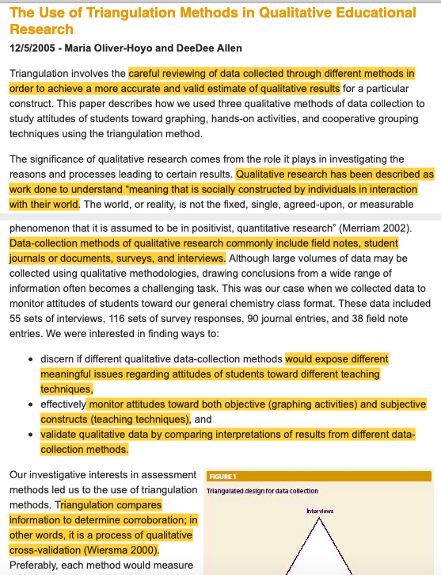
Methodological Approach.
Throughout this research, triangulation was achieved by conducting observations, interviews, desktop research such as government policies and also looking at theoretical perspectives such as Bowlby’s attachment theory and Bronfenbrenner’s Bioecological model. This was stated within the journal article and was done because triangulation aims to achieve a greater accuracy. Triangulation is usually used in qualitative research and as defined by Cohen and Manion (1986), is the ‘attempt to map out, or explain more fully, the richness and complexity of human behaviour by studying it from more than one standpoint’ which occurs due to the researcher using an ‘alternate perspective to validate, challenge or extend existing findings’.Holland (2009) also encourages triangulation as he states, ‘the problem with relying on just one method is to do with bias’ and therefore claims that the triangulation method can help minimise this due to comparing results from each method.

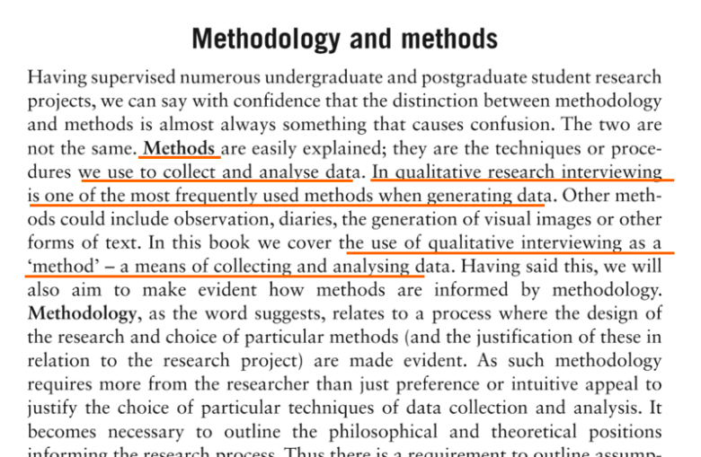
Additionally, semi- structured interviews are increasingly popular among research as found within the journal article highlighted. This is because it can give a greater understanding. Barriball and While (1994, P.323) explain that when conducting an interview, it’s important to remember that it takes up time and is ‘impractical to attempt to interview every’ person involved within the research, however, since this research only allowed me to interview adults, this limited my options and I settled with interviewing the class teacher as I felt that she could give a better insight to what my questions were as she communicated and guided the children I observed every day. Furthermore, Barriball and While (1994, P.323) comments that interviews give the researcher a chance to use probes which can be a ‘valuable tool for ensuring reliability of the data’ as it enables the ‘interviewer to explore and clarify inconsistencies within respondents’ accounts. Barriball and While (1994, P.323) emphasises that getting the respondent to participate in an interview may be hard and should be told that they can withdraw from any moment however, they stress that the ‘quality of the information obtained during an interviewer is largely dependent on the interviewer’ which is why the researcher must try to control the environment by making it a clam and friendly atmosphere by building a rapport with the participant to help obtain the results.

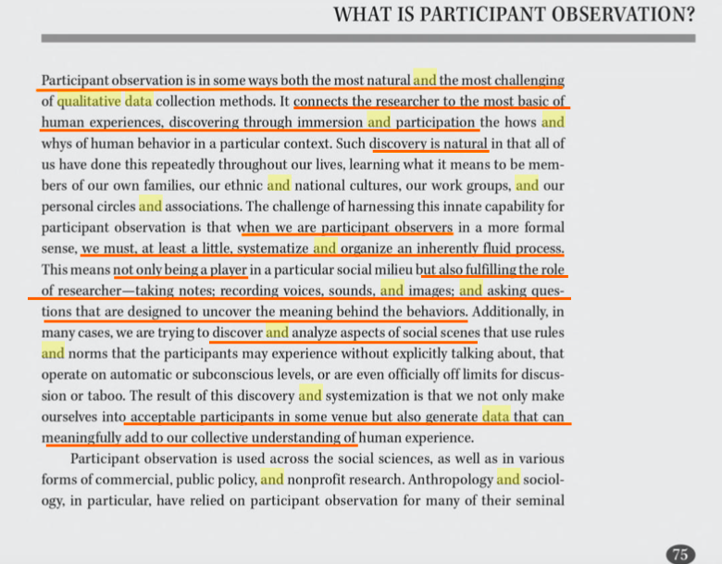
Unstructured observation is also a popular method to conduct research and Price (2010, P.3) explains that the reason for this is because the aim of the method ‘is to obtain a snapshot of specific characteristics of an individual, group, or setting’ and can be done in various ways. Observation can be beneficial as it puts the ‘researcher is in a much better position to understand the viewpoint and experiences of the people they are studying’ (Price, 2010, P.3). The researcher must try to ensure that the participants are being natural as the presence of someone new can often result in the participants acting differently however, Price (2010, P.3) notes that ‘people often become used to being observed and with time they begin to behave naturally in the researcher’s presence’ making the results high in validity.

BERA.
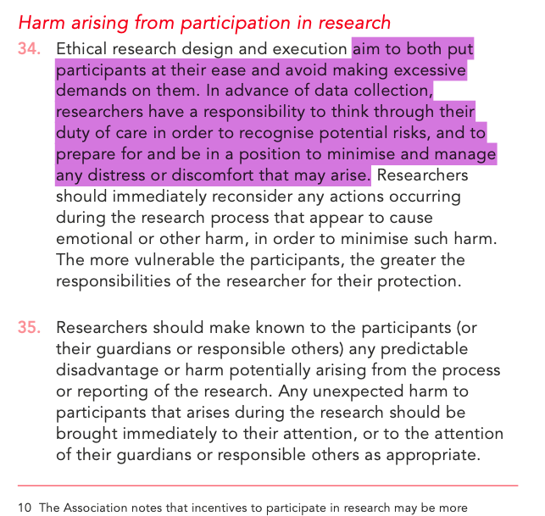
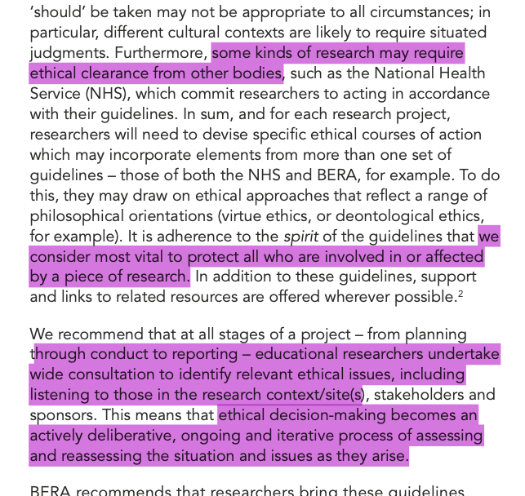

As written above, every researcher must consider the ethical issues and mitigate any harm or risks that could occur, one way of combatting this is identifying the CPO’s of the research place which has been discussed briefly.
Ramrathan, Grange and Shawa (2017, P.432) states that ethics has now ‘become a central issue in educational research’ and as a result, ‘regulatory frameworks and regulatory bodies have been established to manage and approve’ a research before it’s conducted. Ethics can be ‘associated with morals’ (Ramrathan et al. 2017, P.432) and is closely linked to human rights, this is why BERA (2018) mentions that the researcher must also follow the UNCRC (2018) articles to ensure the safety for the children who may be involved. Ramrathan et al. (2017, P.432) references Kant who view on ethics as being a duty of care and that researchers must ‘act in ways that show respect to other human beings’ whereas Aristotle, who he also refers to, perceives ‘ethics as a disposition’ and that the researcher must possess traits such as ‘justice, generosity and honesty’ during the research.

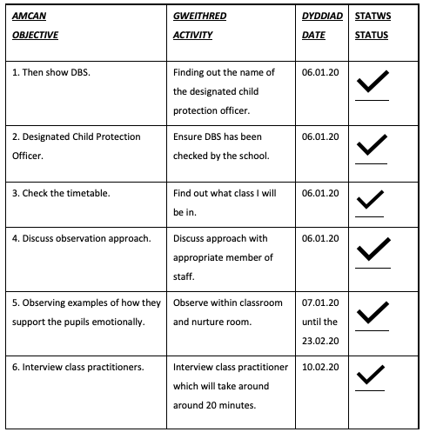
Action plan.

Reflective Diary and Observation Notes.

Day One: 07/01/2020.
On this day I observed the pupils working in pairs in which they had to remember what the other person had told them, and then reveal it to the class which implemented communication and listening skills. On this day, they also started their new topic for ‘Author Skills Week’ based on Roald Dahl books which they had been reading. They then had to work in pairs again to create a fact file using mind maps they would later need to use for their future work. They also did the same thing later on in the day for their ‘topic’ for the semester which was the Victorian era. This is important to note as a lot of the observations after this day based on the Victorian era had emotional wellbeing implemented throughout it.
As this was the first day, I felt nervous and out of my comfort zone however, I do feel as though it went well as I was able to establish a positive relationship with the staff and the pupils resulting in them feeling comfortable and acting natural. Before the pupils arrived to the school and throughout breaktimes, the class teacher would explain to me what she was about to do and the aims for what she wanted the children to achieve. This gave me a better insight on how to make a general lesson plan individualised for each child to meet their needs.

Day Two: 13/01/2020.
On day two, the children started to look at the timeline of the Victorian era. And had to research certain events to add to their own timeline. Another interesting activity I observed was during assembly in which they gave out awards. This stood out during my observation because not only did they give out awards for academic achievements but also how the children acted towards others such as helping someone else with their work if they were struggling. This emphasised to me how important the school values the emotional wellbeing of their pupils and this is clearly proved with their explanation of the school’s ethos which has previously been discussed in this portfolio.

Day Three: 15/01/2020.
At the end of this day, I observed the ‘Talk About’ session which included four students of various ages to help support them develop positive relationships with their families and friends. During the session, the teaching assistant (TA) had planned for the pupils to play trump cards which had scores for personality traits such as ‘honest’ and ‘funny’. Each student could change their card as many times until they felt happy and once everyone settled on a card, they all discussed their scores and why they chose it. For example, most revealed that they would look for the highest score for being honest over the other traits. The TA would then probe and ask for an example of how being honest or funny is an important quality to have and would emphasise throughout that there is no right or wrong answer and that should express how they feel. They would then do this again and it appeared that the students would look for a card which had balanced scores for each trait rather than looking for a high score in the ‘honesty’ category as their view of importance had changed.

Day Four: 21/01/2020.
During this day, I observed the class sitting together on the carpet to discuss and debate using argue and debate cards. The teacher informed them that they would do this in smaller groups and that there would be pupils on different sides. They first went through an example such as ‘homework should be banned’ and students had to put their argument forward in a polite manner and sometimes had to argue for homework to not be banned even though they personally thought differently. This helped teach them empathy, communication and being respectful towards their peers.
I also observed roleplay during an English lesson where groups were given a choice of scenarios in which they had to choose one to act out. They were all given a word mat which included a range of emotions such as ‘ecstatic’ which they needed to include as many as they could to fit the scenario. At the end of each performance, the teacher would probe the class with questions such as ‘did you feel sorry for this character?’ and have the class discuss what words the group used and how they used it to create effect which helped everyone in the class progress their emotive language skills.

Day Five: 27/01/2020.
This is when they started doing meditation for twenty minutes and this would be done every Friday morning onwards, the teacher talked the children through what was about to happen and would help them visualise when they were meditating, they were also told techniques such as placing one hand on their stomach to feel their breathing or holding onto a stone to help ground them.
Additionally, based on their Victorian work, the children had gone to Big Pit on a day I weren’t there to experience the coal mines and what life was like. On this day, they then had to create a recount using bullet points under each photo of them at the visit explaining what was happening and what their guide told them. This was used as a base for writing up paragraphs the next day. Building on this, in the afternoon they then had to research and build a profile on the life of a child growing up and working in the coal mines, they and to research the type of jobs children would do within the coal mine, how much they would earn and also had to write about what the child would be feeling such as scared, hungry and claustrophobic.

Day six: 28.01.2020
This day was mostly the same and was used to research further and finish any pieces of previous work as the afternoon was used for a fire brigade visit who taught the children about safety and also covered how they have the right to safety.

Day Seven: 03.02.2020
This day included an activity where the children had begun to look at the artwork created by Welsh artist Nicholas Evans whose work was heavily influenced by the coal mines. The teacher presented four or five artwork pieces and had the class discuss and debate what they thought was going on and how they thought the people and animals would have felt. The teacher also probed during this discussion by asking ‘what is he trying to convey?’ and “what does it make you feel?’ and again, emphasised that there is no right or wrong answer, creating a comfortable environment. Each child then had to choose one artwork and try to copy it themselves and was reminded by the teacher that they too, had to convey emotions which could be done through the droopy eyes, wrinkles and the shading.

Day Eight: 10.02.2020
This day was mainly used for the artwork however, they had to draw the same picture again but using charcoal to go with the theme and would be put in a frame for the school’s art exhibition. This was also the day which the interview took place, it was after school and lasted around twenty minutes.

Day Nine: 11.02.2020
During English, they had to create a recount of the life of a Victoria school child by creating a word map again to refer to and then acting it out in groups to install the new vocabulary and help them understand how to perceive certain emotions.

Day Ten: 23.02.2020
This was the last day and was also the beginning of the schools ‘Welsh Week’ therefore I observed Welsh activity where… although this may not fit into my research at first glance, it actually shows that they were teaching the children to improve on their conversation skills and gain it was about asking how their friend felt and would create expressions for each emotion to solidify learning the new language. Making this engaging and teaching children that there’s no stigma about talking about emotions.

To conclude this, reflecting back on my experience I’m definitely happy with my choice of subject and that it was conducted in a formally manner. I do wish that I could have interviewed less questions but included staff such as the TA who ran the Talk About session to achieve a better understanding however, on a positive note, I do feel as though I have gained and improved on skills such as observation and researching which is highly important for those who work within an education setting. The reason why it’s important to reflect back on a research project is explained by Balanovskiy (2018, P.75) who refers to Kant’s definition of reflection being ‘the state of mind, which serves as the basis for all findings’ and claims it can used ‘as a tool for differentiating between, analysing and comparing’ (Balanovskiy, 2018, P.75) materials within a research task which as a result, can help the researcher gain a better insight and improve their skills as they should examine not only their results but also their actions throughout the process.

Wordcount: 4352.

Reference List:

Ashokan, V. (2014) ‘Thematic Approach for Effective Communication in Early Childhood Education’ 3rd Edition. International Journal of Education and Psychological Reseacrh. P. 49-51. DOI: https://www.researchgate.net/publication/289868193_Thematic_Approach_for_Effective_Communication_in_Early_Childhood_Education

Balanovskiy. V. (2018). ‘ What is Kant’s Transcendental Reflection?’ World Congress of Philosphy. P. 75. DOI: https://www.researchgate.net/publication/326377298_What_is_Kant's_Transcendental_Reflection
Barriball and While (1994) ‘Collecting data using a semi-structured interview: a discussion paper’ London; Journal of Advanced Nursing . P.328-332 DOI: https://s3.amazonaws.com/academia.edu.documents/34291860/Barriball___While_1994_Collecting_data_using_a_semi-structured_interview_JAN.pdf?response-content-disposition=inline%3B%20filename%3DCollecting_data_using_a_semi-structured.pAmz
Better Buddies Foundation (2019) ‘Benefits to your Child’. Available at: https://www.betterbuddies.org.au/bb-parents/benefits-to-your-child.phps . (Last Accessed: 27.04.20).
Children’s Commissioner (2012) ‘Outstanding Practice in Primary Schools: Practical Tips for Schools’. P.11-12. Avaialable at: https://dera.ioe.ac.uk/15496/2/Practical_Tips_You_Have_Someone_to_Trust_Final_Sept_2012%5B1%5D.pdf (Acessed: 02.05.20).
Clarke, D. and Jha, N. (2013) ‘Educational Achievement and the Allocation of School Resources’. P.2. DOI: http://conference.iza.org/conference_files/ESSLE2013/cobb-clark_d77.pdf
Cohen, T. (2012) ‘Triangulation in Practice’. Journal for the School of Computing. P.1. DOI: https://www.napier.ac.uk/~/media/worktribe/output-220012/triangulationpdf.pdf (Accessed: 30.04.20).
Holland, J. (2009) ‘Practical Triangulation’ Available at: http://johnnyholland.org/2009/08/practical-triangulation/ (Accessed: 01.05.20).
Lazar, A. (2006). ‘Determinants of Child Protection Officers’ Decisions in Emergency Situations: An Experimental Study’. Israel: Springer Science and Business Media Inc. DOI: 10.1007/s10566-006-9013-z, P.1-2.

MISP (2019) ‘Mindfulness as part of the Curriculum for Wales 2022’. Available at: https://mindfulnessinschools.org/mindfulness-as-part-of-the-curriculum-for-wales-2022/ (Acccessed: 30.04.20).
NSPCC. (2020) ‘Recognising and Responding to Abuse’. Available at: https://learning.nspcc.org.uk/child-abuse-and-neglect/recognising-and-responding-to-abuse (Accessed: 01.05.20).

Official National Statistics, (2015) ‘Measuring National Well-being: Insights into children's mental health and well-being’. Available at: https://www.ons.gov.uk/peoplepopulationandcommunity/wellbeing/articles/measuringnationalwellbeing/2015-10-20 (Accessed: 01.05.20).

Price, P. (2010) ‘Observational Research’ London; Journal of American Psychology.P.3. DOI: https://opentext.wsu.edu/carriecuttler/chapter/observational-research/

Ramrathan, L., Grange, L. and Shawa, L. (2017) ‘Ethics in Educational Research’ P.432-440. DOI: https://www.researchgate.net/publication/312069857_Ethics_in_educational_research
Romero, C. (2015) ‘What We Know About Growth Mindset from Scientific Research’ P. 2. DOI: http://mindsetscholarsnetwork.org/wp-content/uploads/2015/09/What-We-Know-About-Growth-Mindset.pdf
UNCRC (2018) ‘Creating Active and Engaged Citizens’. UNICEF. P. 2-7. Available at: https://www.unicef.org.uk/rights-respecting-schools/wp-content/uploads/sites/4/2019/07/Impact-Report-2018_Final-170719.pdf (Accessed: 30.04.20).
Welsh Assembly Government, (2013) ‘The Future Delivery of Education Services in Wales’, p.7. DOI: https://gov.wales/sites/default/files/consultations/2018-01/130621-delivery-of-education-report-en.pdf

