Student: Shaera Miah
Student Number: 1711954
Assignment Title: Knowledge and
Information management skills
For the workplace
Module title: BMSK5006
Lecturer: Dr MD Nazmul Hasan

(1) Explain why the same set of data can be considered as useful information by some and useless data by others. Further, could this useful information can be termed as “knowledge”? Why?
It can be termed as knowledge it can applied to everyday practice and can be relevant. When data is processed to information, it becomes interpretable and gain significance. Data as a general concept refers to the fact that some existing information or knowledge is represented or implied in some form suitable for better usage or processing. For some organisation is useful but for other data might not be useful because their type of business might be totally different to theirs, they might use their data in a different way that run their business, for example their organisation culture and structure are different.
Similarly, useful data is something like my credit card details which are very valuable because these information is important to me but useless to others whereas the information’s won’t be able to accessible also it is illegal and therefore this part of information becomes tacit information because this part is only for me to know and not be explicit information (not shared).
Some organisation think data is pointless without the skills to analyse it. According to Harris (2012) stated that the appearance of the huge information implies breaking down unstructured is going to progressively frame some portion of everybody's work. Supervisors and business investigators will all be called upon more regularly to oversee information driven examinations, to make an interpretation of information, and to create development information-based item and administration.

- Describe the ways in which “knowledge” differs from “data” and “information.” Justify your answer with a relevant diagram.

Knowledge refers to the comprehension and understanding regarding the matter obtained from training or experience of an individual. It very well may be applicable and target data that helps in reaching determinations. Then again, data speaks to the sorted-out information about somebody, or something acquired from different sources, for example, paper, web or dialogs.
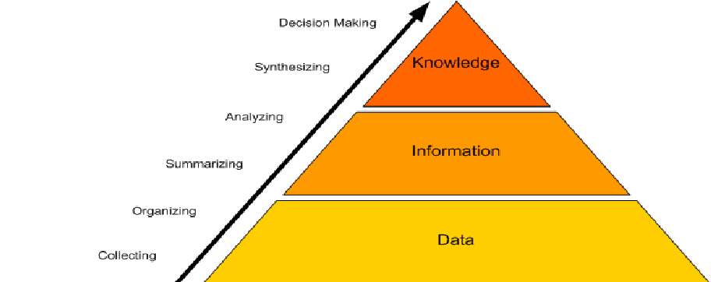

- Does a player in a card game use tacit or explicit knowledge? Explain why. Define and explain the difference between the two.

Tacit knowledge is knowledge that’s difficult to write down, visualise or transfer from one person to another. Tacit knowledge has been placed in human mind through experience and jobs, involves a lot of human interpretation. Tacit knowledge is a form of knowledge that cannot be easily verbalized or otherwise explicated, as indicated in the statement knowing more than one can tell’’. For example, the response to ‘’ how do I learn to ride a bicycle, that cannot be accurately classified in to a set of complete sentence. Learning to ride bicycle requires basic theoretic knowledge of cycling and it requires specific amount of time for individual to get hold of it. Lam (2000) states that our understanding of the nature of the links between tacit knowledge and organisational learning however has been hampered by the lack of a theoretical framework participating micro-level learning activities with organisational forms.

Smith, E. (2001) states that explicit knowledge is created on academic achievement which is underutilised. Explicit knowledge consists of facts, rules, relationship and policies that can be accurately can easily transferred. Explicit knowledge is knowledge that us digitised in books, documents, reports, memos and is easily identified; articulated, shared and employed. This links to according to what Wyatt, J. (2001) had specified. He acknowledged that in an organisation such as NHS, much of the medical progress has been attributable to an evolution from tacit and explicit knowledge and its sharing by other groups including patients and the public. At times it can become a problem while combining both tacit and explicit in workplace, were two professional might have two kinds of knowledge to two kinds of problem and two knowledge management plans.

However, we learn while we play games such as card games – how much information player retain and what type of information it is, therefore it depends on type of game that will be played. experience player or they maybe new or an expert. Tacit knowledge will be applied if they are plying a game that consist of only information’s that should be known to the player and not to others. For example, a card game like’’ solitaire’ if it was made explicit then the information would become known to other players and would be playing totally different card game.
Solitaire is a card game that is played by only one player. And the plyer knows all the rules of the game it requires a standard deck 52 cards to play. the goal of the game is to move all of the cards to foundation theses are four additional stacks of cards

- Consider five decisions you have made today (they could be simple such as taking a turn while driving or even choosing a soda at a convenience store). In each case determine the data, information, or knowledge that were involved in the decision.

- I’ve decided that, I’m going to visit my friend, she lives quite distance away. To see her, I will need to drive to her house. Data is the car, information is to choose the best route and the directions on the sat nav. Knowledge is I will then need to follow the direction of sat nav to drive to a chosen destination.

- I’ve decided that I’m going to travel by train to London from Birmingham train station. Data is the information screen that I will look at it first. Information is that I will have to see at what time the next train to London is and which platform I will need to wait and which route it will take. The knowledge is that I need to collect my ticket, and get to the right platform, the whole process of that is knowledge.

- I have decided that, I’m going to shopping at Tesco store. Data is the shopping, information is the shopping list that contains which different items I am going to buy and then I need to collect a trolley to place all the items in. Information is I need those things e.g. for lunch, dinner, party, family gatherings. The whole process of that would be knowledge.

- I’ve decided that I’m going to email a friend, data is the email address, information is that I have send an email to my friend. Knowledge is that I knew how to use the internet to send this email and who to send the email and how to use email address.

- I’ve decided that I’m going to order a pizza online. Data is all the pizza company. Information is the menu, the list food and choose what to eat. Knowledge is the food items, I’m going add to the bag, set the delivery time, pay and then wait for food to deliver.

- Now consider how those decisions would have been influenced by the lack of pre-existing data, information, or knowledge.

- The first decision was to visit my friend by driving to her house. However, I may face various problems e.g. if they sat nav doesn`t work, I might take the wrong route or exit on the motorway; there could be road work going on the planned route or it may be closed. Another inconvenience I may face is that my car might break down on the way and I would call a breakdown service and take alternative to reach my destination, as a result.

- Mobile apps and site are easier while ordering food, faster and customer can have their own choice of topping, along with that customer will have receive a free side with every main meal, discount and offers too. At times problem might occur such as issue with the mobile website postcode finder which might lead to orders not going through in time or they might place different order by accident, which may lead to disappointed customers.

- While shopping at Tesco store, items that I need may not be in stock or the item I want is damaged or has expired. In addition, to that some staff may seem unapproachable by customers and have negative behaviour having an impact on customers. There also be a lack of customer service resulting in the customers to leave the store.

- Due to lack of data, information and knowledge, the train might be delayed, when collecting ticket, the machine may not be working. In addition, if a mobile ticket is made, phone might be out of battery; or if urgent work has come up, I might miss the train.

- When emailing someone, a problem might occur, at times messaging tools can mess things right up, for example I might have lost my friends email address or may accidently send email to a wrong person; something might go wrong with email account that stops me from receiving email from friends, colleagues and agents.

6. You have recently invented a new product. Collect demographic data from a sample population, determine how you would use this data, and convert it into information and possibly knowledge for promoting the product.
I have created a brand-new makeup line, which includes products such as foundation, concealer, lipsticks. I am going to promote this brand by collecting information from demographic data. I must use promotional analysis to collect demographic data.
Using information from those who are already using my products, I will be using this data to determine the characteristics of the audience I will be targeting. I will be using Instagram and snapchat to publicise my makeup line, as they are the most popular social networks worldwide. Setting up business pages on Instagram, Facebook and snapchat, I can see who is interacting with my social accounts even if they are not customers, existing and new customers, what posts they like and which other profiles they follow. I will also set up a snapchat profile and set up ads as mostly the young generation use snapchat. Setting up a public profile, I can use the analytical tools such as Snapchat insights and track my key metrics involving: detailed views over the last week, months and so no, viewer demographics and competition rates. Through these business pages, I must post entertaining content for instance creating makeup tutorials and listing the products used in each video, to influence the audience to buy them. Through insights and key metrics, I can create new content for the audience and use different promotional methods to influence customers to make purchases for example, selling makeup on sale or providing items with a free gift.
I will also be carrying out a short and quick survey about 3-5 questions during customers shopping order but not too long as this can annoy customers. When creating my data base, I will have to consider the age – mostly females also males are interested in makeup around the ages of 13 – 30 years. However, nowadays people of different ages whether it be young or old, are only appealed to different makeup items. This will also determine what life stage they are in. I will also have to consider the location and time zone – I will turn this into knowledge and decide which geographic areas to target, assisting me to figure when it is best to schedule my social ads and posts to ensure best visibility.
To move further, I can look at what my competitors are up-to which can show me if the competitors are going after the same market segment as I am or how they are positioning themselves.
After collecting a demographic data from a sample population, I have created a bar chart to show what percentage of people liked and which product they bought the most.

Number of People

Reference list
Al-Qdah, M. and Salim, J. (2013). A Conceptual Framework for Managing Tacit Knowledge through ICT Perspective. Procedia Technology, [online] 11, pp.1188-1194. Available at: https://doi.org/10.1016/j.protcy.2013.12.312 [Accessed 13 Oct. 2019].
Baumard, P. and Wauchope, S. (1999). Tacit Knowledge in Organizations. 1st ed. SAGE Publications.
Cairó Battistutti, O. and Bork, D. (2017). Tacit to explicit knowledge conversion. Cognitive Processing, 18(4), pp.461-477.
harris, j. (2012). Data Is Useless Without the Skills to Analyze It. [online] Harvard Business Review. Available at: https://hbr.org/2012/09/data-is-useless-without-the-skills [Accessed 8 Oct. 2019].
Walker, A. (2017). Tacit knowledge. European journal of epidemiology, [online] 32(4), pp.261 - 267. Available at: https://be6rg4tf5u.search.serialssolutions.com/?ctx_ver=Z39.88-2004&ctx_enc=info%3Aofi%2Fenc%3AUTF-8&rfr_id=info%3Asid%2Fsummon.serialssolutions.com&rft_val_fmt=info%3Aofi%2Ffmt%3Akev%3Amtx%3Ajournal&rft.genre=article&rft.atitle=Tacit+knowledge&rft.jtitle=European+journal+of+epidemiology&rft.au=Walker%2C+Alexander+Muir&rft.date=2017-04-01&rft.eissn=15737284&rft.volume=32&rft.issue=4&rft.spage=261&rft_id=info%3Apmid%2F28501907&rft.externalDocID=28501907&paramdict=en-UK [Accessed 13 Oct. 2019].
Wyatt, J. (2001). 10. Management of explicit and tacit knowledge. Journal of the Royal Society of Medicine, [online] 94(1), pp.6-9. Available at: https://journals.sagepub.com/doi/10.1177/014107680109400102 [Accessed 13 Oct. 2019].

Student Name: Shaera Miah
Student Number: 1711954
Module code: BMSK5006
Assignment Title: knowledge and information Management skills for the workplace
Lecturer Name: Dr Md Nazmul Hasan

(1) Describe how the overall approach adopted by American Airlines incorporated the basic competitive strategies of cost leadership and product differentiation.
The American Airline adopted the SABRE’s framework which was unique part of an American airline, launched online exchange. It permitted to replace the hand-written arrangement to digital approach of the 1950s with the online between airline reservation framework during the 2000s. SABRE was worked to reduce the expense of making aircraft seats reservation, which lead to make the airliner become cost efficient.
SABRE interest expanded in view of adding capacity of essential to trip specialists (for example discovering low charges). It additionally extended reservation service to include hotels and rental vehicles. In 1988, the organization offered service for yield management and team planning a large group of choices to help implement.
Cost leadership
American airline jump to the opportunity to take on board and apply the design of SABRE to reduce the cost of American airline seat reservation. It announced that it had a saving of thirty percent on its investment. American airlines were the first to adopt to this type of technology to compete with other airliners.
Product differentiation
Worldwide airliners progressively looked for more developed and advanced technology in the late 80s and other company launched similar online system it was faster. customers had additional choices and it made customers difficult to make a choice. Yet, actually the idea of making new aircraft consumers incentives stays in its onset; airliners and other travel organizations are as yet exploring the difficulties of deciding how to carry increasingly separated traveller encounters.

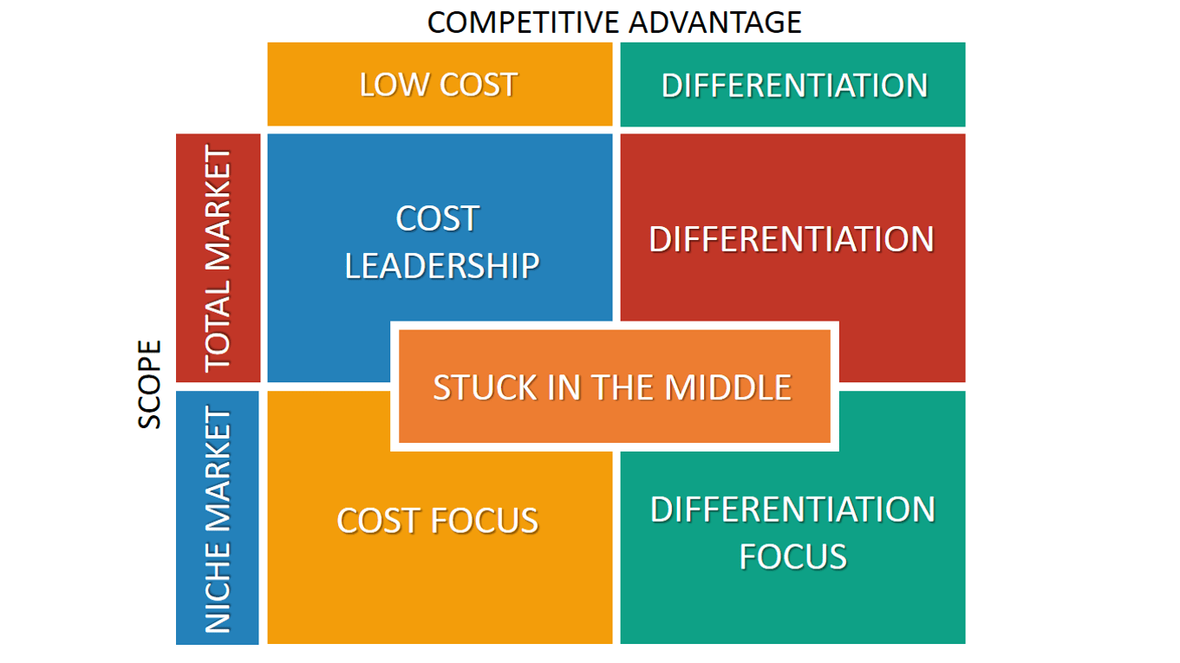
Figure 1

(2) In what ways did SABRE provide American Airlines with a competitive advantage? Your analysis should refer to concepts related to the strategic use of information system, for example, entry barriers.
SABRE is well organised software program that matches the desires of the customers of American Airlines to fly on a selected date with the bookings available on that specific date. SABRE terminals are mounted with the journey marketers which automates the process of airline price tag reserving thereby lowering the denial of bookings to its flyers. American Airlines creates a superior product differentiation that its competitors by way of making use of its price ticket distribution channel (journey agencies) greater effectively the usage of this state of the artwork era i.e. SABRE. You also need to know that tour agent bills for approximately 80 % of American’s revenue due to this generation (Sagar Singh 2017).
Porters five force:
Porter's Five Forces is a model that identifies and analyses 5 competitive forces that shape each industry and make it easier determine an enterprise's weaknesses and strengths. Five Forces analysis is often used to discover an enterprise's shape to decide corporate method. Porter's version may be applied to any section of the economic system to capture the extent of opposition in the business and beautify an enterprise's lengthy-term profitability.
The Five Forces tool was created by Harvard Business School professor, Michael E. Porter to analyse an industry’s attractiveness and likely profitability it was published in 1979, it was most popular business strategy tool (Chappelow, 2019)
Entry Barriers:
purchasing fleet of airplanes is a barrier to entry for some newcomers in the airline business. indeed, even with different expenses of beginning an air fuel, fuel is the largest barrier to entry for some industry newcomers. as per a 2012 report in the New York times, fuel costs represent up to 50 percent of an aircraft’s costs. the variation of fuel costs can make it hard for a start up to budget correctly without money related techniques that focus on specific purchase far in advanced.
Furthermore, in the beginning of the SABRE system travel agent were gaining a 7 percent commission on movement schedules they booked. The section boundaries in to this business were low for travel agent and people were getting in to this business in huge numbers. They fundamentally would get small training, set up a terminal, which conveyed. (Caldwell, 2002).

Besides the five forces model was created by M. Porter in 1970 to understand how five key competitive forces are affecting an industry. (Jurevicius, 2013).

These five forces identified are. (Ovidijus Jurevicius)

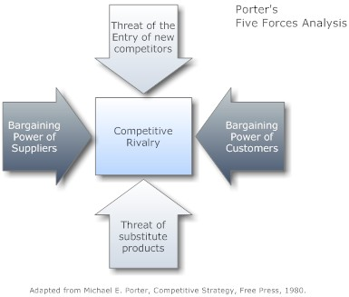

Figure 2. Five Forces Model

These forces decide an industry structure and the level of rivalry in that industry. The stronger competitive forces in the business are the less gainful it is. An industry with low boundaries to enter, having barely any buyers and providers yet many substitute items and competitors will be viewed as completive and therefore, not all that appealing because of its low productivity.
Using the five elements of the porter’s forces has been explained how and if they were low or high in threat barriers.

Threat of entry
The threat of entrance is high, since new entrance brings innovation, new ways of doing things and put pressure on sabre company through lower pricing strategy, reducing costs, and providing new value plan to the customers. in an industry bring new limit and the desire to pick up piece of the overall industry. (2019) fern fort university. New competitors entering the market place can either threaten or decrease the market share and profitability of existing product quality or price levels (Wilkinson 2013). SABRE can tackle threat entry by creating a combined technology platform, replacing the range of pieces that don’t always work well together. SABRE hopes to boost revenue with their new product (Neil 2019).

Bargaining power of customers
Customers are more often a demanding a lot. They want to buy the best offering that’s available by paying the minimum price as possible.
sabre can tackle the bargaining power of buyers
By building an enormous base customers and inventing new products, so customers often look for discounts and offerings on launched products so if sabre company keep on coming up with new products so it can restrict the bargaining power of buyers.

Threat of substitute products
When a new product or service meets a similar customers needs in different way, industry profitability suffers. For example, service like drop box and google derive are substitute to storage hardware drives. The threat of substitute is high if it offers a value suggestion that is uniquely different from present offerings of the business. sabre can tackle the threat of substitute products or service, by understanding the core needs of the customers rather than what the customers is buying. And also, by increasing the switching cost for the customers.

Bargaining power of supplier
All practically every company is in the information technology service by their basic material from various suppliers. Company can tackle that by building efficient supply chain with different supplier. (Fent Fort University, 2019)

Rivalry among the existing competitors
If the rivalry among the existing players in an industry is intense then at that point it will drive down cost and lessening the general gainfulness of the industry. Sabre can tackle intense rivalry among existing competitors by building a reasonable differentiation.

(3) Although SABRE was undoubtedly successful, American Airlines was not able to maintain its competitive advantage beyond the late 1980s. what factors played a part in the erosion of the company’s lead over its competitors and how did the company react?
The fact that caused American airline erosion and how the company reacted to get back in to market.
- is that the new entrance are bringing the similar products and service, coming up with innovation new ways of doing things and that can put pressure on American airline, through lower pricing strategy, reducing cost, and providing new value and proposal to the customers. Therefore, company has to manage all theses challenges and build effective barrier to prevent its competitive edge.

- Whereas with bargaining power of supplier is the main aspect that can reduce the scopes of the company, fuel is the product that replaced in large quantity everyday in the market. The company has significant international reach, and, in this way, it has subsequently affected by this globe trend in the market for long term. So, the company can tackle that by building efficient supply chain with multiple supplier.

- Bargaining power of buyers, customers are often dissatisfied with the product. They want to buy best offerings that is available by paying the minimum price as possible and can put pressure on American airline group for profitability in the long run. To prevent that, if the company come up with new products then it can limit the bargaining power of buyers. New products will also reduce the defection of existing customers of American airlines to its competitors.

- Threats of substitute products or service is very high because similar products and offerings are available in other airline businesses so to prevent that the company can increase the switching cost for the customer.

- Rivalry among the exiting competitors, the company had very high rivalry competitors against many other airline company, where they offered similar product and service that will drive down prices and decrease the overall profitability of American airline. They can challenge by building a scale so that it can compete better.

Part 2 Information system
- Define an information system:
Information system is defined as the software that helps to organize and analyse data. So, the purpose behind a data framework is to turn that in to raw information system that can be used to operate and making decision in an organisation.
Most of the company work with huge amounts of data. Data are basic values or facts and are organized in a database. Many individual consider of data as information synonymous with data; however, information actually consists of data that has been organized to help respond to questions and take care of issues. (2019 study.com)

- Describe the categories of computer-based information systems, providing relevant business examples for each category identified:

There are various types of information system in various organisations for example there are four types of basic computer-based information system in all organisation they are, transaction processing system, management information system. Decision support system and executive support system.
In organisations such as Barclay bank. which has two types of computer terminals used for their information system, one is the department used for bank control and to operate their business and other one which is to locate for the customer home computer terminal is used for the customer to access on to their account from were ever they are. Beside that Barclay bank have several other department rely on the information system in order to operate the business efficiently for example:

firstly, customer information system which includes customers account details and customers enquires that is provided by information system and get to know about products and service are available to them.

Secondly the accounting department, in this department has authority to correct account information. third it is the collection department this sector uses the information system to find out which customer has outstanding debt so this can be managed the debt issued between the originator and customer.

Then it is the fraud sector this were customer claim of fraud on to their account and this is when they need to access on to customers account transaction in order to make decision on whether the claim is valid or not.

- Explain how computer-based information system can support managers at each level of an organisation.

- A management information system in Tesco decision making is the primary functionality of middle managers. Information system helps managers and workers to analyse any issue they come a cross and visualise complex task and to create new product (O’Brien, 2015).
- Decision can be made according to the information on sales, profit and customers choices. Tesco views information system as an important resources in similar way of money, machinery and manpower. which include hardware and software programmes that produces regular reports on operations for every level. It also obtains distinctive reports from the system easily. The main aim of the MIS is to give managers feedback about their own performance by gathering statistics, analysing that information and report data to resource in management decision-making (O’Brian, 2010).

- The information system supports this organisation called Transaction processing system this system are used to automate regular activities and make sure they are performed both quickly and correctly (O’Brian, 2010). In this sector decision making is at the operational level it is significantly with detailed structure. Tesco also uses electronic data exchange to manage daily stock control such as cash at the tills, sells per zone and also to automatically reorder stocks from its supplier. Another transaction system called an inventory management system it supports tescos operational managers with all aspects of stock control. (O’Brian, 2010

- Executive information system in this sector involves in the executives to assist at top level Tesco management with long term strategic decision. At this level executive are more focused on decision they make and come up with an outcome that how organisation should react to the trends in the market place and competitive environment.

- Decision support system supports organisational decision making and business activities. they combine useful information from document raw data, personal knowledge and business model to find and tackle business issue. It also help in the management and arranging activity of business.

References
Fern Fort University. (2019). American Airlines Group Inc. Porter Five (5) Forces & Industry Analysis [Strategy]. [online] Available at: http://fernfortuniversity.com/term-papers/porter5/analysis/2528-american-airlines-group-inc-.php [Accessed 11 Nov. 2019].
O'Brian, J. (2006). Management information System. [online] Dias.ac.in. Available at: http://www.dias.ac.in/download/2015/dtr8/102-112%20Pages%20of%20DTR%208th%20issue.pdf [Accessed 10 Nov. 2019].
O'Brian, L. (2010). Strategic Information Systems Case Study- Tesco. [online] Slideshare.net. Available at: https://www.slideshare.net/LauraOBrien10/strategic-information-systems-continuous-assessment-2 [Accessed 11 Nov. 2019].
O'Neill, S. (2018). American Airlines Feels Vindicated in Its Second Try at Direct Distribution. [online] Skift. Available at: https://skift.com/2018/10/04/american-airlines-feels-vindicated-in-its-second-try-at-direct-distribution/ [Accessed 13 Nov. 2019].
Suriyantphupha, P. (2019). Information Technology in a Traditional Retail Supply Chain: A Structured Literature Review. [online] cairne.info. Available at: https://www.cairn.info/revue-projectique-2019-1-page-89.htm# [Accessed 13 Nov. 2019].
Uqaqahidawic.ga. (2019). - The Fast Track To Profit By Lee G Caldwell. [online] Available at: https://uqaqahidawic.ga/1821.php [Accessed 11 Nov. 2019].

