


Evaluating the Impact of
the NHS App on UK Health
Care
Name : Alina Elena
Adavidoaie
Student Number: 2324349
Module Code: BMHP6026, Component 2
Lecturer’s name:
Zakiyyah

Ahmed
University: University of Wales Trinity
Saint David



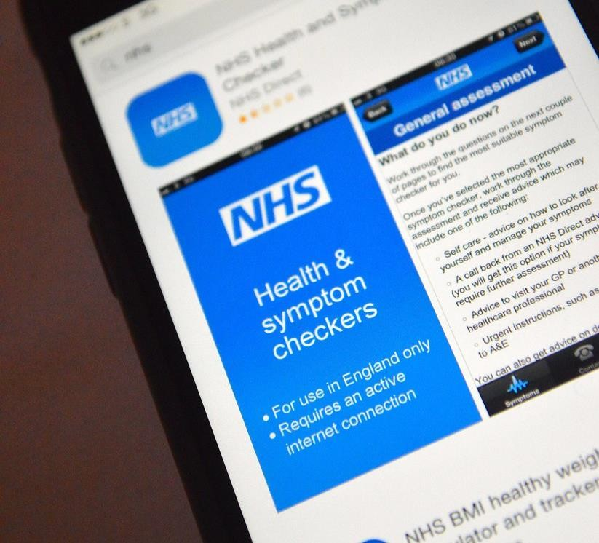

PRESENTATION OVERVIEW
•
Introduction
•
What is the NHS App?
•
Why it was selected
•
Impact on Workforce
•
Impact on Service Delivery
•
Impact on Patients
•
Challenges
•
Recommendations
•
Conclusion
o
This Phot

by Unknown Author is licensed under
Y
CC B

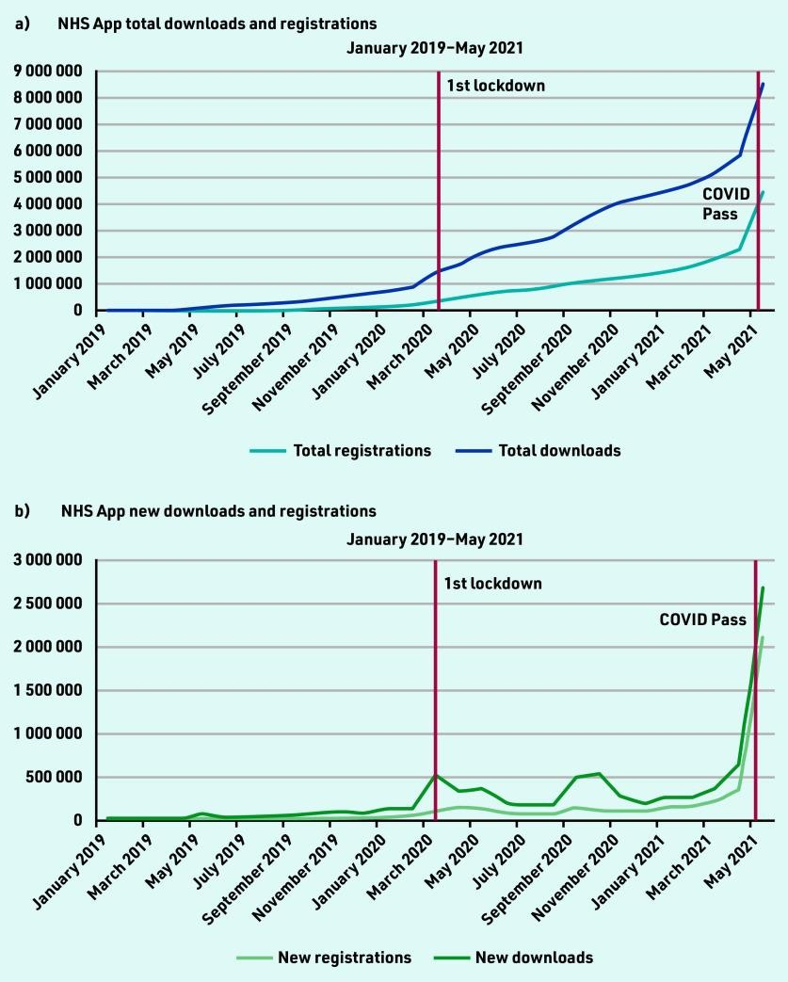

INTRODUCTION
•
Introduced in
2019
•
Developed by NHS England
•
Available across England
•
Free mobile application
•
Supports digital healthcare
(
pcm.pubmed.central
, 2021)



WHAT

IS THE NHS
APP?
Allows patients to:
•
Book GP appointments
•
Order repeat prescriptions
•
View health records
•
Receive NHS updates

WHY WAS THE
NHS APP
INTRODUCED?
Growing
pressure on NHS
Staff shortages
Increase
efficiency
Improve patient
access
NHS Long Term
Plan
Digital
transformation

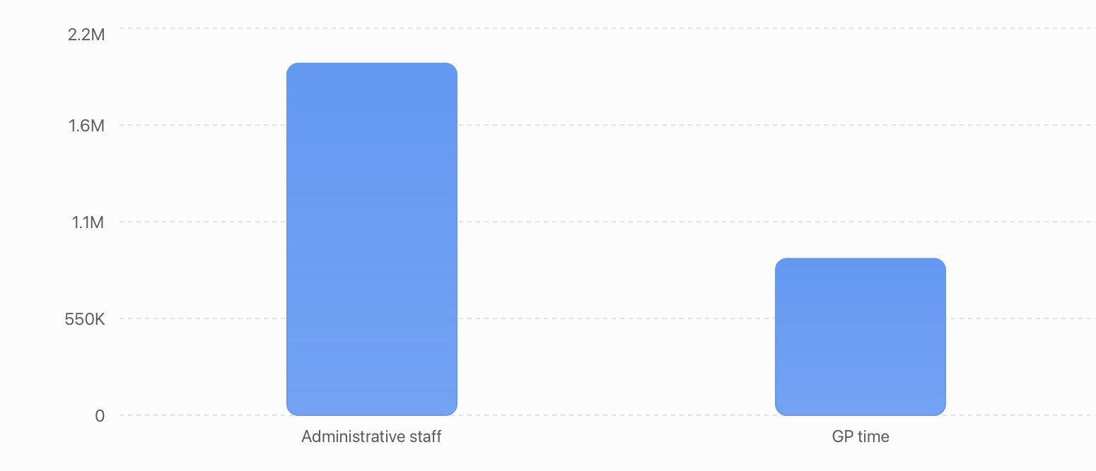
















IMPACT ON THE
WORKFORCE
Positive impacts
Less administrative work
Fewer phone calls
Better communication
More time for patient care
WORKFORCE
CHALLENGES
Challenges
Staff training
Learning new systems
Supporting digitally excluded patients
Managing digital and traditional services
Technical issues



FASTER APPOINTMENT ONLINE EASIER ACCESS TO BETTER IMPROVED EFFICIENCY BOOKING PRESCRIPTIONS HEALTHCARE COMMUNICATION
IMPACT ON SERVICE DELIVERY
BENEFITS

CHALLENGES
TO SERVICE
DELIVERY

Digital exclusion
Internet problem
system down time
Face
-
to
-
face care still needed
Unequal access
IMPACT ON
PATIENTS

Convenient
Better access to records
Greater control
Self
-
management
Saves time
Digital skills |  | Older adults |  | Internet access |  | Privacy concerns

Data security
PATIENT CHALLENGES
CRITICAL EVALUATION
•
Supports NHS digital
strategy
•
Improves efficiency
•
Saves staff time
•
Better patient experience
•
Supports NHS digital
strategy
•
Improves efficiency
•
Saves staff time
•
Better patient experience
Limitation
Strengths


RECOMMENDATIONS
More staff digital training
Community digital support
Better cybersecurity
Continue face
-
to
-
face services
Improve accessibility
Regular NHS App updates
CONCLUSION
NHS App introduced in 2019
Still widely used
Positive impact on:
Workforce
Service delivery
Patients
Challenges remain
Future investment is essential
REFERENCES
- Theodoulou, I., Reddy, A.M. and Wong, J., (2018). Is innovative workforce planning software the solution to NHS staffing and cost crisis? An exploration of the locum industry. BMC Health Services Research, 18(1), p.188.
- Hutchings, R., (2020). The impact of Covid-19 on the use of digital technology in the NHS. Nuffield Trust, 27, pp.20022008.
- Zhou, X., Leiva-Granados, R., Yi, J., Yao, Z., Fang, J. and Skordis, J., (2025). Staff experience in the workplace after investment in digital technologies: a difference-in-differences study in the English NHS. Available at SSRN 5198150
- Salway, R., Sillero-Rejon, C., Forte, C., Grey, E., Jessiman, P., McLeod, H., Harkes, R., Stokes, P., De Vocht, F., Campbell, R. and Jago, R., (2024). A service evaluation of the uptake and effectiveness of a digital delivery of the NHS health check service. BMJ open, 14(11), p.e091417.
- Turner, J., Knowles, E., Simpson, R., Sampson, F., Dixon, S., Long, J., Bell-Gorrod, H., Jacques, R., Coster, J., Yang, H. and Nicholl, J., (2021). Impact of NHS 111 Online on the NHS 111 telephone service and urgent care system: a mixedmethods study. Health Services and Delivery Research, 9(21).
- Madir, J., (2020). Using technology to deliver health services. In HealthTech (pp. 1-22). Edward Elgar Publishing.
- Free, C., Phillips, G., Watson, L., Galli, L., Felix, L., Edwards, P., Patel, V. and Haines, A., (2013). The effectiveness of mobile-health technologies to improve health care service delivery processes: a systematic review and meta-analysis. PLoS medicine, 10(1), p.e1001363.
- Laverty, A.A., Reidy, C., KC, S., Papoutsi, C., Gudgin, B., Majeed, A. and Powell, J., (2026). The NHS App should focus on inequalities to improve population health. Journal of the Royal Society of Medicine, 119(2), pp.37-41.
•
•
Shaw, S.E., Marjanovic, S.,
Papoutsi
, C., Wu, F.M., Newhouse, N.,
Wherton
, J., Alvarez
Nishio
, A.,
Darbyshire
, J.L., Fahy, N., Ford, G.A. and
Hughes, G., (2025). Digitally Enabled Care in Diverse Environments (DECIDE): protocol for a programme of rapid evaluation of
technology
-
enabled remote monitoring in health and social care.
NIHR Open Research
,
5
, p.28.
•
Griffiths, F.E., Griffiths, F.,
Armoiry
, X., Atherton, H., Bryce, C., Buckle, A., Cave, J.A., Cave, J., Hamilton, K.,
Dliwayo
, T.R. and
Dliwayo
, T.
(2018)
. The role of digital communication in patient
-
clinician communication for NHS providers of specialist clinical services f
or young
people [the Long
-
term conditions Young people Networked Communication (LYNC) study]: a mixed
-
methods study.
Health and Social
Care Delivery Research
,
6
(9)
, pp.
1
-
270.

•
Russ, S.,
Sevdalis
, N. and
Ocloo
, J., (2021). A smartphone app designed to empower patients to contribute toward safer surgical care:
qualitative evaluation of diverse public and patient perceptions using focus groups.
JMIR mHealth and
uHealth
,
9
(4)
, p.e
24065.
•
Reidy, C.,
Papoutsi
, C., Kc, S.,
Gudgin
, B., Laverty, A.A., Greaves, F. and Powell, J., (2025). Qualitative evaluation of the implementation
and national roll
-
out of the NHS App in England.
BMC medicine
,
23
(1)
, p.
20.
•
Laverty, A.A., Reidy, C., KC, S.,
Papoutsi
, C.,
Gudgin
, B., Majeed, A. and Powell, J., (2026). The NHS App should focus on inequalities to
improve population health.
Journal of the Royal Society of Medicine
,
119
(2)
, pp.
37
-
41.
•
pcm.pubmed.central
, (2021) Uptake and adoption of the NHS App in England: an observational study Available at :

https://pmc.ncbi.nlm.nih.gov/articles/PMC10562999
/

Accessed on 19 July 2026.

