Material Science and Building Services ACBA4006
Construction materials – sydney opera house
Jocasta Napier
Student Number 2316860
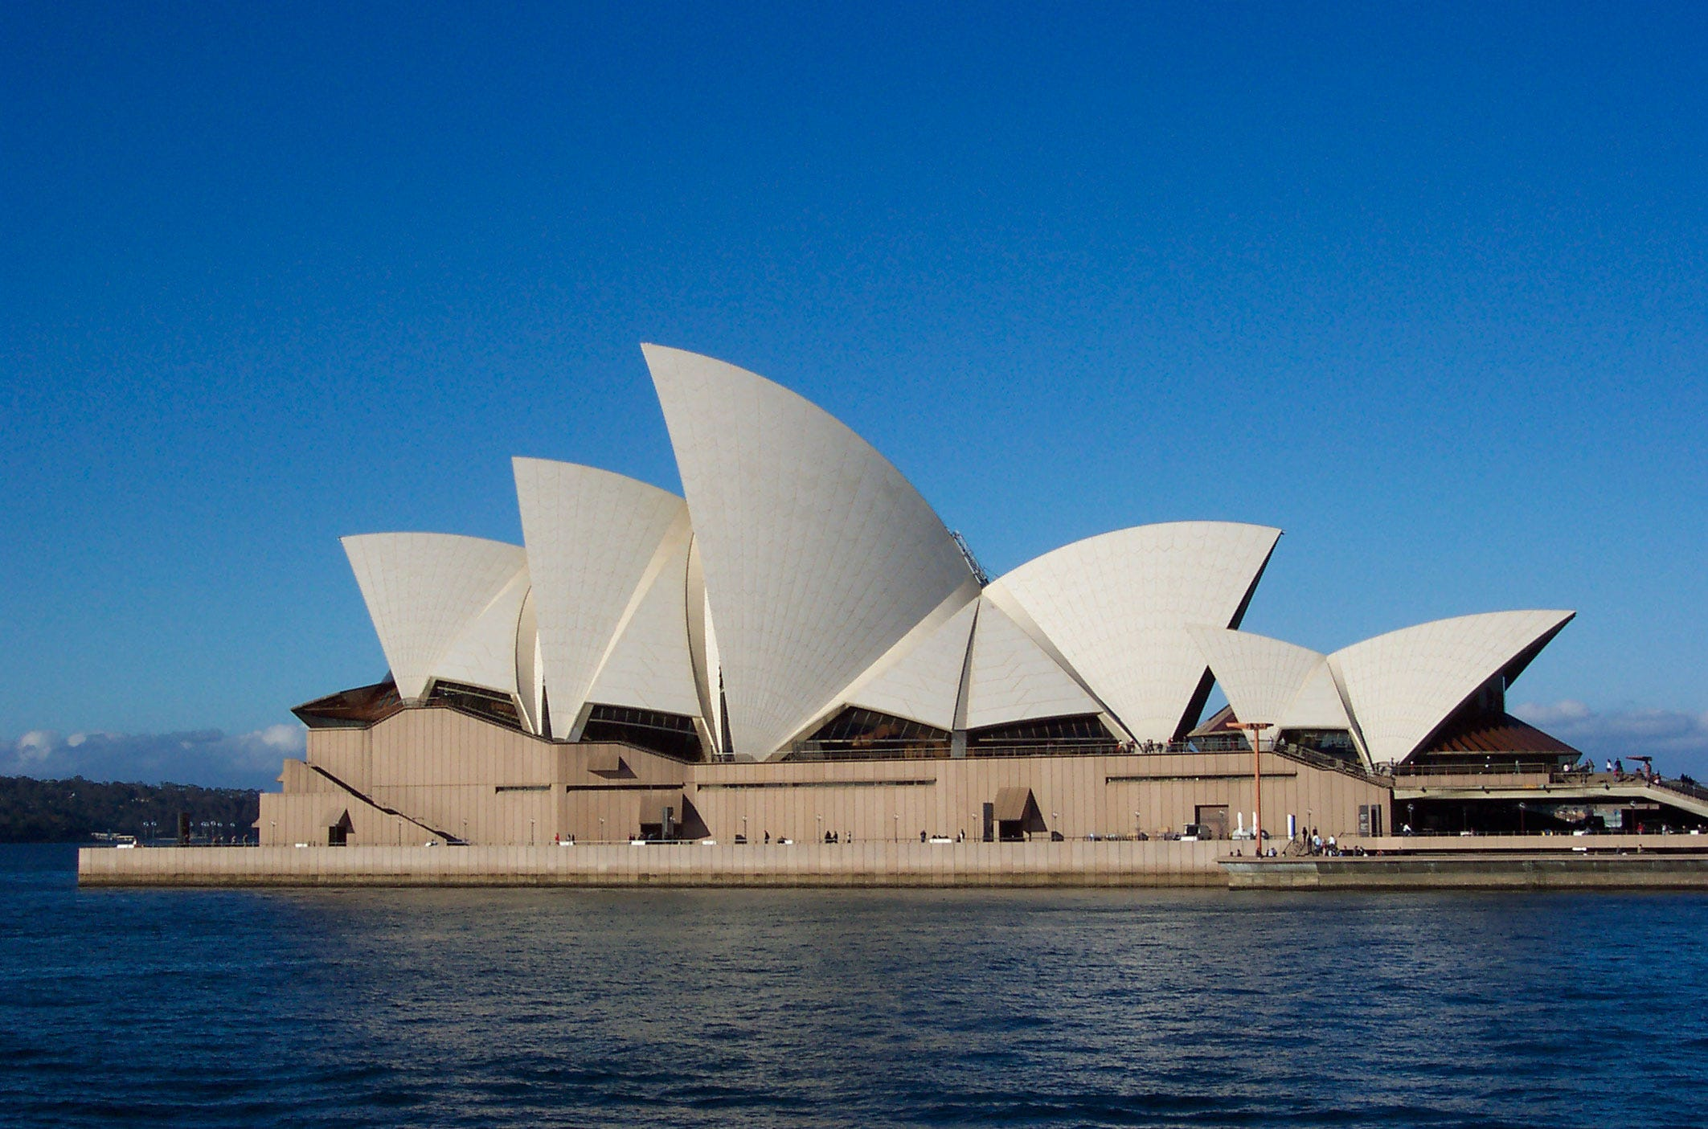
Table of Contents
Introduction 2
History 2
Design Plan 2
Materials Used 5
Pre-Casted Shells 5
Start of construction 6
Material testing 9
Potential Impact and Solutions 10
Roof Sails 11
Roof Pedestals 11
Durability and Climate Resistance 11
Comparison of steel and Concrete 11
Conclusion 12
Reference 12

Introduction

After looking at different habitable concrete structures from around the world what was found most suitable is the Sydney Opera House, this report will have decided on this building due to the different environmental factors it faces due to its location, along with its unique design, which at the time of the build was very advance in both design but the construction methods used before the build had been completed.

History

Bennelong point located in Sydney harbour, got its name from the aboriginal leader. The pier has had many different uses over the years, which is now the location of the Sydney opera house.

Before any construction has taken place on Bennelong Point, it was a small tidal island, made up of rocks and a small beach. In 1788 the land was used as a cattle point and then later used to burn piles of oyster shells (left behind from Aboriginal people) to make lime for cement mortar which then gave its name lime burner point.

There have been two building on this Bennelong Point before the Sydney opera house, these include a brick hut built by it namesake and then in 1798 a half moon battery was built at the north end which was mounted with guns from the HMS supplies.

In 1818 the island was connected to the mainland by rocky rubble which is the main foundation for the Fort Macquarie to be built. This rubble was then forgotten about until the land was being excavated for the construction of the Sydney Opera House in the late 1950’s.
(Historyhit.com, 2021)

Design Plan

The Sydney Opera House started off as just a discussion at the performing arts centre for decades before it gained enough attention from the government to offer fund for the project. To find the right designer for the project, a competition was created where each designer paid a $10 fee to submit their designs to be judge. The competition guidelines came within a 25-page book, which included photos of the site along with the requirements needed for the new opera house.
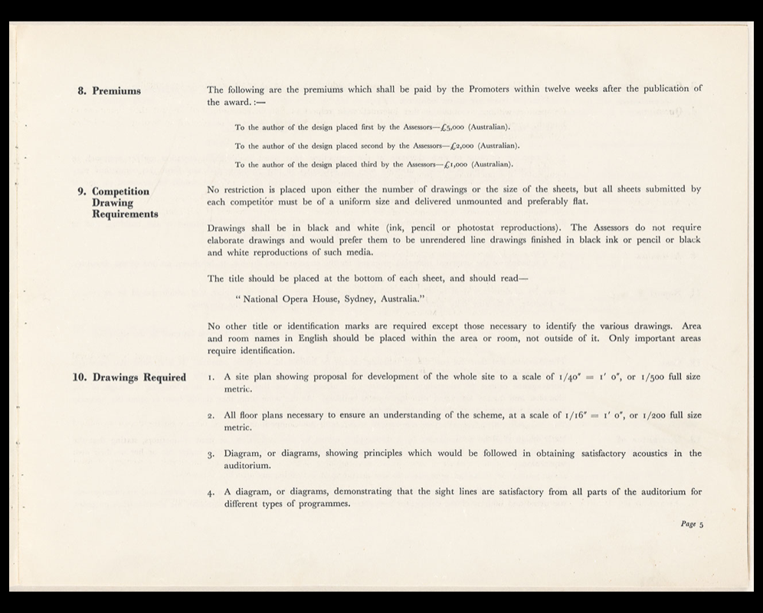

Figure 1 - shows the drawing requirements part one

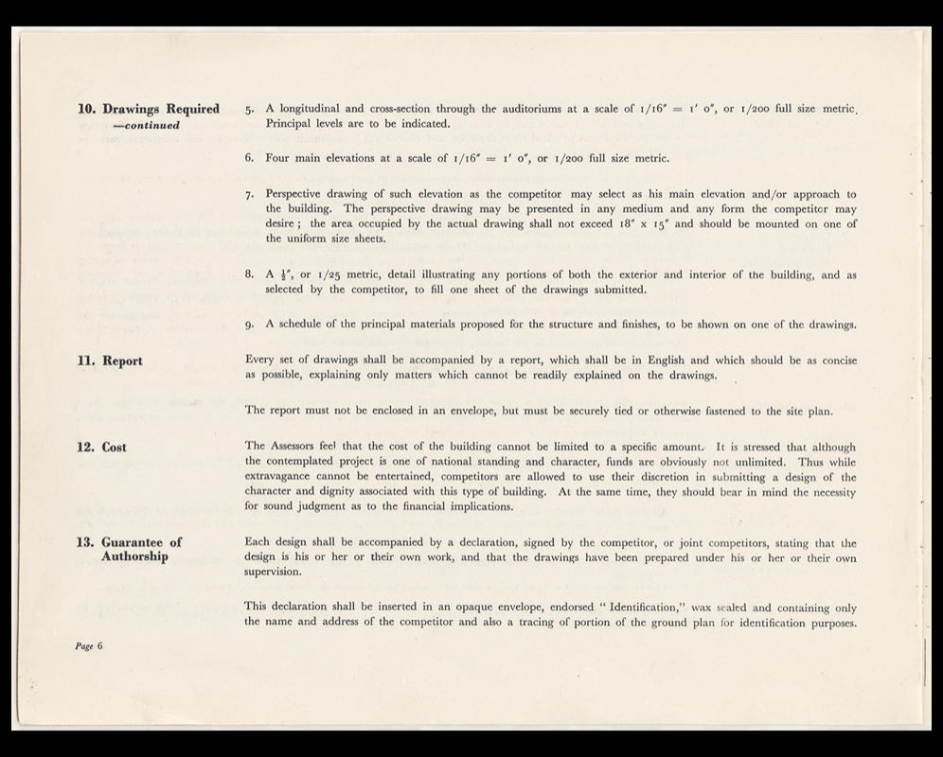
Figure 2 - part two of the drawing requirements

Although Jorn Utzon was not the first choice as leading Architect on the project, it was announced that the unknown designer had won the competition, due to the judges inability to put the drawings down as they believed this would be one of the greatest buildings in the world.

The estimated cost to the project was 3.5 million dollars.

Utzon design was one showing sculpture along with expressionism in the structure. He also made full use of the space at Bennelong point’s harbour side by doing this it allowed the building to be seen from all angles.

When creating his designs Utzon looked over many nautical maps to get as many outlooks as possible on the scope of the harbour. He had been inspired by the Kronburg Castle (shown in figure 3) which is in his hometown, this castle would become a natural reference point for Bennelong Point. Due to how its location of the castle also being located at a pier point.
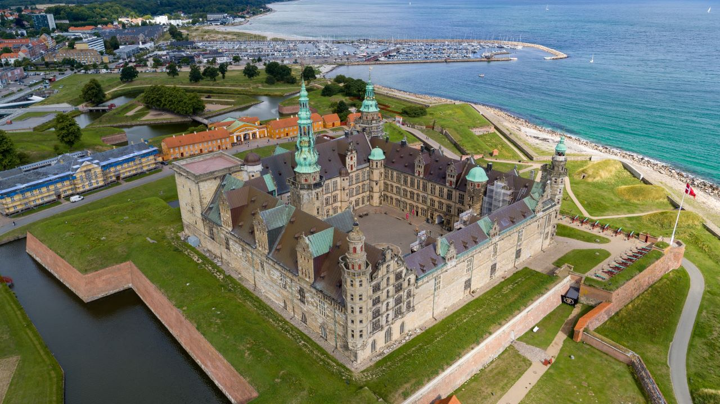
Figure 3 image of Kronborg Castle
(visitcopenhagen.com, 2023)

Utzon design of the Opera house also differed from other designs as it has concert halls placed side by side, with the shell shaped roofs resembling both the Sydney cliffs and boat sails on the harbour.

Utzon quickly got wrapped up in the excitement of his perfect building with both excellent design in the use of optimising the external and internal spaces, Utzon wanted to maintain these founding ideas throughout his work even though, as the construction work continued both the original aspiration and building changed around him. As the work continued his dream would eventually be unattainable and he would be forced to resign.

Materials Used

The main materials used for the project are reinforced concrete, polarized glass, and steel frames.

The building itself is 180m long and 120m wide, the roof design is made up of 2194 pre-fabricated concrete ribs, with some of them weighing up to 15 tonnes, once built the roof was then covered in over one million tiles.

The design also uses 6225m² of glass, to act as a wall for both halls which look out over the harbour. Although there are many elements which are used to build the opera house due to its vast size, these items would all have an impact on the weight of the structure.

Pre-Casted Shells

The unique design of the linking shell design came from the structure of a sphere which had been segregated by curves from the centre of the sphere which when pulled apart and stacked to form the shapes it was known for today.

Each shell was made from pre-casted concrete rib segments which are all connected by a ridge beam, this is held together by a tension steel cable which was 350km long.
The shells of the opera house were originally going to be designed by using parabola design, where all points in the curve would be spaced and supported equally but this design was determined unusable by the engineering team.

When trying to connect the ribs together different methods had been trialled but the one which was chosen was developed through the research, they had come up with a method of use epoxy resin which was used to bond the ribs together and also allowing it to maintain a smooth effect which was perative to Utzon design.

The precast ribs were then casted with ducts to carry the steal stress cables, 4100 duct were made with a totalling length of 70 miles. After the post tension was finished the ducts were then pumped full of grout to seal the steel cables from the outside elements. The rib structure was then also cladded with 3,382 chevron shaped prefabricated concrete tile lids which was then used to support the ceramic tiles.

The tiles have a small spherical curve, so to keep these safe the bolted them down to the rib structure and sealed the with an epoxy sealant, this acts like a grouting to protect the space between the tiles.

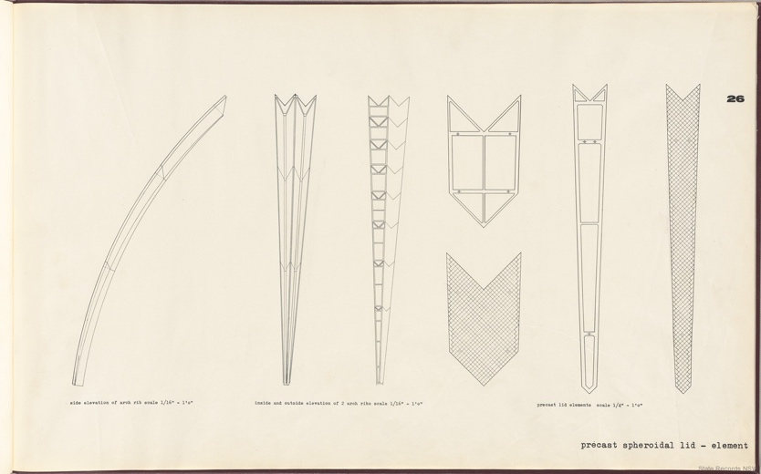
Figure 8 Pre Cast Rib Design (gallery.records.nsw.gov.au, ND)
Construction Method

The construction of the Sydney Opera House was planned to be completed in three stages, over four years, the government wanted construction to start straightaway which Utzon agreed to, even though his designs had not been completed, this the meant that there were unforeseen set back to the project, including the budget and a swap over of the main designer. In total the project took fourteen years to complete and went over budget.

The plan for building was for it to be completed in three stages –

Stage one – was to focus on building the upper podium.

Stage two – is the construction of the shells.

Stage three – is the finishing the interior and fitting of the operation.

(concreteconstruction.net, 2022)

Start of construction

From the start of the project they came across problems, the first major issued they faced was the ground survey had not been carried out accurately, instead of tests being carried out it had been assumed that the land was going to be similar to the land surrounding it which was Hawkesbury Sandstone Rock but instead the land was made up of pools of sea water and rich soils, which meant that the land is not suitable to weight bearing.

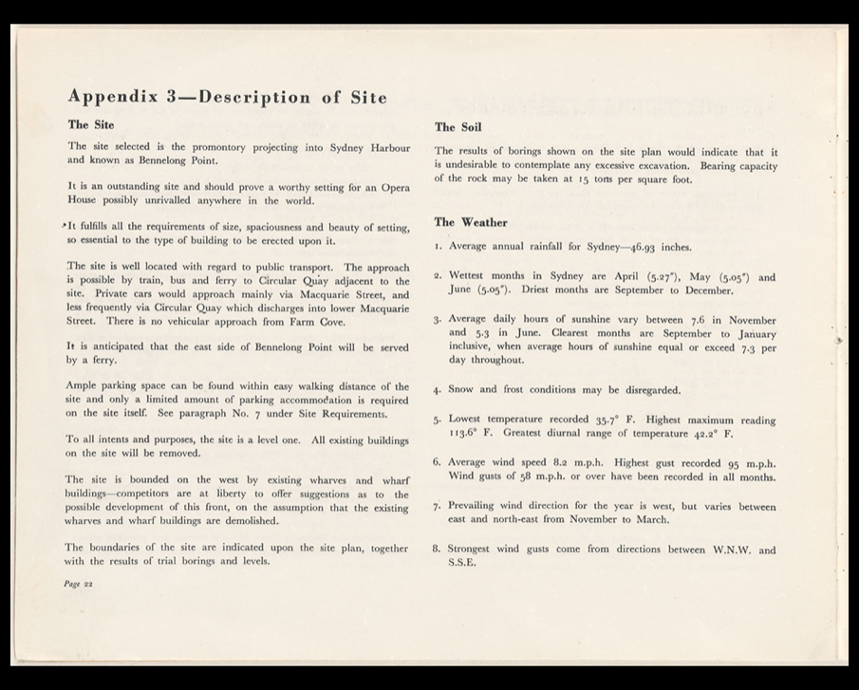
Figure 4 Site Description

To make the ground safe to be built on 700 steel cased concrete shafts, which were each one meter in diameter, these were then bored down into the North half of the site up to 25m below sea level. They also used mass amounts of concrete to fill the unstable rocks in the centre of the site. As it was thought the land would be stable to build on, it became and extra cost to the project and was just the start of the unforeseen costs.

The second major problem they faced was the weight of the roof, this was part of one of the issues caused due to the designs being incomplete, meaning that they are unaware of the load bearing of the shells and the anchor points were unknown.
(sydneyoperahouse.com, ND)

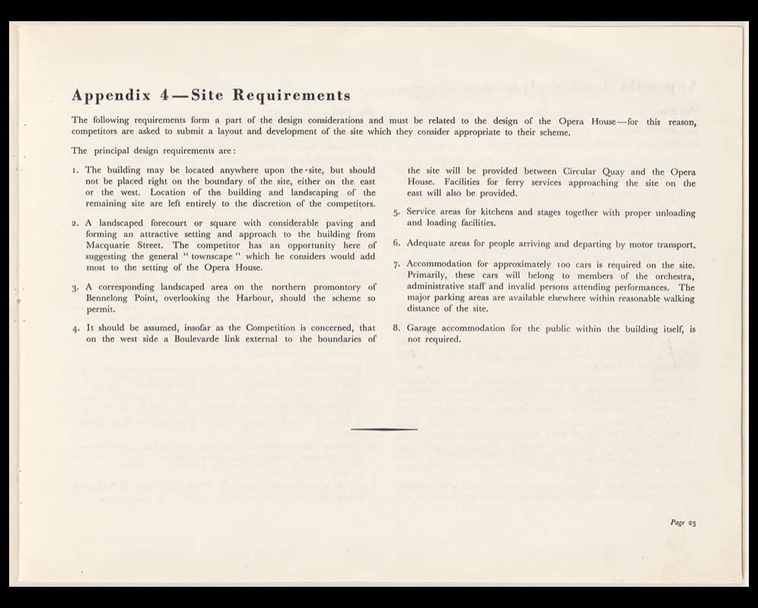

Figure 5 Site Requirements
After 12 trials Utzon came to the idea ‘Spherical Solution’ which is discussed in the ‘Trust in the Yellow Book (1962)’ it advises how the ten roof sails are all segments of the same sphere, they has a 75m Diameter. By using this technique both the pre-casted ribs and post tension system could be made on site which allowed both design coherence and economies of scale.

When assembling the arches they invented a new type of crane which was shipped over from France, designed by a French contractor M.R Hornibrook these cranes along with mounts and assembly arches created removed any need of mass scaffolding during construction.

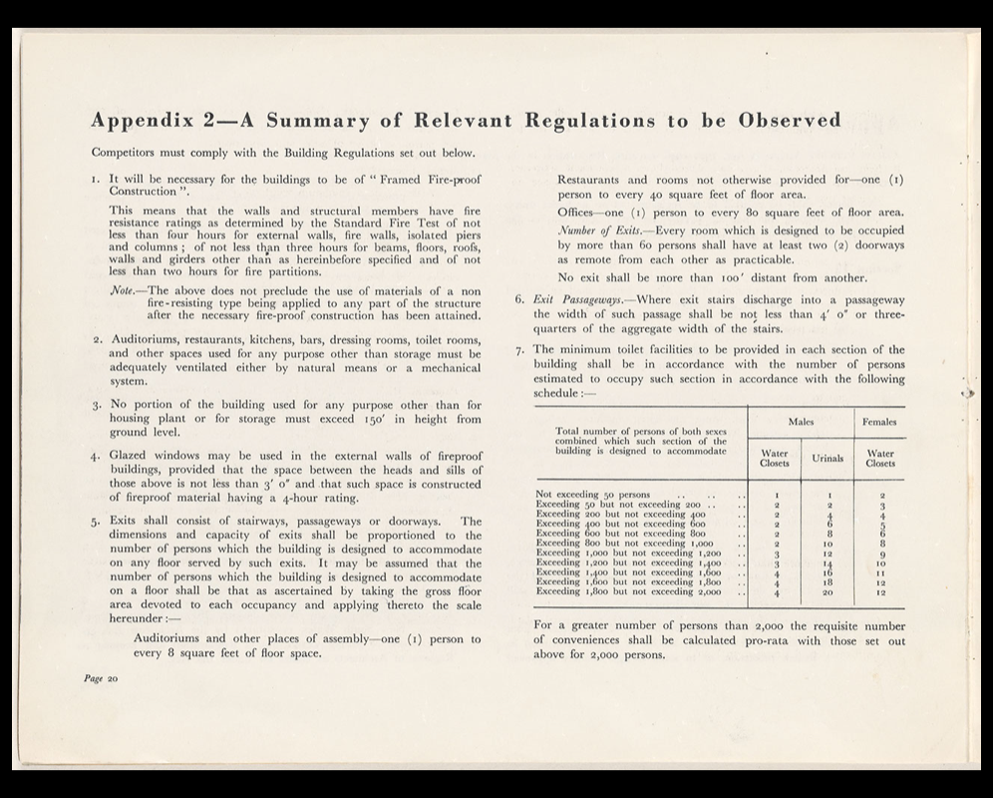
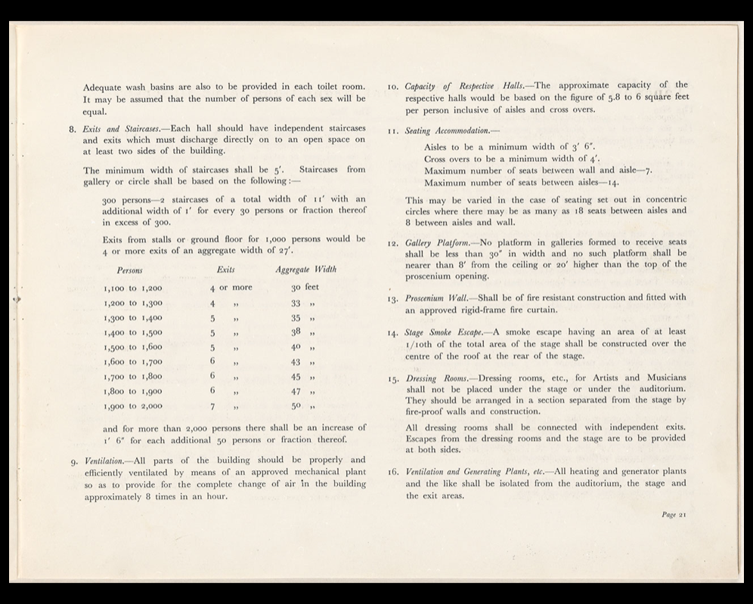
Figure 6bRegulation to be observed

Figure 7 regulation to observed part 2

Material testing

There was structural engineers for each part of the construction of the Sydney Opera House the roof is made of pre-casted concrete shells, 12 shells were made in total along with concourse beams and glass walls.

The concourse beam provide pedestrian and vehicle access to the building is one of the main features of the design with its pre-folded stressed concrete beams which support the base structure. Ove Arup was the designer of this structure and by combining the two different methods it allows for an expansive space, which is open enough to hold a box office without the need of structural columns.

Wind Load
Testing had to be carried out on the curved surface of the sails as the bearing were unknown at this point. They did this by carrying out test in a wind tunnel which was the pioneering of the use of wind tunnels.

When it comes to the glass wall which are found in between (say place) they have chosen laminated glass for the structure due to its strong durability and ability to be shaped on site.
(arup.com, 2023)

Utzon designs were recognised as ground-breaking during this time –

- The designs of the opera theatre were ahead of its time when they and it is known for it.
- Being one of the first structures to use technology to geometrically map out the arches and find the best techniques for managing the design.
- Ove Arup designed folding concrete beams to support the structure.
- Ove Arup and his team also pioneered the wind tunnel testing.
- An innovated epoxy resin was made for the structure.
- The glass walls also pushed the boundaries due to the Meir size.
(Getty.edu, 2018)
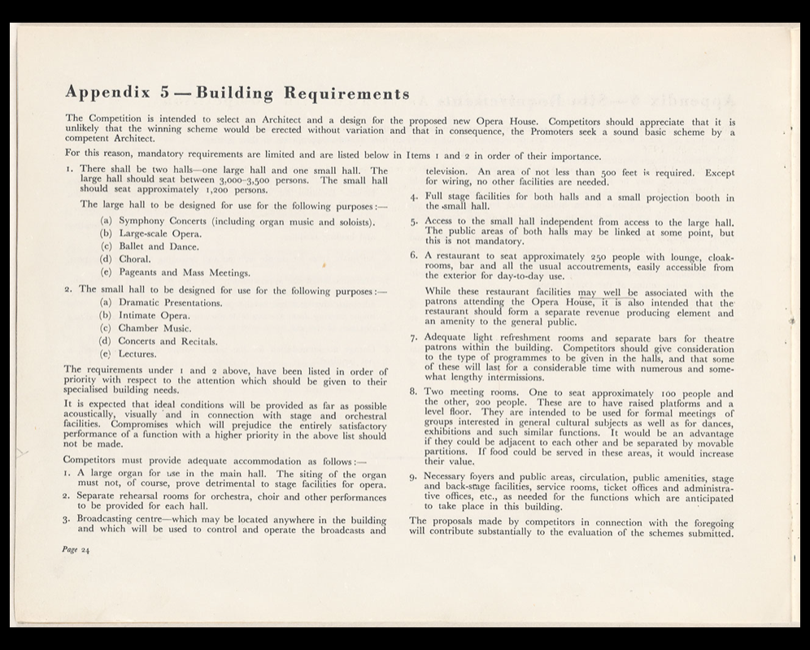
Figure 9 Building Requirements

Potential Impact and Solutions

According to Getty EDU, each year the Sydney Opera House, will host more than 2,000 performances, where they will have around 1.5 million people attend. Along with the 8.2 million people who also attend the site for tourism.

Due to this they want to make sure the site is renewed as well as treasured, to allow further generations. To do this they need to conserve the building itself, as the building has a lot of exposed concrete it has been subject to all elements for over 50 years. To ensure they can do this they have been rewarded a Getty Grant which result in a concrete conservation program being created which along with heritage policies and conservation management plan, they are able to keep Utzon’s vision while being able to use more modern techniques.

There are several students who have been allocated to find past reports (which have been lost) on the projects along with looking into ways to find new technology to allow non-destructive testing going forward.

Roof Sails

The roof sails are fully exposed to the marine environment, which could cause them to be vulnerable water damage, from either the ceramic tiles or if the grouting inside the post tension ducts ribs, so far the testing on this shows good outcomes to the areas they are able to access but they are looking for a less destructive method to test these area, it will also allow them to test the areas they don’t have access to.

Roof Pedestals

At the base of the roof sails, they have steel reinforced structures which are not only exposed to the elements but also human touch. The main issue caused for these areas is rainwater runoff, which is causing both biological growths on the structure and erosion. Although trials have been carried out to try and protect this area, such as protective coating, nothing has been accepted as a good solution which will also not have an effect on the building.

(Getty.edu, 2018)

Durability and Climate Resistance

One factor that needs to be considered with durability of the building against human use, when the opera house was only being spoken about it was always going to be somewhere which will have a high volume of human traffic, not only from walking around the harbour to marvel at the unique design but also for the car park and extra tourism to the sit needs to have constant monitoring on the erosion that could be caused, a planned then has to be put into place to rectify these issue so they don’t cause a larger problem down the line.

Comparison of steel and Concrete

Both concrete and steel both have many advantages in their designs and durability, when it come to the Sydney Opera House the better choice for the main structure is concrete. Due to the exposure, it gets from the sea water, along with the warm climate, it is constantly exposed to excessive moisture and abrasion. Although steel can withstand similar climates, it would be quicker to corrode, meaning there would need to be more costs into maintaining the building’s structure.

Conclusion

This report has shown the process of building the Sydney opera house and how although Utzon design were incredible, not enough planning had gone into the building before construction had started, which caused a lot of delay and was not cost effective to the project.

Although there were setbacks, ultimately as the judges first believed this building is now and will be a well-known landmark in Australia, where people will travel from all over the world to see its beauty and grandeur. With the structure elements chosen to build the opera house and all plans to treasure the landmark, this building will be around for many years to come.

Reference
Unknown, (2023) Designing the Sydney Opera House, Available at https://www.arup.com/projects/sydney-opera-house (accessed 05, December 2023)

Utzon, J, (2023) Sydney Opera House, Available at: https://architectuul.com/architecture/sydney-opera-house (accesed 01, December 2023)
Unknown, (2023), Sydney Opera House, Available at: https://www.designingbuildings.co.uk/wiki/Sydney_Opera_House (Accessed 03, December 2023)

Davidson, L. (2021) Bennelong Point, Available at: https://www.historyhit.com/locations/bennelong-point/, (accessed 02, December, 2023)

Unknown, Construction Begins, Available at:
https://www.sydneyoperahouse.com/our-story/construction-begins (Accessed 02, December 2023)

Unknown, The Spherical Solution, Available at: https://www.sydneyoperahouse.com/our-story/the-spherical-solution (Accessed 02, December 2023)

Unknown, The Spherical Solution, Available at: https://www.sydneyoperahouse.com/our-story/jorn-utzon (Accessed 05, December 2023)

Concrete Construction Staff, (2022) Sydney Opera House, Available at: https://www.concreteconstruction.net/how-to/construction/sydney-opera-house_o (accessed 02, December 2023)

Concrete Conservation Project, (2018) Final Report Summary, Available at: https://www.getty.edu/foundation/pdfs/kim/sydney_final_report.pdf (accessed 02, December, 2023)

Figures-

Rafn-Larsen, T. (2023) Visit Copenhagen [Photograph] Available at: https://www.visitcopenhagen.com/copenhagen/planning/kronborg-castle-unesco-world-heritage-gdk1077722 (Accessed 02, December 2023)

Guiding Architects. (2023) The Brown Book, the competition Guidelines for Sydney Opera House, Available at: https://www.guiding-architects.net/brown-book-competition-guidelines-sydney-opera-house/ (Accessed 04, December 2023)

Unknown, (2023) Sydney Opera House – the brown book Available at: https://mhnsw.au/stories/general/sydney-opera-house-the-brown-book/ (Accessed 03, December 2023)

Unknown, https://gallery.records.nsw.gov.au/wp-content/gallery/sydney-opera-house-the-yellow-book/12708_00028.jpg (Accessed 05, December 2023)

Figure 1 - shows the drawing requirements part one 3
Figure 2 - part two of the drawing requirements 3
Figure 3 image of Kronborg Castle 4
Figure 4 Site Description 5
Figure 5 Site Requirements 6
Figure 6bRegulation to be observed 7
Figure 7 regulation to observed part 2 7
Figure 8 Pre Cast Rib Design 8
Figure 9 Building Requirments 9

