
International Market Entry Strategy and Marketing Mix
Chanel in France and India
Programme: Master of Business Administration
Module: International Marketing: Principles and Practices
Module code: LCMB7026
Name: MD ASIF HOSEN
ID: 2506161
Lecturer: Tushara Balendran

Acknowledgment
USE OF GENERATIVE AI IN ASSESSMENT
RESEARCH | For this assessment, you can use Generative AI to support you in research and data analysis. | Yes ☐  No ☒
STRUCTURE | For this assessment, you can use Generative AI to support you in structuring your submission, including creating a draft argument structure, identifying parts  and headings, etc. | Yes ☐  No ☒
PROOFREADING | For this assessment, you can use Generative AI to check your own text/creation for grammatical and syntactical mistakes, including getting suggestions to  rephrase your work. | Yes ☐  No ☒
WRITING | For this assessment, you can use Generative AI to create text for submission. | Yes ☐  No ☒
CREATIVE | For this assessment, you can use Generative AI to create creative materials, such as images. | Yes ☐  No ☒
PROGRAMING | For this assessment, you can use Generative AI to create and check code. | Yes ☐  No ☒
NONE | For this assessment, you are not allowed to use any type of Generative AI support. This includes research support, structure support, writing/proofreading  support and creative support. | ☐

I acknowledge the use of Grammarly (https://www.grammarly.com/) on 3rd August 2026 to check my work using the prompt(s):
1.check the following text for readability, grammar and syntax.
2. Review citation formatting and referencing consistency (Harvard style).

I confirm that I have not presented any Al generated text as my own work. I confirm I have copies of my drafts, notes, and other resources I used before, and after the use of Al tools which I may be asked to provide in evidence.
I acknowledge the use of Microsoft 365 Copilot (https://www.microsoft.com) on 3rd August 2026 to support my research using the prompt(s):
1. Provide me with materials on Chanel.
I confirm that I have not presented any Al generated text as my own work. I confirm I have copies of my drafts, notes, and other resources I used before, and after the use of Al tools which I may be asked to provide in evidence.
Table of Contents
Section 1 4
1. Introduction 4
2. Background of the Company 4
3. The Macro Environment 5
3.1 PESTEL Analysis: France and India 5
4. Comparative STP and 7Ps Analysis 10
4.1 Segmentation, Targeting, and Positioning 10
4.2 Marketing Mix (7Ps): France and India 13
5. Market Entry Strategy in India 18
6. Ethical Issues in Chanel's Marketing Mix in India 19
7. Recommendations 20
Section 2 21
Reflection: Gibbs' Reflective Cycle 21
References 24

Section 1

1. Introduction
The global luxury fashion industry is one of the most dynamic and competitive sectors in the world, driven by evolving consumer aspirations, cultural identities, and economic shifts (Seo and Buchanan-Oliver, 2015). Amqa1ong the most iconic brands within this space is Chanel, a French luxury fashion house with a legacy spanning over a century. This report examines Chanel's international marketing strategy across two distinct markets: France, its home country, and India, an emerging host market with significant long-term growth potential. The report explores the macro-environmental and cultural differences between the two countries using PESTEL and Hofstede frameworks, compares the STP and 7Ps marketing mix strategies, analyses the market entry approach in India, evaluates ethical considerations, and provides strategic recommendations. Section 2 is a reflection on the process that I went through in researching, analysing and preparing Section 1 of this assessment. The reflection is organized in the Gibbs' Reflective Cycle to critically review my learning and growth while reflecting.

2. Background of the Company
Chanel was founded in 1910 by Gabrielle Bonheur Chanel, widely known as Coco Chanel, in Paris, France (Gross, 2024). Beginning as a modest millinery shop, the brand rapidly evolved into a global symbol of elegance, femininity, and modernity. Coco Chanel revolutionised women's fashion by replacing restrictive, corseted silhouettes with functional yet flattering garments. Today, the company is privately owned by French brothers Alain and Gerard Wertheimer through the holding company Chanel Limited, established in 2018 and headquartered in London. Chanel entered the Indian market in 2005 with the opening of its first boutique at The Imperial Hotel in New Delhi, marking the beginning of its carefully curated presence in South Asia (Fashion bi, 2025).
Mission Statement: Designer, visionary, artist, Gabrielle ‘Coco’ Chanel reinvented fashion by transcending its conventions, creating an uncomplicated luxury that changed women’s lives forever. She followed no rules, epitomising the very modern values of freedom, passion and feminine elegance (Comparably, 2026).
Vision Statement: Chanel’s brand vision is rooted in the spirit of innovation and liberation (fashionabc, 2021).

3. The Macro Environment
PESTEL is a strategic framework which is used to analyse the macro-environmental factors that affect a business (Aithal, 2017).
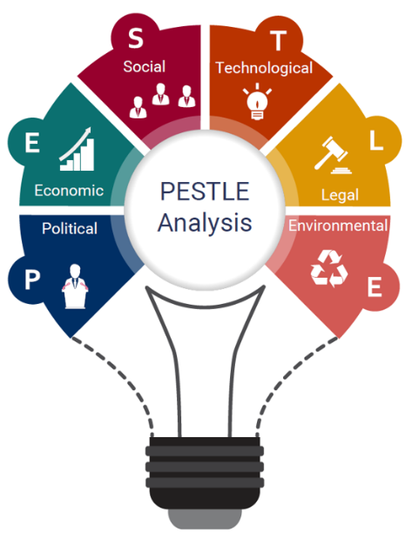
Figure: PESTEL Framework; Source: (IBISWorld, 2020)

3.1 PESTEL Analysis: France and India
The comparative PESTEL analysis shows favourable and unfavourable forces affecting Chanel's business in both France and India.
Political factors: France is a politically very stable country. It is also a member of the European Union, which offers a stable and predictable trade environment and robust IP protection. These are extremely favourable for Chanel. The French Luxury sector is a sector that is supported by the French government, and is a key part of the national economic identity (Kapferer and Bastien, 2017). Not so in India, however. Not so, however, in the case of India. Foreign luxury brands have been given the much-needed opportunities by government initiatives like Make in India and Digital India. But customs policy is not cohesive and import taxes on luxury items are still too high. Prices are very susceptible, as fashion imports may be as high as 100 per cent (Kumar and Steenkamp, 2013). This is an unfavourable political factor for Chanel in India.
Economic Factors: France is one of the biggest economy in Europe. It has a high GDP per capita and a developed consumer culture for luxury goods. The overall economy is favourable to Chanel in France. The Indian economy is a polar opposite. France is the 7th largest economy in the world and 2nd largest economy in Europe, after the UK and Germany (International Trade Administration, 2026). But there is still a considerable amount of income inequality. Up to now, only a small segment of the affluent is able to use luxury. With the increasing disposable income of the urban millennials, a market for high quality products is emerging (Shukla, 2012). The economic climate in India is thus more favourable. It promises to be a very promising long-term option, albeit limited in the short term. Also, Inflation rate of India and France are respectively 4.38% and 1.85. Total sales pf Pizza Hut in India is $2.7 billion (The Times of India, 2026).
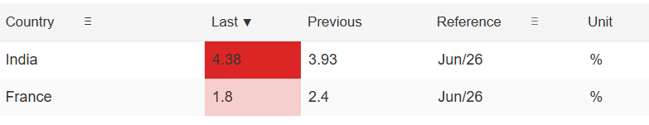
Figure: Inflation Rate of INDIA and and FRANCE; Source: (Trading Economics, 2026)
Social Factors: French people have a strong sense of fashion, heritage and craftsmanship. Chanel is a name that represents French pride with French consumers. This is a favourable social factor for Chanel in France.Opinions are very positive towards luxury consumption. In India social expectations are quickly changing. In the case of luxury brands, they are becoming more associated with social class among the urban elite, with luxury brands being used as status markers (Tynan, McKechnie and Chhuon, 2010). But unless there is mass market penetration, traditional values and price sensitivity can hinder this. This is a Partially Favourable social factor for Chanel in India. In both countries, sustainability and ethical consumption is becoming more popular, creating a common social conscience for the brand.
Cultural Factors
Hofstede Cultural Dimensions: France and India: One of the most popular models for comparing national cultures is Hofstede Cultural Dimensions model which measures national cultures through psychological dimensions (Hofstede, Hofstede and Minkov, 2010). It aids marketers in comprehending the behaviour of consumers and modifying their tactics to suit. The model consists of 6 dimensions: Power Distance, Individualism, Masculinity, Uncertainty Avoidance, Long-Term Orientation and Indulgence.
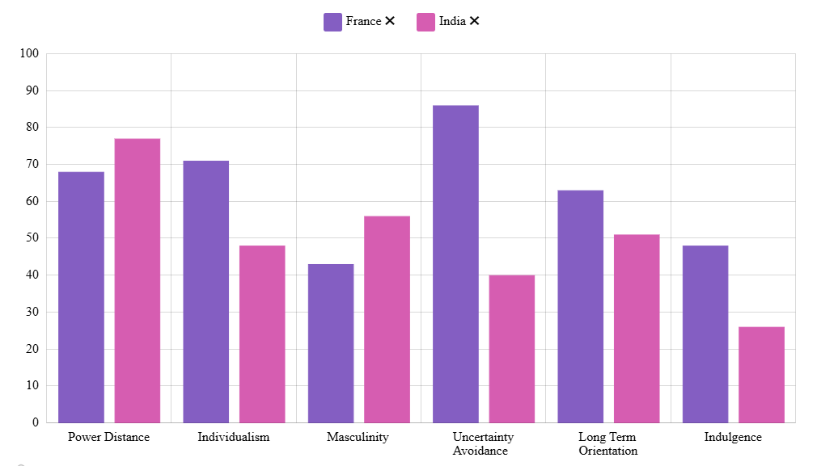
Figure: Hofstede Cultural Dimensions: France and India; Source: (Geert Hofstede, 2025)
Power Distance: France is relatively high on power distance (68), which means that hierarchy and authority are accepted. Chanel would fit in with this as they have an aspirational and elite positioning. The high-power distance index (77) in India shows the presence of a deep hierarchy in society (Geert Hofstede, 2023). In India, the luxury products are a fine emblem of the social statuses and classes, further reinforcing the exclusivity appeal of the Chanel.
Individualism vs Collectivism: France is high on individualism (71). French shoppers tend to buy things according to their own preferences and expression. This helps in Chanel's communication of personal elegance and personal style. India rates a lot lower than the other countries on the individualism index (48), which shows that they have a more collectivist culture. For many, family, peers and community norms play a factor in making purchasing decisions. Luxury brands are often bought in India to convey success to the social group (Shukla 2012). Chanel's brand story is an aspirational one within this framework and messaging needs to take into account the collective approval as well as individual expression.
Masculinity vs Femininity: France's score is 43, which means that France is moderately masculine and caring for quality of life. Indian consumers rate higher on masculinity with a score of 56, which means that they have a strong desire for achievement, success, and material display. This is in sync with Indian luxury spending – status symbols are valued and visible in their spending.
Uncertainty Avoidance: France has a high U.A. (86) score, which indicates that French consumers are not very tolerant of uncertainty. They appreciate heritage, tradition and trusted brands. These further underscores Chanel's status as a century-old brand. India has a relatively low score (40) that reflects a higher acceptance of risk and novelty, which could help foster the launch of new product lines and digital formats.
Long-Term Orientation: India is very high on the dimension of long-term orientation (LTI-51), which is the culture of persisting and saving. This indicates that consumers in India might prefer to invest in timeless luxury goods, not just passing trends, favouring classic Chanel products. France has a moderate long-term view (63).
Indulgence: France scores 48 and India scores 26 on indulgence, meaning that both cultures have some restraint. This indicates that Chanel's less ostentatious luxury and classic style will have a more attractive appeal in both markets than in-your-face branding.
Advantages and Disadvantages of the Hofstede model: There are many benefits of Hofstede model. It offers a systematic and measurable method of cross-culturing. It assists brands such as Chanel to modify the message, positioning and strategy to local values. But there are drawbacks to the model. It considers national culture as being uniform, failing to take into account regional, generational and individual differences (McSweeney, 2002). It was created in the 1970s and may not be an accurate reflection of today's cultural changes. In India, for instance, the average national score does not indicate that urban millennial consumers are more individualistic in their behaviour (Beugelsdijk and Welzel, 2018).
Technological Factors: France has a very advanced digital infrastructure. French shoppers are actively involved with ecommerce and social media. It enables a highly complex digital marketing campaign from Chanel to be used effectively. India is going through a Digitalization revolution. More than 900 million people are using the internet, and digital connectivity is growing at a fast pace (IBEF, 2025). In August 2024, Chanel launched its Indian e-commerce site which spans more than 27,000 pin codes across the country. It also joined forces with Nykaa, India's foremost beauty e-commerce company, in May 2024. The technological landscape is becoming more conducive to Chanel in India.
Environmental Factors: Sustainability is emerging as an issue of concern for both France and India. The EU has made sustainable supply chains (EUROSIF, 2021) and transparency in environmental reporting increasingly demanded. France has a high regulatory risk in this area. Chanel pledges to lower carbon footprint throughout the world. Urban consumers in India are becoming more conscious about the environment, especially the younger generation. But the enforcement of regulations is still quite low.
Legal Factors: France is covered by EU regulations, which give strong protection for consumers, anti-counterfeiting and IP rights. It's very good for a high-end brand such as Chanel. In recent years, India has made progress in the field of intellectual property. But, fake luxury goods are still a major problem in the Indian market place (Phau and Teah 2009). Protection of brands is progressing but still in the process of development. This is still a partially unfavourable legal risk for Chanel in India.
Table: PESTEL Similarities and Differences
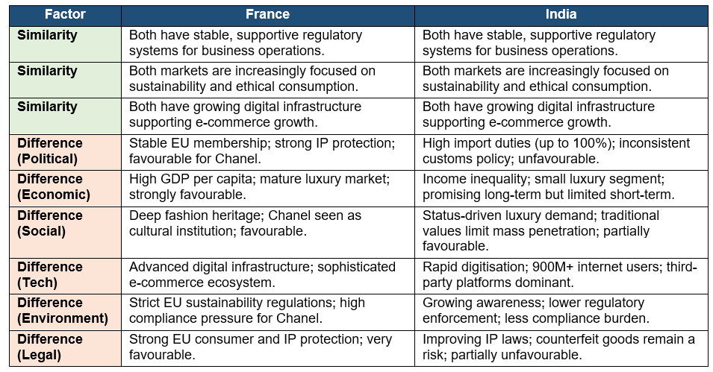

4. Comparative STP and 7Ps Analysis

4.1 Segmentation, Targeting, and Positioning
Segmentation in France: Chanel uses a mix of demographic and psychographic segmentation for the market in France. The main target market is the high net worth female between 25 and 60 years old. Chanel's products appeal to those who appreciate heritage, artisanal craftsmanship and timeless elegance, psychographically. There is also a younger group of fashion-conscious consumers who have aspirations of owning Chanel products, but are not the target audience. France is Chanel's "home market". Knowing the brand is almost universal. The company can thus be segmented more finely to appeal to both loyal customers from the old monetary system and new customers from the new.
Demographic Segmentation (France): Chanel segments its market based on women's age range (25-60) and their net worth as well as their disposable income. The secondary market demographic are younger women (18 - 30) who would like to access entry-level products like fragrance and beauty. The main interest lies in geographically Paris and large French cities.
Demographic Segmentation (India): Chanel goes after women in metros areas (Mumbai, Delhi, Bengaluru, Chennai) between 25 and 50 years of age and they have high purchasing power. Targeting the aspirational urban millennial segment of 22 – 35-year-olds, the beauty and fragrance segment is being targeted through the Nykaa partnership at a lower price point.
Geographic segmentation: Chanel focuses its physical presence in Paris and other cities in France that are rich in fashion-oriented and high-spending consumers, such as Cannes, Lyon and Deauville. The idea of geographic segmentation is focused on the metros of Mumbai, Delhi, Bengaluru and Chennai, and e-commerce and the Nykaa connection have helped reach Tier 1 and Tier 2 cities in India as well.
Psychographic segmentation, VALS: Chanel's main psychographic segments in both markets are close to the Achiever and Experiencer segments defined by the VALS (Values, Attitudes and Lifestyles) framework which are image-conscious, younger and trend-driven consumers desiring self-expression, and the smaller, high-resource Innovator segment who set the trends instead of following them. (Kotler and Keller, 2016). The Achiever segment is represented by urban professionals in India, and the Experiencer segment by digital natives (Gen Z), while the Innovators and Achievers are more balanced across a wider and older client base in France.
Segmentation in India: Chanel's segmentation strategy in India is very focused and target a smaller and better class. The main segment is that of high-net-worth individuals and urban professionals who are based in metropolitan cities like Mumbai, Delhi and Bengaluru. Consumers who are looking for status, affiliation to the global brand and exclusivity are targeted in Psychographic segmentation (Shukla, 2012). The middle class segment is growing in Tier 1 and Tier 2 cities, as digital access grows and disposable income increases, among aspirational millennials and Gen-Z consumers. Chanel's association with Nykaa in 2024 is an attempt to tap this new target group.
Targeting in France: In France, Chanel uses a differentiated targeting strategy that offers several different segments with different products: couture and leather goods, which are the brand's traditional offering, are aimed at a more restricted target group, while fragrance and beauty products are a more appealing product for a broader and more aspirational target group.
Targeting in India: In India, Chanel pursues a concentrated targeting strategy for ready to wear and leather goods, targeting only the top 1 to 2 percent of the market that have a high net worth. The strategy goes more towards the differentiated pathway for the fragrance and beauty segment, where the company is creating a larger base of consumers from the urban, digital segment with the Nykaa partnership, Fashion bi reported (2025).
Positioning in France: Chanel marks itself as the epitome of French haute couture. The brand story is about Coco Chanel's revolutionary impact, timeless designs and national pride. Consumer perception of Chanel in France is not an ordinary commercial brand, but is a real and true cultural institution (Kapferer and Bastien, 2017). The positioning has been smartly chosen to emphasize the exclusivity, heritage, and empowerment of the feminine.
Positioning in India: In India Chanel positions itself as a luxury icon of the world that is a symbol of modern femininity, sophistication and success. The brand takes its slogan from the French tradition, which is a sign of authenticity. Chanel, whose competitors had been scaling up quickly in India, maintained a presence that was carefully thought out and planned. This is a way that complements its premium status. This was an important gesture of recognizing Indian culture and reinforcing global prestige through the Paris-Bombay Métiers d'Art show in Paris in 2011 (Martins, 2025).
Perceptual Map: Chanel in India
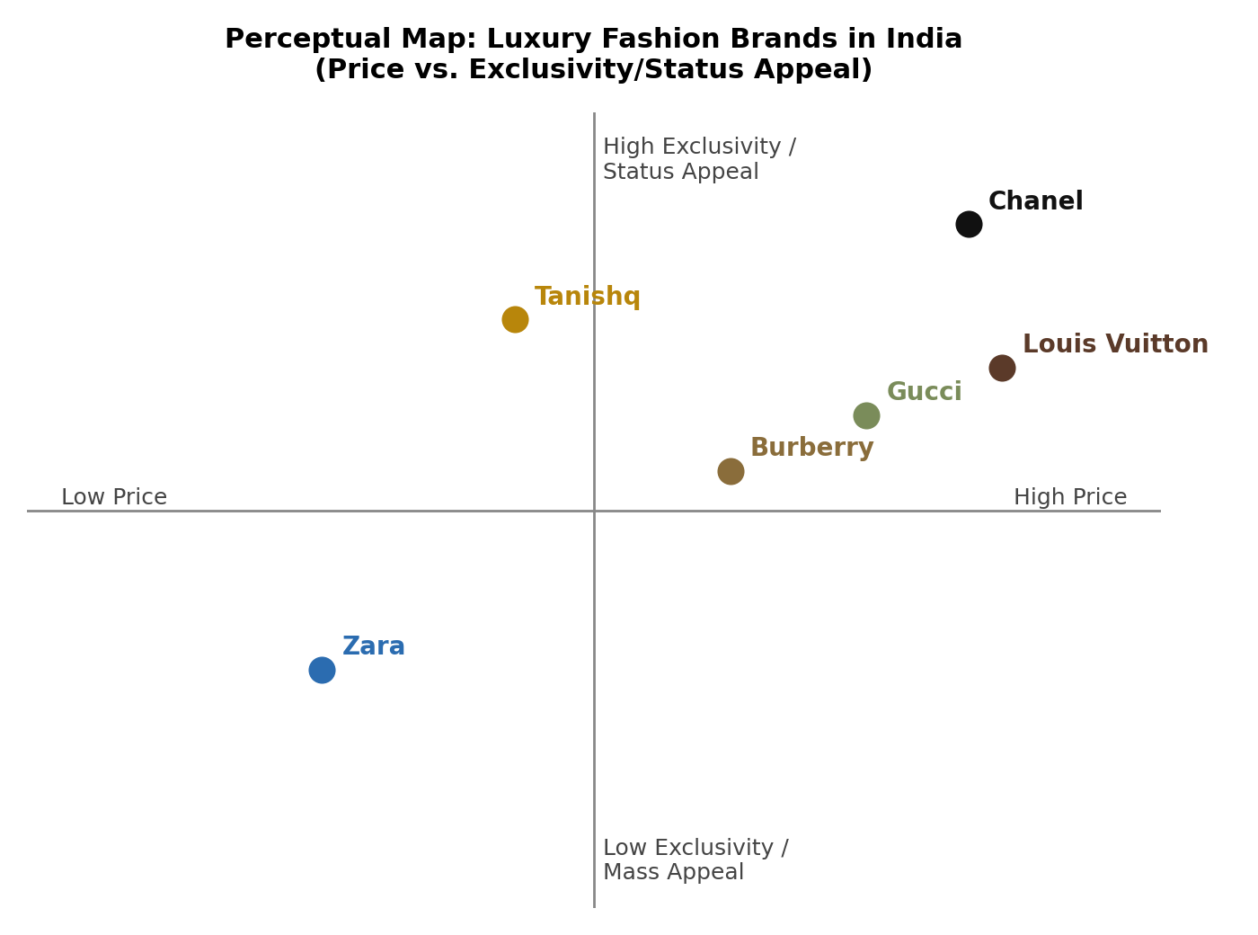
Figure: Perceptual map of luxury fashion brands in India; Source; Author
Chanel and Louis Vuitton are in the high price and high exclusivity zone, while Zara is in the low price and mass appeal zone, with Gucci and Burberry in between. The domestic jewellery company, Tanishq, occupies a middle price and prestige range, embodying culturally connected prestige. This positioning confirms that, in India, the most salient brand in their perception field is Louis Vuitton and not any domestic player, which is why Chanel's case for maintaining a pure positioning, exclusive rather than mass-market is supported.
Similarities and Differences: The main concept of exclusivity and timeless elegance are common in both countries. The basic brand identity is the same throughout the world. The breadth of segmentation and targeting is, however, very different. Chanel caters to a wider audience of fashion buyers in France. The target audience in India is far more restricted and there is a definite target on high-net-worth individuals. There is also a difference in the communication angle. France is a country that values cultural heritage. India places a priority on the aspiration and status in the world.

4.2 Marketing Mix (7Ps): France and India
Product and Product Mix Width and Depth: Chanel's main product lines are ready-to-wear fashion, fine jewellery, watches, fragrances, cosmetics, and leather goods. The complete range is offered in France, including haute couture. The product offering is more discriminating in India. It sells only through its boutiques ready-to-wear leather goods, jewellery and watches. The 2024 e-commerce platform is limited to just fragrances, cosmetics and eyewear. However, Chanel is not selling its luxury leather products in India online, as per the company's policy, it is limited to ‘tactile luxury categories' (Fashion bi, 2025). This product strategy takes into account the cultural and logistical aspects of India. The number of different lines of products Chanel sells worldwide is width. The number of variants included within each line is the depth, such as the Fragrance line, which has No. 5, Coco Mademoiselle, Chance, Gabrielle and Bleu de Chanel. Chanel's breadth is relatively small and depth deep, there are few product lines each of which have many established variants, and this serves to reinforce exclusivity and heritage as opposed to mass-market breadth.
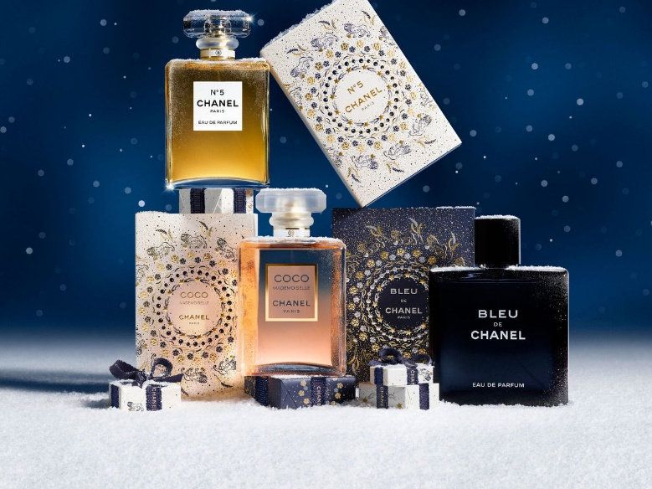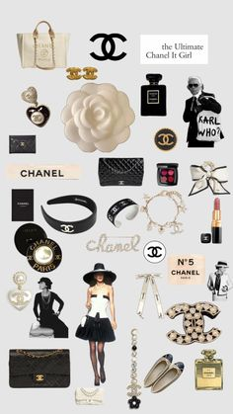
Figure: Product depth variants within the fragrance Figure: Product Width of Chanel
Source: (Nair, 2025) Source: (Pinterest, 2026)
Price: Chanel uses high prices throughout the world. In France, prices are based on the brand's domestic market status. There are high import taxes on other markets, but not on products. Import duty in India can run up to 100 per cent on luxury items and this also contributes to the increased price in India (Kumar and Steenkamp, 2013). The price of a Chanel Classic Flap bag in France is around EUR 10,000 whereas in India after duties and taxes, it can be substantially higher.
Pricing strategy: In both markets Chanel uses a premium (prestige) pricing strategy, in which price conveys the quality, scarcity and status of the product, not primarily its production cost (Kotler and Keller, 2016). This is strengthened in France by the policy of the global price uniformity, which aims at ensuring the protection of exclusivity in markets. In India, the same prestige pricing strategy is accentuated by cost-plus elements due to import duties, meaning the final price reflects the pricing strategy for prestige positioning as well as the unavoidable cost of entering the market.
Place: Chanel has flagship stores in France, such as its 31 Rue Cambon store in Paris. It also has an established ecommerce platform for its products all over the world. Chanel's stores are located in the top malls in India as a premium store, and also operates several Chanel stores in New Delhi, Mumbai, and Chennai. In 2024, the brand introduced its very own e-commerce website for India that delivers throughout the country at 27,000 postcodes. The Nykaa partnership took distribution to Tier 2 & Tier 3 cities. The place strategy in India is less complete and has a more progressive approach than France.
Distribution channels: In both markets Chanel relies on direct, selective distribution designed to protect exclusivity (Hollensen, 2020). In France this is a single-level channel of Chanel-owned boutiques and Chanel's own e-commerce platform, keeping full control with the manufacturer. In India the same direct model applies to boutiques and the 2024 e-commerce site, supplemented since 2024 by an indirect, selective channel through the Nykaa Luxe partnership, but for fragrance and beauty products only. Photographs of individual Chanel boutiques could not be reproduced in this report for copyright reasons; the diagram below therefore illustrates the channel structure rather than store photography.
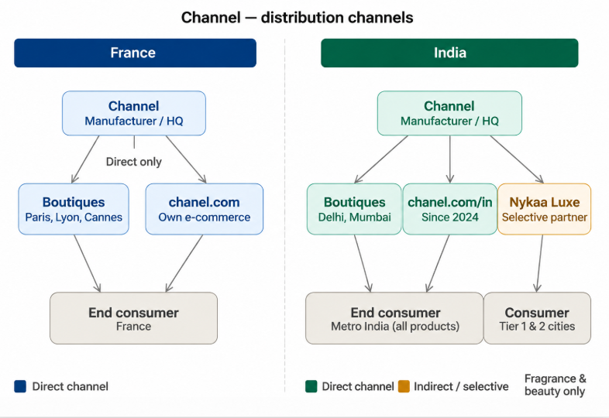
Figure: Distribution Channel Diagram; Source: Author
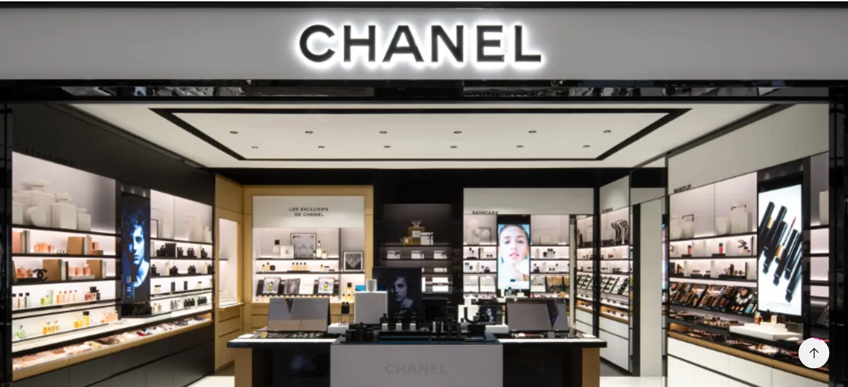
Figure: Chanel Store in India; Source: (Desai, 2024) Figure: Chanel Store in France; Source: (Deeny, 2018)
Promotion: Integrated Marketing Communications (IMC) is the synergic application of several communication elements: advertising, digital media, public relations and personal selling in order to convey a clearly defined brand message to all the points of contact that the brand has with the customer (Kotler and Keller, 2016). Chanel relies on high fashion editorial campaigns, TV advertising, runway shows and digital media in France. The brand's message is in French, reflecting national pride. The promotional strategy in India is going digital. Chanel is leveraging Instagram, YouTube and even working with Indian influencers and stylists. The Nykaa partnership enabled influencer-led campaigns and content specifically geared towards Indian beauty shoppers. Chanel's promotion in India is still subtle and aspirational, without going over the top with mass marketing efforts that risk diluting the brand's cachet (Tynan, McKechnie and Chhuon 2010).
People: Chanel employs extensively trained staff in both countries. In France, sales staff is expected to embody the brand and provide a personalised experience for clients. The brand will invest in training beauty advisors at Nykaa Luxe stores across India to ensure that they uphold the Chanel standard. Leena Nair, who was appointed as the Global CEO in December 2021, comes with an Indian background – a symbolic kind of influence for the Indian market.
Chanel employed around 38,000 workers around the world at the end of 2025 of which about a third were employed in France where design, manufacturing and head-office functions are concentrated (Chanel Limited, 2026; Revelio Labs, 2026). The number of Chanel employees in India is not published by the company, but is estimated to be in the low hundreds, not in the thousands, given that there are few counter and boutique locations in the country.
Process: The process of the customer journey is different in the two markets. It includes couture appointments, custom fittings, and unique client events in France. In India, the process is going on refinement with digital touch points. In 2024, the shopping platform will feature virtual try-on functionality for sunglasses and lipsticks, online booking of boutique appointments and personalised gifting options. This is a conscious process innovation that is geared towards meeting consumers' needs in India, who are increasingly digital.
Customer complaints process: Customer complaints are dealt with mainly by the client advisors within the boutiques, a global customer care telephone line and a customer care email in both markets, and since 2024, a live chat feature in the India e-commerce platform. As with the luxury retail norm of personalised, discreet complaint handling, instead of a public-facing channel for complaints, escalated or product-quality complaints are directed to regional client relations teams for resolution (Jobber and Ellis-Chadwick, 2019).
Physical Evidence: The Chanel outlets in France and India have a similar aesthetic identity: they are low-key, monochromatic and rich in luxury materials. Stores are bigger and have a wider selection of product categories in France. Boutiques are smaller and well-curated in India. All Nykaa Luxe stores stocking in Chanel are consistent in merchandising. Physical environment fosters trust and is a quality communicator in both markets.
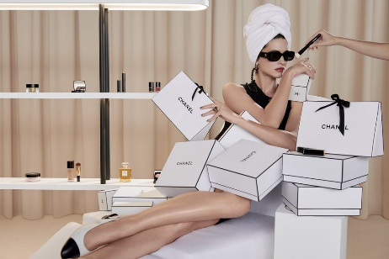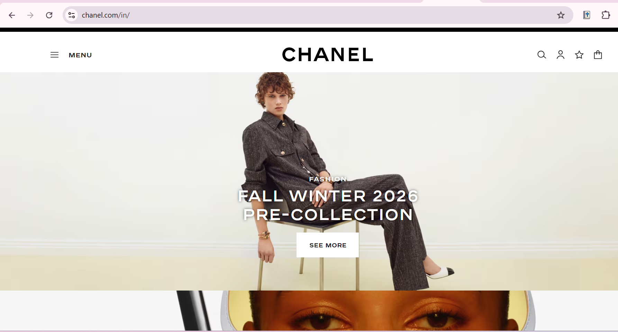
Figure: Packaging and Website of Chanel India; Source: (Martins, 2025)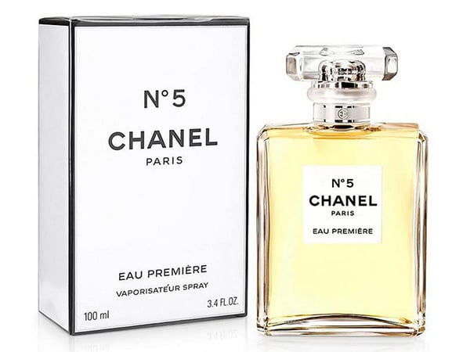 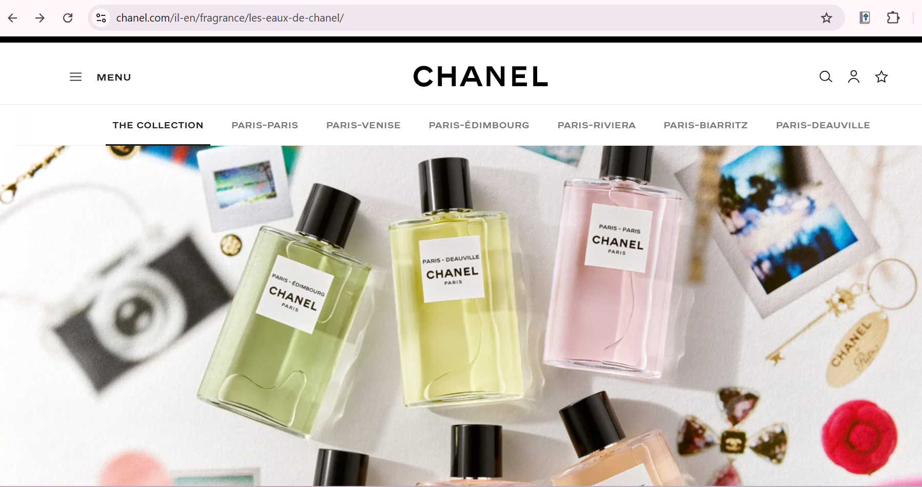
Figure: Chanel Packaging and website of France; Source: (Packly, 2022)
Table: 7Ps Similarities and Differences
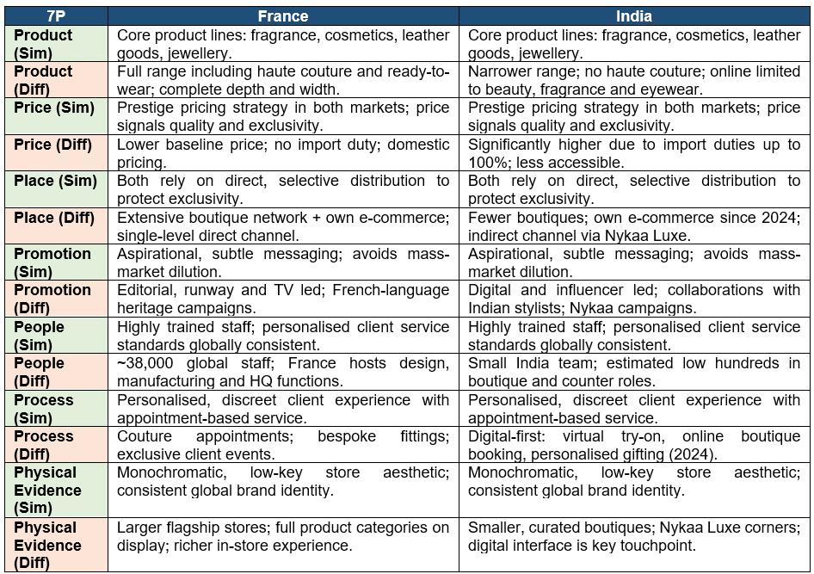

5. Market Entry Strategy in India
The Chanel's decision to enter India was to use a wholly owned subsidiary model as a main tool in their market entry. The brand did not rely on franchising or joint ventures, but instead maintained 100% control of the brand, brand image, and customer experience (Hollensen, 2020). This is in line with Chanel's worldwide message of never compromising on quality or brand image.
In 2005, Chanel's first boutique in India was opened at The Imperial Hotel in New Delhi. It was a completely managed operation as part of the company's international retail model. Later, openings in Mumbai and Chennai were based on the same premise. The brand did not tie up with Indian franchise partners/third party retailers for its ready-to-wear and accessories division.
However, an exception to this was in 2024, when Chanel joined Nykaa for its Fragrance and Beauty segment. This collaboration is, in fact, a selective distribution agreement and isn't a complete market entry strategy. It gave Chanel the opportunity to experiment with digital retail in India with a trusted local partner before it went all in on an independent e-commerce platform (Fashion bi, 2025).
Benefits of the Wholly Owned Subsidiary Approach: It ensures that Chanel has full control over how the brand is presented, its pricing, employees' payroll, and customer experience. It ensures against brand dilution. It helps to not lose the luxury positioning due to partner actions. It also enables for complete feasible maintenance of earnings (Douglas and Shanks, 1929).
Disadvantages: This method is labour-intensive and complicated to operate. India's regulatory and customs landscape can be complex and nuanced, and this requires local expertise to navigate. Expansion of the boutique is limited due to slow pace. The brand could take longer to adjust to the local culture without local partners (Hollensen, 2020).

6. Ethical Issues in Chanel's Marketing Mix in India
Ethical Practice 1 (Promotion): Chanel's promotion plans have been ethical and have been measured in India. The brand does not participate in manipulative or aspirational advertising which sets unattainable beauty ideals. It has included a diversity of skin tones in its campaigns, such as Les Beiges, which recognize the variation in skin tones. This is a good example of responsible beauty marketing in a society where colourism is still a problem.
Ethical Practice 2 (Process): Chanel's 2024 e-commerce entry into India featured virtual tries on and customised consultation platforms. These attributes enable consumers to shop without the pressure to buy. Transparent pricing and clear product information on the platform is a reflection of the desire to empower consumers, which is a part of ethical marketing (Kotler and Keller, 2016).
Unethical Concern 1 (Price): The pricing strategy of Chanel in India is a concern to them.The price of Chanel in India raises a concern as it is unethical. Importing materials makes prices much higher in the Western markets. This implies that Indian consumers have to pay much more for the same products. In addition, Chanel has made several price hikes around the world since 2021, which has led to worries about the fairness of the prices and the exploitation of brand loyalty (Phau & Teah, 2009).
Unethical Concern 2 (Place): Chanel was unable to set up a website in India for many years. This move was driven by commercial interests but had the effect of keeping everyone but the big city consumer from enjoying the brand. The decision had an adverse impact on the smaller cities as they were also able to afford and buy Chanel products, but were not given a chance physically. This selective exclusion can be seen as a distribution practice that was ethically questionable and was a form of urban privilege.

7. Recommendations
The following recommendations are suggested to boost Chanel's international marketing strategy in France and India.
Recommendations for France:
- Extend the fashion editorial reach to younger French consumers by creating immersive content, on Instagram and on YouTube.
- Overcome regulatory hurdles to EU regulation and facilitate speedier commitments to sustainability. Make green/environmental targets with carbon reductions clear to keep trust with green-minded French consumers.
- Maintain control over competitors' access to the market. To keep the boutique brand and regulated e-commerce to maintain the prestige positioning.
Recommendations for India:
- 2. Extend Nykaa Luxe to Tier 2 cities to build the luxury aspirational beauty consumer base without compromising on the luxury positioning (Hollensen, 2020).
- Expand on Paris-Bombay's example and introduce a few limited beauty products to the Indian market with shades that are more in line with the skin tones of the Indian sub-continent.
- Invest in Digital campaigns on Instagram and YouTube, with Indian stylists, to boost brand awareness among urban millennials and Gen Z.
- Ensure that there is a push by the Indian Government to lower tax rates on luxury products, thereby expanding the availability of luxury goods and not affecting the brand value.

Section 2

Reflection: Gibbs' Reflective Cycle
This section will be a reflection on the research, analyses and writing of Section 1 of this assessment, utilizing the Gibbs' (1988) Reflective Cycle, description, feelings, evaluation, analysis, conclusion and action plan, to critically review my own learning.
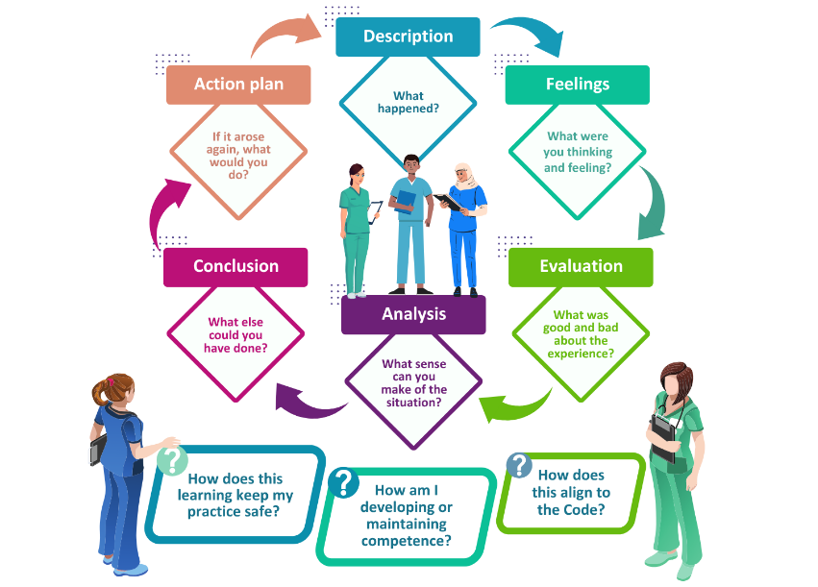
Figure: Gibbs' Reflective Cycle; Source (Nmbi.ie, 2025)
Description
In this assignment I was given the task to analyse Chanel's international marketing strategy for France and India. I started by investigating the background of the company and then used a number of frameworks: PESTEL to compare the macro-environment of both countries, Hofstede's cultural dimensions to grasp consumer behaviour, and STP and the 7Ps to compare segmentation, targeting, positioning and marketing mix across the two markets. I then studied the market entry strategy of Chanel in India and looked at the ethical issues which come up while using the marketing mix and finally came up with a set of practical recommendations. The primary sources consisted of the company's financial results, industry commentary, government trade data and peer-reviewed journal articles that I used in my comparative argument, rather than in two distinct country reports.

Feelings
I was reasonably confident with the frameworks that I used at the beginning of the assignment as they have been introduced in great detail in the module (PESTEL and 7Ps). Indeed, I was not as comfortable when introducing the less familiar tools like VALS segmentation and perceptual mapping and felt initially unsure of how to present these clearly and concisely. I was also frustrated when I found there was no public information about a formal complaints process or the number of staff at a boutique in India, which I found made it difficult to be certain about my reportage in these areas. As this analysis developed, and I started to notice there was a direct connection between, say, Hofstede's power distance scores and Chanel's positioning decisions, I became more confident in the writing and it became more coherent.
Evaluation
Looking back, the best part of the work was the linkage of different frameworks into a unified argument instead of keeping them as separate boxes to tick, and using recent developments that can be verified such as the launch of e-commerce in India by Chanel or its partnership with Nykaa which gave the analysis some ground in reality, beyond theory. Where there was no hard data, for example where there was no specific country information, the weaker elements of the work have been based on general patterns of industry in that country, and in India specifically, on India's disclosures by Chanel and on my own experience and observations over many years. I have deliberately not concealed this, but rather made it clear that such observations have not been verified by hard data. The possibility of over-generalising the national scores of Hofstede onto individual Indian consumers (which I tried to control but could not do away with completely) was also a risk.
Analysis
In the model, I believe that reflection is best achieved by guiding a learner from describing an experience to critically analysing why it was the way it was, and in applying this to the previous drafts of my models, I can see that I very much described what each framework said, but it wasn't until I redrafted later and received feedback from my tutors that I began to analyse and explain why each experience was the way it was for Chanel's strategy. Ryan (2013) is right that there is a balance to be struck when writing reflective academic work between a personal description and a grounded theory; it was obviously easy to simply say "data was missing", but a careful consideration of the best available data and a logical and honest assessment of our uncertainty, was more useful. Reflection can also enhance understanding best when approached as an ongoing (iterative) process, rather than a single event, using feedback on and new evidence to revisit and revise an analysis, according to Husebø, O'Regan and Nestel (2015). This is how the feedback comments on my initial draft worked in practice: with each comment there was a minor cycle of re-reading evidence, adding missing detail and fine tuning the argument, all three of which are described by the authors as being at the heart of true learning as opposed to mere conforming.
Conclusion
Overall, I feel that the goal of the assignment was met of comparing the strategy of Chanel for two very different markets, and that it did so on an evidence basis and not an assumption basis. If I had to do this again, I think I would have created comparative tables earlier in the research process and not as an afterthought, because that would have revealed data gaps, such as the number of Indians in their staff, earlier and would have given me more time to find the best available proxy evidence. I would also be stricter about citing at least two independent sources for the information I would include, especially if it is something that fluctuates from year to year, like employee numbers, or inflation rates.
Action Plan
In the future, I will create comparison tables and diagrams at the note-taking phase of future assignments in order to have visual and written analysis created simultaneously. I will also check quantitative claims with primary company sources, like annual reports, before drafting, look for feedback at a much earlier point in the writing process, and plan diagrams and visuals earlier in the process of writing, not as an afterthought.

Conclusion
To sum up, Chanel had held a solid luxury standing in both France and India through careful segmentation, a selective distribution strategy and the strict control of the brand. Its analysis had revealed it had a more mature strategy in France, and premium adaptation and digital expansion was the growth opportunity in India.

References
Aithal, S., (2017). A critical study on Various Frameworks used to analyse International Business and its Environment. International Journal of Applied Engineering and Management Letters.
Beugelsdijk, S. and Welzel, C., 2018. Dimensions and dynamics of national culture: Synthesizing Hofstede with Inglehart. Journal of cross-cultural psychology, 49(10), pp.1469-1505.
Comparably (2026). CHANEL Mission, Vision & Values. [online] Comparably. Available at: https://www.comparably.com/companies/chanel/mission [Accessed 24 July 2026].
Coulson, D. and Harvey, M., 2013. Scaffolding student reflection for experience-based learning: A framework. Teaching in Higher Education, 18(4), pp.401-413.
Deeny, G. (2018). Chanel opens massive new Paris flagship. [online] FashionNetwork.com. Available at: https://ww.fashionnetwork.com/news/Chanel-opens-massive-new-paris-flagship,1038185.html [Accessed 6 Aug. 2026].
Desai, K. (2024). ELLE Exclusive: A Walk Through Chanel’s New Boutique In The Mall Of India, Noida. [online] Elle India. Available at: https://elle.in/elle-exclusive-a-walk-through-chanels-new-boutique-in-the-mall-of-india-noida/ [Accessed 6 Aug. 2026].
‌Douglas, W.O. and Shanks, C.M., 1929. Insulation from liability through subsidiary corporations. The Yale Law Journal, 39(2), pp.193-218.
EUROSIF. (2021). Corporate Sustainability Reporting - EUROSIF. [online] Available at: https://www.eurosif.org/policies/csrd-sustainability-reporting/ [Accessed 5 July 2026].
Fashion bi (2025). Chanel’s Ambitions in India: From Boutique-Only to E-Commerce Entrance. [online] Fashionbi.com. Available at: https://www.fashionbi.com/insights/chanel-s-ambitions-in-india-from-boutique-only-to-e-commerce-entrance [Accessed 4 July 2026].
Fashion bi (2026). Home | Fashionbi. [online] Fashionbi.com. Available at: https://www.fashionbi.com/ [Accessed 5 July 2026].
fashionabc. (2021). Chanel - fashionabc. [online] Available at: https://www.fashionabc.org/wiki/chanel/ [Accessed 24 July 2026].
Geert Hofstede. (2025). Country Comparison Bar Charts - Geert Hofstede. [online] Available at: https://geerthofstede.com/country-comparison-bar-charts/ [Accessed 7 July 2026].
Gross, R.E. (2024). A Brief History Of The House Of Chanel: Coco Chanel To Virginie Viard. [online] Forbes. Available at: https://www.forbes.com/sites/rachelelspethgross/2024/07/31/a-brief-history-of-the-house-of-chanel-coco-chanel-to-virginie-viard/ [Accessed 22 June 2026].
Hoftede, G., Hofstede, G.J. and Minkov, M., (2010). Cultures and organizations: software of the mind: intercultural cooperation and its importance for survival. McGraw-Hill.
Hollensen, S., (2020). Global marketing (pp. 978-1). Harlow: Pearson.
Husebø, S.E., O'Regan, S. and Nestel, D., 2015. Reflective practice and its role in simulation. Clinical Simulation in Nursing, 11(8), pp.368-375.
IBEF (2025). India’s internet users to exceed 900 million in 2025, driven by Indic languages. [online] India Brand Equity Foundation. Available at: https://www.ibef.org/news/india-s-internet-users-to-exceed-900-million-in-2025-driven-by-indic-languages/ [Accessed 7 July 2026].
IBISWorld (2020). How to Conduct a PESTLE Analysis. [online] ibisworld. Available at: https://www.ibisworld.com/blog/3-step-pestle-analysis/99/1127/ [Accessed 24 July 2026].
International Trade Administration (2026). France Country Commercial Guides. [online] International Trade Administration | Trade.gov. Available at: https://www.trade.gov/country-commercial-guides/france-market-overview/ [Accessed 7 July 2026].
Jobber, D. and Ellis-Chadwick, F., (2019). EBOOK: Principles and Practice of Marketing, 9e. McGraw Hill.
Kapferer, J.N. and Bastien, V., (2017). The specificity of luxury management: Turning marketing upside down. In Advances in luxury brand management (pp. 65-84). Cham: Springer International Publishing.
Kotler, P. and Keller, K.L., (2016). A Framework for Marketing Management-6/E.
Kumar, N. and Steenkamp, J.B.E., (2013). Brand breakout: How emerging market brands will go global (Vol. 18). New York: Palgrave Macmillan.
Martins, M. (2025). Chanel partners with Nykaa to expand presence in India. [online] FashionNetwork.com. Available at: https://ww.fashionnetwork.com/news/Chanel-partners-with-nykaa-to-expand-presence-in-india,1728662.html [Accessed 24 July 2026].
McSweeney, B., (2002). Hofstede’s model of national cultural differences and their consequences: A triumph of faith-a failure of analysis. Human relations, 55(1), pp.89-118.
Nair, S. (2025). Chanel Beauty brings its enchanted symbols to life for Winter 2025. [online] Prestige Online - Singapore. Available at: https://www.prestigeonline.com/sg/style/fragrances/chanel-beauty-brings-its-enchanted-symbols-to-life-for-winter-2025/ [Accessed 6 Aug. 2026].
Nmbi.ie. (2025). NMBI - Standards, guidance for nurses and midwives: NMBI. [online] Available at: https://www.nmbi.ie/Standards-Guidance/Professional-Competence-Scheme/Reflection/Gibbs-Reflective-Cycle [Accessed 6 Aug. 2026].
‌Packly (2022). Packaging and Chanel N°5: The story. [online] Packly. Available at: https://www.pack.ly/en/blog/post/packaging-and-chanel-n5-the-story [Accessed 24 July 2026].
Phau, I. and Teah, M., (2009). Devil wears (counterfeit) Prada: a study of antecedents and outcomes of attitudes towards counterfeits of luxury brands. Journal of consumer marketing, 26(1), pp.15-27.
Pinterest. (2026). [online] Available at: https://www.pinterest.com/hannahblynn/all-things-chanel/ [Accessed 6 Aug. 2026].
Ryan, M., 2013. The pedagogical balancing act: Teaching reflection in higher education. Teaching in Higher Education, 18(2), pp.144-155.
Seo, Y. and Buchanan-Oliver, M., (2015). Luxury branding: the industry, trends, and future conceptualisations. Asia Pacific Journal of Marketing and Logistics, 27(1), pp.82-98.
Seo, Y. and Buchanan-Oliver, M., (2015). Luxury branding: the industry, trends, and future conceptualisations. Asia Pacific Journal of Marketing and Logistics, 27(1), pp.82-98.
Shukla, P., (2012). The influence of value perceptions on luxury purchase intentions in developed and emerging markets. International Marketing Review, 29(6), pp.574-596.
‌The Times of India (2026). Yum Brands sells Pizza Hut in $2.7bn deal. [online] The Times of India. Available at: https://timesofindia.indiatimes.com/business/international-business/yum-brands-sells-pizza-hut-in-2-7bn-deal/articleshow/131783462.cms [Accessed 24 July 2026].
‌Trading Economics (2026). INFLATION RATE by Country in G20. [online] Tradingeconomics.com. Available at: https://tradingeconomics.com/country-list/inflation-rate [Accessed 24 July 2026].
Tynan, C., McKechnie, S. and Chhuon, C., (2010). Co-creating value for luxury brands. Journal of business research, 63(11), pp.1156-1163.

