Developing Innovation Leadership

An Introduction to Practicing Effective Ideation

Meet the Team
On this page you should include details of who is in the team, include names and student numbers. A picture of each team a member would also be nice.

TABLE OF CONTENTS
1. Introduction 4
2. Learning Plan 6
3. Justification of Methods 8
4. How we achieved the task 10
5. References 11

Introduction
As a result of the relentless march of globalisation and increasing customer expectations, innovation has become a key driver of growth, performance and valuation (Brash, et al., 2008; Mickahail, 2015). Innovation is not just about product and service performance, it also involves business models, company configuration, distribution and customer experience (Brash, et al., 2008; de Coutere & Horth, 2016).

In the face of challenging and unpredictable circumstances, leaders cannot rely on rational decision-making based on previous patterns, as ambiguity cannot be managed away (Horth & Buchner, 2014; Mitchell, 2017). Instead, they must try to make sense of the unfamiliar, which requires innovation leadership. This means bringing new thinking and different actions to how leaders lead (approach to leadership) and how they create a climate for innovative thinking (ibid). A number of studies have been conducted in the attempt to establish the impact of leadership approach on the innovation capability of organisations (see Kesting, et al., 2015 for a review and synthesis of the literature). Though no definitive style has been identified, it is agreed the leadership antithesis to developing an innovation culture is that of command and control, especially within the ideation stage (Dodge, et al., 2017; Kesting, et al., 2015).

Design Thinking (DT) has emerged as a mechanism through which ideation can be encouraged (Liedtka, 2015; van Reine, 2017) and as a best practice through which organisations can influence corporate culture (Mickahail, 2015).

DT can be defined as “an iterative process in which we seek to understand the user, challenge assumptions we might have, and redefine problems in an attempt to identify alternative strategies and solutions that might not be instantly apparent with our initial level of understanding” (Hasso Plattner Institute of Design Stanford, 2017). The process consists of a number of defined steps as outlined in figure 5.

Figure 5: Stages of Design Thinking Process
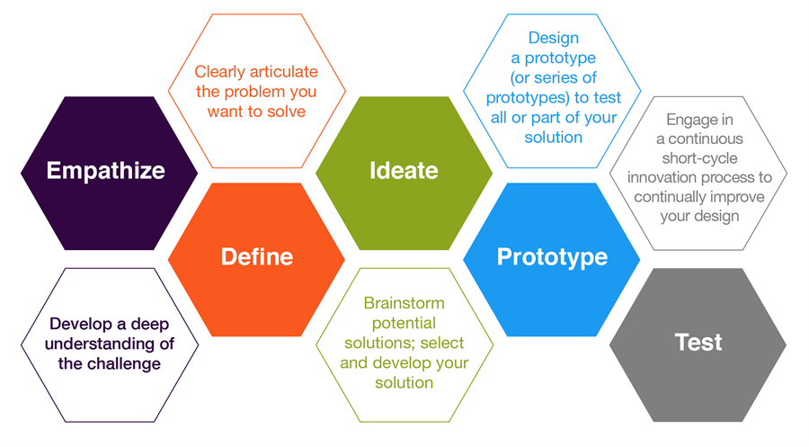

(Source: Hasso Plattner Institute of Design Stanford, 2017)

The aim of this session is to introduce the learner to the concept of ideation within the design thinking process and assumes the learner is already familiar with the overall process and previous stages.

Learning Plan

TOPIC: Innovation Using Design Thinking |  | Intended learners: Leaders at all levels
DATE: TBC | LENGTH OF LESSON: 30 minutes |  | NO IN CLASS: 12
AIM OF LESSON

The aim of this training is to provide an introduction to the ideate phase of the design thinking process.

LEARNING OBJECTIVES

At the end of this session learners should be able to:

- Define the ideate stage of the design thinking process
- Identify the resources and appropriate environment for ideation
- Practice the vote first, then discuss approach to ideation

LOCATION & ROOM LAYOUT
The session will be held in….. (insert citation in relation to learning environment)

The room should be laid out in Cabaret style


Cabaret style is best for this session because …… (insert citation)

PREVIOUS KNOWLEDGE:

The session assumes some previous knowledge of the design thinking process. Specifically, the learners should already be familiar with the first two stages, Empathise and Define.

HEALTH & SAFETY:

There are no identified risks to the learners from carrying out any of the tasks associated with the learning plan.

Justification of Methods
In this section you should refer to learning theories which justify the methods you have chosen in your plan.
You should start with Theories of Learning such as:
- Adult Learning Theory
- Experiential Learning Theory
- Group/Social Learning
- Blooms Taxonomy
Include diagrams to make the content more engaging, but ensure they are correctly labelled and referred to in your discussion as seen in figure 1.
Figure 1: Bloom's Taxonomy
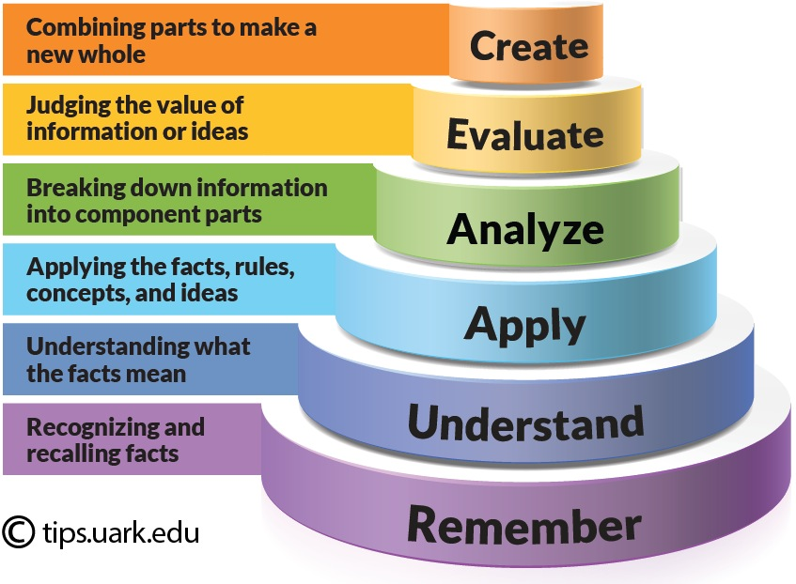

Source: University of Arkansas, n.d.

Further tips on what to include in this section to follow.

how we achieved the task
Play to the strengths of the team. If you have someone who is good at creating slides or at referencing then allocate these task accordingly.

Further tips about what to include in this section to follow.

references
You should include at least 15 individual sources of information in this section for every 2000 words. For a team of 3 this will mean a minimum of 45 sources – you should aim for 60 if you are looking to achieve distinction level marks.
Please use HARVARD referencing convention.

