Communications
&
Protocols

By Dawid Lagwa

Table of Content:

1. Abstract
2. Introduction
3. Amplitude Shift Keying
4. Phase Shift Keying
5. Quadrature Phase Shift Keying
6. Additive White Gaussian Noise
7. Simulation Results & Comparison
8. Comments & Conclusions
9. Bibliography

1. Abstract

Stuff

2. Introduction

This paper will be covering three digital modulation techniques and it will be comparing how they perform in a presence of White Gaussian Noise. The modulation techniques that will be discussed are Amplitude Shift Keying (ASK), Phase Shift Keying (PSK), and Quadrature Phase Shift Keying (QPSK). Theory behind each of previously mentioned filters will be explained, followed by construction and testing in virtual development suite called Mathlab-Simulink.

3. Amplitude Shift Keying

Each modulation technique covered by this paper requires use of a Modulator and Demodulator. Design of each modulator/demodulator is a unique affair, but this uniqueness is the very thing that provides filter its specific characteristics.

Amplitude Shift Keying (ASK) is one of several methods of Amplitude Modulation, which represents binary data in the form of variations in the amplitude of a signal. It’s widely known that any modulated signal has high frequency carrier, so when a binary signal passes through ASK, it will give zero for a low input while giving the carrier output for a high input.

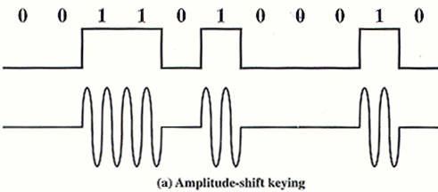
ASK Modulator
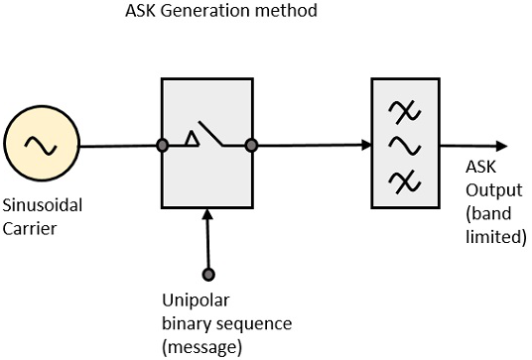
Block diagram of ASK filter is comprised of a carrier signal generator, the binary sequence with a message from the passing signal and band-limiting filter. The modular functions as followed:

Carrier generator sends a constant high-frequency carrier signal, signal is then received by the unipolar input which then set to be either to low or high, depending on the signal one of two things will occur.

-Low signal input will the switch will open preventing voltage from appearing meaning the output is low.
-High signal input will close the switch allowing the carrier wave to form, which means that the output will be the high carrier signal with a high input.

Last step of the process is to shape the pulse depending upon the amplitude and phase characteristics of the band limiting filter or pulse shaping filter.
ASK Demodulator

In the case of ASK there are two types of a demodulator, Synchronous and Asynchronous. Each one can be considered a polar opposite but in reality Synchronous method just matches clock frequency at the receiver while Asynchronous does not.

Both methods only appear to be marginally different from each other but on at a deeper level both are vastly different from one another.

Synchronous Demodulator
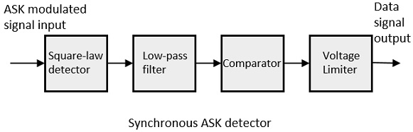

Asynchronous Demodulator
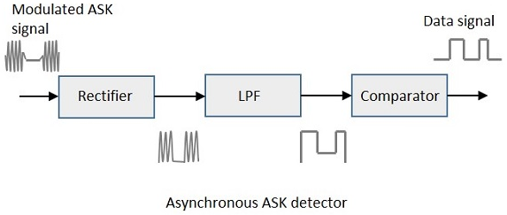

4. Phase Shift Keying

Phase Shift Keying (PSK) is a digital modulation technique, in which the phase of the carrier signal is changed by varying the sine and cosine input at the particular time. This method is best suited for wireless LAN, biometric, contactless operations and Bluetooth communications.

There are two types of PSK Quadrature Phase Shift Keying (QPSK) which will be covered later in this paper and Binary Shift Keying (BPSK). Which in principle is same as PSK and it’s often called two phase PSK, making it the subject of this section.

In BPSK ghd sine wave carrier takes two phases and reversals such as 0 degrees and 180 degrees.

BPSK Modulator
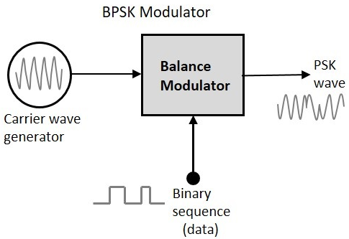
Block Diagram for this method consists of the balance modulator with two inputs and single output. First input is a carrier wave generator and second is a Binary Data Sequence, leaving the output to be a PSK modulated waveform.

Modulation in this method is done by the Balance Modulator which takes both inputs and multiplies them. This process has only two outcomes for Zero binary output the phase will be 0 degrees and in case of the high input the phase reversal is 180 degrees. In either case the output is a modulated sine wave that will be a direct output carrier or the inverted input carrier at 180 Degrees. This is the function of the data signal.
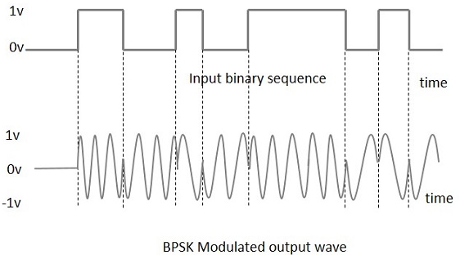

BPSK Demodulator

Block Diagram for the BPSK is composed from a Mixer with local oscilloscope circuit, a Band Pass Filter (BPF) and two input detector circuit. BPSK is divided into two stages. In the first stage band-limiting message signal is recovered with help of the mixer circuit and the BPF. When the signal is recovered the baseband signal which has been band limited is obtained then the signal regenerates the binary message bit stream, with this the first stage is complete.

For the next stage of demodulation, the bit clock rate is required at the detector circuit to produce the original binary message signal. In case if bit rate is sub multiplied by the carrier frequency, then the bit clock regeneration if simplified.
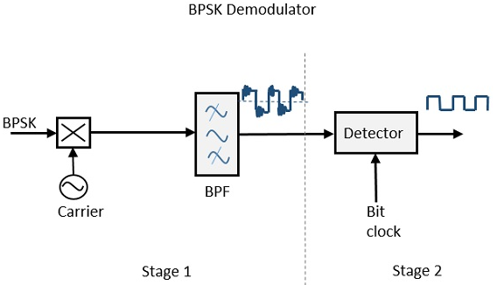

5. Quadrature Phase Shift Keying

As previously mentioned Quadrature Phase Shift Keying (QPSK) is a variation on BPSK modulator. The primary difference between two methods is that QPSK is a Double Side Band Suppressed Carrier (DSBSC) modulation scheme. This means that instead of converting digital bits into a digital stream, they are converted into bit pairs. This method enables decreasing of data bit rate by half allowing more space for other users.

QPSK Modulator

QPSK Modulator block diagram is composed of a bit splitter, two multipliers with a local oscillator, a two bit serial to parallel convertor and a summer circuit (Summer circuit sums or adds, multiple analog voltage signals together. It can be inverting or non-inverting).

Operation of QPSK modulator is bit more complex than the other modulators covered previously in this paper. At the input the message signal even bits and odd bits are separated by the bit splitter and are multiplied with the same carrier as odd BPSK. This signal is then shifted by 90 degrees before being modulated.
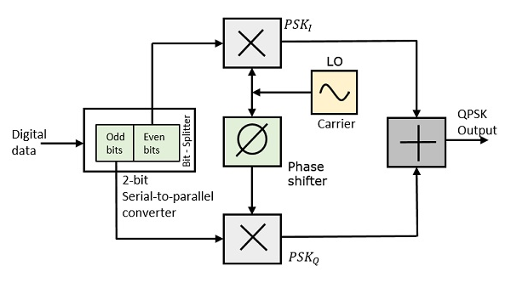

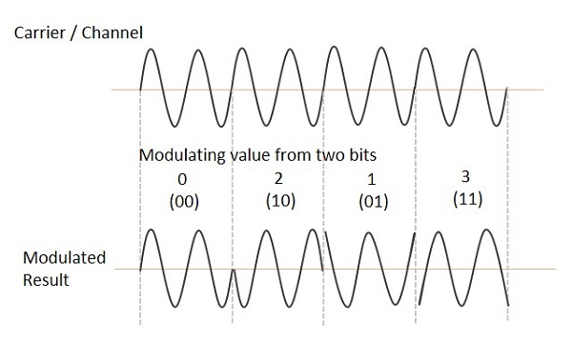

QPSK Demodulator

The block diagram for QPSK Demodulator is composed of two product demodulator circuits with local oscilloscope, two band pass filters, two integrator circuits and a two bit parallel to serial convertor.

Operation of QPSK Demodulator is far simpler compared to the QPSK Modulator. Demodulation is done by two product detectors at the input are simultaneously demodulate two BPSK Signals, the pair of bits are recovered from the original data after being processed they pass to the parallel to serial convertor. 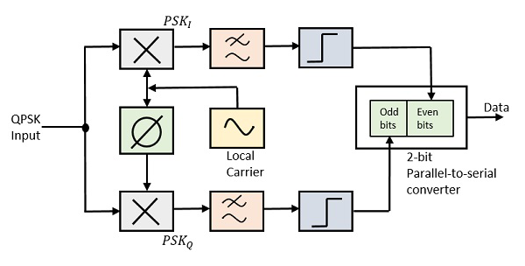

6. Additive White Gaussian Noise

Additive White Gaussian Noise can be simply described as a model of the imperfections communication channel is made of. Whenever a signal is transmitted into space or atmosphere or simply via a copper wire, by the time it arrives at its destination there will be number of disturbances also known as noise will be present in the channel. This is caused by a number of reasons such as thermal noise resulting from electronics moving in the electric circuit being used to send or receive the signal. Resulting noise is modelled as the Additive White Gaussian Noise.

Additive White Gaussian Noise can be broken down into individual terms used in the Communications Engineering. Additive-White-Gaussian-Noise. Each term has its own meaning that factors into calculating the noise.

