

Assessment Component 1
Case study - Supporting Paper

Student name: Elizabeth Cuffie
Student ID: 1913507
Module name: Children, Young People and Families
Module code: (BMHP5004_LON)
Lecturer name: Bianca Sanfilippo
Submission Date: 24/08/2022

Introduction
In this cover note, I will be presenting a case study regarding a troubled family facing adversities in North Somerset which contains factors of vulnerabilities, this case is about , single mum, her ex-partner and the son. The ex-partner does not live with them but he is fully involve in the son’s life. The main factor of vulnerability in this case is Mum’s Poor mental and physical health.

In Cambridge Dictionary online (nd), vulnerability is when someone can be easily physically or mentally hurt, influenced or attacked.
The case also talked about the intervention of the social services, the outcomes of that intervention and the Policies and legislation relating to this case is also discussed.

The Case study:
The family is a family facing adversity: a single mum, her ex-partner and their son in North Yorkshire that was referred in 2014 the ex-partner does not live in the house but he is involved in the son’s life, mum has poor mental and physical health and she is house bound which means she does not usually go out of the house so she has little or no idea of what the son is doing outside the house she was also out of work and the family was struggling financially. There was poor parenting they were also under threat of eviction due to the son’s high level of anti-social behaviour his school attendance has drop down to below 50% and he is often excluded from class because of his uncontrollable behavior.

The risk factors of vulnerability
The risk factor of vulnerability in this case was because of mum’s poor mental and physical health condition, she was house bound not going out and the son has anti-social behaviour he might even be taking drugs,according to Mental Health.gov, poor mental health involved our emotional, psychological and social well-being It can affect the way we think, feel and act It also helps to decide how we handle stress, connect to others and make decisions. factors that can also contribute to mental health problems are: biological factors, such as genes or brain chemistry, life experiences, such as trauma or abuse family history of mental health problems
Because mum has poor mental health, she might not be in a position to make sound judgement and take care of her son like a normal parent. These issues are not seen in an average family therefor the son is exposed to ham, health and safety. According to children’s act 1989 a child should be able to have a good quality of life.

The impact of Mum’s poor mental and physical health on the son’s wellbeing

According to north Yorkshire safeguarding children's partnership the impact on children whose parent or parents suffers from mental health problems can have Behavioral problems, conduct disorder, Depression, Difficulty with friendships, they can also face Difficulties at school. In this case one of the behavioral problems was high level of anti-social behavior committed by the son in the neighborhood which has led to their threat of eviction, his behavior was extremely uncontrollable. The mum could not go to work because of her poor mental health which has led to the family facing financial difficulty
According to mental health foundation, approximately 68% of women and 57% of men with mental health problems are parents. A child that is facing adversity can be classified as a child in need according to the children’s Act 1989, like in this case the child’s school ‘s attendance has dropped to below 50% and he is always excluded from class, there is no control in this child’s life no one tells him what is good or bad he just goes and comes whenever he likes.

The process of intervention by relevant health and social care agencies.
Assessment

There was an intervention process that started with a referral that was carried on based on the policy working together to safeguarding children HM Government (2018) Working Together to Safeguard Children A guide to inter-agency working to safeguard and promote the welfare of children, The intervention in this case was done based on the assessment frame work working Together to Safeguard Children A guide to inter-agency working to safeguard and which looks at three key aspects: Child’s developmental need, Parental capacity and Family and environmental factors promote the welfare of children (2018). As stated in the framework, In this case study the assessment framework focused on the key aspect which was based on parental capacity in this case was poor because of mum’s mental and physical health, based on the assessment, support was provided for the family more especially the mum and her son the United Nations Convention which talks about the Rights of the Child (UNCRC) which places a duty on the Governments to support children in need it is the that protects the right to education, safety

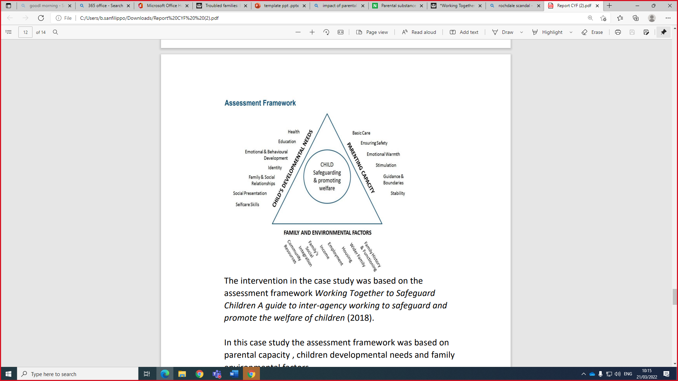

The outcome of the Intervention

Based on the assessment that was carried, The family was provided with a worker to work with them on a one to one basis to address inconsistent parenting, regular meetings were set up between mum and the school in all those times the worker was present present) parenting sessions were provided to help mum to set boundaries and routing for son, his school attendance was up to about 90%, help was provided with managing debts and payment plans were also put in place put in place these interventions were based on policies, the children’s act 2004 which state that integrating and promoting early intervention that brings in a team of multi-disciplinary teams to achieve positive outcomes. The quality Act 2010 was also applied in this case because the social services worked with the family without any form of discrimination, by providing the relevant services that were deemed necessary

6 The legislation related to the case and the work of the agencies involved
The legislation related to this case study includes

The Children Act 2004 justifies the work of the social service in multi-agency. This Act states that agencies should work in co-operation to protect children
.
Equality Act 2010 was applied in the case study as the social services worked with the family without discrimination, providing care, etc….All children should receive same care and protection…
United Nations Convention on the Rights of the Child (UNCRC) this places a duty on Governments to support children in need……this Act protects the right to education, safety , protection…
HM Government (2018) Working Together to Safeguard Children A guide to inter-agency working to safeguard and promote the welfare of children (POLICY).
Children Act 1989
Care Act 2014-Legislation .Gov.UK

Equality Act 2010 was applied in the case study as the social services worked with the family without discrimination, providing care, etc….All children should receive same care and protection…

Conclusion

The family was provided with the necessary support according to government policies and legislation, and things were getting better, there was no more complaint about anti-social behaviour and the sons school attendance was up to 93%.
Appendix: Power Point Presentation for debate WEEK 9
introduction
This power point presentation is about a case study regarding a troubled family in North Somerset,
- Mum, ex partner and their son, ex partner does not live with them but he is fully engaged in the sons life the case contains factors of vulnerability.
The main factor of vulnerability here is
- Mum’s Poor mental and physical health ,
In Cambridge Dictionary online (nd), vulnerability is when someone can be easily physically or mentally hurt, influenced or attacked.
The case also talked about
- The intervention of the social services,
- The outcomes of that intervention.
- Policies and legislation relating to this case is also discussed.



The Case Study
This is a case study from week 6 on our Moodle slides in North Somerset that was referred in 2014
Specific issues identified in this case were:
- Mum suffers from poor mental and physical health and was house bound
- Mum was out of work and struggling financially
- Poor parenting
- Threat of eviction due to high level of anti Social behaviour committed by son
- Son’s behaviour is extremely uncontrollable
- Son’s School attendance dropped to below 50%
- he’s often excluded from class when he is in school

Main Factor: Poor parental mental and physical health
According to Mental Health.gov, poor mental health involved our
- Emotional, psychological and social well-being
- It can affect the way we think, Feel and act
- It also helps to decide how we handle stress, connect to others and make decisions
factors that can contribute to mental health problems are:
- Biological factors, such as genes or brain chemistry
- Life experiences, such as trauma or abuse
- Family history of mental health problems
According to mental health foundation, approximately 68% of women and 57% of men with mental health problems are parents.

Impact on parental mental and physical health


- According to north Yorkshire safeguarding children's partnership,
- The impact of parent mental health are:
- Behavioral problems
- Conduct disorder
- Depression
- Difficulties at school
- Difficulty with friendships

Process of intervention

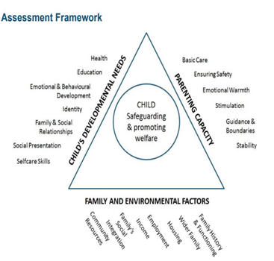

- The intervention process started with a referral that was carried on assessment based on the policy working to safeguard children HM Government (2018) Working Together to Safeguard Children A guide to inter-agency working to safeguard and promote the welfare of children.
- The intervention in the case study was based on the assessment framework Working Together to Safeguard Children A guide to inter-agency working to safeguard and promote the welfare of children (2018)
As stated in the framework, In this case study the assessment framework was based on parental capacity , child’s antisocial behavior and family environmental factors. parental capacity in this case was poor because of mum’s mental and physical health, based on the assessment, support was provided for the family.

Actions by health and social care agencies working with the family
- Working in multi-agency:

- Provide family worker to work with family to address inconsistent parenting

- Set up regular meetings between mum and the school (family worker present)
- Provide parenting sessions to set boundaries and routing for son

- Help with managing debts and payment plans put in place

Result and outcome

- Family was able to take active role in sons school life
- Mum and Dad getting involve in son’s homework
- Effective parenting: praising son for good behaviour
- No more complaint about anti-social behaviour
- Sons attending afterschool clubs which has positive impact on his behaviour
- Children’s school attendance improved to 93%.

Policies and legislation

- HM Government (2018) Working Together to Safeguard Children A guide to inter-agency working to safeguard and promote the welfare of children (POLICY).
- The Children Act 2004
- Children Act 1989
- Care Act 2014-Legislation .Gov.UK
- Equality Act 2010 was applied in the case study as the social services worked with the family without discrimination, providing care, etc….All children should receive same care and protection…
- United Nations Convention on the Rights of the Child (UNCRC) for example article 19 that places a duty on Government to protect children from abuse.

conclusion

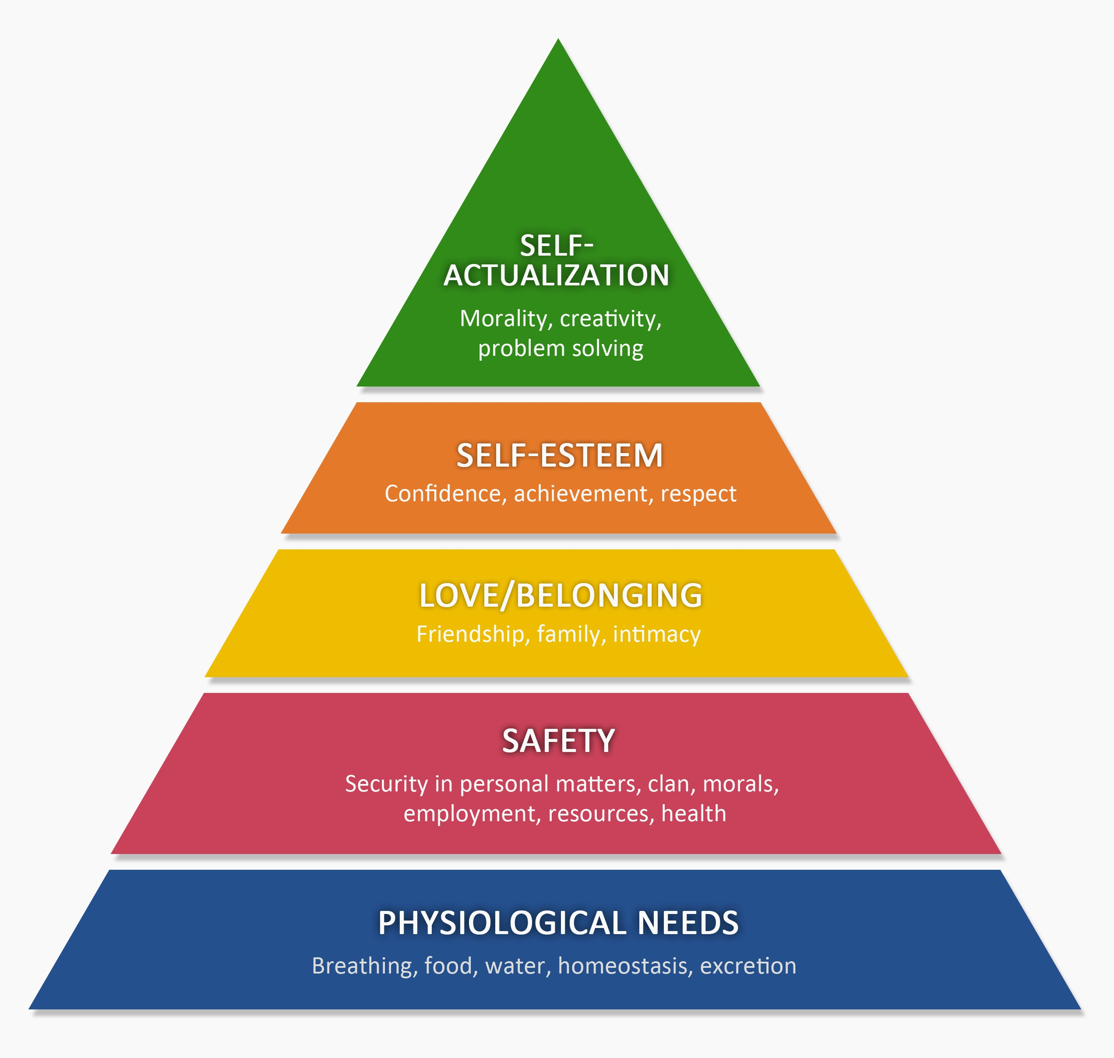

- The family was provided with support like effective parenting,
- meetings with mum and school ,
- After school club for son and
- payment plans put in place for mum all of these help but more could have been done because mum was still in poor health and seek ways to improve which means she cant go to work so these plans were not very helpful because according to Maslow's hierarchy of needs (1954) Safety need were not met which is personal security, employment, resources and health

Recommendation
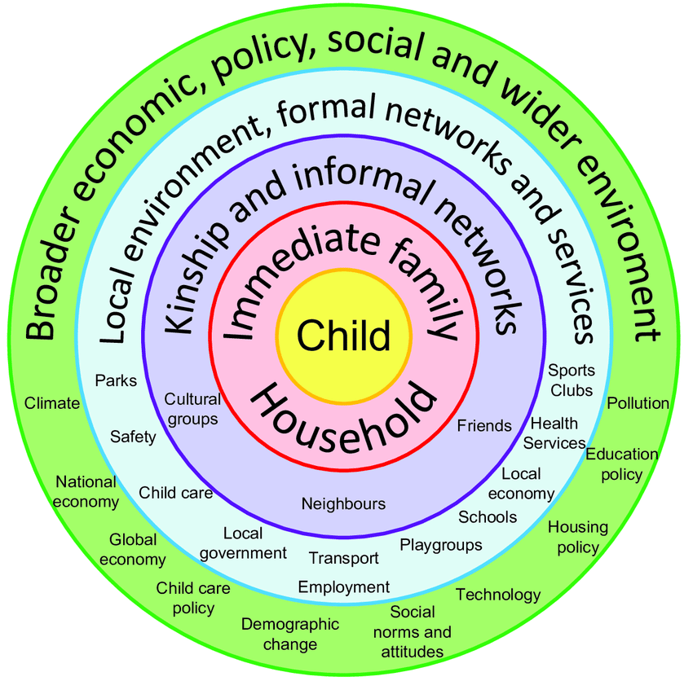

- It is important to provide meaningful services within the community, providing these services within the community according to:
- Bronfenbrenner (1977), local environment, formal networks and services, these services will keep the community safe, children will be engaged in activities. But not all of these services was available.

- References:

- Bronfenbrenner, U. (2005) Making human beings human: Bioecological perspectives on human development. Thousand Oaks, CA: Sage
- Children Act 2004, c. 31. (Online). Available at: http://www.legislation.gov.uk/ukpga/2004/31/contents accessed: 18th July (2022).
- Children Act 1989, (Online). Available at: Children Act 1989 (legislation.gov.uk) (accessed: 21st JULY (2022).
- Clevedon Town Council (nd) North Somerset Council Logo available at: https://www.clevedon.gov.uk/external_links/4777/ (accessed 6th August 2022)
- Cambridge Dictionary (nd) available at: https://dictionary.cambridge.org/dictionary/english/vulnerable. Accessed on 7th August 2022
- HM Government (2018) Working Together to Safeguard Children A guide to inter-agency working to safeguard and promote the welfare of children (Online). Available at: https://assets.publishing.service.gov.uk/government/uploads/system/uploads/attachment_data/file/942454/Working_together_to_safeguard_children_inter_agency_guidance.pdf (date accessed: 21 March 2022).
- Maslow, A.H. (1954) Motivation and personality. New York, NY: Harper & Row Publishers.
- Mental health.gov (2017) what is mental health. Available at https://www.mentalhealth.gov/basics/. (accessed 26th July 2022)

- Mental health foundation (2016) Family and parenting statistics Available at: at:https://www.mentalhealth.org.uk/explore-mental-health/statistics/family-parenting-statistics (Accessed: 28th July 2022)
- North somerset council(nd) Children’s Services Procedures Manual, Social Care Review available at: https://www.proceduresonline.com/northsomerset/cs/p_assessment.html. Accessed on 7th August 2022
- North Yorkshire (2022) Safeguarding children, parental ill health on children available at://www.safeguardingchildren.co.uk/ professionals/one-minute-guides/parental-mental-ill-health-on-children/ (accessed 25July2022)
- Shutterstock Inc (2022) Anti social behavior royalty-free images. available at: https://www.shutterstock.com/search/anti-social-behaviour. Accessed on 7th August 2022
- United Nations (1989)The United Nations Convention on the Rights of the Child (Online). Available at: Layout 1 (unicef.org.uk) (accessed 15th July 2022).

