Name: Ella Ball
Student ID: 2010935
Module Code: BMSW 5102
Assignment Title: Task 2 Developing Relationships and Workplace Achievement
Lecturer: Sujeewa Herath

Table of content
1 Introduction …..................................................................................................................3
2 Organisation details ….....................................................................................................3
3 Motivation types …...........................................................................................................4
4 My critical review .............................................................................................................4
5 The importance of training .............................................................................................5
6 The rewards .....................................................................................................................5
7 Differences between theories ….....................................................................................6
8 Performance management .............................................................................................8
9 PDP....................................................................................................................................8
10 SWOT ..............................................................................................................................9
11 Conclusion ....................................................................................................................10
12 References ….................................................................................................................11

1. Introduction
Here I will be talking about the types of motivation used in a place I work. I will be talking about both extrinsic and intrinsic motivation types. I will critically discuss the different motivations used in my workplace, why they are in place as well as how it encourages both the employee and the children in our care. I will also share the aims along with the objectives and go into how being extrinsic can be a negative thing for this job. I will be talking about the importance of the training given and how it not only helps the staff, but it holds advantages for the children. Along with the rewards that come with the job you can gain a lot from the training that is provided, not only do you receive certificates of your achievements, but you also gain skills you keep for life, as well as the job itself being a satisfaction when you see you have made a difference in a little kid's day/chapter of life.

2. Organisation details
St Matthews C Of E Primary School
Windmill lane,
Smethwick,
Birmingham, B663LX
st matthews primary school windmill lane - Search (bing.com)
St Matthews Primary School are immensely proud of their school. It has served the local community for well over 100 years. As a Church of England Primary School, we have close ties to our parish Church. We teach our children a broad and balanced RE curriculum, focusing on respect, and understanding for all faiths. (www.stmatthews-primary.co.uk, n.d.)

3. Motivation types
Extrinsic and intrinsic motives are the two types of motivation. Extrinsic motivation happens when things are done to or for people to motivate them, such as prizes, increased salary, praise, or even a promotion, as well as consequences like disciplinary action, pay withholding, or criticism.
Intrinsic motivation is connected with the concept of involvement and is provided by the work itself.
Examples of extrinsic rewards | Examples of intrinsic rewards
Pay raises | Self-appraisal
Promotions | Personal gains
praises | Helping others

Intrinsic motivation are all the things that motivate people based on internal rewards, you might be motivated to get a promotion as it involves learning new skills. On the other hand, you might be motivated because you want a positive effect on the lives of the people you work with. Intrinsic motivation can be both positive and detrimental. You can, for example, drive yourself to learn something if you don't want to feel unfulfilled, resulting in beneficial activities, but the motivation was focused on preventing a negative consequence rather than creating a favourable one. There are many different types of intrinsic motivation, each of which focuses on a different type of motivational reward.
In my sector of work, intrinsic motivation is usually more sustainable than extrinsic drive, regardless of the great or negative consequences, because it usually focuses on positive things that you can control. Extrinsic motives, on the other hand, focus on things that are handed to you by someone else and are thus out of your direct control.

4. My critical review
I have been a lunchtime supervisor for many years, and I have enjoyed every day I have worked. Helping, encouraging, and playing with the kids for me is a reward in itself. I have gained three extra qualifications while here and many more are still available for me. I completed a first aid course. I have done a children's NSPCC course along with a health and safety course. While working with kids you hold a care of duty for them, and they must be protected and observed at all times. Doing these courses bettered my knowledge if accidents happen, they are to help me address certain situations with the children and it gives me permission to first aid a child if and when needed. Having these qualifications behind me helps me to help them. In my opinion I don’t feel working in a school hold many motives to help encourage the employees. You go on courses, but I feel people working in this sector should have intrinsic ways as the roles available in the school industry comes with a lot of intrinsic values. Having intrinsic values myself, I felt this job was ideally suited for me. My role was to protect, guide, support and encourage not forgetting play and interact with the children. I found myself being the fun playful supervisor who always obeyed rules but never made them. Two new members started, lovely ladies and seemed to be very eye on which is always needed at playtime but after a week or two I felt their motivations/motives for being there with different to mine. They didn't play and didn’t seem to interact with the kids they seemed quiet, and they didn't want to join in on the silly games we all loved to play. Seeing these two ladies and watching how we worked in different ways made me question the different motivations people have and made me see how effective being in intrinsic is in the school environment. I asked the headteacher if I could have a conversation with her, I just wanted to explain how I felt regarding the different motivations and how it made me feel a little uncomfortable. She advised me how much I'm loved and to just keep doing the great job I do, but a few weeks have gone by, and I still felt uncomfortable after trying even more to include them I felt their motivation didn't fit well with the job role, I felt they had extrinsic ways and was only there for the money. Being there for the money is not a problem, I enjoyed payday too, but I do feel to have a career with kids you need to have intrinsic values and ways and the school with benefits from staff having intrinsic ways as kids needs all the help and support needed to help them grow. In the future, I feel it would be right and only fair to let employee’s/future employees know that having intrinsic values is needed in this field, that the children and their welfare are a priority. The importance of training and courses made available are very important and necessary e.g. if a lunchtime supervisor didn’t have first aid they can’t perform first aid on a child if injured. Following the curriculum and keeping up to terms with all regulations are equally important and must be put in place. The rewards you get from working in a school are the children. Watching them grow, reach their personal targets and just the smile on their face when they get a sticker or/and a letter of achievement is the best ever. The kid’s rewards are simple and easy as children never want much but appreciation when doing right and to be seen.
Working in a school industry actively illustrates that the benefits you get can/will include. Good working conditions e.g. flexitime, a great holiday entitlement, training such as learning and improving the curriculum, sickness & maternity leave/pay and they pay above statutory minimum rates. You're in an appreciative & open environment, opinions & efforts are valued, team ethos & spirit, and that sense of belonging to a community.

5. The importance of training
While critically evaluating the importance of training in my chosen organisation it is clear to see that the importance of training is critical. Training provides up to date needs for the children both medically and educationally, training provides guidance and helps to handle some situations that can occur. For example, if a member of staff has no first aid, they cannot perform first aid on a child. If we are not up to date with how to treat/lookout for certain epilepsy episodes, it would be hard to detect or treat a minor when needed. Then you have courses on and for the NSPCC, a very difficult course to do but very necessary when working in a school. Having these qualifications are especially important and supports the needs of both the employee and the children.

6. The rewards
The rewards working in a school are the children. Seeing their confidence grow, watching them interact with others. Seeing the diverse cultures play together showing and teaching each other new things. Working in a school has self-rewarding rewards so having intrinsic ways is needed and helps as not many other rewards come apart from seeing them blossom and grow. When you have intrinsic ways, the job is a lot more rewarding

7. Difference between the theories
Taylor's classical theory | Mayo theory
This theory is one of the first theories of motivation | People’s needs
Concentrates on money rewards | People's values
The wellbeing of employees is not a priority | People's goals
A scientific theory

Frederick Winslow Taylor was an Americal mechanical engineer who lived from 1856 to 1915. He brought an engineer’s viewpoint to the world of workplace productivity and applied engineering principles to the factory floor. He was the first management consultant and the first to look at work and productivity scientifically. He is known as the father of Scientific Management and the efficiency movement. (Expert Program Management, 2018)
Mayo management theory states that employees are motivated far more by relational factors such as attention and camaraderie than by monetary rewards or environmental factors such as lighting, humidity, etc. Elton Mayo developed a matrix which he used to illustrate the likelihood that a given team would be successful. (philosophy-question.com, 2019)

The Maslow hierarchy of needs is a motivational theory in psychology comprising a five-tier model of human needs, often depicted as hierarchical levels within a pyramid.
From the bottom of the hierarchy upwards, the needs are, physiological (food and clothing) safety (job security) love and belonging needs (friendship) esteem and self-actualization. (McLeod, 2020)

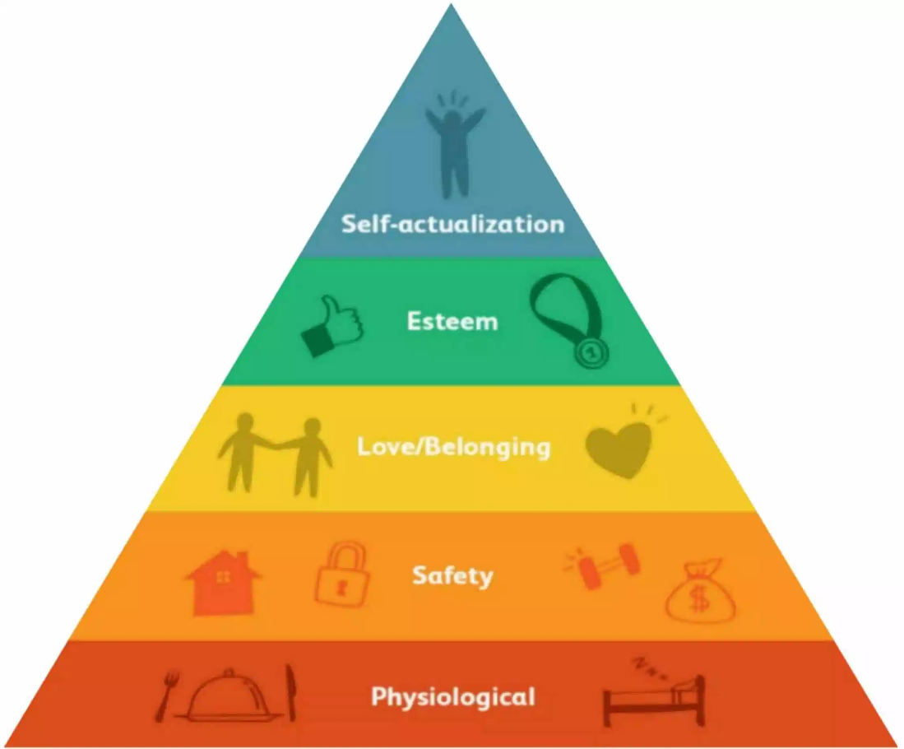
In my critical evaluation, I would recommend the importance to follow both Mayo’s theory and Maslow's hierarchy of needs in a school environment. I also feel it is equally as important to hold intrinsic values when working with children as promotions and pay rises are very unlikely in the field of a teacher. The benefits you receive personally and the gains you can give a child overrides Taylors theories. We are in the 21st centry. We need more motivation as it holds a key to gain better results. Money is no longer the motive and it can’t be working as a teacher.

8. Performance management.
"Performance management," according to Berkley, UC, "is a continual process of communication between a supervisor and an employee that occurs throughout the year in support of the organization's strategic objectives." Clarifying expectations, creating objectives, identifying targets, providing feedback, and reviewing results are all part of the communication process. What does it mean to manage performance? It contributes to the achievement of strategic organisational goals and defines standards. It identifies goals and establishes objectives. It gives feedback and evaluates outcomes. Employee incentive programmes and performance management encourage employee reward and recognition. It improves staff productivity and motivation. It aids in the formulation of development plans. Teamwork is encouraged by performance management.

9. PDP
 | My current weakness and my abilities | What I want/need to learn and achieve | Actions that need attention | Date to review/check progress | The outcome
Priority 1 | My anxiety | Relax, engage in new things | My confidence and timing | 2021 | I am more confident within myself and achieving things I thought I couldn't
Priority 2 | Support team members, stop being shy | More voluntary work at my workplace | Concentrate on bettering me more | 2021 | More voluntary work taken and courses completed
Priority 3 | Level 3 in childcare | Start level 4 business studies | Assignment referencing | 2021 | Passed year 4 and going on to do my BA honours level 5 and 6
Priority 4 | Level 4 qualification | Complete all modules in level 5 | Complete all work on time | Sept 2022
Priority 5 | Get more confident when engaging in class at uni | Engage more | My confidence when it comes to assignments | Sept 2022
Priority 6 | Take a look at what I want and where I want to be | Complete courses to gain confidence and to better my career | Search more | Jan 2022
rewards or environmental factors such as lighting, humidity, etc.
While working at St Matthews and while studying at UWTSD has helped me realise what my SWOT is. A SWOT analysis is a planning tool that seeks to identify the Strengths, Weaknesses, Opportunities and Threats involved in a project or organisation. (CIPD, 2020)
Extrinsic and intrinsic motives are the two types of motivation. Extrinsic motivation happens when things are done to or for people to motivate them, such as prizes, increased salary, praise, or even a promotion, as well as consequences like disciplinary action, pay withholding, or criticism. Intrinsic motivation is connected with the concept of involvement and is provided by the work itself.

10. SWOT

11. Conclusion
While working on this assignment, I realised how important and different both theories are, as well as whether you have intrinsic or extrinsic methods. Mayo's theory is the most appropriate for where I work. It emphasises communication and teamwork while always promoting the well-being of the other team members. The Mayo theory is a theory on relationships. Working in the education industry, I believe, necessitates a relationship theory, as well as smart objectives and 360-degree feedback. Smart is employed because all of its assets are required, as is 360 feedback, in order to obtain information from the community.

12. References

CIPD (2020). SWOT Analysis | Factsheets. [online] CIPD. Available at: https://www.cipd.co.uk/knowledge/strategy/organisational-development/swot-analysis-factsheet#gref.
CIPD. (2021). Performance Management | Factsheets. [online] Available at: https://www.cipd.co.uk/knowledge/fundamentals/people/performance/factsheet#:~:text=There%E2%80%99s%20no%20standard%20definition%20of%20performance%20management%20but.
Expert Program Management (2018). Expert Program Management. [online] Expert Program Management. Available at: https://expertprogrammanagement.com/2018/05/taylors-scientific-management/.
HRF. (2017). Elton Mayo’s Theory of Management Explained - HRF. [online] Available at: https://healthresearchfunding.org/elton-mayos-theory-of-management-explained/.
Kukreja, S. (2019). Elton Mayo And His Key Theories - Management Study HQ. [online] Management Study HQ. Available at: https://www.managementstudyhq.com/elton-mayo-theories.html.
McLeod, S. (2020). Maslow’s Hierarchy of Needs. [online] Simply Psychology. Available at: https://www.simplypsychology.org/maslow.html.
People Insight. (n.d.). PPC 360. [online] Available at: https://peopleinsight.co.uk/lp-360-feedback/?msclkid=77283e3645681478e0ae5f87a7b5f359&utm_source=bing&utm_medium=cpc&utm_campaign=Generics%20%7C%20BOF%20%7C%20360%20Feedback%20%7C%20Exact&utm_term=360%20feedback&utm_content=360%20Feedback [Accessed 9 Dec. 2021].
philosophy-question.com. (2019). What is Mayo theory of motivation? [online] Available at: https://philosophy-question.com/library/lecture/read/370310-what-is-mayo-theory-of-motivation [Accessed 21 Nov. 2021].
UKEssays.com. (2018). Taylor And Mayo Motivation Theory Management Essay. [online] Available at: https://www.ukessays.com/essays/management/taylor-and-mayo-motivation-theory-management-essay.php.
www.stmatthews-primary.co.uk. (n.d.). Welcome | St Matthew’s Church of England Primary School. [online] Available at: https://www.stmatthews-primary.co.uk/welcome/ [Accessed 20 Nov. 2021].

