Zuzanna Tusk
ID 1708231

Community Engagement: A2

Contents
Introduction 3
1. Reflective Evaluation Using Gibbs Reflection Cycle 4
a. Description 4
b. Feelings 4
c. Evaluation 5
d. Analysis 6
e. Conclusion 6
f. Action Plan 7
Conclusion 8
References 9

Introduction
This assignment is the continuation of the first assessment of community engagement and in the first portion it was mentioned that I was playing the role of manager in a care home named Bright Care that is generally a home care service provider. In this second portion of the community engagement I am suggested to discuss about the reflective learning of my role play in the home care. In order make the discussion more organized and easily understandable I will be following the Gibbs reflective cycle so that I can explain my experience in the home care in a better way.
The reflection model was developed in the year 1988 by Graham Gibbs so that people can easily present their experiences in an organized way. The Gibbs reflection model helps an individual to follow a framework to present the experiences and plan the future learning in an effective way as the individual can reduce the activities that did not go well and can add activities that were good for him/her. Basically the model six steps cyclically and those steps are description, feelings, evaluation, analysis, conclusion and action plan. The following graph will be showing these steps cyclically.
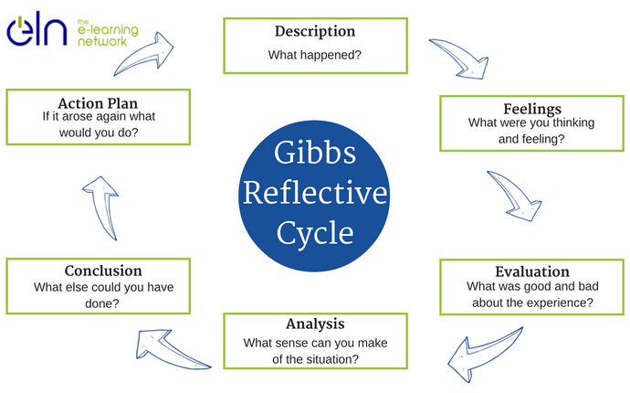

Reflective Evaluation Using Gibbs Reflection Cycle
In my professional life I need to work for a particular organization or maybe many organizations but the learning from my experience will always have a great impact on the future activities. Right now, I have played the role of the manager of a home care organization and I would like work through the experiences I gathered while working there.

Description
The environment of the home care was really good for working. All the staffs and co-workers were so supportive and helpful so that I can complete my tasks properly. Brockbank and McGill (2007) said that as a manager of the organization it was my responsibility to go to the clients if there is any problem with the care service provider and the client. Here I would like share a specific experience with one of my clients where it was happened that one of the care service provider was late to reach the place of the client. In fact, the carer was one hour late due to some personal matters but she did not inform either me or the client. That’s why the situation went wrong and I had to take action against that carer.
As the carer did not come timely, the client called me and describes the problem and asked me to come over her place immediately and she was really angry with the carer. After getting the call I went there and talk to the client and apologized on behalf of my career and contact with the carer and after waiting another 30 minutes the carer arrived to the client’s house. When I was leaving from the office for the house of the client I took another carer with me so that she can perform on behalf of the existing till she arrives. After her arrival she described the situation why she was late on that day and she also mentioned that it was just a mere accident and nothing was intentional. After hearing all the issues from the carer and the client I had to make a decision that makes the client happy as that happiness is the main asset of our organization. So, I had to suspend that carer for a week although I felt that the reason for her being late was a valid one and she did not deserve a big suspension like that. This was really remembering experience for me because I wanted to do something else but I had to do something else for my job responsibility.

Feelings
While dealing with the situation I was feeling puzzled because my mind wanted me to do something else but I could not do that because of my job responsibility. Before reaching the house of the client and hearing the reason for being late from the carer I was very angry with her and wanted to scold her badly for her irresponsible behaviour but after knowing the reasons I felt that her explanation is considerable at least to me personally. Leonard (2002) suggests that I believe that every other people would fell the same I was feeling because every employer has some attachments for his employees as they are a team who works in one organization and they all are human being too. But the peoples form the client’s side was very angry and was not ready to hear a single justification. That’s why I had to take such a harsh decision.
After suspending the carer for a week the client and the peoples of the family of the client were calmed and they suggested me to be more careful in these situations. They also admired my ready wit of taking another carer with me while leaving form the office to the client’s house so that the client can get the services immediately after I reach there. While dealing with the situation I was in the house of the client for around two hours and after taking my decision I was not happy inside as I took the decision that was little harsh for my carer but I had nothing to do as I had to follow the regulations and policies of the organization to handle situation like this. Now, I feel that I should have called the carer after three days reduce the suspension and ask her to join the office immediately and I would also like to help her to resolve her personal problems so that she can avoid such situations.

Evaluation
After taking the decision about that care service provided I was thinking about the good and bad side of that particular decision of mine. Schön (2000) said that the good side is that it would be benchmark for the clients as they will realize that Bright Care will never ignore any irresponsible behaviour of the carer and the care service providers will also be very alert as they know that they will be punished if they show any irresponsible behaviour while working for any client. On the other hand the bad apart of the decision is that I could have gave her a lower punishment that would also satisfy the client but for making every other carer alert and maintaining the good reputation among the clients I was bound to do that.
While handling the situation, I had to take the decision based on some specific rules and regulations of the organization and on the basis of the situational knowledge provided by the client as well as my carer. The client described the situation to me and said their dissatisfactions about the service of the carer before the arrival of the carer that day. After the arrival, the carer also described her justifications and after hearing all these I took the decision by following the policies of the organization. At the same time, the family members of the client also provide much information about the service and they also pointed out the satisfactory and dissatisfactory activities of the service and their conversation helped me to realize that the full family was happy about the service until the bad experience took place. That is how they all contributed to resolve the situation for the organization and me.

Analysis
In the analysis step I need to analyse my decision making and the situation prudently so that it can be said that I take the appropriate decision on that time. The situation was like that, the care service provider of my team should have reached the house of the client before one hour but she failed to do so. That’s why the client asked me to come over and after reaching to the house of the client I came to know the points of dissatisfaction of the client and I had to take appropriate steps against the carer immediately.
While leaving form the office for the house of the client I took one care service provider who will start her activities for the client as soon as we reach the home of the client. According to Zeichner and Liston (2006) this is the major activity that helped me to calm the situation and buy some time to think and give a proper decision. Then, after the existing care service provider reaching there I hear all the details from her and she presented her causes why she was late that day. At the same time the client also presented points. Finally, I suspended the carer for a week although I felt that the carer’s reasons were strong and she should not have been punished so harshly. That’s why I called her to join the office after three days but she will be on service for any client only after the passing of seven days. These are the things that helped me, the manager, to handle the situation in a better way so that the clients do not lose their faith over my organization and neither my service team members.

Conclusion
The situation was like that, the carer of my organization was one hour late due to some personal matters but she did not inform either me or the client. That’s why the situation went wrong and I had to take action against that carer. As the carer did not come timely, the client called me and describes the problem and asked me to come over her place immediately and she was really angry with the carer. After getting the call I went there and talk to the client and apologized on behalf of my career and contact with the carer and after waiting another 30 minutes the carer arrived to the client’s house. While leaving form the office for the house of the client I took one care service provider who will start her activities for the client as soon as we reach the home of the client.
According to Taylor (2010) the situation helped me to learn that what should be the reaction of the manager when any member of his/her organization fails to perform the responsibilities due on him/her. For the current situation I learned that in these types of problems the decision maker should be thinking with cool head and take the decision prudently by following the policies of the organization and expectations of all the parties related to the situation. In a situation like this the manager should think from the perspective of all the stakeholders of the organization because both customer and employees satisfaction is important for the survival of the organization. In the mentioned situation I could have sack the carer who was failed to proper professionalism but that would create a bad impression for the whole human resource of my organization although the clients would be very happy. The major thing is to follow that none of the parties should feel that I was doing any injustice to any of them.

Action Plan
The policy of the organization directs me to the same again if the same situation comes in front of me. But I feel that the decision making should be fair and not biased to any group whether it is employee of the client. According to Sicora (2017) it also can happen that the care service provider was intentionally irresponsible for the situation or may be client triggered the situation to take place by his/her behaviours. It is the sole responsibility of the decision maker to take decision after understanding the situation properly and identifying the party who is responsible for the situation.

Conclusion
In this particular portion of the assessment I tried to present the experience of my working time as a manager of Bright Care. Here is also discussed the decision making criteria and the regulations that provides guidelines for making decisions in such situations. With the help of Gibbs reflection model I presented the whole situation and the decision making and the consequences after the decision was made. Finally, I would like to express that Gibbs model is really helpful to present the past experience and plan the future activities for avoiding the ineffective portions.

References
Brock, A. (2015). The early years reflective practice handbook. London: Routledge.
Brockbank, A. and McGill, I. (2007). Facilitating reflective learning in higher education. Maidenhead, England: McGraw Hill/Society for Research into Higher Education and Open University Press.
Bruce, L. (2013). Reflective Practice For Social Workers. Open University Press.
Leonard, D. (2002). Learning theories, A to Z. Westport, Conn.: Oryx Press.
Rushton, I. and Suter, M. (2012). Reflective Practice For Teaching In Lifelong Learning. Maidenhead: McGraw-Hill Education.
Schön, D. (2000). Educating the reflective practitioner. San Francisco: Jossey-Bass.
Sicora, A. (2017). Reflective practice. Bristol: Policy Press.
Taylor, B. (2010). Reflective practice. Maidenhead: Open University Press.
Zeichner, K. and Liston, D. (2006). Reflective teaching.

