World Building
(ADAA5011)

WEBSITE LINK: AMELIA PEACOCK | photography | United Kingdom
WHAT IS NEEDED FOR A SUCCESSFUL WEBSITE?
A successful website isn’t just about it looking good, it has to work well, deliver value, and achieve its goals. In the context of photography, it should do more than just display photos, it should show your style, build trust, and turn visitors into clients.

THINGS TO CONSIDER:
- CLEAR FOCUS
Visitors should know what type of photography you do and who it’s for.
- STRONG FIRST IMPRESSION
Use a few eye-catching images that show your style right away.
- EASY TO USE
Simple menus and clear pages so people can find your work, prices, and contact info easily.
- FAST LOADING
Photos should load quickly without losing quality.
- MOBILE FRIENDLY
Considering most people are likely to come across a website via their phone, your site should look great and work smoothly on a phone or tablet.
- CURATED PORTFOLIO
Show only your best work and the kind of photography you want more clients for.
- ABOUT YOU
A short, friendly introduction so clients feel connected and comfortable. Also, put include social media links to further expand your presence.
- CLEAR PRICING OR PROCESS
Let people know what to expect before they contact you.
- CLEAR CALL TO ACTION
Make it obvious what to do next: Book, Contact, or Enquire.
- EASY TO FIND ONLINE
Use clear titles, locations, and descriptions so clients can find you on Google.
ARTIST RESEARCH AND DOMAINS
TIBA PHOTOGRAPHY
Tiba Photography is a documentary photographer from Brazil who focuses on natural, people-centred images that feels authentic. His work highlights personality and emotion rather than heavy posing. Tiba uses soft lighting and simple compositions, which help the subject feel approachable, genuine, and human. The type of photographer he is, is heavily translates into his website which is clean and minimal, allowing the images to stand out. Besides the small sections of red, his website is black and white, simply laid out, and easy to navigate making his work accessible and enjoyable to experience.
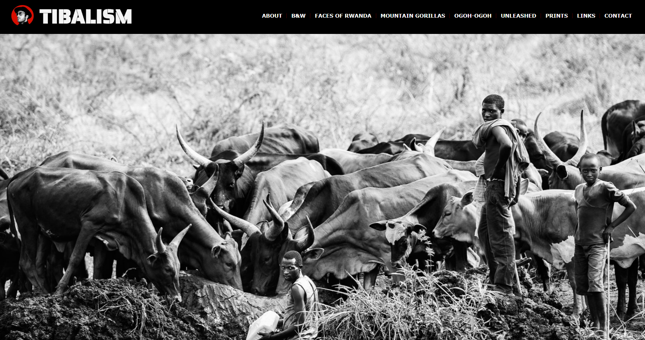
https://tibalism.com/
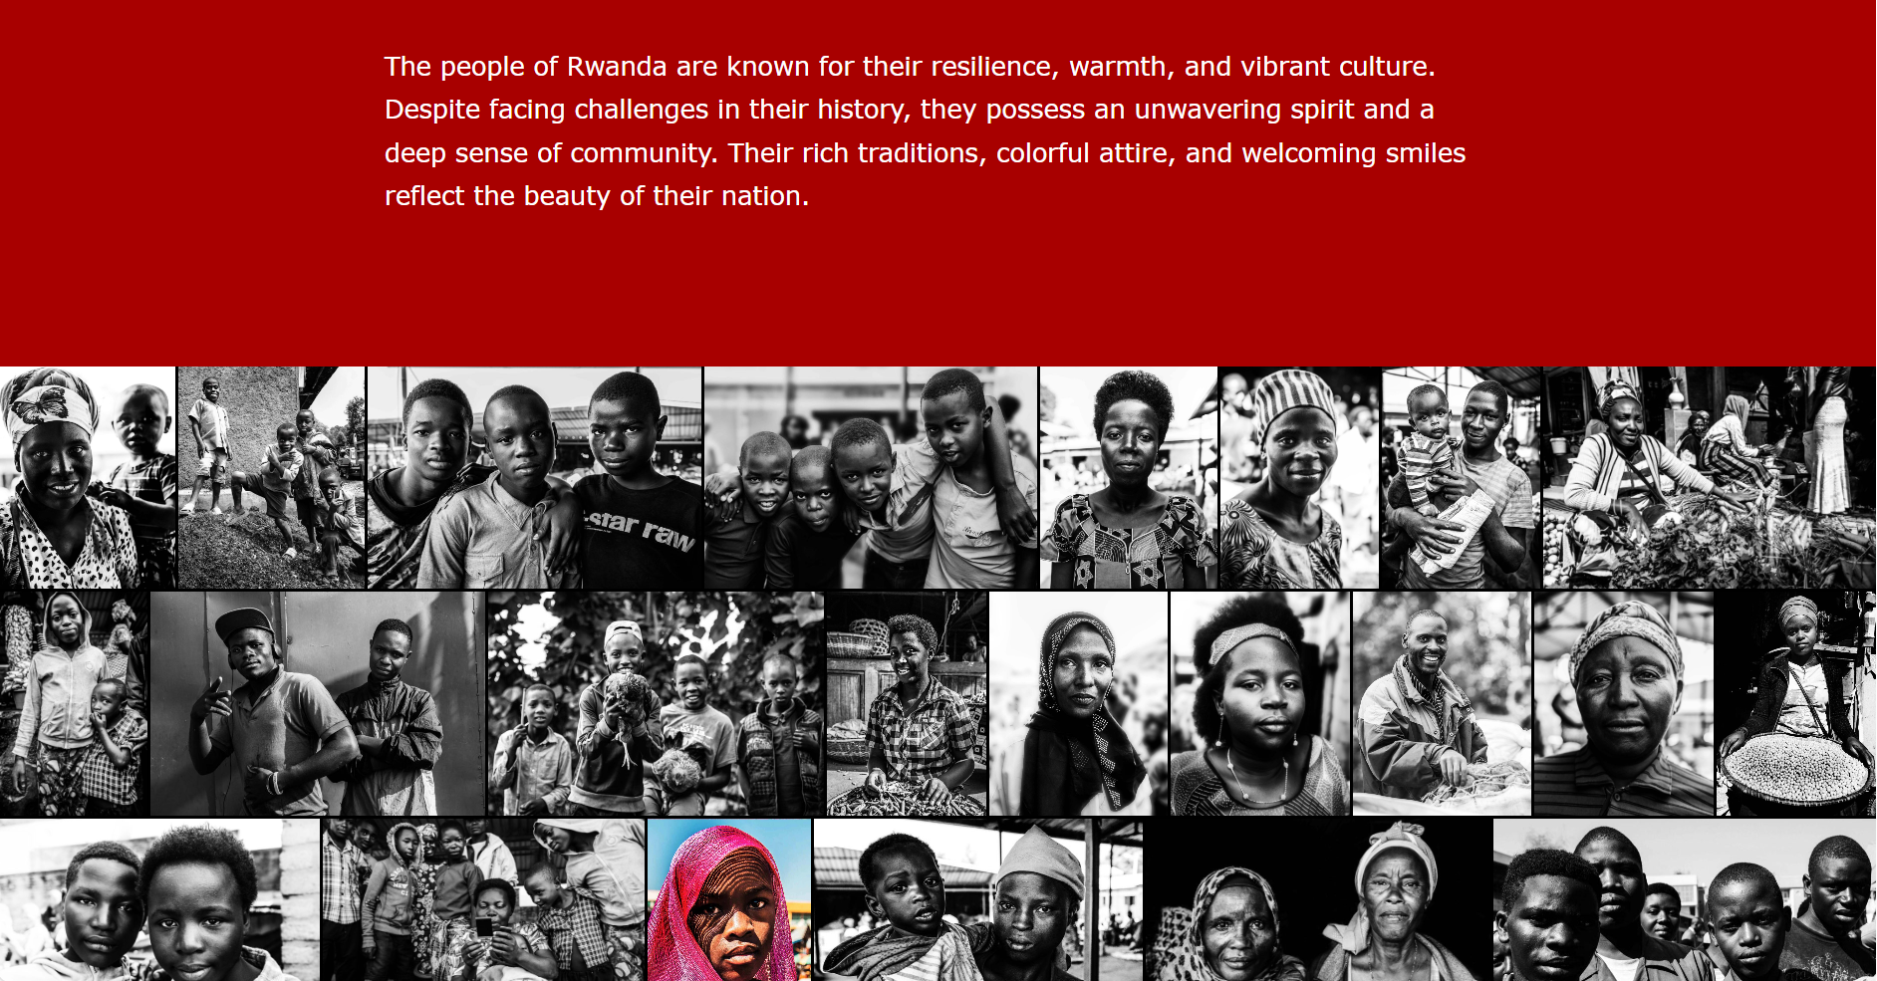
This body of work is taken from his Faces of Rwanda project. It’s presented in a compact layout where images are placed closely together with minimal spacing, encouraging viewers to see the photographs as a part of a continuous narrative rather than individual images. The use of black and white photography removes distractions and draws attention to facial expressions and emotion. The inclusion of a single colour image among the black and white photographs make it stand out, prompting the viewer to pause and engage more deeply, while still fitting with the overall story. This combination of tight layout and restrained use of colour reflects Tiba’s approach as a documentary photographer, prioritising storytelling, authenticity, and human connection over stylised presentation.

PHIL PENMAN
Phil Penman is a well-known British street photographer, especially recognised for his work in New York City where he’s based. His photography captures candid, unscripted moments of everyday life. He often uses black and white photography, which removes distractions and places emphasis on emotion, contrast, and timing. His work tells stories about people, culture, and urban life, making it strongly rooted in documentary photography. Phil Penman’s website is image-led, with large impactful photographs that immediately draw attention. The use of black and white imagery throughout the site reinforces his street photography identity. The layout although minimal feels somewhat bold and immersive, placing the viewer directly into the scenes he captures. Minimal text ensures the images remain the focus, which reflects the observational nature of documentary photography.
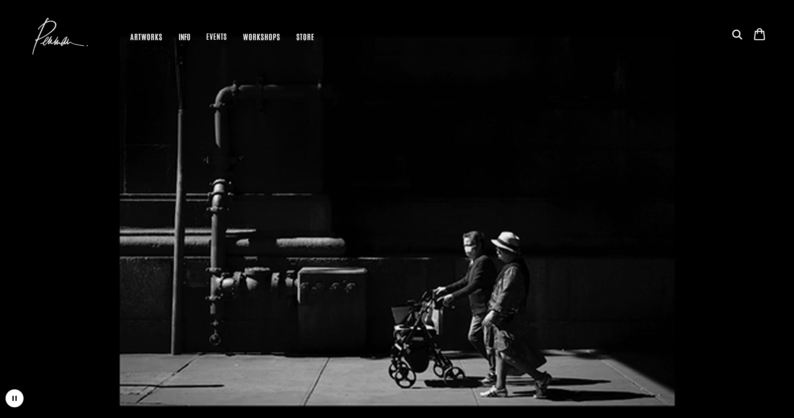
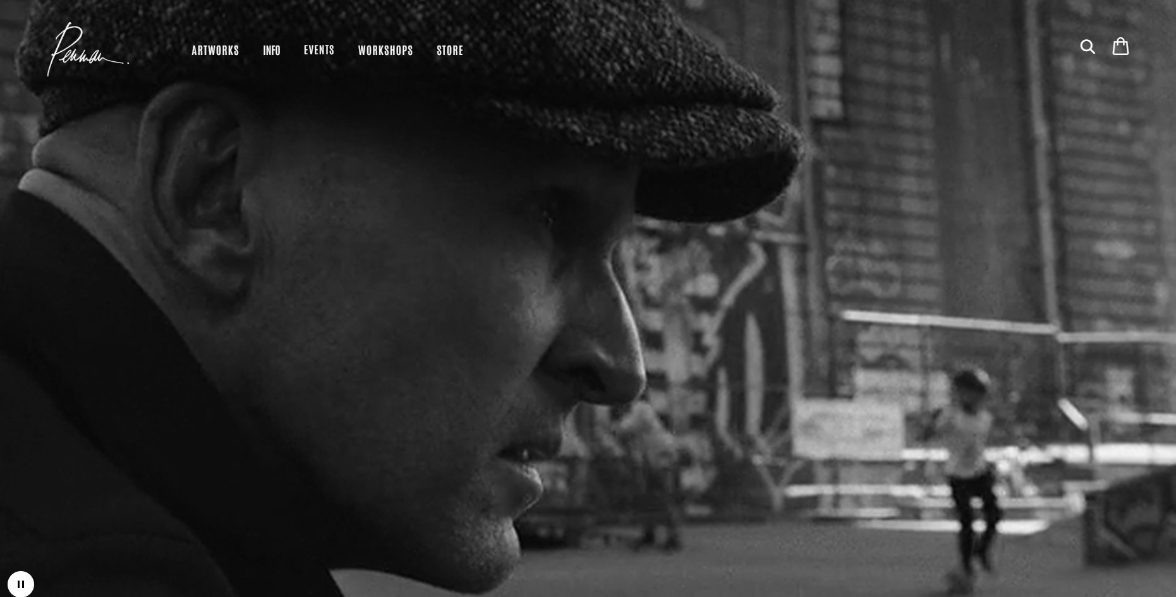
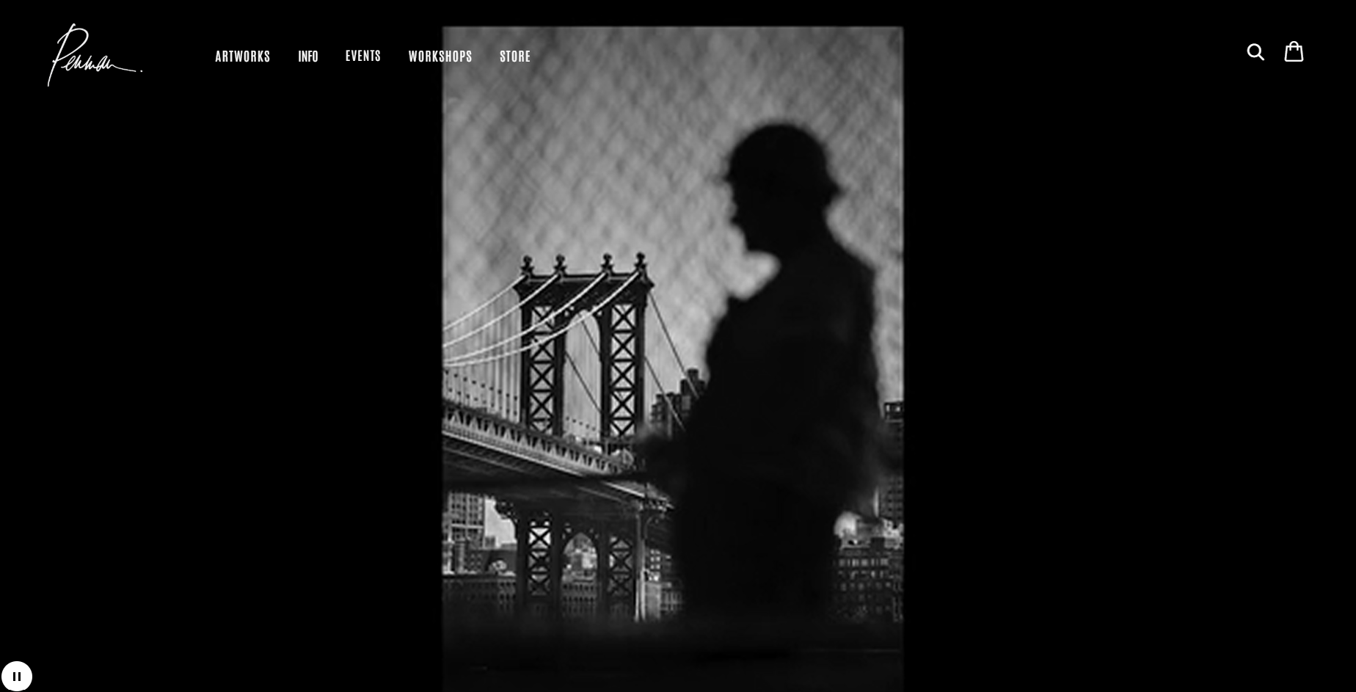
https://www.philpenman.com/
The home page of his website used to be simply black with his name written however, it is now a video in collaboration with Porsche where he walks around New York City taking photos, ending with him getting in a Porsche.
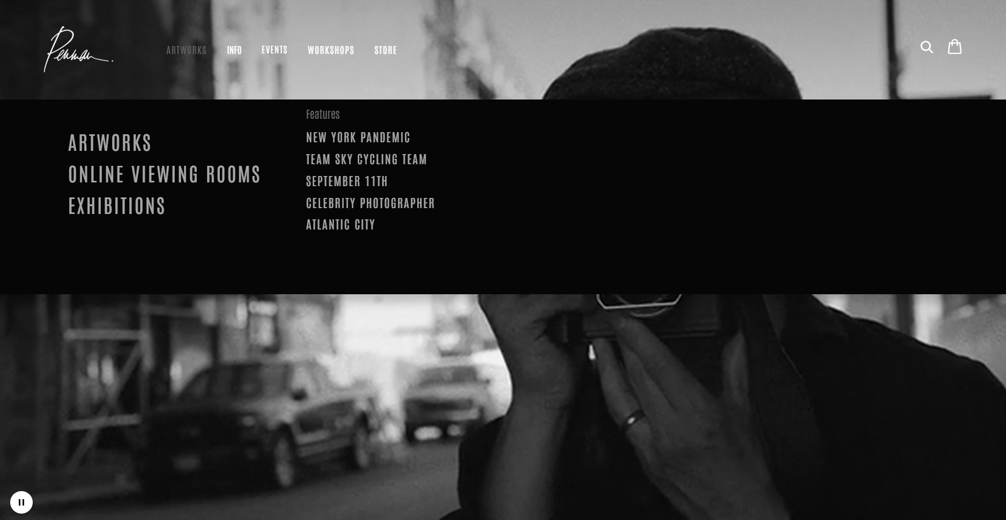
As you can see his website layout is very sleek and effortless, overall very fitting of him.

JAN SOLLBERGER
Jan Sollberger is a young Swiss photographer who primarily shares his work through online platforms such as his personal portfolio website and social media. His photography focuses on creative and artistic expression rather than a tightly defined commercial niche. He presents his work under the idea of photo art, suggesting that is photography is driven by visual exploration, mood, and personal interest rather than client-based work. His images often include elements of nature, landscapes, travel, and creative compositions with a focus on atmosphere, colour, light, and composition, showing an interest in how visual elements work together to create a strong image. Sollberger’s work is more personal and expressive, allowing him to experiment with different subjects and styles.
Jan Sollberger’s website reflects this approach by acting as a simple online portfolio. The site is image-focused, with galleries that allow viewers to scroll through his photographs without heavy text. This layout keeps the attention strictly on the visuals themselves and supports the idea that the images are meant to speak for themselves. The straightforward design matches the personal artistic nature of his photography, presenting his work clearly and accessibly.
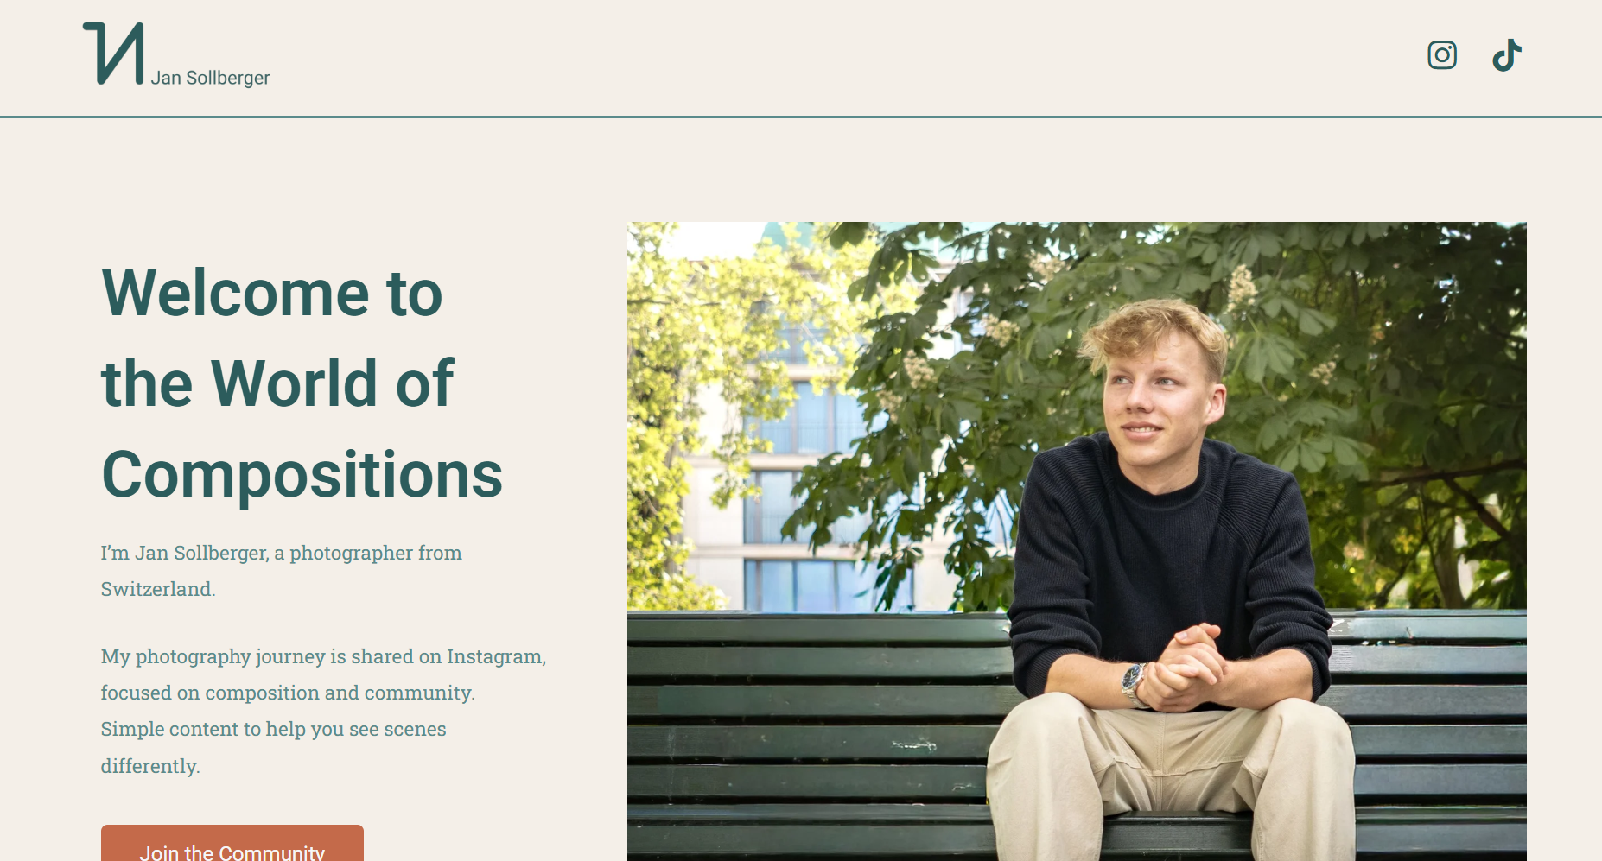
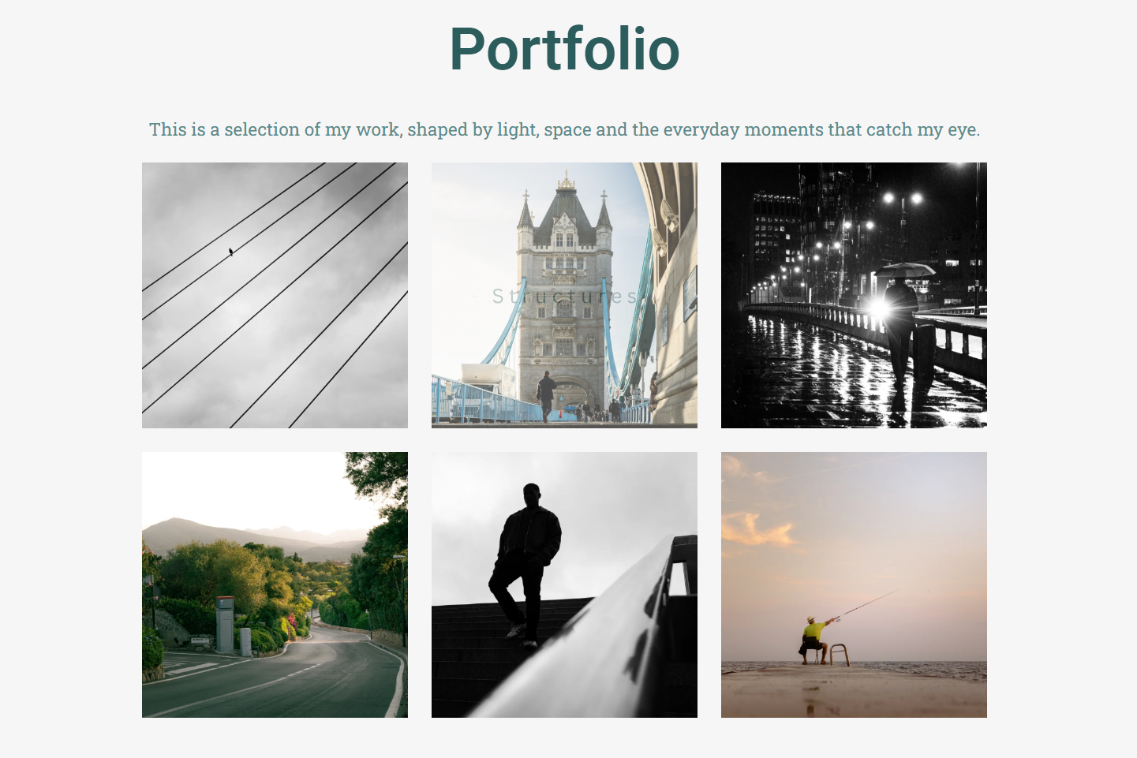
Jan Sollberger | 2026

MY WEBSITE
During my research into website creation, I explored three popular website builders: Wix , Squarespace and Hostinger. Each platform offers different tools and approaches to building a website, with their own strengths and limitations.
Wix is a drag-and-drop website builder that allows a high level of creative freedom. One of its main advantages is how easy it is to use, especially for beginners, as no coding knowledge is required. Wix offers a large selection of templates and design tools, making it suitable for a creative portfolio such as photography websites. However, a drawback of Wix is that the free plan includes Wix branding and advertisements, and some advanced features are locked behind paid plans. Despite this, Wix is still accessible and flexible site to use, which makes it appealing for first time users.
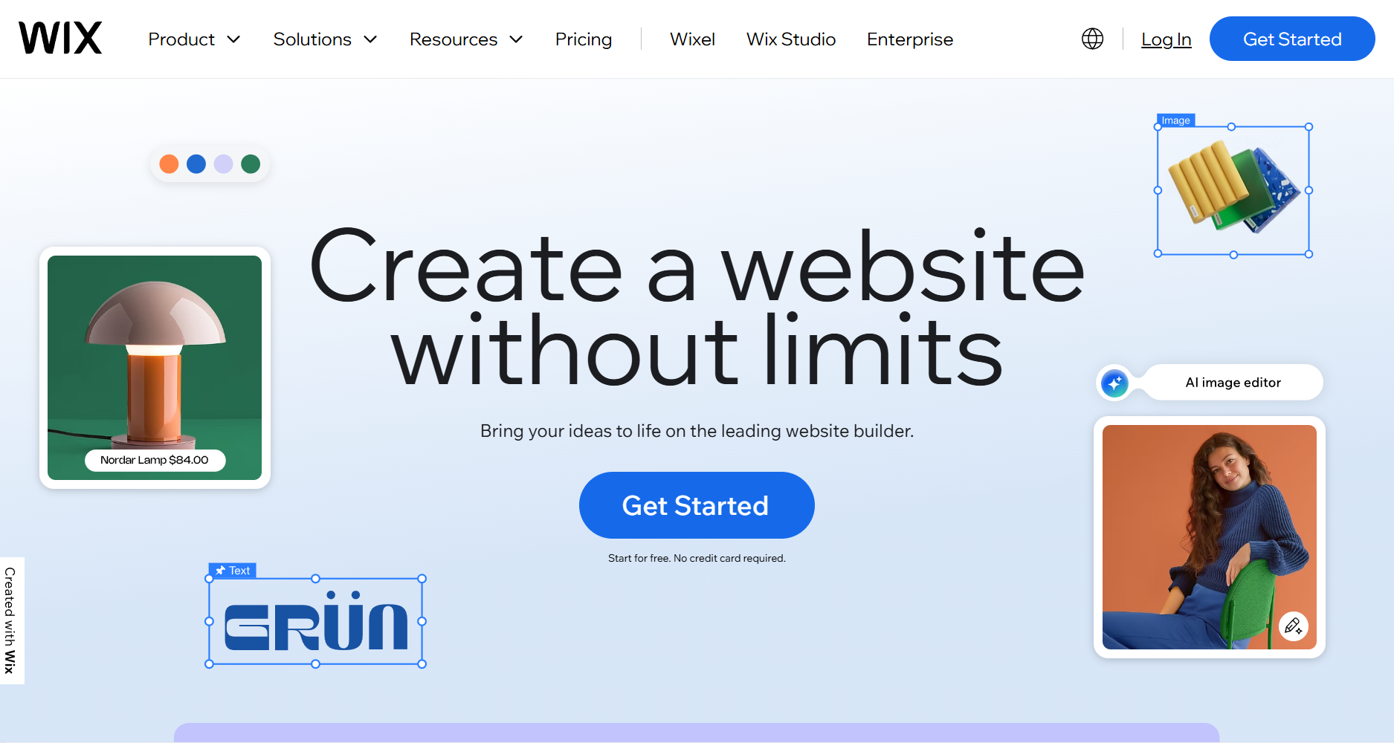
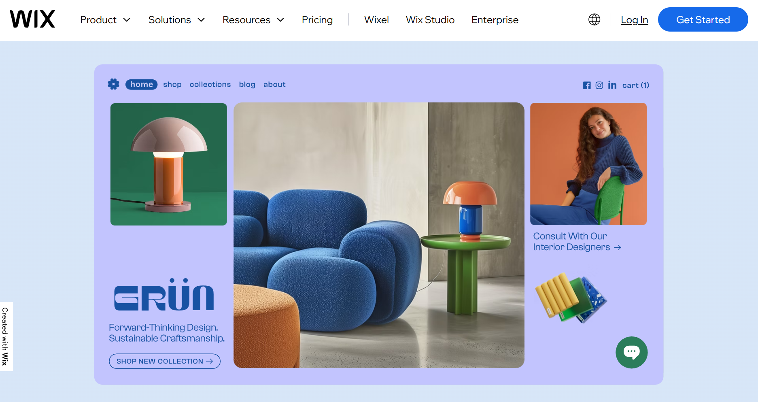
Squarespace is known for its clean, professional, and design-focused templates. It’s particularly popular among photographers and creatives because of its strong visual layouts and polished appearance. A major advantage of Squarespace is that its templates look refined and consistent across devices. However, it offers less design freedom compared to Wix, as templates are more structured and harder to customise. In addition, Squarespace doesn’t offer a permanent free plan, which can be a disadvantage for students or beginners working with a limited budget.
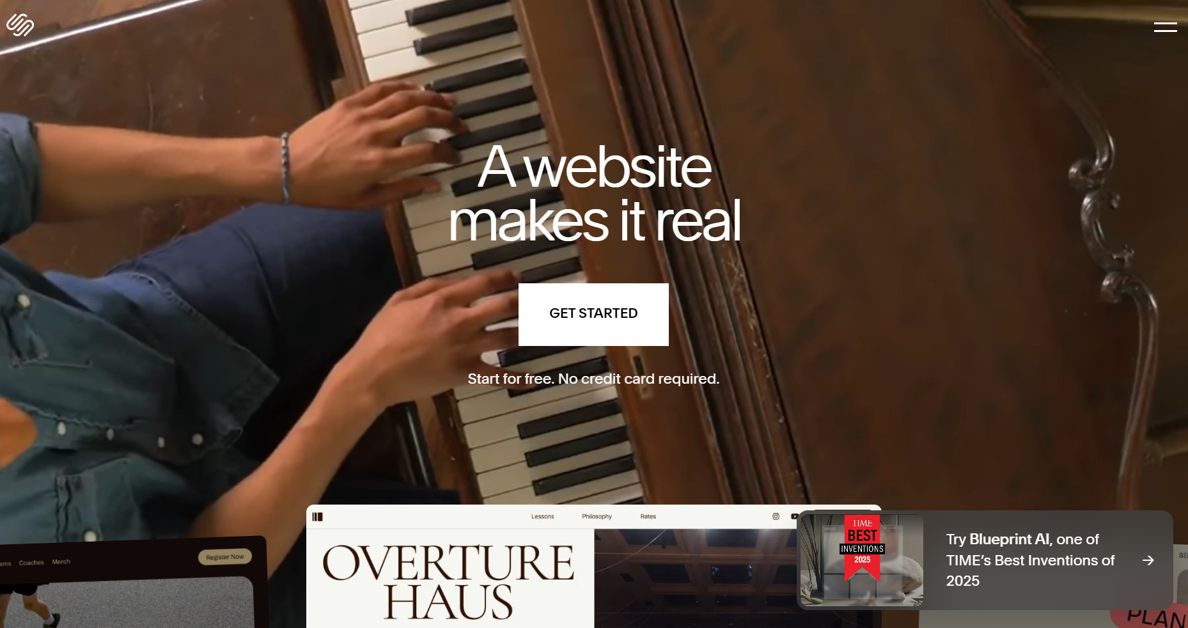
Hostinger differs from Wix and Squarespace as it is primarily a web hosting service that also provides a website builder. One advantage of Hostinger, is that it’s cost-effective and includes hosting within its plans. Compared to many drag-and-drop builders, it offers better performance and speed. However, Hostinger’s website builder is less intuitive for beginners and offers fewer creative design tools. This can make it less suitable for visually driven websites like photography portfolios.
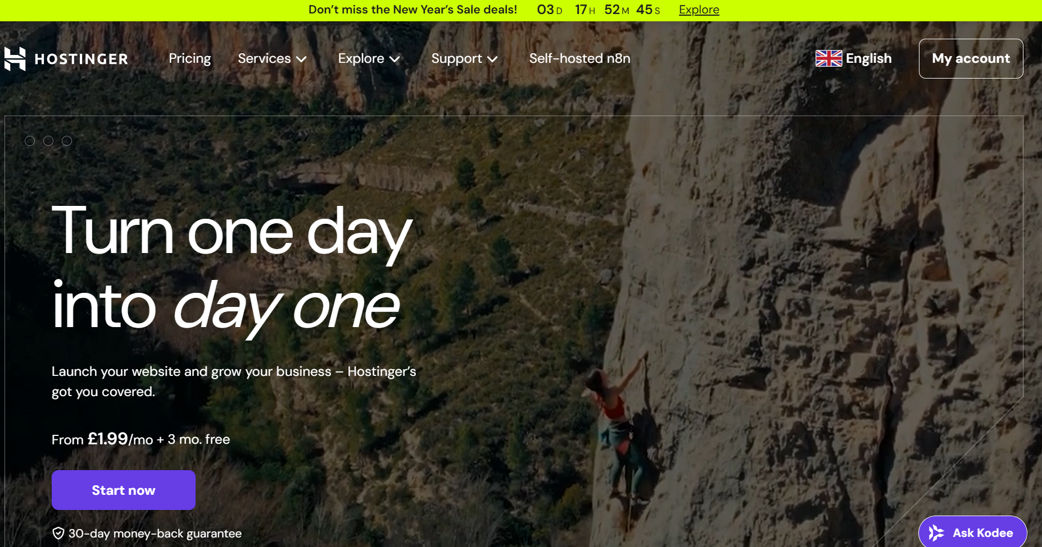
Before completing detailed research on any website builder, I had already decided to use Wix and began working on their free plan. The decision was influenced by my familiarity with the platform, as I had encountered Wix frequently through advertising. I assumed it would be easier to use compared to other builders, which made it feel like a safe accessible option. While my initial choice was based on convenience rather than research, further evaluation shows how Wix aligns with my needs as a beginner creating a photography website, particularly due to its flexibility and ease to use. For now I’m happy with my choice of builder but as my portfolio grows I may want to change it.

EVALUATION
As I reflect on my preferences, I know that I lean towards a cleaner and more minimal look. The three photographers mentioned earlier have greatly influenced how I wanted my website to be, as none of them are overcomplicated but are sleek and have a clean finish.
When it came to the design and choosing a template, I selected the Jack Banks template as I liked its overall layout and functionality. The template supports a minimal design while still feeling professional, which aligns with both my personal taste and the influence of the photographers I researched. Writing about myself in the third person for the about page felt unusual at first; however, it helped me to write a concise and more professional statement, which is appropriate for a photography website.
One challenge I faced was adding a portfolio. At this stage, I do not have a large amount of work that I feel confident displaying. Currently, my website only includes one project, which was part of an exhibition I took part in earlier in December. Although this makes the portfolio feel limited, it has helped me identify a clear goal moving forward. Over the next year, I aim to create more photography that I am confident in and that reflects my style, allowing me to gradually build a stronger and more complete portfolio.
In terms of social media presence, I have created a dedicated photography account specifically for my work. However, I am not very active on social media overall. While this limits my online visibility, it has made me more aware of how important consistency and engagement can be for photographers trying to grow an audience. Social media can act as an extension of a photography website, helping to direct people to the portfolio and build recognition over time.
I follow Jan Sollberger on Instagram, which is where his main online presence exists. His page documents his photography journey and shows not only finished images but also the skills and knowledge he has developed and shares with others who are interested in learning photography. This is helpful to me because it shows how social media can be used as a learning tool rather than just a promotional platform. Seeing his process and progression encourages me to view social media as a space to share development and experimentation, not only final outcomes.
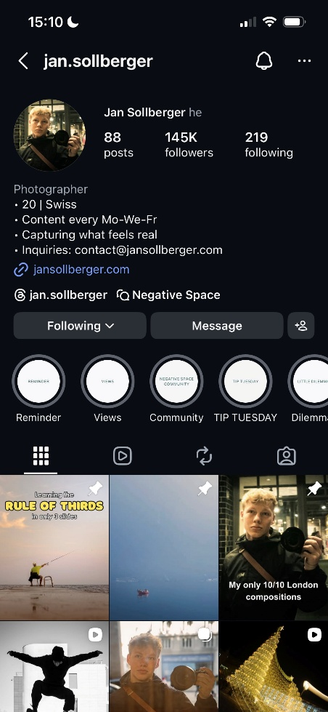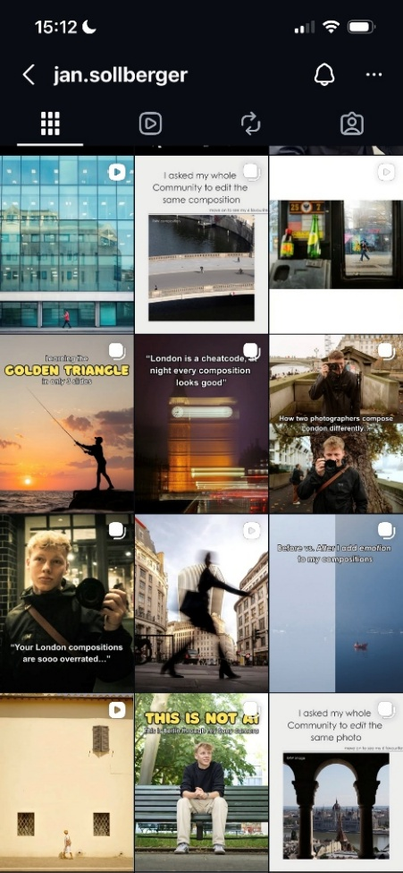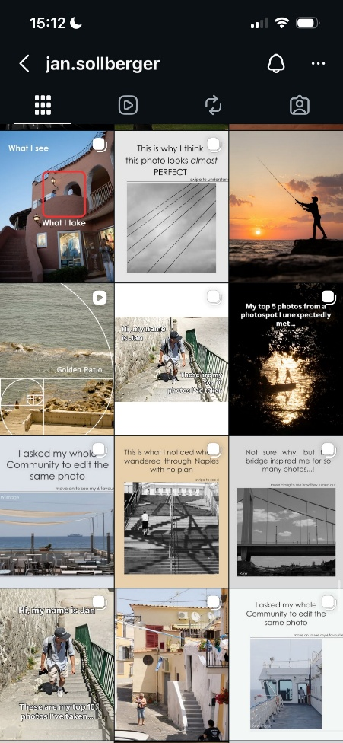
Taking all of this into account, my aim moving forward is to continue developing both my website and my photography alongside each other. I want to focus on producing more work that reflects my style, gradually expanding my portfolio, and becoming more confident in sharing my work online. By doing this, I can create a stronger and more cohesive online presence that aligns with the clean, minimal approach inspired by the photographers I researched.

