Livia Dobrica
2335250
Project Management
LCLM_5003
Assignment Portofolio: Part A,B and C
Rexon Nting

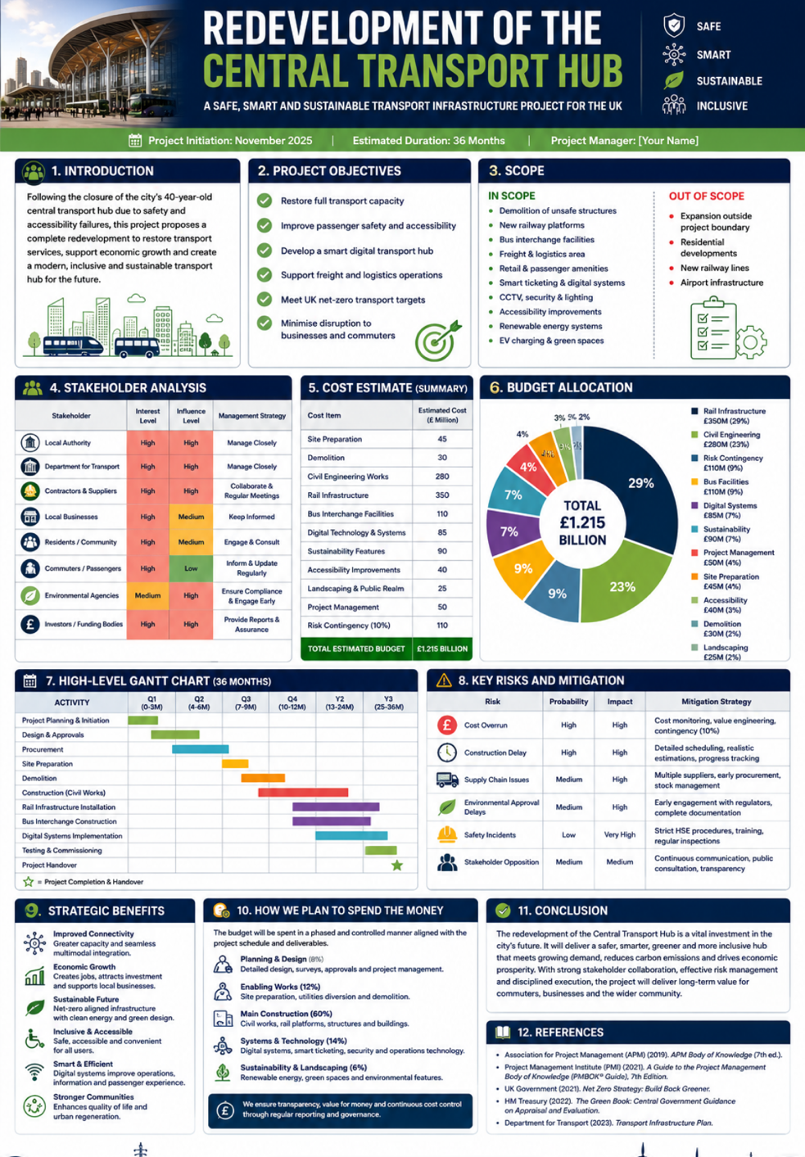
Part A:Poster

Part B: Reflection on Feedback
The feedback I received from my tutor on Part A of my project management poster was overall positive and helped me identify both the strengths of my work and the areas that could be improved. Reflecting on this feedback has allowed me to understand how effective communication, presentation, and attention to detail contribute to a successful project management plan. I have used the comments to make improvements to my final project management plan and to develop my academic skills for future assignments.
One of the key strengths identified by my tutor was that all the required information was included in the poster. This demonstrated that I had carefully followed the assignment brief and addressed the required project management components. The tutor also commented that the overall design of the poster was attractive and well presented. I aimed to create a professional and visually appealing poster by using an organised layout, appropriate colours, and relevant sections. This positive feedback confirmed that the structure and appearance of my work supported the communication of the project information and made the poster engaging for the reader.
Although the overall feedback was positive, my tutor identified some areas for improvement. The main issue was that the Cost Estimate table and the Budget Allocation table contained very similar information. I included both sections because the assignment brief required separate tables for each. However, I now understand that while both tables were included, they appeared repetitive and did not clearly demonstrate the different purposes of each section. This feedback helped me recognise the importance of presenting information in a way that clearly distinguishes similar project management tools. In my final project management plan, I ensured that the explanation of each table highlighted its specific purpose. The Cost Estimate focuses on predicting the expected costs of the project, whereas the Budget Allocation explains how the available funds are distributed across different project activities and resources.
Another area for improvement was the readability of the poster. My tutor explained that some of the text was not clear enough, making it difficult to read. This feedback made me realise that good project communication is not only about including the correct information but also about presenting it clearly. As a result, I reviewed the layout of my work and considered how font size, spacing, and text placement affect readability. For my final project management plan, I improved the formatting by ensuring that headings and content were easier to read and that the information was presented more clearly and professionally.
The tutor’s feedback has been valuable in helping me improve my final project management plan. It encouraged me to think critically about how project information is communicated and how visual presentation can affect the reader’s understanding. By reflecting on both the positive comments and the suggested improvements, I was able to strengthen the quality of my work. Overall, the feedback has increased my understanding of effective project planning, budgeting, and professional presentation, and it will help me produce higher-quality academic work in future assignments.

Part C: Project Management Plan

1. Introduction
The transport sector plays a significant role in supporting economic development, improving mobility, and connecting communities. As urban populations continue to grow, existing transport infrastructure experiences increasing pressure due to higher passenger numbers, ageing facilities, congestion, and changing environmental expectations. Infrastructure redevelopment projects have therefore become essential to improving transport efficiency while supporting sustainable development objectives.
The Redevelopment of the Central Transport Hub is designed to transform an ageing transport facility into a modern, integrated transport hub that provides improved passenger services, increased operational efficiency, and enhanced accessibility. The redevelopment incorporates smart technologies, environmentally sustainable construction methods, and modern safety systems to meet current and future transport demands. The project aligns with the UK’s wider transport strategy by promoting sustainable mobility, reducing congestion, and encouraging the use of public transport.
Project management provides the structured processes necessary to successfully deliver complex infrastructure projects involving multiple stakeholders, significant financial investment, and strict time constraints. Effective planning enables project managers to define objectives, allocate resources, monitor performance, manage risks, and ensure that project outcomes satisfy stakeholder expectations (Project Management Institute, 2021).
This Project Management Plan applies recognised project management techniques to describe how the redevelopment project will be managed from initiation through to completion. The report examines the project scope, work breakdown structure, schedule, stakeholder involvement, resource allocation, and risk management strategies required to achieve successful project delivery. By following a systematic project management approach, the redevelopment aims to deliver a transport hub that improves connectivity, promotes sustainability, supports economic growth, and provides long-term value for passengers and the wider community.
2. Project Description
The Redevelopment of the Central Transport Hub is a large-scale public infrastructure project intended to modernise one of the UK’s key transport facilities. The existing transport hub has experienced increasing passenger demand over several decades, resulting in overcrowding, ageing infrastructure, operational inefficiencies, and accessibility challenges. Without significant redevelopment, these issues are expected to worsen, reducing service quality and limiting future economic growth.
The project seeks to construct a modern transport hub that integrates rail, bus, cycling, pedestrian, and digital transport services within a single accessible location. The redevelopment includes upgrading station facilities, expanding passenger capacity, installing advanced digital information systems, improving security measures, enhancing accessibility for disabled passengers, and incorporating environmentally sustainable construction practices.
The project has several strategic objectives. These include increasing transport capacity, improving passenger safety and customer experience, reducing congestion, supporting environmental sustainability, and strengthening regional economic development. Smart technologies, including real-time passenger information systems, intelligent traffic management, CCTV, energy-efficient lighting, and digital ticketing systems, will improve operational efficiency while enhancing passenger convenience.
The redevelopment will be delivered over approximately 36 months through several project phases, including planning, design, procurement, construction, technology installation, testing, commissioning, and final handover. Throughout the project lifecycle, continuous monitoring and quality assurance processes will ensure that work is completed safely, efficiently, and according to agreed performance standards.
A wide range of stakeholders will contribute to project success, including government departments, transport authorities, contractors, engineers, local businesses, community groups, environmental agencies, and funding organisations. Effective communication and stakeholder collaboration will be essential to minimise disruption during construction while ensuring that project objectives remain aligned with stakeholder expectations.
Upon completion, the redeveloped Central Transport Hub will provide significant long-term benefits by improving transport reliability, supporting economic growth, encouraging sustainable travel, reducing environmental impacts, and creating a safer, more accessible transport environment for all users.

3. Project Scope

3.1 Project Scope Statement
The scope of the Redevelopment of the Central Transport Hub defines the work required to successfully deliver a modern, safe, smart, and sustainable transport facility. A clearly defined scope helps ensure that project objectives are achieved while preventing unnecessary work, controlling costs, and reducing the likelihood of scope creep. Establishing project boundaries also enables project managers to monitor progress effectively and ensure that stakeholder expectations remain aligned throughout the project lifecycle (Project Management Institute, 2021).
The project focuses on replacing ageing infrastructure with modern transport facilities that improve operational efficiency, passenger experience, and environmental performance. The redevelopment also supports the UK Government’s long-term transport strategy by encouraging sustainable travel and improving accessibility for all users.

Project Objectives
The project aims to achieve the following objectives:
- Increase transport capacity to accommodate future passenger demand.
- Improve passenger safety through modern security systems.
- Develop an integrated smart transport hub using digital technologies.
- Enhance accessibility for disabled passengers and individuals with reduced mobility.
- Support environmental sustainability through energy-efficient infrastructure.
- Reduce congestion and improve transport reliability.
- Deliver the project within the approved budget of £1.215 billion and the planned 36-month schedule.

3.2 In Scope
The following activities are included within the project scope:
- Demolition of outdated transport infrastructure.
- Construction of new railway platforms and passenger terminals.
- Development of new bus interchange facilities.
- Installation of modern rail infrastructure.
- Construction of roads, pedestrian pathways and cycling routes.
- Installation of CCTV, smart security systems and emergency communication equipment.
- Digital passenger information displays.
- Smart ticketing systems.
- Renewable energy systems including solar panels and energy-efficient lighting.
- Landscaping and creation of green public spaces.
- Testing, commissioning and final handover of the completed transport hub.

3.3 Out of Scope
The following activities are excluded from the project:
- Expansion of nearby airports.
- Construction of new motorway infrastructure.
- Future residential developments.
- Commercial property developments outside the transport hub.
- Future maintenance after project completion.
- Additional transport projects beyond the approved programme.
Clearly identifying these exclusions helps avoid misunderstandings between stakeholders and prevents unnecessary project expansion.

4. Work Breakdown Structure (WBS)
A Work Breakdown Structure (WBS) is a hierarchical planning tool that divides the project into manageable work packages. According to the Project Management Institute (2021), the WBS provides a structured framework that assists project managers in organising work, assigning responsibilities, estimating costs, and monitoring project performance. Breaking the project into smaller components also improves communication between project teams and reduces the risk of overlooking important activities.

Table 1. Work Breakdown Structure
Level | Work Package | Main Activities
1.0 | Project Management | Planning, monitoring, reporting, governance
2.0 | Project Initiation | Business case, approvals, stakeholder consultation
3.0 | Planning & Design | Engineering designs, environmental assessments, permits
4.0 | Procurement | Tendering, contractor selection, supplier contracts
5.0 | Site Preparation | Demolition, land clearance, utility relocation
6.0 | Construction | Platforms, terminals, roads, interchange facilities
7.0 | Rail Infrastructure | Railway installation, signalling systems
8.0 | Smart Technology | Digital ticketing, CCTV, passenger information systems
9.0 | Sustainability Works | Solar panels, energy-efficient lighting, landscaping
10.0 | Testing & Commissioning | System testing, inspections, quality assurance
11.0 | Project Closure | Final handover, documentation, lessons learned

Project Management (1.0)
Oversees planning, scheduling, budgeting, communication, quality management and overall project governance throughout the project lifecycle.
Project Initiation (2.0)
Includes feasibility studies, obtaining planning permission, identifying stakeholders and securing government approvals.
Planning and Design (3.0)
Develops architectural drawings, engineering designs, environmental impact assessments and technical specifications.
Procurement (4.0)
Manages contractor selection, supplier agreements, procurement of construction materials and specialist equipment.
Site Preparation (5.0)
Demolishes existing structures, clears construction areas and relocates underground utilities before construction begins.
Construction (6.0)
Builds new platforms, passenger buildings, roads, bridges, pedestrian routes and transport interchange facilities.
Rail Infrastructure (7.0)
Installs railway tracks, signalling equipment and operational rail systems.
Smart Technology (8.0)
Implements digital information displays, smart ticketing, CCTV, cybersecurity measures and intelligent traffic management systems.
Sustainability Works (9.0)
Installs renewable energy systems, environmentally friendly drainage, landscaping and green public areas.
Testing and Commissioning (10.0)
Conducts inspections, safety testing, operational trials and regulatory approvals before opening.
Project Closure (11.0)
Completes documentation, transfers ownership to the operating authority, evaluates project performance and records lessons learned for future infrastructure projects.

5. Quad Chart
A Quad Chart is a project management tool that provides a high-level summary of the project’s most important information. It allows stakeholders to quickly understand the project’s objectives, schedule, budget, and expected outcomes. For large infrastructure projects such as the Redevelopment of the Central Transport Hub, the Quad Chart supports effective decision-making by presenting essential project information in a clear and concise format.

Quad Chart Table:
Project Objectives | Schedule
• Increase transport capacity by 40% | Project Duration: 36 Months
• Improve passenger safety and accessibility | Phase 1 – Planning and Design (Months 1–6)
• Introduce smart transport technologies | Phase 2 – Procurement (Months 7–9)
• Reduce congestion and improve efficiency | Phase 3 – Construction (Months 10–27)
• Support environmental sustainability | Phase 4 – Technology Installation (Months 28–32)
• Enhance customer experience | Phase 5 – Testing and Handover (Months 33–36)

Budget | Expected Performance
Total Budget: £1.215 Billion | Increased passenger capacity
Government Funding | Improved transport reliability
Local Authority Investment | Reduced congestion
Private Investment | Enhanced passenger safety
Contingency Fund Included | Improved environmental performance
Continuous Financial Monitoring | Higher customer satisfaction

The Quad Chart demonstrates that project success depends on balancing cost, time, scope, and performance. Regular project reviews allow managers to monitor progress and make corrective actions if necessary.

Gantt Chart
A Gantt Chart is one of the most widely used project scheduling tools. It visually displays project activities over time and helps project managers monitor task progress, identify dependencies, allocate resources, and track milestones. For infrastructure projects involving multiple contractors and stakeholders, the Gantt Chart is essential for ensuring activities are completed in the correct sequence.

Table High-Level Gantt Chart (36 Months)
Activity | Months 1–3 | 4–6 | 7–9 | 10–15 | 16–21 | 22–27 | 28–32 | 33–36
Project Planning & Initiation | ● | ●
Design & Engineering | ● | ●
Procurement | ●
Site Preparation | ●
Construction Works | ● | ● | ●
Rail Infrastructure Installation | ● | ●
Smart Technology Installation | ●
Testing & Commissioning | ● | ●
Final Handover | ●

Project Milestones
Milestone | Planned Completion
Planning Approval | Month 3
Final Design Approved | Month 6
Procurement Completed | Month 9
Construction Begins | Month 10
Structural Works Completed | Month 27
Smart Systems Operational | Month 32
Final Inspection Passed | Month 35
Official Opening | Month 36
The Gantt Chart helps coordinate the work of engineers, contractors, suppliers, government authorities, and project managers. It also identifies the critical sequence of activities and enables managers to monitor progress against the planned schedule. Any delays can be identified early, allowing corrective actions such as reallocating resources or adjusting schedules to minimise the impact on project completion.
Effective schedule management is particularly important for this project because delays could increase costs, disrupt transport services, and affect stakeholder confidence. Regular progress reviews and milestone assessments ensure that the project remains on schedule while maintaining quality and safety standards.

7. Stakeholders Involvement
Stakeholder involvement is a critical element of project management because the success of a project depends on effective collaboration and communication between all parties involved. Stakeholders are individuals, groups, or organisations that can influence or are affected by the project. For the Redevelopment of the Central Transport Hub, stakeholder engagement ensures that project objectives align with public expectations, regulatory requirements, and business needs. Maintaining regular communication throughout the project lifecycle helps reduce conflicts, improve decision-making, and increase stakeholder satisfaction (Project Management Institute, 2021).

Table Stakeholder Analysis
Stakeholder | Role | Level of Interest | Level of Influence
UK Government | Provides funding and strategic direction | High | High
Local Council | Planning approval and community representation | High | High
Project Manager | Oversees project delivery | High | High
Contractors | Construction and engineering works | High | High
Transport Operators | Future operation of the transport hub | High | Medium
Local Businesses | Benefit from increased customer access | Medium | Medium
Local Community | Affected by construction and future services | High | Medium
Environmental Agencies | Ensure environmental compliance | Medium | High
Passengers | End users of the transport hub

Power/Interest Matrix
Manage Closely | Keep Satisfied
UK Government | Environmental Agencies
Project Manager | Local Council
Contractors | Transport Operators

Keep Informed | Monitor
Local Community | Suppliers
Passengers | Media

RACI Matrix
Activity | Project Manager | Government | Contractor | Engineers | Local Council
Project Planning | A | C | I | R | C
Procurement | A | C | R | C | I
Construction | A | I | R | R | C
Testing | A | I | R | R | C
Final Approval | C | A

Communication Plan
Stakeholder | Information | Method | Frequency
Government | Progress reports | Formal meetings | Monthly
Contractors | Work schedules | Site meetings | Weekly
Local Council | Planning updates | Email and meetings | Monthly
Local Community | Construction updates | Public meetings and website | Monthly
Passengers | Service information | Website | Weekly

Effective stakeholder communication helps maintain transparency, encourages collaboration, and supports timely decision-making throughout the project.

8. Allocation of Resources
Resource allocation ensures that the correct people, equipment, materials, and financial resources are available throughout the project. Efficient resource management reduces delays, controls costs, and improves productivity.

Human Resources
Role | Responsibility
Project Manager | Overall project management
Civil Engineers | Infrastructure design and construction
Architects | Station design
Quantity Surveyors | Cost control
Construction Workers | Building works
IT Specialists | Smart technology installation
Health & Safety Officers | Safety compliance
Environmental Specialists | Environmental monitoring

Equipment and Materials
- Construction machinery
- Cranes and lifting equipment
- Concrete and steel
- Railway track materials
- Smart ticketing equipment
- CCTV cameras
- Digital display systems
- Solar panels
- Energy-efficient lighting
- Landscaping materials

9. Risk Analysis
Risk management is essential for identifying potential threats that may affect project objectives. Early identification and mitigation reduce the likelihood of delays, increased costs, and operational problems.
Risk | Probability | Impact | Mitigation
Construction delays | High | High | Detailed scheduling and regular monitoring
Budget overruns | Medium | High | Monthly financial reviews and contingency fund
Material shortages | Medium | Medium | Multiple suppliers and early procurement
Health and safety incidents | Low | High | Strict safety procedures and staff training
Environmental issues | Medium | High | Environmental monitoring and compliance
Technology failures | Low | Medium | System testing before implementation
Poor weather | Medium | Medium | Flexible scheduling and contingency planning

10. Conclusion
The Redevelopment of the Central Transport Hub represents a significant investment in the UK’s transport infrastructure and aims to improve passenger experience, increase transport capacity, and promote sustainable development. This Project Management Plan demonstrates how recognised project management practices can be applied to manage the project’s scope, schedule, budget, resources, stakeholders, and risks effectively.
The report has shown that successful project delivery depends on detailed planning, clear stakeholder communication, efficient resource allocation, and proactive risk management. Tools such as the Work Breakdown Structure (WBS), Quad Chart, Gantt Chart, stakeholder analysis, and risk register provide a structured approach for monitoring project performance and supporting informed decision-making throughout the project lifecycle.
By completing the project within the planned budget of £1.215 billion and the proposed 36-month schedule, the redevelopment is expected to deliver long-term economic, environmental, and social benefits. The modern transport hub will improve accessibility, reduce congestion, support regional economic growth, and provide a safer, smarter, and more sustainable transport system for future generations.

References:
Association for Project Management (APM) (2019) APM Body of Knowledge. 7th ed. Princes Risborough: Association for Project Management.
Burke, R. (2023) Project Management: Planning and Control Techniques. 9th ed. Chichester: Wiley.
Kerzner, H. (2022) Project Management: A Systems Approach to Planning, Scheduling and Controlling. 13th ed. Hoboken: Wiley.
Maylor, H. (2019) Project Management. 5th ed. Harlow: Pearson.
Meredith, J.R., Shafer, S.M. and Mantel, S.J. (2022) Project Management: A Managerial Approach. 10th ed. Hoboken: Wiley.
Project Management Institute (2021) A Guide to the Project Management Body of Knowledge (PMBOK® Guide). 7th ed. Newtown Square, PA: PMI.
Lock, D. (2020) Project Management. 11th ed. London: Routledge.
Turner, J.R. (2020) The Handbook of Project-based Management. 5th ed. New York: McGraw-Hill.
Nicholas, J.M. and Steyn, H. (2020) Project Management for Engineering, Business and Technology. 6th ed. London: Routledge.
Heagney, J. (2022) Fundamentals of Project Management. 6th ed. New York: AMACOM.
Office of Government Commerce (2017) Managing Successful Projects with PRINCE2. 6th ed. London: TSO.
Fewings, P. (2023) Construction Project Management. 3rd ed. London: Routledge.

