Organizational Change: A Case Study of China Post Group Corporation

Chong Zhao（2232349）
Change and Stability Management
University of Wales Trinity Saint David
July 19, 2023

Abstract
This case study explores the theoretical organizational change focusing on China Post Group Corporation. The China Post Group Corporation is a state-owned postal firm providing logistic services to the Chinese population and across borders. This company operated for a long time using traditional postal services approaches. However, the challenges of Brexit sanctions and the novel COVID-19 created an urgency for organizational change. Focusing on the planned and emergent change models, this research investigates the practice of change management. To keep up with the changing needs of its customers, China Post has updated its methods, implemented new technology, and revised its offerings. Through aggressive use of technology, automation, and digitalization, the company increased its operational efficiency, boosted customer happiness, and broadened its presence in the digital sphere. The research explains how cultural considerations, leadership, power dynamics, digitalization, and competitiveness influence developments at China Post. Effective communication, training and assistance, and recognizing and rewarding staff are often emphasized to overcome resistance to change. The research continues with recommendations for China Post to maintain flexibility in the face of future problems by blending planned and emergent change techniques, strengthening leadership, and cultivating a culture of continuous learning and innovation.

Table of Contents
Abstract 2
1. Introduction 4
2. Background of China Post Group Corporation and Reason for Change 5
3. Change Management Models 6
3.1 Planned Change Model 6
3.2 Effectiveness and Weakness of Kotter's 8-step Emergent Change Model in the Case of China Post 9
3.3 Application of Kurt Lewin's 3-step Planned Change Model in the Case of China Post 13
4. Factors Driving Change 17
4.1 Cultural Factors 17
4.2 Leadership 17
4.4 Digitalization 19
4.5 Competition 19
5. Counteracting Resistance 20
5.1 Communication 21
5.3 Providing Training and Support. 21
5.4 Recognizing and Rewarding Employees 22
6 Key Performance Indicators (KPIs) 23
6.1 Employee Feedback 23
6.2 Customer Satisfaction 23
6.3 Financial Performance 23
7. Conclusion and Recommendations 25
7.1 Recommendations 25
7.2 Conclusion 26
9. Reference List 27

1. Introduction
Organizational growth and survival require constant adaptation to new circumstances, making change an inevitable component of organizational behaviour. Companies today face tremendous challenges compelling them to embrace change to sustain their competitive ability in the modern tumultuous business landscape, marked by the severe implications of the novel COVID-19 and the disruptive impacts of Brexit (Cameron and Green, 2020). Using the case study of China Post, one of China's largest state-owned postal service providers, this discussion provides an in-depth examination and implementation of change management theories. Since its inception, China Post has played a crucial role in connecting Chinese enterprises with their customers. However, the COVID-19 epidemic and Brexit are disruptive forces that required substantial reforms within China Post to ensure its ongoing prosperity (Enderwick and Buckley, 2020). The company understood the importance of modernizing its processes, adopting new technologies, and revamping its products and services to meet the demands of its clients. This paper sheds light on China Post's organizational transformation journey and assesses how well it has fared in the wake of the recent epidemic and Brexit, and uses the planned change model (Kurt Lewin's 3-step model) as a recommendation to the firm to effectively implement an incremental change of online services that were significantly necessitated by COVID-19 and Brexit sanctions (Juneja, 2022). Similarly, this investigation underscores the effectiveness of China Post application of the emergent model(Kotter's 8-step change model) in responding to this change because of the prevailing.

2. Background of China Post Group Corporation and Reason for Change
The China Post Group Corporation is the Chinese monopolized mail service. The Imperial Post was founded in 1896 by the Chinese Empire. Delivery of domestic mail and foreign communications were the first focuses of the postal service (Chen, 2023). However, it encountered several difficulties over time due to shifts in Chinese politics and society. The postal service underwent several changes at this time, reflecting the country's evolving requirements.
China Post used to rely heavily on manual methods for mail sorting, routing, and delivery before it adopted modern technologies (Chen, 2023). The company ran on a massive workforce to do the manual labor of mail delivery and operated through a complex system of post offices. However, China Post realized the need for change as technology developed and the amount of mail rose (Yang, 2021). The Chinese Postal Service has a long history of inefficient and antiquated operations. Manual processing caused delays in delivery and shipping, and tracking information was difficult to get. Due to these obstacles, client satisfaction was low, and the mail service fell behind. The organization realized it needed to make adjustments to close the gaps, such as adopting new technologies to streamline operations and boost service quality. There is a need for modernizing the firm’s infrastructure, improving employee training, and establishing improved interaction channels (Li, 2020). Barcodes, automated sorting systems, and automated tracking systems were among the newer innovations the company used to boost productivity and quality of service (Custodio and Machado, 2019).
Several causes prompted China Post to make the bold decision to embrace technologies and make necessary reforms. One of the main reasons was to adapt to the ever-changing international mail system. Cameron and Green (2015) stress the significance of adjusting to a constantly shifting external environment to be competitive in today's global economy. According to Kotter (2023), such transformations are essential for addressing operational inefficiencies and increasing productivity. Hayes's (2018) observations on customer-centric changes are corroborated by the fact that rising consumer expectations and requests for more rapid and dependable mail services were a major factor in propelling China Post's embrace of technology.

3. Change Management Models

3.1 Planned Change Model
The planned change model involves a systematic strategy for leading transformation in organizations. It provides an organized structure for analyzing, enacting, and assessing transformational efforts The company is expected to recognize that change in the organizational culture, especially those imposed by globalization, provides a solid grounding for planning change. According to Aditya (2022), the China Post company had made significant changes, and by 2022, they had 209 automatic parcel sorting machines,20,000 computerized postal offices and 155 letter sorting machines. However, Aditya (2022) observes that the though the company was compelled to introduce these changes, they are not equally exploiting online platforms (social media) in promoting their services. Kurt Lewin's 3-step of change model would make this change more realistic, as depicted in Figure 3. According to Banai (2020), organizations in cities worldwide should have resilience plans to evade uncertainties and remain competitive. In this regard, the company requires a planned change approach to implement these online services effectively. The first tenet of the planned change model is the significance of careful forethought and preparation. China's postal services must evaluate the potential effects of COVID-19 and Brexit on their business, supply chains, and clientele. To accomplish this, the company must be in-depth familiar with the ever-changing market policies and regulations imposed by the home country's government or the international business bodies, market conditions, and buyer habits. The planned change model allows businesses to systematically examine the internal and external elements that impact their operations, leading to better decisions (Hanelt et al., 2020).
The intended change paradigm encourages dialogue and participation from all affected parties. To adapt to changes brought on by COVID-19 and Brexit, China's postal services must include their staff, consumers, and regulators in the general change implementation process. Organizations can better understand their stakeholders, address their problems, and work together by adopting the planned change model. This helps stakeholders feel like they have a stake in the change and increases their likelihood of operating in tandem with organizational set goals. However, according to Cameron and Green (2020), an organizational team is considered psychologically aware of each other and considers one another a group. In this regard, the China Post Group corporation can only realize the objective of their planned change if their stakeholders, especially the service provision staff and management, work in the spirit of the group exemplifying the planned changes (Hanelt et al., 2020).
In light of China's post-organization responses to challenges brought by COVID-19, such as government promotion of limiting crowding and physical contact and the sanction issues brought about by Brexit, it is worth noting that the planned change model may confront significant limits since it is considerate of the stakeholder inputs, especially employees (Ahlstrom et al., 2020; OECD, 2021). The nature of these obstacles, constantly shifting and unpredictable, is one of their limitations. Organizations need to be adaptable and quick to respond to the ever-changing environment, but this can be challenging to do within the rigid confines of the planned change model (Buchanan and Badham, 2020). The weakness of this model is that it fails to fully account for the flexibility that may be necessary to respond quickly to changes in the environment and make sound decisions under pressure. In this regard, the adoption of online operations in China Post has been marked with slow implementation and uptake.
Cultural peculiarities of the Chinese context may also influence the proposed change model's transferability. The importance of rank and authority in Chinese workplaces is constantly emphasized. The intended change model's concentration on widespread engagement from staff members will clash with this work environment. This firm will need to adjust the model to make it more culturally appropriate and effective in China (Ma and Kurscheidt, 2021).

3.2 Effectiveness and Weakness of Kotter's 8-step Emergent Change Model in the Case of China Post
The concept of emergent change highlights the value of flexibility and adaptability in dealing with uncertain and complicated situations (Hall et al., 2019). Rather than being planned and implemented from on high, change is seen as an organic, emergent process that must be accommodated (Bygstad and Øvrelid, 2020). Emergent transformation has been especially important for China's post organizations as the company had to respond to the ever-evolving problems posed by COVID-19 and Brexit.
China Post, the country's national postal service, experienced significant delays to its operations and an uptick in demand for its services due to the COVID-19 pandemic. The company met these issues by introducing many technology adjustments that aided in the emergence of new approaches. China Post, for instance, has begun using contactless delivery techniques by relying on mobile apps and QR codes to reduce the risk of injury to consumers and personnel ( Aditya, 2022). Because of this sudden shift, China Post could keep providing its services despite the new demands and limitations of the pandemic. However, Aditya (2022) notes that China Post introduced online services as an incremental change but failed to market the changes on the social media platforms since, as of September 2022, the company had only a LinkedIn account where it had about 318 followers. The company has no Facebook, Instagram, Twitter, or Youtube accounts. This depicts poor communication of change.
Similarly, Brexit resulted in many difficulties for China Post's foreign business, such as new customs regulations and more stringent oversight. The company made urgent adjustments to its supply chain management and monitoring systems in response. They incorporated cutting-edge technology like blockchain and AI to improve supply chain transparency and efficiency across borders (Memon et al., 2021). These technical advancements allowed China Post to adequately meet the new demands brought on by Brexit adequately, keeping international package delivery times to a minimum and maximizing productivity.
Emergent change necessitates that China Post considers key strategies that consider probable difficulties and constraints. Evaluating the long-term viability and scalability of technology innovations in response to crises like COVID-19 is essential. Even if these adjustments helped in the short- term, they should be reviewed critically to ensure they support the organization's long-term goals and are robust enough to weather any potential future crisis (Brown & Eisenhardt, 2020). Furthermore, China Post should promote an ongoing education and innovation culture, inspiring workers to participate in the emerging change process and adjust to new conditions. According to Cameron and Green (2020), creating a sense of cohesion among organizational teams drives change as every member feels obligated to transform the firm. Figures 1 and 2 critically depict China Post's utilization of Kotter's 8-step model.


Figure 1; Kotter's 8-step Model of Change
(www.managementstudyguide.com/transformational-change-models.htm, 2023)

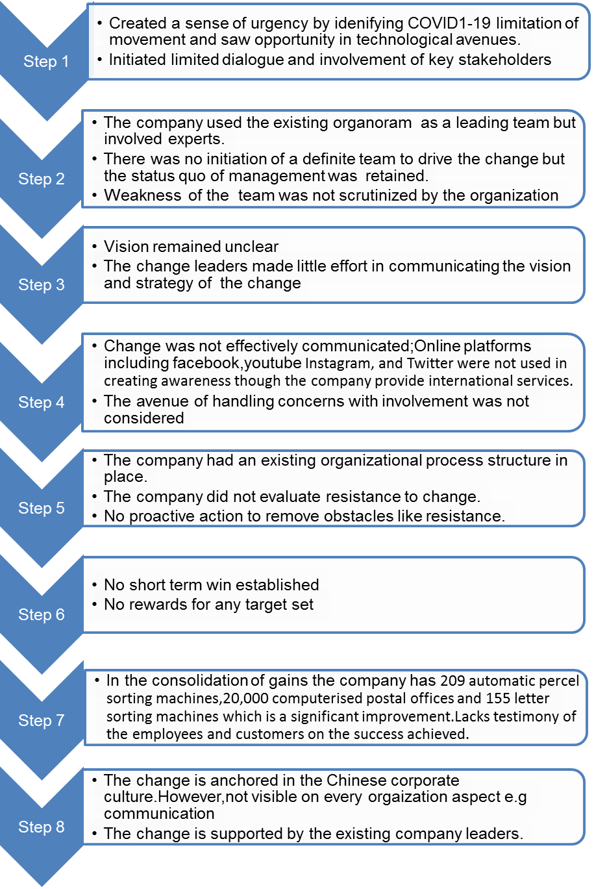
Figure 2 Application of Kotter's 8-Step Model during the introduction of online services by China Post
Source: Author

3.3 Application of Kurt Lewin's 3-step Planned Change Model in the Case of China Post
The emergent Change model was the most appropriate change model in the case of China Post Group Corporation since its changes, particularly involving the adoption of technological operation approaches, were informed by the emerging issues (Edwards et al., 2020). Because of the combined effects of the COVID-19 outbreak and the consequent Brexit dilemma, China Post, the country's preeminent postal and logistics provider, was put to the test (Echo, 2022). The corporation used an emergent change model to adjust to and succeed in the new environment. China Post exploited preventative measures by closely monitoring developments and assessing how Brexit sanctions and the epidemic may affect its business. They assembled a special group to monitor the ever-shifting regulatory landscape and market conditions to spot potential possibilities and threats as they emerged.
The introduction of online services is an incremental change anticipated to add value to service provision and increase company revenue. Kurt Lewin's 3-Step Model is crucial in implementing such a strategy though the company had attempted to implement the change using an emergent change approach. Since the change has not been so effective and the company has only 209 automatic parcel sorting machines,20,000 computerized postal offices and 155 letter sorting machines, there is a need to implement another phase of this change through a planned change concept because the company operates locally and internationally. This model has three simple steps that will aid the company to achieve their goal easily. The first stage, unfreezing phase, would require the company to consider involving the employees to gather their opinions and explain the relevance of this change to them and the expectation of the company. This stage would require an appropriate communication approach to help evade Resistance. At the second change process stage, the firm will also involve stakeholders, including employees, to share their knowledge on the decision for better implementation. This stage requires strong leadership to enhance good choices that would promote change. Finally, in the refreezing stage, the company must implement the change by ensuring they begin with a trial and then choose the most feasible approach (Cameron and Green,2015). To better harness the full potential of the incremental change project, this study recommends Kurt Lewin's 3-step model of change to expand the project since the change was not effectively implemented. Figure 3 and 4 provides the model and its potential application approach respectively.

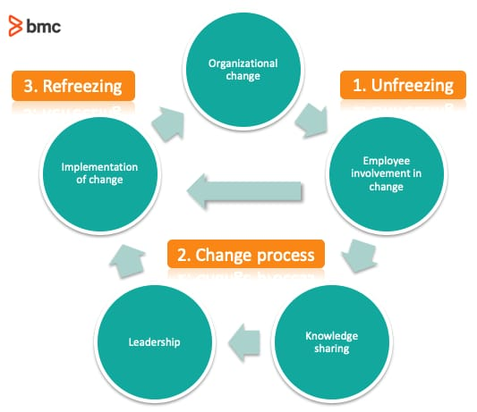
Figure 3. Kurt Lewin's 3-step Model
Source: Bakaria et al. (2017)

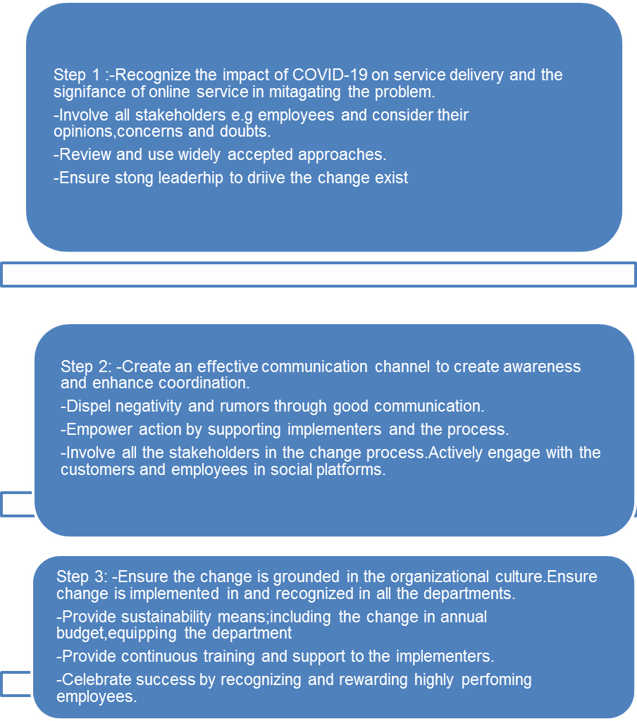
Figure 4 Application of Kurt Lewin's 3-Step Model
Source: Author

4. Factors Driving Change

4.1 Cultural Factors
China Post recognizes the importance of culture in driving transformation. A company's adaptability to change is influenced by the values, attitudes, and behaviors that permeate its culture (Mahadevan, 2023). The cultural setting in which China Post operates places a premium on collectivism, hierarchy, and deference to authority. The organizational culture may shape employees' reactions to and adaption to change initiatives.

4.2 Leadership
According to Cameron and Green (2020), leadership is a crucial tenet that drives an organization's vision and the general company cycle of change. This assertion's validity is supported by Kotter's eight-step model that expresses the qualities of a leader with an effective change implementation strategy. Cameron and Green (2020) posit that this kind of change is viewed as a

Figure 1. Illustrates the change cycle informed by sound leadership.
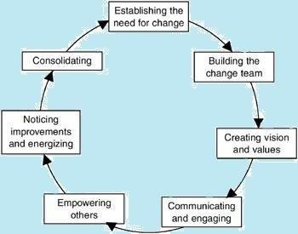
Figure 5 Cycle of Change
(Source: Cameron and Green, 2020)
Change within China Post is largely driven and managed by its leadership. Strong leadership is essential to implement change and successfully inspire long-term commitment from staff. Leaders are crucial in fostering change and energizing staff throughout the transformation, as Cameron and Green (2015) pointed out. Strong leadership makes trust, motivation, and overcoming opposition to change possible.
Change is driven and managed in large part by the leadership of an organization. China Post firm should capitalize on strong leadership to successfully implement change and inspire long-term commitment from staff. Leaders foster change and energize staff throughout transformation (Cameron and Green, 2015). Strong leadership makes trust, motivation, and overcoming opposition to change possible.

4.4 Digitalization
In the contemporary highly digitalized society, digitalization has become a major force in driving transformation. To be competitive and fulfil the needs of its customers, the China Post needs to adjust to the current digital environment (Cameron & Green, 2020). When anything is "digitized," technology is included in this operation procedure, the framework, and the relationship with the client (Lozic, 2019). To meet these demands, China Post must increase spending on digital infrastructure, train workers to become more proficient in digital tools, and try new ways of providing customer care.

4.5 Competition
Competition forms a major component of business operations. Though China Post enjoyed a significant monopoly before the increased rate of technological advancement, today, it has many competitors. China Post is driven to innovate and adapt to the pressure of the market. To keep up with the times, conventional postal services face competition from private logistical firms and new technologies (Hayes, 2018). Also, to maintain its position as a market leader, China Post must change its approach, increase its operational efficiency, and create innovative new services (Mamadiyarov, 2020). Competitors' pressure prompts the company to welcome change and actively pursue expansion prospects.

5. Counteracting Resistance
Resistance to change can be structural, technical, political, cultural and individual. Since these Resistance are escalated by people it is crucial to focus on them while supporting and challenging them to ensure by understanding them. According to Malone (2018) situational leadership provides that a leader becomes flexible to adjust to the need of their team.In this regard,a consideration of Kubler-Ross change Curve as shown in figure 6 may help in recognizing the cause of the above mentioned types of Resistance when focus is given to people influencing the change thus leveraging solution.The following are some of the ways of counteracting Resistance relevant to the case of China Post Group.
Figure 6 Kubler-Ross Change Curve
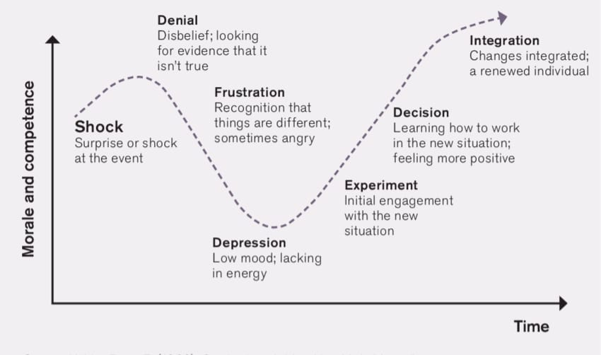
Source: (Malone, 2018)

5.1 Communication
Individual Resistance and may be revealed through frustrations expressed in dialogue and through performance thus communication is key in unlocking them. Creating platforms that enhance dialogue, provides opportunity for the employees to present their views and equally act as a way of establishing Resistance to change (Guth et al., 2019). China Post can ease the transition and increase employee buy-in by employing some strategies and methods to combat Resistance to change (Abualhaija, 2022). One efficient strategy is to set up lines of communication that encourage candid conversation and the free flow of information. Ababneh (2021) state that workers are more open to and accepting of change when they believe their voices and opinions are being heard. China Post can ease employees' concerns by holding regular forums, team briefings, and one-on-one sessions to answer their questions, allay their fears, and explain the rationale behind the changes (Lewis, 2019). China Post may win over the hearts and minds of its staff and lessen their aversion to change if it takes their suggestions seriously and engages them in decision-making.

5.3 Providing Training and Support.
A typical way of identifying Resistance to change that the company should consider is poor employee interest in skill development (Errida, 2021). When employees portray insignificant effort to advance to cope with the prevailing changes, it may be an implication for a perceived difficulty. Providing comprehensive training and development programs to equip staff with the knowledge and skills necessary for enhancing adaptability to emergent changes is a vital strategy for overcoming Resistance to change (Alolabi et al., 2021). Employees are more inclined to accept change if they feel they have been given the information and training to do so (Drosos et al.,2021). China Post may better prepare its staff for the transition by holding seminars, training workshops, and promoting change-oriented courses to help them learn about the changes, acquire new skills, and receive direction. According to Kitsios and Kamariotou (2021), China Post should also consider rewarding and incentivizing workers who help bring about the necessary changes. As a result, staff morale may improve, and a more open attitude toward the transition may result.

5.4 Recognizing and Rewarding Employees
Employees' inclination towards preserving the status quo preservation is a dangerous sign of resistance to change. Employees sometimes overlook new modifications and structural or system changes while seeing no value in embracing change (Amir and Mangundjaya, 2021). China Post must create an organization-wide culture that encourages and rewards creativity and openness to change. The company's culture can influence employees' reactions to change (Bagga et al., 2023). A culture of innovation, risk-taking, and constant development is possible to foster at China Post. Leaders and managers can inspire their teams to adopt new practices by committing to change. In addition, China Post can form cross-functional teams to encourage cooperation between departments during transformational initiatives (Cameron and Green, 2020). This can help people unite, share information, and collaborate to create organizational change.

6 Key Performance Indicators (KPIs)

6.1 Employee Feedback
China Post can exploit employee opinions as a key performance indicator to measure the success of recent reforms. There may have been a need for retraining, fresh procedures, and altered work habits due to the introduction of technology in their operation procedures (Su et al., 2019). Staff reaction to changes, potential for enhancements, and general satisfaction levels can be determined by collecting and evaluating feedback (Stuber et al., 2021). The Chinese Post can conduct polls, interviews, and ideation platforms to gauge employee satisfaction.

6.2 Customer Satisfaction
China Post should consider customer satisfaction as a key performance indicator to gauge the efficacy of its reform efforts (Chen et al., 2020). The company's incorporation of technology into its operations was motivated by a desire to enhance the quality of service, increase delivery speed, and improve customer experience. Though this kind of change was motivated by circumstances forcing the organization to strive to fit, the outcome is likely to change the mindset of its leadership owing to consumer response concerning service provision changes. Enhanced consumer satisfaction has increased positive word of mouth, brand loyalty, and repeat purchases (Tjahjaningsih et al., 2020). Feedback forms, customer satisfaction surveys, and star ratings would be essential for China Post to monitor this indicator (Chiny et al., 2021).

6.3 Financial Performance
China Post's financial success is a key performance indicator for gauging the efficacy of the measures taken in reaction to COVID-19 and Brexit sanctions. Adopting technology can enhance income creation, operational efficiency, and cost savings. Revenue growth, cost-cutting, and profit margin are significant examples of financial measurements that might provide light on how these alterations would affect a company's bottom line (Syriopoulos et al., 2022). Figure 2 demonstrates how the changes in the Chinese postal industry have informed critical growth in revenue over the years.
Figure 2; changes in the Chinese postal industry have informed critical growth in revenue over the years.
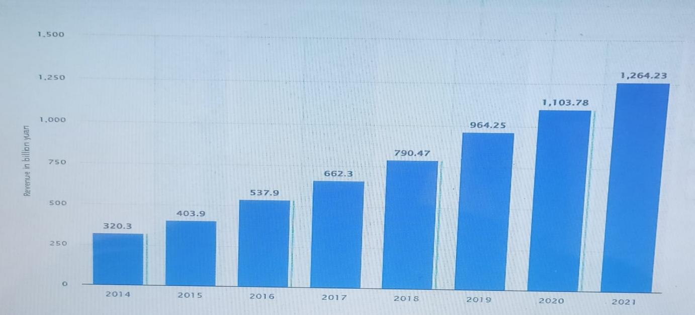
Figure 7. Chinese Postal Industry Income from 2014-2021(in billion yuan)
Source: (Statista, 2023)

7. Conclusion and Recommendations

7.1 Recommendations
The China Post firm should adopt emergent and planned change models based on the intended change. Since the Chinese population have a culture of recognizing hierarchical leadership and collective action, integrating the two models may produce significant change (Agostini and van Zomeren, 2021). The China Post should keep using deliberate and organic approaches to transformation. Emergent change fosters adaptability and flexibility in reaction to unforeseen circumstances, whereas planned change gives structure and systematic analysis. This synergy will help China Post face future problems and confidently embrace new possibilities.
The company should strengthen its leadership. Implementing change effectively requires strong leadership. China Post needs to put resources into grooming leaders who can invigorate and motivate staff, encourage creativity, and negotiate organizational politics. China Post can push through change and overcome opposition by investing in its leaders and equipping them with the tools they need to succeed.
Fostering ongoing learning and innovation culture in the organization will enhance the perfection of change adoption in the company. China Post needs to emphasize learning and new ideas if it anticipates to succeed in the future. It involves things like recognizing and rewarding people for being creative and adaptable and giving them training and assistance. China Post can increase its agility and remain competitive by fostering a culture that fosters advancement and creativity.

7.2 Conclusion
China Post Group Corporation's adoption of digital changes will set the stage for continued success and expansion. The organization has effectively responded to changing market conditions, new technological developments, and client preferences by applying a well-thought-out change management strategy. Post Group Corporation has revitalized its model of operation and increased its market share by adopting innovation, simplifying operations, and promoting a culture of responsiveness and collaboration. Efficiency, customer satisfaction, and the company's bottom line have all benefited from the new procedures and systems. Post Group Corporation, however, must acknowledge that organizational transformation is a continuous process and always be ready to adapt to new circumstances. The only way for a company to keep up with the ever-shifting business landscape is to foster a culture for ongoing growth and learning and to pay close attention to market dynamics and consumer demands. Post Group Corporation is set up to continue its success and expand into new markets thanks to its articulated goals, solid management, and relentless pursuit of excellence.

9. Reference List
Ababneh, O.M.A. (2021). How do green HRM practices affect employees’ green behaviors? The role of employee engagement and personality attributes. Journal of Environmental Planning and Management, 64(7), pp.1–23. Doi: https://doi.org/10.1080/09640568.2020.1814708.
Abualhaija, M. (2022). Change and Resistance to Change during COVID-19. [online] Available at: https://files.eric.ed.gov/fulltext/ED626668.pdf#page=124 [Accessed 19 Jul. 2023].
Aditya, S. (2022). Extensive Marketing Strategy of China Post – Detailed Explanation: A Case Study of China Post Company. [online] Available at: https://iide.co/case-studies/marketing-strategy-of-china-post [Accessed 19 Jul. 2023].
Agostini, M. and van Zomeren, M. (2021). Towards a comprehensive and potentially cross-cultural model of why people protest: A quantitative research synthesis of four motivations for collective action. [online] The University of Groningen research portal. Available at: https://research.rug.nl/en/publications/towards-a-comprehensive-and-potentially-cross-cultural-model-of-w [Accessed 19 Jul. 2023].
Ahlstrom, D., Arregle, J., Hitt, M.A., Qian, G., Ma, X. and Faems, D. (2020). Managing Technological, Sociopolitical, and Institutional Change in the New Normal. Journal of Management Studies, 57(3), pp.411–437. Doi: https://doi.org/10.1111/joms.12569.
Alolabi, Y.A., Ayupp, K. and Dwaikat, M.A. (2021). Issues and Implications of Readiness to Change. Administrative Sciences, 11(4), p.140. Doi: https://doi.org/10.3390/admsci11040140.
Amir, M.T. and Mangundjaya, W.L. (2021). How Resilience Affects Employee Engagement? A Case Study in Indonesia. The Journal of Asian Finance, Economics and Business, [online] 8(2), pp.1147–1156. Doi: https://doi.org/10.13106/jafeb.2021.vol8.no2.1147.
Badham, R. (2020). Power, Politics, and Organizational Change. www.torrossa.com, [online] pp.1–344. Available at: https://www.torrossa.com/gs/resourceProxy?an=5019348&publisher=FZ7200 [Accessed 19 Jul. 2023].
Bagga, S.K., Gera, S. and Haque, S.N. (2022). The mediating role of organizational culture: Transformational leadership and change management in virtual teams. Asia Pacific Management Review, [online] 28(2). Doi: https://doi.org/10.1016/j.apmrv.2022.07.003.
Banai, R. (2020). Pandemic and the planning of resilient cities and regions. Cities, 106. Doi: https://doi.org/10.1016/j.cities.2020.102929.
Bygstad, B. and Øvrelid, E. (2020). Architectural alignment of process innovation and digital infrastructure in a high-tech hospital. European Journal of Information Systems, 29(3), pp.220–237.
Cameron, E. and Green, M. (2020). Making sense of change management: A complete guide to the models, tools and techniques of organizational change. London; New York; New Delhi Kogan Page.
Chen, T., Peng, L., Yin, X., Rong, J., Yang, J. and Cong, G. (2020). Analysis of User Satisfaction with Online Education Platforms in China during the COVID-19 Pandemic. Healthcare, 8(3), p.200. Doi: https://doi.org/10.3390/healthcare8030200.
Chen, L. (2023). Censorship and the Postal Service in China during World War One. British Journal of Chinese Studies, [online] 13(1), pp.41–62. Available at: https://eprints.soas.ac.uk/38748 [Accessed 19 Jul. 2023].
Chiny, M., Bencharef, O., Hadi, M.Y. and Chihab, Y. (2021). A Client-Centric Evaluation System to Evaluate Guest’s Satisfaction on Airbnb Using Machine Learning and NLP. [online] Applied Computational Intelligence and Soft Computing. Available at: https://www.hindawi.com/journals/acisc/2021/6675790/ [Accessed 19 Jul. 2023].
Custodio, L. and Machado, R. (2019). Flexible automated warehouse: a literature review and an innovative framework. The International Journal of Advanced Manufacturing Technology, 106(1-2), pp.533–558.
Drosos, D., L. Kyriakopoulos, G., C. Gkika, E., Komisopoulos, F., Skordoulis, M. and Ntanos, S. (2021). Managing Change and Managerial Innovation towards Employees Satisfaction at Workplace. TEM Journal, 10(2), pp.597–606. Doi: https://doi.org/10.18421/tem102-15.
Echo, X. (2022). China Post to test all overseas mail for Covid-19 as outbreak continues. [online] South China Morning Post. Available at: https://www.scmp.com/news/china/science/article/3168755/china-post-test-all-overseas-mail-covid-19-outbreak-continues [Accessed 19 Jul. 2023].
Edwards, K., Prætorius, T. and Nielsen, A.P. (2020). A Model of Cascading Change: Orchestrating Planned and Emergent Change to Ensure Employee Participation. Journal of Change Management, 20(4), pp.1–27. Doi: https://doi.org/10.1080/14697017.2020.1755341.
Enderwick, P. and Buckley, P.J. (2020). Rising Regionalization: Will the Post-COVID-19 World See a Retreat from Globalization? [online] papers.ssrn.com. Available at: https://papers.ssrn.com/sol3/papers.cfm?abstract_id=3692317 [Accessed 19 Jul. 2023].
Errida, A. and Lotfi, B. (2021). The Determinants of Organizational Change Management success: Literature Review and Case Study. International Journal of Engineering Business Management, [online] 13(1), pp.1–15. Doi: https://doi.org/10.1177/18479790211016273.
Guth, L.J., Pollard, B.L., Nitza, A., Puig, A., Chan, C.D., Singh, A.A. and Bailey, H. (2019). Ten Strategies to Intentionally Use Group Work to Transform Hate, Facilitate Courageous Conversations, and Enhance Community Building. The Journal for Specialists in Group Work, [online] 44(1), pp.3–24. Doi: https://doi.org/10.1080/01933922.2018.1561778.
Hall, A., Cox, P., Huntingford, C. and Klein, S. (2019). Progressing emergent constraints on future climate change. Nature Climate Change, 9(4), pp.269–278. Doi: https://doi.org/10.1038/s41558-019-0436-6.
Hanelt, A., Bohnsack, R., Marz, D. and Antunes, C. (2020). A systematic review of the literature on digital transformation: insights and implications for strategy and organizational change. Journal of Management Studies, 58(5), pp.1159–1197.
Juneja, P. (2022). Kurt Lewin’s Change Management Model: The Planned Approach to Organizational Change. [online] Management Study Guide. Available at: https://www.managementstudyguide.com/kurt-lewins-change-management-model.htm [Accessed 19 Jul. 2023].
Kitsios, F. and Kamariotou, M. (2021). Job satisfaction behind motivation: An empirical study in public health workers. Heliyon, 7(4), p.e06857. doi: https://doi.org/10.1016/j.heliyon.2021.e06857.
Lewis, L. (2019). Organizational Change: Creating Change Through Strategic Communication. Google Books. John Wiley & Sons.
Li, T. (2020). A SWOT analysis of China’s air cargo sector in the context of COVID-19 pandemic. Journal of Air Transport Management, 88(1), p.101875.
Lozic, J., (2019). Core concept of business transformation: from business digitization to business digital transformation. Economic and Social Development: Book of Proceedings, pp.159-167.
Mahadevan, J. (2023). Cross-Cultural Management. SAGE.
Malone, E.D. (2018). The Kubler-Ross change curve and the flipped classroom: Moving students past the pit of despair. Education in the Health Professions, 1(2), p.36. Doi: https://doi.org/10.4103/ehp.ehp_26_18.
Mamadiyarov, Z., Toshtemirovich, Tsue and Head (2020). The innovative approaches of remote banking types services in the process of transformation of banks to e-commerce. [online] Available at: https://media.neliti.com/media/publications/428945-innovative-approaches-of-remote-bankingt-8f455dca.pdf [Accessed 19 Jul. 2023].
Ma, Y. and Kurscheidt, M. (2021). Modifying Tradition: Understanding Organizational Change in Chinese Elite Sport Training at the Grassroots Level. Sustainability, 13(7),
Memon, S.U.R., Pawase, V.R., Pavase, T.R. and Soomro, M.A. (2021). Investigation of COVID-19 Impact on the Food and Beverages Industry: China and India Perspective. Foods, [online] 10(5), p.1069.
OECD (2021). The Territorial Impact of COVID-19: Managing the Crisis and Recovery across Levels of Government. [online] OECD. Available at: https://www.oecd.org/coronavirus/policy-responses/the-territorial-impact-of-covid-19-managing-the-crisis-and-recovery-across-levels-of-government-a2c6abaf/ [Accessed 19 Jul. 2023].
Stuber, F., Seifried-Dübon, T., Rieger, M.A., Gündel, H., Ruhle, S., Zipfel, S. and Junne, F. (2020). The effectiveness of health-oriented leadership interventions for the improvement of mental health of employees in the health care sector: a systematic review. International Archives of Occupational and Environmental Health, 94(2), pp.203–220. Doi: https://doi.org/10.1007/s00420-020-01583-w.
Su, W., Lin, X. and Ding, H. (2019). The Influence of Supervisor Developmental Feedback on Employee Innovative Behavior: A Moderated Mediation Model. Frontiers in Psychology, 10. Doi: https://doi.org/10.3389/fpsyg.2019.01581.
Statista, (2023). Business income of the postal service industry in China from 2014 to 2021(in billion yuan). Available at: https://www.statista.com/statistics/1037163/china-postal-service-business-revenue/.
Syriopoulos, T., Tsatsaronis, M. and Gorila, M. (2020). The global cruise industry: Financial performance evaluation. Research in Transportation Business & Management, p.100558. Doi: https://doi.org/10.1016/j.rtbm.2020.100558.
Tjahjaningsih, E., Ningsih, D.H.U. and Utomo, A.P. (2020). The Effect of Service Quality and Product Diversity on Customer Loyalty: The Role of Customer Satisfaction and Word of Mouth. The Journal of Asian Finance, Economics and Business, 7(12), pp.481–490.
Yang, Y. (2021). China’s postal industry continues to grow rapidly. [online] global.chinadaily.com.cn. Available at: https://global.chinadaily.com.cn/a/202110/14/WS6167ce9ba310cdd39bc6ef7c.html [Accessed 19 Jul. 2023].

