

LOCATION: Swansea | LLEOLIAD: abertawe
LEVEL 6 | LEFEL 6
EXAMINATION PERIOD | CYFNOD ARHOLIADAU
JULY 2021 | Gorffennaf 2021

MODULE CODE: ACCA6022
COD Y MODWL: ACCA6022
SWITCHING, ROUTING AND WIRELESS ESSENTIALS
TIME: 2 HOURS

Name :

Student ID :

Date & Time :

This is an individual practical test, held under examination conditions. You will be assigned three Switches and three Routers; you should configure these devices based on the given specifications.

This paper is marked out of 100.

Topology

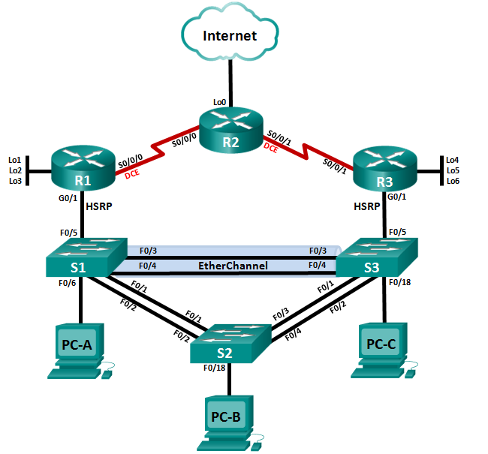

Addressing Table
Device | Interface | IP Address | Subnet Mask | Default Gateway
R1 | G0/1 | 192.168.0.1 | 255.255.255.0 | N/A
 | S0/0/0 | 192.168.123.1 | 255.255.255.252 | N/A
 | Lo1 | 192.168.1.1 | 255.255.255.0 | N/A
 | Lo2 | 192.168.2.1 | 255.255.255.0 | N/A
 | Lo3 | 192.168.3.1 | 255.255.255.0 | N/A
R2 | S0/0/0 | 192.168.123.2 | 255.255.255.252 | N/A
 | S0/0/1 | 192.168.123.5 | 255.255.255.252 | N/A
 | Lo0 | 209.165.200.225 | 255.255.255.248 | N/A
R3 | G0/1 | 192.168.0.3 | 255.255.255.0 | N/A
 | S0/0/1 | 192.168.123.6 | 255.255.255.252 | N/A
 | Lo4 | 192.168.4.1 | 255.255.255.0 | N/A
 | Lo5 | 192.168.5.1 | 255.255.255.0 | N/A
 | Lo6 | 192.168.6.1 | 255.255.255.0 | N/A
S1 | VLAN 6 | 192.168.0.11 | 255.255.255.0 | 192.168.0.2
S2 | VLAN 6 | 192.168.0.12 | 255.255.255.0 | 192.168.0.2
S3 | VLAN 6 | 192.168.0.13 | 255.255.255.0 | 192.168.0.2
PC-A | NIC | 192.168.0.21 | 255.255.255.0 | 192.168.0.2
PC-B | NIC | 192.168.0.22 | 255.255.255.0 | 192.168.0.2
PC-C | NIC | 192.168.0.23 | 255.255.255.0 | 192.168.0.2

VLAN Table
VLAN | VLAN Name | Ports
2 | Sales | Fa0/7 - 9
3 | Finance | Fa0/10 – 12
4 | Guest | Fa0/13 – 16
5 | Warehouse | Fa0/21– 24
6 | Management & Native | Fa0/6, Fa0/17 - 20

Task 1: - Topology Creation (5 marks)
Using Packet Tracer software create the topology shown above and complete all tasks below.
- Configure hostnames on each device.
- Disable DNS lookup on all routers
- Configure all devices with IP address shown in the above tables and network topology.

Task 2: - Device Configuration (80 marks)
- Configure RIPv2 on R1, R2 & R3. Advertise directly connected Networks. Disable automatic summarization.
- Set Router ID, 1.1.1.1 on R1, 2.2.2.2 on R2 and 3.3.3.3 on R3.
- Set the bandwidth on serial links to 256kbps.
- On R2, configure default route using Lo0 as exit interface and propagate the default route to all other RIP routes.
- Configure S1 as VTP Server and S2 and S3 as clients. Use soac.com as domain and set uwtsd as password.
- Configure VLANs as shown in the table.
- Force trunking on interfaces connected between switches. Use VLAN 6 as native VLAN.
- Configure PortFast and BPDU Guard on the interfaces connected to PCs. Shutdown all unused ports.
- On all switches, configure Rapid PVST as spanning tree mode.
- Configure S1 with root priority of 24576 and S3 with 28672.
- Enable port security on ports connected to end devices. Set the maximum so that only one device can access the Fast Ethernet ports.
- Secure the ports so that the MAC address of a device is dynamically learned and added to the running configuration. Set the violation mode so that the Fast Ethernet ports are not disabled when a violation occurs, but a notification of the security violation is generated and packets from the unknown source are dropped
- On S1, configure an PAgP EtherChannel on interfaces connected to each other. Use group 1 and enable PAgP unconditionally.
- On S3, configure an PAgP EtherChannel on interfaces connected to S1. Use group 1 and enable PAgP only if a PAgP device is detected.
- Configure HSRP on R1 and R3. Group: 1, Virtual IP address: 192.168.0.2. Make R1 as the primary router.

Task3: Network connectivity (10 marks)
Using ping command, verify end-to-end connectivity:
From PC-A, ping PC-B & PC-C. Is it successful? ___yes/no_____
From PC-A, ping default gateway. Is it successful? ___yes/no_____
From PC-B, ping 192.168.0.1. Is it successful? ___yes/no_____
From PC-A, ping 209.165.200.225. Is it successful? ___yes/no_____

Verify HSRP is working as expected
Issue the shutdown command on R1 G0/1, and then re-issue the following commands to verify that HSRP is working as expected:
From PC-B, ping 192.168.0.1. Ping should not be successful ___yes/no___
From PC-B, ping default gateway. Is it successful? ___yes/no_____
From PC-B, ping 209.165.200.225. Is it successful? ___yes/no_____

Submission Requirement
The packet tracer file should be saved as “studentname_id” and uploaded onto Moodle. In addition to packet tracer file, you must also submit

- the output of show running-configuration command in a text file for all devices configured.
- This document with Task 3 completed

All documentation for your solution should be submitted electronically on Moodle.
It is your responsibility that you submit all the outputs and files correctly.

