

Assessment 1 – Reading Task Template
Upload your photo of your A3 in-class notes here:
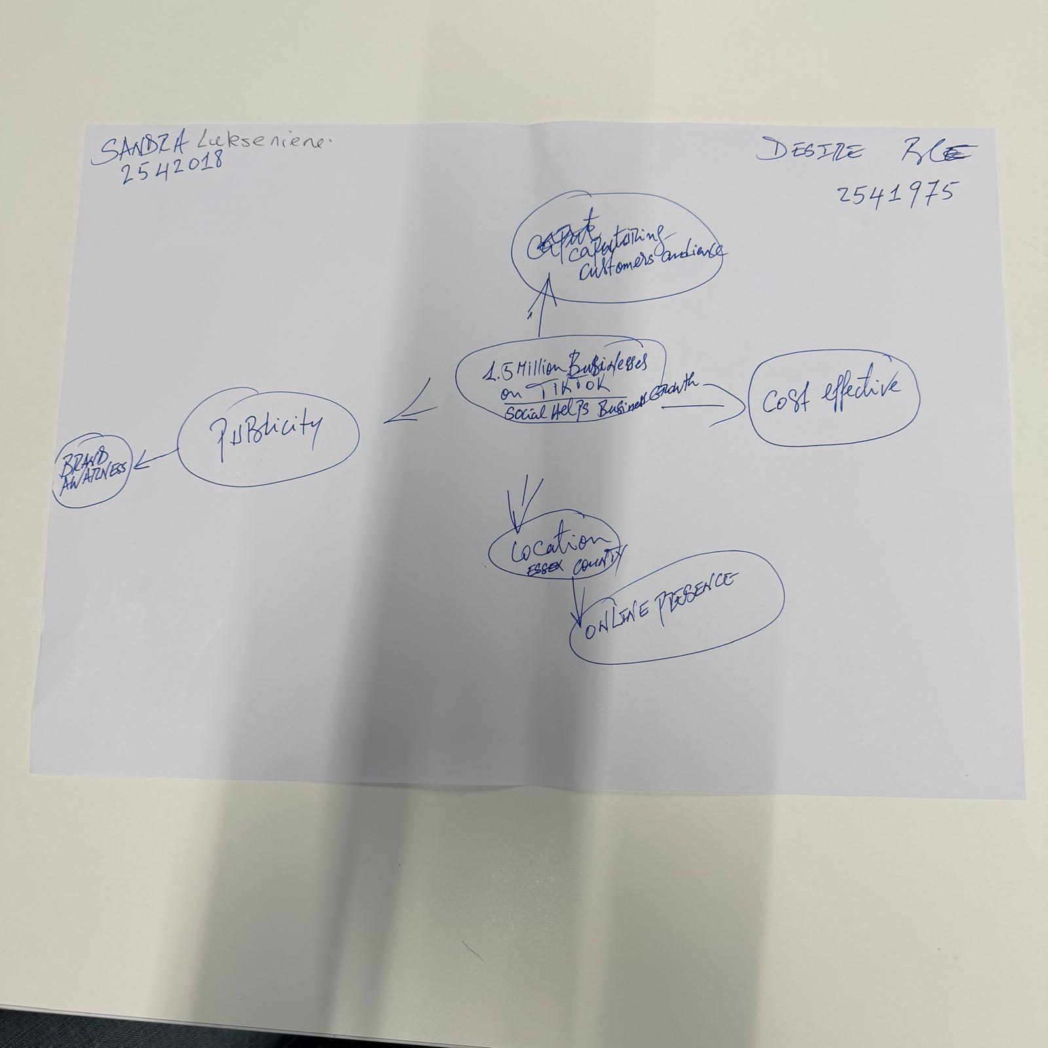

1. Answer these questions using the sentence starters below
a. What is the main idea of the text?
The main idea is to demonstrate the importance of the use of the Social Media plays in the modern day business.
b. What are two key points?
One key point is local businesses being present online.
Another key point is regional, national and global presence online.
c. What part of the text did you find most important? I found Murat Mutlu saying that she is surprised at how far his clients travelled to reach his sandwich shop. Why : The advert on the social medial made a great impact on his business presence online.
The most important part is the customers travelled three hours for a chicken burger.
d. Was anything unclear or difficult to understand?: No , nothing was unclear to me.
I was not sure about how to structure in an orderly manner.
e. How did your group help you understand the text better?: By interacting with each other.
My group helped me by solidifying our work.
2. One sentence reflection : I have admired the impact the media can bring to a local business.
Question: What did you find challenging about this task?
The hardest part was structuring things.

