Name: Koyesh Ahmed
Student Number: 1705021
Assignment Title: Problem Solving and Decision Making

Executive Summary:
The NHS is under constant pressure to find solutions that have the potential to improve health care outcomes or deliver cost savings at scale. This has become even more apparent to me over the past few months as I’ve explored scaling up in the UK health care sector more closely. Spring Impact has been travelling across the country to meet with project teams that have been supported by the Health Foundation.

We’ve seen inspirational clinicians and managers who go above and beyond every day, to invest in improvement and innovation solutions to boost health care outcomes. The landscape of possible solutions is diverse, ranging from delivering multi-disciplinary support to advanced symptom Parkinson’s patients, to preventing prescribing errors in GP practices. But too often these solutions exist as isolated pockets of excellence and are infrequently implemented at wider scale locally or nationally.

As we explored the specific challenges of replication within the UK health care sector we found that a popular way to ‘scale up’ an approach or intervention to improve patient care is through sharing best practice. SPRING IMPACT calls this activity ‘dissemination’. It can work excellently for particular solutions or contexts, for example clinical networks – where clinicians share best practice and ideas for making small scale changes to practice. But for other approaches and interventions, particularly those that are more complex, dissemination alone can be insufficient.

To begin to understand why dissemination only works for some solutions or contexts, we listened, and we learned through available literature and interviews with people working in the health care sector. We heard time and again about the challenges associated with dissemination – that more support was needed to create behaviour change, or that there was a lack of clarity about the approach or intervention being scaled up.

We believe more structured ways of replication such as social franchising or licensing have particular potential to help scale solutions across the NHS. Social franchising is based upon the commercial franchising model where companies, such as the Body Shop, use franchises to expand. Our chief executive Dan Berelowitz spent time with The Body Shop, McDonald’s and some great social enterprises, understanding what makes replication and franchising work. In this model a proven business model is ‘boxed’ up and passed on to others to replicate with appropriate support. Social franchising follows the same principle, allowing an organisation to package what works and provide support to others to adopt it, with a focus on replicating impact. This retains the essence and fidelity of the core elements of the approach, while remaining flexible and open to adaptation to the local context.
The National Health Service (NHS) is the name used for each of the public health services in the United Kingdom- the National Health Service in England, NHS Scotland, NHS Wales, and Health and Social care in Northern Ireland- as well as a term to describe them collectively. They were established together in 1948 as one of the major social reforms following the second world war.
The founding principles were that services should be comprehensive range of health services, free for people ordinarily resident in the United Kingdom, apart from dental treatment and optical care. (The English NHS also requires patients to pay prescription charges with a range of exemptions from these charges).
Each of the UK’s health service systems operates independently and is politically accountable to the relevant government: the Scottish Government, Welsh Government; Northern Ireland Executive; and the UK Government, responsible for England’s NHS. NHS Wales was originally part of the same structure as that of England until powers over the NHS Wales were firstly transferred to the secretary of state for wales in 1969 and thereafter, in 1999, to the welsh assembly as part of Welsh devolution. Some functions may be routinely performed by one health service on behalf of another.
For example, Northern Ireland has no high-security psychiatric hospitals and depends on hospitals in Great Britain, routinely at Carstairs hospital in Scotland for male patients and Rampton Secure Hospital in England for female patients. Similarly, patients in North Wales use specialist facilities in Manchester and Liverpool which are closer than facilities in Cardiff, and more routine services at the Countess of Chester Hospital. There have been issues about cross-border payments.
Taken together, the four National Health Services in 2015-16 employed around 1.6 million people with a combined budget of £136.7 billion. In 2014 the total health sector workforce across the UK was 2,165,043. This broke down into 1,789,586 in England, 198,368 in Scotland, 110,292 in Wales and 66,797 in Northern Ireland. In 2017, there were 691,000 nurses registered in the UK, down 1,783 from the previous year. However, this is the first-time nursing numbers have fallen since 2008.
Although there was been increasing policy divergence between the four National Health Services in the UK, it can be difficult to find evidence of the effect of this on performance since, as Nick Timmins says: “some of the key data needed to compare performance- including data on waiting times- is defined and collected differently in the four countries”. Statistics released in December 2017 showed that, compared with 2012/3, 9% fewer patients in Scotland were waiting more than four hours than four hours in accident and emergency, whereas in England the numbers had increased by 155%.
Funding
The systems are 98.8% funded from general taxation and National insurance contributions, plus insignificant amounts from patient charges for some services. About 10% of GDP is spent on health and most is spent in the public sector. The money to pay for the NHS comes directly from taxation. The 2008/9 budget roughly equates to a contribution of £1,980 per person in the UK.
When the NHS was launched in 1948 it had a budget of £437 million (roughly £9 billion at today’s prices). In 2008/9 it received over 10 times that amount (more than £100 billion). In 1955/6 health spending was 11.2% of the public services budget. In 2015/6 it was 29.7%. this equates to an average rise in spending over the full 60-year period of about 4% a year once inflation has been considered. Under the Blair government spending levels increased by around 6% a year on average. Since 2010 spending growth has been constrained to just over 1% a year.
Some 60% of the NHS budget is used to pay staff. A further 20% pays for drugs and other supplies, with the remaining 20% split between buildings, equipment, catering and cleaning. Nearly 80% of the total budget is distributed by local trusts in line with the health priorities in their areas. Since 2010, there has been a cap of 1% on pay rises for staff continuing in the same role. Unions representing doctors, dentists, nurses and other health professionals have called on the government to end the cap is damaging patient care. The pay rise is likely to be below the level of inflation and to mean a real-terms NHS funding per head will fall in 2018-19 and stay the same for two years afterwards.
There appears to be support for higher taxation to pay for extra spending on the NHS as an opinion poll in 2016 showed that 70% of people were willing to pay an extra penny in the pound in income tax if the money were ringfenced and guaranteed for the NHS.
Two thirds of respondents to a king’s fund poll favour increased taxation to help finance the NHS.
The Guardian has said that GPs face excessive workloads throughout Britain, and that this puts the GP's health and that of their patients at risk. The Royal College of Physicians did a survey of doctors in England, Wales, Scotland and Northern Ireland. Two thirds of doctors surveyed maintained patient safety had deteriorated during the year to 2018, 80% feared they would be unable to provide safe patient care in the coming year while 84% felt increased pressure on the NHS was demoralizing the workforce. Jane Dacre said, “We simply cannot go through this [a winter when the NHS is badly overstretched] again. It is not as if the situation was either new or unexpected. As the NHS reaches 70, our patients deserve better. Somehow, we need to move faster towards a better resourced, adequately staffed NHS during 2018 or it will happen again.”

62% of Intensive Care Units function below normal because there are not enough nurses, a survey of ICU consultants by the Faculty of Intensive Care Medicine (FICM) stated. The survey found the 210 intensive care units throughout the UK were short of 12 nurses each on average and nurses are vital caring for critically ill patients.

Theresa May is under pressure from MP's of both the main political parties to increase funding for the NHS and for social care, also to consider tax rises to achieve this. 98 signatories to a letter maintain the NHS, public health and social care are “overstretched, poorly integrated and no longer able to keep pace with rising demand and the cost pressures of new drugs and technologies”. Without action, patients will experience a serious further decline in services.” One possibility is a NHS tax where the money would be earmarked for the NHS. 61% of voters favour higher taxes to pay for improvements to the NHS. The NHS is a major concern for voters and consensus for finding more money exists.

It is this model that we recommended to NSPCC for scaling their Baby Steps programme, with the charity transitioning from being the direct provider of the service, to acting as a franchisor overseeing implementation by local mainstream organisations such as Children’s Centres and also by midwifery teams. We believe this model enables NSPCC to ensure fidelity to the evidence-based model, whilst enabling local ownership.

Introduction
NHS recognised as national health service, established 1948 public tax funded health service for British Citizens. The current dilemma erupting within the health service has become apparent through media, public and among the politicians. The problems vary in either expenses to run are too immense, shortage of staffs unorganised discordant failures increased patients waiting times or conceivably due to population and economical transition. Innovative ideas can be implemented to reduce the scope of problems, but the mass scale has had an effect previously therefore continuously introducing solutions to overcome this predicament can temporarily reduce tensions regarding the service and reputation NHS should provide to the public. Continuous resolution is the only salvation to an ongoing verdict, public tax, payer’s demands are high ensuring that they get the best treatments when visiting the hospitals and surgery.
https://www.ukessays.com/essays/health/analysis-and-evaluation-of-the-nhs-health-essay.php
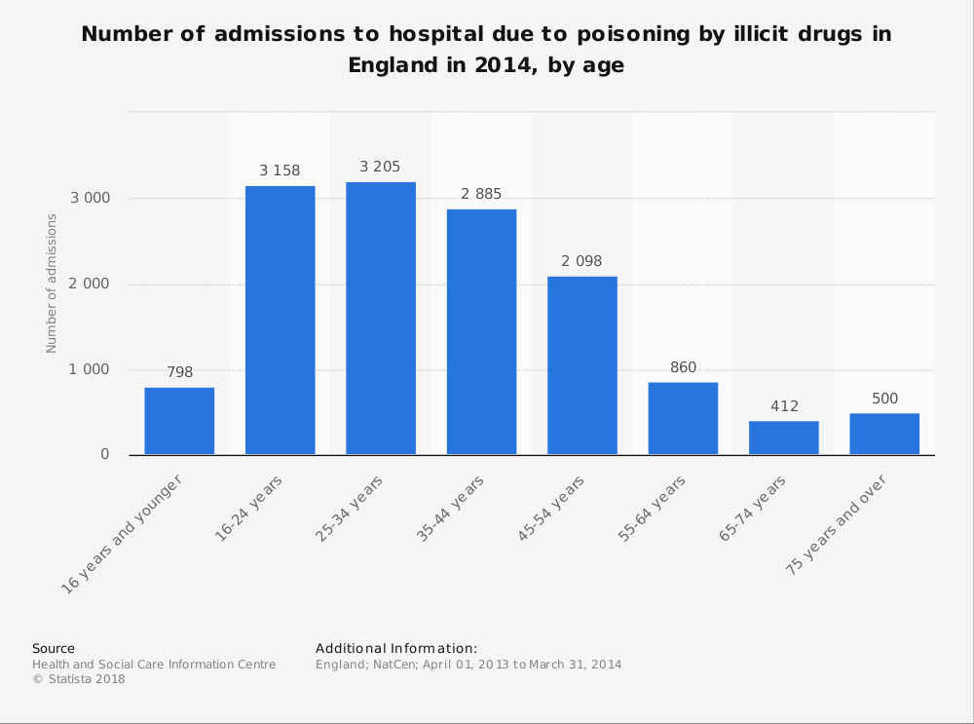
https://uk.images.search.yahoo.com/yhs/search;_ylt=AwrIRha5AtlaAwkAJ4d3Bwx.?p=nhs+statistics&fr=yhs-adk-adk_sbnt&fr2=piv-web&hspart=adk&hsimp=yhs-adk_sbnt&type=re_appfocus63_cr#id=17&iurl=http%3A%2F%2Fwww.statista.com%2Fgraphic%2F1%2F377758%2Fnhs-hospital-admissions-for-drug-poisoning-by-age-in-england.jpg&action=click
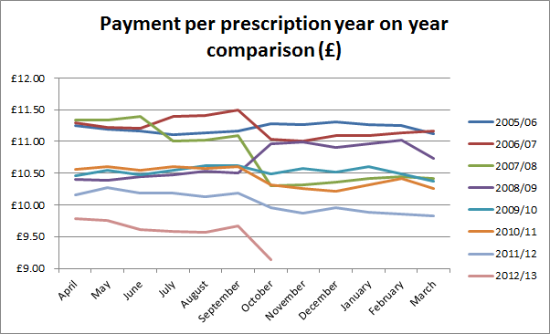
https://www.google.co.uk/search?q=statistics+on+nhs&source=lnms&tbm=isch&sa=X&ved=0ahUKEwiIpv7-nsfaAhXHxqQKHWIdDM8Q_AUICygC&biw=1366&bih=662#imgrc=HKZmzX3tR1JB1M:
Stakeholder Analysis
Stakeholders are those individuals with vested interest towards a business. Usually can be defined as bettors, holders or attained percentage of an organisation. The concept of understanding stakeholders can vary between theorist as some do mention in simple terms, stakeholders can be affected or disrupt the business depending on the dynamic situation.
Influence of stakeholders relating to NHS are those key players of government organisation with high power interest, they direct and deliver also assess. To ensure that NHS England, as the commissioner for primary care support services, understands the views of key stakeholders and enables them to influence the delivery and direction of the services to ensure high quality, effective services are provided to the satisfaction of users. NHS England.

Internal stakeholders:
- Head of health intelligence and information
- Director of public health services
- Procurement
- Public health strategies
- Director of nursing
- Research scientist
- Communications
- Environmental health analyst
- Board committee members
- Public health management analyst
- Director of programmes and services
- Public health manager
- Trustees
- Shareholders

External stakeholders
- Media
- Patients
- Customers
- Quality assessors
- Residents
- Community
- Providers
- Suppliers
- Health visitors/school nurses
- LINK group
- Acute trusts
- Service users
- Local authority/council
- Funders
- Special interest groups
- Wider public health workforce

Level of interest

Minimal effort | Keep informed | Keep satisfied | Keep players
Community residents or public they have no authority to introduce any changes to NHS except opinions | Patients- those who receive medical assistance free of charge only pay through taxes. | Doctors- disciplined to remain calm whatever the outcome. | Government- is required to keep high interest in NHS funding. Assessment of employee statistics and implement any changes.
Infants- unaware of surroundings. | NHS- employees- adjustments are made through implemented changes towards service. | Caterers- staff who cook food. | Royal family- law legislators ‘font of justice’.
Foreigners- visit only for tourism purposes. | Media- informers for the public expressing current situation | Cleaners- those who routinely clean the hospitals. | Politicians- members of the parliament.
 | Stakeholders and shareholders- are required to be involved for commercial purposes. | GP’s- only assess patients and remain satisfied with occupation.
 |  | Receptionist- are only ordered to fulfil their duties

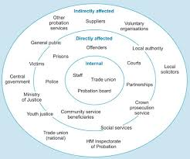
Evaluation
Measuring Shared Decision Making (see link below) provides a summary of the types of measures that are available, a recommendation of which measures might be appropriate for the national programme and a rationale for the suggested approach. It may be useful background for commissioners considering how to measure SDM activity locally. The report refers to a trend towards measuring the Shared Decision Making process from a dyadic perspective i.e. from the point of view of both the patient and clinician. As part of their work on creating a receptive culture for Shared Decision Making, AQuA are already starting to use this type of approach. AQuA have used the SURE and SHARED evaluation forms in their work with clinical teams, these are attached below.

Measuring Shared Decision Making report (December 2012)
SURE Evaluation form
SHARED Evaluation form
READ codes can routinely be used to measure activity in Primary Care. With one health economy we worked with they asked all practices to use the READ codes below to record Shared Decision Making activity in Primary Care. This could be used as a way of measuring activity linked to an incentive such as Quality Premium.

Version 2 READ Codes (used by all GP clinical systems except TPP SystmOne and HealthySoft Crosscare)

8Cl. Shared decision making
8Cl0. Shared decision making with patient decision aid
8Cl1. Shared decision making without patient decision aid
8Cl2. Shared decision making with decision support
8Cl3. Shared decision making without decision support
CTV3 Codes (used by TPP SystmOne and HealthySoft Crosscare)

XaYjg Shared decision making
XaYjh Shared decision making with patient decision aid
XaYji Shared decision making without patient decision aid
XaYjj Shared decision making with decision support
XaYjm Shared decision making without decision support
Evaluation of the impact of Patient Decision Aids on changes in activity, including numbers of procedures, can be undertaken. This provides a view of the impact on procedures, but not on any impact on less invasive management options. For example, the number of hip replacements can easily be measured, but the number of patients choosing less invasive options such as pain relief medication, physiotherapy or steroid injection is far less easy to measure. The resource below provides a mapping of some of the early PDAs produced to the relevant ICD and OPCS codes which may help you to identify measures for monitoring impact.

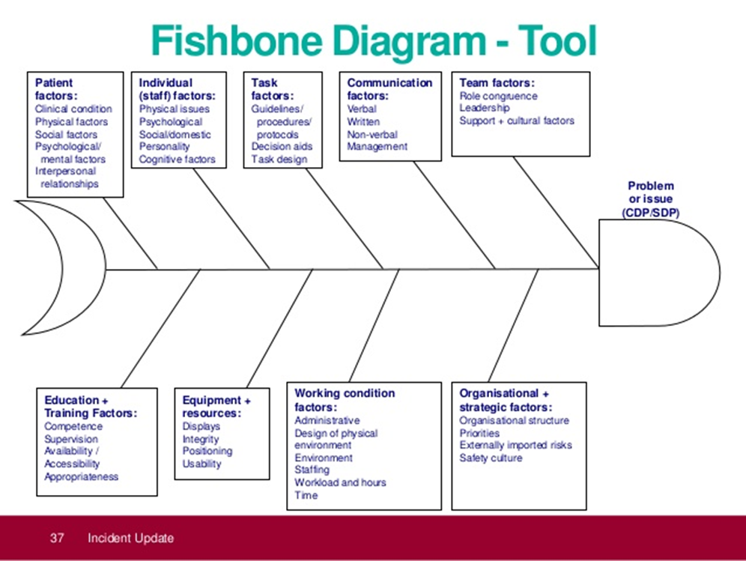
Fishbone analysis

Patient factors
- Some patients require more assistance medically.
- Waiting times regardless of your emergency are very long.
- Operation times are long.
- Priority of children’s healthcare as well as elderly are inadequate.
- Beds are either not in use or insufficient.
- Physio therapist are not available in all hospitals or times for waiting are long.
- Patients with mental health issues require constant help.
- Electronic reminders and reduction of letters.
- Make easier access for elderly.
- Patients with more than one medical condition.
- Drug addicts and anti-behavioural risk assessments need to be taken in account,
- Social factors religiously devoted individuals require certain privacy.

Individual staff factors

- Nurses and doctors over work.
- Working hours are long.
- NHS staff wages of nurses are less, and workload varies.
- Nurses and doctors suffer from depression occasionally.
- Verbal, physical and mental harassments occur.
- Staffs who follow religion need breaks.
- Nurses, doctors and health care professionals need to be fully qualified.
- Staffs need to inform of absents.
- Staffs required to work as a team.
- Customer service or hospitality must be professional.
- Personality issues must be formal and comforting.

Task factor
- Protocols have been stricken due to funding.
- Patients are not fully aware of the process timing.
- Trainee doctors cannot accurately diagonise properly.
- Failed attempts of diagnosis.
- There is no immediate action taken.
- Forgetfulness occurs following protocols.
- Managers, supervisor guidelines are not heard to full extent in order to commence task design.
- Cancer misdiagnosis also fracture, diabetes and kidney.
- Doctors cannot assess patients any further than they are supervised to.
- Decision makers neglect feedback.
- Procedures of paramedics are commanded to wait outside until its clear to go.

Communication factors
- Consultants not communicating.
- Verbal communication between doctors and nurses inadequate.
- No direct communication between doctors and patients.
- Exchange between nurses and doctors shift is lacking and inconsistent resulting in shortage of staff.
- Managers fail to assess, problem solve and analyse feedback.
- Errors occur during patients’ medical reports and surgeries due to staff delays.
- More language translators are required to communicate with patients.
- Doctors are not clear with pharmacists, patients’ medication intake changes. Pharmacy employees are not made aware.
- Frustration occurs among manager, doctors and nurses due to lack of communication.
Team factors
- Doctors need to communicate effectively.
- Managers responsibility and roles lack consistency due to team collaboration.
- Need more head of department doctors.
- Training and recruitments of nurses and trainee doctors need to communicate with each other.
- GP’s, doctors, nurses, trainee doctors are required to develop a mutual relationship.
- Sometimes there are too many managers within one department.
- Human rights and discrimination, team members can have access to their beliefs.
- Burdens of higher role players are placed on lower role players.
- Nurses and doctors cannot communicate and work as a team due to the lack of workload they are busy to dissipate.

Education and training factors
- Not enough individuals taking interest of becoming doctors and nurses.
- Training fund is not available.
- Nurses are not being informed how to supervise beyond their qualification.
- Nurses within certain qualification need updated knowledge.
- Lack of supervision.
- Nurses for home service are not always available due to less employees.
- Doctors and nurses lack medical knowledge.
- Diagnosis of patients’ symptoms are lacking. Doctors and nurses follow assumption.

Equipment and resources
- Ambulance/paramedic/air ambulance need updates.
- Medical devices are in demand and need to be updated.
- Radiography, MRI scan, X-ray machines are needed more as volume of patients are increasing.
- Theatre rooms require new equipment.
- Drugs and medication are required at large volumes, new research into drugs cost money.
- Syringes and medical supply are in demand.
- Computer systems need to be updated to process information and data properly.
- Cyber attacks occur therefore preventation are needed.
- Infusion machines, fluid bags need replacements.
Organisational and strategic factors
- Stakeholder have vested in NHS, stakeholders can affect NHS and NHS can affect stakeholders.
- Head of departments must assess the funding.
- They need to prioritise how to reduce cost without affecting the patients and community.
- Centralisation of hospitals.
- Safely measures must be displayed, or public awareness needs to be made.

PESTEL analysis
PESTEL is the politics, Economics, socio-cultural, Technological, ecological, and Legal factors.
politics
- Different parties/ministers responsible in Wales and England
- Different ideologies- right wing open to privatisation, left wing not
- Electorate reluctant to any change
- Brexit causing political uncertainty

Economics
- Limited revenue from taxpayers
- Brexit may free up more public money
- Increasing investment but decreasing per head
- Austerity- less money being spent on the public sector in general due to national debt

Socio-cultural
- Brexit may result in staff shortages
- Changing demographics- growing elderly population, increasing life expectancy, increasing birth rate, increasing co-morbidities, increasing population, increasing numbers of people with disabilities/ needing specialist medical care
- Expectations and values of the population in relation to the NHS
- Treatment available abroad but not in the UK
- Health tourism

Technological
- Improving technologies making better, newer treatments but these are expensive at least initially
- Medical devices
- Medical equipment
- Drugs
- Brexit may make drugs etc more expensive

Ecological
- New recycling and other environmental requirements
- Disposal considerations
- Toxic and contaminated products/ waste
- Costs of patient requirements e.g. sharps bin
Legal
- Patients suing when things go wrong
- Health and safety laws becoming stricter
- Brexit could lead to uplifting of some laws
- Very stringent laws relating to clinical trials

Ways to improve the NHS working environment:
There is growing understanding of the causes of low morale, high attrition and
burnout in the medical workforce and their impact on operational performance
and patient outcomes.1234 The working environment for staff is an important
window into the culture and leadership of an organisation. Doctors have
recommended actions that can be taken to improve their working environment
and morale.5,6,7,8,9,10
Working with a range of trusts, we identified eight of these actions that can
be delivered with immediacy and give examples of solutions they found.
Meaningful improvements will require engagement locally between trusts
and junior doctors, with support from senior clinicians and, in some instances,
investment of resources. However, the benefits to staff engagement,
performance, cost savings and most importantly, patient care and reduction of
harm will provide a worthwhile return.
These eight high impact actions are supported by:
Tackling work pressure- The significant burden of administrative and basic clinical tasks can negatively affect
patient experience and safety by detracting from time for tasks that specifically
require doctors. Reviews of deteriorating patients, patient flow and discharges can be
expedited by reducing time spent on data entry, blood taking and filling in request
forms.
Potential solutions
• Alleviate work pressures on doctors and improve patient flow: eg University Hospital
Southampton’s clinical administrator11 or Brighton and Sussex University Hospitals’
clinical assistant12 roles.
• Use electronic task management software such as those used at Bolton13 or
Calderdale and Huddersfield14 NHS foundation trusts or senior nurses to triage
bleeps.
Promoting rest breaks and
safe travel home
Sleep deprivation leads to increased clinical error and poor psychomotor abilities.
Conversely, rest-breaks contribute to the provision of safe care by ensuring staff are
making safe, effective decisions for patients.1
Following tragic deaths15 of doctors
driving home after night shifts, the 201616 junior doctors’ contract mandates provision
of adequate rest facilities or alternative arrangements for safe travel home.
Potential solutions
• Foster a culture that supports staff in taking rest-breaks to ensure they can provide
safe, effective patient care to the best of their ability – eg Guy’s and St Thomas’
HALT17 campaign.
• Provide information18 on strategies to improve sleep and cope with working
nightshifts.
• Introduce and clearly communicate a policy for rest facilities or alternative
arrangements when staff are too tired to travel home: eg those used at Guy’s and St
Thomas’19 or Central and North West London20 NHS foundation trusts.
Improved access to food
and drink 2An overwhelming majority of doctors told the Royal College of Physicians they had
worked at least one shift in the past month without eating a meal (65%) or drinking
enough water (73.7%).5
Reasons for this include removal of canteen provision out of
hours, closures of doctors’ mess facilities and lack of water coolers. An NHS England
CQUIN21 requires trusts to provide healthy food options for staff 24/7. Addressing
hygiene factors like these will make the trust an attractive place to work.
Potential solutions
• Provide easily accessible drinking water in clinical areas.
• Ensure 24-hour access to healthy and hot food or facilities to warm food,
ideally in staff-only areas.4/7
Better engagement between
trainees and the board
Engaging junior doctors poses particular challenges due to the short nature of rotations
and perceived disconnect between the front line and wider trust strategy. However,
improved engagement is tied to better staff recruitment, retention and productivity as
well as improved quality and safety outcomes including reduced clinical error, infection
and mortality.1,22
Potential solutions
• Board-to-ward reach-out: board members shadowing junior doctors, board
members23 at junior doctor forums.
• Ward-to-board reach-out: junior doctors’ ‘stories’ at board meetings, junior doctor
representatives on executive committees and an open calendar of corporate
meetings and events.
Rewarding excellence
Due to the rotational nature of junior doctors’ training, they are often overlooked in
organisational efforts to appreciate staff.

