DS 1 Template

My Screenshots/Photos
- Please add 4–6 screenshots or photos of your digital life.
- You can use your phone or laptop.
- For each screenshot, write one or two sentences explaining what it shows.

Screenshot/Photo 1
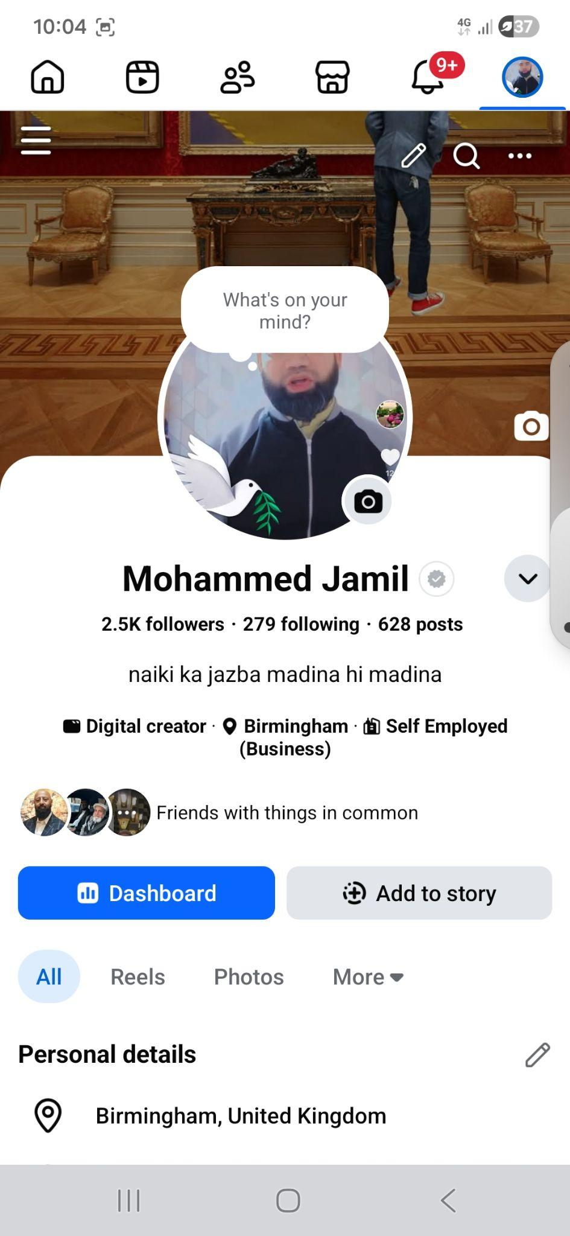
This is my facebook account. I use this to upload my videos to spread messages. I use this for a marketplace too, sometimes I use this as a messenger. Before i was not able to upload clear videos but now with the digital skills I have learnt from uni I can improve my videos.

Screenshot/Photo 2
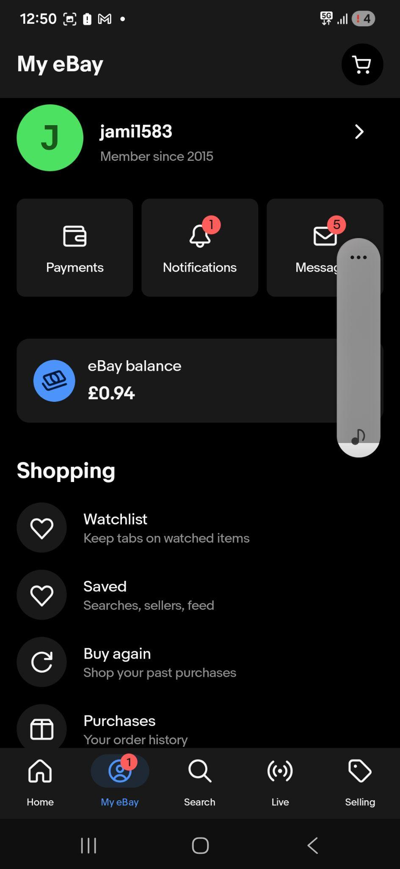
This is my business ebay account. I do online business on this account and my feedback is good hundred percent. Before I uploaded my items but not able to do it to a high standard. Now I believe with uni education and gradually learn better skills to improve my online business. I am very positive after this course it will make a big difference for my future business.

Screenshot/Photo 3
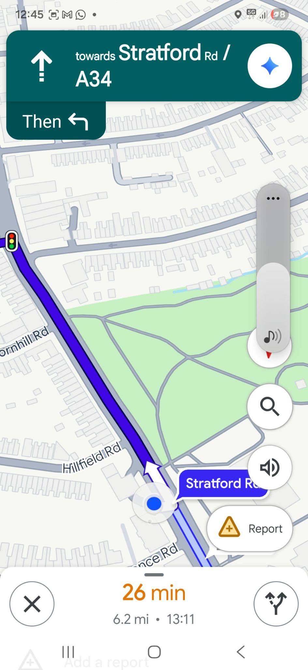
This is my google navigation system. I use this if I need to travel to places where I have not been before. I use this regularly and I can save my time from traffic or accidents and any road works that are happening. I believe I will learn more skills by searching google to increase my knowledge. Bottom line, I'm thinking forward to improving my digital skills better than before.

Screenshot/Photo 4
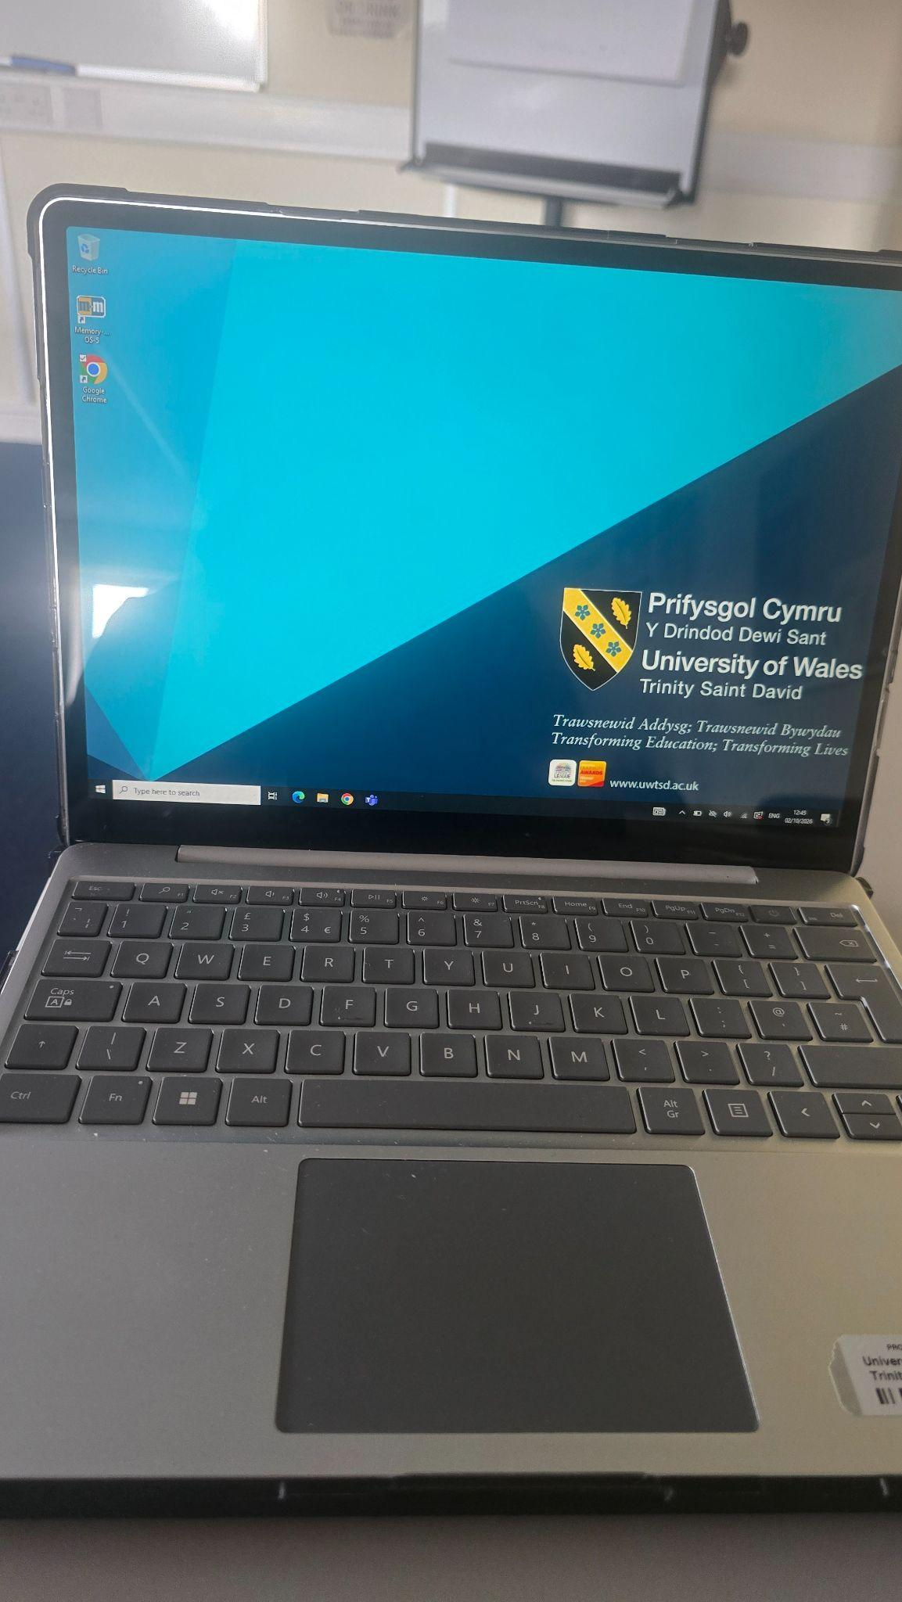
This is my uni laptop. I can use my phone to text people or use google to search different things. But I have less confidence to use a laptop because i dont use it regularly. Now since 4 weeks I have been using my laptop in class and I can log into my account, use moodle confidently, access the library, organise my folder, can save my documents, download class materials and be able to see my assignment deadlines. I am happy to see this progress in my life. I am confident this effort will make me brighter.

Screenshot/Photo 5
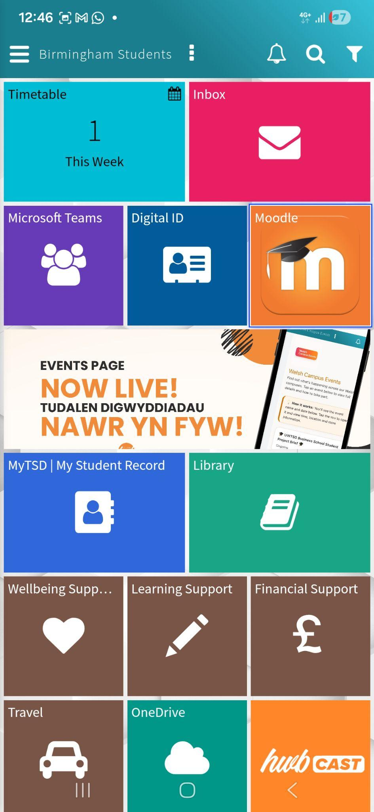
This is my university hub. As you can see there is moodle, office 365, one drive, email box and if i go into moodle i can see the weekly powerpoints and all the facilities are on there. From this hub I can also contact the engagement team and confidently use the email box. I am able to send emails to different individuals and can save important documents to one drive. One drive is safe to look after the documents.

Screenshot/Photo 6
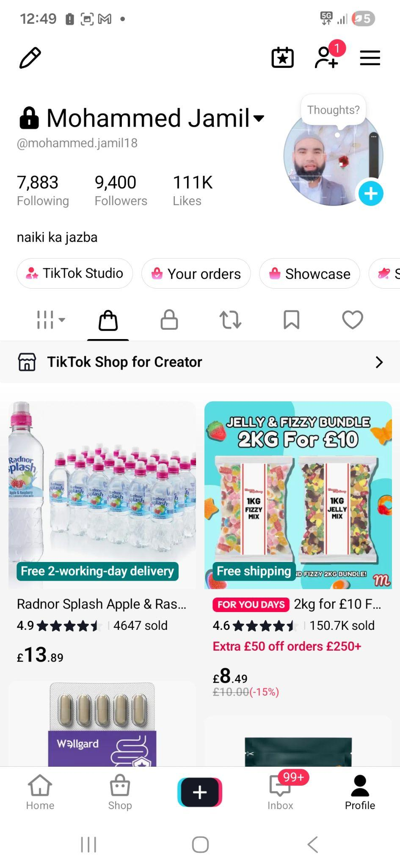
In my digital life circuit, another way I use tiktok for my videos and also tiktok shop as a business. As you can see there are almost 10K followers where they can watch my activities. I can upload new videos and it used to be my hobby. I believe with my more digital skills that I have learnt from uni can improve my social media platform.

My Short Reflection
- Write 5–8 simple sentences about your digital life.
- You can use the sentence starters below if helpful.
I use digital tools for my business or my personal social media.
I feel confident when people watch my videos and give me feedback.
I sometimes feel nervous to use my laptop as quickly as others but I encourage myself which is why I come to learn.
I believe digital skills are important in our lives to get more benefits from social media to achieve our target.
I am positive and confident that one day I will be successful with my hard work and commitment and positive attitude and full concentration in my class. When I come home I revise my homework and set more related things to the course.

Sentence starters
- I use digital tools to …
- I feel confident when I …
- I want to improve …
- I often use these tools: …
- I sometimes feel nervous about …
- I hope this module will help me …
- Digital skills are important for me because …
You can write more if you want.

Submission Checklist
Before you submit, please check:
​​​ ☐ I added 4–6 screenshots
☐ I wrote short sentences for each screenshot
☐ I wrote my short reflection
☐ My work is my own
☐ My file opens correctly
​​☐ My file opens correctly

