

BA BUSINESS MANAGEMENT
Assignment 1

Module: Marketing Fundamentals
Code: LCBB4004
Lecturer: Dr Mohammad Rahman
Name: Denislav Nestorov Dimitrov
Student ID: 2127998

SUBMITTED ON THE 25th November 2022

Table of contents

Nike 3
Brand Strategy 3
Product range of Nike 4
-Nike footwear 4
Nike sports equipment 5
Performance Accessories 5
Nike Clothing Apparel 6
Features of products 7
Nike prices 8
Premium Pricing Strategy of Nike 8
Nike Skimming Pricing Strategy 9
Is Nike’s product available in your hometown (Place) 9
Nike promotion 10
Mass customisation 10
Celebrity endorsement 11
References 13

Nike
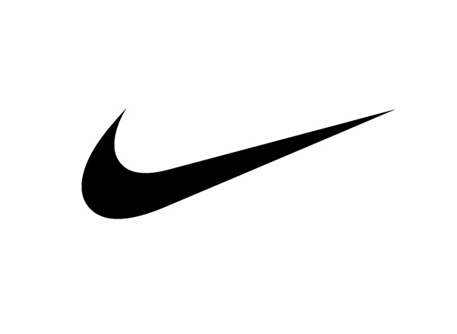
A variety of vital marketing methods can assist enterprises in recovering the losses they suffered during COVID-19. Cooperation between company employees is essential to successfully execute a strategy and achieving goals. Several tasks must be assigned to different employees during the development of the marketing plan so that it can be implemented effectively. A short-term objective is used to measure accomplishments in order to gather feedback from the market. There are many opportunities for Nike Corporation to grow and develop, regardless of its strengths and weaknesses (Herskovitz & Crystal, 2010). In order to build upon your strengths, you must utilize both your strengths and weaknesses. It is essential that such an endeavor be undertaken for the purpose of learning.
Branding Strategy
An umbrella branding strategy has been adopted by Nike for its firm. Brand-established companies use this method when launching new items. There is no doubt that we are all familiar with Nike’s famous slogan, “Just do it.” Since Nike sponsors notable athletes and uses a distinctive logo to attract consumers, Nike’s market share has steadily increased. As one of the top corporations, Nike’s distinct “Nike” logo has been a key factor in building its reputation as an innovative and astute marketing company. Nike was much more than its iconic logo at the time, as one of the most prominent corporations at the time. Branding is fundamental to Nike’s brand strategy, which involves designing a brand that inspires a global passion among customers. Using archetypes and myths as emotional branding methods in Nike’s advertising is common. As a result, no technical knowledge is required. A company must offer customers relevant and true values in order for this strategy to work. Adapting to this trend is the key to successful marketing campaigns (Gobbi, 2022).

Product Range of Nike
For men, women, and children of all ages, Nike produces a wide variety of athletic clothing. Clothing in this category includes shoes, shorts, jerseys, tracksuits, American football, tennis clothing, and cross-training clothing, golf clothing, and is designed for a wide range of sports, including basketball, track and field, football, tennis, golf, American football, and hockey (Helstein, 2003).
- Nike footwear:
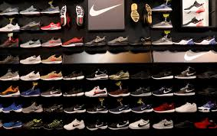
Sportswear (our sports-inspired lifestyle items) is one of the nine major categories in which the NIKE Brand develops new goods: Running, the Jordan Brand, NIKE Basketball, Action Sports, Football (Soccer), Women’s Training, Men’s Training, and Sportswear (our sports-inspired lifestyle items). Equipment for baseball and American football is available in the Men’s Training area. We also sell sports and leisure items for fitness, such as wrestling, cricket, tennis, lacrosse, volleyball, and walking equipment. Sports footwear by NIKE is designed to help athletes perform at their best, regardless of whether they use them for enjoyment or non-sporting activities. High-quality craftsmanship and unique concepts are key components of our design and manufacturing process. The majority of our revenue will continue to come from Sportswear, Running, and Jordan Brand.

Nike Sports equipment:
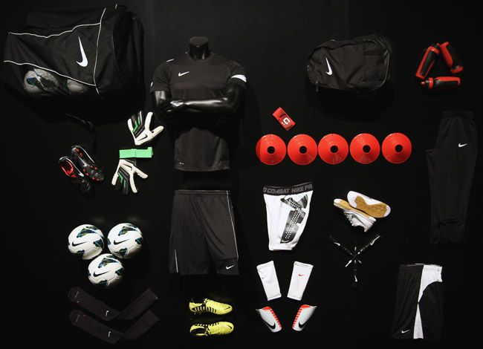
We also carry a number of additional products to complement the above categories of athletic apparel. As with our sports footwear, these goods are marketed and distributed primarily through the same channels. Sports clothing also displays our commitment to innovation and great workmanship and is primarily intended for athletic purposes. By providing both categories of products, we fulfil a client’s needs. As of now, Sportswear, Men’s Training, and Running will continue to be the top-selling apparel categories. Shoes, clothing, and accessories are most often marketed as “collections” or grouped according to similar objectives. Furthermore, we have our own logos on apparel in addition to logos from clubs and leagues.

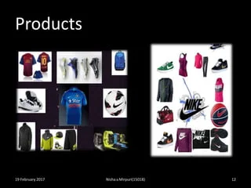
Performance Accessories: There are a wide variety of performance items and accessories available under the Nike Brand, including bags, sports balls, socks, sunglasses, digital devices, watches, bats, protective equipment, gloves, and other sports equipment. Furthermore, we sell smaller quantities of plastics to other manufacturers through our wholly-owned subsidiary Nike IHM, Inc.

Nike Clothing Apparel:
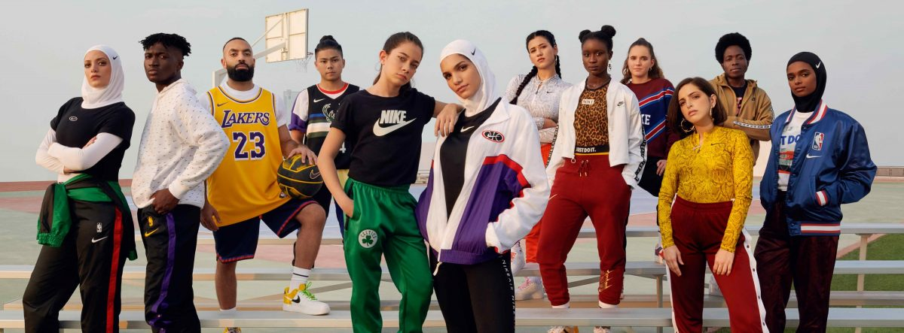
Sports balls, sunglasses, watches, and electronic gadgets are available under the Nike brand, in addition to bats, gloves, protective equipment, and sports balls. Nike also manufacture plastic products in smaller quantities through Nike IHM, Inc., a wholly-owned subsidiary.

Features of products
- High quality: Lightweight and sturdy, Nike sneakers are both comfortable and durable. Nike shoes are lightweight even though they are very comfortable and flexible. The benefits of Nike shoes designed for your sport will last for a long time if you buy quality shoes.
- Comfortable: Nike shoes are an important factor in the brand's success because they reduce the risk of foot injuries. Regardless of what activity you are engaging in, these shoes will protect your feet. The likelihood of sustaining a significant foot injury is lower if you wear shoes.
- Styles: There are several styles of Nike sneakers available. It is possible to find athletic footwear in a variety of styles and silhouettes. Different sports require different types of footwear, based on their nature. The activity for which the Nike shoes will be used should be taken into account when selecting them. Running and walking footwear are also available from Nike.
- Various uses: There are a large number of individuals who do not participate in sports who purchase Nike shoes. Whether attending an event or having a casual outing, they wear their favourite Nike shoes. Sports shoes from Nike are frequently regarded as some of the best on the market for a number of reasons.

Nike Prices
There are various pricing strategies implemented by Nike (2022). There are several of them below (Liu & Zhang, 2022).
- Value-Based Pricing Strategy of Nike
Using value-based pricing, Nike assesses the worth of each product based on customer perceptions. Pricing is determined by the maximum price point of the customer for sports apparel, footwear, and equipment. The company started making profits when it realized the value of its customers and used its price strategy effectively.
- Nike Price Leadership Strategy
It is appropriate for Nike's industry to use this strategy since it operates in markets defined by oligopoly. With Nike as the dominant player in sports equipment manufacturing, the market is oligopolistic.
Premium Pricing Strategy of Nike
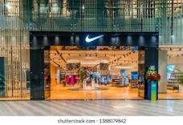
Nike utilizes a pricing strategy known as premium pricing in order to charge a higher price for its superior products than those of its competitors. Founders and workers of Nike understand the importance of the image consumers project when they purchase Nike gear along with producing high-quality products. Customers can easily recognize Nike's products when they purchase Nike's distinctive products. Additionally, Nike is perceived to be worth more because of its premium pricing approach.

Nike Skimming Pricing Strategy
It is a well-known fact that Nike uses the pricing strategy known as "price skimming" to create initially high prices associated with products and accessories with new designs and to introduce them to the market. As the name suggests, price skimming refers to the practice of charging inflated prices, especially for limited edition items of high value, for products that are of high value. By targeting customers who show interest in its product and are willing to pay the asking price, Nike attempts to maximize profits. Nike also uses a few other methods for determining their price, but they do not play a significant role in totalling their price. Prices can be segmented, psychologically, or penetration priced.
Is Nike's product available in your hometown (Place)?
To acquire, sell, or distribute their products to consumers, sports goods companies may use elements of the marketing mix. With this 4P variable, Nike plans on contacting the most potential clients possible. Distributing athletic apparel, footwear, and equipment across a multitude of markets is the firm's main activity.
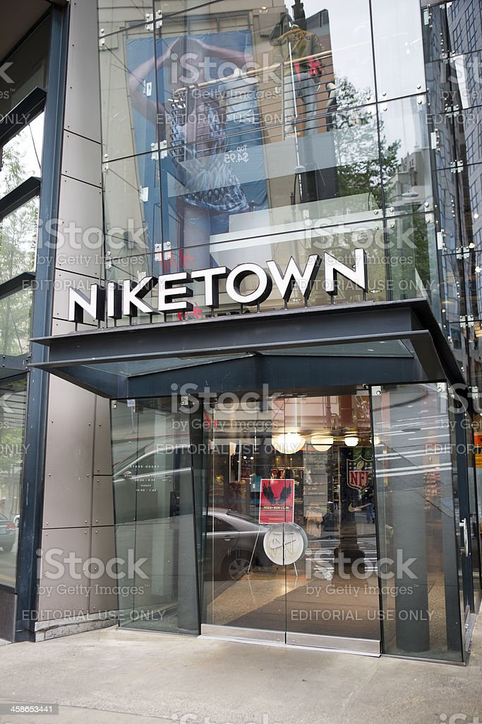
There are over 1,000 Nike retail stores outside the United States, as well as more than forty-five offices. Since buyers like to try on Nike items in-store, the vast majority of its items are sold in retail stores. The Nike retail outlets are located in every city worldwide, making it easy to buy Nike products. The retail strategy of Niketown includes a retail store. Having four storefronts and offering a wide range of products and services, these companies provide a luxurious shopping experience. There are innovative and cutting-edge items available at Niketown, an upmarket shopping establishment. Moreover, they offer professional assistance with product selection and a manned zone in addition to a personalised booth. Consumers are treated with respect throughout the purchase process.

Nike Promotion
In its advertising campaign, Nike focuses heavily on celebrities and athletes who are famous for their sports accomplishments. Aside from discount coupons, Nike uses several sales promotion strategies to encourage consumers to buy its products (Knight & Greenberg, 2002).
Mass customisation:
What are the chances of creating one's own shoes? If you are a fan of Nike, you may wish to take advantage of this offer. Consumers are targeted through this marketing strategy.
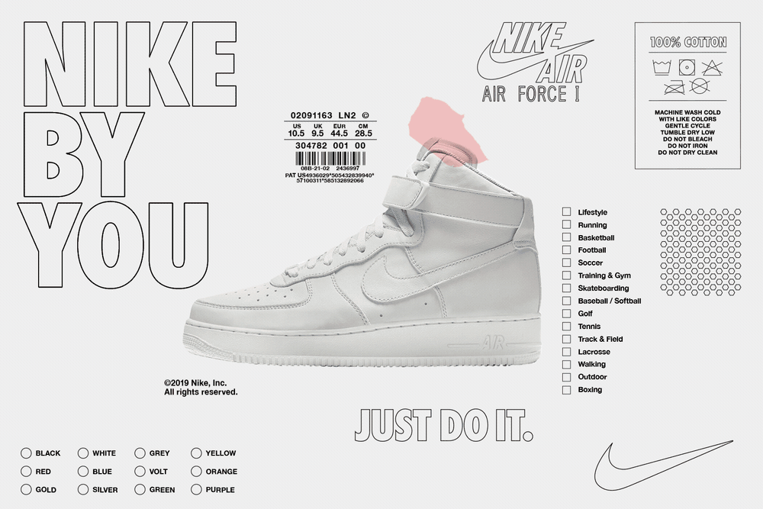
The combination of mass customisation and modularity, combined with the efficiency of mass production, makes mass customisation a feasible method of incorporating individual customer preferences into goods, thus making them more affordable.
Customers are able to personalise the things they purchase from Nike via a process known as "mass customisation," which is made possible by the company's expansive facilities and involves a mix of conventional manufacturing techniques and innovative thinking.
Their supply chain for shoes is structured into three stages, each of which takes a more specialised, individualised approach. The production of a pair of shoes via the labour-intensive technique of handcrafting calls for a high level of knowledge.
The website offers one-of-a-kind footwear that is available for browsing and purchase by anyone: https://www.nike.com/nike-by-you

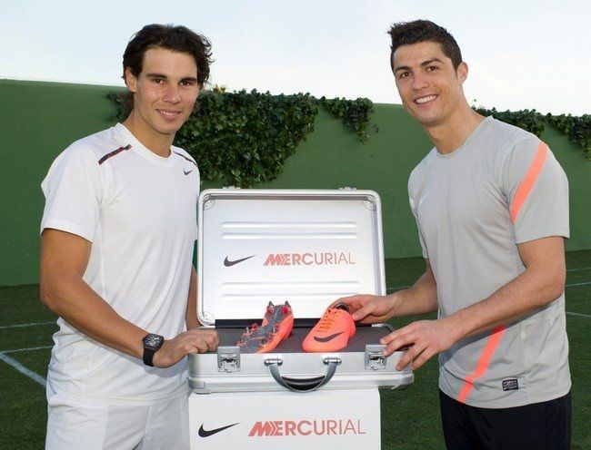
Celebrity endorsement:
Furthermore, it is well known that Nike's brand ambassadors are frequently celebrities. As one of the most successful celebrities and commercial partnerships in history, Nike's relationship with Michael Jordan stands out. The Air Jordan brand of sports sneakers was introduced by Jordan and Nike as a result of their successful partnership.
Since Nike began, it has developed a distinctive brand identity and brand personality. A similar approach is taken by Asian companies during the initial stages of brand building.
The three main reasons why an organization should work with a celebrity must be evaluated before working with him or her. Other advertising strategies are employed by Nike as well.

Social Media: Nike is able to interact with millions of consumers and find new ones all around the globe thanks to social media. The organisation maintains a presence on social media by maintaining accounts on a variety of social networks, including Facebook, Twitter, YouTube, and LinkedIn. As a direct consequence of Nike's efforts in social media, the company now has a larger number of new customers.
Advertisement: In order to increase brand recognition among potential customers, Nike uses one of its most effective marketing techniques. Nike has created a few memorable advertisements over the past few years that have garnered global attention. A large part of Nike's advertising strategy consists of partnering with large organisations and supporting celebrities and megastars. Cristiano Ronaldo and Maria Sharapova appeared on the field with Roger Federer in the Nike Free Power to your feet television advertisement.
Public Relations: Among the marketing strategies, Nike uses in order to reach potential consumers is public relations. Customers and the market are equally important to the company's management. Despite its size, this company welcomes customers in an approachable manner and demonstrates a keen interest in building a relationship with them. A customer service channel includes Nike's public relations department.

Sponsorship: Nike's exposure has expanded in every region of the world as a result of the company's sponsorship of a wide range of sports competitions and a significant number of athletes of the highest calibre. Nike provided financial assistance to a number of athletic events in order to back up their direct engagement strategy.
Direct Marketing: The advertising campaign for Nike is expanded via the use of a direct marketing strategy. The company capitalises on the market for its new products by using new items to both attract customers and gain a competitive advantage over its rivals in the market for new goods.

References
Gobbi, B., (2022) “The advertising of Western fashion brands in China: some case studies”.
Helstein, M.T. (2003) “That’s who I want to be: The politics and production of desire within Nike advertising to women,” Journal of Sport &amp; Social Issues, 27(3), pp. 276–292. Available at: https://doi.org/10.1177/0193-723503255479.
Herskovitz, S. and Crystal, M. (2010) “The Essential Brand persona: Storytelling and branding,” Journal of Business Strategy, 31(3), pp. 21–28. Available at: https://doi.org/10.1108/02756661011036673.
Knight, G. and Greenberg, J. (2002) “Promotionalism and subpolitics,” Management Communication Quarterly, 15(4), pp. 541–570. Available at: https://doi.org/10.1177/0893318902154002.
Liu, P. and Zhang, F.-jie (2022) “Pricing strategies of dual-channel Green Supply Chain considering big data information inputs,” Soft Computing, 26(6), pp. 2981–2999. Available at: https://doi.org/10.1007/s00500-021-06611-6.

