LCLM5001:

Understanding and Engaging Stakeholders

Executive Summary
This report addresses the stakeholder engagement procedure to launch and implement the successful intervention of the StaySmart+ at InterContinental Hotels Group (IHG). StaySmart+ is a new service that is aimed to incorporate AI-based guest interaction devices, individual travel planning, and sustainable amenities to improve the experiences of guests. This report mentions the important internal and external stakeholders, examines their roles and responsibilities, as well as issues, and offers suggestions on the effective engagement. The stakeholder engagement is presented with several theories such as stakeholder theory and transformational leadership which make sure that the stakeholder interests are aligned with the project objectives. Through stakeholder participation e.g. customers, employees, suppliers and regulatory bodies, IHG will be able to enhance customer satisfaction and promotional efficiency and brand image. The report also offers practical measures to engage in the future, including customized dealings with customers, interdepartmental coordination, long-term supplier relationships, and participation of the community. Finally, this strategy will pursue long-term success of StaySmart+, by supporting the IHG philosophy of innovation, sustainability, and customer-focused service provision, resulting in the continued business expansion and competitive edge.

Table of Contents
Executive Summary 2
Introduction 4
Situational Analysis 5
Stakeholder Identification and Categorization 6
Stakeholder Roles, Responsibilities, and Challenges 7
Stakeholder Engagement Frameworks 9
Stakeholder Engagement Process 11
Impact of Stakeholder Engagement on Business Performance 13
Recommendations for Future Stakeholder Engagement 16
Conclusion 18
References 19

List of Figures
Figure 1: InterContinental Hotels Group 4
Figure 2: Stakeholder identification and categorization diagram 6
Figure 3: Stakeholder engagement plan infographic 10
Figure 4: RACI matrix 10
Figure 5: Stakeholder map with engagement strategies 11
Figure 6: Graph showing engagement vs business performance 14

Introduction
One of the top hotel companies in the world is the InterContinental Hotels Group (IHG), and the group operates over 5,900 hotels situated in different locations across the world (100 countries) (Da and Bastias, 2022). One of its brands, InterContinental, Holiday Inn, and the Crowne Plaza are recognised, and the range of its customer segments is focused on both the high and middle-income market. The firm has gained a solid reputation in delivering quality hospitality services, and customer satisfaction as well as sustainable services. A new premium service, which is set to be rolled out by IHG throughout its international network is the StaySmart+ service. The desired enhancement of the guest experience is made through the incorporation of AI-based applications to plan the personalised travel, the issue of improved contact with customers, and the provision of sustainability-related services. StaySmart+ will distinguish the offerings made by IHG in a competitive hospitality market which is becoming more and more competitive. This report is meant to find and involve important stakeholders whose participation is vital in successful design, launch, and adoption of the StaySmart+ service. A high level of stakeholder interaction will make the service achieve its goals in both the local and international market.
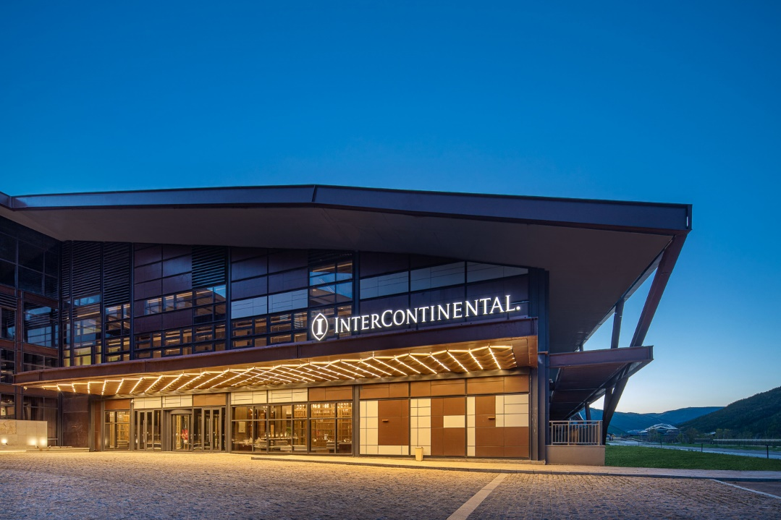
Figure 1: InterContinental Hotels Group
Source: (IHG Development, 2026)

Situational Analysis
SWOT Analysis of IHG
- Strengths: The presence of IHG globally recognised brands, including InterContinental, Holiday Inn, and Crowne Plaza, enables the company to serve multiple customer segments, including high-end and middle-income markets. IHG has more than 5,900 hotels based in more than 100 countries and that gives it a formidable international presence (Fernandes, 2021). It is also committed to sustainability and environmental programs and is in line with the emerging consumer preferences of eco-friendly services.
- Weaknesses: One weakness of IHG is the complexity of its stakeholder management because the company has to manage various expectations and control measures in its global business divisions. In addition, it competes intensively on the international scene in the hospitality sector and rivals such as Marriott and Hilton are innovating and taking market share on a continuous basis.
- Opportunities: Increasing the need in sustainable traveling creates a chance where IHG can capitalize on StaySmart+ and introduce AI and environmentally friendly facilities (Dixit, 2025). The AIs and data analytics technology provide the possibility to optimize personalization to increase customer experience and differentiation in services.
- Threats: The IHG business is threatened by global competition, economic cycles and external shocks like geopolitical unrest or pandemics. That can cause a decline in demand of travel and specifically in high-end service packages such as StaySmart+.
PESTLE Analysis of IHG
- Political: IHG has to adhere to numerous rules in a range of countries, specifically, in the field of labor laws, taxation, and environmental policies. The operations may get influenced by political instability or change in government policies, particularly in major areas.
- Economic: Consumer spending behavior can be affected by economic factors around the world like inflation, exchange rates and recessions (Omazic, Pihir and Machrafi, 2023). The economic recessions could lead to the decrease of demand in luxury traveling and services, which will affect the adoption of StaySmart+.
- Social: Customers are ready to enjoy personalised and sustainable experience, and that is what StaySmart+ concentrates on AI-driven service and environmentally friendly products (Garg, Bohara and Srivastav, 2025). The trend will give IHG a chance to lure eco-friendly travelers.
- Technological: The development of AI and data mining gives IHG the chance to increase the customer experiences in terms of personalization and operational efficiency. Nonetheless, the adoption level of technology differs across markets, and preparedness to new technology might differ by region.
- Legal: The international operation in which IHG has to deal with complicated data privacy regulations and requirements on compliance is evident in its deployment of AI-supported guest service. There are also legal aspects in the area of environmental and labor regulations, which are challenging.
- Environmental: Sustainable practice is a major issue that consumers and governments consider, and IHG investment in eco-friendly approaches with StaySmart+ is in line with the regulatory demands and the market demand on green travel opportunities (Raut et al., 2025).

Stakeholder Identification and Categorization
To achieve the effective design, launch, and adoption of the StaySmart+ service, IHG will need to involve a set of stakeholders, including internal and external ones. The presence of such stakeholders can be grouped in accordance with their impact and interest in the project.
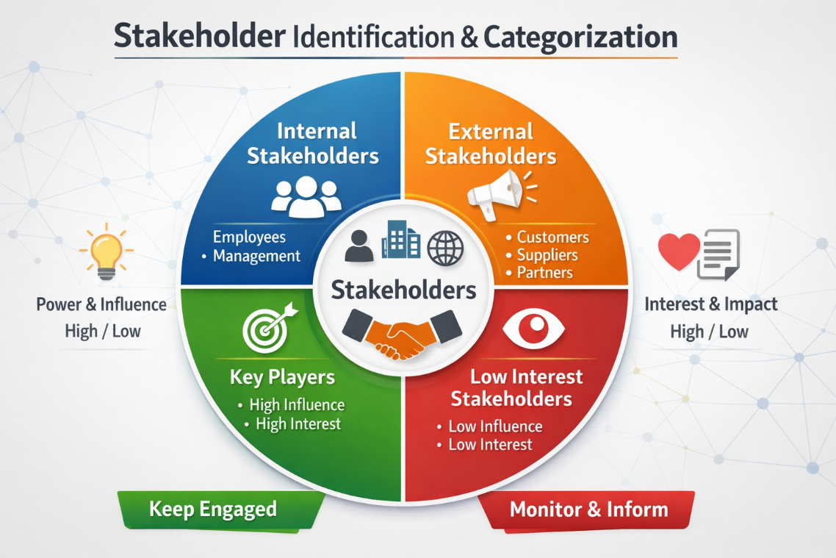
Figure 2: Stakeholder identification and categorization diagram
Source: Self-made (Adapted from Amen, 2024)
Internal Stakeholders
- Executive Leadership Team: Leaders in strategy making, offerS direction, approval and resources to the project of StaySmart+.
- Product Development Team: The design and development of the AI-driven tools and sustainable amenities which would be incorporated into the service will be vital in this team (Amen, 2024).
- Marketing and Sales Teams: The teams will be in charge of marketing and sell awareness of StaySmart+ and engage customers with specific campaigns.
- Operations Team: Operations Team will perform the implementation of the service to the hotel properties that should be easily integrated into the daily operation and staff training.
- IT Department: The key to proper implementation and sustainability of the technological elements of StaySmart+, including AI tools and sustainability features.
External Stakeholders
- Customers: The key external stakeholders, the needs of whom and their preferences will inform the design of StaySmart+ and its acceptance in international markets.
- Suppliers: Supporters of the eco-friendly products and technologies needed to produce StaySmart+ such as eco-friendly amenities and artificial intelligence software (Svitlana et al., 2025).
- Local Communities: The sustainability of IHG hotels and the creation of local sales in the community where the companies are located affect local communities.
- Regulatory Bodies: Government and industry regulators putting up policies on data protection, environmental standards and labor laws should be involved in making sure that there is compliance with local law.
Categorization
By analyzing the stakeholders using a stakeholder matrix, internal stakeholders like the Executive Leadership and Product Development teams are categorized as being the ones possessing high power and high interest in the project. Outside stakeholders such as customers and suppliers are very interested but to different extents based on their participation and involvement in the execution of the project.

Stakeholder Roles, Responsibilities, and Challenges
The stakeholders should be engaged effectively to ensure the successful implementation of the StaySmart+. Each of the stakeholder groups has its crucial role and has its problems.
Internal Stakeholders
- Executive Leadership Team
Role: The Executive Leadership Team gives strategic advice to the StaySmart+, to ensure that it aligns with the overall goals of IHG.
Responsibilities: To approve budgets, to allocate the resources, and a decision-making strategy in terms of the launch of the service and its advertising.
Challenges: The issue of balancing the short-term project, and long-term strategic targets, and the problem of how to manage the possible clash between the department.
- Product Development Team
Role: This group would deal with AI tools design and the development of staying smart+ with the sustainability features.
Responsibilities: Market research, working with suppliers and meeting standards of the product in terms of customer and technology (Veile et al., 2020).
Challenges: Find ways to eliminate technical impediments and make the product scalable with a sustainable objective.
- Marketing and Sales Teams
Role: These teams promote StaySmart+ and lead to its adoption.
Responsibilities: The creation of the marketing campaigns, the measurement of the customer engagement, and the fit of the service to the customer expectations.
Challenges: Adapting the marketing strategies to the various global market segregations and the customer resistance towards adopting new technologies (Hasan et al., 2024).
- Operations Team
Role: In charge of executing StaySmart+ to the daily operations of the hotel.
Responsibilities: This should be the implementation of the service in the hotel properties, staff training, and assuring the quality of the service.
Challenges: The problem with dealing with operational changes without interrupting current operations and training in several different places.
External Stakeholders
- Customers
Role: The final users of StaySmart+ are customers.
Responsibilities: To give feedback and to implement the new service.
Challenges: The resistance to AI-driven tools and ensuring that the service is capable of adapting to meet the needs of the varied customers across the whole world.
- Suppliers
Role: Suppliers are the suppliers of the technology and sustainable products of StaySmart+.
Responsibilities: Supplies quality material and supplies on time.
Challenges: To achieve timelines in IHG and to make sure environmental standards are taken care of.
- Regulatory Bodies
Role: Be the responsible party in regard to the legal and regulatory standards of StaySmart+.
Responsibilities: The supervision of data protection compliance, labor and environmental legislation.
Challenges: Finding a way through complicated laws in various jurisdictions.
IHG can implement the StaySmart+ successfully by defining roles and responsibilities and addressing challenges.

Stakeholder Engagement Frameworks
Stakeholder engagement is important in the successful realization of the StaySmart+. This process can be facilitated using several frameworks and models that will ensure the stakeholders are fully engaged, informed, and aligned in the project.
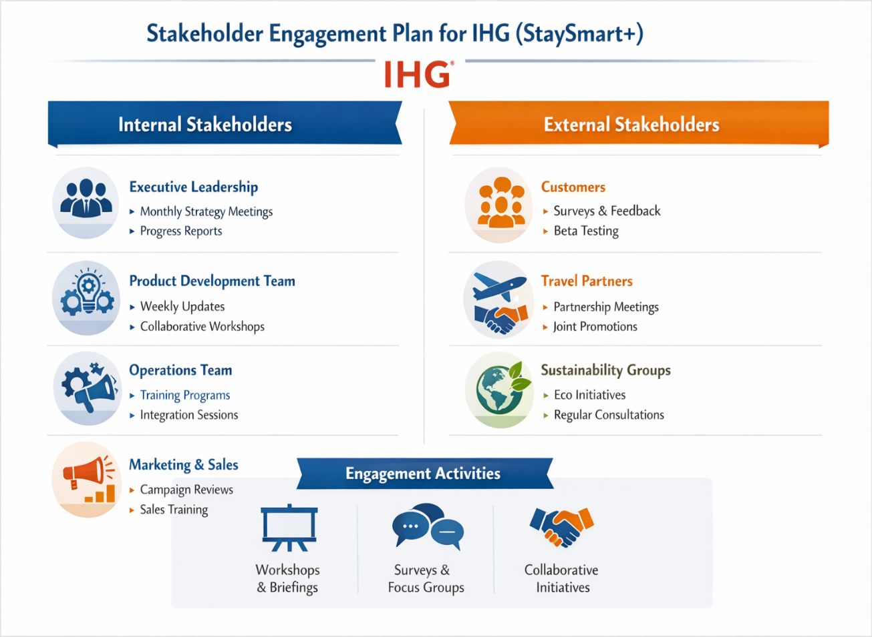
Figure 3: Stakeholder engagement plan infographic
Source: Self-made (Adapted from Gutterman, 2023)
Stakeholder Matrix
The stakeholder matrix classifies the stakeholders depending on their influences and interest regarding the project (Maqbool, Rashid and Ashfaq, 2022). Internal stakeholders like the Executive Leadership Team and Product Development Team would be in the high power and interest category of stakeholders, where they have to be engaged and they should communicate frequently with one another. The high interest, but not influential external stakeholders, such as customers and suppliers should be informed and consulted with ensuring that their needs and expectations are taken into account.
RACI Matrix
The RACI matrix (Responsible, Accountable, Consulted, Informed) explains the roles and responsibilities of every stakeholder of the project (Lee et al., 2021). As an example, the Product Development Team, in turn, can be Responsible in terms of designing AI tools, whereas the Executive Leadership Team will be the person (team) Accountable in the general direction the project should take. Such a matrix aids in preventing confusion and makes the stakeholders aware of their roles making the probability of missing their roles low.
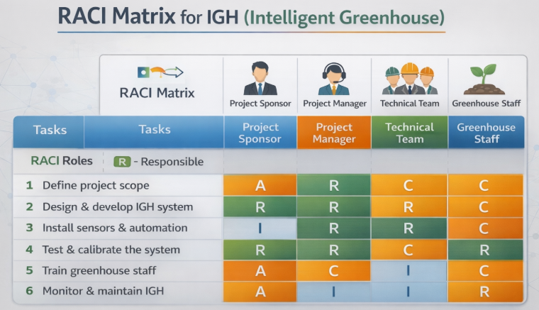
Figure 4: RACI matrix
Source: Self-made (Adapted from Lee et al., 2021)
Engagement Plan
An engagement plan defines particular activities to take as to the engagement of every group of stakeholders (Gutterman, 2023). To illustrate, by means of surveys, focus groups, and direct communication, IHG can communicate with customers and obtain their feedback, thus, refining the service. The internal teams will be kept in line through regular updates, which can be in the form of newsletters and meetings. The engagement plan has a regular and active communication which will respond to the stakeholder concerns throughout the project stages.
Communication Plan
Communication plan holds information on how the information shall be distributed among the stakeholders. There will be schedules, frequency, medium (emails, meetings, electronic resources) and the nature of information which will be shared in this plan (Azzahra et al., 2023). The focus on the specific communication strategies to various stakeholders would promote coherence and timely communication and information flow.
The use of these frameworks will enable IHG to have efficient stakeholder interaction during the roll out of StaySmart+, which will generate collaboration and commitment.

Stakeholder Engagement Process
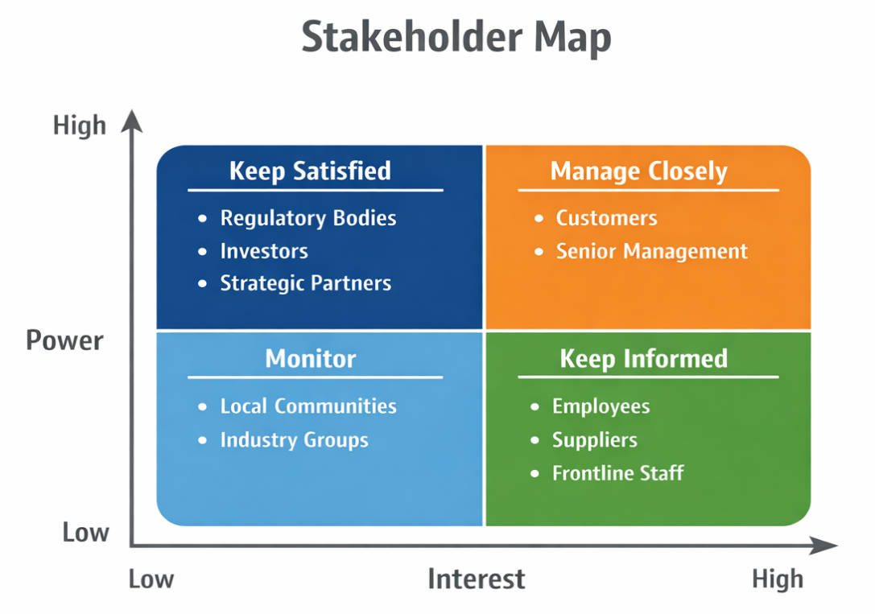
Figure 5: Stakeholder map with engagement strategies
Source: Self-made (Adapted from Boukhaoua and Habbache, 2024)
Engagement Strategy
The stakeholder engagement plan of stay smart + should be multi level such that both internal and external stakeholders are adequately engaged at every project phase. The approach should be focused on transparency, communication, and collaboration. IHG engagement strategy must take the form of first mapping main stakeholders (applying the stakeholder matrix) and their level of interest and power. To the internal stakeholders, frequent updates and cross-departmental meetings are made to make sure that, the teams, Product Development, Operations, and Marketing stay in line. Outwards, IHG needs to approach the customers in terms of targeted campaigns and keep the feedback loop consistent (adopt surveys and focus groups) to continuously improve the service as per real-time feedback. The same tactic was employed when Hilton Worldwide introduced its digital systems of check-in and keyless entry. It involved the stakeholders, particularly the guests, with email campaigns, and to give them rewards on feedback, which ensured ease of adoption.
The 4C’s Model
The management of stakeholder relations to StaySmart+ will center on the 4Cs model (Communication, Collaboration, Consultation, and Commitment).
- Communication: Timely and personalised communication is the key to the success of StaySmart+. Stakeholders will receive regular updates in forms of emails, reports and meetings. As an example, customers will be contacted with the help of social media posts and individualized emails, whereas internal teams will obtain a detailed report on the progress. Marriott International utilizes reviews and surveys to have a personalised communication plan about the loyal customer to keep them updated on the new service offerings (Boukhaoua and Habbache, 2024).
- Collaboration: Co-operation makes sure that each of the involved parties in the service adds his/her expertise to the success of the service. The departments that IHG will need to develop cooperation between include the IT department, the Operations department, and the Marketing department. On the outside, IHG will work with technology partners to introduce AI-based functionality, and suppliers to guarantee the sourcing of eco-friendly products to Power-StaySmart+, to support the delivery of services and raise customer satisfaction.
- Consultation: The consultation is essential in collecting the feedback and adjusting the service according to the needs of the stakeholders. IHG will engage customers via surveys and focus groups regularly (particularly in the pilot stage) in order to optimize the features of StaySmart+. The internal stakeholders will also be consulted to determine the challenges and areas of improvement. Four seasons Hotels regularly involves both its employees and customers in surveys in order to narrow down its luxurious services that uphold high standards of service and customer satisfaction (Yi, 2024).
- Commitment: Stakeholder commitment is in place so that all concerned parties are invested in the project. IHG should make sure that internal stakeholders are driven by the use of goals and milestone rewards. On the outside, the loyalty of customers can be fostered via loyalty systems and special deals to the users of StaySmart+. Ritz-Carlton can leverage brand loyalty by delivering custom experience and rewarding loyalty, as the company can ensure brand loyalty in the long term (Dimitrakaki, 2022).
Cultural and Market Context
The issue of cultural and market context is vital when involving stakeholders in global projects such as StaySmart+. StaySmart+ will be implanted in various markets that have different expectations and policies. To succeed in the engagement process, IHG needs to change its strategies to local cultural standards and consumer demands. As an example, AI-driven services should be launched with a high customer education rate in less technologically adapted markets and as a luxury, hi-tech service that will attract more customer demand in the regions where the population is technological. In launching its mobile app, Marriott International used regionalized marketing approaches in various territories based on regional technology usage and customer service demands.
Conflict Management
Stakeholder engagement involves a lot of conflict. The lack of alignment of the expectations or varying priorities within the departments or external stakeholders can create possible conflicts. To resolve disagreements, IHG can employ the model of 4C as a structured method to establish open communication, collaborate, and involve a stakeholder often to avoid any misunderstanding.
To clarify, in case the Operations Team is against the integration of AI tools, IHG can arrange consultations to address their concerns, explain the advantages, and cooperatively address operational issues. This makes everybody feel listened to and part of the decision making process eliminating possible friction. In implementing new technology, Hilton world wide has been facing internal conflict. The company addressed this by establishing cross-functional groups to discuss issues and develop collective solutions to make the technology roll out with ease (WUBATIE, 2024).

Impact of Stakeholder Engagement on Business Performance
Stakeholder engagement is an essential factor of the success of the StaySmart+ and directly determines the business performance of IHG. The involvement of internal and external stakeholders will maximize customer satisfaction, boost operational performance, increase brand image, and lead to long-term financial prosperity. By prioritising the stakeholder interests in line with the project objectives, the IHG will be able to enjoy streamlined implementation process, minimised risk, and competitive advantage.
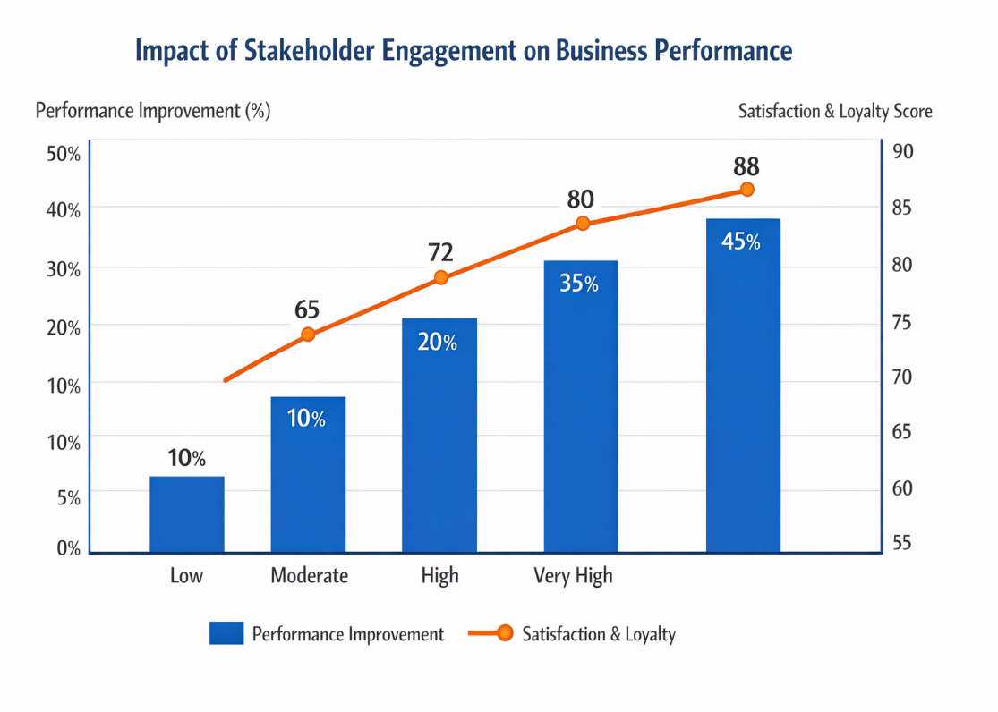
Figure 6: Graph showing engagement vs business performance
Source: Self-made (Adapted from Awa, Etim and Ogbonda, 2024)
Customer Satisfaction and Adoption Rates
The customers must be engaged to improve on the feedback mechanisms such as surveys and focus groups to make sure that StaySmart+ suits their requirements. Customers that feel that their views are taken into consideration would be willing to embrace new services.
Stakeholder Theory stresses on the importance of considering the customers as partners since they are among the most important stakeholders (Awa, Etim and Ogbonda, 2024). This early customer involvement will help IHG to keep the service at par with customer expectations, hence increasing the adoption rates. Indicatively, Hilton Worldwide has made efforts to use customer feedback to enhance its mobile check-in service functionality and usage in the pilot stage, and this has resulted in better functionality and usage of the application. Likewise, customer engagement will lead to increased satisfaction, loyalty, and adoption of the StaySmart+ by IHG, leading to an increase in the business in long-term.
Employee Engagement and Productivity
Another vital factor is engagement of the employees. Having such internal teams in the project since the inception of this process makes them more dedicated towards the success of the project. Active employees have increased productivity and are therefore better placed to provide better customer service.
Transformational Leadership Theory states that employees should be motivated by communicating and engaging in decision making which will increase their engagement (Santoso, Sulistyaningtyas and Pratama, 2022). As an illustration, Marriott international has managed to involve employees, especially by involving them in feedback channels leading to increased job satisfaction and improved services delivery. Using the same strategies, IHG will be able to achieve high employee engagement, which would result in better service and customer experiences.
Operational Efficiency and Cost Management
The stakeholder engagement also assists in enhancing the operational efficiency. Early integration of teams like IT and operations will enable IHG to foresee issues in the form of technology integration or supply chain delays. The involvement of suppliers helps guarantee the delivery of materials and technologies in time and avoid delays as well as cost-reduction.
According to the Resource-Based View (RBV), internal resources including human capital are key in achieving competitive advantage (Hossain et al., 2021). IHG will be able to maximize its internal resources through the involvement of key stakeholders in order to achieve operational efficiencies and minimize cost. Accor Hotels have also enhanced efficiency in its operations by consulting the suppliers at the early stages of its sustainability program, which has translated to cost-efficient materials and efficient delivery of services. In the same vein, IHG interaction with suppliers and internal teams will make the implementation of StaySmart+ smooth and cost-effective.
Brand Reputation and Competitive Advantage
Interaction with stakeholders is important in enhancing brand reputation. Quality in the interaction will inform customers of IHG more attentiveness to input and its willingness to provide innovative and customer oriented customer-facing services. IHG can distinguish itself in the highly competitive market by prioritizing new features of the staysmart program: StaySmart+.
According to the Competitive Advantage Theory put forward by Porter, competitive advantage can be achieved through differentiation (Kennedy and Kamau, 2025). The involvement of customers and suppliers in the process of sustainability and innovation makes IHG stronger in the market. The Ritz-Carlton is a good illustration of customer engagement in the brand image. Providing a personalised experience and responding to customer feedbacks should enable Ritz-Carlton to win over customer loyalty and provide competitive advantages. Likewise, the interactions with stakeholders will help IHG develop the reputation of an innovator in the hospitality industry, which will draw customers who are concerned about sustainability and technology.
Financial Performance and Long-Term Success
Finally, the financial performance at IHG is driven by the stakeholder engagement. Satisfied customers mean higher satisfaction and loyalty as well as repeat business. Engaged suppliers aid in cost reduction whereas devoted employees aid in improvement of service delivery. What it yields is increased revenue and profitability.
According to the Stakeholder Theory, involvement of stakeholders generates value to both the company and stakeholders. In the case of StaySmart+, the contact with customers, employees, and suppliers is the way to make the service meet the demands of the market and be enacted in the most efficient way possible. Such interaction results in the enhancement of the adoption rates, lowering the cost of operations, and boosting customer retention, which facilitates both the immediate and the sustained success.

Recommendations for Future Stakeholder Engagement
The stakeholder engagement is a continuous process, and to go sustainable, IHG needs to constantly improve and adjust the strategies of engagement to achieve sustainable success of StaySmart+. The following are the recommendations to be made so as to positively impact the stakeholder involvement, collaboration and long-term alignment with the goals of IHG.
1. Strengthening Customer Engagement through Personalization
IHG needs to expand its individualized engagement practices to ensure the retention of its customers and enhance adoption. By relying on data analytics, IHG will be able to divide customers into segments, basing the division on preferences, traveling patterns, and comments. The customers will experience individualized communication and special offers and promotions regarding StaySmart+ and feel valued by this brand.
As an illustration, frequent contact followed by personalised emails, customized loyalty program, and AI-supported recommendations may help to make sure that customers are not bored during the process. The information presented by the clients will also help IHG refine the service on a never-ending basis and meet the changing needs.
2. Enhancing Internal Stakeholder Collaboration
The participation of internal stakeholders is essential to the continuous running of affairs. IHG needs to introduce cross-departmental cooperation programs to make sure that all departments, operations and marketing ones are on the same page. Internal teams can also be more successful in their collaboration because the regular workshops, feedback sessions, and collaborative platforms can make them realize the perspectives of each other and cooperate more efficiently (WEINGART, JEHN and KRUEGER, 2023).
Moreover, participation of frontline employees in the ideation stage of service improvement can result to excellence in ideas and more qualitative implementation of these ideas. An effective feedback that incorporates not only the leadership but operational staff members will help the company predict the problems and enhance service provision.
3. Developing Long-Term Supplier Relationships
In the case of StaySmart+, it is essential to interact with suppliers to achieve high standards in service as well as sustainability of the service. IHG needs to aim at making long term suppliers as opposed to transactional relations. Opening good channels of communication, shared sustainability targets, and innovations through team efforts will generate synergies (Holubčík, Soviar and Lendel, 2023).
Frequent meetings and performance basis with the suppliers may assist in ensuring that sustainability practice, as well as technological innovations is being upheld. The alignment of the objectives of the suppliers with those of IHG can help this assurance in the fact that the resources, including the green materials and the latest technologies, are kept to respond to the changes occurring in the service.
4. Building Stronger Community Engagement
External stakeholders, such as local communities, are also important, and IHG must work on community engagement by sponsoring local events and encouraging positive social contributions. This may entail offering sponsorship to local environmental or social initiatives that are in line with the sustainability objectives of StaySmart+. This approach to communities helps evolve the brand image of IHG along with promoting the collaboration with the local communities.

Conclusion
In summary, the stakeholder involvement is one of the most important in the successful introduction and retention of the StaySmart+ at the IHG hotel. This step of identifying its key stakeholders will enable IHG to guarantee that the service will support the interests of the customers, employees, suppliers and regulatory agencies by determining their roles and will be integrated in the process of service-designing process, service launch and its ongoing enhancement. The other models, which are applicable and can be discussed are the Stakeholder Theory and the Transformational Leadership that explain how the interests of the stakeholders should be aligned with the project goal so that there is a win-win scenario.
Stakeholder support is an active and a consistent method of increasing customer satisfaction, employee composition and activity and brand view. Through effective communication, collaboration, and conflict pre-emption, IHG will be able to establish better relations with internal and external stakeholders, making the StaySmart+ an effective and long-term product. With the dynamic nature of the hospitality industry, IHG will need to continuously improve its stakeholder engagement approaches in order to remain ahead of a dynamic industry, including with regard to technological innovation, sustainability concerns, etc. As IHG is dedicated to engaging the stakeholders, a successful launch of the StaySmart+ will be achieved, the company will be able to promote sustainable development, and retain its competitive edge in the international market.
Overall, stakeholder engagement is a constant process, which greatly influences business performance, customer retention, and brand differentiation, which culminates into success of the firm in the long term, which is the case with StaySmart+ and IHG.

References
Amen, M.A. (2024). AI-Driven Sustainable Habitat Design: Key Policy Frameworks and Ethical Safeguards. Smart Design Policies, 1(1), pp.23–32. doi:https://doi.org/10.38027/smart-v1n1-4.
Awa, H.O., Etim, W. and Ogbonda, E. (2024). Stakeholders, Stakeholder Theory and Corporate Social Responsibility (CSR). International Journal of Corporate Social Responsibility, 9(1), pp.1–14. doi:https://doi.org/10.1186/s40991-024-00094-y.
Azzahra, S.F., Titisari Ramadhane, Muhammad Fakhrul Safitra, Lubis, M. and Sinung Suakanto (2023). Stakeholder Management and Communication Management Plan on E-Government Project. Stakeholder Management and Communication Management Plan on E-Government Project. doi:https://doi.org/10.1109/citsm60085.2023.10455566.
Boukhaoua, A. and Habbache, F. (2024). The importance of communication through social media in building clients satisfaction for hotel institutions. Journal of Innovations and Sustainability, [online] 8(1), pp.02–02. doi:https://doi.org/10.51599/is.2024.08.01.02.
Da, R. and Bastias, F. (2022). MASTERS FINAL WORK PROJECT EQUITY RESEARCH: INTERCONTINENTAL HOTELS GROUP. [online] Available at: https://repositorio.ulisboa.pt/bitstream/10400.5/26913/1/DM-RFB-2022.pdf.
Dimitrakaki, I. (2022). Organizational culture and performance. The case of Google. Global Research Review in Business and Economics [GRRBE], [online] 8(5), pp.1–9. Available at: https://grrbe.in/Vol-8-issue-05/GRRBE-A-08050010070372.pdf.
Dixit, P. (2025). Tourism and Technology. Educohack Press.
Fernandes, F. (2021). Intercontinental Hotels Group - Time to Check-In - ProQuest. [online] Available at: https://www.proquest.com/openview/5c61b3410b66a714c863c054e647c987/1?pq-origsite=gscholar&cbl=2026366&diss=y.
Garg, V., Bohara, S. and Srivastav, A. (2025). AI-driven sustainability marketing transforming consumers’ perception toward eco-friendly brands. Discover Sustainability, 6(1). doi:https://doi.org/10.1007/s43621-025-01934-y.
Gutterman, P. (2023). Stakeholder Engagement. [online] papers.ssrn.com. Available at: https://papers.ssrn.com/sol3/papers.cfm?abstract_id=4393164.
Hasan, M.M., Rayhan, Z., Mukta, R.T. and Faruq, O. (2024). Research on Adapting Marketing Techniques to Different Culture Economics and Regulatory Environment to Entering New International Markets. Информатика. Экономика. Управление / Informatics. Economics. Management, [online] 3(4). Available at: https://cyberleninka.ru/article/n/research-on-adapting-marketing-techniques-to-different-culture-economics-and-regulatory-environment-to-entering-new-international.
Holubčík, M., Soviar, J. and Lendel, V. (2023). Through Synergy in Cooperation towards Sustainable Business Strategy Management. Sustainability, 15(1), p.525. doi:https://doi.org/10.3390/su15010525.
Hossain, M.S., Hussain, K., Kannan, S. and Kunju Raman Nair, S.K. (2021). Determinants of sustainable competitive advantage from resource-based view: implications for hotel industry. Journal of Hospitality and Tourism Insights, 5(1). doi:https://doi.org/10.1108/jhti-08-2020-0152.
IHG Development. (2026). InterContinental Hotels & Resorts. [online] Available at: https://development.ihg.com/hotel-brands/intercontinental-hotels-resorts.
Kennedy, M. and Kamau, S. (2025). Strategic Management and Competitive Advantage in Hospitality and Tourism Consulting: A Critical Review. International Journal of Science and Research Archive, 16(2), pp.367–371. doi:https://doi.org/10.30574/ijsra.2025.16.2.2067.
Lee, W., Lee, S., Jin, C. and Hyun, C. (2021). Development of the RACI Model for Processes of the Closure Phase in Construction Programs. Sustainability, 13(4), p.1806. doi:https://doi.org/10.3390/su13041806.
Maqbool, R., Rashid, Y. and Ashfaq, S. (2022). Renewable Energy Project success: Internal versus External stakeholders’ Satisfaction and Influences of Power‐interest Matrix. Sustainable Development, 30(6), pp.1542–1561. doi:https://doi.org/10.1002/sd.2327.
Omazic, M., Pihir, I. and Machrafi, M. (2023). Economic and Social Development Book of Proceedings. [online] Available at: https://esd-conference.com/upload/book_of_proceedings/Book_of_Proceedings_esdPlitviceLakes2023_Online.pdf#page=81.
Raut, N., Ahmad, S.K., Nagarkar, S., Prasad, V.K.S., Long, C.S. and Shrivastava, N. (2025). The Role of Smart Home Technologies in Promoting Sustainable Lifestyles: Marketing Innovations for Eco-Friendly Consumer Behavior. pp.873–878. doi:https://doi.org/10.1109/ce2ct64011.2025.10939654.
Santoso, N.R., Sulistyaningtyas, I.D. and Pratama, B.P. (2022). Transformational Leadership During the COVID-19 Pandemic: Strengthening Employee Engagement Through Internal Communication. Journal of Communication Inquiry, 0(0), p.019685992210951.
Svitlana, M., Kudinova Iryna, Mosiiuk Stefaniia, Samsonova Viktoriia and Neilenko Sergii (2025). Eco-Friendly Hospitality in the Digital Era: Trends, Technologies, and Transformations. Communications in computer and information science, pp.3–28. doi:https://doi.org/10.1007/978-3-032-04228-6_1.
Veile, J.W., Schmidt, M.-C., Müller, J.M. and Voigt, K.-I. (2020). Relationship follows technology! How Industry 4.0 reshapes future buyer-supplier relationships. Journal of Manufacturing Technology Management, 32(6), pp.1245–1266. doi:https://doi.org/10.1108/jmtm-09-2019-0318.
WEINGART, L.R., JEHN, K.A. and KRUEGER, K.L. (2023). Manage Intrateam Conflict Through Collaboration. Principles of Organizational Behavior, pp.403–427. doi:https://doi.org/10.1002/9781394320769.ch20.
WUBATIE, N. (2024). THE EFFECT OF SUPPLY CHAIN MANAGEMENT ON HOTEL SERVICE DELIVERY IN THE CASE OF HILTON ADDIS HOTEL. Smuc.edu.et. [online] doi:http://hdl.handle.net/123456789/8108.
Yi, M. (2024). Sustainable Practices in Luxury Hotels: Case Study of Four Seasons Hotels and Resorts. [online] Ssrn.com. Available at: https://papers.ssrn.com/sol3/papers.cfm?abstract_id=5928063.

