INTERNATIONAL BUSINESS COMUNICATION

Assignment 1 : Essay

Student name: A nca Ghizela Hotca (2021006 L6T1G1)
Tutor’s name: Charles Nwaogwugwu
Module code: LCBB6001
Date: 27/04/2023

Contents
Report A1 3
Introduction 3
Company overview: Barclays Bank 3
Theories of international and intercultural communication 4
Critical evaluation of cultural sensitivity in context of diverse workplace culture 6
Distinct communication barriers witness by diverse employee base of Barclays Bank 7
Recommendations 10
Conclusion 13
References 14

Assessment 1 - Report

Introduction
Working as a business communication consultant a report to be documented shortly and presented to the HR direction of the concerned organisation discussing the practical and theoretical aspects connected with business communication. The underlying objective of this report is to focus on the roles of the line managers effective towards fostering the growth of inclusive workplace policies. The primary contents of this report shall include a discussion on theories of international and intercultural communication, cultural sensitivity along an evaluation of the distinct communication barriers evident within a diverse employee base. The organisational example of Barclays Bank to be considered for developing the report.
The process of communication involves an interactive process wherein effective flow of information is assured. The concept of British business communication tends to project the overall communication style within the corporate entities of the United Kingdom. It is observed that British people prefer verbal communication rather than non-verbal communication and their overall style of communication is indirect. As British people are mostly indirect communicators they generally avoid indulging into a conflict and their communication in the corporate sectors are polite and prefer to participate in discussion rather than arguments. The business communication of the British is based on the core principles of courtesy, politeness, discipline, punctuality (Guffey and Loewy, 2022).

Company overview: Barclays Bank
Founded several centuries ago in 1690, Barclays Bank is a British multinational universal bank operating as a public limited company. It is associated with offering a range of financial and banking services. The cited bank currently operational as two major divisions namely Barclays UK and Barclays International. The company has a primary listing on the London Stock Exchange and a part of the FTSE 100 Index along with a secondary listing on the New York Stock Exchange. At present the cited universal bank has an employee base of 81, 000 reflecting inheritance to a diverse workplace culture (About Barclays - who we are 2023).
Barclays Bank being operating as a universal bank support the consumers and small business through its retail banking services and larger business enterprises are offered investment banking services. the core objective of this universal bank is to address the societal needs and to facilitate a clear expression of the kind of the business it is operating. The company has developed various policies and procedure to assure embedding an inclusive workplace culture. The employee performances are evaluated through several KPIs and workplace diversity and inclusion ensured through understanding the needs of its major stakeholders (About Barclays - who we are 2023).

Theories of international and intercultural communication
Barclays bank being actively functional as a universal bank at a multinational level is inevitable to have a culturally diverse employee pool that can be further evaluated referring to relevant theories of intercultural and international communication. In this context the Hofstede model of intercultural communication can be referred which is recognised as globally renowned framework for analysing the cultural variations. The model was conceived by Geert Hofstede wherein variation of culture between countries are plotted along five dimensions and used as a base for interpreting the cultural differences. The five dimensions of this model are power distance, masculinity vs femininity, long term orientation vs short term thinking., individualism vs collectivism and uncertainty avoidance. The model is comprehensive and exhaustive in its treatment of cultural variation across cultures (Arasaratnam, 2015).
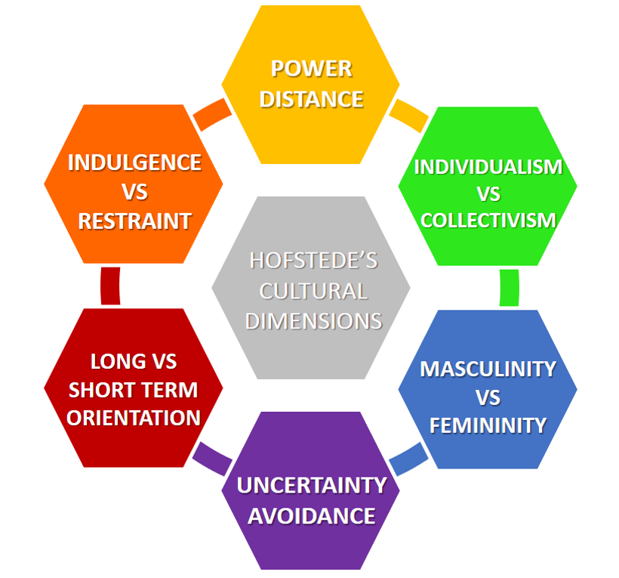
Source: (Hofstede, 2015).
Applying the referred communication model power distance can be used to measure the extent to which hierarchy dominates in this banking working environment while individualism vs collectivism focusses on accumulating the results that staffs of this bank located in UK are individualistic compared to the employees of this bank located in the Asia countries. It is hence by embedding Hofstede model it is possible for the HR managers to understand the overall cultural variation in the working ambiance of the bank.
Aligning to the book published by Larry A. Samovar, communication between varied cultures reflects the need for understanding different cultures by the people for improving their respective communication with other culturally different individuals. He further stated that intercultural communication adheres to four distinct principles namely language, culture, intercultural mediation. Channels of communication and subconscious elements in communicative attitude. Citing the example of Barclays Bank, it is vital for its line manages to acquire the knowledge on the cultural background of their colleagues in order to strengthen the potential of communication with culturally staffs (Hofstede, 2015).

Critical evaluation of cultural sensitivity in context of diverse workplace culture
Cultural sensitivity in workplace is closed linked with cultural diversity in workplace and is also applicable to Barclays Bank. An insight into the work culture of the United Kingdom indicate that it is more of relaxed and social in nature and employees like to meet one another take a break and socialize. However, citing the example of Barclays bank that is having a diverse employee base people from different cultural background are appointed in this bank. The employees belonging to other cultural origin but posted at different locations of the United Kingdom are vulnerable to experience cultural sensitivity that might affect the interpersonal recognition. Hence to eliminate the degree of cultural sensitivity it is important for the HR managers of this banking organisation to appreciate cultural diversity within its banking professionals. Formulation of adequate policies and procedures are also crucial in this respect. To note the culturally diverse employees working in the United Kingdom in Barclays bank need to understand that the business culture of this country are courtesy, politeness, discipline, punctuality (Bennett and Hammer, 2017).
Hence responding to the cultural sensitivity issues the cited business organisation has embedded five values like respect, integrity, service, excellence, stewardship. The company has also developed an inclusive work environment which promote inclusiveness with respect to race, ethnicity, nationality and faith, the HR department has been concerned to cultivate supportive work environment wherein employees are made comfortable with their cultural values and beliefs (Ting-Toomey and Dorjee, 2018).
This multinational bank has been focused on strengthening its diverse, equitable, and inclusive culture thereby forming a competent and diverse employee base. The bank’s DEI (Diversity, Equity and Inclusion) vision is to build the best talent of high performing teams although culturally diverse. In this context the example of Barclay’s Employee Resource Groups can be cited that are concerned in promoting diversity and inclusion thereby eliminating cultural sensitivity at the workplace. At Barclays the Employee Resource Groups colleagues-led groups dedicated to assure that all voices are being heard and to create a culture that attracts, retains, engages the best talents from diverse workplace (Barclays bank, 2023)
Responding to the issues of cultural sensitivity, the HR department of Barclays Bank has also considered focusing on cultural awareness enabling its staff to become informed regarding certain things like body language, etiquette, attitudes to personal space etc. Emphasis is also given to embed mutual trust within the diverse employee base. Incorporation of relationship-based trust is developed through knowledge sharing and bonding with the employees. Hence the Barclays bank has considered communication to be a major determinant in eliminating cultural sensitivity within its diverse employee pool and assured presence of a good communication platform within its organisational premises (Barclays bank, 2023).

Distinct communication barriers witness by diverse employee base of Barclays Bank
Communication barriers in context of business are considered as the issues that has the potential to prevent effective communication within the employees of an organisation. Citing the example of Barclays Bank its diverse employee base are evident to come across certain issues projecting as communication barriers. In a multicultural workplace like Barclays bank cross cultural communications barriers are mainly the issues connected with anxiety within the employees., uncertainty, stereotyping and ethnocentrism that are primarily caused due to lack of adequate knowledge regarding intercultural communicative skills (Jenifer and Raman, 2015).
Highlighted below the major barriers to communication within the diverse workplace of Barclays bank:
Differences in speaking language
The diverse workplace of Barclays bank has employee speaking different languages and hence this appear to be a highly complex issue as it become difficult for the employees to understand other employee’s language hence addressing this issue it is important for the concerned banking business to implement a regulation within its employees for speaking in only one language which is understandable for all. English is hence considered as the spoken language for the employees of this diverse workplace of Barclays bank assuring effective flow of information.
Inaccurate and hostile stereotypes
The evidences of inaccurate and hostile stereotype attitude within the staffs from culturally diverse background act as a major barrier of communication in the diverse workplace of Barclays bank. The stereotyped nature of the individuals tends to negatively affect the communication within the diverse work culture of Barclays. For example, the stereotypical American people appear to reflect impatient attitude and arrogance but some are friendly and tolerant. Hence in Barclays following presence of a diverse workplace culture stereotyped nature staffs are dangerous affecting the entire cross cultural communication process leading to emergence of conflicting situation due to gaps in communication (Jenifer and Raman, 2015).
Differences in attitude
In a culturally diverse workplace like Barclays bank events of behavioural differences within its staffs act as a major barrier to communication as this also increase the susceptibility to employee level misunderstanding. It is inevitable to reflect a variation of behaviour within people belonging to difference culture however an increase sensitivity to cultural variation when dominate the behavioural attribute result in major communication gap at the concerned workplace. For example, in some cultures it is normal for people to talk with one another at a closer proximity while some culture people stand at a certain distance communicating with one another. This behavioural difference often surfaces as a barrier to cross cultural communication within Barclays (Jenifer and Raman, 2015).
Emotional unbalance
The degree of emotion projected by the employees in a diverse culture workplace is another barrier to communication. Referring to Barclays its multicultural employee base reflects too much or loo less emotions as influenced by their respective cultures. For example, people belonging to some cultures display fear, anger or frustration at workplace considered inappropriate on professional frontier while staffs associated with other cultural background tend to hide their emotion and only prefer to discuss the factual aspects of situation surfaced.
Ethnocentrism
Ethnocentrism is identified as a major problem with respect to barrier in cross cultural communication. Presence of high-level of ethnocentrism within the individuals and their prejudices are likely to influence their willingness to communicate. Hence ethnocentric individuals prefer not to communicate with someone from other cultural background considering them to be inferior. To note, ethnocentrism is also reflected through specific; linguistic features and result in increasing the feelings of social distance between groups and outgroups. Referring to the example of Barclays bank, in UK ethnocentric attitude is mainly centred around the white people thereby leading to a barrier in communication within the culturally diverse working place (Campbell, 2016).
Psychological barrier
The Barclays bank in course of managing the cross-cultural teams is evident to witness presence of certain psychological barriers in their communication process. A difference in psychology within the people belonging to different cultural background tend to increase communication gap within the employees. For example, the French culture is to give feedback and remain focused which is distinct from the UK’s way.
Hence the above identified issues are considered as barrier in communication experienced by the employees of Barclays bank while embedding a multicultural working environment. Effective recognition to the communication barriers and responding to the same is hence crucial for the managers of Barclay (Campbell, 2016).

Recommendations
In the following section a brief note recommending effective strategic approaches that can be undertaken by the employees of Barclays bank to improve the existing communication process assuring incorporation of a positive work environment. Understanding the presence of a diverse employee pool within the organisational premises of Barclays bank it is important to strengthen the communication process for embedding appositive and transparent work environment. To begin with it is advisable for the line managers of Barclays bank UK to focus on maintaining the professional etiquette as diverse cultures have diverse etiquette around the way they communicate. Also, the staffs of this bank need strictly avoid using bad words and focus on keeping the communication simple by selecting simple words. An avoidance to complicated sentences is also advisable to assuring incorporation of a positive work culture. Moreover, the employees of this bank are advised to avoid indulging into any conflicting situation and should prefer to discuss issues rather than argue on the same. This attitude is expected to incorporate a positive working culture within Barclays bank. Last but not the least it is recommended for the HR managers of Barclay bank to develop and implement training session of cultural awareness intending to enhance the knowledge of varied work cultures within the staffs (Coffelt et al., 2019).
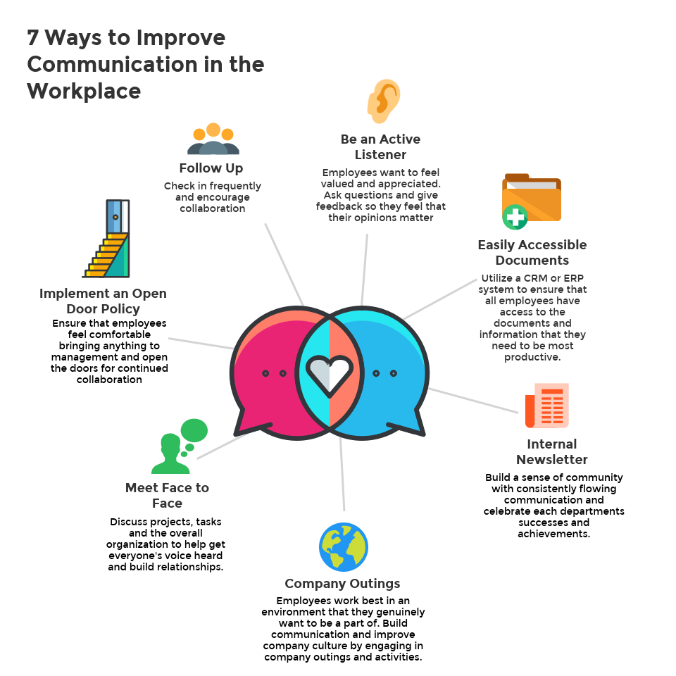
Source: (Coffelt et al., 2019).
Referring to the above incorporated pictorial presentation it is further suggested for the employees of Barclays bank to acquire the skill of active listening, utilising a CRM or ER system to ensure easy access to information by its staffs. Furthermore, it is advised to publish newsletter and circulate to the staffs, organising company outlining and to arrange interpersonal meeting on a regular basis in order to assure effective level of intercultural communication. Implementation of an open-door policy is also recommended to the senior HR managers of this business assuring easy and effective exchange of information (Lall-Trail et al., 2023).
Additionally, the line managers of this bank are recommended to develop the habit of patience listening giving an opportunity to the other side to speak. A positive working environment can be developed bt incorporating the habit of taking turns to talk. The employees and business managers of Barclays Bank are suggested to focus on setting clear objectives clearly communicating the long- and short-term objectives to its staff. Additionally, it is recommended for the HR managers of Barclays bank to formulate and execute diversity initiatives thereby promoting inclusive work culture within the staffs. A promotion of organisational transparency, assuring effective information flaw and open communication are further recommended intending to incorporate a positive working culture within Barclays bank (Lall-Trail et al., 2023).
The front-line managers of Barclays bank are also advised to focus on their respective communication skill prioritizing a boost to employee morale and employee engagement assuring formation of an inclusive workplace culture. It is suggested to focus on open communication within the culturally diverse employee pool of Barclays bank focusing on team working, mutual coordination and synchronization. Justified to add, in course of developing a positive work culture within Barclays bank it is important to keep its mission and values at the fore front of its communication strategies (Lall-Trail et al., 2023).

Conclusion
In line with the above developed report, it is evident that communication is a vital factor in corporate sectors assuring to strengthen the overall competitive advantage of the same. The theories and models highlighted has also indicated the need for the line managers of Barclays bank to acquire significant knowledge on business communication assuring inclusive workplace culture. Therefore, the identified issues leading to cultural sensitivity in diverse workplace environment of Barclays bank and the barriers of intercultural communication are key players to business communication. It is also expected that the existing communication process within the organisation premises of Barclays bank to improved adhering with the suggesting communication strategies. Efforts to build an include workplace ambience for the culturally diverse employee base of Barclays bank is crucial to the bank long run viability adding an improved operational efficacy (Guffey and Loewy, 2022).

References
About Barclays - who we are (2023) Barclays. Available at: https://home.barclays/who-we-are/ (Accessed: March 21, 2023).
Arasaratnam, L.A., 2015. Research in intercultural communication: Reviewing the past decade. Journal of International and Intercultural Communication, 8(4), pp.290-310.
Bennett, M.J. and Hammer, M., 2017. A developmental model of intercultural sensitivity. The international encyclopedia of intercultural communication, 1(10).
Campbell, N., 2016. Ethnocentrism and intercultural willingness to communicate. Journal of Intercultural Communication, 40(1), p.1.
Coffelt, T.A., Grauman, D. and Smith, F.L., 2019. Employers’ perspectives on workplace communication skills: The meaning of communication skills. Business and Professional Communication Quarterly, 82(4), pp.418-439.
Diversity, equity and inclusion (2023) Barclays. Available at: https://home.barclays/who-we-are/our-strategy/diversity-and-inclusion/ (Accessed: March 21, 2023).
Guffey, M.E. and Loewy, D., 2022. Essentials of business communication. Cengage Learning.
Hofstede, G., 2015. CHAPTER ONE NATIONAL DIFFERENCES IN COMMUNICATION STYLES GEERT HOFSTEDE. Culture’s software: Communication styles, 1.
Jenifer, R.D. and Raman, G.P., 2015. Cross-cultural communication barriers in the workplace. International Journal of Management, 6(1), pp.348-351.
Lall-Trail, S.F., Salter, N.P. and Xu, X., 2023. How Personality Relates to Attitudes Toward Diversity and Workplace Diversity Initiatives. Personality and Social Psychology Bulletin, 49(1), pp.66-80.
Ting-Toomey, S. and Dorjee, T., 2018. Communicating across cultures. Guilford Publications.

