ECAD4014
Tuesday 19th March 2024
RESOURCE
This session is focussed on science and technology AoLE. Maths and literacy links from sequencing and reading/writing.
After observing how plants grow and reading the book ‘Sam Plants a sunflower’.
Pupils will be required to form a sequence of how a sunflower grows.
Lower ability children will match the picture to the correct word.
Middle ability children will put the picture in the correct place and write the correct word.
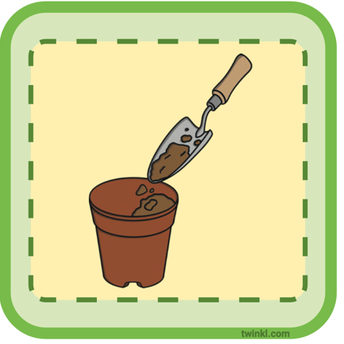
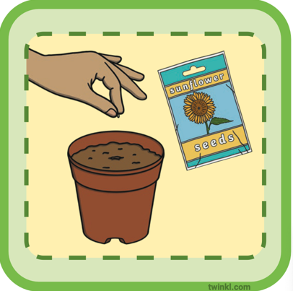
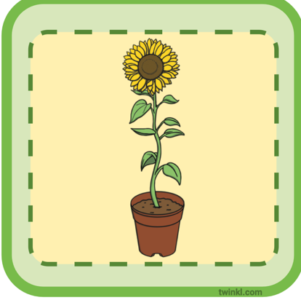
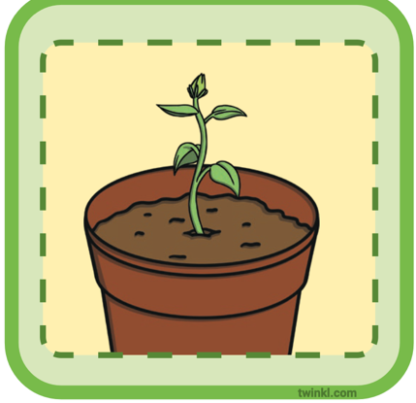
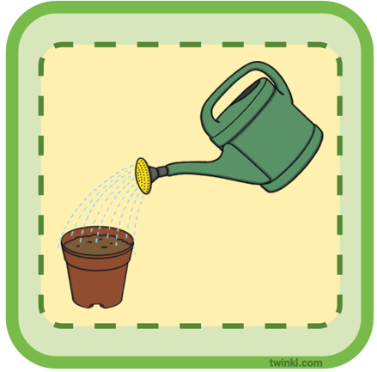
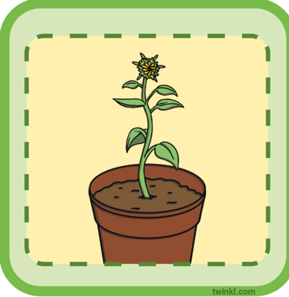
MAT pupils will draw and write the correct words in the sequence of the life cycle.

Soil | Plant seed | Germinated seed | seedling | Young plant | Adult plant

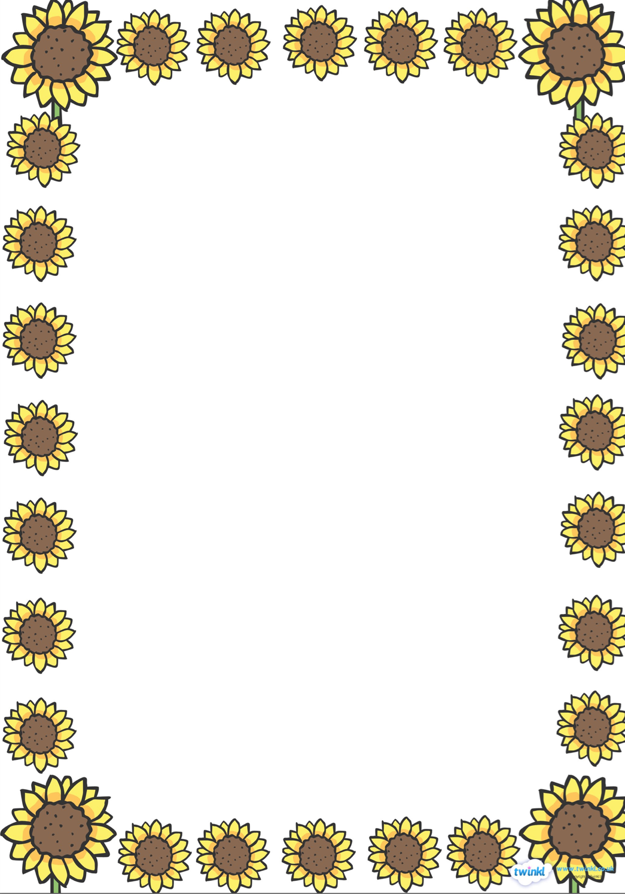

Sam Plants a Sunflower

