How organisational cultures impact officers’ willingness to accept psychological help
Analysis
Katie-Louise Bellew
2319739

This chapter of the dissertation attempts to present and interpret data collected via research, showing how it related to the research objectives. It will outline key themes that have emerged from the individual participants’ experiences and perceptions and examine how these themes reflect how Organisational Cultures Impact Officers Willingness to Seek Psychological Help. The analysis will connect the data to existing theories and literature, highlighting patterns, contradictions and insights into the factors that influences officers’ decisions.
The questionnaire was placed on a shared resource site between Gwent Police and South Wales police, asking those who are interested in taking part to do so. Over the time frame of it being placed on the site, 40 participants of varied ranks took part in the questionnaire. Due to the large number of responses and the limited word count within this chapter, only some of the themes will be analysed.

Theme one: Organisational norms within Policing
One of the first charts created for this questionnaire was based on current organisational norms within policing and what the participants agreed or disagreed with based on their experience. The below chart reflects that emotional suppression remains defining feature of organisational culture within policing.
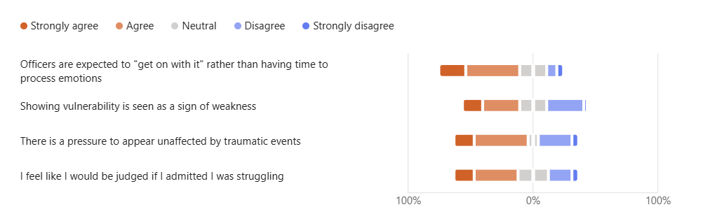
This shows that 64.8% of participants strongly agree or agree that officers are expected to just “get on with it” and 59.4% of those also agreed that there is a pressure to appear unaffected by events within their career. These questions show the “cult of coping” within policing which reflects the argument that Reiner made that those who join the police force are forced into a culture that expects emotional control, detachment and toughness (Reiner, 2010).
Further to this, 45.9% of participants agree that showing vulnerability is a sign of weakness compared to the 32.4% who disagreed. This aligns with research based on stigma and masculinity that prominent in policing and how traditional masculine norms remain present and shaping officers’ behaviour. These norms contribute to the stigma where officers negatively view themselves for experiencing psychological strain and refrain from opening up (Forensic Focus, 2025).
Overall, this theme shows that the emotional suppression and stigma are still deeply embedded within policing in Welsh policing culture. These organisational cultures shape officers’ internal beliefs surrounding mental health, influence how they portray their own distress and significantly reduce their willingness to seek help.

Theme two: Mental Health Climate within Policing
The below chart was created based on questions relating to mental health within policing and the openness that the forces have surrounded this subject.
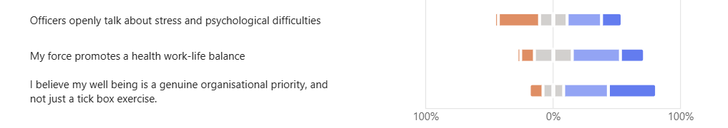
High workloads, unpredictable shifts and emotional labour are just a few things that characterise policing. Studies by Houdmont and Elliott-Davies show that officers frequently report burnout and fatigue, which undermines wellbeing (Officer, 2016). 56.7% of participants from this study, which was placed across two different Welsh Police Forces, state that they disagree that their force promotes a healthy work life balance whilst 13.5% agree.
The key part to this theme is the scepticism surrounding the organisations wellbeing initiatives. 72.9% of the participants in this study feel that officer wellbeing is more of a tick box exercise rather than a genuine priority, whilst 10.8% disagree. These findings echo those of Brown et al !!!!!! who argued that wellbeing programmes in police forces often appear to be performative or compliance driven rather than being embedded in day-to-day practice. When officers perceive wellbeing efforts as tick box exercises, trust in the organisation diminishes meaning they are less likely to seek support from them, this is reflected in Heslin and Kleiner who showed that employees are less likely to access support services when they doubt the sincerity of the interventions (HESLIN, VANDEWALLE and LATHAM, 2006).
Overall, this theme demonstrates that despite the increased attention to police wellbeing, police officers are continuing to experience a disconnect between policy and practice. This supports broader literature that suggests genuine change around organisational culture requires not only policy development but structural reform.

Theme three: Central concerns regarding organisational cultures
The word cloud below highlights how “mental health” is a central concern within policing as the majority of participants have used this phrase to describe their main concerns.
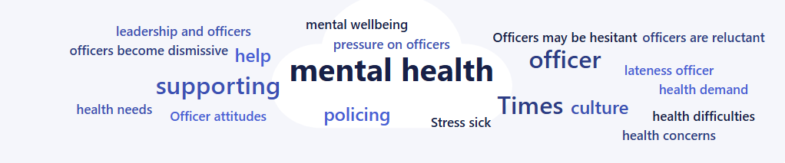
Participants also regularly mentioned phrases such as “hesitant”, “reluctant” and “dismissive” which reflects a culture where the psychological issues faced by officers are often minimised or deprioritised. These findings align with long-standing research that shows occupational culture encourages emotional suppression and discourages help seeking behaviours (Lewsey, 2022).
Further reoccurring phrases are “pressure on officers”, “stress” and “support” indicate that officers are experiencing the significant psychological strain yet may not feel comfortable addressing it. It also suggests that officers recognise the importance of support, but the negative terms imply that accessing the support is complicated by the culture.
The word cloud illustrates a policing environment where mental health issues are widespread, yet the cultural expectations continue to contribute to the hesitation and reluctance to seek support. This theme reinforces that organisational culture remains a powerful determinant of help-seeking behaviour, and that without meaningful change, the toxic environment will remain for officers and officers will not feel supported in addressing the wellbeing issues.
Overall, this chapter demonstrates that organisational culture continues to shape help-seeking behaviour within Welsh Policing. Emotional suppression, stigma regarding mental health, and the expectation to be tough remains embedded leading to officers being discourages from seeking support. Although it appears some cultural change is occurring, the developments are uneven and insufficient to counter the long-standing norms.

Word count – 918

Bibliography

