Digital signal processing & communications
ACDA5008

Abstract

This report will look at four different digital modulation techniques and how they perform with varying amounts of noise. The techniques used in this report are ASK, PSK, QPSK and QAM. Each system was modelled on Simulink at varying levels of noise until it failed.

Contents
Abstract 1
Introduction 3
Digital modulation 3
ASK 3
PSK 3
QPSK 3
QAM 4
AWGN 4
Bit error rate 4
Simulink modelling 5
ASK & PSK modelling 6
QPSK & QAM modelling 7
Constellation diagrams 8
Results 9
Discussion 12
Conclusion 13
Bibliography 14

Introduction

Digital signal processing is widely used to manipulate real world signals such as sound, video, temperature and pressure. These signals are digitised and manipulated to enable them to be sent and received and the data extracted back into useable signals. There are several ways the signals can be modulated and demodulated, those featured in this report are: ASK, PSK, QAM and QPSK. Each technique has its own advantages and disadvantages, the technique used to send the data depends on the application of the data. Noise is a big problem in digital signal processing and each modulation technique is susceptible to varying amounts of noise, this will affect which modulation technique is used.

Digital modulation
There are several different ways to process digital signals, some of these are detailed below.

ASK
In ASK (Amplitude shift keying) the carrier wave is modulated between two discrete values. The modulated wave can take one of two values, either a one or a zero. An ASK modulator can consist of a simple switch or a conventional modulator. The demodulator uses a copy of the carrier wave and a low pass filter. The low pass filter removes high frequencies, from which a digital output signal can be read.

PSK
Phase shift keying (PSK) is one of the most widely used forms of digital modulation [1]. There are many uses for PSK, some of these are: contactless operations, RFID and Bluetooth communications and wireless LAN’s [2].
PSK modulates the carrier wave between zero and π giving a 180-degree phase shift, 1 and 0 (or 1 and -1) are represented by the two polarities of the signal, thus giving the binary output. To help the receiver distinguish between to two phases a phase shift of π is used to make the phases differ as much as possible. As the signal is changing between maximum and minimum this gives a sharp slope, this is undesirable as this could interfere with other signals. To reduce the slope the bit period is equal to one or more cycles of the carrier wave, and the transitions need to match the carrier wave.

QPSK
ASK and PSK both use two state modulation meaning one bit is transmitted per symbol, 1 or 0, QPSK (quadrature phase shift keying) transmits two bits per symbol. Rather than transmitting 1 or 0 QPSK can transmit 00, 01, 10 or 11, this type of data is called grey code. This is achieved by using four phase shifts rather than the two used in PSK. As with PSK the maximum separation between phases is desirable hence why π/2 or 90° is used. This two-bit per symbol increases the rate at which data can be transmitted, an advantage over PSK. QPSK also has high slopes and to mitigate this there are two versions of QPSK offset QPSK and π/4-QPSK. Offset QPSK uses a delay added to the signal to reduce the maximum phase shift to 90°, π/4-QPSK reduces the maximum shift to 135° [3].

QAM
Quadrature amplitude modulation uses phase and amplitude modulation to give a very effective form of data transfer. There are limited applications for analogue QAM such as AM radio, however for data transfer it is extensively used. It has many applications from high speed data communications to mobile phones and WI-FI. A QAM modulator uses two carrier waves that are shifted in phase by 90° and combined, from this difference in phase they are in quadrature. These two signals are the I signal, in phase and the Q signal, quadrature signal. The output signal contains a mixture of I and Q signals which have amplitude and phase differences. Figure 6 shows the constellation diagram for 16-bit QAM. Because QAM modulates the phase and amplitude more data can be sent per symbol, common versions of QAM are 4, 8, 16, 32 and 64-bit QAM. As the amount of data increases there are more points on the constellation diagram, this increases the chance of noise on the signal, and therefore a greater chance of data errors. Lower order QAM is not used as two-bit QAM is the same as PSK and 4-bit QAM the same as QPSK. 16-bit QAM is the most used version as this gives a good signal to noise ratio. [4]

AWGN

Noise can be a big problem in digital signal processing and communications, as a signal is transmitted noise can interfere with the signal. This noise can cause errors in the signal or could lead to signal loss [5]. Noise comes from many natural sources such as radiation from earth, solar sources like the sun, short noise, and the natural vibration of atoms in a conductor. [6]
In the Simulink models an AWGN (additive white gaussian noise) block is used to add varying levels of noise to the system. The block adds AWGN to the signal, the amplitude frequency response is flat, and the frequency response is linear. There is no phase distortion or amplitude loss therefore the only the noise added by the block is transmitted out of the block [7].

Bit error rate

The aim of digital signal processing and communications is to send and receive a signal, that signal could be interfered with by noise causing errors or a loss off the signal. To check if the received signal is correct a bit error rate (BER) calculator is used. BER provides a means of verifying that a signal has been received correctly. It does this by taking a copy of the transmitted signal and the received sign and comparing the two signals. It then divides the number of errors detected by the number of bits sent, giving a bit error rate. [8]

$$BER= \frac{number of errors detected}{number of bits sent}$$

For the purpose of this report any system with a bit error ratio of 0.5 or more is deemed as a failure of the system as over half of the received data is incorrect.

Simulink modelling

All the models detailed in this report were built using Simulink within MatLab R2020a, Simulink is a MathWorks product part of the MatLab package. For each model a Bernoulli binary generator was used with the probability of zero set at 0.5. The Bernoulli binary generator creates a random dataset for transmission of ones and zeros. That data is modulated using the required technique, AWGN is then added at different levels before the data is demodulated. The data then passes into the bit error calculator which compares the output data to the input data. The results are shown on a display.
Each model was run ten times at each noise level, this transmitted 11 symbols per run. The noise levels were chosen as they show each type of modulation from no failures to total failure. The levels of noise used are shown in Table 1. Each run of the simulation gave three outputs on the display, the number of bits received, the number of errors detected and the bit error rate. The display data for each run was input into an excel sheet to give easy comparison of each modulation technique at different levels of noise. An average bit error rate was taken from each noise level.
noise
15
10
8
7
6
5
4
3
2
1
0
-1
-2
-3
-4
-5
-6
-7
-8
-10
-15
-20
-25
-30
-35
-40
Table 1

ASK & PSK modelling

Figure 1 shows the ASK modulator and demodulator circuit. The data is passed through a switch which switches the data between a sine wave and zero. It then passes through the AWGN block which adds noise to the signal. Once the noise is added the signal is multiplied by the carrier wave. The data then passes through another switch that demodulates the data between one and zero.
PSK’s model is almost identical to ASK however the first switch has two sine waves rather than a sine wave and zero. The second sine wave has a phase shift of π, thus giving the phase shift element to PSK. Both ASK and PSK have a delay at the bottom of the model to remove the delay the system places on the signal.
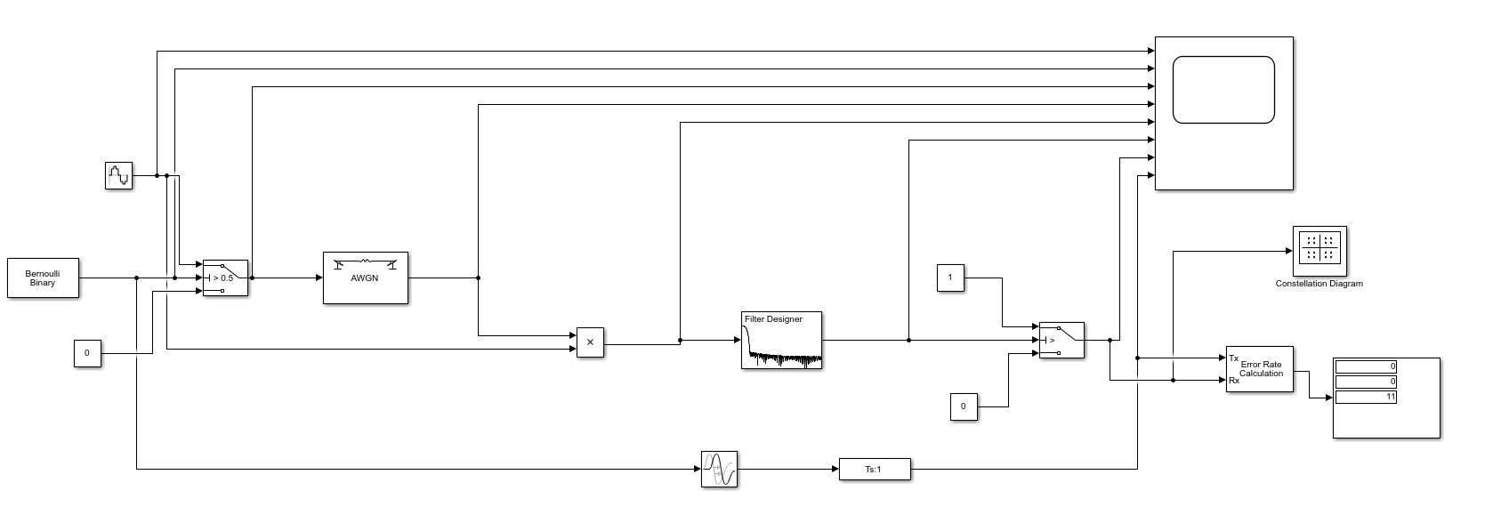
Figure 1

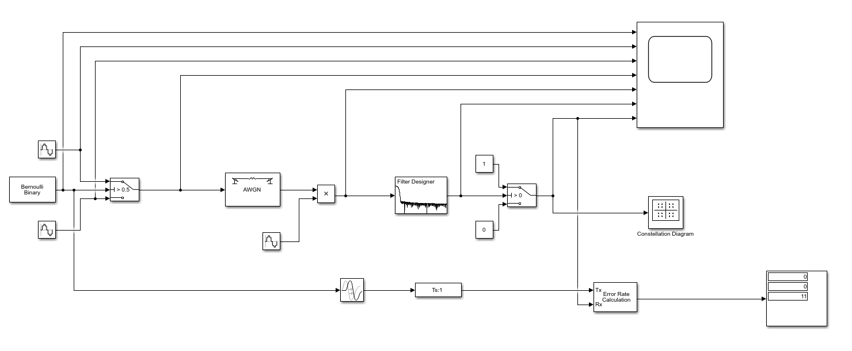
Figure 2

QPSK & QAM modelling
The QPSK and QAM models had the same input of a Bernoulli binary generator input and BER calculator as ASK and PSK. However, the modulation and demodulation were carried out using predefined blocks within Simulink. These blocks automatically modulate or demodulate the signal into or out of the required data transfer technique. It is possible to manually model these modulators and demodulators. An attempt to model QPS was made as shown in Figure 4 however the predefined block was used to generate the results.

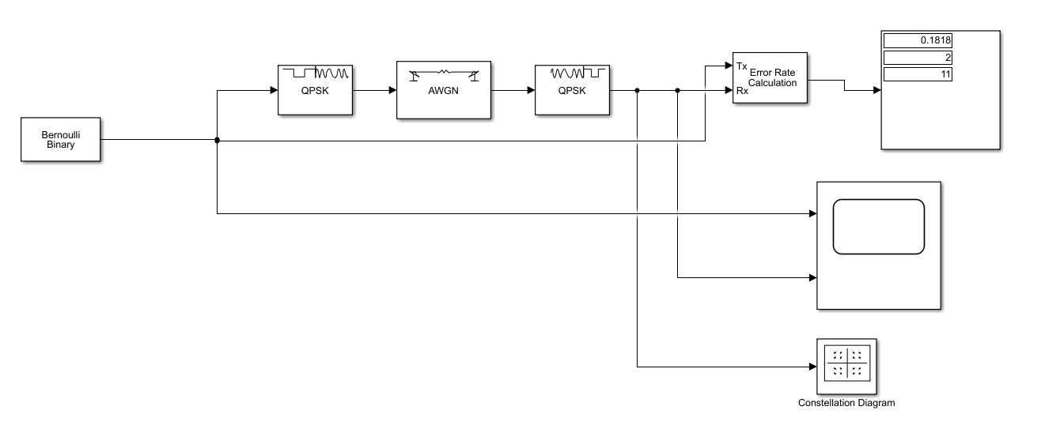
Figure 3

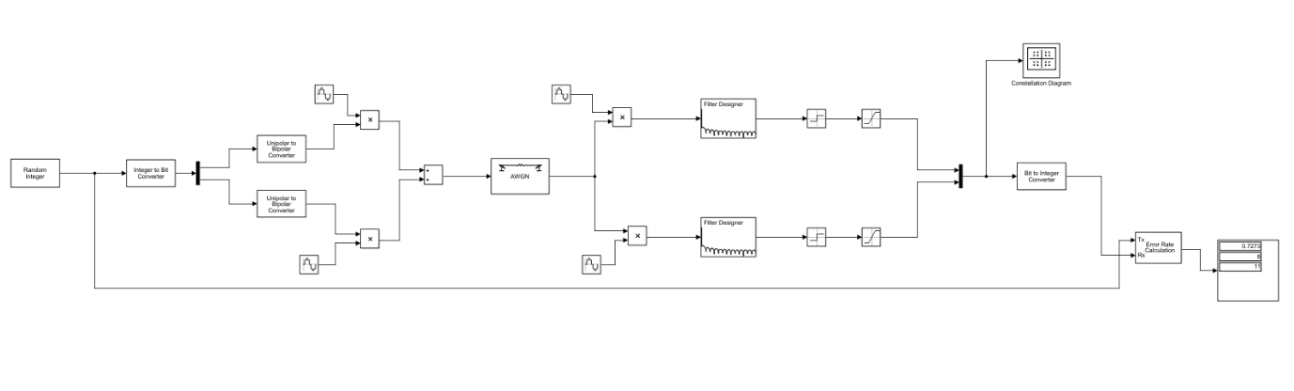
Figure 4

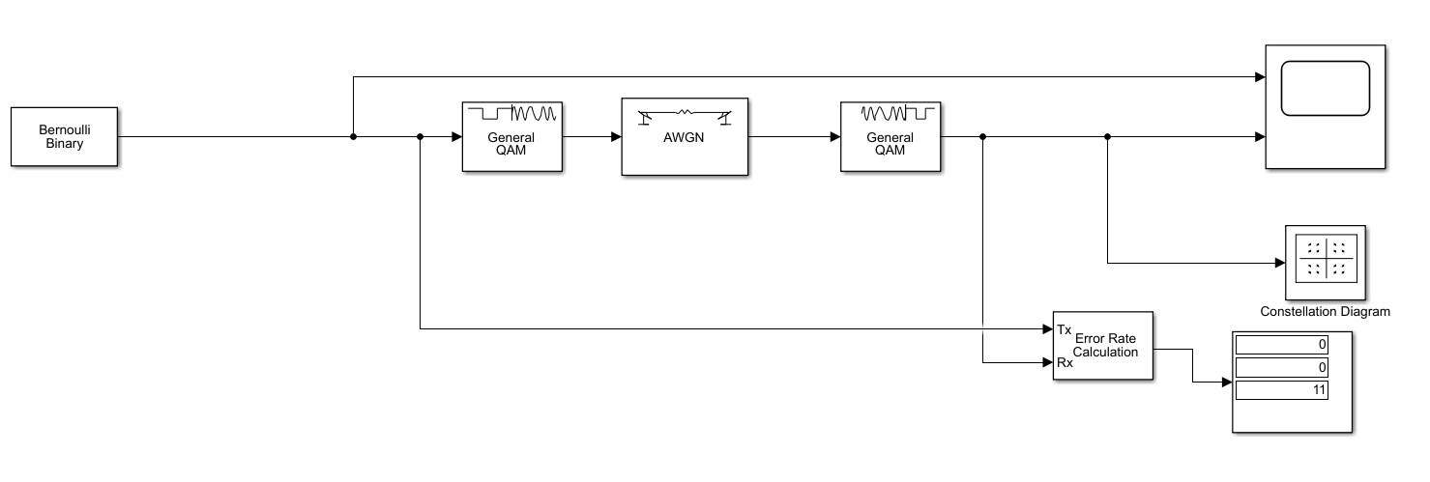
Figure 5

Constellation diagrams

A constellation diagram is a graphical representation of a digital signal. The data is shown on a constellation diagram as a phase and magnitude. The greater the number of points on the diagram the more data the system can transmit. However, as the points on the constellation diagram increase as does the chance of noise interfering with the signal. [9]

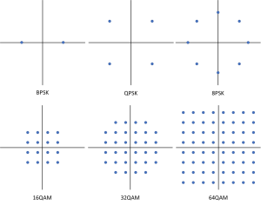
Figure 6

Results

Table 2 shows the average bit error rate for each of the models against varying levels of noise. Figure 7 shows a graph of the results.

noise | ASK | PSK | QPSK | QAM
15 | 0 | 0 | 0 | 0
10 | 0 | 0 | 0 | 0
8 | 0 | 0 | 0 | 0.090909
7 | 0 | 0 | 0 | 0.109091
6 | 0 | 0 | 0 | 0.109091
5 | 0 | 0 | 0 | 0.109091
4 | 0 | 0 | 0 | 0.172727
3 | 0 | 0 | 0.036364 | 0.236364
2 | 0 | 0 | 0.109091 | 0.327273
1 | 0 | 0 | 0.127273 | 0.418182
0 | 0.018182 | 0 | 0.163636 | 0.418182
-1 | 0 | 0 | 0.2 | 0.436364
-2 | 0 | 0 | 0.236364 | 0.636364
-3 | 0 | 0 | 0.181818 | 0.663636
-4 | 0 | 0 | 0.190909 | 0.672727
-5 | 0.2 | 0 | 0.281818 | 0.672727
-6 | 0 | 0 | 0.4 | 0.7
-7 | 0 | 0.045455 | 0.527273 | 0.718182
-8 | 0 | 0.045455 | 0.581818 | 0.736364
-10 | 0.236364 | 0.163636 | 0.590909 | 0.790909
-15 | 0.245455 | 0.254545 | 0.645455 | 0.9
-20 | 0.427273 | 0.327273 | 0.718182 | 0.9
-25 | 0.463636 | 0.454545 | 0.727273 | 0.9
-30 | 0.390909 | 0.472727 | 0.836364 | 0.9
-35 | 0.554545 | 0.327273 | 0.872727 | 0.909091
-40 | 0.6 | 0.445455 | 0.872727 | 0.927273
Table 2

Figure 7

The following figures show the constellation diagram for the ASK, PSK, QPSK and QAM models.

ASK
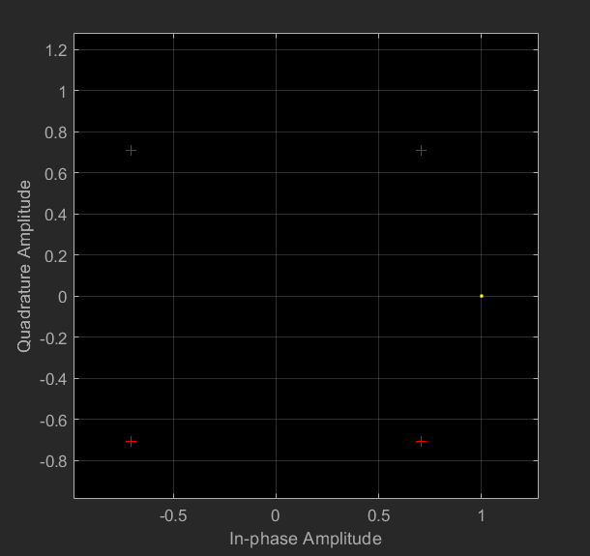
Figure 8

PSK
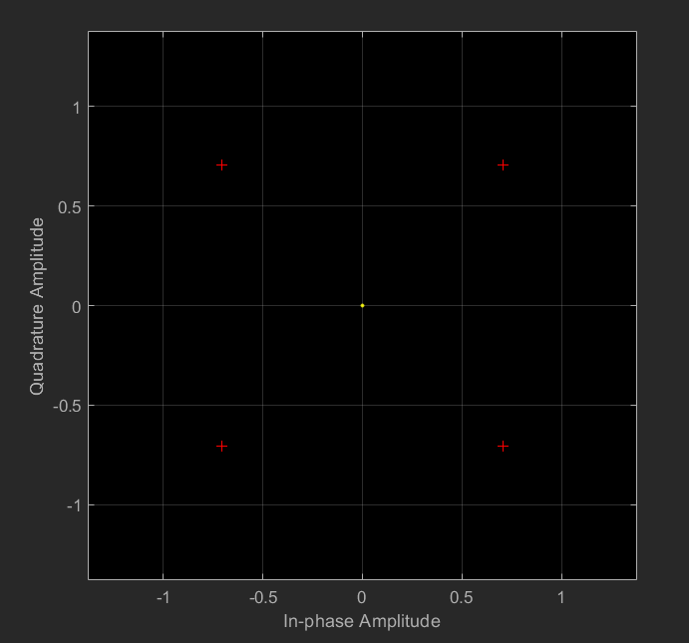
Figure 9

QPSK
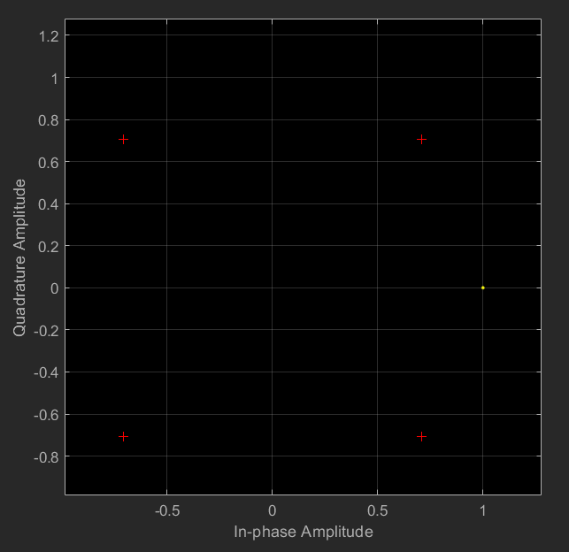
Figure 10

QAM

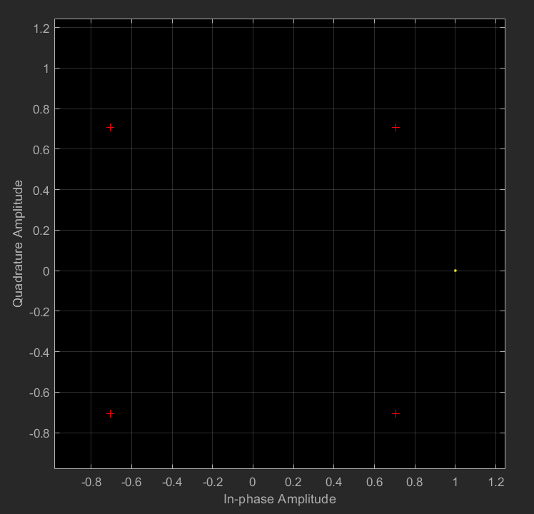
Figure 11

Discussion

The results shown in Table 2 show that none of the systems are greatly affected by AWGN in the positive domain. QAM is the only system affected by positive noise with it failing just below zero at negative 2. ASK had errors at zero and negative 5, these are spurious readings and can be disregarded as all other runs around those noise values show as zero errors. Figure 7 shows the signal to noise ratio of all the models. The graph shows that QPSK and QAM fail catastrophically after -7db and -2db. These failures are due to the extra data being transmitted per bit, as there are more symbols per bit the phase shifts are closer together making it easier for noise to interrupt the signal.
Figures 8 - 11 show the constellation diagrams for each of the models. Each diagram only shows one point however more points should be shown. The correct constellation diagrams are shown in Figure 6 and this is what was expected. There could be several reasons the diagrams aren’t showing the points correctly.
As these simulations were run in Simulink the results could vary if these modulation techniques were used in a real-world situation. They give a good general idea of the operating ranges of each technique, but this can change in the real world.

Conclusion

All four modulation techniques are affected by varying amounts of noise. From the graph shown in Figure 7 ASK and PSK are subject to noise however do not fail as badly as QPSK and QAM. From this graph we can see that ASK and PSK have an operating range of negative eight into the positive domain, this can be used to define what the techniques are used for. With QAM and QPSK they can transmit more data per symbol but are much more susceptible to noise than ASK and PSK. This means that QPSK and QAM from these simulations can only be used where there will noise above zero. Although other methods can be used to create QPSK and QAM they are beyond the scope of this report.

Bibliography

[1] | OU, “1.6 Phase-shift keying (PSK),” OU, 2020. [Online]. Available: https://www.open.edu/openlearn/science-maths-technology/exploring-communications-technology/content-section-1.6. [Accessed 09 12 2020].
[2] | tutorialspoint, “digital communication phase shift keying,” tutorialspoint, 2020. [Online]. Available: https://www.tutorialspoint.com/digital_communication/digital_communication_phase_shift_keying.htm. [Accessed 09 12 2020].
[3] | a. a. circuits, “digital phase modulation,” all about circuits, 2020. [Online]. Available: https://www.allaboutcircuits.com/textbook/radio-frequency-analysis-design/radio-frequency-modulation/digital-phase-modulation-bpsk-qpsk-dqpsk/. [Accessed 10 12 2020].
[4] | S. Mosey, advanced digital modulation, Swansea: UWTSD, 2020.
[5] | M. G. Sadeque, “Bit Error Rate (BER) Comparison of AWGN Channels for Different Type’s Digital Modulation Using MATLAB Simulink,” American Scientific Research Journal for Engineering, Technology, and Sciences (ASRJETS) (2015) , , vol. Volume 13, pp. No 1, pp 61-71, 2015.
[6] | noisecom, “what-is-awgn,” noisecom, 2020. [Online]. Available: https://www.noisecom.com/resource-library/articles/artmid/1867/articleid/1233/what-is-awgn. [Accessed 14 12 2020].
[7] | N. K. a. L. Kansal, “Performance Comparison of MIMO Systems over AWGN and Rician Channels with Zero Forcing reciviers,” International Journal of Wireless & Mobile Networks (IJWMN), vol. Vol. 5, no. 1, February 2013.
[8] | M. A. R. P. P. Subrato Bharati, “Implementation of ASK, FSK and PSK with BER,” Department of EEE, Ranada Prasad Shaha University,, Bangladesh, Unknown.
[9] | nuwaves, “constellation-diagrams,” nuwaves, 2020. [Online]. Available: https://www.nuwaves.com/2019/07/constellation-diagrams/. [Accessed 16 12 2020].

