Domestic Construction Today; Design and Performance
Technology and Environment (M4X01974)
Keiran Thomas (1650739)
1000 words

Within this report is a reflective analysis of the group project and design regarding the Welsh national police memorial commissioned by the South Wales police through individual merit and group participation.

- Brief

The brief, in which was specific to the representation of the South Wales police was to emphasise the contribution and sacrifice of the police force in an impactful, emotional way. Holistic design is essential for the design process to represent a form that is cogent for the viewer that has a stimulating and inspirational message of perseverance and sacrifice. The form will be approximately 1200mm to 1800mm in height placed on a 1800mm diameter plinth of a 250mm height. Materials sourced from Wales also are mentioned for a coherent representation of the Welsh community, in which the Welsh police protects. Durable, yet low maintenance materials are required as the memorial needs to maintain presentability at all times located within Cathay Park, Cardiff.

- Site Analysis

Cathays park, located in Cardiff city centre is a prominent area of grandeur and cultural significance, Located here are the prominent architectural sites such as the City Hall, Law Courts and National Museum. It is unusual for a city to present such prominent nature close to significant buildings. Also a place of peace and tranquility.

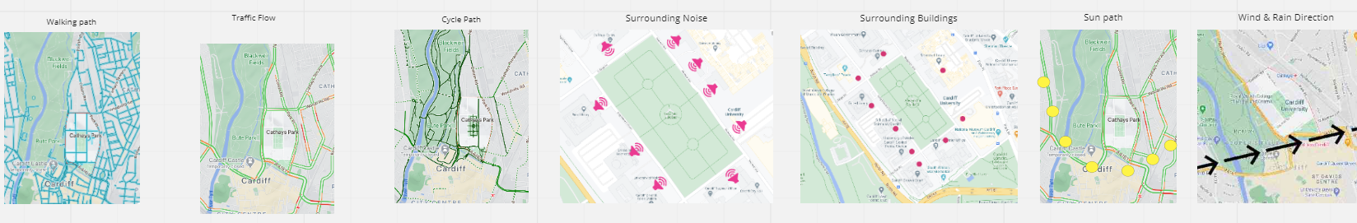
- Precedents

The precedent studies I personally put forward to show a range of interpretations of monumental design from simple forms that convey emotion to more deliberate bold expressions to represent a cause or death. New York AIDS Memorial by Studio a+i (2016) National Holocaust Monument by Studio Libeskind, located in Ottawa, Canada, (2017) National Monmument for peace and justice by MASS design group Montogramy Alablbam (2019) and the Le Mémorial des Martyrs by Adjaye Associate Architects. Located in Niamey, Niger. (2020). What these designs represent is a deconstivre nature in which simple forms and shapes can be interpreted differently and express different emotional values.

- Concept Development

In the design concept stage many ideas were suggested and influenced around the group through precedent research. From a personal perspective I wanted to include non traditional monumental designs as a conceptual idea as monuments should not conform to one particular way of design in my personal opinion as every monument has a different meaning and individuality to them. However, the brief was quite specific to what the client wanted to express, so my initial thoughts had to be toned down a bit to meet the clients needs, as every good designer should listen and interpret the brief creatively but also respectfully of the client. I am personally influenced through architects such as Zaha Hadid, Daniel Libeskind and Bjark Ingels; the innovative nature they represent through deconstructivism and influence in modern architecture is something I am inspired to uphold within my designs and concepts. However being in a group, other design proposals could be considered and integrated with my own ideas and thoughts.

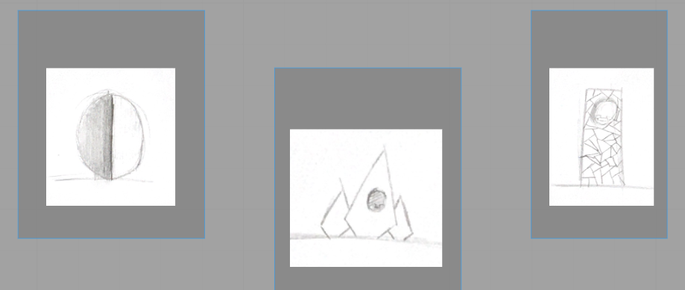

- Materiality Choices

The materiality choices considered for the memorial are extremely influential in expressing the formality of the form and a positive representation of the police force. The materials chosen for analysis are of Welsh origin, the benefits of this are the support of local businesses, reducing import and the carbon footprint of such materials, as well as emphasising the sense of community and patriotism. This analysis allows us to assess the juxtaposition of the memorial within the park, relating to aesthetic details and also the benefits and disadvantages of each material requirement of the brief. After much consideration as a group, the elemental materials Welsh slate, stone, and glass have been chosen. The Welsh slate will be utilized for the plinth to create a sophisticated and monochromatic aesthetic that represents the protection and support the Welsh police department provides. In addition to the slate, stone provides an appearance of strength, the light grey overtone of the stone suggests an elegant yet proud aesthetic. The glass will represent the monument within the structure as the clear fragility of sacrifice. This represents a certain vulnerability in which it is needed to empower, not just the police force but the public themselves. The juxtaposition within the design between the bold stone and slate, visually comes together as a whole piece of architectural integrity with modern design principles. A certain deconstructed nature to the design helps distinguish the potential shapes the viewer will see resulting in the integrated form of police protection. In conclusion, Welsh slate is abundantly a stable and durable material which is non fading and can have different finishes. Also fire resistant which has the potential to be resistant to vandalism as well. Environmentally friendly which is substantial when designing current architectural forms. Welsh stone is as above and also can fade through sun and time. Safety glass for the emblem is strong, safe and resistant to heat. But cannot be removed after installation.

- Final Design Outcome

Through group discussion and process of elimination the final design was chosen. The final design consists of an oval deconstructed into two that are connected by the police crest in the center. The conceptualization through the materials used to represent those as a unity. The design, through deconstructed form emphasises cupped hands for protection, the form can also be seen as as wings of a bird symbolic of freedom and peace. In addition the group discussed a third meaning of how the glass emblem is protected by the two arches, in the same way the ribs protect the heart, this high concept idea is used to show that the police are both the heart of the community and protect the community. The representation and meaning behind the design are thought provoking towards the viewers perception in which good architecture should be represented. There are an infinite number of possibilities and meaning behind the design which can intrigue and provoke thought and questions of what the police force can represent.

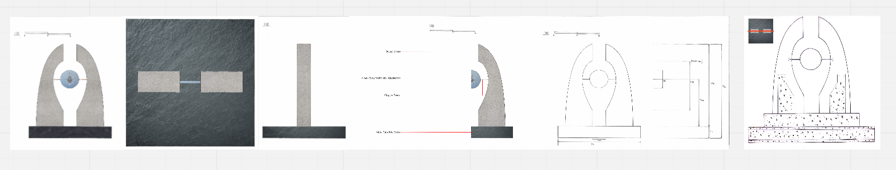

In conclusion I believe the design outcome was a success and would be aesthetically convincing towards the police and the general public. In regards to the personal and outward meanings of the mommonent I think the success of emotion and significant prominence of sacrifice within the police force is met here and will challenge the viewers own personal emotions of how we are all a community that is safe though police presence.

