University of Wales Trinity Saint David
School of Engineering
Log Book
Ainsley Martin
P149894
23/04/2018

Contents
Session 1 3
Session 2 5
Session 3 7
Session 4 9
Session 5 11
Session 6 15
Session 7 17
Session 8 20
Session 9 23
Session 10 25
Session 11 27
Session 12 30
Session 13 32
Personal Skills Evaluation 34

Session 1
Lathe – Gareth Staddon 10/10/17
2pm-4pm
MTB04
Aims
Introduction to the equipment in the workshop, the health and safety rules for the workshop and any procedures that need to be followed when in the workshop.

PPE
Steel toe capped shoes and dust coats must always be worn when in the workshop. When working with any machines or cutting tools safety goggles must be worn to protect the eyes. Pull strings on jumpers or trousers must be tied up or tucked away to avoid them getting caught in a machine. Barrier cream should be applied before working with metal to prevent against dermatitis.

Health and safety
Workshop health and safety rules must be followed at all times. Any issues that may come up should be reported to an instructor.

Task
An aluminium cylinder was handed out as was the engineering design for the final product. First the height of the cylinder had to be measured using a digital height gauge. The gauge first had to be zeroed and then the height was measured. The material started off at 106.50mm and had to be cut down to 105mm as specified in the engineering design. To do this the material is placed into the lathe and locked in place using the chuck. The cutting tool is placed on the edge of the material and the z axis is set to the height of the material (106.50mm). The material is cut until the computer reads 105.50mm. It is then removed from the lathe and remeasured to make sure the correct amount has been cut off. If the reading is different the material is placed back into the lathe and the cutting tool touches the edge of the material. The computer is set to the remeasurement of the cylinder and material is taken off until it reaches the desired length (105mm). The material can be removed and remeasured during this process to ensure that it gets cut to the correct length. The final measurement ends up being 105.02mm which is within the given 0.2mm tolerance.

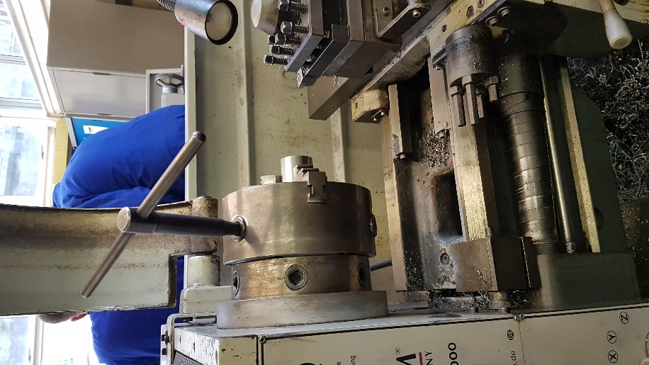
Pictures
Figure 2 - First height measurement
Figure 3 - Lathe face off
Figure 1 - Engineering design for lathe

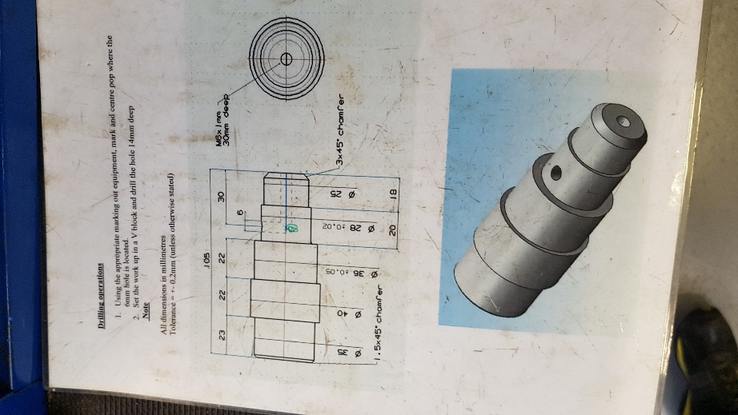
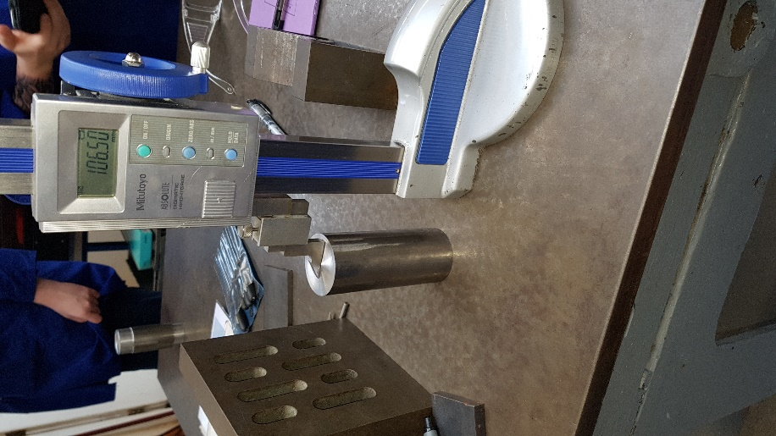
Figure 4 – Lathe computer
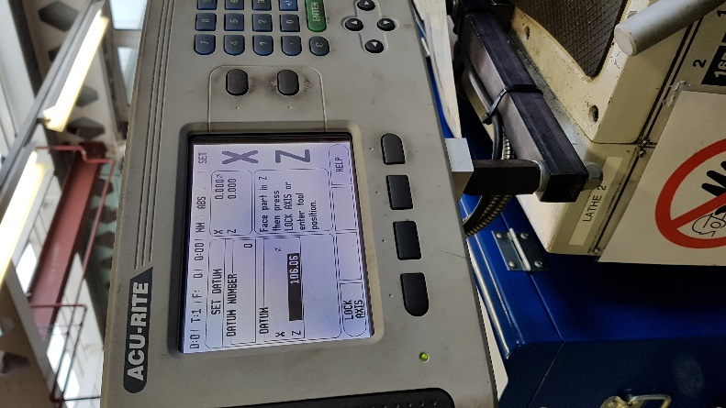
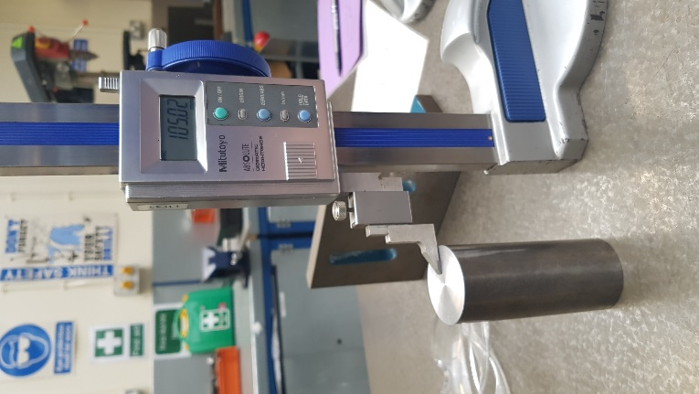

Figure 5 – Final height measurement

Session 2

Lathe – Gareth Staddon 17/10/17
2pm-4pm
MTB04
Aims
Get the 35mm diameter cut done

PPE
Steel toe capped shoes and dust coats must always be worn when in the workshop. When working with any machines or cutting tools safety goggles must be worn to protect the eyes. Pull strings on jumpers or trousers must be tied up or tucked away to avoid them getting caught in a machine. Barrier cream should be applied before working with metal to prevent against dermatitis.

Health and safety
Workshop health and safety rules must be followed at all times. Any issues that may come up should be reported to an instructor.

Task
The diameter of the cylinder is measured using a micrometre. For the first cut the diameter should be 35mm and it should be 23mm long. The cylinder is placed in the lathe and the cutting tool is placed against the edge of the cylinder. The x axis on the lathes computer is set to the diameter of the cylinder (in this case 38.99mm) and the z axis is set to 23mm (the desired length of the cut). Set the lathe so it will take off 0.5mm from the x axis and then cut along the z axis until the computer has the z axis at 0.05mm. Continue to do this until the x axis reads 36mm. Remove the cylinder and remeasure the diameter using the micrometre. Also use a height gauge and zero it on the top of cylinder on the side that is being cut. Then lower the height gauge to the lip that has been cut to check the correct amount of material has been removed. Place the material back into the lathe and update the computer with the corrected x measurement. Remove 0.2mm until the x axis reads 35mm. The cylinder can be removed and remeasured during the final cuts to ensure accurate cutting. Once the cut is at 35mm take the z axis to the end and touch the lip that has been created at 23mm to remove excess material at the end.

Photos
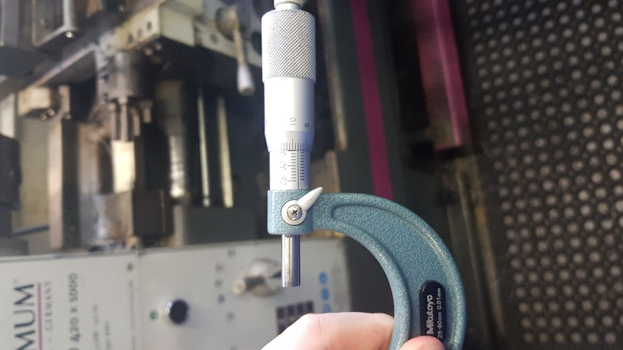
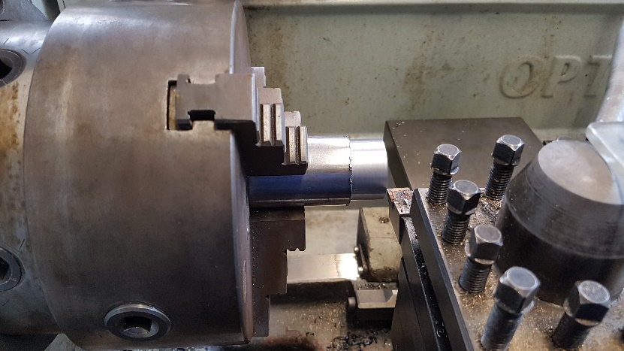
Figure 6 – 35mm cut

Figure 7 - Micrometre
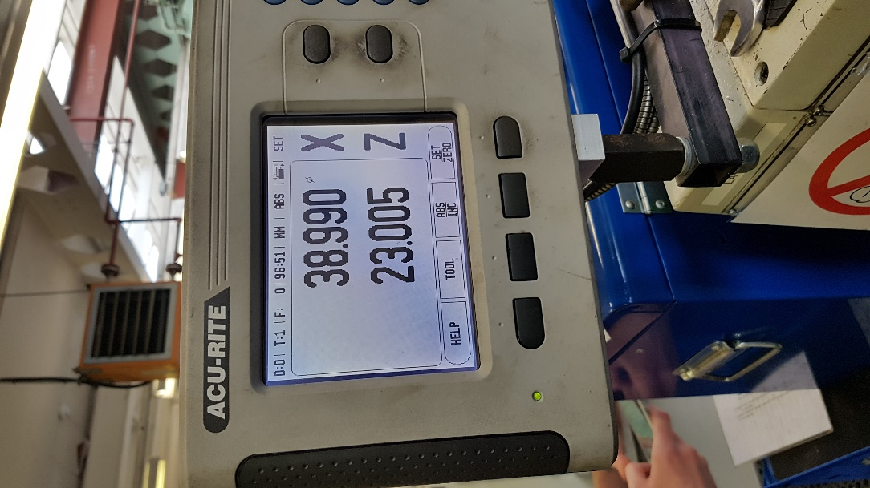
Figure 8 – Lathe computer

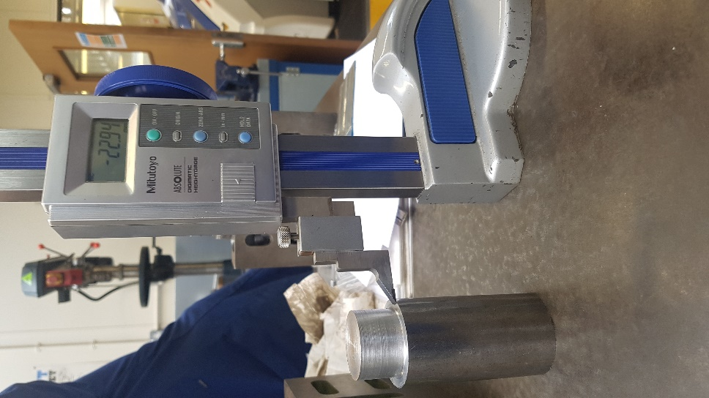
Figure 9 – Height gauge for 35mm

Session 3

Lathe – Gareth Staddon 24/10/17
2pm-4pm
MTB04
Aims
Create the ‘island’ part of the cylinder
Cut a centre hole

PPE
Steel toe capped shoes and dust coats must always be worn when in the workshop. When working with any machines or cutting tools safety goggles must be worn to protect the eyes. Pull strings on jumpers or trousers must be tied up or tucked away to avoid them getting caught in a machine. Barrier cream should be applied before working with metal to prevent against dermatitis.

Health and safety
Workshop health and safety rules must be followed at all times. Any issues that may come up should be reported to an instructor.

Task
To create the centre hole a Jacobs chuck is used. First the cylinder is placed in the lathe and the Jacobs chuck with the drill bit inserted is placed near the cylinder. The chuck is then inserted slightly into the cylinder to create the centre hole. This can then be used to hold the cylinder while it is being cut by the lathe.
To create the island in the diameter is first measured to know how much material to take off. It is then inserted into the lathe and a Jacobs chuck is used at the other end to give strength to the material as it is being cut. The required dimensions are put into the computer and the dimensions are taken down to the required amount, while measuring between to check the correct amount of material is being taken off.

Problems
The lathe was found to be off centre which resulted in a cutting error of 0.1mm. This shows how important it is to measure the piece multiple times during the cutting process as it can pick up errors such as this one.
The cutting tip was also found out to be wearing out and was replaced with a new tip to provide a better finish.

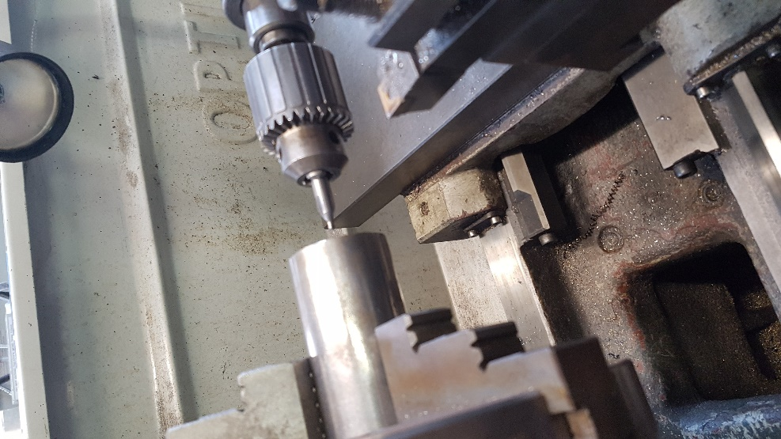
Photos
Figure 10 – Drilling centre hole

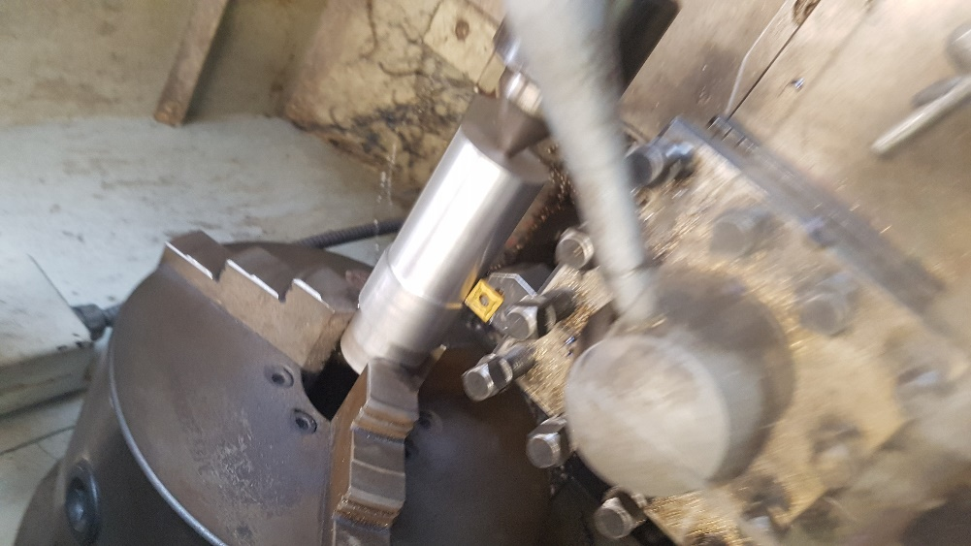
Figure 11 – Using Jacobs chuck to support cylinder

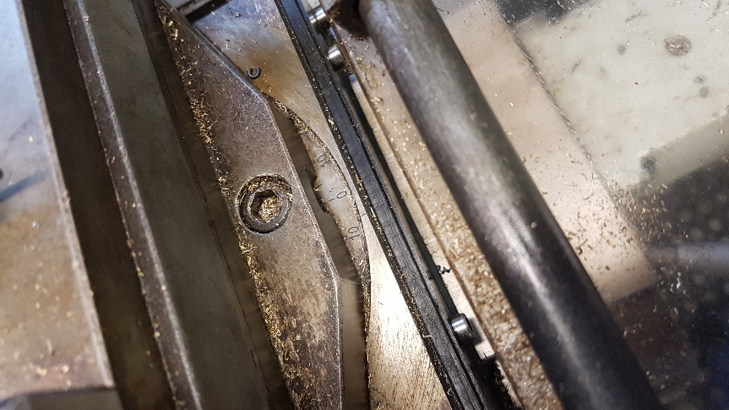
Figure 12 – Lathe off centre

Session 4

Lathe – Gareth Staddon 31/10/17
2pm-4pm
MTB04
Aims
Cut the 36mm, 28mm and 25mm sections of the cylinder

PPE
Steel toe capped shoes and dust coats must always be worn when in the workshop. When working with any machines or cutting tools safety goggles must be worn to protect the eyes. Pull strings on jumpers or trousers must be tied up or tucked away to avoid them getting caught in a machine. Barrier cream should be applied before working with metal to prevent against dermatitis.

Health and safety
Workshop health and safety rules must be followed at all times. Any issues that may come up should be reported to an instructor.

Task
Measure the diameter of the section of the cylinder that is going to get cut so it can be placed in the computer. The cutting tool is placed against the edge of the cylinder and the measured diameter is inputted in the computer as the x axis and 60mm is input as the z axis as this is how long the first cut should be from the side that hasn’t been cut yet. Material is taken off 1mm at a time until the x axis reads 37mm. Remove the cylinder and measure the diameter to make sure the computer is reading correctly. Place the cylinder back into the lathe and enter the updated dimensions into the computer. Start removing 0.2mm off the x axis until the computer reads 36mm on the x axis. (The cylinder can be removed and measured during this process). Remove the cylinder and do a final measurement. To remove the lip that has been created place the cylinder back into the lathe and touch the edge of the cylinder with the cutting tool, move it down to the z axis and lightly touch the lip that has been created to remove it.
To create the 28mm diameter section the same process from the previous step is repeated, however this time the x axis should end up at 28mm and the z axis should be set to 38mm.
To create the 25mm diameter section the same process is again repeated, this time the x axis should end up at 25mm and the z axis should be set at 18mm as specified in the engineering design.

Photos

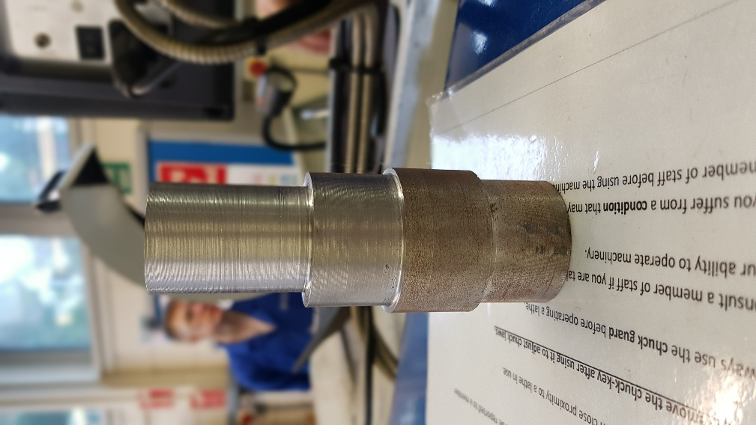
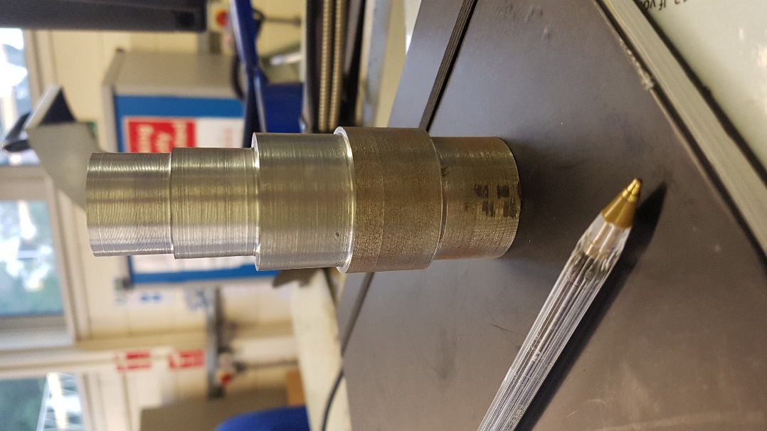
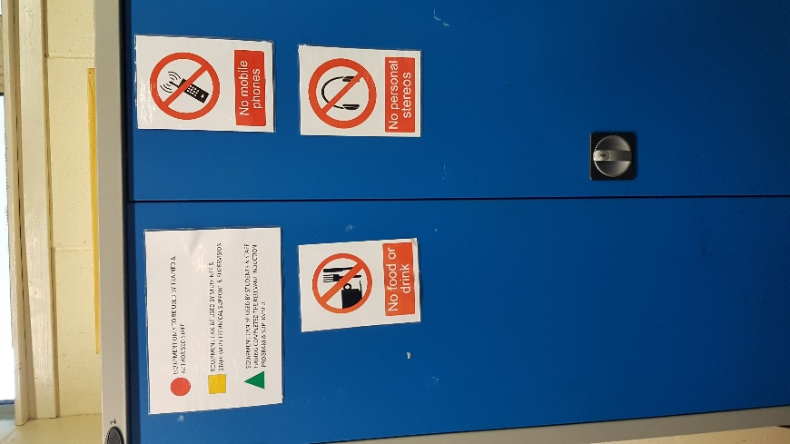
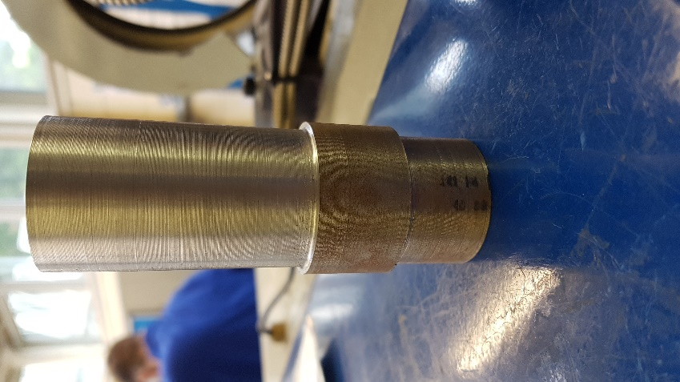
Figure 15 – 28mm cut
Figure 16 – 25mm cut
Figure 13 – Health and safety warnings
Figure 14 – 36mm cut

Session 5

Lathe – Gareth Staddon 14/11/17
2pm-4pm
MTB04
Aims
Cut the chamfer
Cut the centre hole
Cut the 6mm hole, tap the 6mm hole

PPE
Steel toe capped shoes and dust coats must always be worn when in the workshop. When working with any machines or cutting tools safety goggles must be worn to protect the eyes. Pull strings on jumpers or trousers must be tied up or tucked away to avoid them getting caught in a machine. Barrier cream should be applied before working with metal to prevent against dermatitis.

Health and safety
Workshop health and safety rules must be followed at all times. Any issues that may come up should be reported to an instructor.

Task
To create the 3x45° chamfer on the angle cutting tool is set to 45°. The compound slide is used to set the angle. Touch the face of the cylinder with the cutting tool and set the computer to 0. Use the Jacobs chuck to give the cylinder extra strength when being cut. Take off small amounts of material until the cut is at 3mm. To create the 1x45° chamfer cut the same process is repeated, however this time only 1mm of material is taken off which creates a smaller chamfer.
To cut the centre hole first return the lathe to 0°. Replace the Jacobs chuck with a 5mm bit (as the hole is m6 x1). Place the drill bit against the edge of the cylinder and set the z axis to 30mm as this is how deep the hole should be. Slowly start to insert the drill bit, if this is done too quickly the drill bit can snap inside the cylinder. When there starts to be resistance on the drill bit pull the drill bit out of the cylinder and some excess material should fall out. Repeat the process until the 30mm hole has been drilled.
To cut the 6mm hole a mark first needs to be made, to do this use a height gauge. Centre the gauge on the top of cylinder then move down 30mm from the top and use the height gauge to mark the cylinder at this height. This mark can be highlighted using a marker to make the cutting location more obvious. Use a hole punch and a hammer to make a relief hole in the cylinder where the hole should be cut. Place the cylinder in the pillar drill making sure the clamp is tight. Using a 6mm drill bit start drilling the hole in the cylinder. As with the centre drill if there is a strong resistance when drilling take the bit out of the cylinder and keep making small cuts in the cylinder until you break through to the centre hole. When this is done turn off the pillar drill and remove the cylinder from the clamp. Try to remove any excess material from the cut.

Problems
The holes could not be tapped due to running out of time. This would have to be done in the next session

Photos
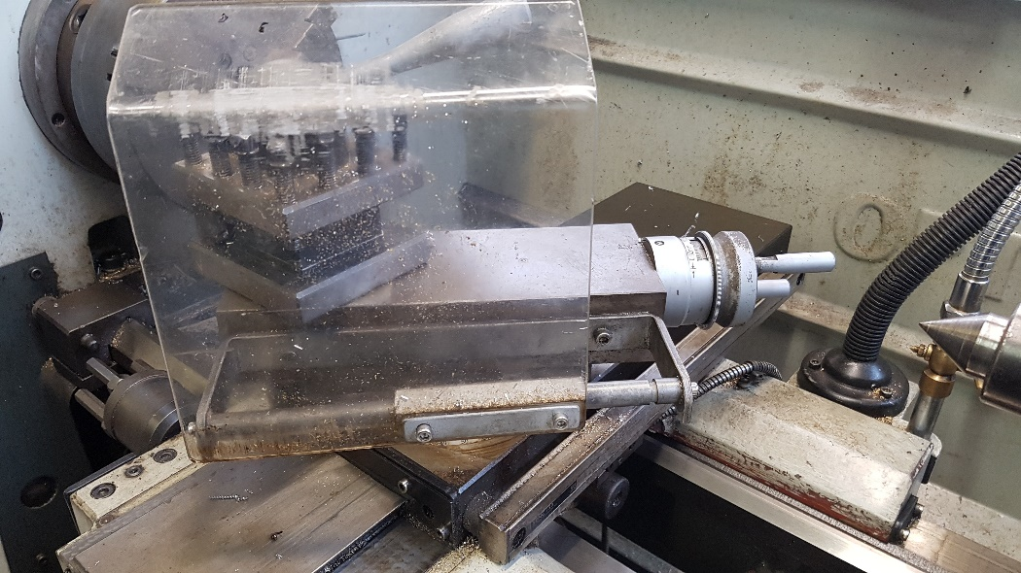
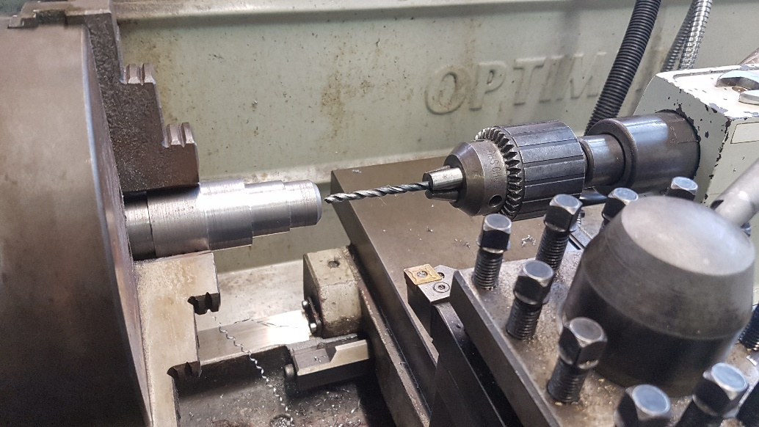
Figure 18 – Angling the lathe for the chamfer
Figure 17 – Drilling the centre hole
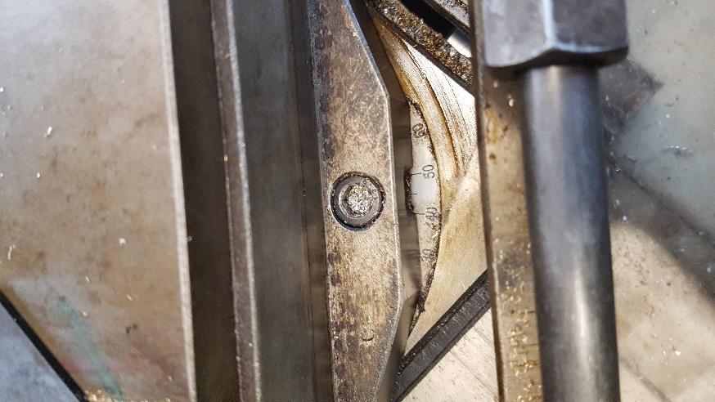
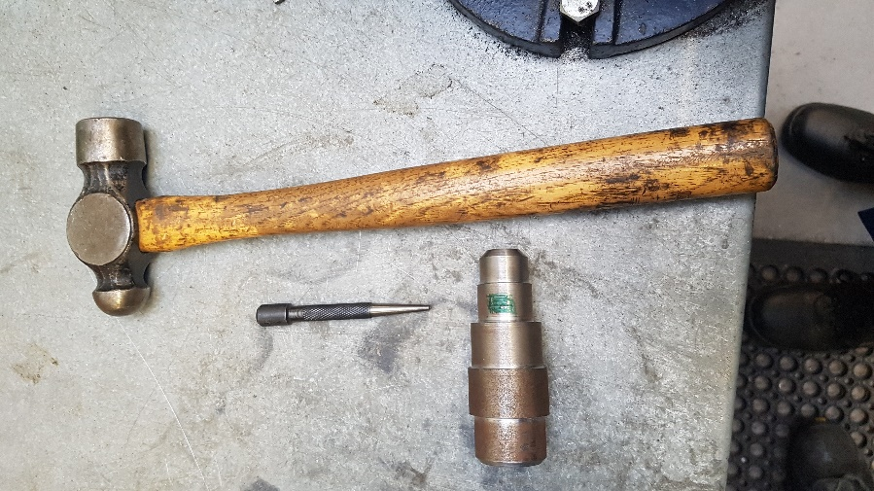
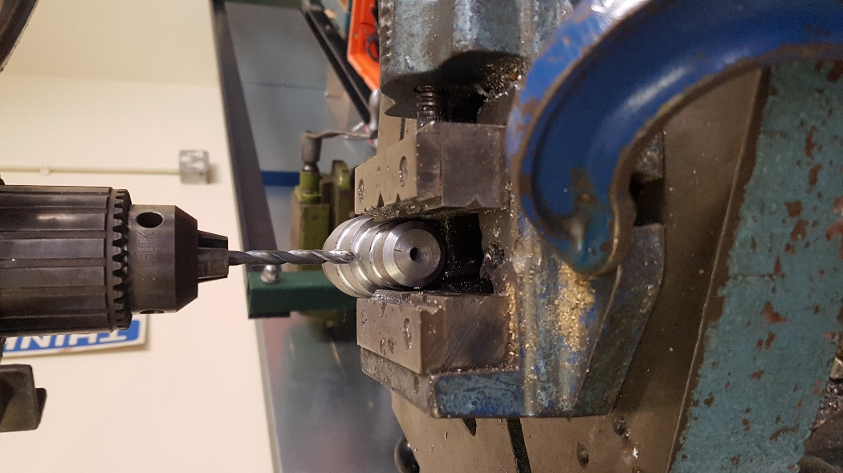
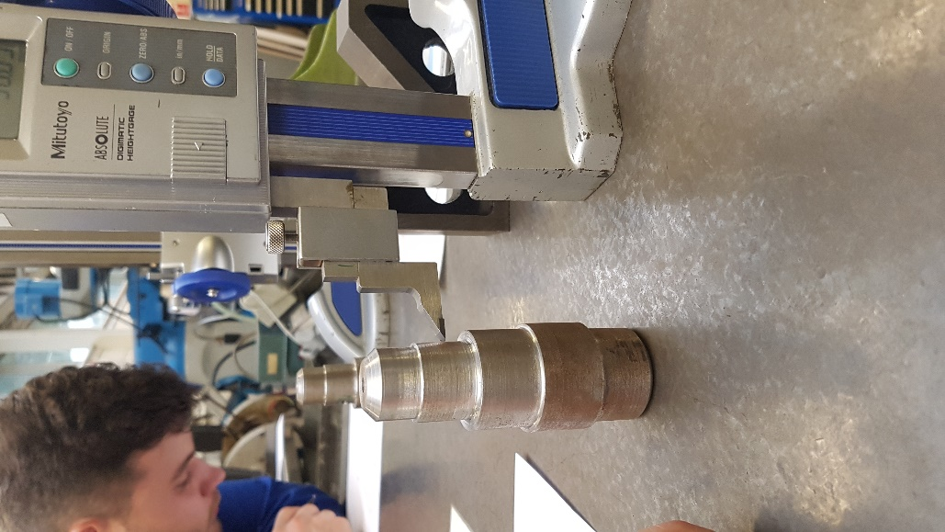
Figure 22 – Angle set for chamfer
Figure 20 – Tools needed for centre punch
Figure 21 – Drilling the 6mm hole
Figure 19 – Marking the 6mm hole

Session 6

Lathe – Gareth Staddon
Milling machine – Dave Cooper
21/11/17
2pm-4pm
MTB04
Aims
Tap the holes for the cylinder
Mark out the rectangle

PPE
Steel toe capped shoes and dust coats must always be worn when in the workshop. When working with any machines or cutting tools safety goggles must be worn to protect the eyes. Pull strings on jumpers or trousers must be tied up or tucked away to avoid them getting caught in a machine. Barrier cream should be applied before working with metal to prevent against dermatitis.

Health and safety
Workshop health and safety rules must be followed at all times. Any issues that may come up should be reported to an instructor.

Task
To tap the holes the cylinder is placed in the vice. The smallest bit is placed in the tap handle. The bit is placed on top of the hole and a small amount of metal working lubricant is placed around the bit and in the hole, the handle is then rotated clockwise while applying gentle pressure. This action is done until the tap bit has gone as far as it can go. The handle is then rotated anticlockwise with some pressure upwards to remove the bit from the hole. The smallest bit is then replaced with the medium sized bit and the process is repeated. Finally, the medium bit is replaced with the largest bit and the process is repeated a final time. Remove the cylinder from the vice and place it back in with the 6mm hole facing upwards. Repeat the process with the 6mm hole.
To mark out the rectangle place the rectangle against a flat surface to make sure it is straight and use a height gauge to mark out the heights given in the engineering design. Where 2 lines cross use a hole punch and a hammer to make a relief hole where the holes will be cut as it will make them easier to be drilled as well as making where the hole should be cut easier to see.

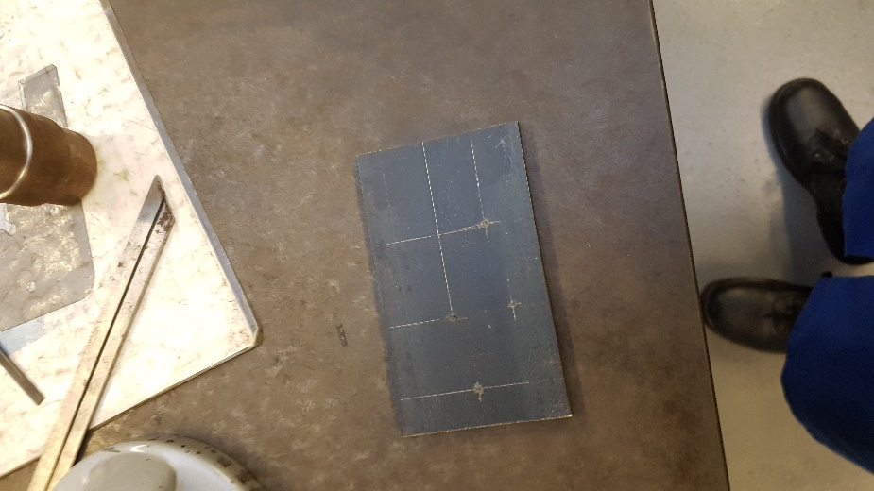
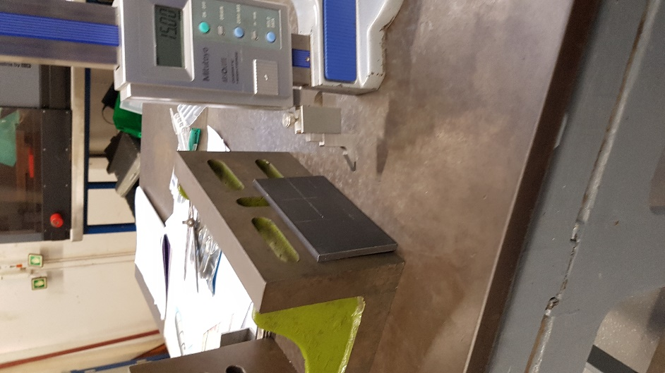
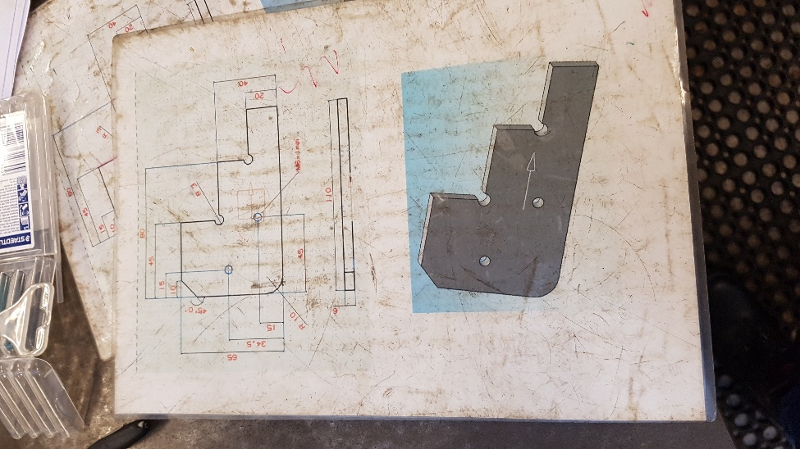
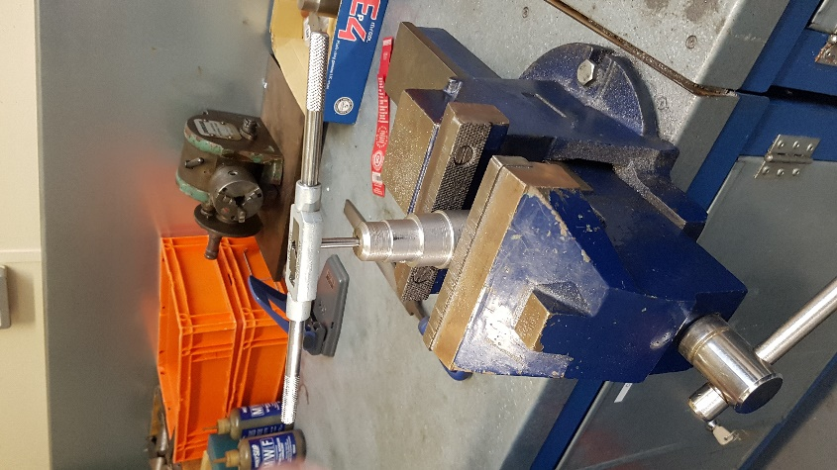
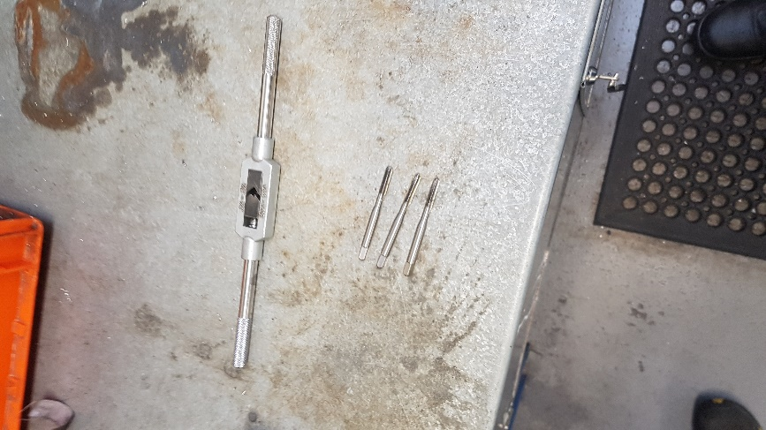
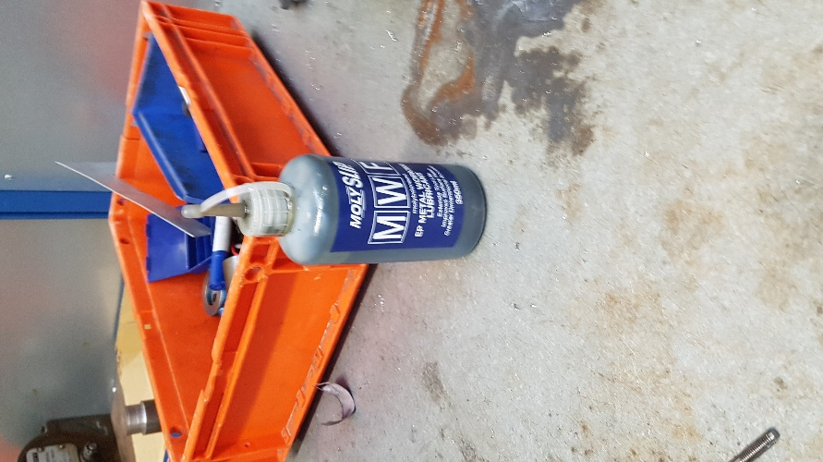
Photos
Figure 28 – Final markings on the rectangle
Figure 27 – Marking the rectangle
Figure 26 – Rectangle engineering drawing
Figure 25 – Tapping the hole in the cylinder
Figure 24 – Tap set
Figure 23 – Metal working lubricant

Session 7

Milling machine – Dave Cooper
28/11/17
2pm-4pm
MTB04
Aims
Drill out the holes
Tap the m6x1 holes
Start cutting the metal

PPE
Steel toe capped shoes and dust coats must always be worn when in the workshop. When working with any machines or cutting tools safety goggles must be worn to protect the eyes. Pull strings on jumpers or trousers must be tied up or tucked away to avoid them getting caught in a machine. Barrier cream should be applied before working with metal to prevent against dermatitis.

Health and safety
Workshop health and safety rules must be followed at all times. Any issues that may come up should be reported to an instructor.

Task
To fill the holes first place the rectangle in the vice on the pillar drill. Place a 2mm drill bit in the pillar drill to create a pilot hole. With the pillar drill turned off line up the drill bit up with the previously created relief hole. Turn the pillar drill on making sure the guard is down and drill all the way through the material. If you a drilling a r3 hole replace the drill bit with a 6mm drill bit, if you are drilling a m6x1 hole replace the drill bit with a 5mm drill bit. Make sure to complete one hole at a time, if you try and drill all the pilot holes then fully drill out all the holes it can compromise the integrity of the material. To replace the drill bit, loosen the bit using a chuck key, take it out and place the new bit in, then tighten using the chuck key. Once the drill bit has been replaced drill the hole using the larger bit. Repeat this process for the other 3 holes using the correct drill bit. If the drill bit size is unknown it can be checked using a Vernier calliper.
To tap the holes, place the rectangle in a vice horizontally. Place the smallest tap in the tap holder and hold the tap over the 5mm hole. Place some metal working lubricant inside the hole and around the tap to reduce the friction. Start twisting the handle clockwise and apply gentle pressure until the tap has gone all the way through the hole. To remove the tap, rotate the handle anticlockwise and gently pull. Replace the small tap with the medium size tap and repeat the process. Finally replace the medium sized tap with the largest tap and repeat the process. As there are 2 5mm holes this process has to be replaced again starting with the smallest tap and finishing with the largest tap.
To start cutting the rectangle place the rectangle in the vice vertically. Using a hack saw start cutting along the previously marked lines making sure not to apply too much press and letting the saw do the work as this will make the material easier to cut.

Photos

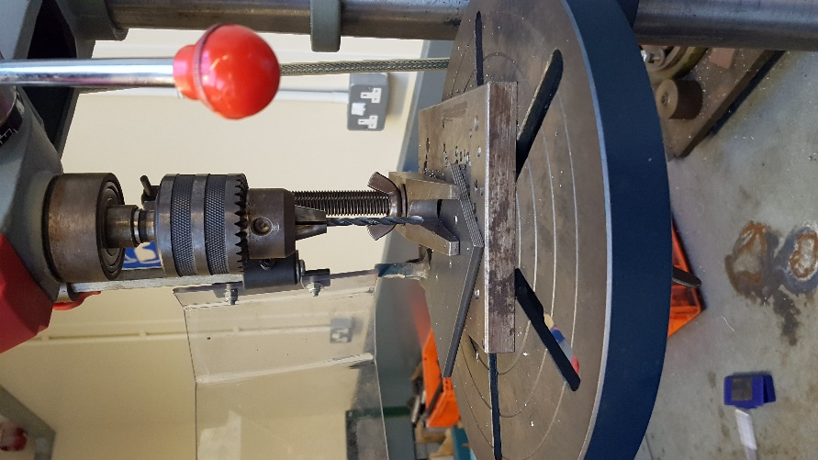
Figure 29 – Drilling the holes
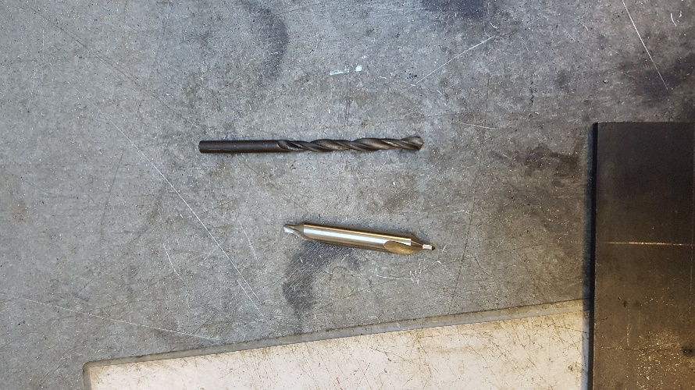
Figure 30 – Drill bits

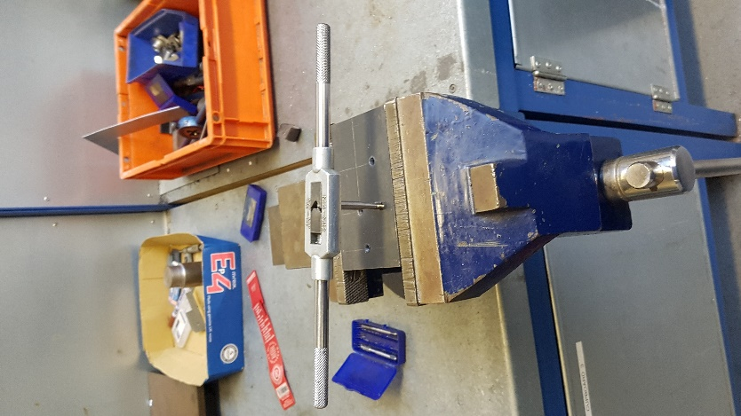

Figure 31 – Tapping the holes
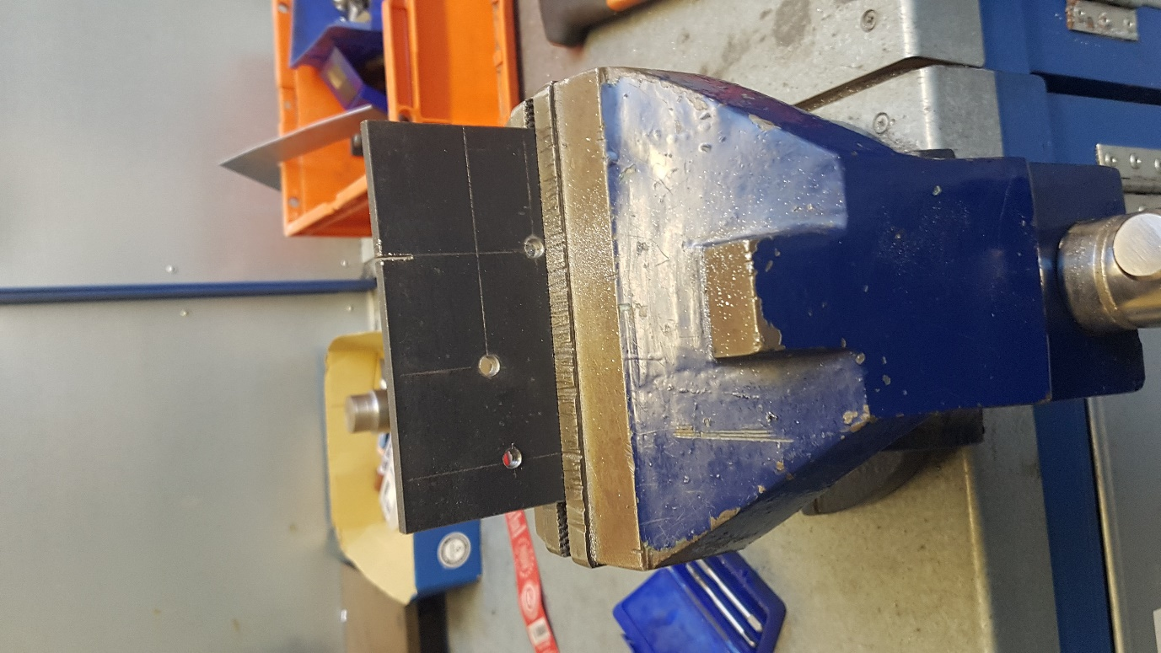
Figure 33 – Starting to cut the rectangle

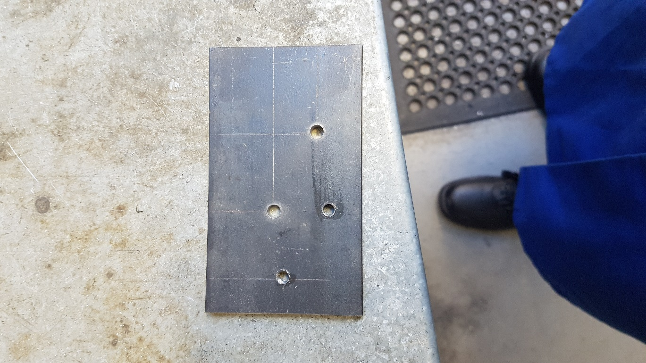
Figure 32 - The drilled holes

Session 8

Milling machine – Dave Cooper
05/12/17
2pm-4pm
MTB04
Aims
Finish cutting the material
Start using the milling machine

PPE
Steel toe capped shoes and dust coats must always be worn when in the workshop. When working with any machines or cutting tools safety goggles must be worn to protect the eyes. Pull strings on jumpers or trousers must be tied up or tucked away to avoid them getting caught in a machine. Barrier cream should be applied before working with metal to prevent against dermatitis.

Health and safety
Workshop health and safety rules must be followed at all times. Any issues that may come up should be reported to an instructor.

Task
To cut the material use a hacksaw, cut slightly past the line to account for the width of the saw blade. When the cutting has been finished use a file to trim the edges of the cuts, make them smooth to avoid getting cut when handling the material and make the cut more even.
To start using the milling machine first measure how much material needs to be taken off. Place the rectangle in the milling machines vice and tightly secure it. Touch the edge of the material with the cutting tool and set the x and z axis on the computer to 0 and set the y axis to how much material needs to be taken off. Start taking off 0.2mm off the y axis at a time until the y axis reaches 0. The rectangle can be removed and remeasured to make sure the correct amount of material is being removed.

Photos
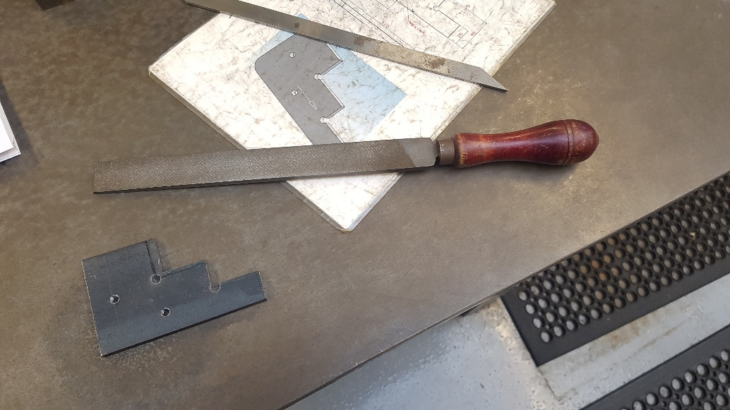
Figure 34 – The finished hacksaw cut and file

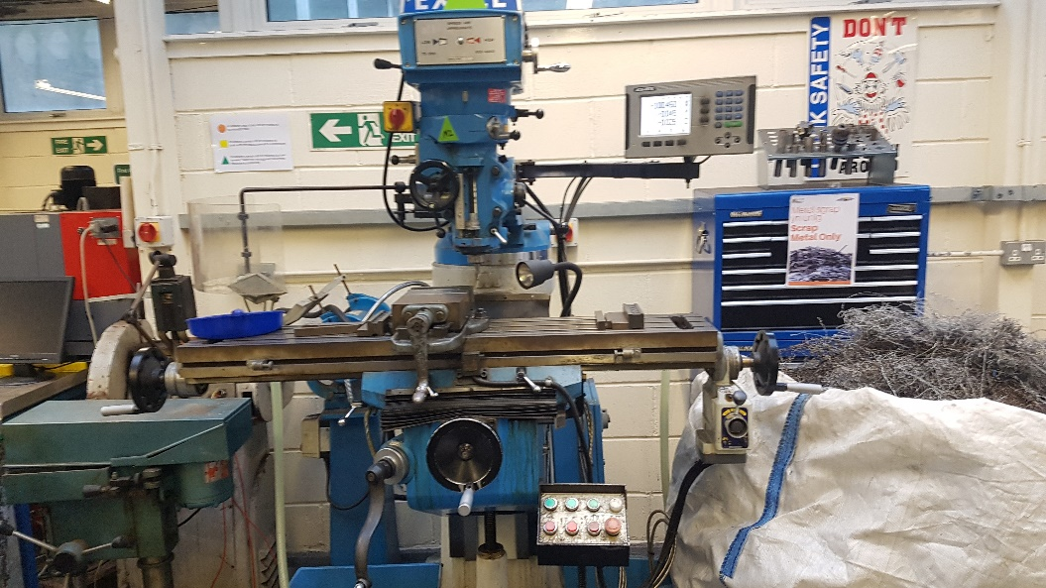
Figure 35 – Milling machine

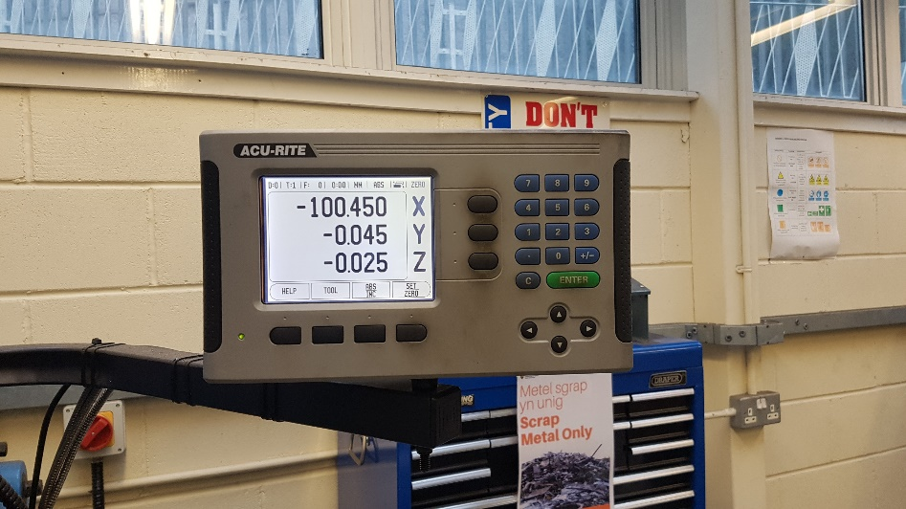
Figure 36 – Y axis set

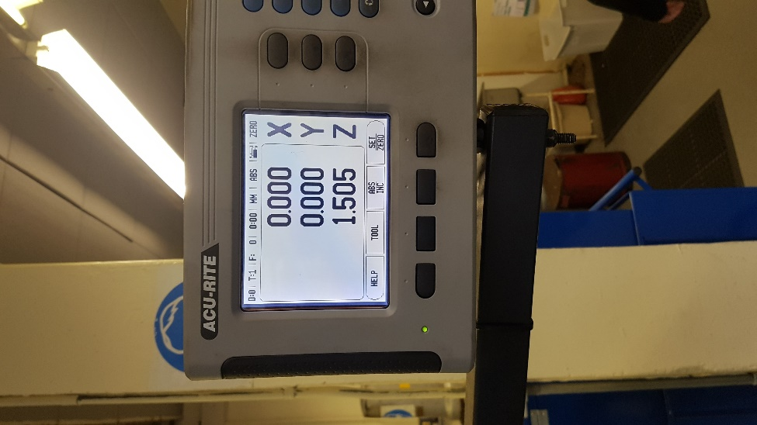
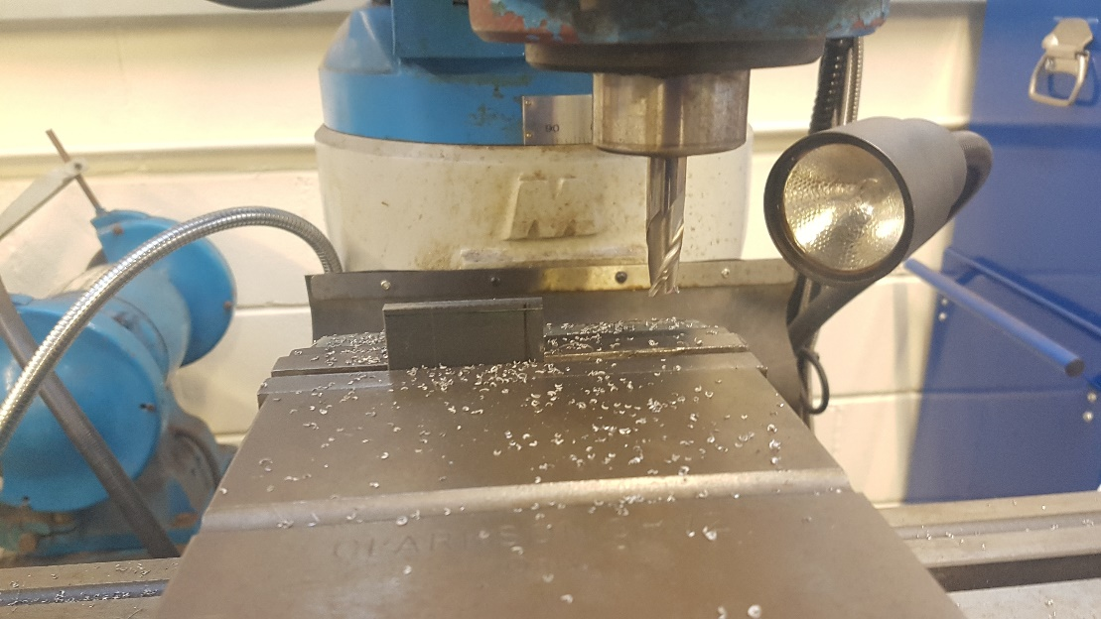
Figure 38 – Y axis at 0
Figure 37 – Cutting on milling machine

Session 9

Milling machine – Dave Cooper
12/12/17
2pm-4pm
MTB04
Aims
Finish the cutting on the milling machine
Create the radius
Create the chamfer

PPE
Steel toe capped shoes and dust coats must always be worn when in the workshop. When working with any machines or cutting tools safety goggles must be worn to protect the eyes. Pull strings on jumpers or trousers must be tied up or tucked away to avoid them getting caught in a machine. Barrier cream should be applied before working with metal to prevent against dermatitis.

Health and safety
Workshop health and safety rules must be followed at all times. Any issues that may come up should be reported to an instructor.

Task
To complete the cuts on the milling machine the same process is used from the previous session. The section that will be cut is measured. The rectangle is placed in the vice and tightly secured. The cutting tip is placed against the edge of the rectangle and 0 is input on the x and z axis. The amount that is to be cut is input on the y axis. Take off 0.2mm of material at a time going forward and back on the x axis. Do this until the material is at the desired height. The material can be left slightly longer than needed and filed to the given dimensions.
To create the radius the rectangle is placed in a vice with the corner than will become the radius facing upwards. Start filing the corner in a rocking motion to create the radius. The radius can be checked using a radius gauge, keep filing until the radius gauge matches the radius on the corner.
To create the chamfer, mark out a 10mm line from top to bottom at 45° on the material. Place the material in the milling machine with a bar. Keep the chamfer line straight and keep cutting until the desired line is met. Mark out 10mm from the top and side and connect the lines using a pen. Use this as a guide when cutting on the milling machine. For a smaller edge use larger parallel bars to hold in the piece.
Problems
Due to time constraints not all the lines could be cut, also the chamfer could not be cut but it was marked out.

Photos

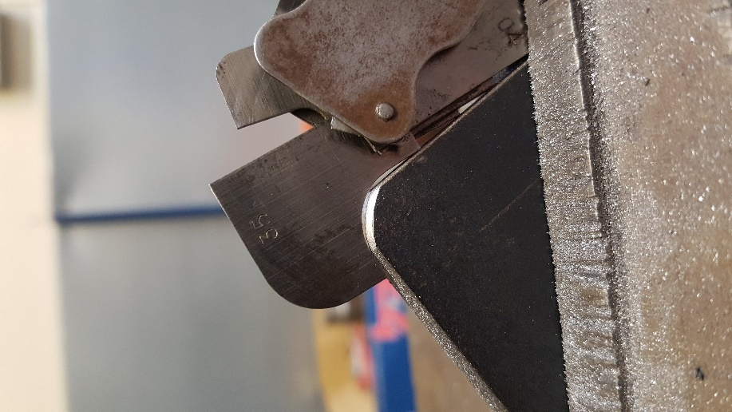
Figure 39 - Radius

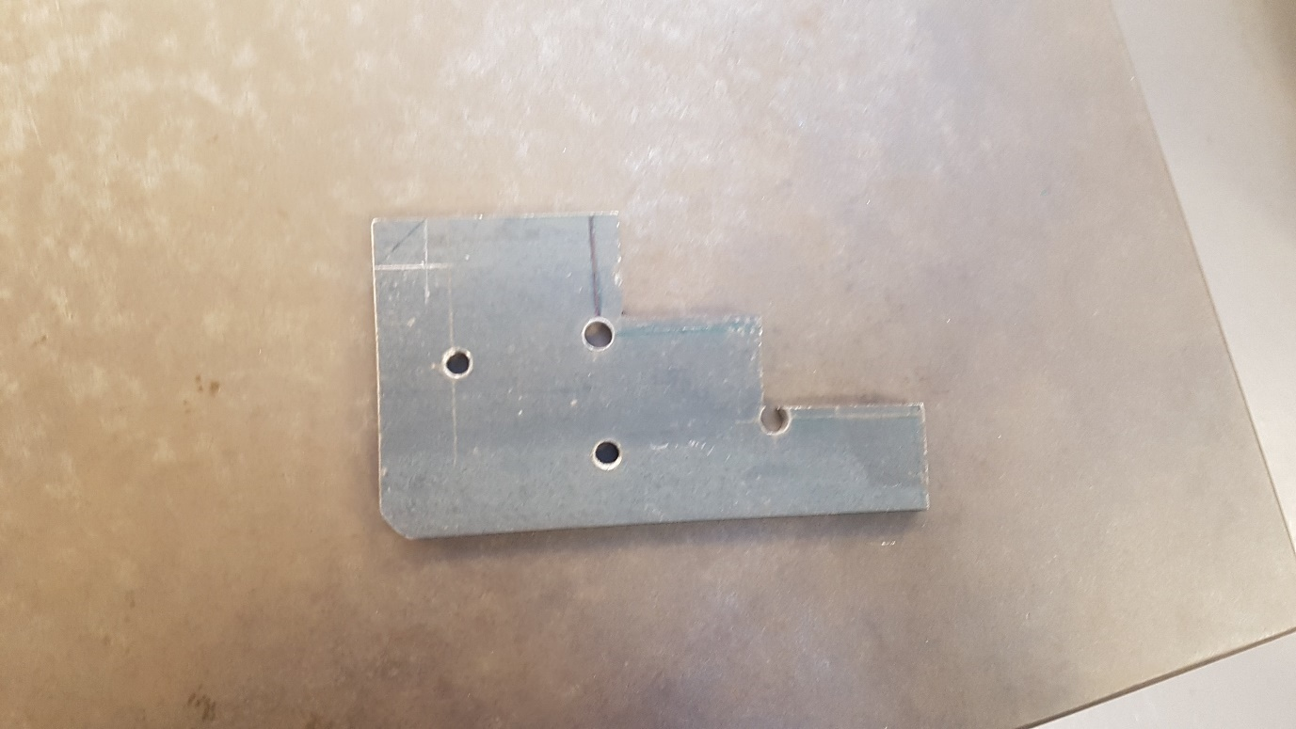
Figure 40 – Final piece

Session 10
Engine strip down – Barry John 30/01/18
2pm-4pm
MTG05
Aims
Take everything up to and including the head

Equipment used
Socket set mainly 10mm, 12mm, 21mm and spark plug socket. Extensions were also used.
10 and 12mm spanner

Health and safety
Workshop health and safety rules must be followed at all times. Any issues that may come up should be reported to an instructor. Some bolts can be tight and in awkward places so there is a risk of cuts. To prevent this, extensions can be used to allow more free space. If a cut occurs wash it and keep an eye on it as oil can get inside and infect the cut.

PPE
Steel toe capped shoes and dust coats must always be worn when in the workshop. Barrier cream should be applied before working with metal to prevent against dermatitis.

Task
First the coil packs are removed, this is done by pulling the 4 ht leads from the spark plug holes and then removing 3 bolts. To remove the engine cover, undo the 12 bolts holding the engine cover to the head and simply lift the cover off. Remove the 1 bolt on the crankshaft pulley and take it off. By removing the crankshaft pully, the timing cover is now able to be removed by removing the 10 bolts holding the cover to the engine block. The next thing to be removed is the timing belt. To do this the engine needs to be set at top dead centre. Then loosen the bolt on the tensioner which will loosen the tension on the belt. (If this engine was working and going to be placed in a car a mark could be added on the top of the camshaft sprocket and on the original mark on the engine used to line up the timing.) There is a cover holding the timing belt onto the block, this can be removed by undoing the 3 bolts, removing the cover and removing the belt. When this is done the intake manifold can be removed. To do this the fuel rail must first be disconnected. The 6 bolts holding the manifold to the block need to be removed and any electrical connectors also need to be removed. When they have all be removed the intake can be removed.
To remove the spark plugs use a spark plug socket and remove them. The camshafts must be removed. First the cams are removed by taking the bolt out and removing the cams. Next there are 8 camshaft bearing covers (4 on each side) with 2 bolts in each. These are removed by taking off the bolts and removing the cover. When this is done the shims need to be removed. To do this use a magnet to pick the shims up and remove them. If everything has been removed the camshafts should just lift out. The next step is to remove the head, to do this just remove any final bolts holding the head to the block, when these have been removed just remove the head from the block being careful as it is heavy.

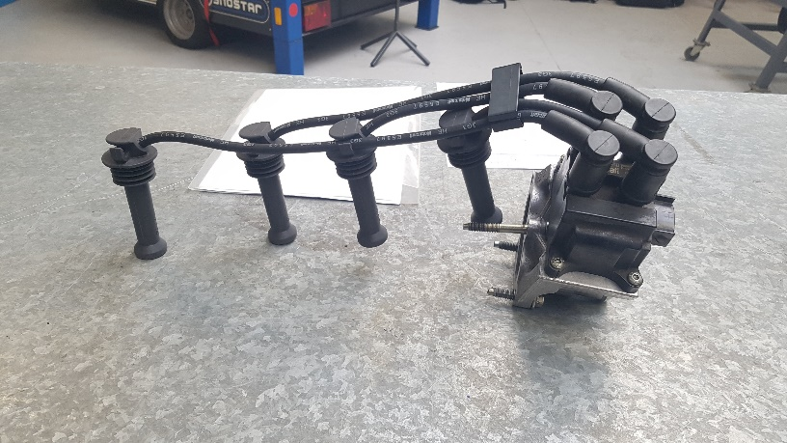
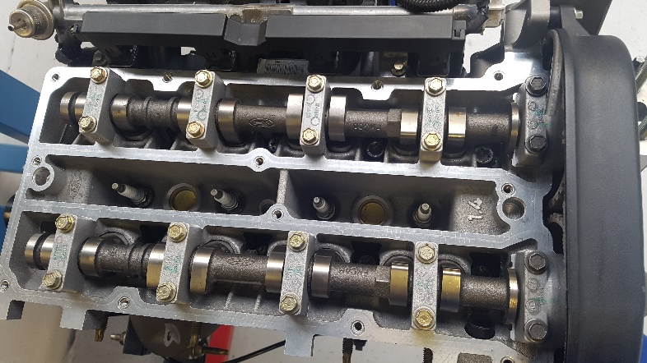
Photos
Figure 41 – HT leads and coil pack
Figure 42 – Engine without rocker cover

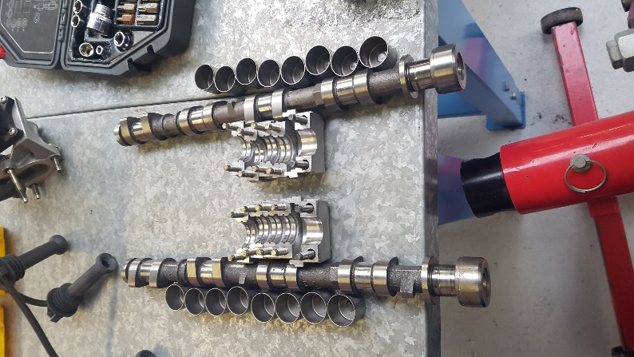
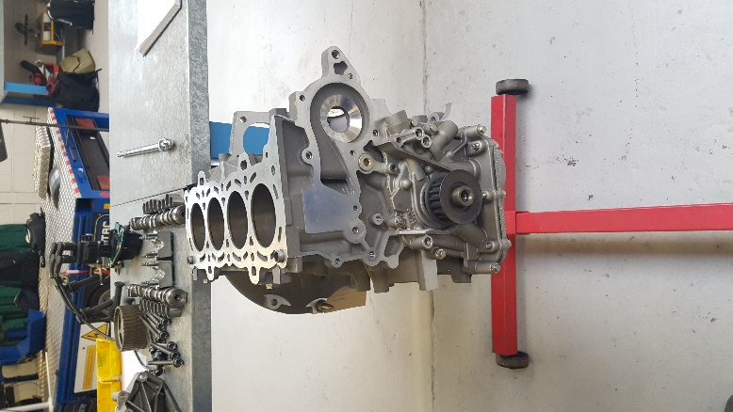
Figure 44 – Camshaft parts
Figure 43 – Engine without head and timing parts

Session 11
Engine strip down – Barry John 06/02/18
2pm-4pm
MTG05
Aims
Complete the strip down of the engine

Equipment used
Socket set mainly 10mm and 12mm. Extensions were also used.
10 and 12mm spanner
T8 torx

Health and safety
Workshop health and safety rules must be followed at all times. Any issues that may come up should be reported to an instructor. Some bolts can be tight and in awkward places so there is a risk of cuts. To prevent this, extensions can be used to allow more free space. If a cut occurs wash it and keep an eye on it as oil can get inside and infect the cut.

PPE
Steel toe capped shoes and dust coats must always be worn when in the workshop. Barrier cream should be applied before working with metal to prevent against dermatitis.

Task
Start by turning the engine upside so the sump is now facing up. The oil pump can be removed by undoing the 5 bolts holding it to the block and removing it. Remove the 13 bolts holding the sump to the block and remove the sump. As this is a dry engine there is no need to worry any oil spilling out but if this was a working engine rags could be placed under the engine to catch any oil that may remain in the sump and engine. With the sump removed the oil pickup should be revealed. This can be removed by taking off the 3 bolts and lifting out the pickup. Under the pickup there should be a cover which can be removed with 4 bolts (2 of the pickup bolts hold the cover in place). With the cover removed the crankshaft components should be visible. First the crankshaft bearing caps and bearings should be removed, this is done by removing the 10 bolts and carefully lifting the caps out making sure to not drop bearings and damaging them. An inspection would be done on the bearings to make sure they are in good working order. Each piston has 2 torx bolts holding them in place when these are removed the piston can be pushed out of the top of the engine. While the pistons are out of the engine the rings should be checked for any damaged and be replaced if needed. With all the pistons out the remaining bolts on the crankshaft can be removed and the crankshaft can be taken out and inspected for damage. This should complete the engine strip down.

Problems
The pistons were in the wrong order in the engine.
The rings on piston 3 were cracked and would need replacing

Photos
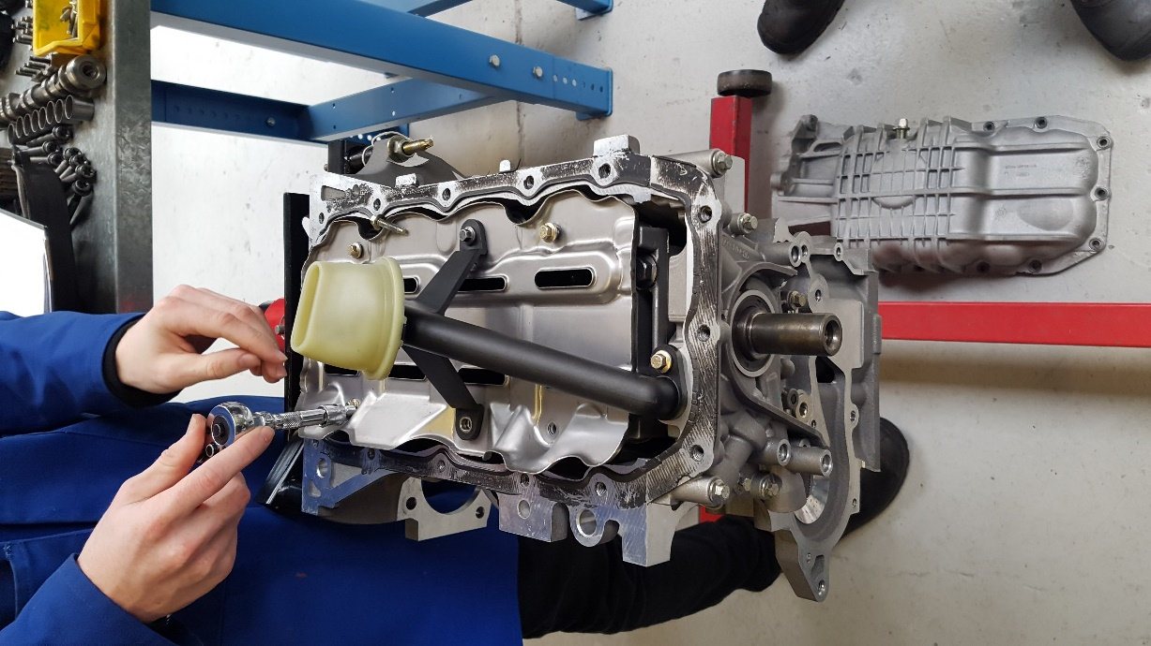
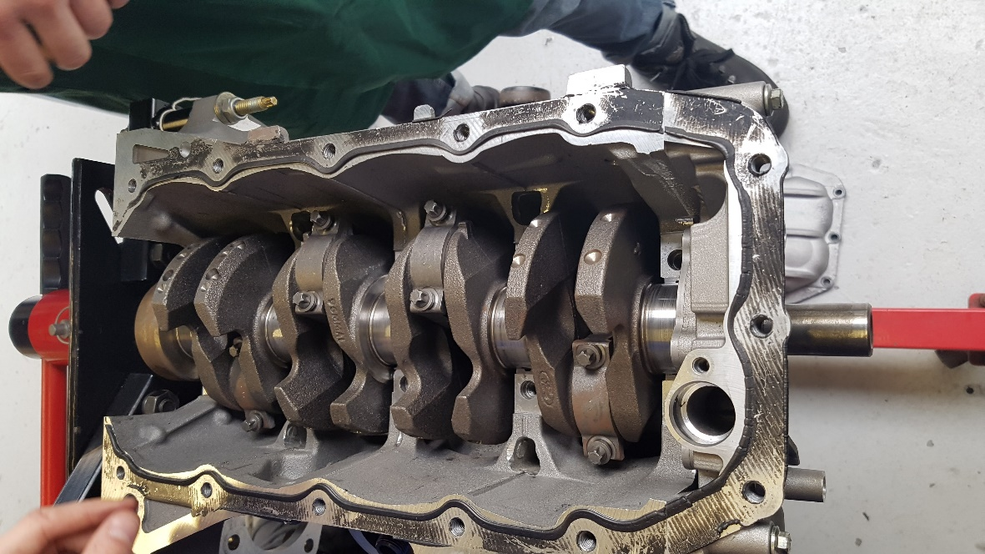
Figure 45 – Engine without the sump
Figure 46 - Crankshaft

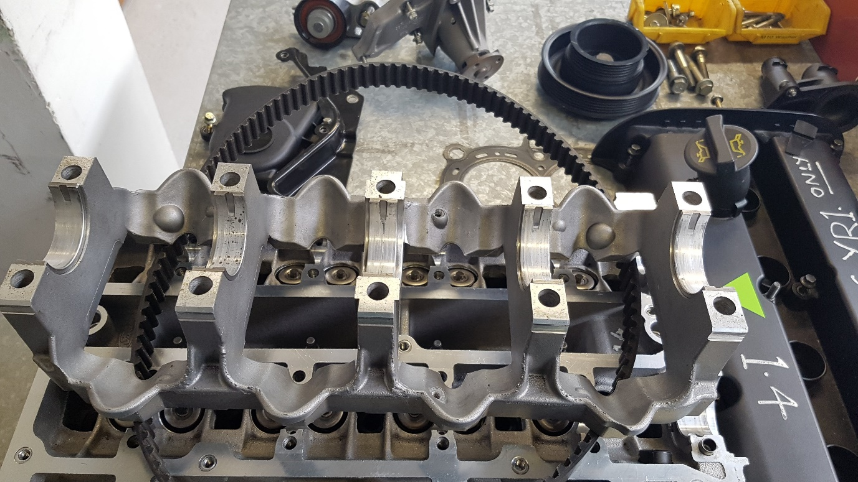
Figure 47 – Crankshaft bearings and caps

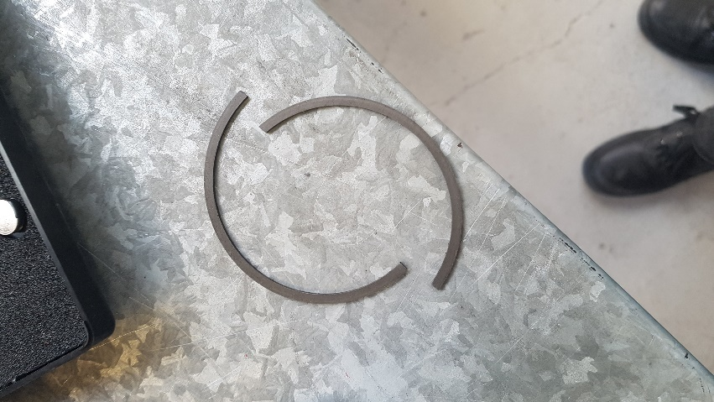
Figure 48 – Cracked piston ring

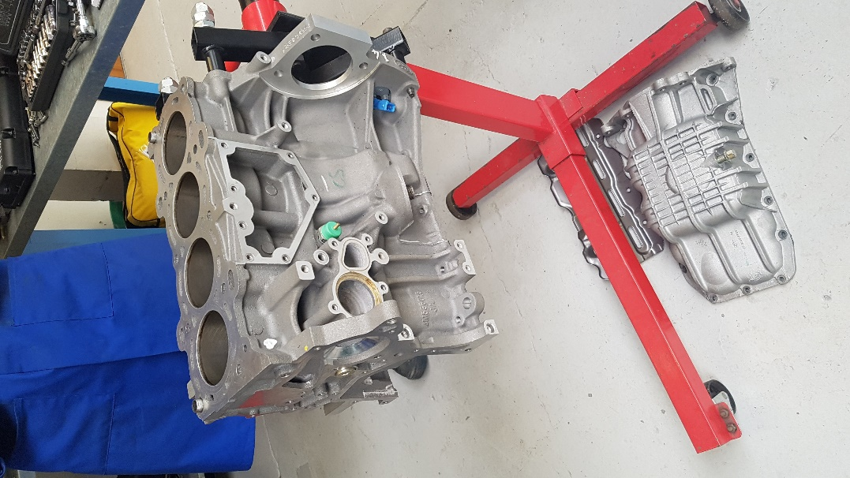
Figure 49 – Engine fully stripped

Session 12
Engine strip down – Barry John 06/02/18
2pm-4pm
MTG05
Aims
Start the rebuild of the engine

Equipment used
Socket set mainly 10mm and 12mm. Extensions were also used.
10 and 12mm spanner
T8 torx
Piston compressor
Hammer

Health and safety
Workshop health and safety rules must be followed at all times. Any issues that may come up should be reported to an instructor. Some bolts can be tight and in awkward places so there is a risk of cuts. To prevent this, extensions can be used to allow more free space. If a cut occurs wash it and keep an eye on it as oil can get inside and infect the cut.

PPE
Steel toe capped shoes and dust coats must always be worn when in the workshop. Barrier cream should be applied before working with metal to prevent against dermatitis.

Task
To rebuild the engine the parts must be placed back in the opposite order they were taken out. If this was a real engine all the bolts would be torqued to the manufacturers specifications. Also any bolts that have any damage or are missing would be replaced. First the crankshaft needs to be placed in the block and all the blots placed back in. The engine needs to be rotated on the stand as the pistons need to be inserted from the top. To insert the pistons a piston compressor must be used to compress the rings allowing the piston to be inserted into the cylinder. To do this insert the piston into the compressor and using an allen key to tighten the rings. Place the piston on top of the cylinder and use a hammer to make sure the compressor is flush. Then use the handle of the hammer to knock the piston into place. Place the bolts back in and tighten them making sure the piston stays in place. Repeat this process for the other 3 pistons, making sure they are in the correct order. The engine needs to be rotated on the stand, so it is sump side up. Place the crankshaft bearings into the crankshaft bearing caps and bolt it back into the block. Make sure the base of the piston is aligned correctly and if it isn’t either move it into the correct position or take it out and replace it. Place the cover in the sump over the crankshaft, then attach the oil pickup to the cover. When all these components have been attached the sump can be attached with the 13 bolts. The engine can again be rotated on the stand. The head can be placed back onto the engine and all the bolts can be torqued to 30Nm then a 90° turn. These bolts must be torqued in a sequence given by the manufacturer. Normally starting from the edge and working inwards.

Photos

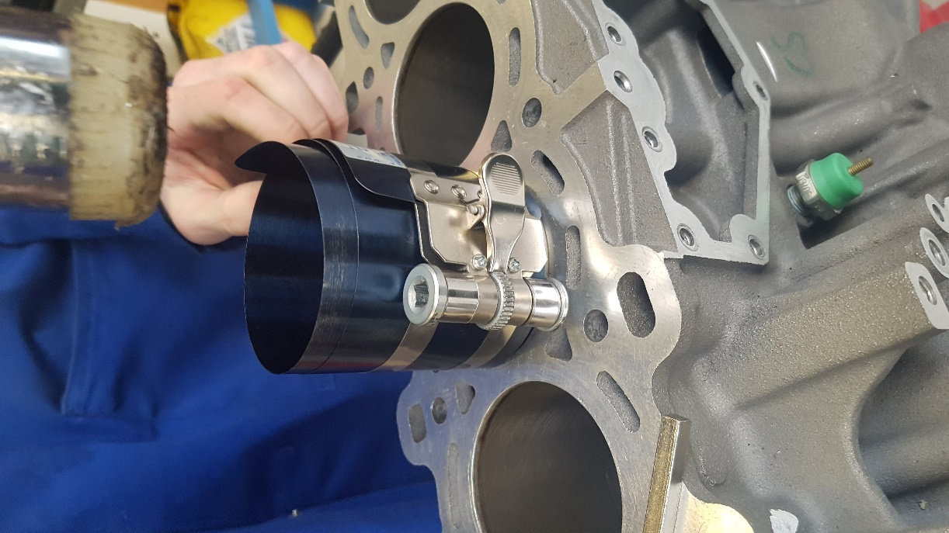
Figure 50 – Piston ring compressor
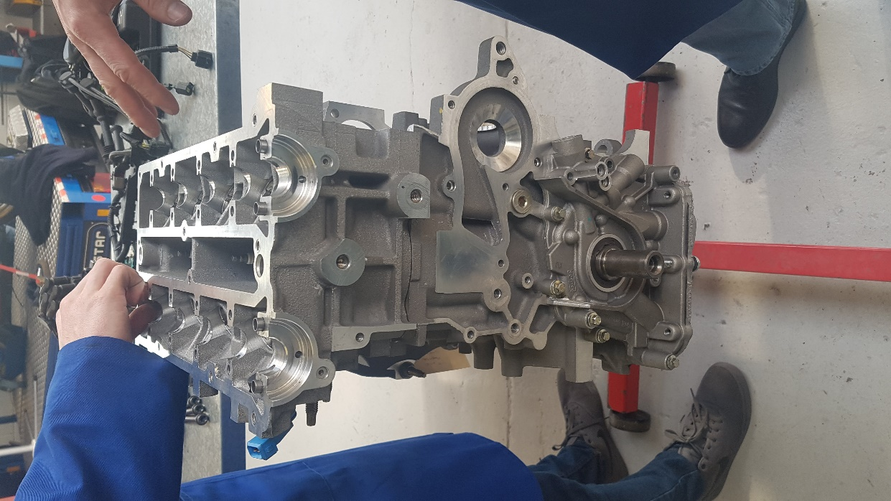
Figure 51 – Engine with head

Session 13
Engine strip down – Barry John 20/02/18
2pm-4pm
MTG05
Aims
Finish the engine rebuild

Equipment used
Socket set mainly 10mm, 12mm, 21mm and spark plug socket. Extensions were also used.
10 and 12mm spanner

Health and safety
Workshop health and safety rules must be followed at all times. Any issues that may come up should be reported to an instructor. Some bolts can be tight and in awkward places so there is a risk of cuts. To prevent this, extensions can be used to allow more free space. If a cut occurs wash it and keep an eye on it as oil can get inside and infect the cut.

PPE
Steel toe capped shoes and dust coats must always be worn when in the workshop. Barrier cream should be applied before working with metal to prevent against dermatitis.

Task
The oil pump can be placed back by reattaching the 3 bolts. The intake and fuel pump can be reconnected, and any electrical connectors need to be reattached. The next item to be attached is the crankshaft pulley. Before the timing components can be connect the camshaft need to be installed. First the camshaft needs to be inserted the shims can then be placed in by dropping them in place. The camshaft bearings can be placed and tightened. With these firmly attached the cams can be installed.
When the cams are attached the rest of the timing components can be attached starting with the idle pulley, then attaching the timing belt and tightening it up so it is attached to the cams but has some give stopping it from snapping. The spark plugs can be inserted using a spark plug socket and tightened down. The rocker cover can be attached, the bolts should stay inside the cover, so these can’t be replaced. The coil pack can be attached and the ht leads can be popped back in place. Finally any items or connectors on the outside of the block should be reattached. Make sure there are no remaining bolts and if there are try and identify where they should go.

Photos

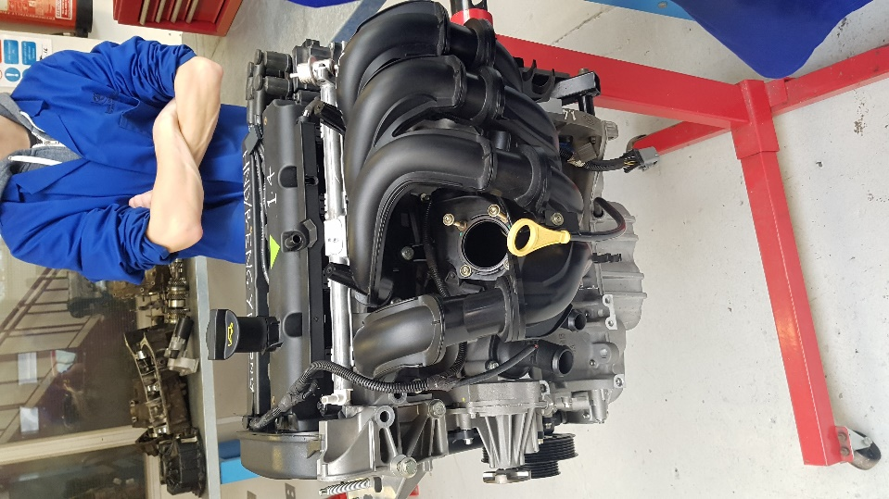
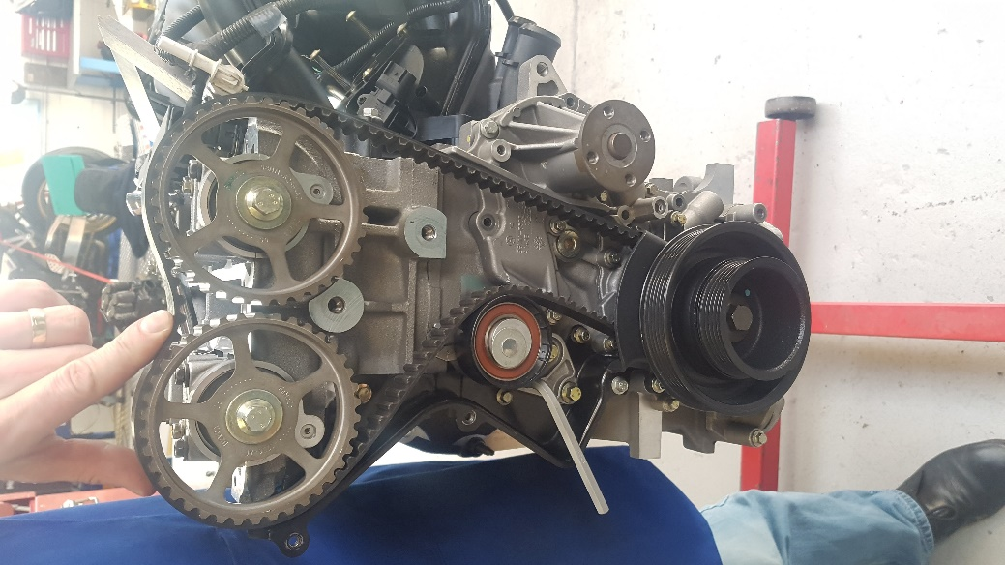
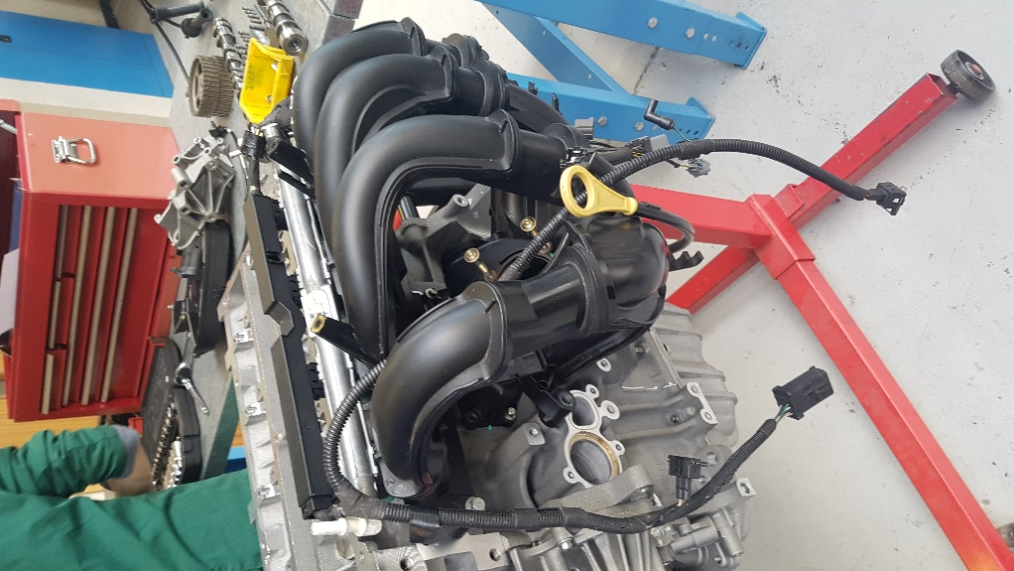
Figure 52 – Manifold replaced
Figure 54 – Rebuilt engine
Figure 53 – Timing redone

Personal Skills Evaluation
During these workshop sessions I have learnt many skills and have been able to improve skills I had previously. During the lathe I quickly understood how important it is to measure accurately and measure more than once to get a more accurate result. It also taught me that you are better off cutting less material and measuring more because even though it will take longer the final product will end up better. If I was given more time on the lathe I would like to improve the finish on the metal and treat the metal as it began to rust after a few weeks.
Working with the rectangle made me understand how you must account for errors such as not cutting straight or the thickness of a blade. As there were only 2 lathes time was more limited than ideal so to improve on the lathe more time would help.
To further my skills I would like to use the machines more as I feel this would help me be more confident while using them and would improve my skills on them.

