L5 - Changemakers: Creativity and Value Creation
Assignment 2

La-Raib khan
2005781

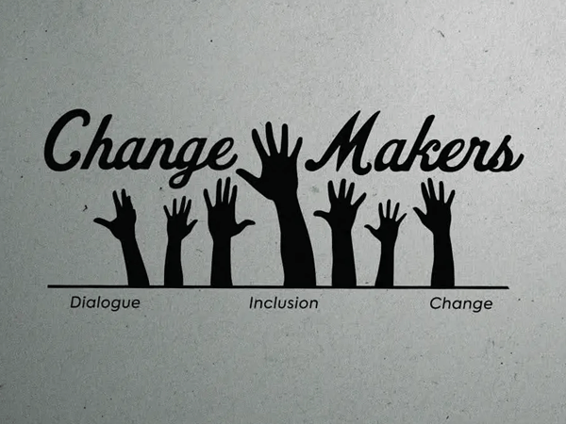

Task 1: Understanding Innovation

Innovation may also be taken to refer to the process of coming up with new ideas, practices, or technologies that add value, enhances experiences, or addresses the current problems in better ways. It entails not only originality, but accomplishment of new solutions in practical situations. Innovation can be in the form of new products or by improving on the existing services, systems or process and make them more useful, meaningful and relevant.

The modern society requires innovation because of the high rate of technological progress, digitalization, and changing social requirements. With the changing nature of lifestyles and the emergence of new challenges, people and organizations must keep evolving. Specifically, the growing consciousness and prioritization of mental health support point to a social need of wellbeing solutions, which are accessible, empathetic and personalized. Conventional mental health services are traditionally scarce or inaccessible, so it creates a possibility of innovative digital services that provide self-help and early intervention methods.

The Mental Health Wellness App designed during the project is an instance of innovation, since it focuses on the emotional wellbeing in a user-centred and personalised manner. The app does not claim to be a replacement to professional therapy, but it empowers more autonomy to the user based on the features of mood tracking, daily wellbeing encouragements, reflective journals, and positive habit reminders. This is being consistent with the modern trends that promote self-awareness and consistent emotional check-ins as preventive measures to enhance wellbeing [3].

More so, the app embodies the design thinking principles in which emotional experience is put at the forefront with functionality. According to Norman, emotionally considerate design determines the relationship of people with technology [1]. The app aims to provide the users with a secure online space to express themselves by offering a soothing interface and positive tone. As such the digital tools provided are not the only thing that has been innovative, but rather how the application has established a supportive relationship between the user and the system.

To conclude, innovation plays a critical role in addressing changing mental health requirements, and the Mental Health Wellness App shows that digital solutions could be developed that would allow a positive emotional support in daily life.

---

Task 2 (Innovation Route)

Q1. The major points of consideration in Innovation Revise Ethical, Legal, and Practical.

The Mental Health Wellness App will have to be developed with the consideration of the ethical and legal issues since the app is related to personal emotional expression and wellbeing support. The duty to make sure the app is not harmful is one of the ethical considerations. The information provided and advice should be positive, non-clinical and should be presented in a respectful empathetic manner. The app is not going to diagnose any condition or give medical advice but will provide general wellbeing related strategies that are consistent with those suggested by the population, including reflective journaling, breathing exercises and mood tracking [3].

One of the legal aspects that matter greatly is the data protection and privacy. The application will use sensitive emotional data, and hence, the data protection policies (e.g., GDPR) will have to be adhered to. The data about the users will be anonymised (where applicable) and safely encrypted. The application will enable the user to erase their data any time they wish, and this will provide them with full access to the history of their emotions, which will be transparent.

Practically, the innovation is centred on value creation to the user as opposed to sophistication. The interface will be based on visually gentle pastel colour, light font and minimal distractions, which will be in favour of emotional comfort and psychological security. The significance of emotional design is stressed by Norman who mentions that the users establish relationships with the products based on the aesthetic comfort and perceived empathy [1].

Inclusivity is also taken into account in the innovation. There are numerous wellness applications that presuppose self-confidence or literacy with the emotional reflection; this application uses straightforward language and with optional voice-assisted prompts and step-by-step structure. Through this, the innovation will not just be technological, but user-centred, empathetic and accessible.

Q2. Creation, Implementing and Sustaining the Innovation.

Reiterative development strategy will be employed to make sure that the innovation can be developed and maintained. Visual and emotional identity is developed through the low-fidelity sketches and mood boards that are used to define the design process. The next step will involve a rudimentary interactive prototype which will initially concentrate on essential functionality: mood tracking, everyday reminder inquiries and relaxing activity proposals.

An Agile approach will be employed in the creation of the app, which will allow realizing small advancements in accordance with user feedback. The first testing will be done using small pilot group of young adults who will give feedback according to how easy it is to use, emotional tone and relevance of features. It is also consistent with Werntz et al., who mention that digital mental health tools are the most effective when they are developed through continuous user engagement and emotional responsiveness [2].

The deployment will be done in small scale with the help of a mobile platform like Android or iOS TestFlight, which will provide real-life testing but with controlled access. Maintenance will include updating, refining of usability and content movement depending on the experiences of users. In order to maintain reliable sustainability, emotional wellbeing professionals can be consulted so as to maintain guidance as safe, balanced and appropriate.

The value is going to be built over time with the inclusion of the optional supporting functions like positive habit streaks, gratitude reminders, community goal-sharing or seasonal wellbeing challenges. These aspects facilitate continuous motivation and automatic emotional introspection, which will play a role in preventive mental health care as opposed to a reactive management approach.

Generally, the creation and sustainability of the innovation will be built upon a combination of the emotional sensitivity, user-based design, data accountability and continuous enhancement.

---

Task 3: Project Reflection

Introduction

This reflection is about the development of the Mood Support Mobile Application, a wellbeing application that is designed to assist university students in monitoring their emotions, wellbeing tactics, and documenting personal thoughts. The reflection discusses the way I applied the project to acquire new skills, the ways the project may help the society, and the possible risks and solutions.

1. What did you do with this task to acquire new skills?

The experience on this project enabled me to acquire certain technical and transferable skills. To begin with, I enhanced my research and analytical abilities through researching on academic literature related to mental health in university students and considering the available wellbeing applications. This helped me find such missing elements as customised emotional support elements and the inclusion of daily mental check-ins that are easy to do [3].

Another main creative problem solving aspect that I was able to gain is how to transfer conceptual ideas about wellbeing into app screens using wireframing and UI/UX design as the main tools. I adopted a user-centred approach [1], thus making the layouts of the screens easy, visually understandable, and accommodating to users in distress of emotions.

Project planning and time management is another skill that I was able to acquire. I applied task breakdown structures and incremental development whereby each phase (concept design feedback improvement) assisted in improving the end-user experience. The use of early drafts also enabled me to be open to feedback and make changes based on the feedback.

Moreover, I was able to become more confident in the field of digital communication and in particular, presenting my app concept visually. The project enhanced my skills in describing design decisions and connecting decisions with the needs of users.

2. What positive effect and contribution to the society could your project have?

Academic pressure and lifestyle change can be the cause of stress, loneliness, and anxiety to university students. This application allows an easy, confidential, and supportive emotional wellbeing space.

The application has a positive effect on society in various ways:
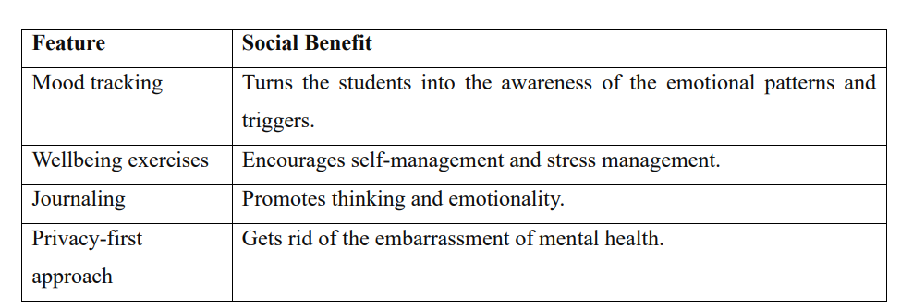

Studies indicate that emotional self-awareness at an early age minimizes the chances of developing mental problems in the long run [3]. The app facilitates prevention and not only intervention by allowing micro-reflection daily.

To put it in broader perspective, academic success is becoming to be recognized by universities as associated with wellbeing. The application is an addition to the institutional support services and can possibly lower the rates of student dropouts associated with uncontrolled stress.

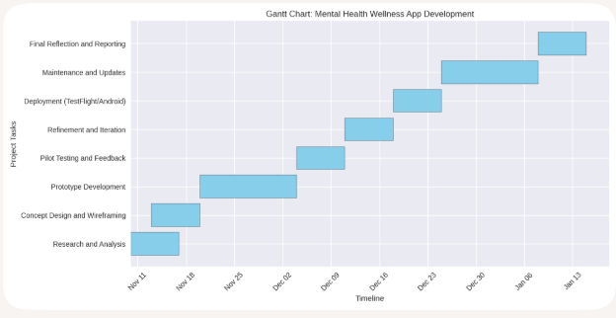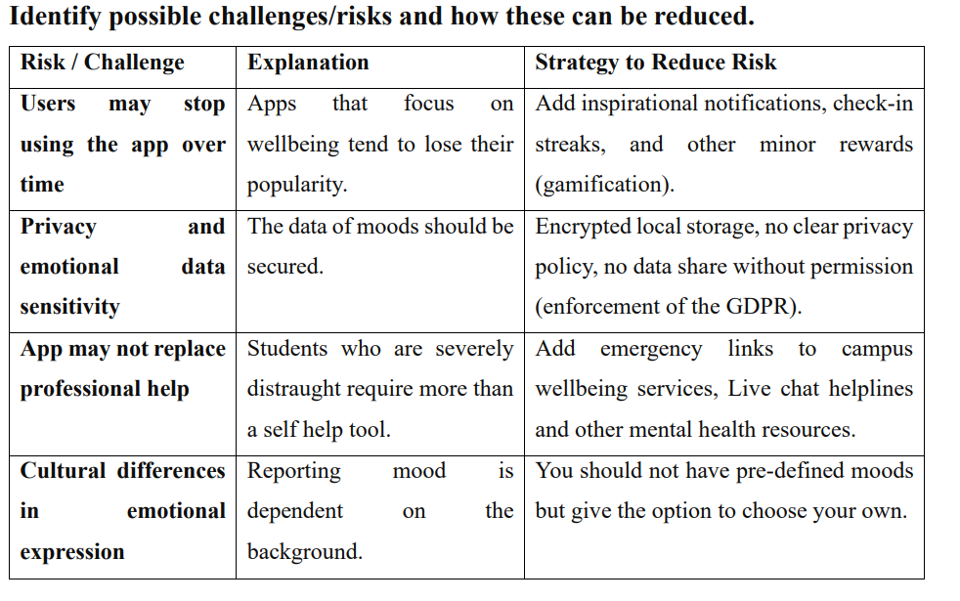

Conclusion

The given task helped me to acquire some hands-on design and research abilities and better understand the mental health needs of students. The project illustrates how considerate digital enables support of wellbeing to be more available. Although this also entails some challenges of engagement and ethical data usage, they could be overcome with the help of inclusive design.

Bibliography:
[1] D. Norman, Emotional Design: Why We Love (or Hate) Everyday Things. New York, NY, USA: Basic Books, 2004.
[2] A. Werntz, S. Amado, M. Jasman, A. Ervin, and J. E. Rhodes, “Providing human support for the use of digital mental health interventions,” J. Med. Internet Res., vol. 25, p. e42864, 2023.
[3] World Health Organization, Mental Wellbeing Support Guidelines, Geneva, Switzerland, 2022

