Data Analysis & Visualisation
ACBA4002

Networking and Cyber Security BSc

Timothy Ferfers
1903054

Experimental data analysis

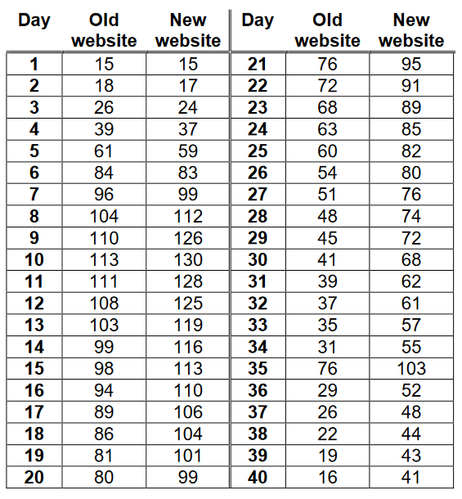
Initial Observation
Through A/B testing the online retail company have conducted their own research to how many sales their old and new website(s) made respectively in a 40 day period. The recorded data is displayed in the following table:
The table clearly shows the gradual increase in popularity of the New website.
On the 7th day the New website gains popularity over the Old website and maintains these higher sales for the rest of the test period.
The data presented in this table will be input into Microsoft Excel for the purposes of carrying out any calculations regarding this data and this experiment.

Descriptive Statistics
Old Website
Mean | 63.075
Standard Error | 4.970991169
Median | 62
Mode | 26
Standard Deviation | 31.43930865
Sample Variance | 988.4301282
Kurtosis | -1.361700556
Skewness | 0.036911041
Range | 98
Minimum | 15
Maximum | 113
Sum | 2523
Count | 40

New Website
Mean | 80.025
Standard Error | 5.057171539
Median | 82.5
Mode | 99
Standard Deviation | 31.98436116
Sample Variance | 1022.999359
Kurtosis | -0.835646087
Skewness | -0.287496805
Range | 115
Minimum | 15
Maximum | 130
Sum | 3201
Count | 40

Hypothesis

H₀: The New Website ($\overline{X}$_{New}) makes as many or less sales than the Old Website ($\overline{X}$_{Old}).
H₁: The New Website ($\overline{X}$_{New}) makes more sales than the Old Website ($\overline{X}$_{Old}).
A One-Tailed results approach will be used to prove the specific difference between these data sets.
This will be tested against 3 different levels of significance (represented by ‘a’ for the reason MS Excel identifies levels of significance as Alpha): 0.10, 0.05 & 0.01.

The t Test
The t Test is a form of statistical test which is used to discover the significance in the difference between two sets of data. This test is capable of proving if the difference between the mean values of two sets of data is different to a determinable, significant statistical degree.
In addition, the test can work with both independent and paired samples, the latter implying that the two samples originate from the same source, e.g. samples taken before and after from the same origin. In the current case, the data used are independent samples as they describe to performance of two different websites, recorded in simultaneous time.

This testing method is able to work (in this case) as the sales of the old and new website are comparable data.
Through the use of the independent samples t Test, the true significance in the difference between the Old and New websites sales can be ascertained.
Using The Data Analysis tool pack on MS Excel, the t Test has been conducted on the initial data set. This first t Test uses a = 0.10, desirably proving the results to a statistical accuracy of 10%.
From this test, the t Stat value is revealed to be greater than t Critical one-tail value. The negative sign on t Stat is irrelevant; the magnitude of the number is still greater than t critical.
(Note: t Stat = t_{opt} / t Critical = t_{crit}).
As H₁ is trying to prove the specific difference between ($\overline{X}$_{New}) an ($\overline{X}$_{Old}), the sample answer used is one-tailed.

The values of note are:
t_{obt} = -2.390271823
t_{crit} = 1.292499597
t_{obt} > t_{crit}

As t_{obt} is a greater value than t_{crit}, the null hypothesis can be rejected and the alternative hypothesis must be accepted. Therefore we accept that The New Website ($\overline{X}$_{New}) makes more sales than the Old Website ($\overline{X}$_{Old}), proven to a statistical accuracy of 10%.
Despite the favourable outcome of this test further measurements must be taken. In order to determine the accuracy of this outcome the hypothesis must be tested again, against multiple cases where a different a will be used in each instance.

The following t test makes use will follow the same input data as the previous test, however in this test: a = 0.05, desirably proving the results to a statistical accuracy of 5%.
Once again, the t Test was performed through the use of MS Excels Data Analysis tool pack.
These independent variables will serve to show whether the previous hypothesis is further reinforced or will be challenged with a different outcome.
This t test appears to have produced similar results to the previous test.
Since the hypothesis of the experiment is unchanged for this test, the value which t_{crit} represents is still one tailed.

The values of note are:
t_{obt} = -2.390271823
t_{crit} = 1.664624645
t_{obt} > t_{crit}

As this second test has shown; t_{obt} is again a greater value than t_{crit}, the null hypothesis can be rejected and the alternative hypothesis must be accepted. Therefore once again we accept that The New Website ($\overline{X}$_{New}) makes more sales than the Old Website ($\overline{X}$_{Old}), proven to a statistical accuracy of 5%.

Following the outcome of the previous tests, the overall results are looking to be in favour of disproving the null hypothesis. The following t test makes use will follow the same input data as the previous test, however in this test: a = 0.01. This level of significane will desirably prove the results to a statistical accuracy of 1%.
Yet again, this t Test was performed through the use of MS Excels Data Analysis tool pack.
These independent variables will serve to show whether the previous hypothesis is further reinforced or will be challenged with a different outcome.
Interestingly, this t test appears to have produced similar results to the previous test.
Still, the hypothesis of the experiment is unchanged for this test, plus the value which t_{crit} represents is still one tailed.

The values of note are:
t_{obt} = -2.390271823
t_{crit} = 2.375110958
t_{obt} > t_{crit}

As this third and final test has shown; t_{obt} is once again a greater value than t_{crit}, the null hypothesis can be rejected and the alternative hypothesis must be accepted. Therefore once again we accept that The New Website ($\overline{X}$_{New}) makes more sales than the Old Website ($\overline{X}$_{Old}), proven to a statistical accuracy of 1%.
The 3 tests carried out have undoubtedly confirmed that H₀ (: The New Website ($\overline{X}$_{New}) makes as many or less sales than the Old Website ($\overline{X}$_{Old}) ) can be rejected and therefore H₁ (: The New Website ($\overline{X}$_{New}) makes more sales than the Old Website ($\overline{X}$_{Old}) ) can be accepted.By carrying out the t test multiple times, the validity of H₁ has been proven with a level of significance of not only 0.10 (10%), but also 0.05 (5%) and 0.01 (1%). Carrying out the test multiple times helps to ensure the validity of the produced answers.

Outliers
The null hypothesis has been rejected and the expected outcome H₁ is accepted, however there is always the ever present doubt whether the test was accurate enough or if the results were affected by any outliers.
Upon re-observing the tested data, it is clear that there is a very b wide range of value in the data sets. Before considering re-doing the tests, the initial data should be examined for any clear outliers.

As this graph shows, there is a spike in the data, showing an abruptly large number of sales on the 25th day of the A/B testing period. This outlying section of the data is noticeably simultaneously present at some degree in both the Old Websites and New Websites data set.
Since this discovery could have had a possible effect on the results of the previous tests, there is no other option but to redo the t tests and observe any changes to the results. It is still possible that these outliers will not affect the overall conclusion of the null hypothesis rejection; however it must be properly proven all the same.

As before, this next round of testing will retain the following, unchanged hypothesis:
H₀: The New Website ($\overline{X}$_{New}) makes as many or less sales than the Old Website ($\overline{X}$_{Old}).
H₁: The New Website ($\overline{X}$_{New}) makes more sales than the Old Website ($\overline{X}$_{Old}).
In addition, the One-Tailed results approach will still be used to prove the specific difference between these data sets.
To ensure the tests are carried out the same way, they will be performed through MS Excel and tested against the same 3 different levels of significance: 0.10, 0.05 & 0.01.
This is the first of three new tests, using the same data as the previous round of tests, however the data value for day 35 has been removed, therefore the test will consist of 39 samples between either source (website).
This first t Test is making use of the Data Analysis tool pack on MS Excel, the t Test has been conducted on the modified initial data set. This first t Test uses a = 0.10, desirably proving the results to a statistical accuracy of 10%.
From this test, the t Stat value is revealed to be greater than t Critical one-tail value. The negative sign on t Stat is irrelevant; the magnitude of the number is still greater than t critical.
As with the previous tests, due to the fact H₁ is trying to prove the specific difference between ($\overline{X}$_{New}) an ($\overline{X}$_{Old}), the sample answer used is one-tailed.

The values of note are:
t_{obt} = -2.30482
t_{crit} = 1.29279
t_{obt} > t_{crit}

As the above test shows; t_{obt} is a greater value than t_{crit}, the null hypothesis can be rejected and the alternative hypothesis must be accepted. Therefore even after modifying the data to remove outliers we will accept that The New Website ($\overline{X}$_{New}) makes more sales than the Old Website ($\overline{X}$_{Old}), proven to a statistical accuracy of 10%.

The following is the second t Test which has been conducted on the modified initial data set. This test will use an a = 0.05, desirably proving the results to a statistical accuracy of 5%
From this test, the t Stat value is revealed to be greater than t Critical one-tail value. The negative sign on t Stat is irrelevant; the magnitude of the number is still greater than t critical.
As with the previous tests, due to the fact H₁ is trying to prove the specific difference between ($\overline{X}$_{New}) an ($\overline{X}$_{Old}), the sample answer used is one-tailed.

The values of note are:
t_{obt} = -2.30482
t_{crit} = 1.665151
t_{obt} > t_{crit}

The test has shown that t_{obt} is a greater value than t_{crit}, thereby proving the null hypothesis can be rejected and the alternative hypothesis accepted. This is the second test to produce results akin to the first round of testing, despite the removal of outliers. This proves that the New Website ($\overline{X}$_{New}) makes more sales than the Old Website ($\overline{X}$_{Old}), proven to a statistical accuracy of 10%.

This third and final t Test has been conducted under the same pretences as the previous two tests. The same modified input data is used in this t Test and level of significance has been further reduced: a = 0.01. This level of significane will desirably prove these new results to a statistical accuracy of 1%.
This final test and its modified independent variables will serve to show whether the previously proven hypothesis is further reinforced or will be challenged with a different outcome.
Once more like the previous tests, due to the fact H₁ is trying to prove the specific difference between ($\overline{X}$_{New}) an ($\overline{X}$_{Old}), the sample answer used is one-tailed.

The values of note are:
t_{obt} = -2.30482
t_{crit} = 2.37642
t_{crit} > t_{obt}

As this third and final test of this new round has shown; t_{crit} is once actually a greater value than t_{obt}, the null hypothesis must be accepted and the alternative hypothesis must be rejected. Therefore the New Website ($\overline{X}$_{New}) makes as many or less sales than the Old Website ($\overline{X}$_{Old}), proven to a statistical accuracy of 1%.
The 3 new tests carried out have provided a mixed consensus. After the removal of outliers in the initial data sets and re-performing the three tests, the results have shown that H₁ (: The New Website ($\overline{X}$_{New}) makes more sales than the Old Website ($\overline{X}$_{Old}) ) can only be accepted in the first two tests where is was proven to satistical accuracys of 10% and 5%. However the final test revealed that the null hypothesis / H₀ must be acepted when the test is carried out to a statistical accuracy of 1%.
A possible outlying cause for the now uncertain conclusion is the company’s decision to apply a 15% discount to the new website to encourage sales.
Appendix
Excel Workings
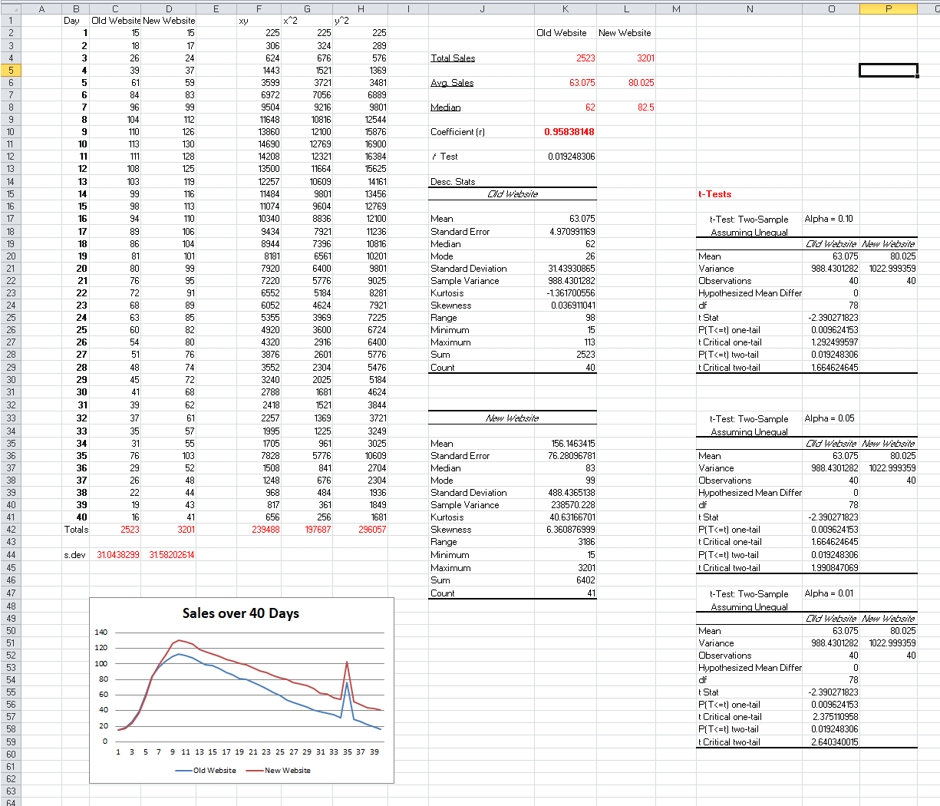
(Note: Not all workings are relevant to final reports contents; some are merely early speculations about the method to approach the assignment)



