Smart Home Device Manager
A Console-Based Device Tracking System for Bright Minds Academy

Student Name: Taishee Khan
ID number: 2133060
Module Name: Scripting and Programing Concepts
Module Code: ACCA5036
Lecturer: Dr. Mobolanle Bello
Submission date: 24th July 2026

GitHub Link: Add Smart Home Device Manager application · taisheekhan/Scripting-and-Programing@996b88b

Contents
1. Analysis 3
1.1 Introduction 3
1.2 Requirements Analysis 3
2. Software Design and Development 4
2.a Design 4
2.a.i Flowchart 4
2.a.ii Pseudo-code 4
2.b Implementation Decisions 5
2.b.i Data Structures 5
2.b.ii Programming Constructs 6
2.b.iii Python Modules and Libraries 6
2.c Source Code 7
3. Testing and Debugging Report 11
3.a The Importance of Program Testing 11
3.b Types of Programming Errors 11
3.c Test Cases and Results 11
4. Evaluation 13
4.1 Challenges Faced 13
4.2 Future Improvements 14
4.3 Self-Reflection 14
5. References 14

1. Analysis

1.1 Introduction
Bright Minds Academy is a small private tutoring centre that is piloting a smart classroom in which everyday teaching equipment smart lights, thermostats and projectors is connected through a central setup. At present these devices are managed entirely by hand. Staff have no single place to see which devices exist, which room each one belongs to, or whether a device is currently working, switched off, or being repaired. This leads to wasted teaching time, confusion when a device fails, and no reliable record of the state of equipment the Academy owns [1,2].
The software solution presented in this report is a simple, menu-driven console application in Python: Smart Home Device Manager. It's designed to provide employees with a single instance to document devices, rooms and whether they're connected or not. The system is intentionally not a database system but rather in-memory Python data structures, in keeping with the project scope; it is not a real time control or automation system, but rather a tracking and record-keeping tool. The issue is really about information management – collecting a handful of properties for a large number of devices, and making information available for employees to add, edit, browse, and query efficiently and reliably.
The requirements were checked via two standard methods to reach a viable design. For this purpose, the problem was abstracted to its essentials that each device has a name, a room and a status. All other information (brand, wiring, power draw etc.) is of no significance. The overall goal was then decomposed into four independent operations that directly correspond with the staff's desire: add a device, change status, display all devices, search for a device [3]. The operations create one small self-contained function, keeping design tidy and each component easily tested individually.

1.2 Requirements Analysis
A features requirement analysis was carried out to decide precisely what this version of the software would provide. Requirements are separated into functional requirements (what the system must do) and non-functional requirements (qualities the system should have).
Functional requirements:
- FR1 – Add device: staff can register a new device by entering its name and room, and set an initial status.
- FR2 – Update status: staff can change an existing device’s status to online, offline or under maintenance.
- FR3 – View devices: staff can list every device together with its room and current status in a readable table.
- FR4 – Search: staff can type a device name and instantly see that device’s room and status.
- FR5 – Input validation: the system must reject empty names, duplicate devices, and invalid status values, and must react safely to unexpected menu input.
- FR6 – Exit: staff can leave the program cleanly from the menu.
Non-functional requirements:
- NFR1 – Usability: a clear numbered menu that non-technical tutoring staff can use without training.
- NFR2 – Reliability: invalid input must never crash the program; it must show a helpful message and return to the menu.
- NFR3 – Maintainability: the code should be organised into small commented functions so it can be read and extended later.
- NFR4 – Performance: searching for a device should be effectively instant even as the number of devices grows.
These requirements set the boundary of the solution. Anything outside them — for example remote switching of a light, or saving data permanently to disk — is noted as a possible future improvement in Section 4 rather than built now, keeping this version focused and achievable within scope.

2. Software Design and Development

2.a Design

2.a.i Flowchart
The overall logic and control flow of the program are shown in the following flowchart. The System turns ON, presents a menu and reads the user's choice. All the alternatives go to the corresponding operation, while the decision diamonds indicate where input validation takes place, and all the branches return to the menu until the user chooses Exit.
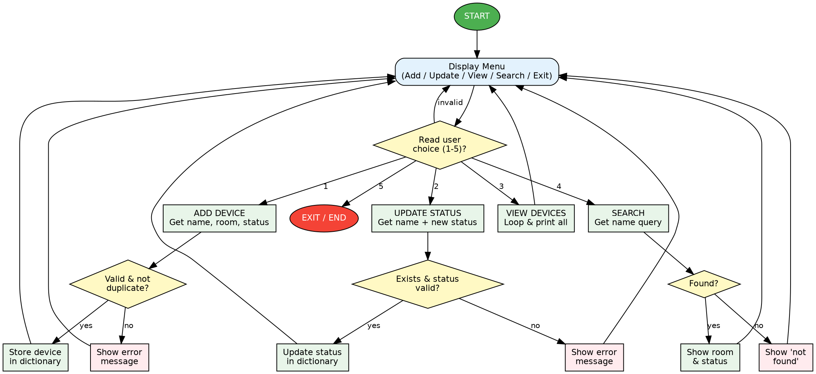
Figure 1: System flowchart showing the menu loop and validation branches
Figure 1 shows the whole process of the Smart Home Device Manager system. It starts at the starting node and provides the user with a menu from which to add, update, view, search, or exit the program. The decision diamond verifies that the user has chosen from one of the options (1-5) and that the user has not chosen (none). All functions are logical validated: checks for duplicate or empty names, device existence and status validity for updates, all records for prints, etc. for searching. The flowchart is overall clear and structured, showing input validation and error-handling

2.a.ii Pseudo-code
Pseudo-code for the core functionalities is given below. It translates the logic into steps that are easy to understand in plain language, regardless of the language used to implement them, before even examining the Python implementation [4].

BEGIN Program
devices <- dictionary of {name: {room, status}}
VALID_STATUSES <- (online, offline, maintenance)

WHILE True
DISPLAY menu
READ choice

IF choice = 1 THEN CALL AddDevice
ELSE IF choice = 2 THEN CALL UpdateStatus
ELSE IF choice = 3 THEN CALL ViewDevices
ELSE IF choice = 4 THEN CALL SearchDevice
ELSE IF choice = 5 THEN PRINT goodbye; BREAK
ELSE PRINT "invalid choice"
END WHILE
END Program

FUNCTION AddDevice
READ name
IF name is empty THEN PRINT error; RETURN
IF name already in devices THEN PRINT error; RETURN
READ room
IF room is empty THEN PRINT error; RETURN
READ status
IF status NOT in VALID_STATUSES THEN PRINT error; RETURN
devices[name] <- {room, status}
PRINT success
END FUNCTION

FUNCTION UpdateStatus
READ name
IF name NOT in devices THEN PRINT error; RETURN
READ new_status
IF new_status NOT in VALID_STATUSES THEN PRINT error; RETURN
devices[name].status <- new_status
PRINT success
END FUNCTION

FUNCTION ViewDevices
IF devices is empty THEN PRINT "no devices"; RETURN
FOR EACH name, info IN devices
PRINT name, info.room, info.status
END FUNCTION

FUNCTION SearchDevice
READ query
FOR EACH name, info IN devices
IF lower(name) = lower(query) THEN
PRINT info.room, info.status; RETURN
PRINT "not found"
END FUNCTION

2.b Implementation Decisions

2.b.i Data Structures
The main design consideration was how to store the devices. There were two possible solution strategies taught on this module: parallel lists and a dictionary. A parallel-list design would have three lists one for names, one for rooms, and one for statuses and ensure that they are "synced up" by their indices. In a dictionary design, however, the device name is used as the key to access the data of the device [5].
A dictionary of dictionaries was selected. Every name for a device (which, of course, is unique) is considered a key, and the value is a small nested dictionary that contains the room and status of the device, such as {"Smart Light A1": {"room": "Room 101", "status": "online"}}. This was preferred compared to parallel lists for three reasons. Correctness: Parallel lists should always be perfectly in step remove a list element in the middle of the list and all other lists are silently misaligned and return incorrect data. The Dictionary has all of the attributes of any device in one place, so this type of bug does not exist. Secondly, performance: a dictionary lookup by name is an average O(1) operation whereas the search of a list is O(n); so duplicate-name and ‘device exists?’ checks are both more efficient and easier to write. Third, readability: devices[name]["status"] is explicit providing they meet the intent of the requirement maintainability. The major drawback offered is that if the program is ever closed, the data is lost; this is a possible improvement in the future (file or database storage) as discussed in Section 4. These are the important variables for the solution:
Table 1: Main variables and data structures used in the solution
Variable | Type | Purpose
devices | dict of dicts | Main data store; maps a device name to its {room, status}.
VALID_STATUSES | tuple | The only accepted status values; single source of truth for validation.
name / query | str | The device name entered by the user for adding, updating or searching.
room | str | The room a device is located in.
status / new_status | str | The connectivity status being set or changed.
choice | str | The menu option the user selects (1–5).
info | dict | The nested value for one device while looping through the store.

2.b.ii Programming Constructs
A number of common programming constructs were chosen with intention. The number of actions a staff member will take is not known in advance, and a while-True loop drives the main menu, so it is the convention to use an interactive console application. Using a 'menu' with if / elif / else, the menu choice is used to call the correct function, and the final else block will catch any unexpected value - otherwise the program will crash. The for loop is used to loop over the dictionary to display and search devices in the operations, while the if statement is used to implement validation rules.
The solution is broken down into user-defined functions, each performing a well-named task. This is because this mimics the analysis problems decomposition, there is no repeated code, and a single function can be tested at a time. Error handling implemented as defensive validity: each function contains a check for the rules (not empty, not a duplicate, a valid status, an existing device), and if a rule is not met the function returns early with a clear statement about the error. This ‘guard clause' approach was selected over deep nested if statements, as this maintains the happy path readable and each failure reason explicit, a good code writing practice.

2.b.iii Python Modules and Libraries
This solution deliberately does not rely on any external third-party libraries. The solution is provided using the features available in the Python language: dictionaries, tuples, input() and print(), string methods like .strip() and .lower(), and ordinary control structures. Putting in an external module here would introduce a dependency and installation requirement, which would have no advantage, and so would be a legitimate engineering decision that would make it harder to port the program and to run by staff. The os, time and sys modules were deliberately omitted from the earlier sample programs to clear the screen and force pauses to help make validation messages easier to see during testing, and because these modules would add platform-specific behavior that is not required for a record-keeping program.

2.c Source Code
"""
============================================================================
Smart Home Device Manager
Bright Minds Academy - Smart Classroom Device Tracking System
----------------------------------------------------------------------------
Module : Scripting and Programming Concepts (ACCA5036)
Purpose: A simple, menu-driven console application that lets staff keep
track of smart classroom devices, the room they are located in,
and their current connectivity status (online / offline /
maintenance).

Data structure: A DICTIONARY OF DICTIONARIES.
devices = {
"Smart Light A1": {"room": "Room 101", "status": "online"},
...
}
The device name is the key (device names are unique), and the value is a
nested dictionary holding that device's attributes. This gives fast
O(1) look-up on search and keeps each device's data grouped together.
============================================================================
"""

# ---------------------------------------------------------------------------
# GLOBAL DATA STORE
# ---------------------------------------------------------------------------
# The dictionary is pre-loaded with a few sample devices so the program is
# usable immediately for demonstration and testing. Staff can add more.
devices = {
"Smart Light A1": {"room": "Room 101", "status": "online"},
"Projector B2": {"room": "Room 102", "status": "offline"},
"Thermostat C3": {"room": "Room 103", "status": "maintenance"},
}

# The only status values the system will accept. Keeping them in one place
# (a "single source of truth") means validation is consistent everywhere.
VALID_STATUSES = ("online", "offline", "maintenance")

# ---------------------------------------------------------------------------
# FUNCTION: display_menu
# ---------------------------------------------------------------------------
def display_menu():
"""Print the main menu of options to the user."""
print("\n========================================")
print(" BRIGHT MINDS ACADEMY")
print(" Smart Home Device Manager")
print("========================================")
print("1. Add a new device")
print("2. Update a device's status")
print("3. View all devices")
print("4. Search for a device")
print("5. Exit")
print("----------------------------------------")

# ---------------------------------------------------------------------------
# FUNCTION: add_device
# ---------------------------------------------------------------------------
def add_device():
"""
Add a new device to the dictionary.

Validation performed:
* Device name cannot be empty / only spaces.
* A device with the same name cannot be added twice (duplicate check).
* Room name cannot be empty / only spaces.
* The starting status must be one of the VALID_STATUSES.
"""
print("\n--- Add a New Device ---")

# --- Validate the device name --------------------------------------
name = input("Enter device name (e.g. Smart Light A1): ").strip()
if name == "":
print("[!] Error: Device name cannot be empty. Device not added.")
return
if name in devices:
print(f"[!] Error: '{name}' already exists. Device not added.")
return

# --- Validate the room ---------------------------------------------
room = input("Enter the room it is located in (e.g. Room 101): ").strip()
if room == "":
print("[!] Error: Room cannot be empty. Device not added.")
return

# --- Validate the starting status ----------------------------------
print(f"Choose a starting status {VALID_STATUSES}")
status = input("Enter status: ").strip().lower()
if status not in VALID_STATUSES:
print(f"[!] Error: '{status}' is not a valid status. Device not added.")
return

# --- All checks passed: store the new device -----------------------
devices[name] = {"room": room, "status": status}
print(f"[OK] '{name}' has been added successfully.")

# ---------------------------------------------------------------------------
# FUNCTION: update_status
# ---------------------------------------------------------------------------
def update_status():
"""
Update the connectivity status of an existing device.

Validation performed:
* The device must already exist in the dictionary.
* The new status must be one of the VALID_STATUSES.
"""
print("\n--- Update Device Status ---")

name = input("Enter the device name to update: ").strip()
if name not in devices:
print(f"[!] Error: '{name}' was not found in the system.")
return

print(f"Current status of '{name}' is: {devices[name]['status']}")
print(f"Choose a new status {VALID_STATUSES}")
new_status = input("Enter new status: ").strip().lower()

if new_status not in VALID_STATUSES:
print(f"[!] Error: '{new_status}' is not a valid status. No change made.")
return

devices[name]["status"] = new_status
print(f"[OK] '{name}' is now '{new_status}'.")

# ---------------------------------------------------------------------------
# FUNCTION: view_devices
# ---------------------------------------------------------------------------
def view_devices():
"""Display every device with its room and current status in a table."""
print("\n--- All Registered Devices ---")

if len(devices) == 0:
print("There are no devices in the system yet.")
return

# Print a simple aligned table using formatted (padded) strings.
print(f"{'Device Name':<22}{'Room':<15}{'Status':<12}")
print("-" * 49)
for name, info in devices.items():
print(f"{name:<22}{info['room']:<15}{info['status']:<12}")

# ---------------------------------------------------------------------------
# FUNCTION: search_device
# ---------------------------------------------------------------------------
def search_device():
"""
Search for a single device by name and show its room and status.

The look-up is case-insensitive for convenience: the user does not have
to remember the exact capitalisation.
"""
print("\n--- Search for a Device ---")

query = input("Enter the device name to search for: ").strip()
if query == "":
print("[!] Error: Please enter a device name to search.")
return

# Case-insensitive search: compare the lower-cased query against each
# lower-cased key. Dictionary keys are unique so at most one matches.
for name, info in devices.items():
if name.lower() == query.lower():
print(f"[OK] Found '{name}':")
print(f" Room : {info['room']}")
print(f" Status : {info['status']}")
return

print(f"[!] '{query}' was not found in the system.")

# ---------------------------------------------------------------------------
# FUNCTION: main (program controller / event loop)
# ---------------------------------------------------------------------------
def main():
"""
Run the main program loop.

The loop keeps showing the menu and reacting to the user's choice until
they select option 5 (Exit). Using a while-loop with a menu is the
standard pattern for an interactive console application.
"""
while True:
display_menu()
choice = input("Enter your choice (1-5): ").strip()

if choice == "1":
add_device()
elif choice == "2":
update_status()
elif choice == "3":
view_devices()
elif choice == "4":
search_device()
elif choice == "5":
print("\nExiting the Smart Home Device Manager. Goodbye!")
break
else:
print("[!] Invalid choice. Please enter a number from 1 to 5.")

# ---------------------------------------------------------------------------
# PROGRAM ENTRY POINT
# ---------------------------------------------------------------------------
# The 'if __name__ == "__main__":' guard ensures main() only runs when this
# file is executed directly, not when it is imported as a module elsewhere.
if __name__ == "__main__":
main()

Listing 1: Complete annotated source code (smart_device_manager.py)
The following two screenshots are of the program running normally, listing the pre-loaded devices and successfully adding a new device.
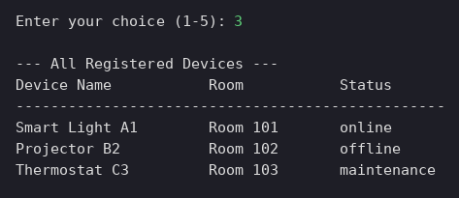
Figure 2: Viewing all registered devices (menu option 3)
Figure 2 displays the output produced upon selecting option 3 which is used to display all the registered devices. The program will be represented by a formatted table with three major columns: Device Name, Room and Status. The current status of the devices is as follows: Smart Light A1: Online, Projector B2: Offline, Thermostat C3: Under Maintenance. This output verifies that the system can retrieve and output the information about the devices stored in the system in a readable format. It also shows that the dictionary based Storage is working correctly for multiple records
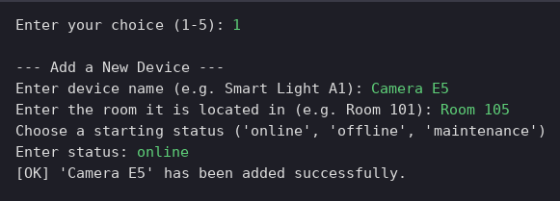
Figure 3: Adding a new device successfully (menu option 1)
Figure 3 shows the successful execution of the Add Device function which was selected by the user at option 1. The system prompts for the name of the device, room location and initial status. The user logs into Camera E5, sets the room it is housed in to Room 105, and chooses the status of 'online'. The program accepts the entry and writes to the device and confirms successful addition because the device name is not empty, doesn't already exist, and the status is valid. This number shows that it can properly receive and process valid user input and add to the device dictionary in memory without error.

3. Testing and Debugging Report

3.a The Importance of Program Testing
Testing involves executing a program against known inputs to ensure it performs as expected, and it is crucial in software development for various reasons. It ensures that each requirement is actually satisfied, it uncovers defects before they impact the user, and it instills trust in the software that is operational with real users [6]. Reliability is important, particularly with a tool that is used by non-technical tutoring personnel, so that it does not crash when it receives incorrectly typed data. It is this testing of both the right paths (valid input) and the wrong paths (invalid input, edge cases) that provides that assurance and for this reason, the validation in this system was checked using the intentional test cases below.

3.b Types of Programming Errors
Three broad categories of error arise in programming. Syntax errors break the rules of the language itself a missing colon or unbalanced bracket and Python refuses to run the file at all; they are fixed by reading the interpreter’s error message, which points to the offending line, and correcting the code. Runtime errors occur while the program is running, for example trying to access a dictionary key that does not exist, and they are fixed either by defensive checks (as this program does with its ‘if name in devices’ guards) or by handling the exception. Logical errors are the most subtle: the program runs without complaint but produces the wrong result for instance updating the wrong device because two lists fell out of alignment. Logical errors are found through careful testing and tracing the code, and fixed by correcting the underlying logic; choosing a dictionary here removed a whole class of such alignment bugs by design [7].

3.c Test Cases and Results
The following test cases were designed to verify every validation rule, including edge cases, exercising both correct and incorrect user input. Each was executed against the program; the outcome column records the actual result, and all cases passed. Console evidence for representative cases follows the table. Table 2 shows that the Smart Home Device Manager was tested across all core functions and important edge cases. The results confirm that the system successfully displays pre-loaded devices, adds valid new devices, updates existing records, performs case-insensitive searches, and exits cleanly. It also handles invalid inputs correctly, including empty device names, duplicate device entries, invalid statuses, non-existent devices, missing search results, and wrong menu choices. Since all twelve test cases passed, the program demonstrates reliable functionality, strong validation, and stable control flow. Overall, the testing confirms that the system behaves as expected under both normal and error conditions.
Table 2: Test cases covering valid inputs, invalid inputs and edge cases
ID | Test Case | Input | Expected Result | Outcome
T1 | View pre-loaded devices | Menu: 3 | Table of 3 sample devices shown | Pass
T2 | Add a valid new device | Camera E5 / Room 105 / online | Device added and appears in list | Pass
T3 | Add with empty name (edge) | Name: (blank) | Rejected: 'name cannot be empty' | Pass
T4 | Add a duplicate device (edge) | Name: Projector B2 | Rejected: 'already exists' | Pass
T5 | Add with invalid status | status: flying | Rejected: 'not a valid status' | Pass
T6 | Update existing device status | Projector B2 / online | Status changed to online | Pass
T7 | Update non-existent device (edge) | Name: GhostDevice | Rejected: 'was not found' | Pass
T8 | Update with invalid status | Smart Light A1 / broken | Rejected: 'not a valid status' | Pass
T9 | Search (case-insensitive) (edge) | smart light a1 | Found; room + status shown | Pass
T10 | Search for missing device | Toaster | 'not found' message | Pass
T11 | Invalid menu choice (edge) | Menu: 9 | 'Invalid choice' message, menu repeats | Pass
T12 | Clean exit | Menu: 5 | Goodbye message, program ends | Pass
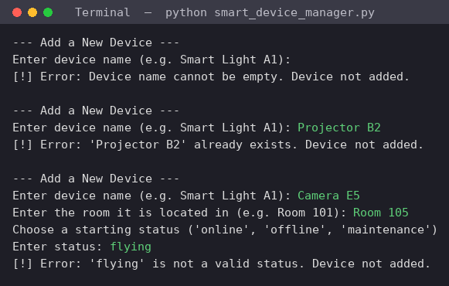
Figure 4: Add-device validation — empty name (T3), duplicate (T4) and invalid status (T5) are all rejected
Figure 4 shows the system's error-handling during the add-device process. The first is for the user to enter a blank device name and the program rejects the entry instantly with an error message. The user then tries to create Projector B2, which is already created in the system, and the program does not allow the duplication to occur. At last, the user enters in Camera E5 with a valid room ID but enters flying as the status, which is not one of the accepted statuses: online, offline and maintenance. This is an invalid status. This validates that the program is equipped with robust validation rules prior to adding devices
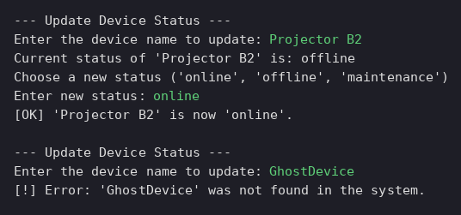
Figure 5: Updating a valid device (T6) and rejecting a non-existent device (T7)
In figure 5, a new device has been added and the validation checks are again highlighted. It re-iterates three vital error scenarios: empty device name, duplicate device name, invalid status specification. The outputs are crucial because they demonstrate that the system is not just taking input from the user. In contrast, it checks if the name exists, if the device is already created, and if the status is in one of the allowed categories. These increase reliability, avoid corrupted records, and only meaningful device data is stored. If the test is repeated, then it will also produce the same behaviour with a number of invalid inputs
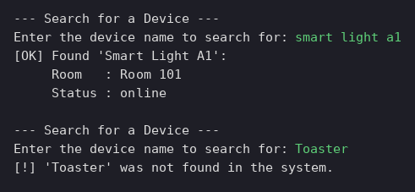
Figure 6: Case-insensitive search finds the device (T9); a missing device returns 'not found' (T10).
Figure 6 figure shows the output of the Search Device function. In the first search the user will type smart light a1 and it will return Smart Light A1 in the list with its room and status. This means that the search function is probably case insensitive, making it easier for users to use since they do not have to match the capitalization stored in the database. The system then shows Room 101 and online. The second search is made with Toaster (which isn't registered) and the program outputs the correct message of “Not found”. This verifies correct search handling
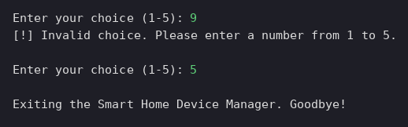
Figure 7: An invalid menu choice is handled safely (T11) and the program exits cleanly (T12)
Figure 7 illustrates two behaviors, at the menu level: invalid input and system termination. First, the user types the number 9, which is not within the range of 1 - 5. This will be seen as an invalid option in the program and a suitable error message will be printed out to the screen, asking the user to enter a valid number. This avoids program crash and/or undefined operation. Then the user types in 5 which causes the exit function to be activated. The system responds with a message: “Exiting the Smart Home Device Manager. Goodbye!” This is a verification of a controlled and user friendly termination process of the program The images shown above are from the program running in the console. They each represent the test IDs in Table 2 showing correct validation behaviour for valid and invalid / edge cases.

4. Evaluation

4.1 Challenges Faced
The first real challenge was choosing the right data structure. It was tempting to follow the parallel-list sample directly, but working through how a deletion or an out-of-order edit would misalign the lists showed how fragile that approach becomes once each device carries several attributes. This was addressed by moving to a dictionary of dictionaries, which keeps each device’s data together and removed the alignment problem entirely. A second challenge was making validation thorough without making the code hard to read; the answer was to use early-return guard clauses so each rule is checked in one clear place. A third, smaller challenge was deciding how far validation should go — for example, making search case-insensitive so staff are not penalised for capitalisation — which was resolved by testing the program the way a real, occasionally careless user would.

4.2 Future Improvements
- Persistent storage: save the dictionary to a JSON or CSV file and the data will persist between sessions (currently not supported).
- Delete and edit device details: enable staff to remove a decommissioned device or update the room not only the device status.
- A last-used timestamp: record when each device was last online, to meet the Academy's initial request for a last used date for each device.
- Filtering and reporting: only display the devices in a selected room or only show devices in maintenance to accelerate the fault-finding process.
- A graphical interface: a basic GUI (Tkinter) or web front end would be helpful for non-technical staff.

4.3 Self-Reflection
The project reinforced the point that programming is not only about writing code, but also about making decisions. It gave me a better sense of what it means to be correct and efficient, instead of ‘what works’ when I made comparisons between the list and dictionary approaches, and had to explain why the one I chose was correct and efficient. Breaking the problem up into small functions was much easier to write and test than one large function, and sketching out pseudo-code and a flowchart first, allowed implementation to run smoothly and there was no logic to mess up. Most importantly, intentionally considering the wrong ways that names could be used, the duplicated ones, the bad ones, the statuses changed my thinking about robustness: a program is not finished until it also considers how it should behave with inputs that it shouldn't have been given. The project is complete and I'm more confident in being able to translate a real requirement into a clean, well-documented validated Python solution.

5. References
[1] Majeed A, Ali M. How Internet-of-Things (IoT) making the university campuses smart? QA higher education (QAHE) perspective. In2018 IEEE 8th annual computing and communication workshop and conference (CCWC) 2018 Jan 8 (pp. 646-648). IEEE.
[2] Daniel S, Olaoye G. Improving Equipment Utilization and Maintenance Using IoT Sensors in Construction Projects.
[3] BAdapa CS. Eliminating duplicate medical records: How modern solutions are revolutionizing healthcare data management. Journal of Computer Science and Technology Studies. 2025 Apr 25;7(2):496-505.
[4] Vayadande K, Bailke PA, Dombale AB, Dange VR, Kulkarni AM. Converting pseudo code to code: A review. How Machine Learning is Innovating Today's World: A Concise Technical Guide. 2024 Jun 17:57-68.
[5] Fu Y, Sun H, Wu Y, Xin H, Deng B, Lin Z, Zhang H, Yin L, Bing X, Shang T, Yuan H. Design and Implementation of a Medical Device Data Dictionary System Based on Software Engineering Theory. IEEE Access. 2024 Aug 12;12:113126-37.
[6] Aniche M. Effective Software Testing: A developer's guide. Simon and Schuster; 2022 Apr 26.
[7] Solouki MA, Angizi S, Violante M. Dependability in embedded systems: a survey of fault tolerance methods and software-based mitigation techniques. IEEE Access. 2024 Dec 2;12:180939-67.

