GLOBAL BUSINESS ENVIRONMENT
Student ID:2110948

Table of Contents
Introduction 3
Major forces shaping the global business environment 3
Demonstrate understanding of the changing global business environment – 4
Apply relevant business models 4
Porter’s Diamond 4
PESTLE Analysis 6
Porter’s five forces 7
Evaluate core reasons why the business venture engages with the international trade 9
Micro-economic and macro economic factors of the business 10
Different market structures and their impact on the firm’s strategy 11
Long-term and short-term changes in the company 11
Critically discuss the influence of the market structure 12
Major features of current international economy and their impact on the business 13
Recommendations 13
Conclusion 13
References 14

Introduction
No matter how hard we try to create a stable and healthy organization, the nature of the international business environment guarantees that dramatic changes will occur that are beyond our control. An international business faces many challenges due to political, social, economic, and cultural factors. This case examines how foreign market dynamics affect Nissan's business.
It will examine the major forces shaping the global business environment and show an understanding of its changing nature. It will also look at models like Porter's Diamond and Five Forces, and assess why Nissan engages in international trade. It will also assess the impact of various market structures on Nissan's long- and short-term operations. Finally, it will examine the global economy and its impact on business.

Major forces shaping the global business environment
Various forces can shape the global business environment for the company, according to Zahra et al. (2021, p. 143). Here are the five major forces that can impact Nissan's business.
International policies- - According to Xu et al. (2020, p. 54), various rules and regulations affect a company's economic survival. Taxes are levied on products, raw materials, and other business requirements. Moreover, strategic alliances between countries impact the business environment.
Demand and supply conditions of the economy. According to Vlados et al. (2019, p. 34), all businesses are highly dependent on consumer demand and market supply. This industry is currently looking for more eco-friendly products. To meet this demand, the supply must be balanced.
Social Behavior of the people residing- Sukardi et al. (2019, p. 180) mention that culture influences consumer willingness to buy a car.
Advancements in technology- Smys et al. (2019, p. 181) note that while developed countries are generally more technologically advanced, developing nations are ideal for sourcing resources.
Changing products range in the market- According to Sarvankar et al. (2019, p. 4), Nissan is undergoing major product changes as it transitions to using electrical energy as fuel in its cars. Since most transportation is now powered by electricity rather than gasoline or other sources of energy.

Demonstrate understanding of the changing global business environment –
The most significant change in this industry is the advancement of technology. As a result, the country's transportation system is increasingly powered by electricity. In order to reduce pollution, governments that support this change have begun declaring that they will convert most gasoline cars to electric cars. Consumption of these cars is therefore higher. Encouraging more people to buy electric vehicles also benefits the country's overall development.

Apply relevant business models

Porter’s Diamond
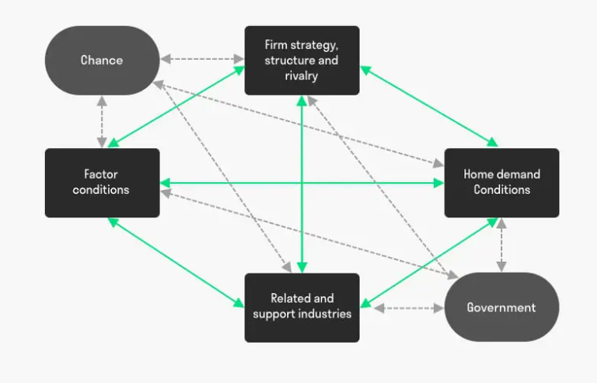
Figure 1: Porter’s Diamond Model.
(Source: Efremov et al., 2019, p. 30)
Porter's Diamond framework is used to assess a nation or group's comparative advantage. The Porter's Diamond Framework assesses the following major topics.
Demand conditions | - Covid-19 outbreak- The pandemic initially reduced demand for transportation due to transportation restrictions. After the pandemic, people were more inclined to prioritize safety, which increased demand for private vehicles.  - Transportation cost reduction: Electric vehicles use less energy than gasoline vehicles, lowering transportation costs and increasing demand.  - Market size has increased in all available markets of the automobile industry due to lower transportation costs and increased demand for private vehicles.
Factors Conditions | - Lack of charging stations, required equipment, and skilled labor force is a major issue for Nissan.  - The post-pandemic boom in human resources has shifted people's focus to their own personal growth. Thus, the availability of qualified professionals has increased, as has their cost and commitment to the company.
Related and supporting industries availability | - Rival companies: Honda, Maruti, General Motors, Toyota, etc. So Nissan must also compete with these forces (Belhadi et al., 2021, p. 17).  - Strategic partnership- To diversify their risks and reduce costs, Nissan formed a strategic partnership with Renault.
Firms’ strategy and structure | - Organizational culture – Following the pandemic, Nissan's leadership approach has changed as well, affecting consumers' mindset and thus their attitude towards travel. Thus, the transformational leadership approach shifts the mindset of consumers and employees.  - To meet the increasing business demands, the Company has expanded its operational regions. However, more infrastructure development is required to support industry expansion.

PESTLE Analysis

Political factors | - Worldwide, governments are providing more subsidies to suppliers and consumers to help the automobile industry shift towards electric vehicles.  - Electric cars are the only available substitute for gasoline cars due to the increased taxes levied on gasoline energy.  - Partnerships- The company benefited greatly from the Brexit alliance because of the trade policies formed between the nations. But it has partnered with Renault to reduce risk.
Economic factors | - Consumer demand has increased since the pandemic. People's health has taken precedence over their financial situation, increasing the demand for private vehicles.  - Supply- Now that major competitors are building electric vehicles, supply has increased. Thus, Nisan must accelerate its operations to gain a major market share.  - Economy- The pandemic has reduced the number of activities in economies, affecting people's purchasing power. Thus contributing to the company's growth.  - Maintenance and parts costs are significantly higher than gasoline cars. However, the cost of operation is 1/10th, which encourages consumers to buy these vehicles.
Social factors | - Human resources- The pandemic has improved human resource quality. Most people started focusing on improving their skills and qualifications, which benefited the company.  - Consumers' attitudes towards the automobile industry have also changed, with more people viewing it as a necessity than a luxury.  - Culture – As people realized the value of human value and touch, the organizational culture shifted. Transformative leadership approach in organizations.  - Population dynamics- A younger generation is more interested in the automobile industry. So Nissan can also benefit from this demand.
Technological factors | - Infrastructure - Electric vehicles require charging stations and other equipment to operate. These are not widely available. Getting it to the most remote areas is a major challenge for the industry. Overcoming this obstacle can help the industry grow.  - Electric vehicle – The advent of this new technology has shifted global demand and supply patterns. Nissan has already begun producing electric vehicles, but it must work harder to meet consumer demand.
Legal factors | - Infrastructure - Electric vehicles require charging stations and other equipment to operate. These are not widely available. Getting it to the most remote areas is a major challenge for the industry. Overcoming this obstacle can help the industry grow.  - Electric vehicle – The advent of this new technology has shifted global demand and supply patterns. Nissan has already begun producing electric vehicles, but it must work harder to meet consumer demand.
Environmental factors | - Consumer behavior- After the pandemic, consumers want more eco-friendly products. Thus, switching to electric vehicle production could benefit the company.  - Benefits for future generations: Using shale gas and electric vehicles can help save non-renewable resources like coal, petroleum, and certain gases. Thus, the industry's shift is beneficial for the environment and reducing global warming.

Porter’s five forces
According to Kosaka et al. (2020, p. 37), it helps understand market competition and the power of suppliers and buyers. It also assesses the threat of substitutes and newcomers to the market, assisting Nissan in major strategic decisions (Christodoulou et al., 2019, p. 6046).
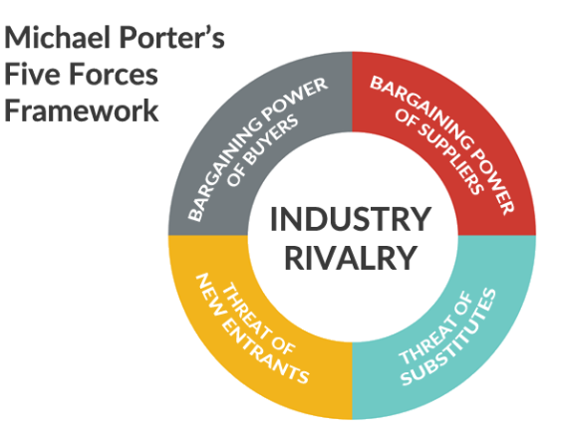
Figure 2: Porter’s five forces framework.
(Source: Christodoulou et al., 2019, p. 6046).

Threat of new entrants | Low | - A manufacturing unit in the automobile industry requires large investments and resources, so new entrants are unlikely.  - Current competition- There are also long-established companies. These companies have gained experience in product marketing and company management. Keeping up with them is difficult for newcomers.
Bargaining power of suppliers | Moderate | - Availability varies by region. Several suppliers in a few areas help the company save money. Nissan should avoid operating in areas with fewer suppliers of automotive equipment and raw materials.  - It can be costly to switch to electric vehicles if a company's production is urgently needed.
Bargaining power of buyers | Moderate | - Because the products are nearly identical, the company may lose customers due to minor differences.  - As this industry is still in the early stages of electric vehicle adoption, Nissan faces a minimal threat.  - New product introduction – Because the industry is young, new products and changes are frequent, posing a major threat to Nissan.
Threat of substitutes | High | - Nissan's customer profile is middle income groups who are very price conscious, so pricing strategy plays an important role in the company's survival.
Competitive rivalry in the market | High | - • Nissan's customer profile is middle income groups who are very price conscious, so pricing strategy plays an important role in the company's survival.

Evaluate core reasons why the business venture engages with the international trade
According to Kokodey et al. (2018, p. 488), Nissan does things like increasing revenue potential, entering new markets, accessing new customer data, and analyzing their buying behavior. Expansion also aids Nissan in product diversification and backward and forward integration. The company gains a competitive advantage over competitors and improves its reputation as it expands globally. Finally, it helps the company save money.

Micro-economic and macro economic factors of the business
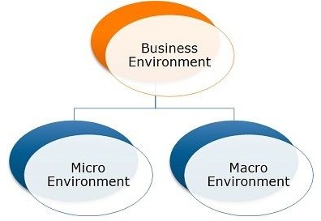
Figure 3: Macro and microenvironments of business
(Source: Demirbas et al., 2018).
According to Guan et al. (2020, p. 577), the business is affected by two environments.
Internal factors of the business, according to Fang et al. (2018, p. 720). Among them are: -
Suppliers- The ones who provide the company with raw materials, machinery, and equipment.
Prior customers- Nissan targets middle-income groups as prior customers.
As stated by Farnsworth et al. (2018), competitors include Honda, Tesla, and others.
The environment affects shareholders and employees in many ways.
Nissan's media channels are controlled by the company's internal environment.
Macro environment- These are external factors that the company cannot control. The company's PESTLE analysis discussed the political, social, economic, legal, environmental, and technological factors.

Different market structures and their impact on the firm’s strategy
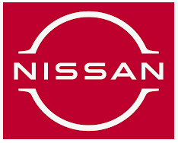
Figure 4: Nissan Logo
(Source: Ding et al., 2018, p. 117)
There are four types of market structures in the economy-
This market includes products that are similar but can be distinguished by their features. Hotels, clothes, etc.
Monopoly market- These products have no substitutes on the market. Railways, Microsoft, etc (Ding et al., 2018, p. 117).
Oligopoly: homogeneous products with few competitors. Like the auto industry and commercial air travel.
Perfect market- Products are not differentiated but there are many competitors. Food, shopping, etc.
Impact of oligopoly market on the company-
Because it is an oligopoly, it has both positive and negative effects. Because this industry has few players, the threat of competition is low. However, it is a group behavior from suppliers that makes it difficult for consumers to distinguish between the company's offers. To meet market demands, post-covid-19 has increased the value of distinction.

Long-term and short-term changes in the company
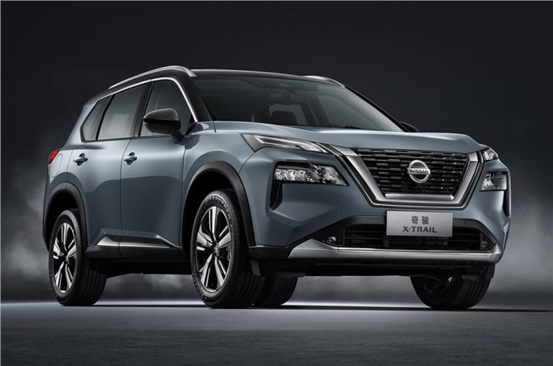
Figure 5: Nissan Cars
(Source:Corona et al., 2019, p. 108).
There are many long-term and short-term impacts on Nissan Company due to the covid-19 pandemic.
Short-term impact-
Infrastructure issues- Currently, Nissan is facing issues with infrastructure. These include the installation of charging stations, maintenance equipment, and a strong electricity production infrastructure in Nissan's operating regions (Corona et al., 2019, p. 108).
The new omicron variant may cause a decline in the company's sales.
Meet changing technological demands- This forces the company to raise production costs in order to meet changing consumer demands.
Long-term impact-
Improved environmental impacts- The industry is moving towards using renewable energy sources to power its vehicles. A major positive environmental impact on the company and nations may result.
In 5 years, the infrastructure should be able to handle the new technology that will improve transportation and thus the economy's overall productivity.
Nissan has high growth potential due to its oligopoly market position and current product introduction curve. Thus, the company's profits may rise in the coming years.

Critically discuss the influence of the market structure
According to Pauwels et al. (2018, p. 287), this industry will shift to more eco-friendly products, benefiting the entire world. However, as argued and demonstrated by Parente et al. (2018, p. 54), this shift will take years because consumers cannot switch to electric cars because electric cars currently cost more than gasoline cars. Moreover, developing charging station infrastructure and making equipment available will take a long time. So, the industry may grow rapidly or moderately, but it will grow because of the post-pandemic transportation demands.

Major features of current international economy and their impact on the business
According to Min et al. (2019, p. 238), the global economy has slowed since the pandemic. Countries are becoming more aware of accepting multinational companies and promoting their own products. These changes have harmed Nissan. However, to meet rising consumer demand and oligopoly sector demands, governments will soon open their markets, which is good news for Nissan..

Recommendations
Following the above research, we have some recommendations for Nissan.
Rapidly adopt new technology- Electric vehicles are more environmentally friendly and cost effective than gasoline cars. So the company should start producing these electric vehicles right away.
Focus on the company's microenvironment- The macro-environment is currently an opportunity for the company, so it should focus on aspects it can control like suppliers, customers, product and service diversifications, etc.

Conclusion
The above case study concludes that Nissan's external environment benefits the company. The Pestle analysis, Porter's Diamond, and Five Forces analysis helped understand the company's environment. The studies also showed Nissan's benefits from market structure and its impact on the business.

References
Belhadi, A., Kamble, S., Jabbour, C.J.C., Gunasekaran, A., Ndubisi, N.O. and Venkatesh, M., 2021. Manufacturing and service supply chain resilience to the COVID-19 outbreak: Lessons learned from the automobile and airline industries. Technological Forecasting and Social Change, 163, p.17.
Christodoulou, A. and Cullinane, K., 2019. Identifying the main opportunities and challenges from the implementation of a port energy management system: A SWOT/PESTLE analysis. Sustainability, 11(21), p.6046.
Corona, B., Shen, L., Reike, D., Carreón, J.R. and Worrell, E., 2019. Towards sustainable development through the circular economy—A review and critical assessment on current circularity metrics. Resources, Conservation and Recycling, 151, p.108.
Demirbas, D., Wilkinson, L. and Bennett, D., 2018. Supplier relations impact within the UK automotive industry. Benchmarking: An International Journal.
Ding, C., Chen, P. and Jiao, J., 2018. Non-linear effects of the built environment on automobile-involved pedestrian crash frequency: a machine learning approach. Accident Analysis & Prevention, 112, pp.116-126.
Efremov, V.S. and Vladimirova, I.G., 2019. Globalization of the World Economy: Features of the Current Stage. Economic and Social Development: Book of Proceedings, pp.27-36.
Fang, K., Zhou, Y., Wang, S., Ye, R. and Guo, S., 2018. Assessing national renewable energy competitiveness of the G20: A revised Porter's Diamond Model. Renewable and Sustainable Energy Reviews, 93, pp.719-731.
Farnsworth, K., Cole, L. and Conn, M., 2018. Oiling the Wheels: Nissan, private investment and British corporate welfare. Corporate Welfare Watch.
Guan, D., Wang, D., Hallegatte, S., Davis, S.J., Huo, J., Li, S., Bai, Y., Lei, T., Xue, Q., Coffman, D.M. and Cheng, D., 2020. Global supply-chain effects of COVID-19 control measures. Nature human behaviour, 4(6), pp.577-587.
Kokodey, T., Gnezdova, I. and Lomachenko, T., 2018, October. Modeling the global business environment based on polycyclic theory. In The International Science and Technology Conference" FarEastСon" (pp. 487-499). Springer, Cham.
Kosaka, G., Nakagawa, K., Manabe, S. and Kobayashi, M., 2020. The vertical keiretsu advantage in the era of Westernization in the Japanese automobile industry: investigation from transaction cost economics and a resource-based view. Asian Business & Management, 19(1), pp.36-61.
Machado, M.A., Rosado, L.F.S.G., Mendes, N.A.M., Miranda, R.M.M. and dos Santos, T.J.G., 2021. New directions for inline inspection of automobile laser welds using non-destructive testing. The International Journal of Advanced Manufacturing Technology, pp.1-13.
Min, S., 2019. Strategic divergence of keiretsu Toyota suppliers and Nissan suppliers. Annals of Business Administrative Science, 18(6), pp.237-249.
Parente, R.C., Geleilate, J.M.G. and Rong, K., 2018. The sharing economy globalization phenomenon: A research agenda. Journal of International Management, 24(1), pp.52-64.
Pauwels, K., Silva-Risso, J., Srinivasan, S. and Hanssens, D.M., 2018. New products, sales promotions, and firm value: The case of the automobile industry. In LONG-TERM IMPACT OF MARKETING: A Compendium (pp. 287-324).
Sarvankar, S.G. and Yewale, S.N., 2019. Additive manufacturing in automobile industry. Int. J. Res. Aeronaut. Mech. Eng, 7(4), pp.1-10.
Smys, S. and Ranganathan, G., 2019. Robot assisted sensing control and manufacture in automobile industry. Journal of ISMAC, 1(03), pp.180-187.
Sukardi, S., Rusdiawan, R. and Wardana, L., 2019. The Competitiveness of Master of Education Graduates: Porter’s Diamond Analysis. International Journal of Emerging Technologies in Learning (iJET), 14(19), pp.179-187.
Vlados, C., 2019. Porter’s diamond approaches and the competitiveness web. International Journal of Business Administration, 10(5), pp.33-52.
Xu, Z., Elomri, A., Kerbache, L. and El Omri, A., 2020. Impacts of COVID-19 on global supply chains: facts and perspectives. IEEE Engineering Management Review, 48(3), pp.153-166.
Zahra, S.A., 2021. International entrepreneurship in the post Covid world. Journal of World Business, 56(1), p.143.

