12/11/2025
Changemakers: Creativity and Value Creation
Module: ACCA5033
Lecturer: Dr Fahad Ahmed

Higor Scaffi Dutra Do Nascimento (2413595)
University of wales Trinity saint david – east london
Contents
Introduction 2
Task 1 – Project Management 2
Project Scope 2
Technologies & Resources 2
Constraints 2
Project Timeline & Schedule 2
Development Method 3
Gantt Chart: 3
Wireframe Design Work 6
Task 2 – Innovation 7
PEST Analysis (Google) 7
SWOT Analysis 8
Development, Deployment & Maintenance 8
Task 3 – Reflection 9
Conclusion 10
References 11

Introduction
Cybersecurity incidents continue to escalate globally as individuals increasingly depend on digital services for communication, financial transactions, and personal data storage. A substantial proportion of successful cyberattacks exploit human error, behavioral patterns, and limited awareness of digital threats. CyberGuard is a mobile application designed to improve cybersecurity awareness among non-technical users. Through structured modules, real-world examples, and quizzes, the app aims to help users make safer online decisions. This report outlines project management strategies, innovation considerations, and reflective learning elements related to the CyberGuard initiative.

Task 1 – Project Management

Project Scope
The CyberGuard project aims to address the growing challenge of human vulnerability within the cybersecurity landscape. Research from ENISA indicates that human error continues to play a major role in successful cyber incidents across Europe [1]. CyberGuard seeks to mitigate these risks by offering a mobile learning platform that delivers structured educational content covering phishing awareness, password hygiene, malware avoidance, device protection, and social engineering. The solution includes interactive lessons, scenario-based activities, quizzes, and tailored recommendations designed to support users in making informed security decisions.

Technologies & Resources
The project will rely on Android Studio with Kotlin for development, Firebase Authentication and Firestore for secure cloud integration, GitHub for version control, and Figma for UI/UX prototyping. Security guidelines will follow NIST Cybersecurity Framework [2] and OWASP Mobile Top 10 [3] to ensure safe development practices.

Constraints
Constraints include limited development time during the academic period, reliance on external cybersecurity frameworks for accurate learning material, and hardware fragmentation across Android devices affecting compatibility.

Project Timeline & Schedule
Week 1 – Requirements gathering and research
Week 2 – UI/UX wireframes
Week 3 – Firebase setup
Week 4 – Front-end development
Week 5 – Module integration
Week 6 – Testing and refinement
Week 7 – Final documentation and quality assurance.

Development Method
Agile Scrum was selected due to its iterative cycle process, enabling continuous refinement and reduced project risks. Research shows Agile improves adaptability, enhances quality and allows for faster response to requirement changes [4].
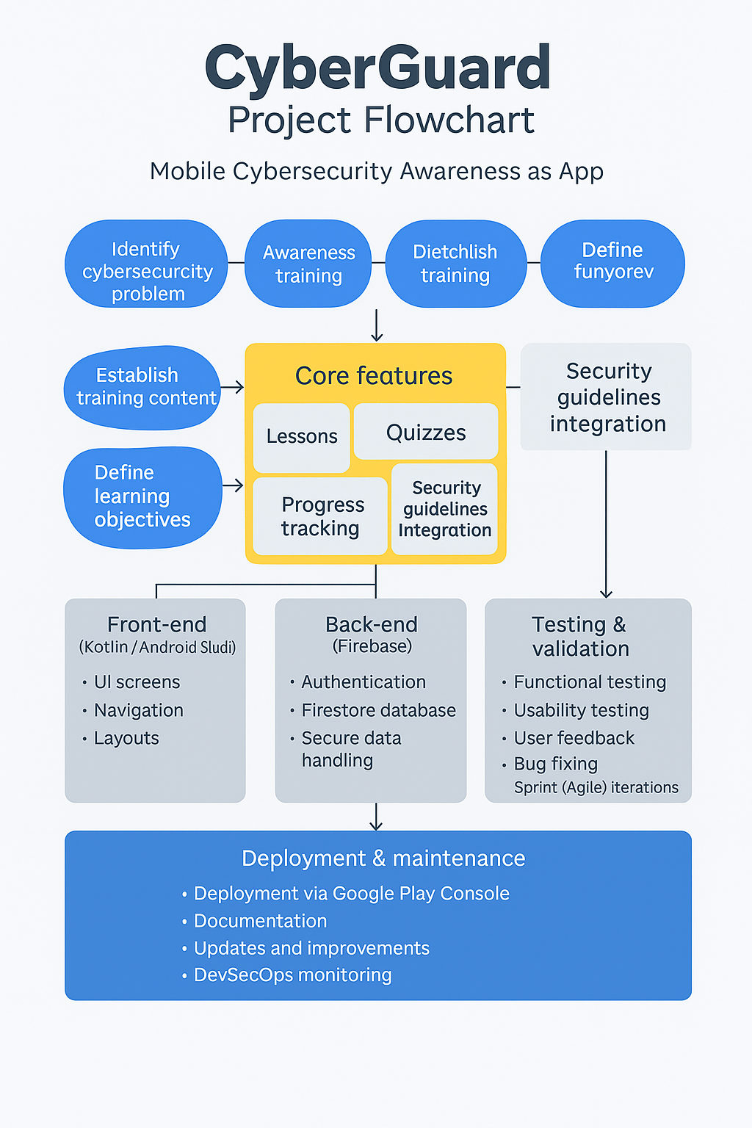
  - Figure 1. Flowchart:

Gantt Chart:
The Gantt chart provides a concise overview of the CyberGuard project timeline across four key phases: planning, development, testing, and launch. The planning stage (May–June) includes defining the project scope, completing research, and selecting the technology stack. Development activities run from late May to July, covering UX/UI design, module creation, and quiz functionality. User testing begins in June and continues through early August, allowing iterative improvements based on feedback. The project concludes with the final launch in August. This timeline ensures a structured and realistic progression from concept to deployment while supporting Agile, user-centered development.

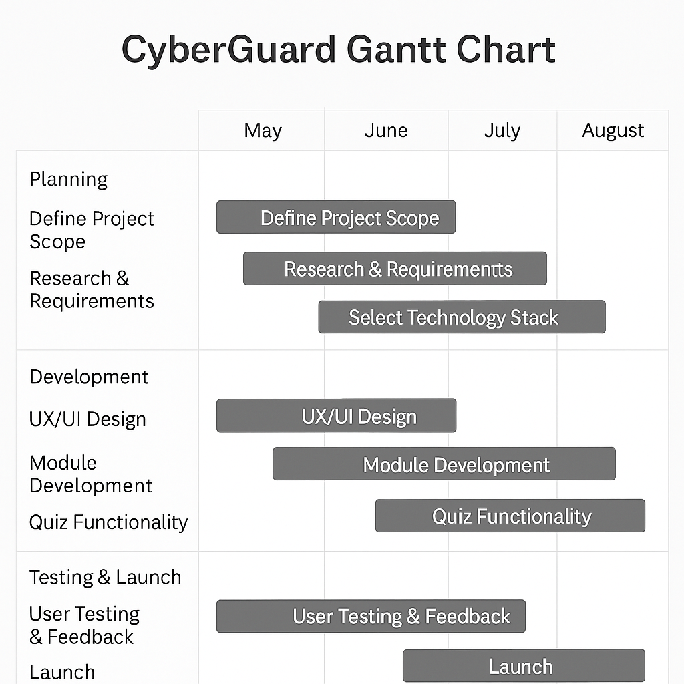
Figure 2. Gantt Chart:

UML Diagram:
The UML Use Case Diagram provides a concise overview of how the CyberGuard app interacts with its main stakeholders. The User engages with the system through actions such as registering an account, logging in, starting lessons, completing quizzes, and viewing personal progress. On the other hand, the Administrator manages the learning content by creating lessons, updating quizzes, and reviewing user analytics. The diagram also includes Firebase as an external authentication service, showing how the app relies on secure third-party verification for login and registration. Altogether, the diagram highlights the core functional areas of CyberGuard and the relationship between users, administrators, and the system.
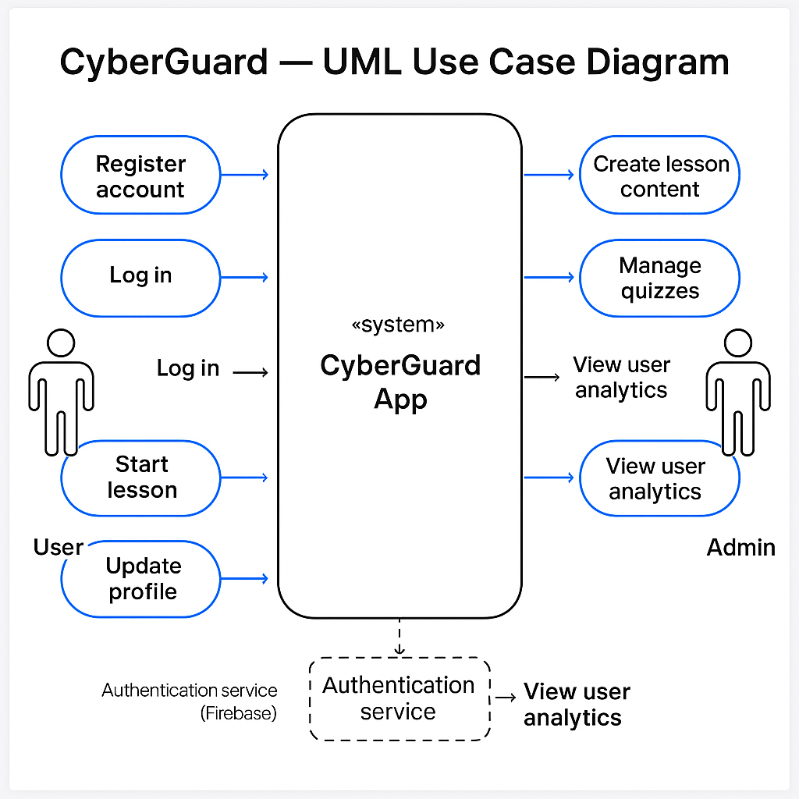
  - Figure 3. UML Diagram:

Wireframe Design Work
Four low‑fidelity wireframes were produced: a Login Screen, Dashboard. These focus on accessibility, clear layout hierarchy, and intuitive navigation.

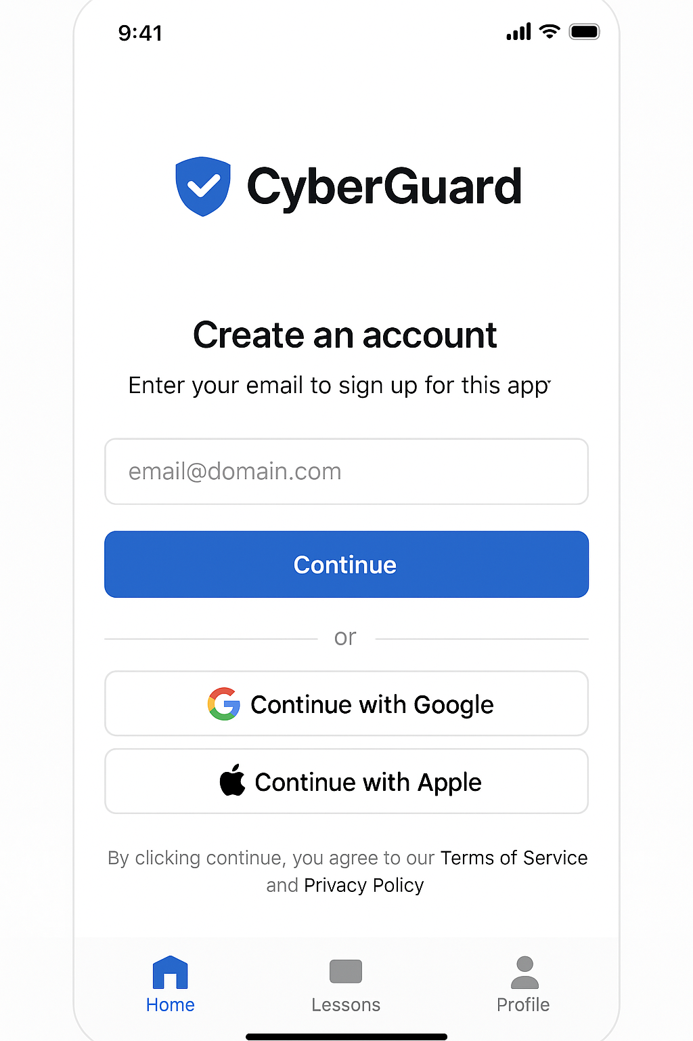
  - Figure 4: Login Screen Wireframe

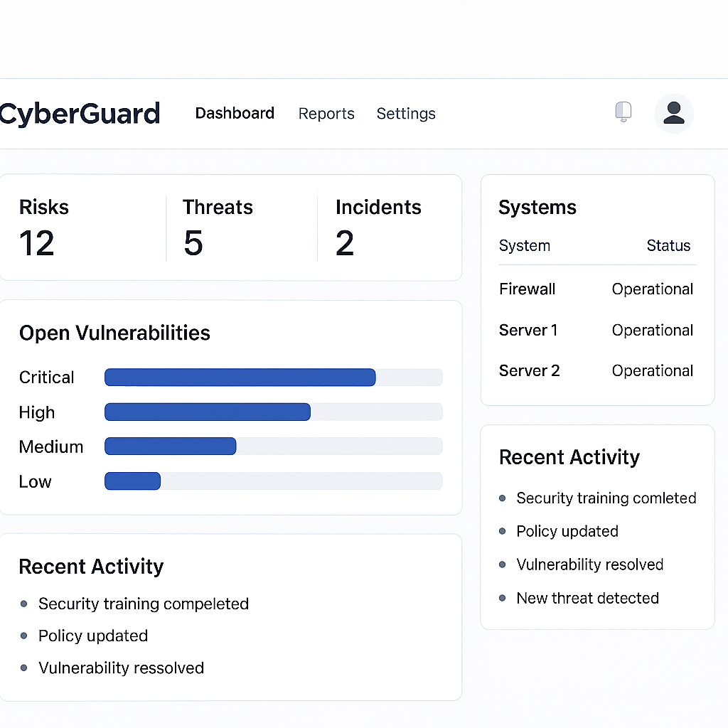
  - Figure 5: Dashboard Wireframe

Task 2 – Innovation

PEST Analysis (Google)
Political: Google must comply with GDPR and the UK Data Protection Act 2018, which enforce strict requirements for user consent and data transparency [5]. Global political scrutiny influences how Google develops privacy‑sensitive applications.
Economic: As cybercrime continues to rise globally, demand for cybersecurity education and digital protection tools grows significantly. The economic impact of cybercrime is projected to reach trillions, motivating investment in skills‑based apps like CyberGuard [6].
Social: Public awareness of phishing, fraud and online scams is increasing. Research from the NCSC highlights that user behavior remains a key weakness in cybersecurity, reinforcing the importance of awareness platforms [7].
Technological: Google benefits from industry‑leading AI, secure cloud computing, and large-scale infrastructure, enabling advanced threat detection and supporting scalable applications [8].

SWOT Analysis
Strengths: Market reach, AI leadership, robust infrastructure.
Weaknesses: Global privacy concerns, regulatory pressure.
Opportunities: Growth in cybersecurity education.
Threats: Competition from Apple and specialist cybersecurity companies [9].

Development, Deployment & Maintenance
CyberGuard would be developed using Agile Scrum, CI/CD automation, and OWASP secure coding recommendations [3]. Deployment through Google Play Console or enterprise systems ensures safe delivery. Long‑term maintenance would rely on regular updates, analytics‑driven improvements and DevSecOps practices [10].

Task 3 – Reflection
Reflecting on the development of CyberGuard has provided significant insight into both the technical and professional skills required to design a functional cybersecurity awareness application. One of the most valuable aspects of the project was the opportunity to strengthen competencies across mobile development, UI/UX design, and cybersecurity frameworks. Working with Kotlin and Android Studio allowed me to deepen my understanding of mobile application structure, lifecycle management and integration of cloud services. Incorporating Firebase for authentication and data storage further enhanced my skills in secure user management and backend connectivity, both of which are critical components in modern mobile applications.
The project also contributed substantially to my understanding of security principles and the importance of integrating recognised frameworks into software design. For example, ENISA’s annual threat landscape reports emphasise that human error remains a leading cause of cybersecurity breaches across Europe [1]. This insight shaped CyberGuard’s purpose by highlighting the need for accessible educational tools that address behavioural weaknesses. Similarly, the NIST Cybersecurity Framework provided foundational guidance on structuring the app’s learning content, helping me align the project with recognised industry standards for managing risks and building user resilience [2]. Applying these frameworks not only improved the quality of the product but also strengthened my knowledge of real-world cybersecurity practices.
From a design perspective, the creation of wireframes and user flows enhanced my appreciation for the importance of user-centred design. Developing CyberGuard required careful consideration of how users learn, navigate information and engage with digital content. This encouraged me to apply key UI/UX principles such as clarity, minimalism and accessibility, ensuring that the app would support users with differing levels of technical confidence. By iterating on prototypes and refining screen layouts, I gained deeper insight into the value of designing interfaces that complement educational objectives rather than distract from them.
Agile project management also played an important role in my development. The use of iterative workflows, regular planning sessions and progressive refinement helped me manage the project’s complexity more effectively. Literature indicates that Agile methods support adaptability and reduce project risk by enabling continuous feedback and frequent reassessment of priorities [3]. Following Agile principles allowed me to break the project into manageable phases, maintain steady progress, and address challenges as they emerged. This experience strengthened my organisational skills and highlighted the importance of flexibility when working on technical projects with evolving requirements.
Beyond technical learning, CyberGuard has important societal value. As digital dependence increases globally, individuals are more frequently exposed to phishing attacks, online fraud, identity theft and device-related vulnerabilities. Studies consistently show that public awareness remains insufficient, and many people underestimate the risks associated with daily digital behaviours [1]. CyberGuard’s goal of providing practical education in a simple mobile format has the potential to help users recognise suspicious activity, apply stronger security habits and ultimately reduce personal exposure to cyber threats. The project reinforced my belief that education is one of the most effective defences against cybercrime, particularly for non-technical audiences who may not have access to formal training.
However, the development process also introduced several challenges. Cyber threats evolve rapidly, meaning that educational content must be continuously updated to remain relevant. Incorporating guidance from frameworks such as NIST helps ensure accuracy and reliability, but maintaining up-to-date material would require ongoing research and refinement [2]. Time constraints also posed difficulties during development, particularly in balancing research, design, implementation and testing within an academic schedule. Agile planning helped mitigate these issues, but the experience highlighted the need for strong time management and prioritisation skills when delivering technical projects.
Overall, CyberGuard has been academically and professionally valuable. It has strengthened my technical abilities in mobile development, improved my understanding of cybersecurity practices, and provided practical experience in Agile methodologies and user-centred design. More importantly, it reinforced the importance of accessible cybersecurity education and its role in supporting safer digital behaviour. The project has laid a strong foundation for my continued development in cybersecurity and software engineering, while also highlighting the meaningful social impact that well-designed educational tools can achieve.

Conclusion
The CyberGuard project highlights the growing importance of accessible cybersecurity education in an increasingly digital society. By transforming essential security concepts into an intuitive mobile-learning experience, the project demonstrates how technology can support users in recognizing threats and developing safer online habits. The structured planning, innovative design, and reflective evaluation undertaken throughout the project provide a strong foundation for CyberGuard’s potential impact. Integrating recognized frameworks such as NIST and OWASP further strengthens the project’s credibility and ensures alignment with industry’s best practices. Overall, CyberGuard presents a practical and meaningful contribution to improving public cybersecurity awareness and demonstrates clear value as an educational and safety-enhancing solution.

References

[1] ENISA, Cybersecurity Threat Landscape 2023, European Union Agency for Cybersecurity, 2023.
[2] National Institute of Standards and Technology (NIST), Framework for Improving Critical Infrastructure Cybersecurity, Gaithersburg, MD, USA, 2022.
[3] OWASP Foundation, OWASP Mobile Top 10, 2023.
[4] K. Schwaber and J. Sutherland, The Scrum Guide, Scrum.org, 2020.
[5] UK Government, Data Protection Act 2018, London, UK, 2018.
[6] Cybersecurity Ventures, 2023 Cybercrime Report, 2023.
[7] National Cyber Security Centre (NCSC), Cyber Security Behavioural Insights, London, UK, 2022.
[8] Google Cloud, Security and Compliance Overview, Google LLC, 2023.
[9] European Commission, Competition in Digital Markets Report, Brussels, Belgium, 2023.
[10] Amazon Web Services & Google Cloud, DevSecOps Best Practices, 2023.

