Marketing Management
For Tesco
Programme : MBA

Module : Marketing Management
Module code : LCMB 7001

Assignment Title : 1
Student Name : Payyavula Sai Kishan
Student Number : 2126308

Lecturer Name : Tushara Balendran

Executive Summary
The report has critically appraised the innovative marketing strategy of Tesco and how it can manage the journey of the customers. Tesco is a UK-based multinational grocery company. The report has explained that Tesco should improve its marketing communication by using a push and pull strategy and improving social media and email marketing. The report has highlighted the new promotional strategies to increase brand awareness and has also mentioned the ones that Tesco can take up to improve the same. The report has rightly highlighted the brand equity model and has aligned with the company, Tesco. This has shed light on the strategies of brand awareness and the position of brand resonance of the company with its customers. Furthermore, Keller's brand equity model has been used here to improve the brand equity of Tesco and to analyse the loopholes and areas of improvement in the company regarding brand equity. The customer journey has been explained with illustrations of the touchpoints regarding Tesco. The report concludes with an explanation of the total engagement model for Tesco. The total engagement model has highlighted the link and collaboration between the company’s employees and the customers so that the company can ensure a long term success.

Table of Contents
Introduction 4
Organisational Background 4
Definition and Model of Communication 5
Integrated Marketing Communications 7
New Promotional Strategies to raise brand awareness 8
Definition of Branding and Brand Equity 11
Brand Equity Model 12
Customer Journey and Touchpoints for Tesco 14
Explanation of Total Engagement Model to Tesco 16
Conclusion 18
References 19

Introduction
Marketing is considered the heart of an organisation as it helps the brand reach directly to consumers’ minds. Due to increasing competition, all the brands have focused on innovating their marketing strategies to promote their products or services uniquely to the customers. According to Krizanova et al. (2019), the traditional or classical forms have become the things of the past. Marketers have adopted new online marketing communication strategies to cover wider audiences and advertise their products in a better way. Therefore, it has been understood that innovative marketing strategies help to increase awareness of the brand and also enhance the management of the journey of a customer.
The current report is going to critically appraise how an organisation can innovate their marketing strategies to increase brand awareness as well as enhance customer journey through various communication channels. The organisation chosen for this present scenario is Tesco Plc which is the largest grocery retailer in the United Kingdom.

Organisational Background
Tesco Plc or commonly known as only Tesco is a British multinational grocery retailer. Along with groceries, the company also sells general merchandise to customers. It is now headquartered in Welwyn Garden City in England. The company was founded by Jack Cohen in 1919 as a market stalls group at Hackney in London. In 1924, the brand first appeared under the name Tesco. Currently, Tesco is the grocery market leader in the United Kingdom with more than 27% of the market share and is named as one of the big 4 supermarkets along with Sainsbury, ASDA and Morrisons in the UK (Statista, 2022). Not only in the UK, but Tesco has also now expanded its operations across the world in more than 11 countries. As per Statista (2022), Tesco’s sales increased by 7.2% in 2020 as compared to the past years.
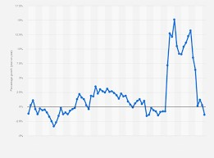

Figure 1: Sales Growth of Tesco in the UK

(Source: Statista. 2022)
The leading grocery retailer in the UK, Tesco has always focused on customers to improve their experience with the brand. Its mission is "serving our customers, communities and planet a little better every day” (Tesco Plc, 2022). In order to enhance the customer journey and be the market leader in the UK, the brand spends a lot on marketing communication to make it more innovative.

Definition and Model of Communication
Communication is a term that most organisations follow to maintain a good relationship with media and marketers to easily communicate with the target market. Marketing communication refers to the technique which is adopted by the companies like Tesco to convey messages about their product and services to customers directly or indirectly to improve their purchase intention (Prikhodko et al. 2019). Adaptation of marketing strategy is one of the effective aspects of communication that could help to exchange the information about the services to the corresponding consumers by who the company could fulfil the future stakeholder's expectations. Communication in marketing helps create an innovative marketing strategy for raising brand awareness. It also helps to evaluate the customer journey (Patel, 2022). There are different types of communication channels present in the business market such as single channel communication and Omni channel communication.
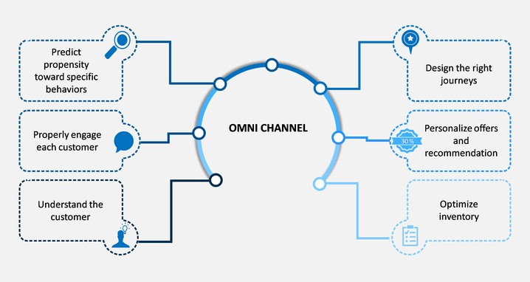

Figur
e 2
:
Omni channel communication

(Source: Patel, 2022)
Compared to a single channel or traditional marketing communication channel, the Omni channel or digital marketing channel including social media, email, videos, and online advertisement are more effective for any brand in contacting their consumers and understanding their desires easily (Patel, 2022). In this scenario, Tesco should utilise Omni channel communication to empower consumers to connect with their brand as their preferable channel which could provide a smooth transition in future (Krizanova et al. 2019).
In this scenario to determine the effectiveness of communication, the Shannon and Weaver Model of Communication would be effective for Tesco by which they can create innovative marketing strategies for raising brand awareness as well as improve their communication channel.
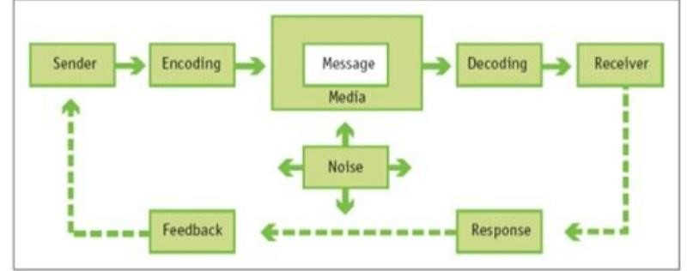

Figure 3: Shannon and Weaver Model of Communication
(Source: Week5, slide-3)
According to the Week5, slide-3 lecture module, Shannon and Weaver's Model of Communication is effective for large-scale organisations like Tesco to improvise their mode of communication as well as improvise the marketing strategies to raise brand awareness (Jovanov Apasieva, 2018). This is because the Shannon and Weaver Model of Communication provides a framework to show how the message is sent and received. The Shannon and Weaver Model of Communication is called the mother of all communication models because this model uses digital transformation like Omni channel communication with the company and their stakeholders and suppliers (Popova et al. 2019). This particular model uses the concept of digital transformation such as checking the signal, transmitter, the mood of the receiver as well as the probability of errors. Therefore, Tesco can utilise this model of communication to create innovative marketing strategies with the help of digital marketing communication channels like social media posting and online advertisement (Muniesa and Giménez, 2020).

Integrated Marketing Communications
Integrated Marketing Communication (IMC) has remained a contemporary topic of debate among researchers and professionals in marketing communication. Different scholars or researchers have provided different definitions of integrated marketing communication. As per Adebiyi and Bello (2018, pp 91), integrated marketing communication focuses on “joining and integrating elements of marketing communication in order to make them speak with one voice and one sound”. On the other hand, Li, Zhang and Yang (2018) have argued that integrated marketing communication covers more than one promotional activity by involving and integrating all the resources of the company to accomplish maximum efficiency.
Thus, it is appropriately mentioned in the Week 5 lecture note, slide 17 that IMC ensures all communication forms and messages are carefully connected. IMC has now become one of the most common promotional tools adopted by all brands.
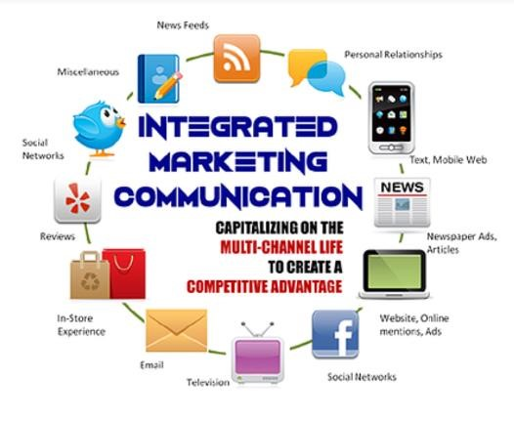

Figure 4: Concept of IMC

Source: Week 5 Lecture (Slide 18)
The chosen company Tesco, widely uses different marketing channels to communicate with the customers. It uses email marketing, social media, website, print media like magazines, newspapers, television advertisements, in-store experiences, reviews and many more to send promotional messages to the customers. Tesco also uses relationship marketing to enhance customer loyalty (James and Cooper, 2015).

New Promotional Strategies to raise brand awareness
A business promotional strategy is effectively helpful for increasing brand awareness and in this scenario, Tesco already increased its brand awareness in the UK. Therefore it is necessary for Tesco to improve their innovative marketing strategy by raising their brand to evaluate their customer journey and make adequate relations with their future stakeholders. This is because brand promotion is helpful for business profit and it is not as important as implementing operational strategy (Prikhodko et al. 2019). Proportional strategy is effectively helpful for improving business growth and exposing the product and services to a wide range of audiences.
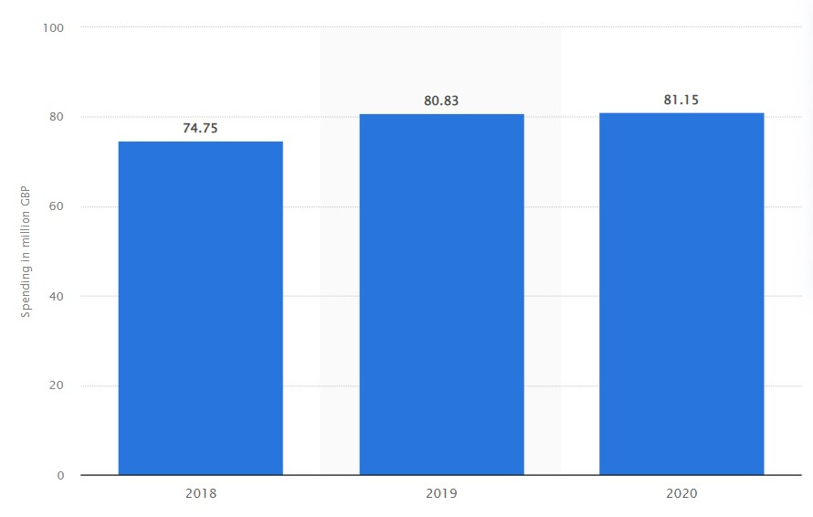

Figure 5: Ad spend of Tesco

(Source: Statista, 2022)
According to the graph, it has been evident that in the year 2020 the grocery giant Tesco will have spent approximately 81.15 million pounds on its advertisement in the United Kingdom. Therefore it has been concluded that Tesco did not shrink themselves when it came to investing in an advertisement by which Tesco increased its margin compared to the previous year which was approximately 80.83 million pounds (Statista, 2022). Therefore it would be beneficial if Tesco can utilise the push and pull strategy for promotional growth which can lead the company to raise its brand awareness (Vieira et al. 2022).
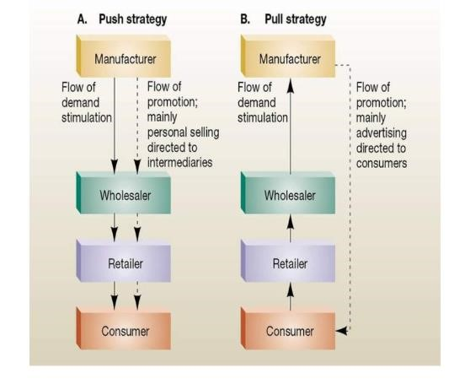

Figure 6: Push and Pull promotional strategy
(Source: Week5, slide-10)
According to the Week5, slide-10 lecture module, the push and pull strategy is effective for Tesco to increase its brand awareness because this promotional strategy involves taking the product and sending it directly to its consumers. This includes setting up different distribution channels and in this aspect, Tesco can utilise Omni channel distribution to increase their retailer and stock (Katsikari et al. 2020). Additionally, the push-and-pull promotional strategy can be adopted by Tesco to encourage the retailers to stock their products by which consumers could get the product of Tesco easily. The push and pull strategy helps the company to be directly connected with retailers by which Tesco can encourage those local retailers to stock Tesco's products by which Tesco can increase their brand awareness easily (Molitor et al.
2018).
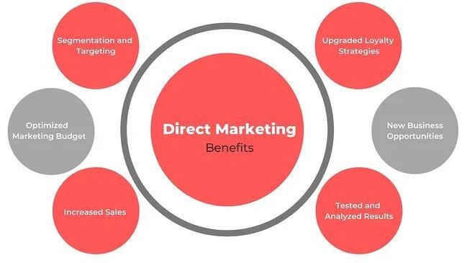

Figure 7: Direct marketing promotional strategy
(Source: Week5, slide-15)
According to the Week5, slide-15 lecture module, direct marketing promotional strategy is effective for organisations to communicate directly to their consumers through a variety of media. The direct communication promotional strategy can also provide effective brand awareness to Tesco if the company could utilise email marketing and social media marketing (Kitchen, 2020). This is because the direct marketing promotional strategy includes digital transformation by which Tesco can provide details about their products and services through their website as well as social media pages like Facebook and Instagram (Yasa et al. 2020). This strategy could easily grab the attention of consumers simultaneously and it would automatically increase brand awareness of Tesco among the maximum number of communities around the United Kingdom. The direct market promotional strategy also includes content marketing and a customer loyalty program (Elrod and Fortenberry, 2020). These two aspects could easily grab the attention of consumers because if Tesco could provide additional discounts and extra loyalty bonuses to the customers then the company could boost their preference among consumers easily.
Push and Pull promotional strategy and Direct marketing promotional strategy, both can be used by Tesco to raise their brand awareness by which Tesco could create more community around the United Kingdom by utilising different communication channels such as only channel and ensure the future stakeholder's expectations as well.

Definition of Branding and Brand Equity
In marketing, branding plays the most important role to attract customers. Branding is the process to provide meaning to a particular organisation and its products or services by developing and shaping a brand in the minds of the customers. According to Keller and Kotler (2015), branding not only increases the competitive advantage of the company but also improves customer welfare. Thus, Philip Kotler has truly defined branding from "purpose to beneficence" (The Marketing Journal, 2016). There are different types of branding adopted by the companies such as emotional branding, personal branding, product branding, retail branding etcetera. For instance, Starbucks, Apple and many other companies have appropriately adopted the concept of emotional branding (The Marketing Journal, 2016). On the other hand, brand equity, as referred to in the lecture (Slide 2), is" a value premium that a company generates from a product with a recognisable name when compared to a generic equivalent”. The brands develop brand equity for their products to make them easily recognisable, superior and memorable to the customers. Therefore, developing brand equity is crucial for the brands as it is an outcome of marketing strategy (Shariq, 2018). As per the below figure, there are different dimensions which can improve brand equity.
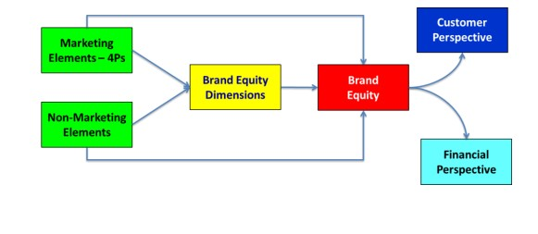

Figure 8: Relationship between the different dimension of brand equity Source: Shariq (2018)

Brand Equity Model
The concept of brand equity refers to the process of adding value to a brand by providing better pricing to the customers and better revenue to the brand or the company. As per studies it can be established that a brand is an intangible asset of an organisation and that brings financial profits to the company (Raut et al., 2019). Brand equity depends on an array of factors like the performance of the brand, brand loyalty, brand awareness and the quality of the brand or the products and services of the same. There are certain brand equity models that are like frameworks and processes that help to create value for the brand. One of the most effective models for brand equity is Keller's brand equity model which can be analysed to understand the brand equity of Tesco. Tesco is the largest retail chain in the UK as mentioned above. The company focuses mainly on the experience of the customers regarding the products of the brand and the services as well (Jara, 2018). Therefore Keller’s brand equity model will serve the purpose of analysing the brand equity of Tesco as it is a customer-based model.
Keller’s brand equity model is a pyramid which has 4 steps namely brand identity, brand meaning, brand response and brand resonance. The brand identity or brand salience refers to the awareness of the brand among the customers (Efanny et al., 2018). It involves the process to help the customer recognize a brand and be aware of the same. The brand identity of Tesco is created by targeting all genders and families of middle income mainly through print advertisements and media like TV (Molinillo, Ekinci, and Japutra, 2019). However, Tesco can enhance its brand awareness by indulging in social media advertisements and influencer marketing. Further, the second step refers to the brand meaning. It refers to the value of the brand to the customers or where the products stand for the customers. This can be done through the analysis of the performance as how the products are meeting the needs and demands of the customers on a social and psychological level (Jara, 2018). In this case, Tesco has a high brand meaning as it has high customer loyalty and customers prefer the wide variety of products of the brand with high quality. However, the company should offer other services like fast home deliveries and effective online purchase opportunities with easy payment and exchange options (Raut et al., 2019).
The third step in the model is a brand response where the brand should consider the response of the customers in terms of the quality and credibility of the products. The brand response of Tesco is quite positive as the customers are quite satisfied with the quality of the products as the company focuses on the high quality of the products at low prices and is quite capable of meeting the needs of the customers through frequent innovations in the product collection (Jara, 2018). However, the company lags behind d in customer services ads website the company lags in an efficient user interface. The fourth and final step of the model refers to brand resonance. Brand resonance is a phase where the customers indulge with the brand on a psychological level and identifies a bond with the brand through repeat purchases and communities (Efanny et al., 2018). In the case of Tesco, the company has repeat customers and loyal customers as well but the brand is yet to achieve full brand resonance which is quite difficult in the industry. The company faces stiff competition being in the topmost position and moreover, the products of all the competitors are barely different and this prevents the company to attain complete brand resonance (Molinillo, Ekinci, and Japutra, 2019).
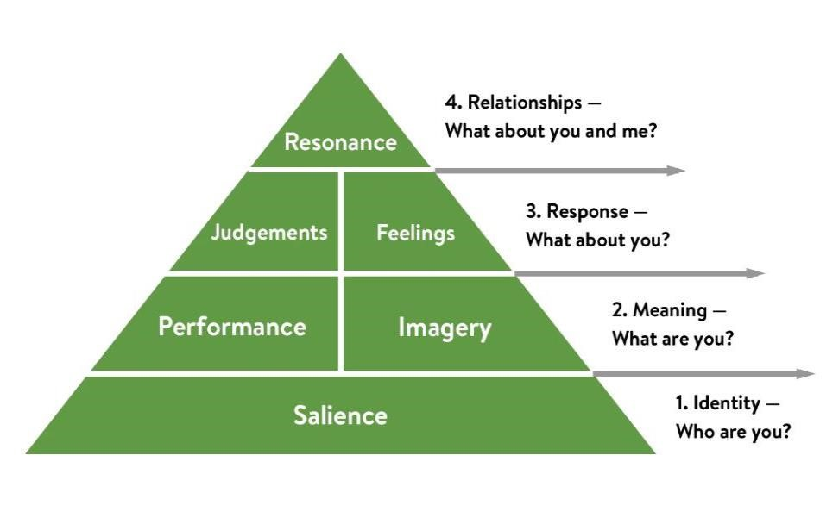

Figure

9
:
Keller’s brand equity model

(Source: Raut et al., 2019)

Customer Journey and Touchpoints for Tesco
The customer journey and touchpoints are two aspects of a single concept which is the engagement of the customer with the brand. The customer journey of a brand includes the awareness of the brand to the purchase till the after-purchase customer service. It is the path of the journey of the customer through touchpoints to take the purchase decision (Customer journey and touchpoints, slide 4). Additionally, the touchpoints are places in the journey where the interactions of the brand take place with the customers (Burton, Gruber, and Gustafsson, 2020). The company, Tesco reaches its customers through channels and mediums and the primary ways that the company used is the print media and TV but recently it has expanded the medium by indulging in digital media to interact and reach the customers. The first step in the customer journey is completed through awareness through print media and social media where the touchpoints are social media like Facebook and newspapers along with TV advertisements (Rooderkerk, and Kök, 2019). The Facebook account of Tesco indulges in the activity to maintain a community of Tesco customers and Twitter is also used by the company for other activities of interaction. The next step in the customer journey is the consideration of the products and the touchpoint of this step in the customer journey is the Facebook community, the website of the company and the mobile app of the company where the customers will find vlogs (Video blogging) and reviews respectively that would help the customers to build an image of the products of the brand (Koetz, 2018).
The next step in the customer journey is the purchase of the products of the brand. The touchpoints of the purchase include the stores of Tesco. In recent times, the company has made its presence felt on digital and online platforms (Rooderkerk, and Kök, 2019). The company has an app of its own that is accessible on mobiles and through the app as well as the website of the company customers can purchase the products of the brand. Further, the steps include retention of the customers. In this step, the touchpoints include the loyalty programs of the company as Tesco offers discounts and promotional offers as well to retain its customers (Alam, and Raut-Roy, 2019). The touchpoints also include robust customer services through websites and contact numbers. The final step is the advocacy of the brand. The touchpoint of advocacy for Tesco includes word-of-mouth marketing, reviews on social media and the website or the app, and reviews in the Facebook community as well (Koetz, 2018).
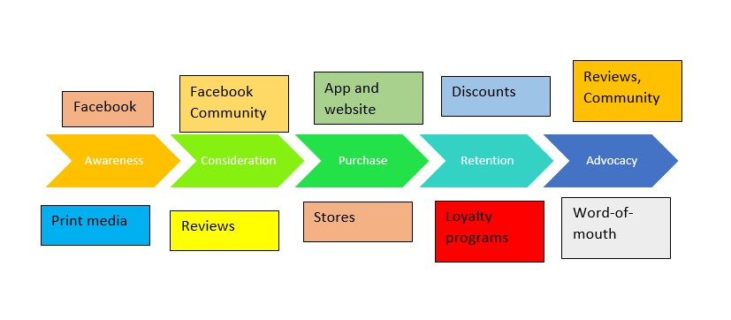

Figure 10: Overview of Customer journey and Touchpoints of Tesco (Source: Author developed)

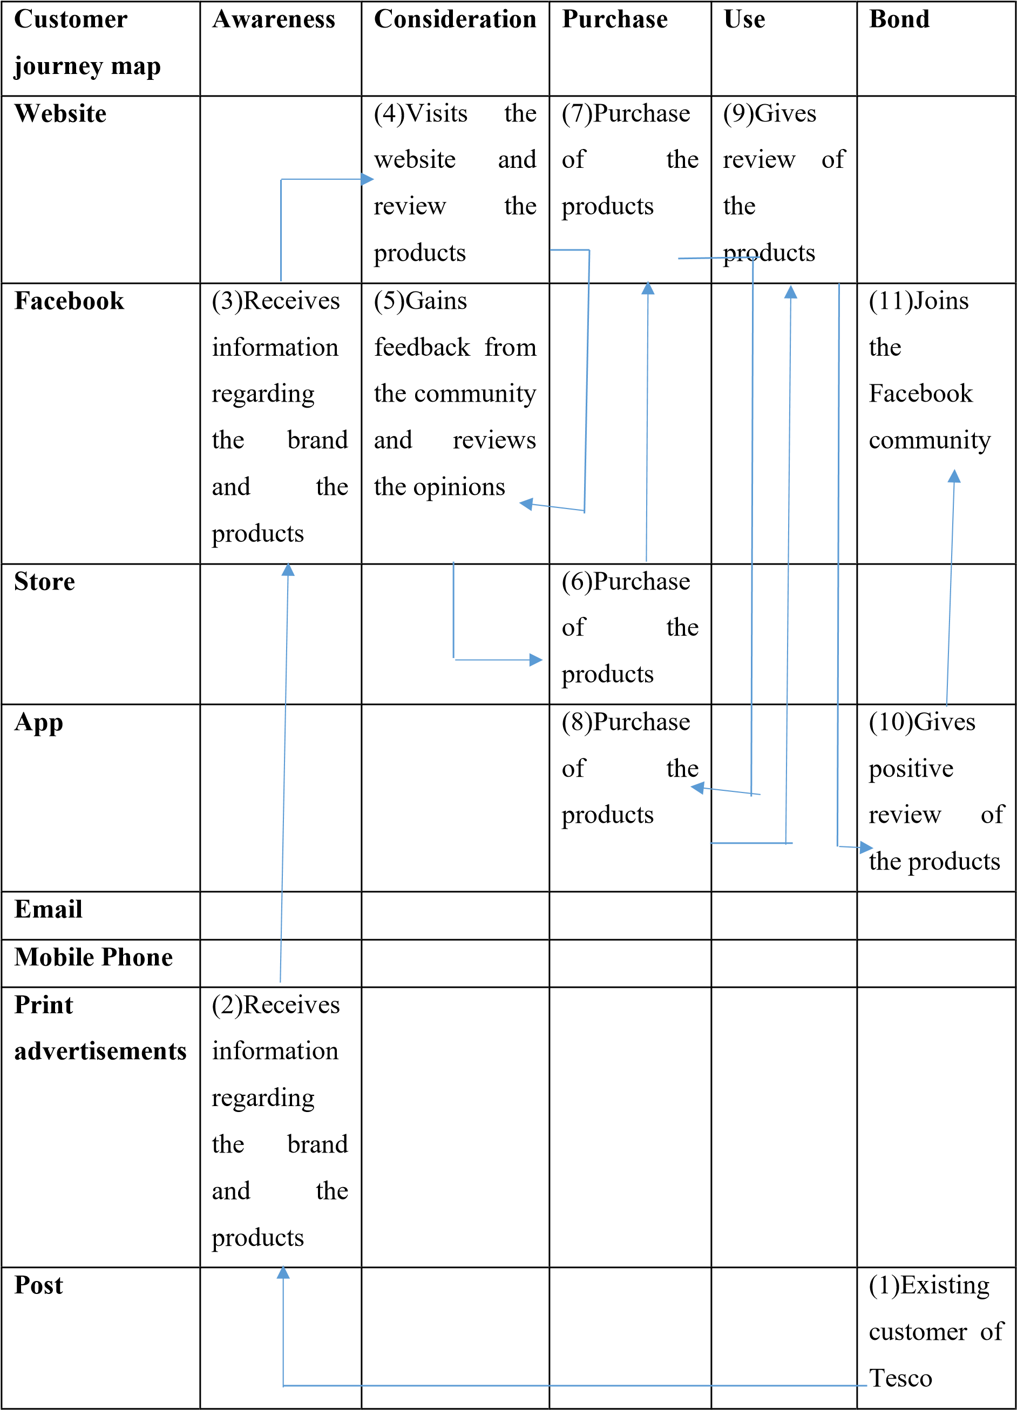
Table 1: Customer journey and Touchpoints of Tesco
(Source: Author developed)

Explanation of Total Engagement Model to Tesco
The total engagement model is concerned with customer engagement with the brand. It defines the need to create a strategic link with collaboration between the engaged customers and the engaged customers to achieve long-term growth (Customer journey and touchpoints, slide 25). The total engagement model includes all the components like organisational culture, the employees, customer service, promises of the brand and performance delivery. In the first step, it is important to create a robust organisational culture (Paavola, and Cuthbertson, 2022). In this case the company, Tesco has a positive organisational culture that is customer-centric and indulges in sustainable measures as well. However, in the past, the company has suffered from legal battles when the employees had taken legal actions in terms of inequality in gender pay. The company trains the employees well to serve the customers according to their needs and demands and the after-sale services as well (Loonam et al., 2018). The company has indulged in RFID so that the employees and the organisation can enhance the customer in-store experience. The company needs to focus on the interface of the websites as well which lacks effectiveness and efficiency (Beckers et al., 2022).
The brand advertising is robust as well as recently the brand has engaged in social media marketing and has also built communities on Facebook for better marketing and brand resonance (Beckers et al., 2022). Earlier the brand had only engaged in print media and TV ads to inform the customers regarding the products and to promote the same. However, the app of the brand and the social media advertising have helped the brand to reach out to the customers and add value to the brand by increasing its awareness of the brand. Tesco has a brand strategy that indicates the practice of high quality and low pieces. This strategy has been permanent and the company has never failed to provide high quality to the customers at low prices through campaigns like “cheap prices every day” (Tesco, 2022). This has helped the company to keep its promise to serve the customers with high-quality products at low prices and therefore the company has targeted customers that have middle income (Paavola, and Cuthbertson, 2022). Moreover, Tesco has been able to cater to the changing needs of the customers by including innovations in the products and collection of the same. The company has also been able to pace up with the technological changes through RFID, online payment, home deliveries, online sales and so on (Loonam et al., 2018)).
However, the company, Tesco needs to bring improvements in some of the areas and steps in the total engagement of the customers. The company should increase its presence in digital media and it should also improve the user interface of the website of the company (Loonam et al., 2018). The company should also solve the conflicts in the workforce through equality in terms of employee rights so that customer service can be strengthened and enhanced in the future. This would also help the company to gain a competitive advantage and stay ahead in the competition in the market.
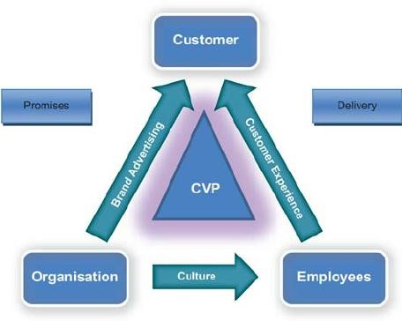

Figure 11: Total Engagement Model
(Source: Customer journey and Touchpoints, slide 28)

Conclusion
The report has effectively discussed the importance of innovative marketing strategies for Tesco to raise brand awareness as well as manage the journey of the customers. Branding is highly important for a company to attract customers and make its products different from its competitors. In order to talk about Tesco, it is the grocery market leader in the UK with more than 27% market share. Therefore, it is important to improve its communication strategies to promote products to the customers. Tesco should utilise a push-and-pull marketing strategy along with an omnichannel presence to improve its communication channel. Furthermore, the brand can also improve its focus on direct communication, social media and email marketing. Keller's brand equity model has been applied in this context to improve brand equity and manage the customer journey of Tesco.

References
Adebiyi, R.A. and Bello, S., 2018. Perception and practice of Integrated Marketing
Communication (IMC) among selected marketing communication agencies in Nigeria. Acta Universitatis Danubius. Communication, 12(1). http://journals.univdanubius.ro/index.php/communicatio/article/view/4865.
Alam, S. and Raut-Roy, U., 2019. Evaluating the Effectiveness of Reward Strategy at Tesco: Evidence from Selected Stores in the UK. Indian Journal of Industrial Relations, 55(1). https://search.ebscohost.com/login.aspx?direct=true&profile=ehost&scope=site&authtype=cr awler&jrnl=00195286&AN=137810777&h=1665NZQGpkU6I7DnMSxV7IQTOpYUzfhnM VDgfeTE8hwDEw9V6PtK%2B8NPj%2BTqpYBaP3Z0cZi5G%2FSvCBhmf2w1bA%3D%3 D&crl=c
Beckers, J., Birkin, M., Clarke, G., Hood, N., Newing, A. and Urquhart, R., 2022. Incorporating
E‐commerce into Retail Location Models. Geographical Analysis, 54(2), pp.274-293. https://onlinelibrary.wiley.com/doi/abs/10.1111/gean.12285
Burton, J., Gruber, T. and Gustafsson, A., 2020. Fostering collaborative research for customer experience–connecting academic and practitioner worlds. Journal of Business Research, 116, pp.351-355. https://www.sciencedirect.com/science/article/pii/S0148296320302861
Efanny, W., Haryanto, J., Kashif, M. and Widyanto, H.A., 2018. The relationship between marketing mix and retailer-perceived brand equity. IMP Journal.
https://www.emerald.com/insight/content/doi/10.1108/IMP-12-2016-0019/full/html
Elrod, J.K. and Fortenberry, J.L., 2020. Direct marketing in health and medicine: using direct mail, email marketing, and related communicative methods to engage patients. BMC Health
Services Research, 20(1), pp.1-7. https://bmchealthservres.biomedcentral.com/articles/10.1186/s12913-020-05603-w
James, A. and Cooper, B., 2015. The Impact of Relationship Marketing On Customer Loyalty
At Tesco Plc, UK.
https://www.academia.edu/download/57746526/The_Impact_of_Relationship_Marketing_On _Customer_Loyalty_AtTesco_Plc_UK.pdf.
Jara, M., 2018. Retail Brand Equity: Measurements through Brand Policy and Store Formats. American Journal of Industrial and Business Management, 8(03), p.579.
https://www.scirp.org/html/11-2121145_83152.htm
Jovanov Apasieva, T., 2018. Inter-functional coordination: the importance of employee communication in marketing activities of entrepreneurial companies in a developing economy.
Balkan Soc. Sci. Rev., 11, p.149.
https://js.ugd.edu.mk/index.php/BSSR/article/download/2308/2030
Katsikari, C., Hatzithomas, L., Fotiadis, T. and Folinas, D., 2020. Push and pull travel motivation: segmentation of the Greek market for social media marketing in tourism. Sustainability, 12(11), p.4770. https://www.mdpi.com/2071-1050/12/11/4770/pdf
Keller, K.L. and Kotler, P., 2015. Holistic marketing: a broad, integrated perspective to marketing management. In Does Marketing Need Reform?: Fresh Perspectives on the Future
(pp. 308-313). Routledge.
https://www.taylorfrancis.com/chapters/edit/10.4324/9781315705118-48/holistic-marketingbroad-integrated-perspective-marketing-management-kevin-lane-keller-philip-kotler.
Kitchen, P.J., 2020. Marketing communications. In A reader in marketing communications (pp.
1-9). Routledge. https://www.taylorfrancis.com/chapters/edit/10.4324/9781003060420-
1/marketing-communications-philip-kitchen
Koetz, C., 2018. Managing the customer experience: a beauty retailer deploys all tactics. Journal of Business Strategy. https://www.emerald.com/insight/content/doi/10.1108/JBS-09-2017-0139/full/html
Krizanova, A., Lăzăroiu, G., Gajanova, L., Kliestikova, J., Nadanyiova, M. and Moravcikova, D., 2019. The effectiveness of marketing communication and the importance of its evaluation in an online environment. Sustainability, 11(24), p.7016. https://www.mdpi.com/20711050/11/24/7016/pdf
Krizanova, A., Lăzăroiu, G., Gajanova, L., Kliestikova, J., Nadanyiova, M. and Moravcikova, D., 2019. The effectiveness of marketing communication and the importance of its evaluation in an online environment. Sustainability, 11(24), p.7016. https://www.mdpi.com/591378. Li, T., Zhang, X. and Yang, K., 2018. The dilemma of implementation of Integrated marketing communication. https://www.diva-portal.org/smash/record.jsf?pid=diva2:1218133.
Loonam, J., Eaves, S., Kumar, V. and Parry, G., 2018. Towards digital transformation: Lessons learned from traditional organizations. Strategic Change, 27(2), pp.101-109. https://onlinelibrary.wiley.com/doi/abs/10.1002/jsc.2185
Molinillo, S., Ekinci, Y. and Japutra, A., 2019. A consumer-based brand performance model for assessing brand success. International Journal of Market Research, 61(1), pp.93-110. https://journals.sagepub.com/doi/abs/10.1177/1470785318762990
Molitor, D., Spann, M., Ghose, A. and Reichhart, P., 2018. Measuring the effectiveness of location-based mobile push vs. pull targeting. https://scholar.archive.org/work/4k2b7zntkbaktkq45dg6chrhem/access/wayback/https://aisel. aisnet.org/cgi/viewcontent.cgi?article=1210&context=icis2018
Muniesa, R.L. and Giménez, C.G., 2020. The importance of the loyalty of fashion brands through digital marketing. Journal of Spatial and Organizational Dynamics, 8(3), pp.230-243. https://www.jsod-cieo.net/journal/index.php/jsod/article/download/245/192
Paavola, L. and Cuthbertson, R., 2022, January. The transformative power of mundane technologies in institutional change. In Proceedings of the 55th Hawaii International Conference on System Sciences. https://scholarspace.manoa.hawaii.edu/handle/10125/80209
Patel, S (2022). What is Omnichannel Communication? (and Why It’s Important). Available at: https://www.revechat.com/blog/omnichannel-communication/ [Accessed on: August 20th, 2022]
Popova, N., Kataiev, A., Skrynkovskyy, R. and Nevertii, A., 2019. Development of trust marketing in the digital society. Economic Annals-XXI, (3-4), pp.13-25. https://www.ssoar.info/ssoar/bitstream/handle/document/67692/ssoar-econaxxi-2019-3-4popova_et_al-
Development_of_trust_marketing_in.pdf?sequence=1&isAllowed=y&lnkname=ssoareconaxxi-2019-3-4-popova_et_al-Development_of_trust_marketing_in.pdf
Prikhodko, K., Danilevskaya, E., Savina, K. and Shupenko, R., 2019. Innovative opportunities and reserves of contemporary marketing communication.
https://www.um.edu.mt/library/oar/bitstream/123456789/46162/1/Innovative_opportunities_a nd_reserves_of_contemporary_marketing_communication.pdf
Raut, U.R., Pawar, P.A., Brito, P.Q. and Sisodia, G.S., 2019. Mediating model of brand equity and its application. Spanish Journal of Marketing-ESIC.
https://www.emerald.com/insight/content/doi/10.1108/SJME-04-2019-0021/full/
Rooderkerk, R.P. and Kök, A.G., 2019. Omnichannel assortment planning. In Operations in an omnichannel world (pp. 51-86). Springer, Cham.
https://link.springer.com/chapter/10.1007/978-3-030-20119-7_4
Shariq, M., 2018. Brand equity dimensions-a literature review. International Research Journal of Management and Commerce, 5(3), p.312. https://www.researchgate.net/profile/Mohammad-Shariq-
2/publication/326302689_BRAND_EQUITY_DIMENSIONS-
A_LITERATURE_REVIEW/links/5b44e4bcaca272dc385e1d47/BRAND-EQUITYDIMENSIONS-A-LITERATURE-REVIEW.pdf.
Statista (2022). Advertising expenditure of Tesco in the United Kingdom (UK) from 2018 to 2020. Available at: https://www.statista.com/statistics/549738/tesco-uk-adspending/#:~:text=In%202020%2C%20grocery%20giant%20Tesco,at%20around%2080.83 %20million%20pounds [Accessed on: August 20th, 2022]
Statista., 2022. Percentage change in sales at Tesco in Great Britain compared to a year earlier from January 2015 to November 2021 Available at: https://www.statista.com/statistics/386598/tesco-sales-percentage-change-great-britain-uk/ . [Accessed on: August 20th, 2022]
Tesco Plc., 2022. Core Purpose and Values. Available at: https://www.tescoplc.com/about/how-we-do-business/core-purpose-and-values/. [Accessed on: August 20th, 2022]
Tesco, 2022. [online] Tesco. Available at: &lt;https://www.tesco.com/&gt; [Accessed 25 August 2022].
The Marketing Journal., 2016.“Branding: From Purpose to Beneficence” – Philip Kotler. Available at: https://www.marketingjournal.org/brand-purpose-to-beneficence-philip-kotler/. [Accessed on 25 August 2022]
Vieira, V.A., Severo de Almeida, M.I., Gabler, C.B., Limongi, R., Costa, M. and Pires da Costa, M., 2022. Optimising digital marketing and social media strategy: from push to pull to performance. Journal of Marketing Management, 38(7-8), pp.709-739.
https://www.tandfonline.com/doi/abs/10.1080/0267257X.2021.1996444
Yasa, N., Giantari, I.G.A.K., Setini, M. and Rahmayanti, P.J.M.S.L., 2020. The role of competitive advantage in mediating the effect of promotional strategy on marketing performance. Management Science Letters, 10(12), pp.2845-2848.
http://m.growingscience.com/msl/Vol10/msl_2020_120.pdf

