

Allan Costa Oliveira - 2328469
DDA - BSc Degree Apprenticeship Computing (Software Engineering)
L4 - Computer Architecture and Operating Systems (ACCA4022)
Operating Systems

Contents
Introduction 4
The key/main functions of Operating Systems 5
File System Management 6
Device Management 7
Memory Management 8
Process Management 9
Where some of these functions can be seen, monitored and managed 10
Kernel 16
Job Scheduler 17
OS Networking 18
OS Security 19
Use of Windows OS CLI commands 20
Mkdir 21
Dir 22
Copy 23
Move 24
Del 25
Xcopy 26
Cls 27
Robocopy 28
Timeout 29
Tasklist 30
Use of Linux OS CLI commands 31
Mkdir 32
Ls 33
Touch 34
Cd 35
Rm 36
Grep 37
Awk 38
Clear 39
Sed 40
Find 41
Use of Windows OS Scripts 42
Use of Linux OS Scripts 46
Conclusion 51
References 52
Appendices 55

Introduction

This report is a well-structured document done by me for the OS Word document assignment given to us all to complete, covering 5 main topics which are: Key functions of general OS, Use of Windows OS CLI commands, Use of Linux OS CLI commands, Use of Windows OS Scripts and Use of Linux OS Scripts. Apart from these topics and summarised information about each one of them, we can find on this document some relevant images/screenshots, as well as references and appendices for further connection and explanation of all the content of this report as supporting documentation/further information.

The key/main functions of Operating Systems

The main/key functions of operating systems can be the following ones (As demonstrated in [1]):
- File System Management
- Device Management
- Memory Management
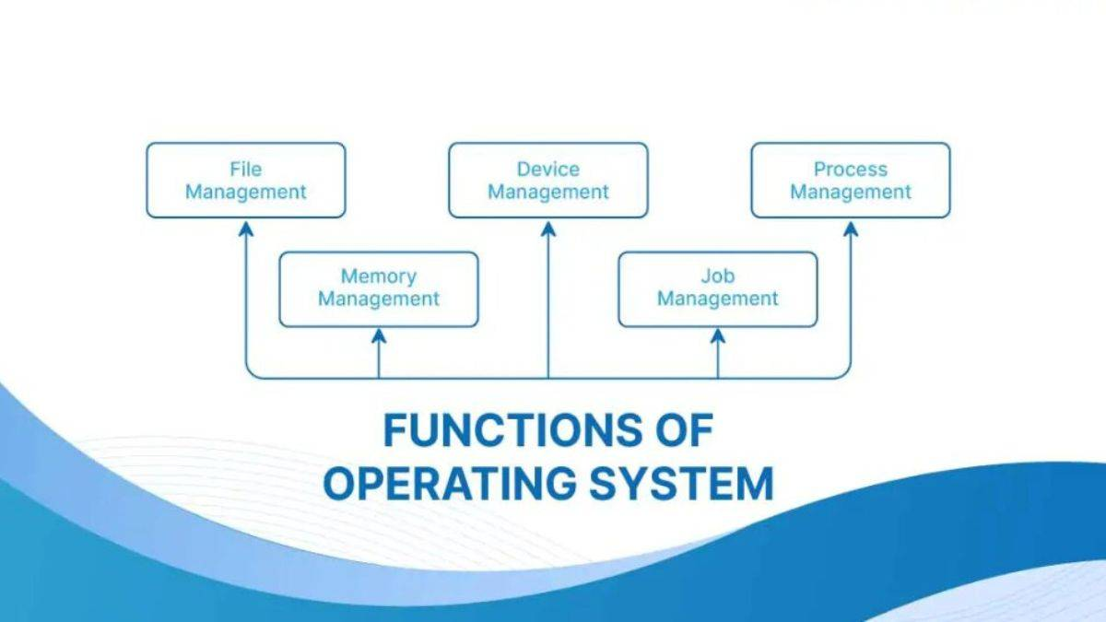
- Process Management

File System Management

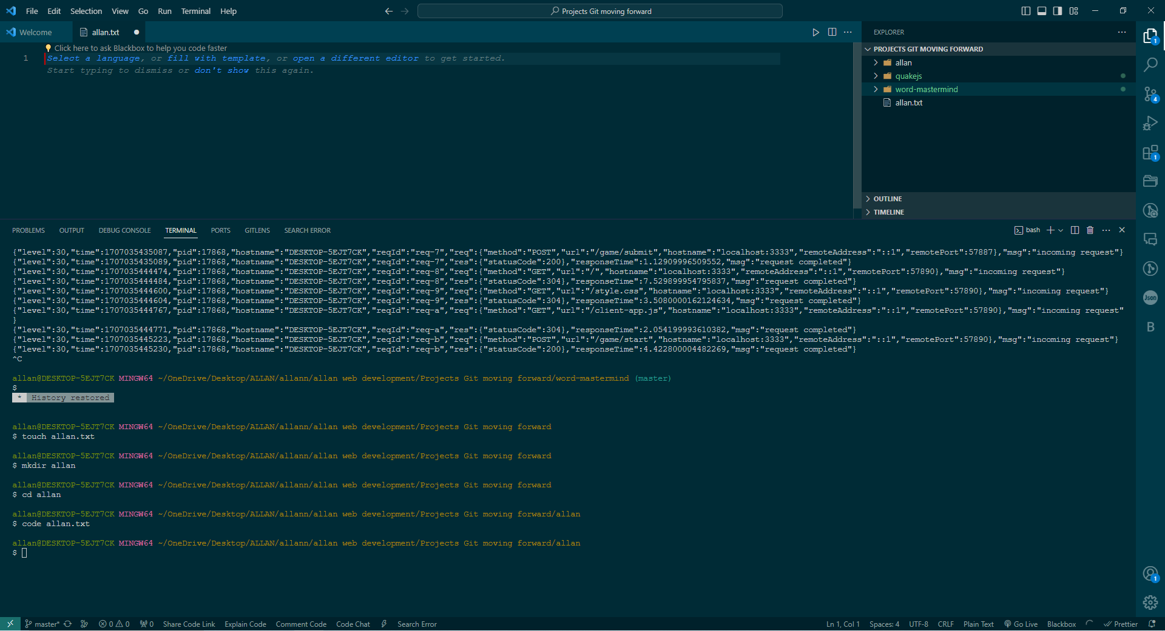
The Operating system also deals with data files when managing them, storing, arrange/organise and retrieve/locate those files and data, which is where File System management comes in place, so we can’t lose data or get files overwritten accidentally or any sort of lack of data tracking. As demonstrated in [1].
1 Creating/managing files and folders on Git/Node Bash

Device Management

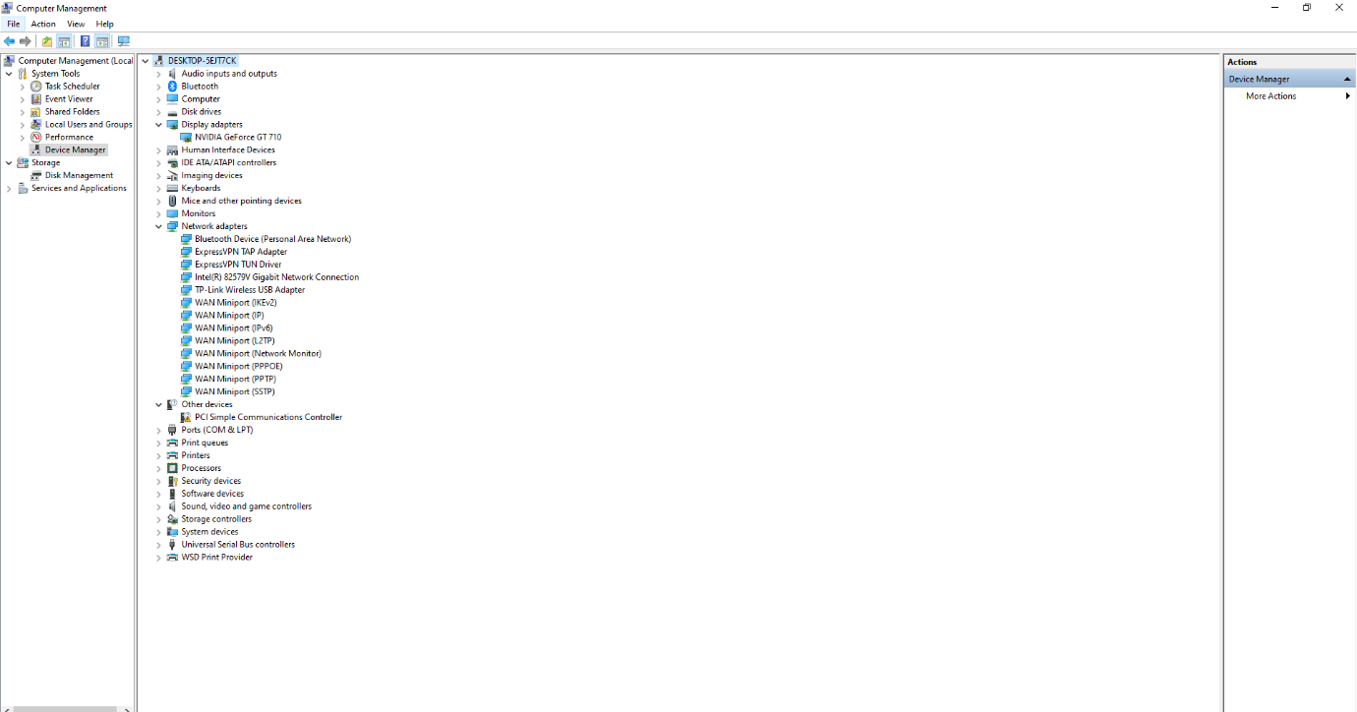
The Operating System can manage devices when dealing with input and output to allocate memory and process those input and output requests as well as managing storage devices. This happens with normal computer devices such as a mouse or keyboard, headphones or printers, drivers and network adapters and all sort of input output devices that can have a specific function/connection with the OS/computer. As demonstrated in [3].
2 Windows Device Management for drivers, adapters, and input output

Memory Management

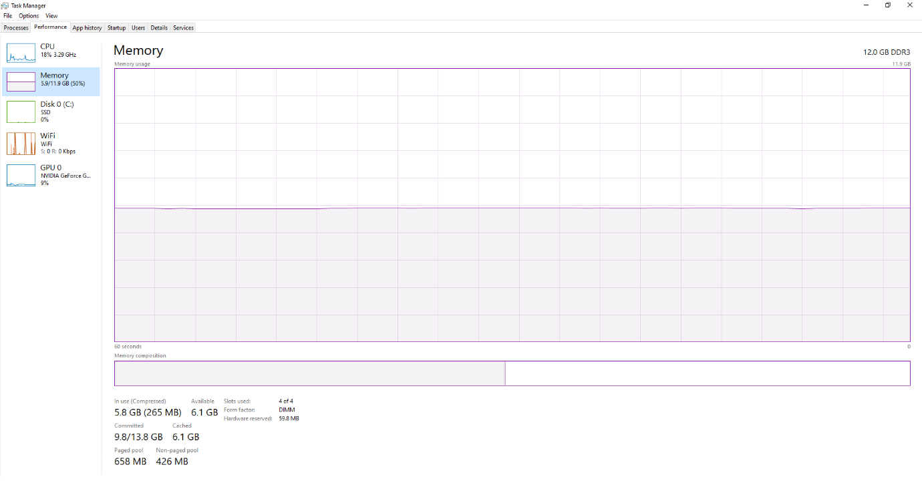
The Memory Management is when the Operating System keeps track of the primary memory and where data is being stored as well as which space is still available for further data to be stored. It is where also decided the order of which processes/tasks will receive the prospective memory address allocation which is at the moment available and will soon be used to store that specific process. As demonstrated in [2].
3 Memory Management Task Manager Memory Performance stats

Process Management

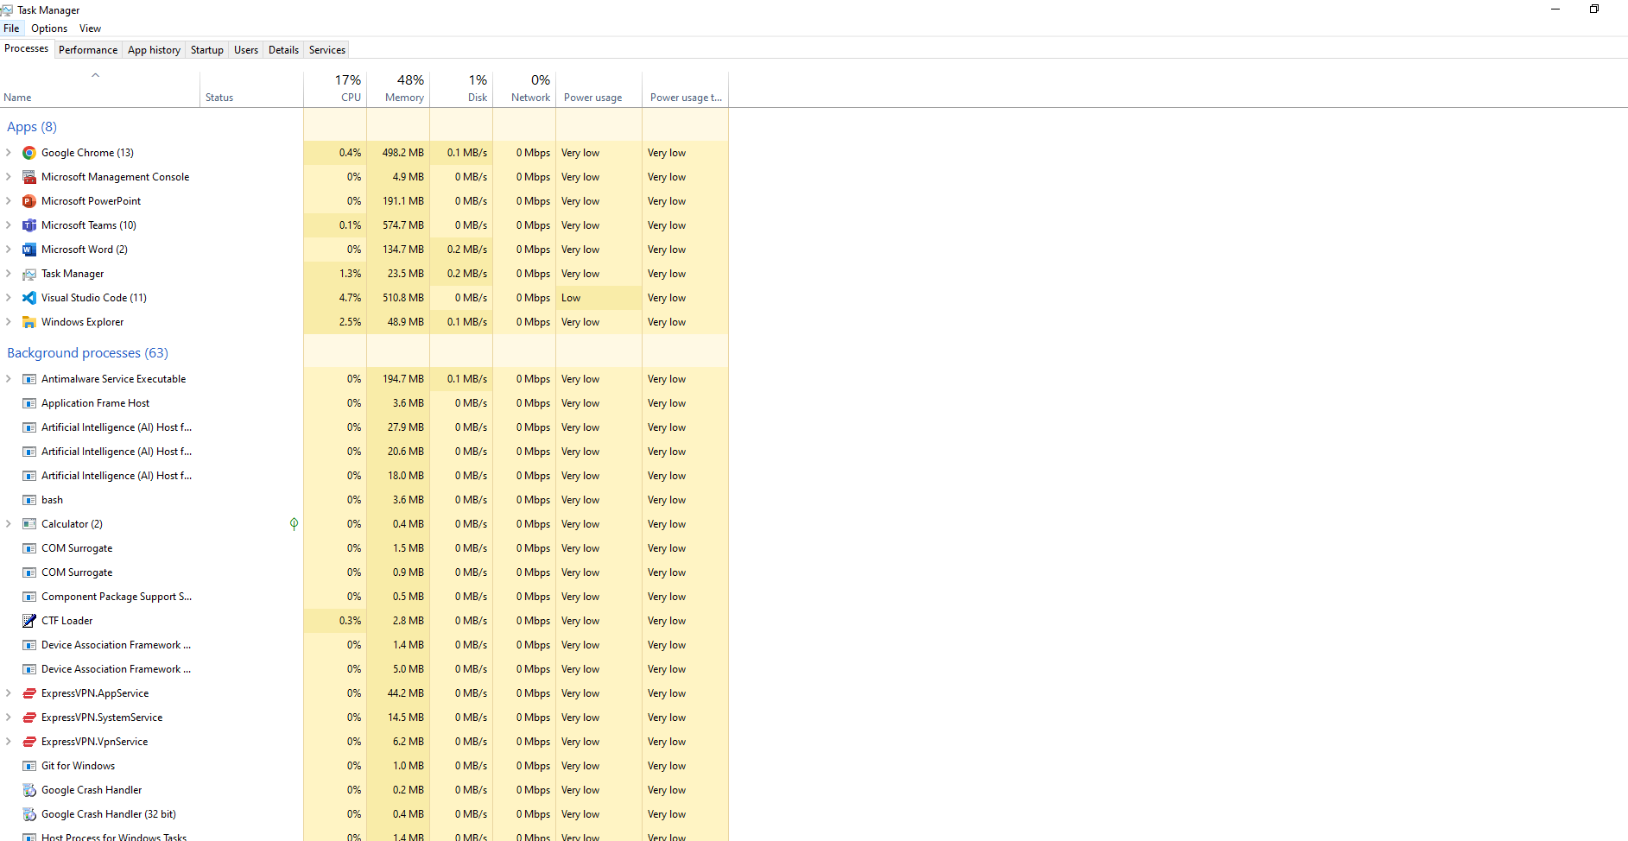
Operating systems have a structure method when dealing/managing processes to make sure they will follow certain order to be executed as well as redirecting them to the correct memory allocation and scheduling those processes to the right/correct time to be started and finished by using algorithms. As demonstrated in [4].
4 Process Management Task Manager all live processes

Where some of these functions can be seen, monitored and managed

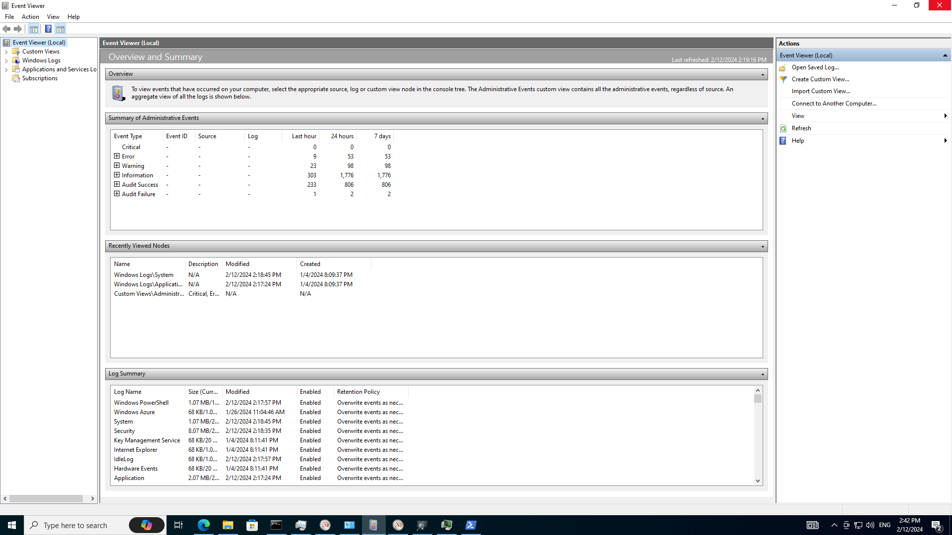
5 Event Viewer

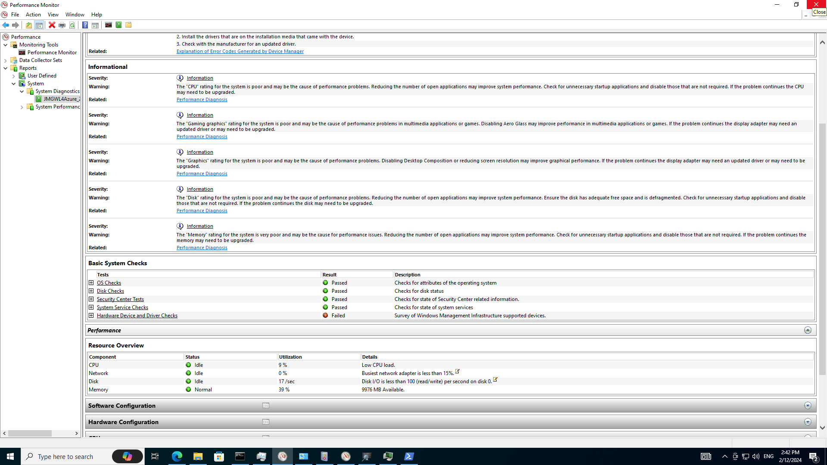
6 Performance Monitor

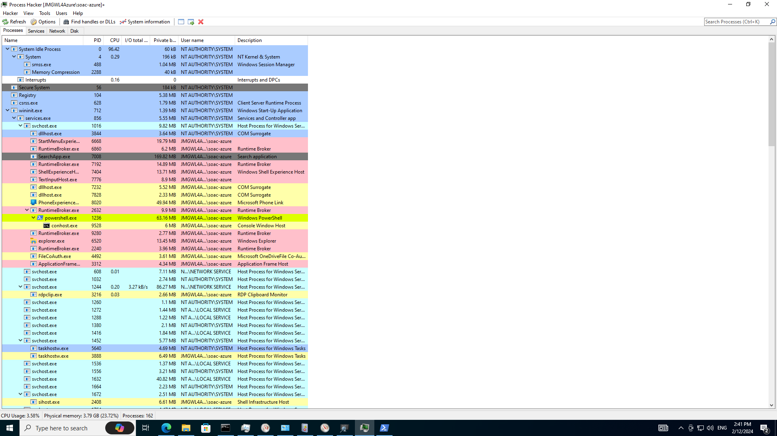
7 Process Hacker

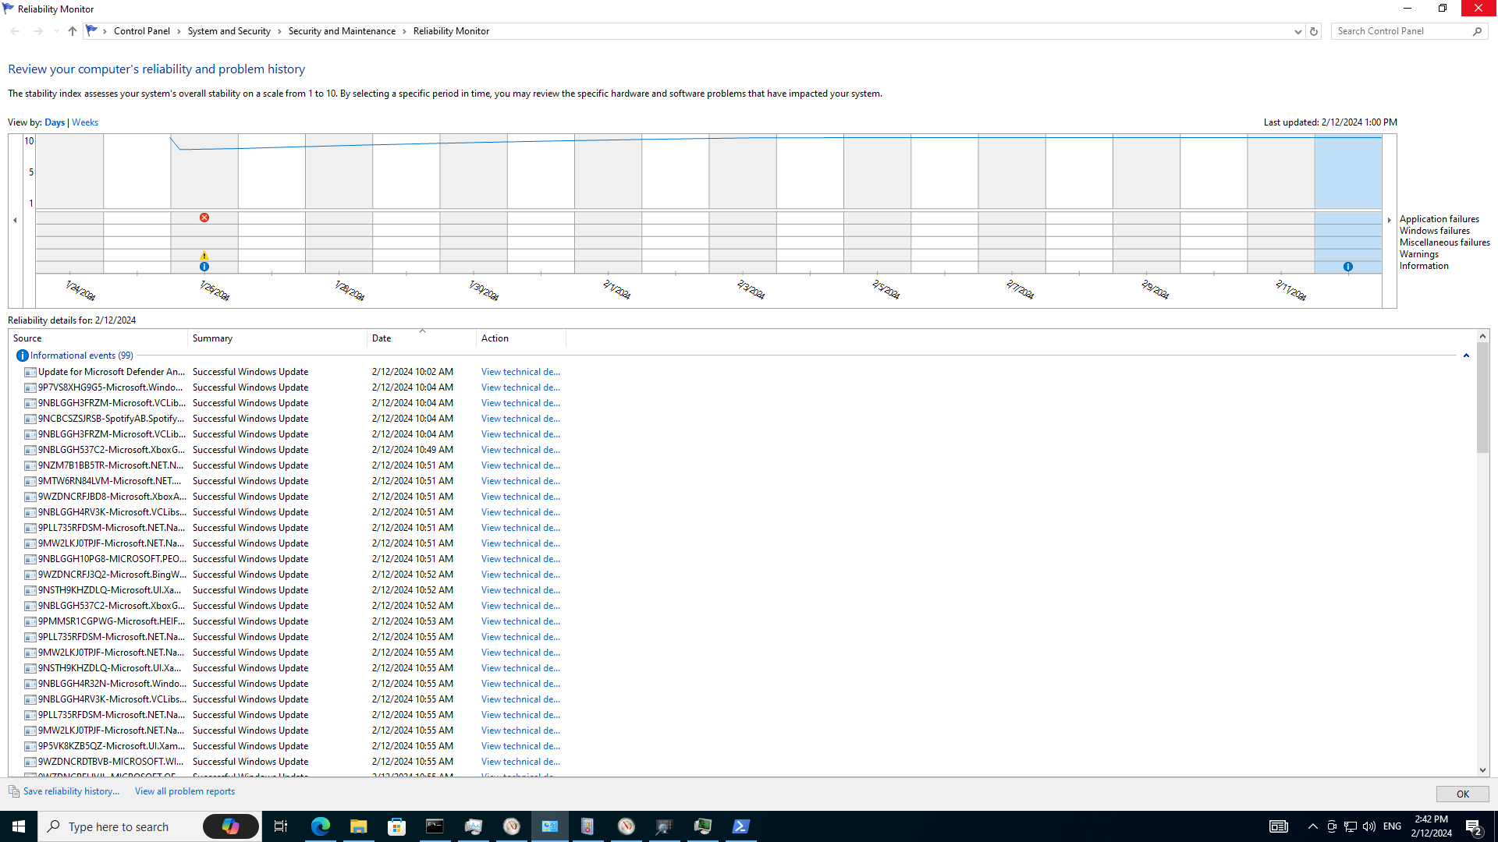
8 Reliability Monitor

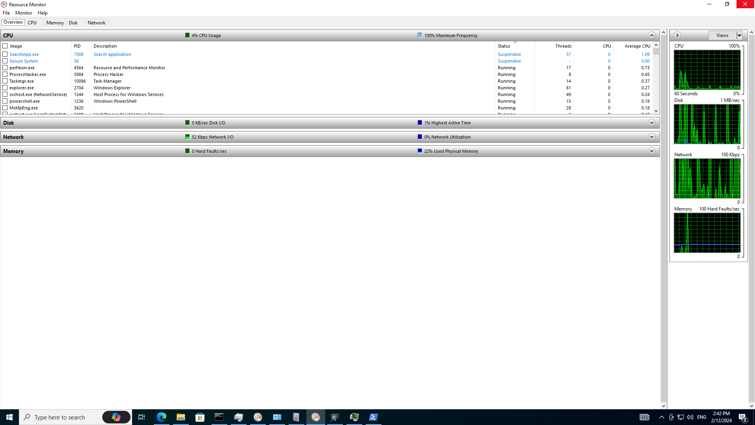
9 Resource Monitor

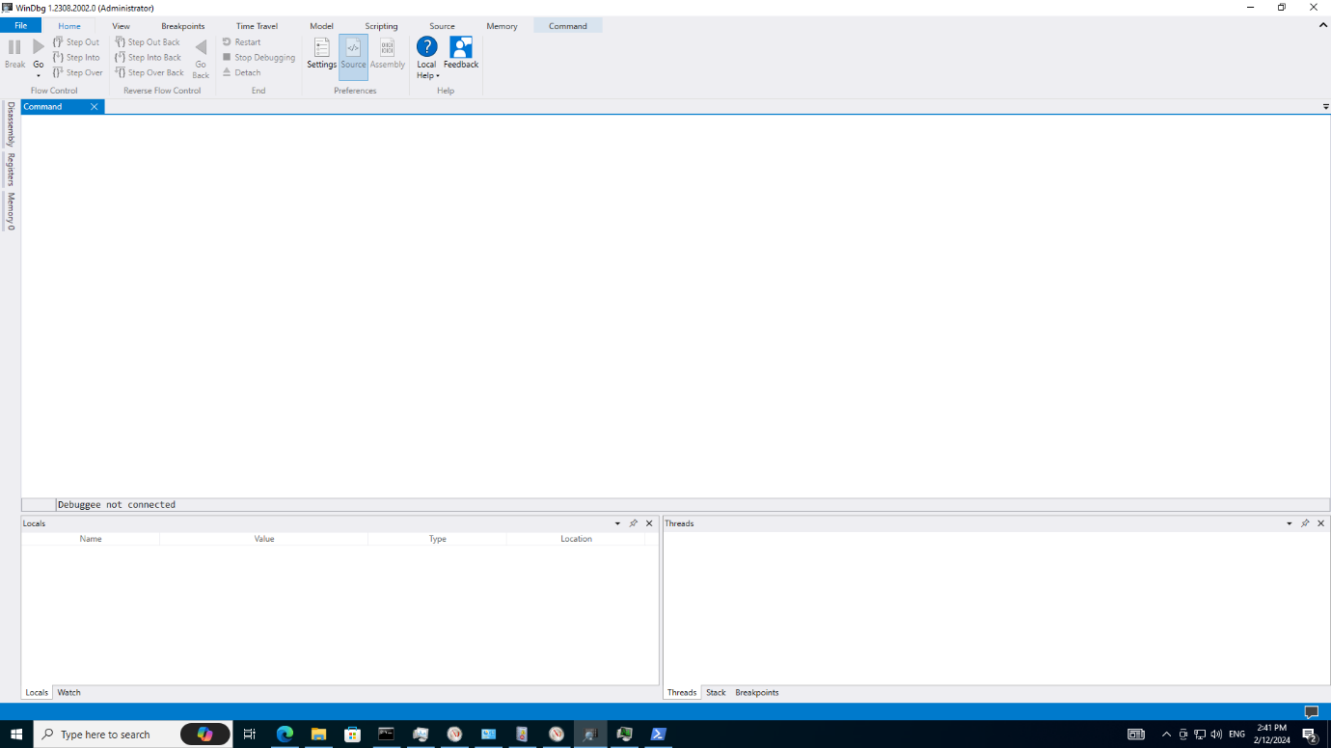
10 Win Debug

Kernel

The Kernel is basically a computer program which is the central core and responsible to connect the software/apps with the hardware like a bridge, by dictating the process and order as well as which component of the computer would be needed/activated for each specific task. It allocates time and memory for those processes the applications are following to execute tasks. As demonstrated in [5].

Job Scheduler

When dealing with tasks and processes, the OS is responsible for managing those and ordering those to make sure that the correct one is executed on the right time and sequence. Also called as process scheduler, when it comes to swap, wait and run processes and the order to follow, that is a job scheduler, it is a feature the OS has to run/interrupt, wait or initiate/finalise processes so we can’t have crashes or issues with all the tasks in the queue to be done/processed by the OS and computer itself during the exchange of information and connection to the actual hardware. As demonstrated in [5].

OS Networking

When it comes to interacting with the internet and data from the web, Oss have a built-in feature to control data sharing and data transfer/transmission between computers/users. It follows certain protocols to pass data packages/buses, such as IP, HTTP, FTP and more in order to allow data being shared over the internet or local network as well as having programs to enable wi-fi, Bluetooth and some other type of wireless connections as option for the users. As demonstrated in [5].

OS Security

The OS have also some important features to be added or already built-in, to protect the system and data, which is the OS Security, where we have some options to make the environment safer such as authentication using user and password protection, or card keys and biometrics or finger print recognition, and among other options to make the system and data safer to prevent leaks and data breaches/hacking and other issues.
Here it comes the network security as well which we talk very often when dealing with the OS anti-virus or firewall to prevent/block certain things as a filter or barrier/layer of protection. IOS, most Iphones, I believe they do follow the protection rings approach when it comes to layers created with certain permission and access of information and apps which is another way of making your OS safer and any sort of data inside it protected as well. Not forgetting about encryption of files/data/disks and important content to make it harder to hack or steal/leak information during transfers of packages/buses on the internet/intranet. As demonstrated in [5].

Use of Windows OS CLI commands
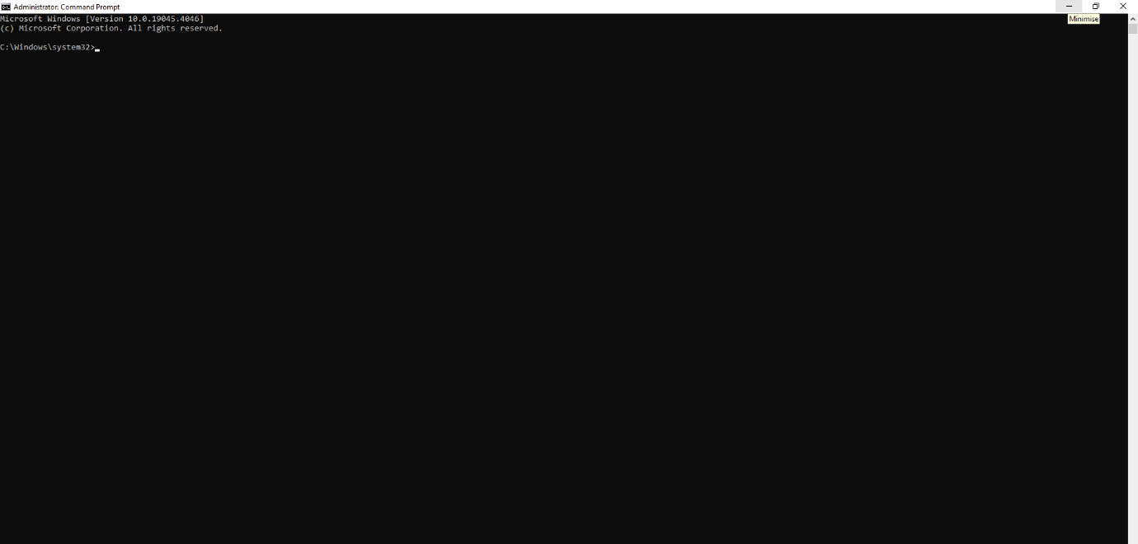
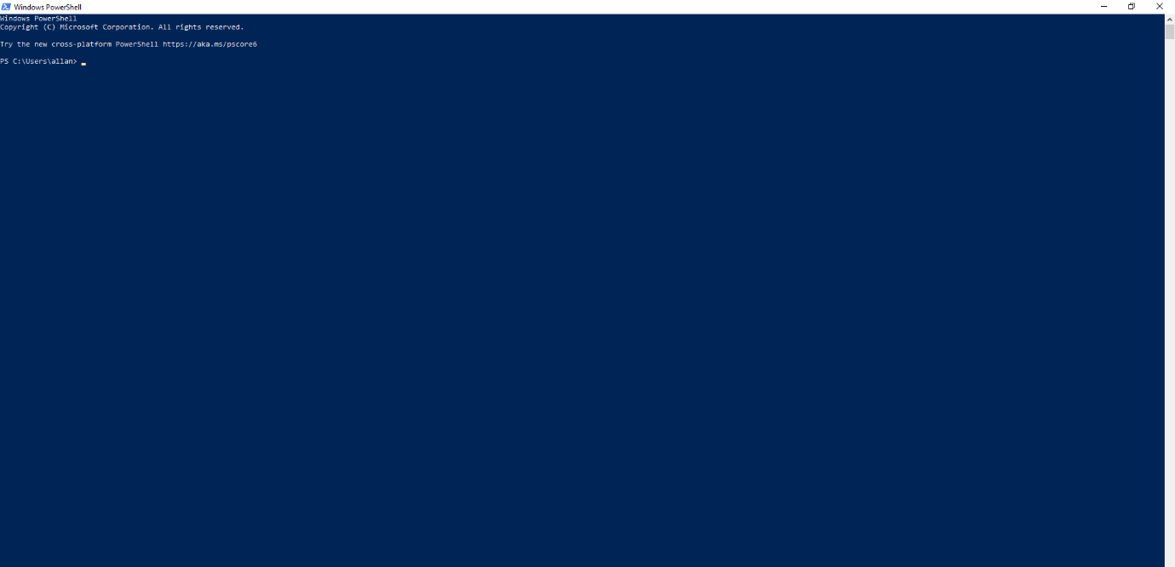

Mkdir

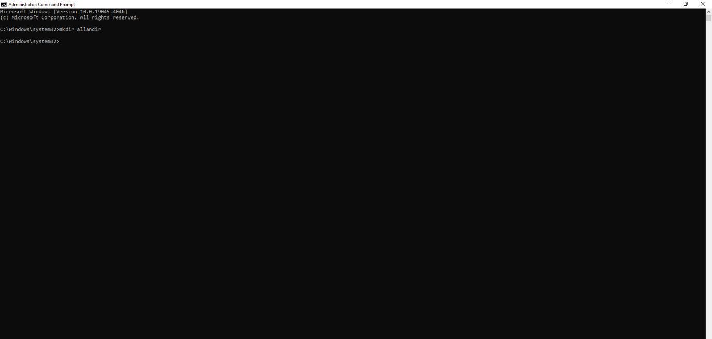
The mkdir command allows you to create a folder/directory. Mk = make and dir = directory. Instead of using the File Explorer an creating the folder from there, you can also use the batch command to make it happen.

Creates a directory or subdirectory. Command extensions, which are enabled by default, allow you to use a single mkdir command to create intermediate directories in a specified path [6].

Dir

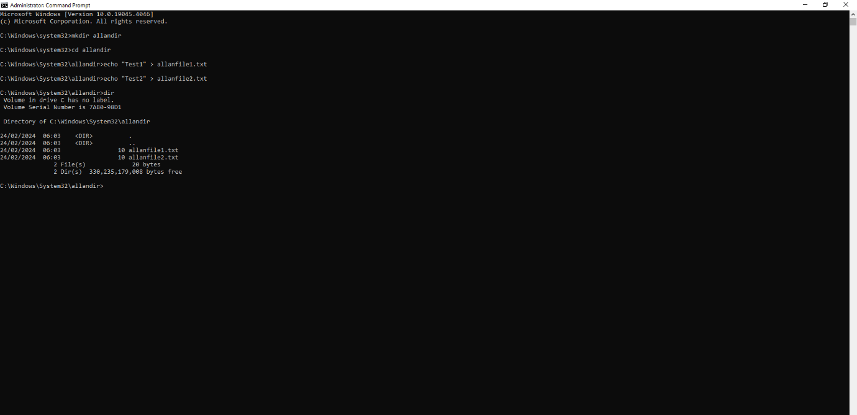
The command dir allows you to view all the available content inside that specific directory you are on directly from the command line instead of having to use File Explorer to view the list of files there.

This batch command lists the contents of a directory [7].

Copy

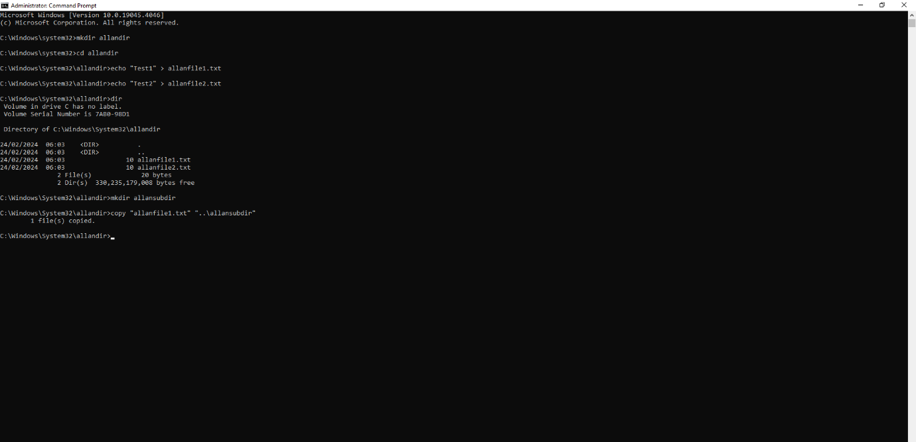
The copy command allows you to copy a file and add that copy to a certain specific location like another directory of your project for example.

Copies one or more files from one location to another. If you specify more than one file in source, the copy command combines them all into a single file using the file name specified in destination. The copy command assumes the combined files are ASCII files unless you use the /b option [8].

Move

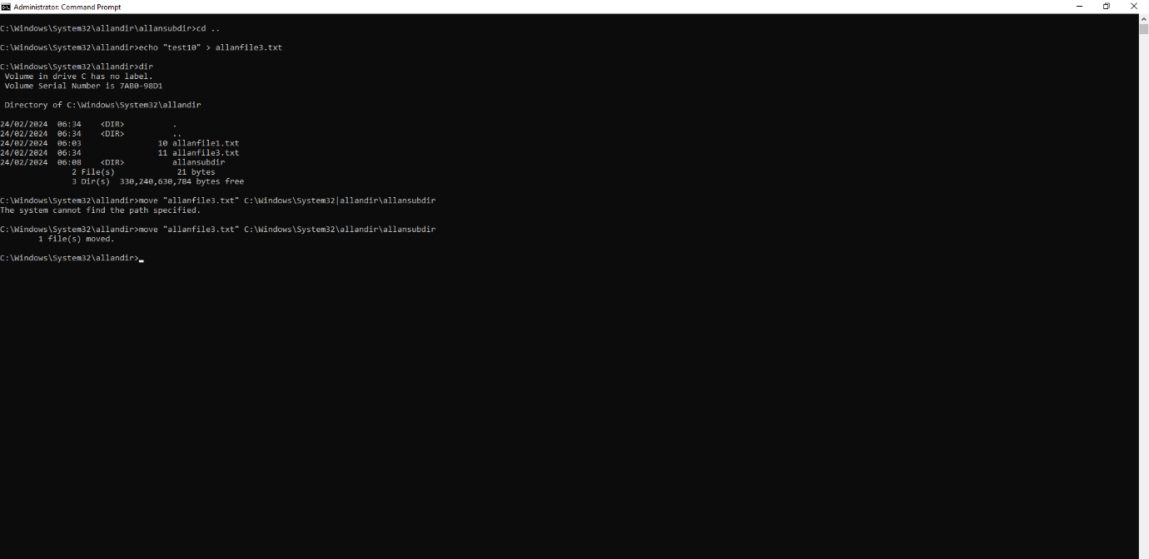
The move command allows you to move your file from a location to another, for example when working on a certain project, you need to a specific new txt file you created in a random folder to be moved to a specific folder of txt files where you keep all the relevant txt files for your project.
For moving files, Batch Script provides the MOVE command. [drive:][path]filename1
Specifies the location and name of the file or files you want to move.
move c:\windows\temp\*.* c:\temp
The above command will move the files of c:\windows\temp to the temp directory in root [9].

Del

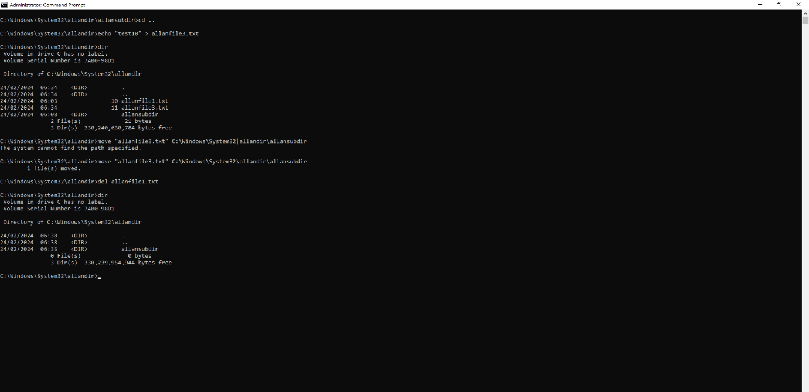
The del command allows you to delete certain files from your directory if you don’t need those files anymore within your project, for example, deleting a test file which you won’t need anymore from the list of files.
Delete one or more files. Syntax:
DEL [options] [/A:file_attributes] files_to_delete
If a folder name is given instead of a file, all files in the folder will be deleted, but the folder itself will not be removed [10].

Xcopy

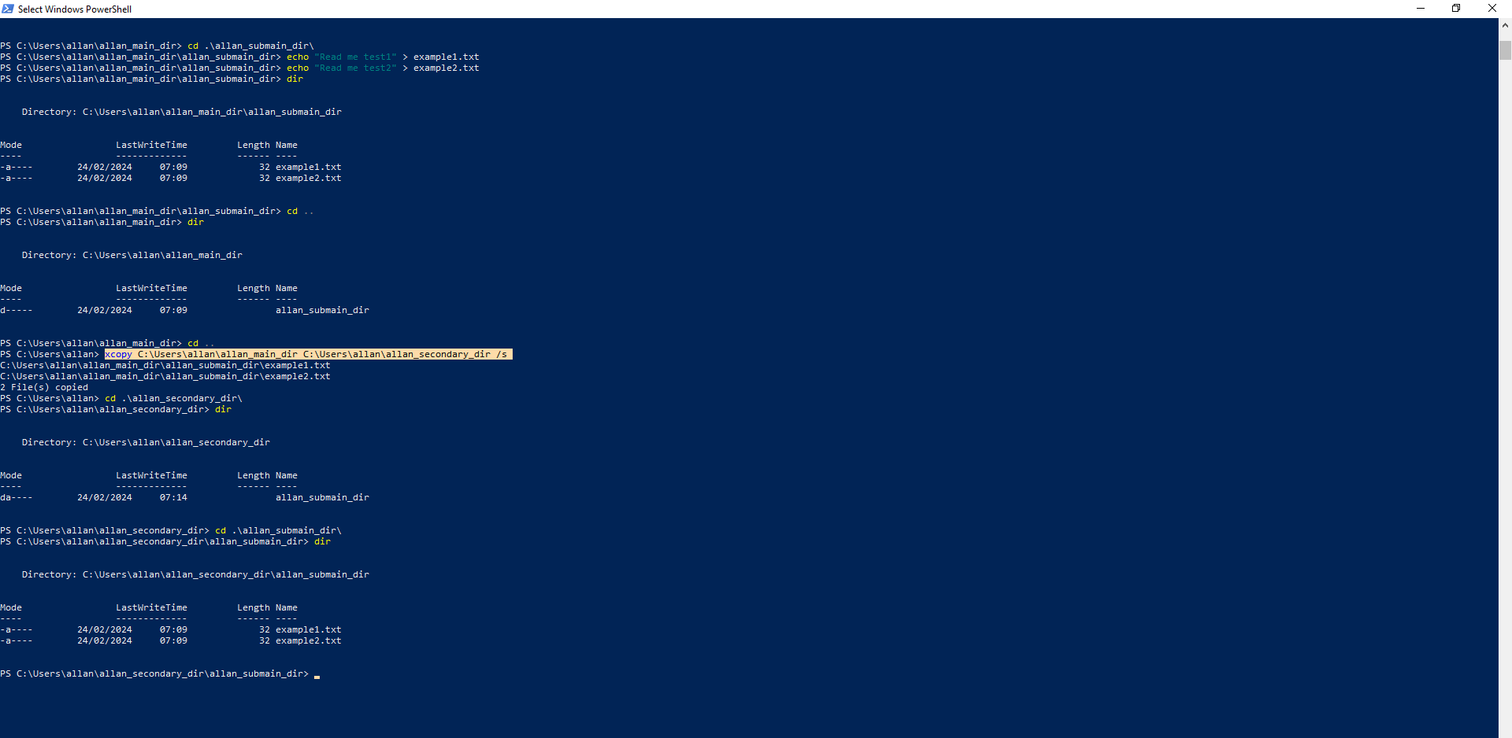
The xcopy command allows you to not only copy a file or files within the directory, but also copies the whole tree structure, like directory and subdirectory and its files, where you have some options like /e, /s or /y to specify what will be copied as well as overwrite confirmation.

The xcopy command is a Command Prompt command used to copy one or more files or folders from one location to another location. With its many options and ability to copy entire directories, it's similar to, but much more powerful than, the copy command. The robocopy command is also similar but has even more options [11].

Cls

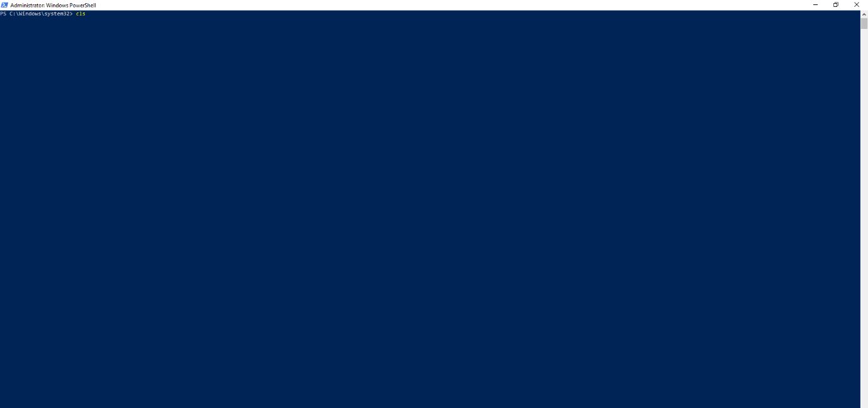
The cls command allows you to clear the command history from the window you are currently working on if you want to start from scratch or prefer a clear window to work on certain command line.

Cls: The cls command clears the prompt screen [12].

Robocopy

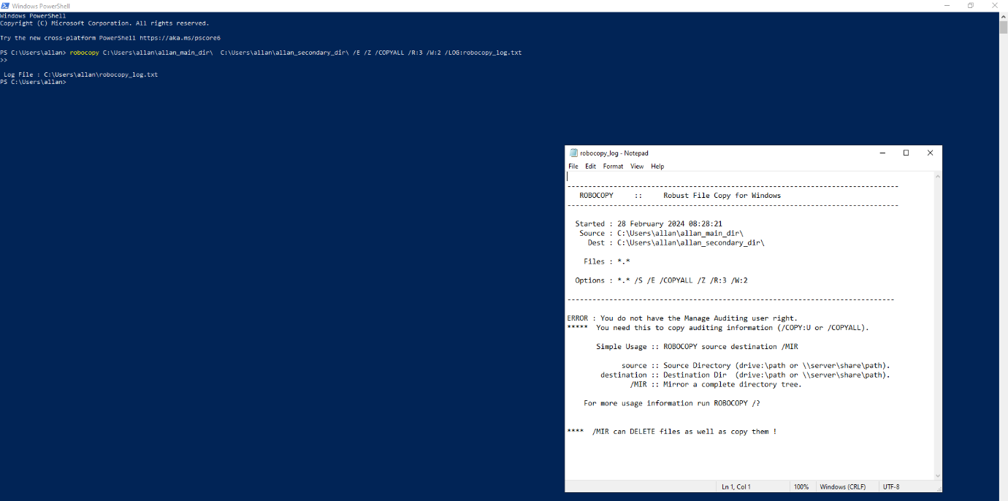
The robocopy command allows us to have more features and control when copying files and directories, differently from xcopy and copy, where you can be more precise of what is being copied as well as keeping track of the copying process with records as well as logging the waiting time and failed/successful copies, permissions control and among other versatile options/features. Commonly used for bigger tasks such as mirroring or clone of big files/directories.
Copies file data from one location to another. Syntax:
robocopy <source> <destination> [<file>[ ...]] [<options>]
For example, to copy a file named yearly-report.mov from c:\reports to a file share \\marketing\videos while enabling multi-threading for higher performance (with the /mt parameter) and the ability to restart the transfer in case it's interrupted (with the /z parameter), type:
robocopy c:\reports "\\marketing\videos" yearly-report.mov /mt /z [13]

Timeout

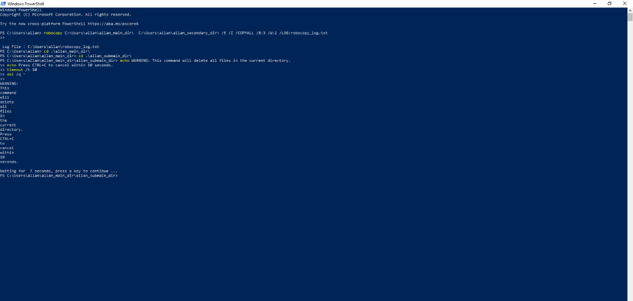
The timeout command allows us to set a specific amount of time where the execution of a certain command is being on hold. For example, if you have a del /q * , would delete all the files so, by using echo to pass a message of warning saying they have 10 seconds to cancel the action by pressing certain keyboard keys, the timeout would set those 10 seconds for the del command to be on hold in case it is needed, so very useful for certain things specially for scripts.
Use the timeout command to specify the delay time in seconds. By inserting the timeout command into your batch file, you can prompt the batch file to wait a specified number of seconds (or for a key press) before proceeding. This command is available on all modern versions of windows, including Windows 10.
timeout /t <timeoutinseconds> [/nobreak] [14]

Tasklist

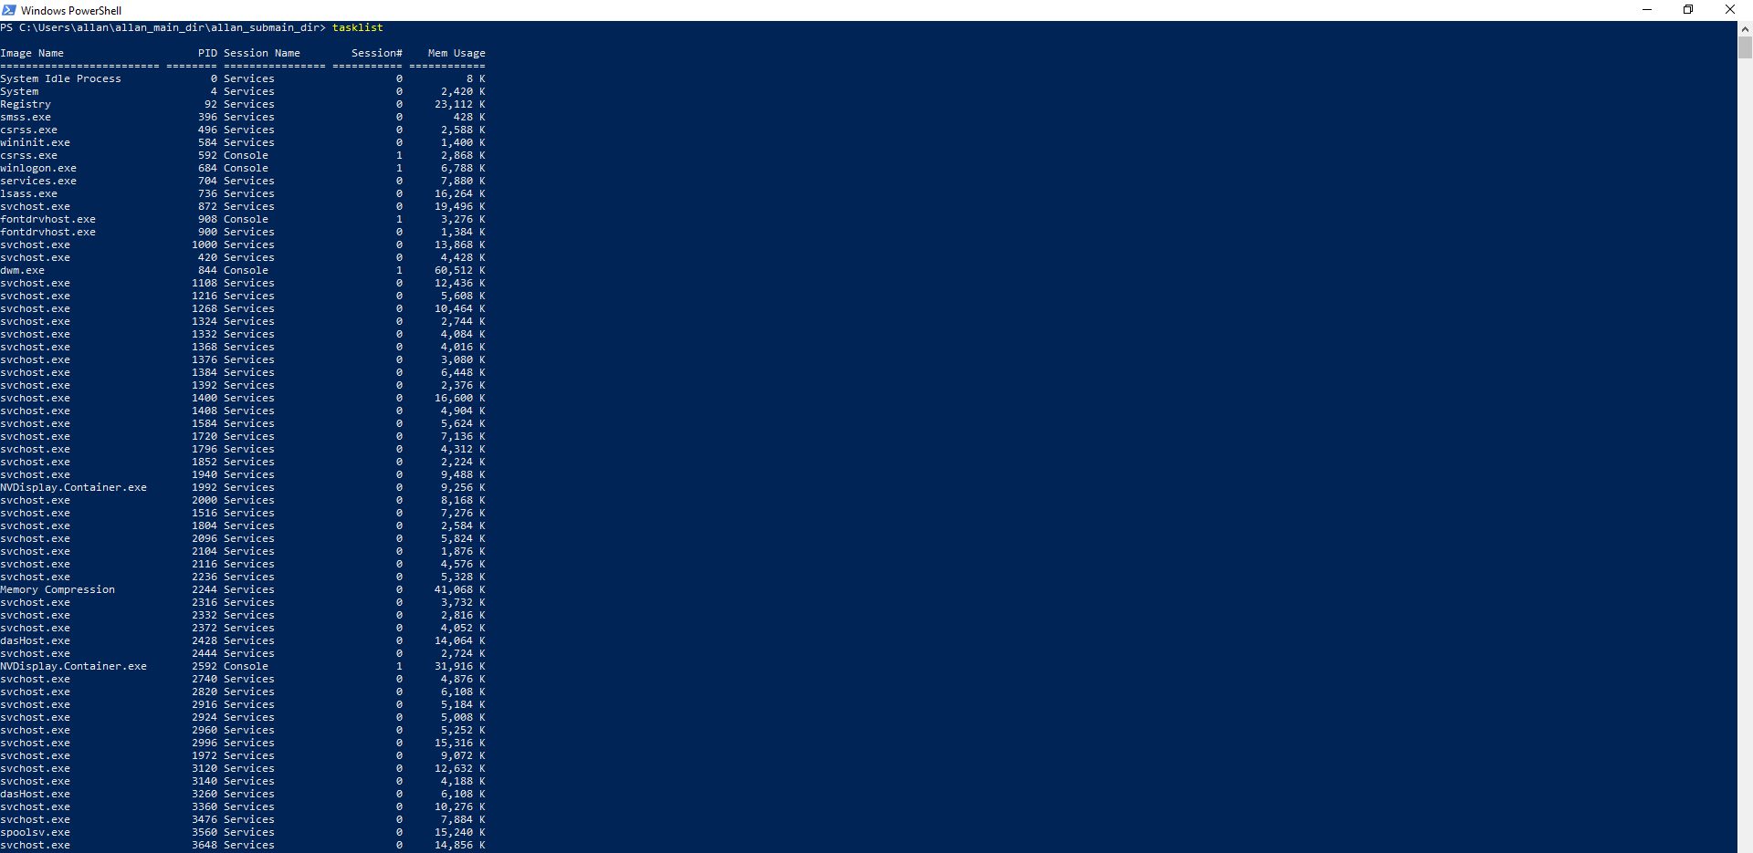
The tasklist command allows us to view all the current processes that are running at that specific time on the machine with the respective name, process ID and memory usage details for each process.
Viewing the List of Running Processes. In Batch Script, the TASKLIST command can be used to get the list of currently running processes within a system. Syntax:
TASKLIST [/S system [/U username [/P [password]]]] [/M [module] | /SVC | /V] [/FI filter]
[/FO format] [/NH] [15]

Use of Linux OS CLI commands
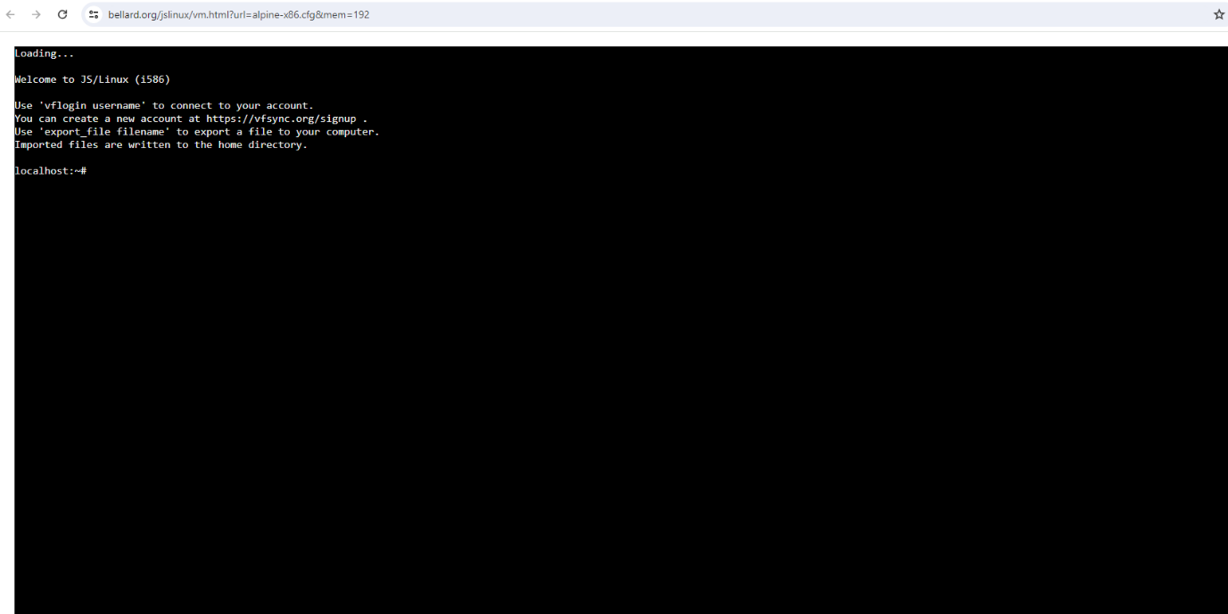

Mkdir

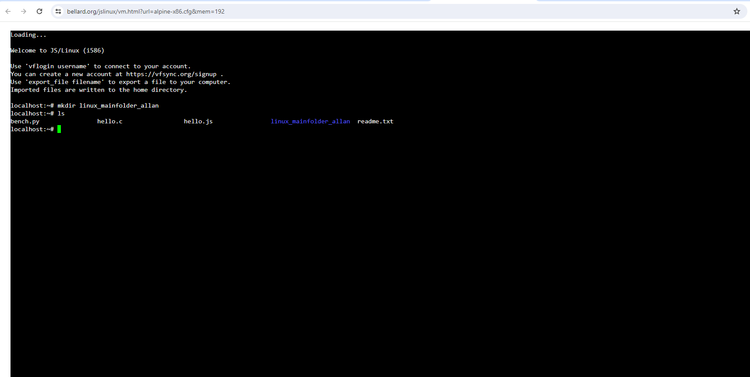
The mkdir command allows you to create a folder/directory. Mk = make and dir = directory. Instead of using the File Explorer an creating the folder from there, you can also use the bash command to make it happen. I personally use it often when creating projects on Visual Studio Code.

Use the mkdir command to create one or more directories specified by the Directory parameter. Each new directory contains the standard entries dot (.) and dot dot (..). You can specify the permissions for the new directories with the -m Mode flag. When you create a directory, it is created within the current, or working, directory unless you specify an absolute path name to another location in the file system [16].

Ls

The ls command allows you to view all the available content inside that specific directory you are on directly from the command line instead of having to use File Explorer to view the list of files there.
Bash ls - ls is a command on Unix-like operating systems to list contents of a directory, for example folder and file names [17].

Touch

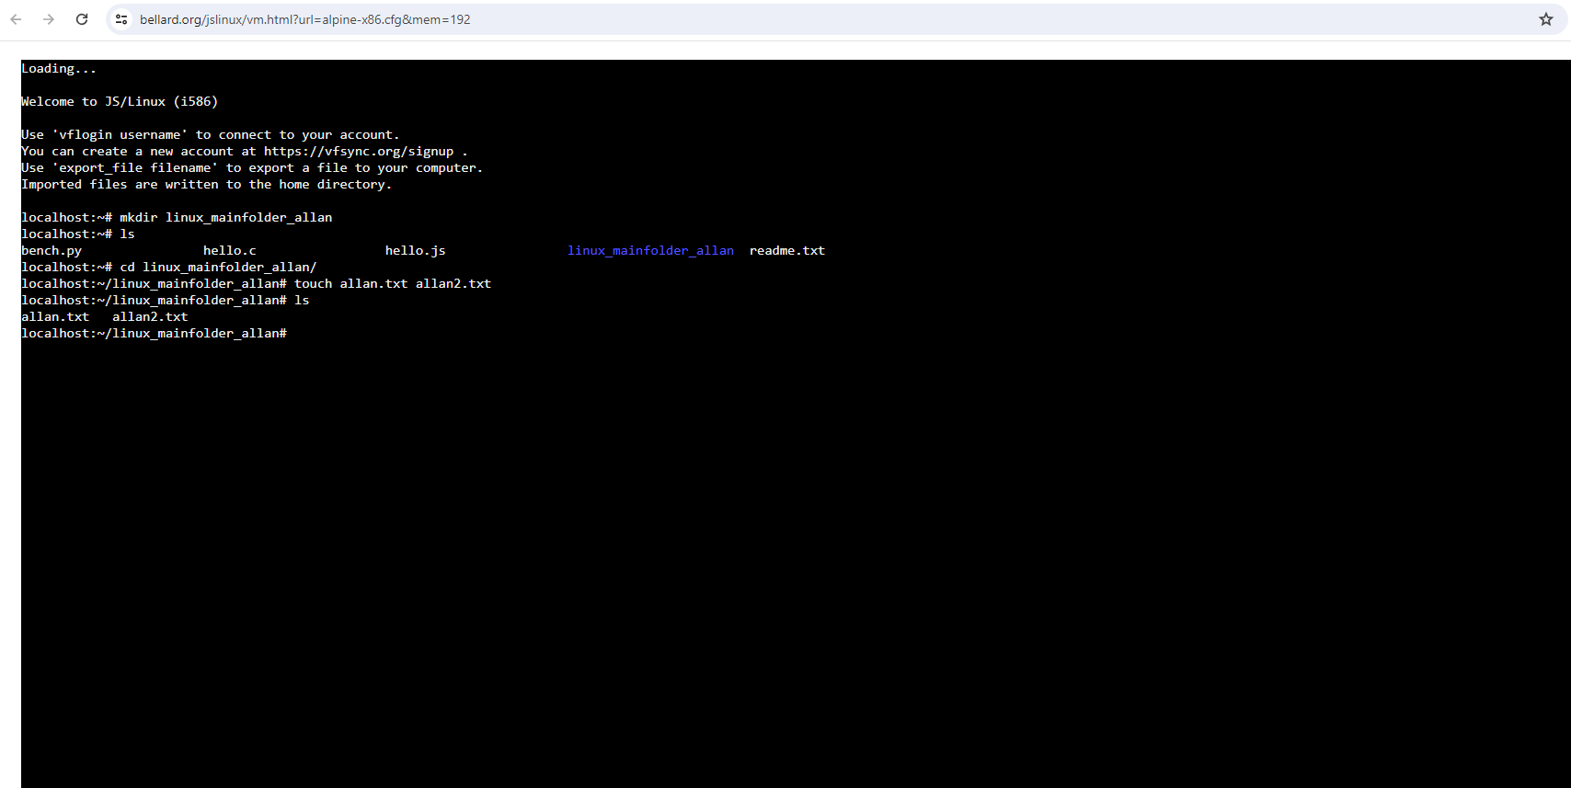
The touch command allows you to create new empty files. Very useful for example when creating the css, html and js files within a VS project and eventually using command code to open the files to start coding.
The touch command is a standard command used in the UNIX/Linux operating system which is used to create, change and modify the timestamps of a file. Basically, there are two different commands to create a file in the Linux system which are as follows:
touch command: It is used to create a file without any content. The file created using the touch command is empty. This command can be used when the user doesn’t have data to store at the time of file creation [18].

Cd

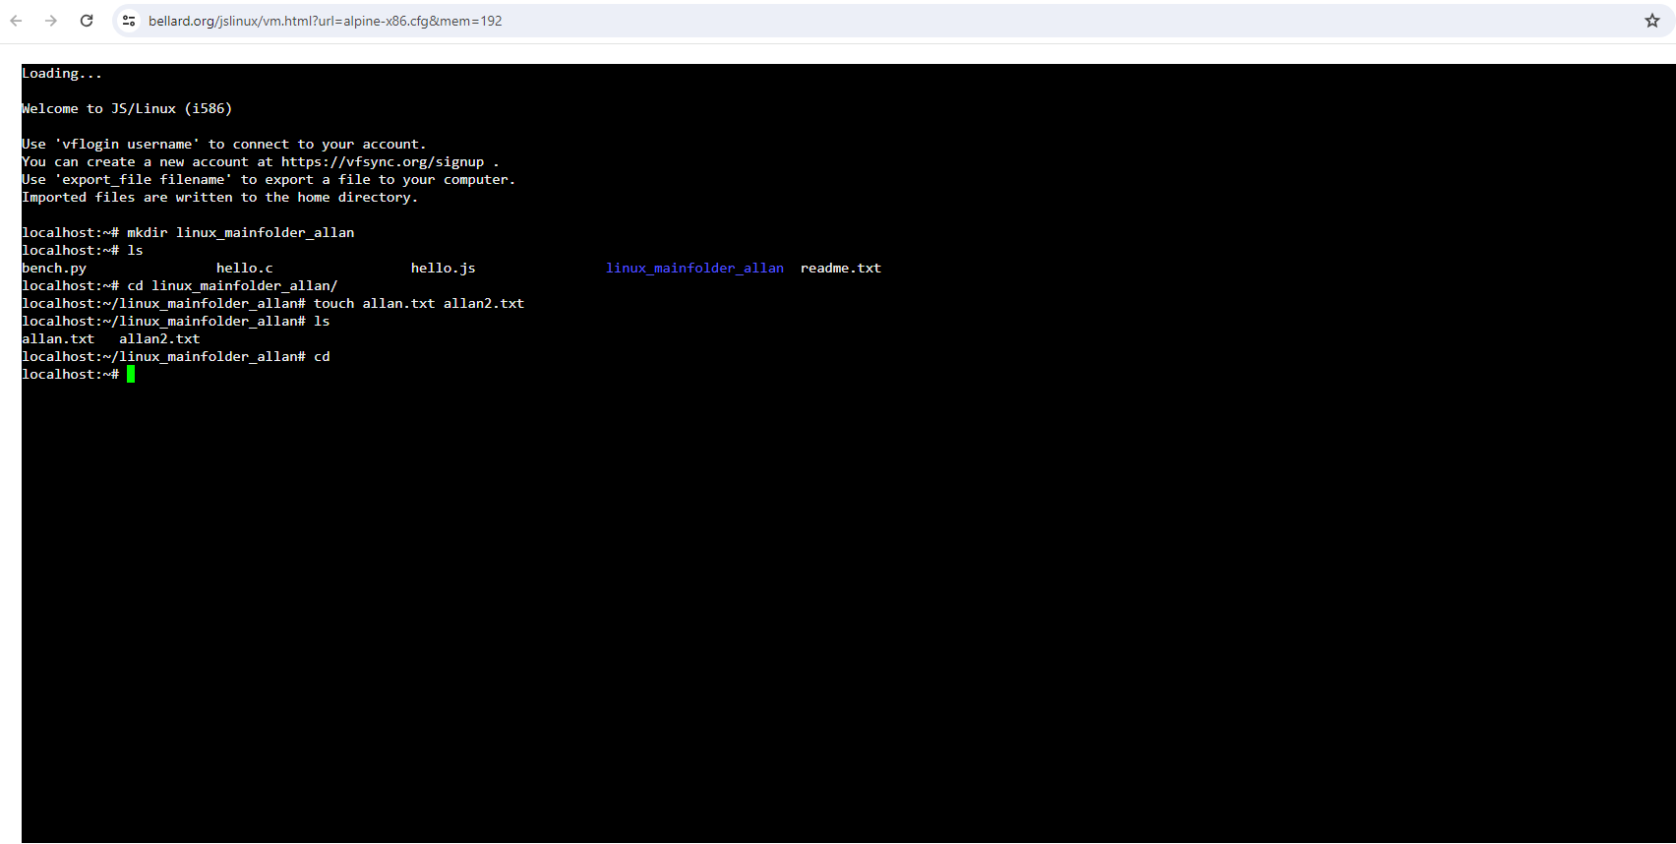
The cd command allows us to move from a directory to another, so it changes the directory like the 2 lines of example below moving in to the folder and later on going back to localhost.

The cd (“change directory”) command is used to change the current working directory in Linux and other Unix-like operating systems. It is one of the most basic and frequently used commands when working on the Linux terminal. The current working directory is the directory (folder) in which the user is currently working in. Each time you interact with your command prompt, you are working within a directory [19].

Rm

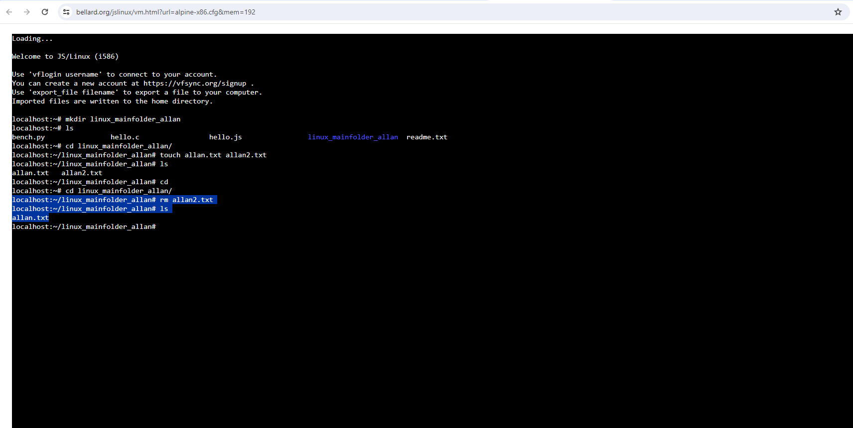
The rm command allows us to remove/delete a file from our directory or even multiple files.
The rm command is the most basic and commonly used command when it comes to deleting files in bash. The term rm stands for ‘remove’. As simple as it sounds, it’s a powerful tool in bash, and understanding how it works is the first step in mastering file deletion [20].

Grep

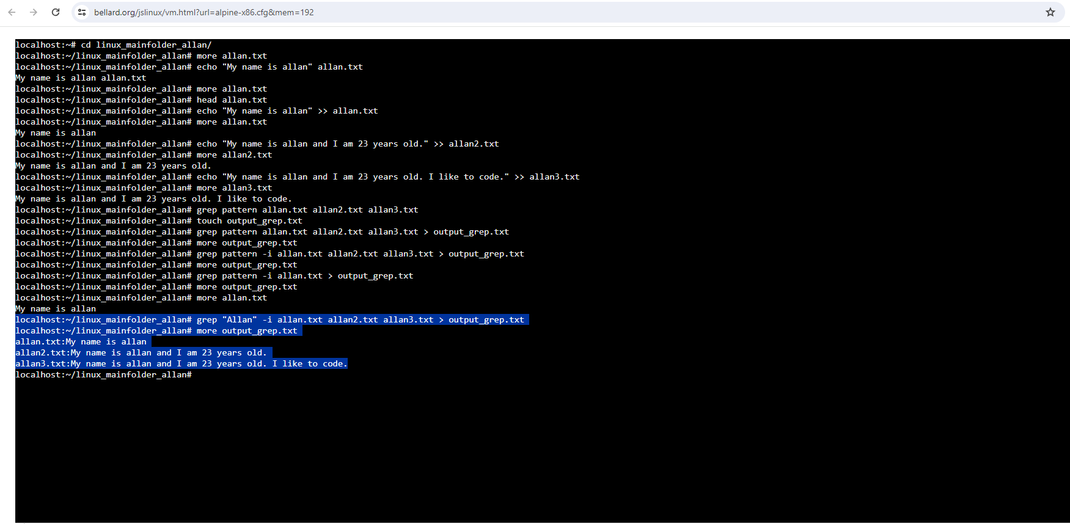
The grep command allows us to do a quick search on our files in order to find patterns within them such as keywords or specific information that matches on all the files within that directory with also some supporting commands to make the search more specific and accurate.
The grep (global regular expression print) utility is a powerful command-line tool. It can be used to search for text patterns in files, variables, and the output of commands. When combined with Bash variables, grep becomes a versatile tool for text processing and data extraction in scripts. In particular, grep can be useful for a variety of tasks:
checking if a variable contains a specific value
finding all the lines in a file that contain a specific string
filtering the output of a command based on a text pattern [21]

Awk

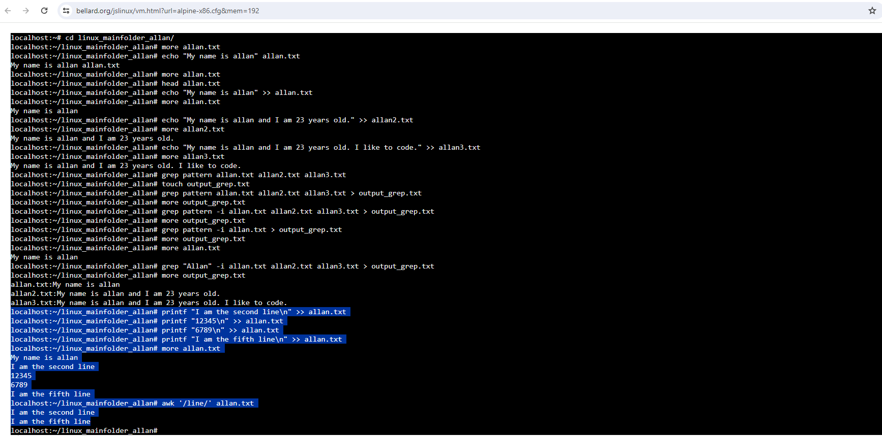
The awk command allows us to manipulate, retrieve and organise text as it is a text processing tool, something a bit more advanced than other commands, which is very powerful and has also other capabilities. One of them is similar to grep which is retrieving lines that have the same pattern.

Awk is a scripting language used for manipulating data and generating reports. The awk command programming language requires no compiling and allows the user to use variables, numeric functions, string functions, and logical operators. Awk is a utility that enables a programmer to write tiny but effective programs in the form of statements that define text patterns that are to be searched for in each line of a document and the action that is to be taken when a match is found within a line. Awk is mostly used for pattern scanning and processing. It searches one or more files to see if they contain lines that matches with the specified patterns and then perform the associated actions. Awk is abbreviated from the names of the developers – Aho, Weinberger, and Kernighan [22].

Clear

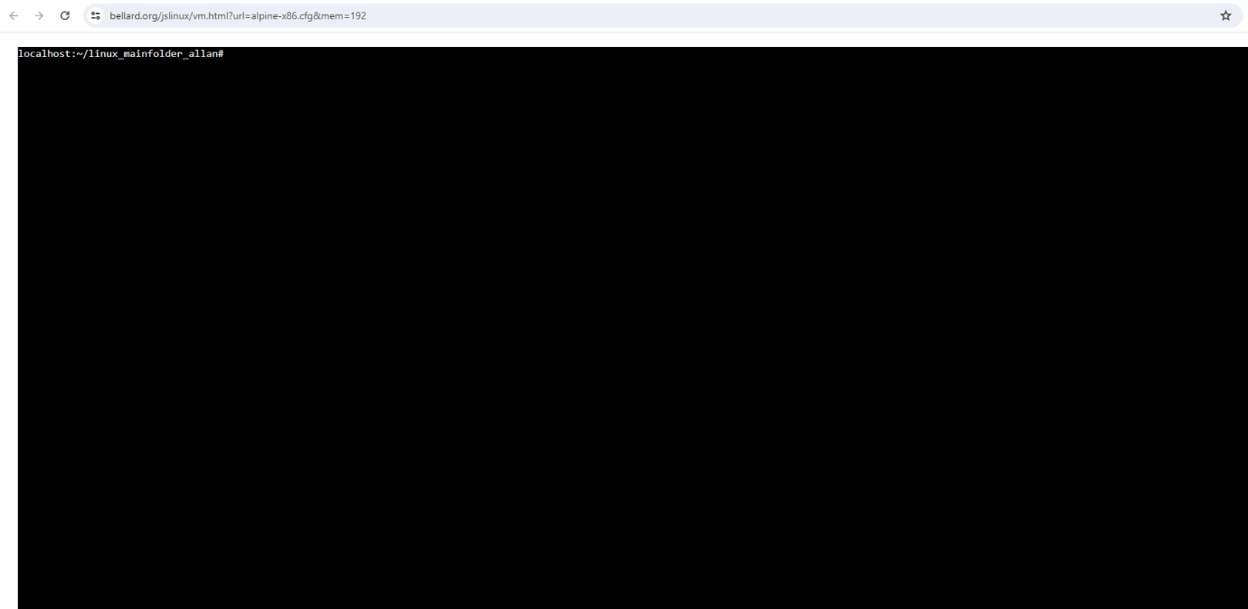
The clear command allows you to clear the command history from the window you are currently working on if you want to start from scratch or prefer a clear window to work on certain command line.
You can use the command clear to clear all Bash terminals, also you can use CTRL + L or CTRL + SHIFT + K as shortcut keys to clear terminals in Bash [23].

Sed

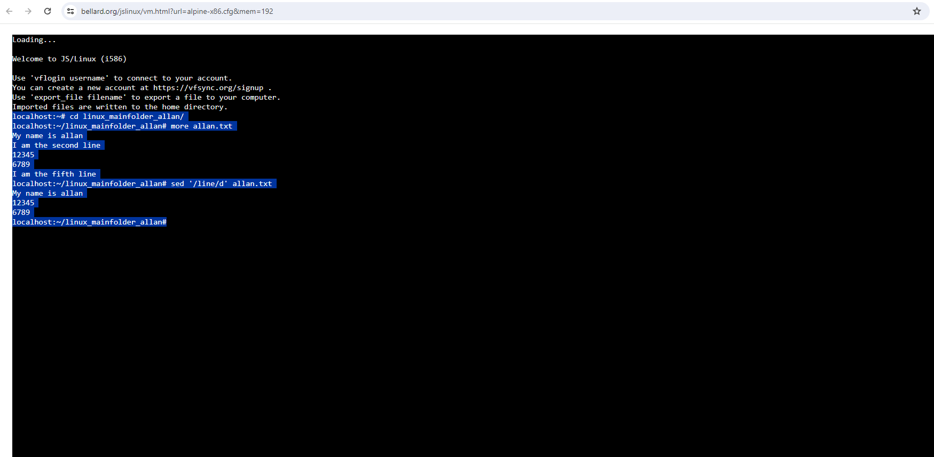
The sed command allows us to perform certain operations within text files, as it is a nice text manipulation tool, we are able to make data insertions and deleting as well as search and among other things. Using the same example as done with grep and awk, sed can delete specific lines that contain the same pattern.
SED command in UNIX stands for stream editor and it can perform lots of functions on file like searching, find and replace, insertion or deletion. Though most common use of SED command in UNIX is for substitution or for find and replace. By using SED you can edit files even without opening them, which is much quicker way to find and replace something in file, than first opening that file in VI Editor and then changing it. SED is a powerful text stream editor. Can do insertion, deletion, search and replace(substitution). SED command in unix supports regular expression which allows it perform complex pattern matching [24].

Find

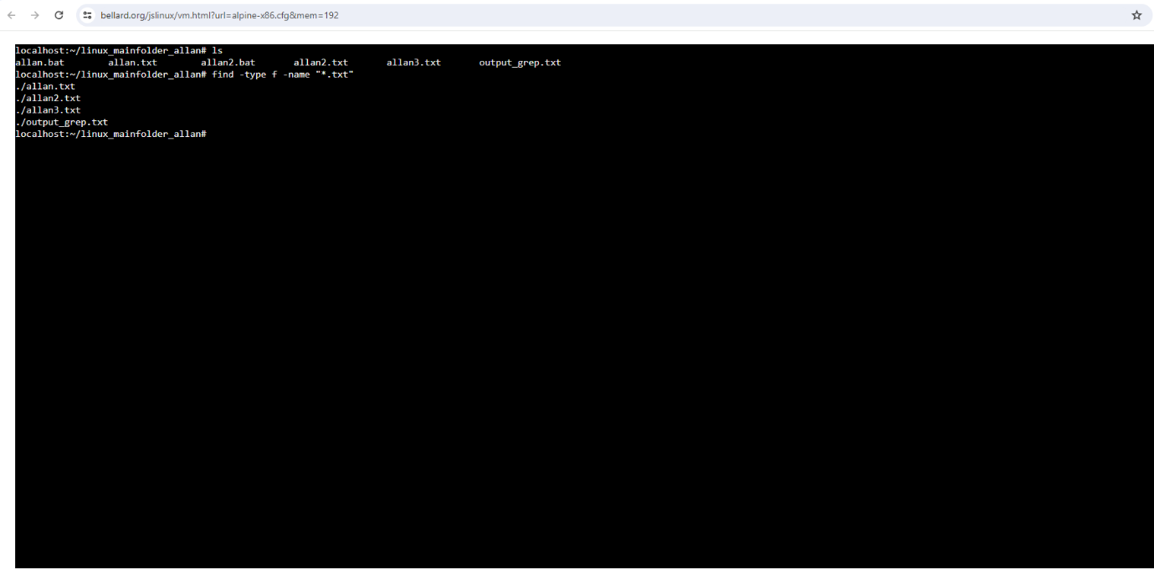
The find command allows us to locate specific files with a targeted search within our directory, with a specified type of files and name/format/extension as well. In this example below, regular files with .txt extension.
Linux, renowned for its robust command-line interface, provides a suite of powerful tools for efficient file and directory management. Among these, the “find” command stands out as an indispensable asset, offering unparalleled versatility in searching for files based on diverse criteria. This article explores the prowess of the find command, shedding light on its capabilities and how it serves as a go-to tool for Linux users aiming to locate files swiftly and effectively [25].

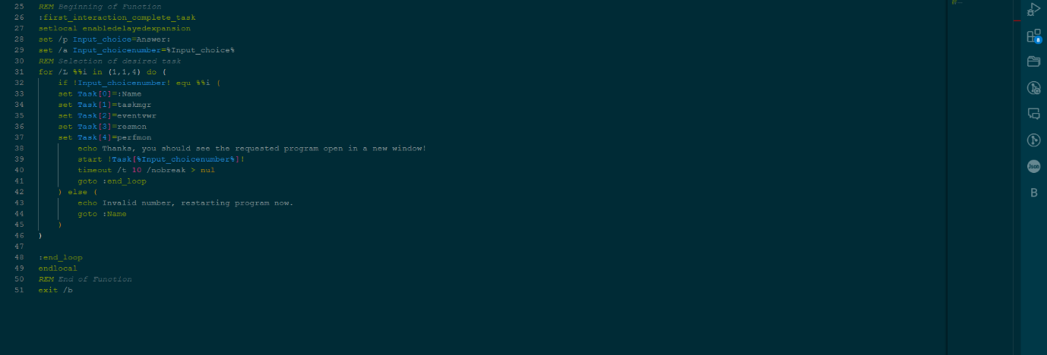
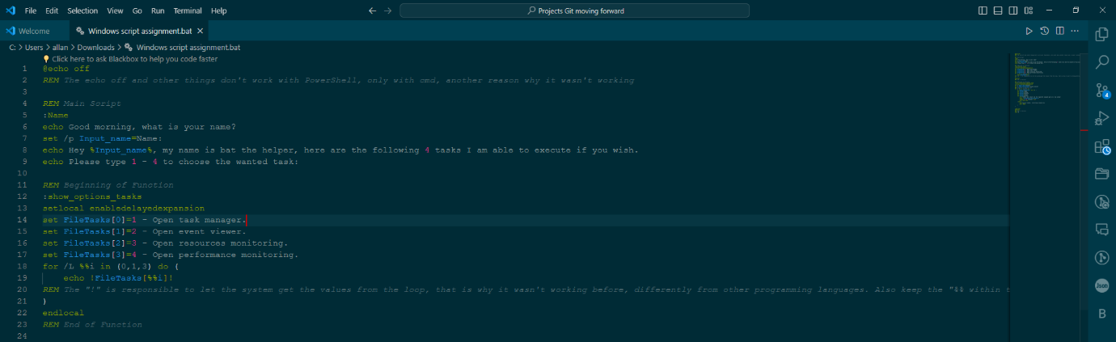
Use of Windows OS Scripts

Above we have a simple script covering some content of Windows OS scripts and bat programming syntax and structure built by me. I also interacted on Stack Overflow in order to get some insights too, there I got the solution to fix the conversion of a string to integer, as my code wasn’t getting it the value.
The script above, interacts with the user by asking their name and present itself to the user as bat the helper, and offers 4 options of tasks it can perform once the user chooses it.
Note: copy of the file on appendices.

Let’s break down the code lines a bit for more understanding of what was used and done here:
REM Main Script
:Name
echo Good morning, what is your name?
set /p Input_name=Name:
echo Hey %Input_name%, my name is bat the helper, here are the following 4 tasks I am able to execute if you wish.
echo Please type 1 - 4 to choose the wanted task:
Here we have the main part of the script where we retain the user’s name to interact with and let them how we want them to interact with the program. Using echo to display the messages and set /p to gather the input and save its data to that input variable. The :Name was create as a go to, so we can go back to it eventually during another part of the code, when it needs to.

REM Beginning of Function
:show_options_tasks
setlocal enabledelayedexpansion
set FileTasks[0]=1 - Open task manager.
set FileTasks[1]=2 - Open event viewer.
set FileTasks[2]=3 - Open resources monitoring.
set FileTasks[3]=4 - Open performance monitoring.
for /L %%i in (0,1,3) do (
echo !FileTasks[%%i]!
REM The "!" is responsible to let the system get the values from the loop, that is why it wasn't working before, differently from other programming languages. Also keep the "%% within the brackets with the i"
)
endlocal
REM End of Function
Here we have the first function to display the options we promised to the user by retrieving the data from an array I created with a for loop from 0 to 3 , where the echo would be displaying the value of the array 4 times according to the loop created. I have used setlocal and expansion to make the whole block accessible, even within the loop to avoid bugs I was having before when displaying the values.

REM Beginning of Function
:first_interaction_complete_task
setlocal enabledelayedexpansion
set /p Input_choice=Answer:
set /a Input_choicenumber=%Input_choice%
REM Selection of desired task
for /L %%i in (1,1,4) do (
if !Input_choicenumber! equ %%i (
set Task[0]=:Name
set Task[1]=taskmgr
set Task[2]=eventvwr
set Task[3]=resmon
set Task[4]=perfmon
echo Thanks, you should see the requested program open in a new window!
start !Task[%Input_choicenumber%]!
timeout /t 10 /nobreak > nul
goto :end_loop
) else (
echo Invalid number, restarting program now.
goto :Name
)
)

:end_loop
endlocal
REM End of Function
exit /b

Finally, we have the last part of the script, which is another function.
As previously, we also have the setlocal and expansion to avoid issues with getting values and access variables within the function and loop without problems. Following the options message, we get the answer from the user from 1 -4 and match that with the new array we create for options where we set the array values as the cmd commands already to just execute the value inside the array. So, we get the answer, convert the input of string to a number with the set /a which is also a creation and declaration of a new variable, then we get our new for loop from 1 to 4 just as a counting tool instead of writing more lines of ifs, and we use the if to compare the converted input number to match i, if does, great, the start !Task[] will make sure to run the command and open the relevant program, and if doesn’t, we have our else to display with echo a message and a goto where we get back to the beginning of the script to request the info again. That also happens when they press number 0 as Task[0] is assigned a value of the goto :Name. We also have the goto :end loop and the :end loop to avoid that cycle repeating over and over again and just execute once.

@echo off
By default, a batch file will display its command as it runs. The purpose of this first command is to turn off this display. The command "echo off" turns off the display for the whole script, except for the "echo off" command itself. The "at" sign "@" in front makes the command apply to itself as well. [26]
The other way in which variables can be initialized is via the ‘set’ command. Following is the syntax of the set command. Syntax: set /A variable-name=value
Where: Variable-name is the name of the variable you want to set. Value is the value which needs to be set against the variable. /A – This switch is used if the value needs to be numeric in nature [26].

%%i-1 does not work. The evaluation of an arithmetic expression is possible only with set /A. It is not possible to write anywhere in a command line %%i-1 and expect that cmd.exe processing the batch file detects that as arithmetic expression to evaluate during parsing the command line. See also debugging a batch file and How does the Windows Command Interpreter (CMD.EXE) parse scripts? exit /b at the end of a batch file is useless and should be removed for that reason. – Mofi [27]

Arithmetic Operators in a Batch Script
List of operators :
SET /A sum=1+1 ::addition operator
ECHO %sum%
SET /A mul=7*9 ::multiplication operator
ECHO %mul%
SET /A div=9/3 ::Division operator
ECHO %div%
SET /A assign=10 ::Assignment operator
ECHO %assign%
SET /A assign+=15 ::Increment then assignment operator
ECHO %assign%
SET /A mod= 10%3 ::Modulus/Remainder operator
ECHO %mod% [28]

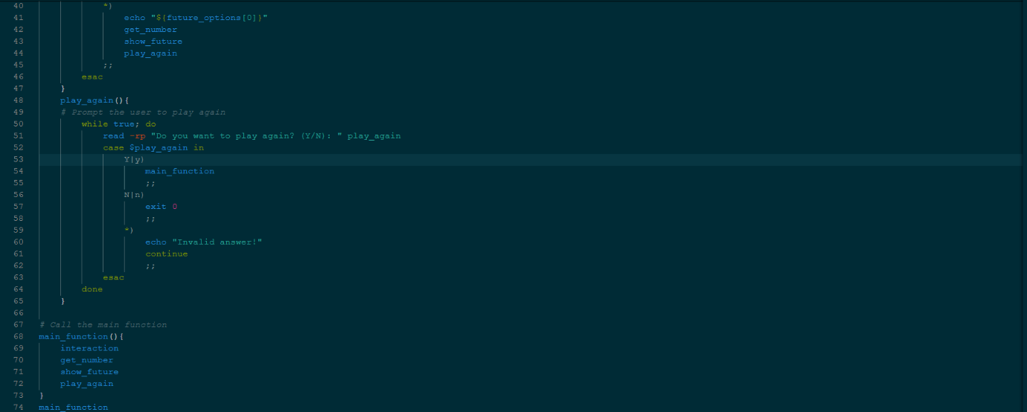
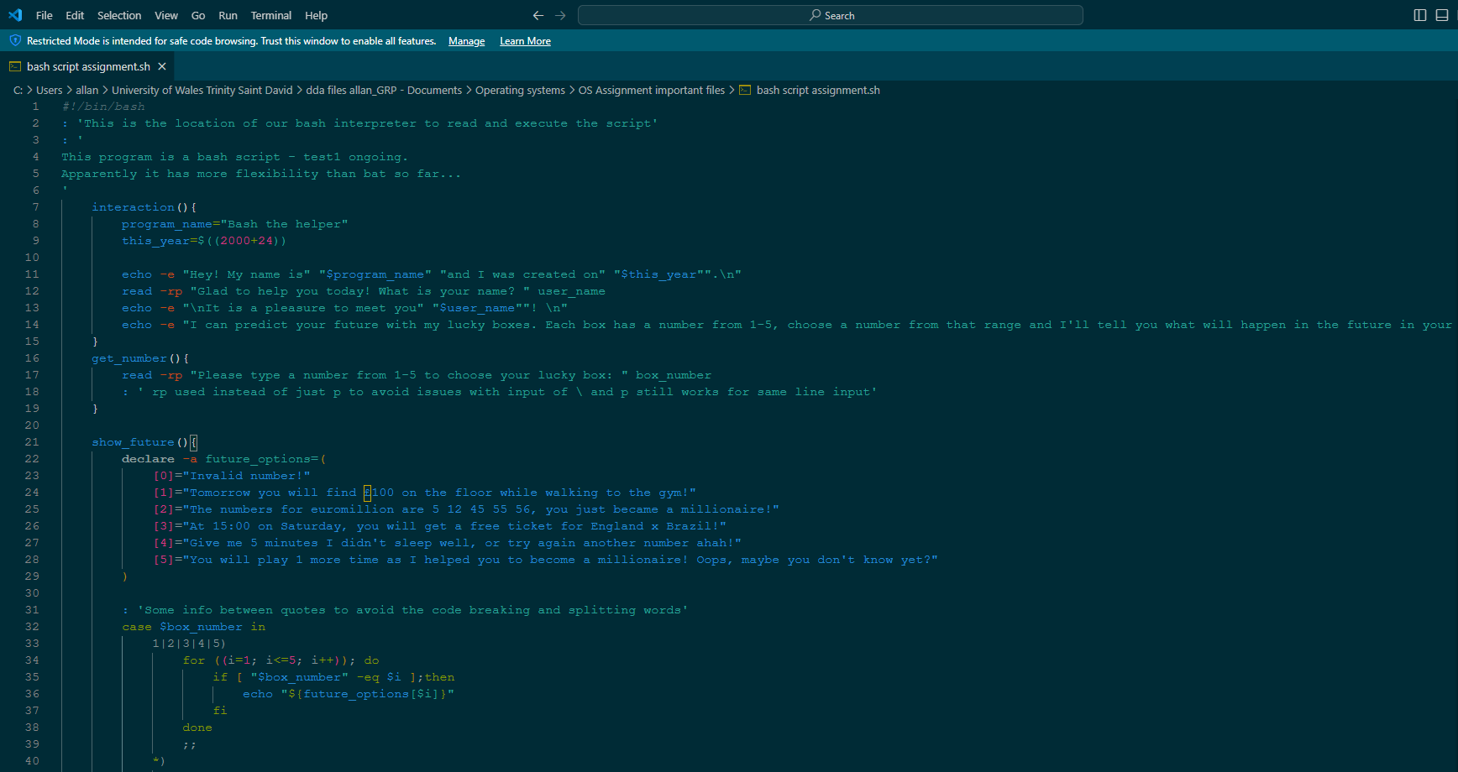
Use of Linux OS Scripts
Above we have a simple script covering some content of Linux OS scripts and bash programming syntax and structure built by me. I believe it was way more flexible to work with bash than batch, specially with scope and variable interactions and functions and loops.
The script above is a basic game/helper (Bash the helper) which interacts with the user getting their name and presenting the function of the program with 5 options (lucky boxes) and getting an input from them in order to reply, and the cycle goes on if they wish to play again.
Note: copy of the file on appendices.

Let’s break down the code lines a bit for more understanding of what was used and done here:

#!/bin/bash
: 'This is the location of our bash interpreter to read and execute the script'
: '
This program is a bash script - test1 ongoing.
Apparently it has more flexibility than bat so far...
'
interaction(){
program_name="Bash the helper"
this_year=$((2000+24))

echo -e "Hey! My name is" "$program_name" "and I was created on" "$this_year"".\n"
read -rp "Glad to help you today! What is your name? " user_name
echo -e "\nIt is a pleasure to meet you" "$user_name""! \n"
echo -e "I can predict your future with my lucky boxes. Each box has a number from 1-5, choose a number from that range and I'll tell you what will happen in the future in your life! \n"
}
get_number(){
read -rp "Please type a number from 1-5 to choose your lucky box: " box_number
: ' rp used instead of just p to avoid issues with input of \ and p still works for same line input'
}

Here we start the file with the access to the interpreter for execution and our first function interaction() where we create some variables (program_name and this_year), and interact with the user with echo -e as well as read -rp to get their name and show what the program can do. Then, we have the get_number() function to request input from 1-5 to get a lucky box reply with read -rp.

show_future(){
declare -a future_options=(
[0]="Invalid number!"
[1]="Tomorrow you will find £100 on the floor while walking to the gym!"
[2]="The numbers for euromillion are 5 12 45 55 56, you just became a millionaire!"
[3]="At 15:00 on Saturday, you will get a free ticket for England x Brazil!"
[4]="Give me 5 minutes I didn't sleep well, or try again another number ahah!"
[5]="You will play 1 more time as I helped you to become a millionaire! Oops, maybe you don't know yet?"
)

: 'Some info between quotes to avoid the code breaking and splitting words'
case $box_number in
1|2|3|4|5)
for ((i=1; i<=5; i++)); do
if [ "$box_number" -eq $i ];then
echo "${future_options[$i]}"
fi
done
;;
*)
echo "${future_options[0]}"
get_number
show_future
play_again
;;
esac
}

We also have the show_future() function just to declare an array future_options (lucky boxes) with our set replies to the user, as well as a case statement with a for loop and an if to control the choice of the user from 1-5 and compare the value of the i from the loop to display with echo the lucky box the user got, as well as the case * if they type anything else that isn’t 1-5, where we echo invalid and call the other functions again to be executed.

play_again(){
# Prompt the user to play again
while true; do
read -rp "Do you want to play again? (Y/N): " play_again
case $play_again in
Y|y)
main_function
;;
N|n)
exit 0
;;
*)
echo "Invalid answer!"
continue
;;
esac
done
}

# Call the main function
main_function(){
interaction
get_number
show_future
play_again
}
main_function

Finally we have our play_again() function with a while loop with another case statement to check the Y/N input from the user about wanting to play again or not(if yes it runs main_function(), if no the loop continues). At the end, we have just our main_function() which was used to represent the main script part, where all the functions are called to execute the whole script, and a call of main_function() in order to get those blocks of code to be started.
Used : ‘ ‘ and # to add comments as well.

Since BASH is a command-line language, we get some pretty feature-rich experience to leverage the programming skills to perform tasks in the terminal. We can use loops and conditional statements in BASH scripts to perform some repetitive and tricky problems in a simple programmatic way. In this article, we are going to focus on the for loop in BASH scripts. Depending on the use case and the problem it is trying to automate, there are a couple of ways to use loops:
Simple For loop, Range-based for loop, Array iteration for loops, C-Styled for loops, Infinite for loop [29]

The syntax of the if command is:
if test-commands; then
consequent-commands;
[elif more-test-commands; then
more-consequents;]
[else alternate-consequents;]
fi
The test-commands list is executed, and if its return status is zero, the consequent-commands list is executed. If test-commands returns a non-zero status, each elif list is executed in turn, and if its exit status is zero, the corresponding more-consequents is executed and the command completes. If ‘else alternate-consequents’ is present, and the final command in the final if or elif clause has a non-zero exit status, then alternate-consequents is executed. The return status is the exit status of the last command executed, or zero if no condition tested true [30].
case
The syntax of the case command is:
case word in
[ [(] pattern [| pattern]…) command-list ;;]…
esac
case will selectively execute the command-list corresponding to the first pattern that matches word. The match is performed according to the rules described below in Pattern Matching. If the nocasematch shell option (see the description of shopt in The Shopt Builtin) is enabled, the match is performed without regard to the case of alphabetic characters. The ‘|’ is used to separate multiple patterns, and the ‘)’ operator terminates a pattern list. A list of patterns and an associated command-list is known as a clause [30].

Conclusion

In conclusion, this report was made by me, Allan Costa Oliveira, where I believe I could cover the most of it requested from the assignment sheet provided by James Williams and Mark Huntly. The following was covered on this report:
1 - Key functions of general Operating Systems
2 - Use of Windows OS CLI commands.
3 - Use of Linux OS CLI commands.
4 - Use of Windows OS scripts.
5 - Use of Linux OS scripts.

I focused on demonstrating my own knowledge and understanding of each part of those 5 main topics, but also managed to add relevant citations and screenshots to support my explanation and perspective.
By developing this report, I gained more knowledge about the content of this module, as well as getting more familiar with programming/coding of scripts and usage of commands for batch, bash and PowerShell. In my point of view, Bash gave me more flexibility to work with the syntax and variables as well as loops and statements to build the logic of the program/script, and would put PowerShell in second and batch in third, due to its limitation and scope. Even though I focused more on the coding aspects, the whole content of this module will definitely be still relevant to my future and career somehow.
I also had an aim to support more the important aspects that are more connected to my area of studies, Software Engineering, particularly when it comes to the development of my scripts. The reference list is included on this report as well as the appendices, where we have relevant files with more information and content, to support the understanding and explanation of the information given on this report (citations references, evidence of engagement with an online certified course, and documents from tutorial classes are available on this report – page 52-55).

References

[1] StudySmarter, “Operating Systems: Functions, Types, Examples”, StudySmarter, [Online] Available: Operating Systems: Functions, Types, Examples | StudySmarter [Accessed Mar. 24, 2024]
[2] GeeksforGeeks, “Functions of Operating System”, GeeksforGeeks, [Online] Available: Functions of Operating System - GeeksforGeeks [Accessed Mar. 24, 2024]
[3] Anshuman Singh, “Functions of Operating System”, Shiksha Online, Jan 23, 2024. [Online] Available: Functions of Operating System - Shiksha Online [Accessed Mar. 24, 2024]
[4] Akshat Dhawan, “Everything about Process Management OS”, DataTrained, Feb, 27, 2023. [Online] Available: https://datatrained.com/post/process-management-os/#:~:text=Process%20management%20refers%20to%20the,%2C%20and%20I%2FO%20devices. [Accessed Mar. 24, 2024]
[5] Professor James Williams, “OS 2 – OS Functions PowerPoint document”, UWTSD 2024
[6] Microsoft, “Windows Server mkdir”, Microsoft Learn, Mar, 2, 2023. [Online] Available: https://learn.microsoft.com/en-us/windows-server/administration/windows-commands/mkdir [Accessed Mar. 24, 2024]
[7] TutorialsPoint, “Batch Script - DIR”, TutorialsPoint, [Online] Available: https://www.tutorialspoint.com/batch_script/batch_script_dir.htm [Accessed Mar. 24, 2024]
[8] Microsoft, “Windows Server copy”, Microsoft Learn, Mar, 2, 2023. [Online] Available: https://learn.microsoft.com/en-us/windows-server/administration/windows-commands/copy [Accessed Mar. 24, 2024]
[9] TutorialsPoint, “Batch Script – Moving Files”, TutorialsPoint, [Online] Available: https://www.tutorialspoint.com/batch_script/batch_script_moving_files.htm [Accessed Mar. 24, 2024]
[10] SS64, “DEL”, SS64, [Online] Available: https://ss64.com/nt/del.html [Accessed Mar. 24, 2024]
[11] Tim Fisher, “Xcopy Command”, Lifewire, Jul, 7, 2023. [Online] Available: https://www.lifewire.com/xcopy-command-2618103 [Accessed Mar. 24, 2024]
[12] Rahul Awati, “batch file”, TechTarget, Jan, 2022. [Online] Available: https://www.techtarget.com/searchwindowsserver/definition/batch-file#:~:text=Cls%3A%20The%20cls%20command%20clears,execution%20of%20the%20batch%20file. [Accessed Mar. 24, 2024]
[13] Microsoft, “Windows Server robocopy”, Microsoft Learn, Dec, 2, 2024. [Online] Available: https://learn.microsoft.com/en-us/windows-server/administration/windows-commands/robocopy [Accessed Mar. 24, 2024]
[14] Nicole Levine, “How to Delay a Batch File: Timeout, Pause, Ping, Choice & Sleep”, WikiHow, Aug, 30, 2023. [Online] Available: https://www.wikihow.com/Delay-a-Batch-File [Accessed Mar. 24, 2024]

[15] TutorialsPoint, “Batch Script – Process”, TutorialsPoint, [Online] Available: https://www.tutorialspoint.com/batch_script/batch_script_process.htm [Accessed Mar. 24, 2024]
[16] IBM, “Creating directories (mkdir command)”, IBM, Mar, 24, 2023. [Online] Available: https://www.ibm.com/docs/en/aix/7.1?topic=directories-creating-mkdir-command [Accessed Mar. 24, 2024]
[17 ] freeCodeCamp, “Bash Commands: Bash ls, Bash head, Bash mv, and Bash cat Explained with Examples”, freeCodeCamp, Jan, 6, 2023. [Online] Available: https://www.freecodecamp.org/news/bash-commands-bash-ls-bash-head-bash-mv-and-bash-cat-explained-with-examples/ [Accessed Mar. 24, 2024]
[18] GeeksforGeeks, “How to Create an Empty File in Linux | Touch Command”, GeeksforGeeks, [Online] Available: https://www.geeksforgeeks.org/touch-command-in-linux-with-examples/ [Accessed Mar. 24, 2024]
[19] Linuxize, “Cd Command in Linux (Change Directory)”, Linuxize, Jun, 27, 2021. [Online] Available: https://linuxize.com/post/linux-cd-command/ [Accessed Mar. 24, 2024]
[20] Gabriel Ramuglia, “How to Delete Files in Bash: Your Guide to the Bash Shell”, I/O Flood, Nov, 28, 2023. [Online] Available: https://ioflood.com/blog/bash-delete-file/#:~:text=To%20delete%20a%20file%20in,txt%20.&text=In%20this%20example%2C%20we've,txt'. [Accessed Mar. 24, 2024]
[21] Ali Imran Nagori and Hiks Gerganov, “How to Use grep on a Bash Variable”, Baeldung, Mar, 18, 2024. [Online] Available: https://www.baeldung.com/linux/grep-bash-variable#:~:text=The%20grep%20(global%20regular%20expression,and%20data%20extraction%20in%20scripts. [Accessed Mar. 24, 2024]
[22] GeeksforGeeks, “AWK command in Unix/Linux with examples”, GeeksforGeeks, [Online] Available: https://www.geeksforgeeks.org/awk-command-unixlinux-examples/ [Accessed Mar. 24, 2024]
[23] Lamisa Musharrat and Md. Ashakul Islam Sowad, “How to Clear Screen Using Bash Script? [2 Effective Methods]”, LinuxSimply, Jan, 18, 2024. [Online] Available: https://linuxsimply.com/bash-scripting-tutorial/basics/examples/clear-screen/#:~:text=You%20can%20type%20from%20your,to%20clear%20terminals%20in%20Bash. [Accessed Mar. 24, 2024]
[24] GeeksforGeeks, “Sed Command in Linux/Unix with examples”, GeeksforGeeks, [Online] Available: https://www.geeksforgeeks.org/sed-command-in-linux-unix-with-examples/ [Accessed Mar. 24, 2024]
[25] GeeksforGeeks, “How to Find a File in Linux | Find Command”, GeeksforGeeks, [Online] Available: https://www.geeksforgeeks.org/find-command-in-linux-with-examples/ [Accessed Mar. 24, 2024]
[26] TutorialsPoint, “Batch Script – Syntax”, TutorialsPoint, [Online] Available: https://www.tutorialspoint.com/batch_script/batch_script_syntax.htm [Accessed Mar. 24, 2024]

[27] Mofi, “Bat - Script - If + loop + array (i and j) - blank cmd window shows up instead of running the programs | I want to keep the i and j loops”, StackOverflow, Mar, 2, 2024. [Online] Available: https://stackoverflow.com/questions/78093646/bat-script-if-loop-array-i-and-j-blank-cmd-window-shows-up-instead-o/78095989#78095989 [Accessed Mar. 24, 2024]
[28] GeeksforGeeks, “Basics of Batch Scripting”, GeeksforGeeks, [Online] Available: https://www.geeksforgeeks.org/basics-of-batch-scripting/ [Accessed Mar. 24, 2024]
[29] GeeksforGeeks, “Bash Scripting – For Loop”, GeeksforGeeks, [Online] Available: https://www.geeksforgeeks.org/bash-scripting-for-loop/ [Accessed Mar. 24, 2024]
[30] DevDocs, “Bash Features”, DevDocs, [Online] Available: https://devdocs.io/bash/ [Accessed Mar. 24, 2024]

Appendices

