
Module Name | Analysing and Solving Problems
Module Code | ACCA 4019
Student Name | VITHURSHA PARAMESWARAN
Student ID | 2442072
Group | 4
Lecturer’s Name | Dr Amitane Bamik
Analysing & Solving Problems
Contents
Introduction 2
2. Deconstructing the Problem 2
2.1 MoSCoW Requirements 2
2.2 Variables, Inputs and Constraints 2
3. Proposed Solution 3
3.1 Improved Workflow Diagram 4
3.2 Workflow Explanation 5
4. Reflection and Justification 5
When choosing the best meeting time, the highest score may not always be the fairest choice. Some students may have personal responsibilities, a long journey or other important reasons that make certain times difficult. Because of this, the system should help the group make a decision rather than make the whole decision for them. Only the information needed to find a suitable meeting time should be collected, especially when calendar information is used [5]. 5
4.1 Abstract Thinking 5
4.2 Sub-division and Testing 6
The task is divided into smaller steps, such as collecting information, checking available times, choosing the best time and informing the group. This makes the system easier to understand and test. The system can also check problems, such as a meeting going past the deadline or a member not providing their available times. More features, such as room booking, can be added later if needed. 6
4.3 Justification of the Solution 6
4.4 Limitations 7
4.5 Assumptions 7
5. Conclusion 7
References: IEEE 8

Introduction

Group meetings are central to computing projects because they provide a regular point at which progress can be compared, technical problems discussed and responsibilities agreed. In practice, the meeting itself is rarely the difficult part. The difficulty lies in finding a time that respects different college timetables, part-time employment, travel arrangements and personal commitments. When this is handled through an extended group chat, the information quickly becomes unreliable. One reply may refer to the current week while another refers to the next, and a time that looked suitable in the morning may no longer be possible by the evening. The result is often a late decision
This report treats the situation as a small scheduling problem rather than a communication inconvenience. The proposed solution records availability in a common format, rules out times that are genuinely impossible and compares the remaining options using attendance, preference and fairness. Computational thinking is relevant because a complicated everyday situation is reduced to data, constraints and a repeatable sequence of decisions [1]. The first version could be implemented with a shared form and spreadsheet; a web application would only be justified if repeated use showed that greater automation was needed.

2. Deconstructing the Problem
“When is everyone free?” sounds like one simple question, but there are several things to think about. Everyone’s availability needs to be collected in a way that makes it easy to compare. The meeting also needs to fit the required amount of time continuously, so two separate 30-minute gaps wouldn’t be enough for a one-hour meeting. Other things, like lessons, work shifts, travel time, the weekly submission deadline, and whether a room or online platform is available, also need to be considered. If there are several suitable times, the group should have a fair and clear way of choosing one and letting everyone know the final decision.
The distinction between hard and soft constraints is important. A compulsory class, an unavailable room or a finish time after the deadline makes a slot infeasible. By contrast, a preference for an afternoon meeting is negotiable. Hard constraints are therefore applied first. Otherwise, a popular option could appear to score well even though one of the basic rules has been broken. This follows the principle used in constraint-satisfaction problems: the search space is reduced before the surviving alternatives are ranked [2]. Separating collection, validation, filtering and selection also makes faults easier to locate during testing.

2.1 MoSCoW Requirements

Moscow prioritisation was used to decide which features were most important. “Must Have” features are the basic things the system needs to work properly. “Should Have” features are useful and add value, but the system can still work without them. “Could Have” features are optional extras, while “Won’t Have this time” features are left out for now [3]. This helps make sure that attractive features, such as a heat map, do not take priority over the main functions the group depends on.

Priority | Requirement | Reason
Must Have | Collect availability; define duration, deadline and permitted window; reject invalid slots; enforce the attendance rule; show the selected time. | Without these controls, the process cannot produce a dependable meeting before submission.
Should Have | Rank valid slots by attendance, preference and fairness; send reminders and invitations; retain a decision record. | These features reduce disruption and make repeated decisions more equitable.
Could Have | Calendar free/busy import, hybrid attendance, room booking, travel buffers, time-zone support and a heat map. | Useful for convenience, but not required in the first working version.
Won’t Have this time | Alter lectures or work shifts; expose private event titles; predict behaviour with machine learning; resolve interpersonal conflict. | The boundary protects privacy and avoids unnecessary scope expansion.

2.2 Variables, Inputs and Constraints

The system should work for groups of any size. M means the group members, W is the time when the meeting can happen, d is the meeting length, and g is the length of each time slot. D is the weekly deadline, and T is the minimum number of people needed for the meeting. For each person, Aᵢ shows when they are free, and Pᵢ(t) shows which times they prefer. Bᵢ includes extra time needed for travel or preparation. Fᵢ keeps track of who has had inconvenient meeting times recently, so the same person is not always disadvantaged.

Variable | Meaning | Example or rule
M | Set of group members | Five students
W | Permitted scheduling window | Monday 09:00–Friday 17:00
d, g | Meeting duration and slot size | 60 minutes; 30-minute units
D | Weekly project deadline | Friday 17:00
T | Minimum attendance threshold | 4 of 5, where policy permits
Aᵢ, Pᵢ(t) | Availability and preference | Available / preferred / unavailable
Bᵢ, Fᵢ | Buffer and fairness history | Travel time; previous inconvenience
Table 2. Principal variables and their operational meaning
A candidate time t is valid only when the complete meeting fits within W, ends before D, has the required facility and is available to at least T members. The surviving slots can then be scored. An illustrative rule is S(t) = 100A(t) + 10P(t) + 5F(t) − C(t), where A is expected attendance, P is preference, F is fairness and C is disruption. The weights are not presented as universal values. They make the reasoning visible and should be agreed before members see the weekly options. Attendance receives the largest weight so that a minor preference cannot outweigh another person’s ability to participate.

3. Proposed Solution
At the start of each week, the group leader enters the duration, deadline, attendance rule and any room or online-platform requirement. Members submit availability by a stated response time. A calendar free/busy view could be used with consent, although a short form is sufficient for the first version. A missing response is treated as “unknown/unavailable”, not silently converted into free time. This may occasionally exclude a possible slot, but it is safer than arranging a meeting on an unsupported assumption.
The system splits the available time into smaller time slots. It checks each time to make sure it does not clash with classes, work or other important commitments. It also makes sure enough group members can attend and that the meeting is before the deadline. If there is more than one suitable time, the system chooses the one that works best for most people. If two times are equally suitable, the fairer option is chosen. If they are still equal, the earlier time is selected. Finally, the group is told the meeting time, place or online link, and what they need to prepare.
No feasible slot is a meaningful result rather than a software failure. If module rules permit, the group may reduce T by one and provide the absent member with notes and a defined asynchronous task. A second option is to hold two short overlapping meetings and combine the outcomes. If attendance by every member is compulsory, the exception should be referred to the tutor. Whatever route is used, attendance, cancellations and inconvenience are recorded so that the following week’s decision is based on evidence rather than memory.

3.1 Improved Workflow Diagram

START

Enter members’ availability, meeting duration and deadline

Compare available times

Create possible meeting time slots

Check for clashes and deadline

Is there a suitable meeting time?
NO YES

Choose the best meeting time
Try another option or ask the tutor

Confirm meeting and send details to the group

END

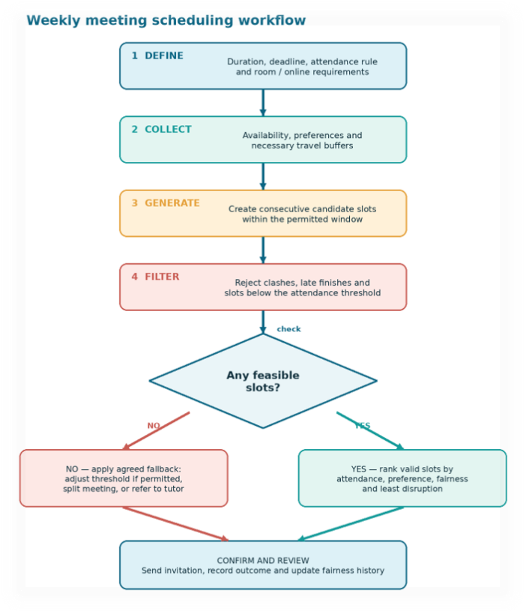

Figure 1. Constraint-led workflow for selecting a meeting and activating an agreed fallback

3.2 Workflow Explanation
The workflow starts by collecting the meeting details and the times when group members are available. The system then checks possible meeting times and removes any times that clash with classes, work or the deadline.
If a suitable time is found, the best meeting time is chosen and confirmed with the group. If no suitable time is found, another option can be considered, or the tutor can be asked for help. Finally, the meeting details are shared with the group.

4. Reflection and Justification

When choosing the best meeting time, the highest score may not always be the fairest choice. Some students may have personal responsibilities, a long journey or other important reasons that make certain times difficult. Because of this, the system should help the group make a decision rather than make the whole decision for them. Only the information needed to find a suitable meeting time should be collected, especially when calendar information is used [5].

4.1 Abstract Thinking

Abstract thinking means changing real-life information into simple information that the system can understand. For example, if someone works in the afternoon, that time is marked as unavailable. The week can be divided into smaller time slots to make it easier to find a suitable meeting time. This helps the system focus only on the important information needed to choose a meeting time [1].
Abstract thinking means changing real-life information into simple information that the system can understand. For example, if someone works in the afternoon, that time is marked as unavailable. The week can be divided into smaller time slots to make it easier to find a suitable meeting time. This helps the system focus only on the important information needed to choose a meeting time [1].
From real-life commitments to an explainable decision

PRACTICAL OUTPUTS
- Selected meeting time
- Reasons for rejection
- Fallback plan
- Record for next week

LOGICAL MODEL
- Common time slots
- Hard-constraint filter
- Attendance calculation
- Fairness-weighted score

REAL-WORLD INPUTS
- Lesson timetable
- Work and caring duties
- Travel / preparation
- Stated preferences

Figure 2. Improved abstraction model linking real commitments to an explainable outcome

4.2 Sub-division and Testing

The task is divided into smaller steps, such as collecting information, checking available times, choosing the best time and informing the group. This makes the system easier to understand and test. The system can also check problems, such as a meeting going past the deadline or a member not providing their available times. More features, such as room booking, can be added later if needed.

4.3 Justification of the Solution
The proposal addresses the causes of late or missed meetings directly. Deadline checking is built into candidate validation, while a single structured availability record is more reliable than reconstructing decisions from a long message thread. Attendance remains the dominant factor, but fairness history reduces the risk that one member repeatedly accepts the least convenient time. Because the weighting and tie-break rules are agreed in advance, the result is less vulnerable to pressure from the most vocal member.
The technical approach is proportionate. Constraint checking is a recognised method for eliminating impossible combinations [2], but a small student timetable does not justify machine learning or an expensive platform. A transparent weighted calculation is easier to explain, test and correct. The interface should be reviewed with actual users and made accessible; WCAG 2.2 provides relevant guidance for keyboard access, labels and understandable interaction [7]. Success should be evaluated through attendance, meetings confirmed before the deadline, late changes, time spent arranging each meeting and short group feedback. These measures support a practical review cycle consistent with project-management guidance [6].

4.4 Limitations
The outcome depends on the quality and timing of the information supplied. A forgotten work shift or incorrect time entry can make a technically valid result unusable. A fairness score cannot fully interpret sensitive personal circumstances, and its history may become misleading if a genuine absence is recorded in the same way as an unexplained non-attendance. Calendar integration also creates privacy and consent concerns. Finally, securing a time does not guarantee a productive meeting or equal contribution; agendas, chairing, action records and supportive group behaviour remain necessary.

4.5 Assumptions
ID | Working assumption
A1 | The deadline, duration and permitted scheduling window are known before candidates are generated.
A2 | Members provide accurate availability by the response time and consent to any free/busy access.
A3 | Group or module rules state whether an attendance threshold below unanimity is allowed.
A4 | All members can access the form, invitation and asynchronous material in an accessible format.
A5 | Preference and fairness weights are agreed before results are produced and are periodically reviewed.
Table 3. Assumptions governing operation of the proposed solution

5. Conclusion
The group meeting problem can be solved using a simple scheduling process. The problem was divided into smaller parts, and the important requirements were identified using MoSCoW. The system finds possible meeting times and removes the times that do not work. The remaining times are compared to find the best option for the group. If no suitable time is found, the group can use another agreed option.
The best part of the design is that it is easy to understand.Members can see why a time was rejected, how valid options were ranked and what will happen when full attendance is impossible. This should make it easier to arrange meetings each week and reduce disagreements. The system depends on group members giving correct information and making fair decisions. However, it is a simple and practical solution that can be improved in the future if needed.

.

References: IEEE
[1] J. M. Wing, “Computational thinking,” Communications of the ACM, vol. 49, no. 3, pp. 33–35, Mar. 2006, doi: 10.1145/1118178.1118215.
[2] V. Kumar, “Algorithms for constraint-satisfaction problems: A survey,” AI Magazine, vol. 13, no. 1, pp. 32–44, 1992, doi: 10.1609/aimag.v13i1.1008.
[3] Agile Business Consortium, “MoSCoW prioritisation.” [Online]. Available: https://www.agilebusiness.org/dsdm-project-framework/moscow-prioririsation.html. [Accessed: Aug. 10, 2026].
[4] ISO, ISO 9241-210:2019, Ergonomics of human-system interaction—Part 210: Human-centred design for interactive systems. Geneva, Switzerland: International Organization for Standardization, 2019.
[5] Information Commissioner’s Office, “A guide to the data protection principles: Data minimisation.” [Online]. Available: https://ico.org.uk/for-organisations/uk-gdpr-guidance-and-resources/data-protection-principles/a-guide-to-the-data-protection-principles/. [Accessed: Aug. 10, 2026].
[6] Project Management Institute, A Guide to the Project Management Body of Knowledge (PMBOK Guide), 7th ed. Newtown Square, PA, USA: Project Management Institute, 2021.
[7] World Wide Web Consortium, Web Content Accessibility Guidelines (WCAG) 2.2, W3C Recommendation, Oct. 2023. [Online]. Available: https://www.w3.org/TR/WCAG22/. [Accessed: Aug. 10, 2026].
[8] Doodle AG, “Group polls.” [Online]. Available: https://doodle.com/en/product/polls/. [Accessed: Aug. 10, 2026].

