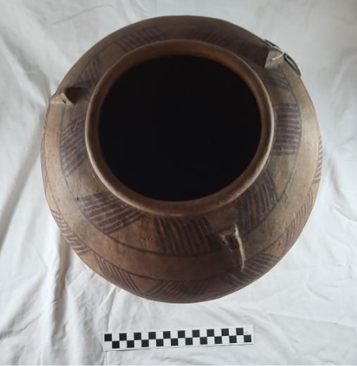
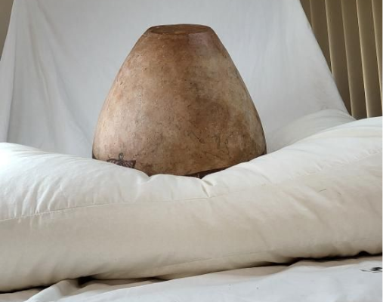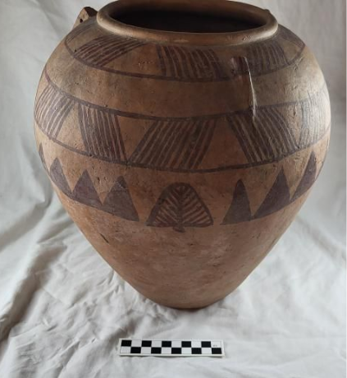

Predynastic Ceramic Vessel
Cyfartha Castle, Merthyr Tydfil CCM 270.004
Object type: Ceramic Vessel
Material: Ceramic
Period: Naqada II
Provenance: Major Harry Hartly Southey
Dimensions: 3400mm x 2800mm. Thickness of rim – 12mm, Vessel – 1600mm, Diameter of top rim – 1560mm, Widest part of vessel – 2800mm, Base of bottom – 1010mm

Object analysis by Leon Griffiths
This ceramic vessel is handmade with an irregular shaped rim; its surface is smooth with a red glazed marl clay surface. It is 34cm tall with its widest part being 28cm wide with ornamental decorations surrounding the upper half of the vessel. As shown in the pictures above there are two bands consisting of diagonal lines that repeat around the entire perimeter of the vessel that are repeating in alternate directions in groups. With the lower band consisting of groups of triangles also repeating around the perimeter of the vessel, the pattern being broken up by palm fronds which are shown three separate times on the vessel. The surface of the vessel itself is somewhat textured; which for ceramic vessels such as this one means that a coiling method was used in its construction.
This ceramic more than likely served both a utilitarian and symbolic purpose, as most vessels such as this one were used for liquid storage or served as offerings/ grave goods so that it could provide the dead with nourishment after death. Upon the rim of the vessel there are three lugs that are spaced evenly with a hole in each of them; this was so a string or tie could be used to secure a lid for the vessel.
In predynastic Egypt, offerings were often placed in graves with the dead to accompany them to the next realm as an expression of practical and religious necessities (Murry 1956). In the Naqada II period, these grave goods were often given as gifts; these included various ceramics such as this one, ornaments and statues which often expressed in some way of the individual's status in society and sometimes displayed commemorative parts of their life.
Pottery such as this was commonly used as grave goods in the Naqada II period, “they may have been included in burials for a specific ritual purpose, or as goods that could be taken to the next life.” (Garstang Museum 2018), this shows that even in early predynastic Egypt there was much development of ancient Egyptian funerary beliefs as well as the cultural identification of links between material culture and the idea of everlasting life after death.

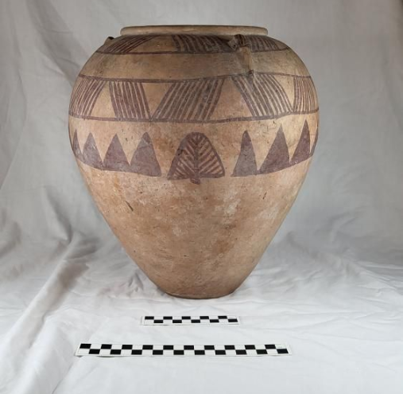
Fig 1 – Leon Griffiths – Picture of Decorated ceramic vessel
This vessel; as well as many other Ceramic vessels, inform modern archaeologists with much insight into predynastic Egyptian beliefs and values. The choice of imagery on these decorated vessels allows for a glimpse into the semiotic communication that the decorative features offered that predynastic Egyptians used in their pottery. (Bebbington 2018). These decorations can help to identify what was important to people in the Naqada II period.
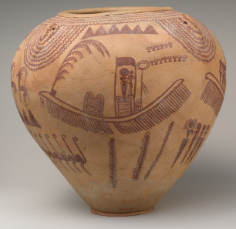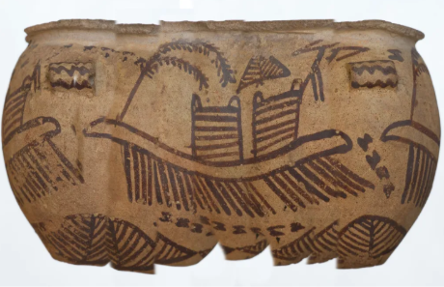
Fig 2 – Garstang museum – A collage of images shows decorations on d ware vessel Fig 3 – The Met Museum - Vessel Depicting Ungulates and Boats with Human Figures
The vessel shown in figure 3 is another example of a predynastic decorated ceramic vessel from the Naqada II period, easily identified by its red painted decoration (The met museum 2021). This vessel shows scenes of palm trees, animals, people and boats which are all artistic features that reoccur very often in predynastic art. These artistic features lead to the idea that the vessel shown in fig 3 specifically had ritualistic or ceremonial importance and symbolises the journey into the afterlife (Bebbington 2018).
The vessel shown in figure 2 is also easily identifiable by its marl clay surface with red pigment applied to create more a more complex decorative piece of pottery; especially when compared to the vessel shown in figure 1. Though this vessel shows the same imagery; boats, flora, humans and animals just the same as figure 3, it shows that these elements were not randomly arranged but instead were a form of a cohesive visual composition that reflects a representation of the landscape of ancient Egypt and human interaction with it (Bebbington 2018).
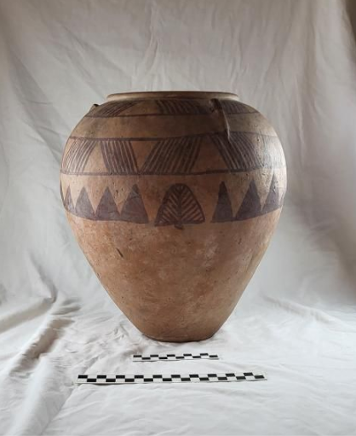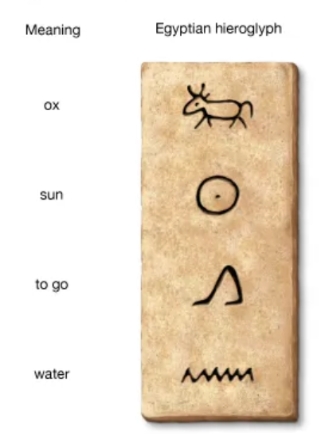
Fig 4 – Leon Griffiths - Picture of Decorated ceramic vessel Fig 5 – image showing certain hieroglyphics
The diagonal line patterns shown in figure 4 closely resemble the hieroglyphic sign for water, which is likely a stmbolic reference to the Nile as it was the central source of fertility and life in Egypt. The palm fronds can be associated with growth, development and regeneration, and the triangles could be interpreted as representations of hills or mountain landscapes; potentially being used as a representation of the realms of life and death. When put together these elements reflect an early way of understanding the natural world as ordered and significant, with importance placed on balance and the connection between people and their surroundings.
The context that this vessel was a grave good suggests that it had symbolic and ritual function, which further reinforce the interpretations of its decorative features (University College London 2001). With the presence of lugs upon the rim of the vessel indicating that a lid or cover may have been attached to it, which further implies that it was used to carry and contain grains or liquids, though its role was likely extended beyond practical use to be used as grave goods. Since it was found in a predynastic Egyptian tomb, it reflects the beliefs surrounding the afterlife that people would have in that time period. As such, this particular vessel can be understood as both a functional piece of pottery for everyday use and as an early showcase of the developing religious and cultural practises in the Naqada II period in ancient Egypt.

Bibliography
Murray, M.A. (1956). Burial Customs and Beliefs in the Hereafter in Predynastic Egypt. The Journal of Egyptian Archaeology, 42, p.86. doi:https://doi.org/10.2307/3855127.
‌ Bebbington, C. (2018). Decorated Ware – A Landscape in Ceramic. [online] Garstang Museum of Archaeology. Available at: https://garstangmuseum.wordpress.com/2018/08/15/decorated-ware-a-landscape-in-ceramic/.
Metmuseum.org. (2021). Available at: https://www.metmuseum.org/art/collection/search/545755.

Britannica Kids. (2020). hieroglyphics. [online] Available at: https://kids.britannica.com/kids/article/hieroglyphics/353247.

University College London (2001). Predynastic Burial customs. [online] Available at: https://www.ucl.ac.uk/museums-static/digitalegypt/burialcustoms/predynastic.html.
‌

‌

‌

