

LOCATION: Swansea | LLEOLIAD: abertawe
LEVEL 6 | LEFEL 6
EXAMINATION PERIOD | CYFNOD ARHOLIADAU
January 2020 | IONAWR 2020

MODULE CODE: ACDA6004
Power Electronics and Drives
TIME: 2 HOURS
answer all questions

Equipment or materials required – Calculator
Adnoddau neu ddefnyddiau sydd eu hangen - Cyfrifiannell

ANSWER ALL QUESTIONS

- Compare and contrast the working principles of a three phase synchronous motor, and a three phase induction motor.
[10 Marks]
Description should include:
- Rotating magnetic field in stator produced by three coils 120° apart.
- Induction motor uses squirrel cage. Voltage induced in squirrel cage by RMF.
- Squirrel cage forms closed circuit so current flows.
- Currents in squirrel cage create magnetic field opposing RMF.
- Forces generated between RMF and squirrel cage turn rotor.
- Induction motor relies on slip and does not run at fixed speed.
- Speed of induction motor is dependent on load
- Synchronous motor starts as induction motor using squirrel cage.
- Near full speed induced currents in the squirrel cage are low and torque is now from forces between field from rotor windings and RMF.
- Synchronous motor speed governed by line frequency.

- Control of several operational parameters of an induction motor may be achieved by an inverting motor controller. Assuming a controller is using PWM as its control mechanism:
  - Provide a block diagram of an inverting motor drive and give a brief explanation of the operation of each of the sections.
[2 Marks]

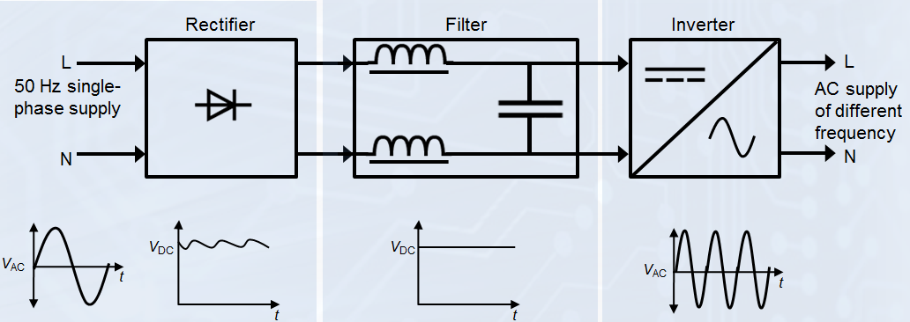
The rectifier converts the incoming AC to DC
The filter is used to smooth the previously rectified DC.
The inverter is used to convert the previously rectified and smoothed DC back into an AC form at a frequency and amplitude required by the motor.

  - Describe the operation of an inverting motor controller to accelerate and decelerate a motor while maintaining torque.
[6 Marks]
An inverting controller may control the acceleration/deceleration of an induction motor by manipulating both the speed of the motor (by AC power frequency variation) and torque of the motor (by AC power amplitude variation) simultaneously.
Acceleration is achieved by ramping up of the frequency to the desired level whilst deceleration is achieved by ramping down of the frequency to the desired level. The torque when producing drive or braking may be controlled by controlling the voltage/current applied to the motor.

  - Analyse how an inverting PWM motor controller may control the speed of an induction motor and the torque it produces.
[6 Marks]
The speed of an induction motor is directly controlled by the frequency of the AC supply. Thus, to vary the speed of the motor the frequency of the output of the inverter must be varied.
To achieve modification of the frequency, the PWM period is varied but the mark / space ratio remains. i.e. if the PWM period is 0.5mS and the number of periods is 40 per cycle the cycle period is 20mS or 50Hz. Should the PWM period be halved to 0.25ms and the number of periods remains at 40 per cycle the cycle period is now 10mS or 100Hz. As can be seen extending the PWM period will lower the output frequency while shortening the PWM period will increase the frequency, the speed will change proportionally with the change in frequency.
The torque of an induction motor may be controlled by limiting the voltage / current supplied to the motor. This type of control may be derived from a PWM based controller by modifying the mark/space ratio.
i.e.
To achieve max V output of the system would be given by
$$V_{out}=V_{in}×(mark/space ratio)$$
To achieve an 80% max V output, multiply the mark time by 0.8. =
$$V_{out}=0.8×V_{in}×(mark/space ratio)$$

  - A PWM signal may be utilised to provide a sinusoidal power supply to a motor from an inverting motor controller analyse how this is achieved.
[6 Marks]
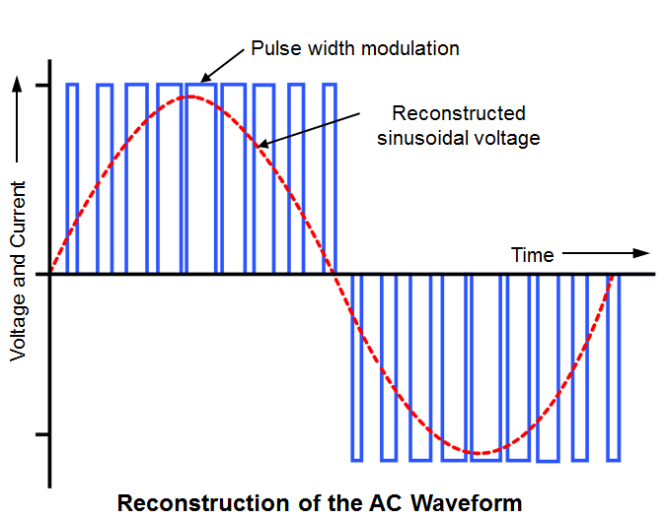
PWM may be used to generate an approximation of a sinusoidal wave as shown above.
The average voltage of the PWM signal approximates the red line.
To achieve this, the PWM period is selected, usually approx. 20 - 100 times faster than the fundamental frequency period required. The PWM mark / space ratio can then be modified to achieve the required %age of the full output and set to provide a sinusoidal wave. i.e. an equal mark space ratio will provide an average V * 50% output or V/2.
The frequency of the output is given by the period of the PWM and the number of periods per cycle. i.e. if the PWM period is 0.5mS and the number of periods is 40 per cycle the cycle period is 20mS or 50Hz. The pulse width and frequency are proportional to the instantaneous voltage of the AC waveform and its frequency respectively.
Once filtered the output from the PWM signal is very close to a sine wave.

- The new de Havilland Beaver electric sea plane is powered by a 560 kW four pole, three phase induction motor operating between 1900 and 3000 rpm. The motor is rated for an RMS supply voltage of 540 V Suggest a transistor technology that would be suitable for this application, and show in a circuit diagram how they would be connected to the motor.
[20 Marks]

$$I=\frac{P}{V}=\frac{560000}{540}=1037.037 A$$

Four poles = 2 pole pairs.
$$f=\frac{ωp}{60}$$

$$f_{min}=\frac{1900×2}{60}=63.333 Hz$$

$$f_{max}=\frac{3000×2}{60}=100 Hz$$

V = 540V, I = 1037A, f = 63.333 to 100 Hz Assuming the PWM signal contains 40 pulses per cycle the gate switching frequency of the driving transistors would be between 2533.32 Hz and 4 kHz.

Characteristic | Power bipolar | Power MOSFET | IGBT
Voltage rating | High <1kV | High <1kV | Very high >1kV
Current rating | High <500A | Very High > 500A | Very High >500A
Input drive | Current ratio h_{FE}  20-200 | Voltage V_{GS}  3-10V | Voltage V_{GE}  4-8V
Input impedance | Low | High | High
Output impedance | Low | Medium | Low
Switching speed | Slow (µs) | Fast (ns) | Medium
Cost | Low | Medium | High

Power bipolar transistors would not be suited to this application as the load current is too high for this type of device.
Although power MOSFET transistors could be used in this application, the high load current would cause a higher power dissipation within the power MOSFET transistor than in the IGBT, therefore the transistor technology best suited to this application would be insulated gate bipolar transistors (IGBT) as they can withstand very high voltages, high currents and switch at the required frequency. The transistors would be connected in a push pull configuration on each phase. This would allow each phase to be connected to either the positive supply or the ground return path.

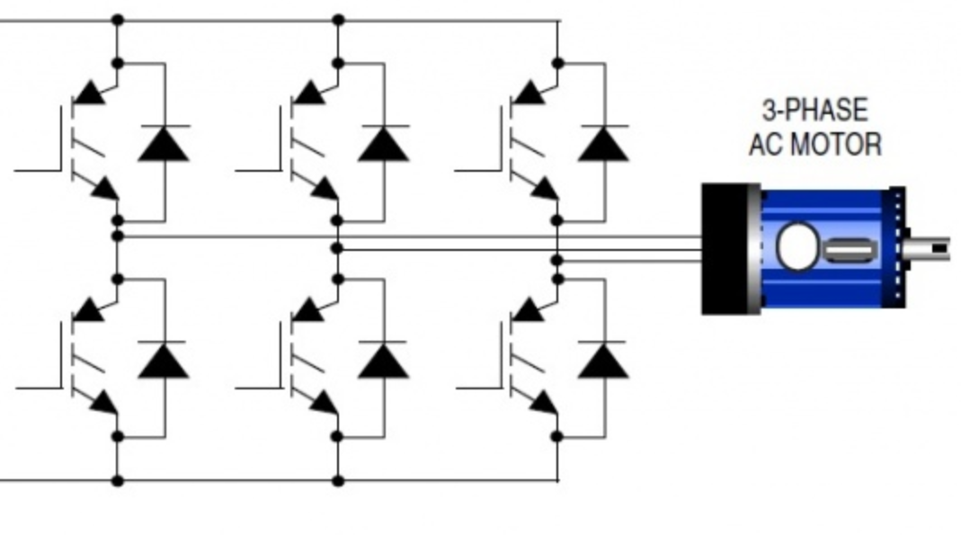
The gate drives for the transistors would be derived from a sinusoidal waveform encoded as PWM. The top transistors would be pulsed on when the associated phase output is positive, and the bottom transistors would be pulsed on when the associated phase output is negative.
The diodes fitted across the collector and emitter of the transistors protect the transistors from the back EMF produced when the coils of the motor are de-energised.

Diwedd/End

