Name: Benson Becehemayor Student Nr: 1909011
Lecturer: Dr. Jia Miao

The Importance of Artificial Intelligence (AI) in the 21st Century Banking and Finance and its Impact in Third World Countries

ABSTRACT
The 21st century has witnessed a transformative shift in the banking and finance sector with the integration of transformational technology, one of which is the Artificial Intelligence (AI). This integration is particularly critical for third-world countries where financial inclusion and operational efficiency are paramount for economic growth and stability. AI's potential to revolutionize banking operations, enhance risk management, and personalize customer service offers unprecedented opportunities and challenges. This study aims to determine the impact of AI on operational efficiency in banking and finance, evaluate the role of AI in financial risk management and fraud detection, examine how AI enhances customer service and personalization, explore the potential challenges and ethical considerations associated with AI adoption in banking and finance and evaluate bank customer’s perception over the integration and use of AI in financial operations. A mixed-methods approach was employed, utilizing both quantitative and qualitative data. Quantitative data were analyzed using descriptive statistics to measure the impact of AI on various operational metrics. Qualitative data were gathered through interviews and thematic analysis to gain insights into the experiences and perspectives of banking professionals and customers regarding AI implementation. The findings reveal that AI significantly enhances operational efficiency by automating routine tasks and reducing processing times. In financial risk management and fraud detection, AI systems provide superior analytical and predictive capabilities, resulting in more effective risk identification and mitigation efforts. AI also enhances customer service by providing personalised financial goods and services, resulting in higher customer happiness and loyalty. However, the use of AI raises ethical problems, such as data privacy, employment displacement, and the need for legislative frameworks to ensure responsible AI use.

Table of Contents
CHAPTER ONE 1
INTRODUCTION 1
1.1 Introduction 1
1.2 Statement of Problem 2
1.3 Aim of the Study 3
1.4 Research Objectives 3
1.5 Research Questions 4
1.6 Significance of the Study 4
1.8 Dissertation Structure 5
1.9 Summary 6
CHAPTER TWO 7
LITERATURE REVIEW 7
2.1 Introduction 7
2.2 Evolution of AI Technologies and their Integration into Banking and Finance 7
2.4 Impact of AI on Third-World Countries 10
2.5 Challenges of AI in Third World Countries Banking and Finance 11
2.6 Ethical and Regulatory Considerations of AI Adoption in Banking and Finance 13
2.7 Theoretical Framework 14
2.8 Review of Empirical Studies 15
2.9 Research Gaps 16
2.10 Summary 18
CHAPTER THREE 19
METHODOLOGY 19
3.1 Introduction 19
3.2 Research Philosophy 19
3.3 Research Approach 19
3.4 Research Design and Methodological Choice 20
3.5 Data Collection Technique 21
3.6 Data Analysis 21
3.7 Ethical Consideration 22
3.8 Summary 23
CHAPTER FOUR 24
FINDINGS AND ANALYSIS 24
4.1 Introduction 24
4.3: Impact of AI on Operational Efficiency in Banking and Finance. 28
4.4: Role of AI in Financial Risk Management and Fraud Detection in the Banking Sector 33
4.5: Impact of AI on Customer Service and Personalisation in the Finance Industry. 38
4.6: Potential Challenges and Ethical Considerations Associated with the Adoption of AI in Banking and Finance 41
4.7: Customer’s Perception over the Integration and use of AI in Financial Operations. 44
4.8 Summary 57
CHAPTER FIVE 58
DISCUSSION, CONCLUSIONS, RECOMMENDATIONS, AND LIMITATIONS 58
5.1 Introduction 58
5.2 Discussion of Research Findings 58
5.3 Conclusion 65
5.4 Recommendations 66
5.5 Research Limitations 67
5.6 Implications for Future Research 68
5.7 Implications for Practice 68
5.8 Chapter Summary 69
REFERENCES 70

LIST OF TABLES
Table 4.2.1: Years of Experience 24
Table 4.2.2: Respondent’s Gender 25
Table 4.2.3: Educational Attainment of Respondents 25
Table 4.2.4: Respondent’s Role 26
Table 4.3.1: Does the adoption of AI in the banking and financial sector support and ease operational efficiency of banks globally? 27
Table 4.3.2: Does AI facilitate financial transactions and collaboration between banks and other financial institutions? 27
Table 4.3.3: Does AI facilitate data analysis and contribute to making informed decisions in the banking and finance sector globally? 28
Table 4.3.4: Is AI helping developing third world banks in their daily operations? 28
Table 4.3.5: Is AI changing the way 21st century banking is being practiced? 29
Table 4.4.1: Do you believe AI has the potential to significantly improve financial risk management? 30
Table 4.4.2: Are AI models capable of predicting financial risks with greater accuracy than traditional models? 30
Table 4.4.3: Do you think AI can identify emerging financial risks that human analysts might overlook? 31
Table 4.4.4: Are AI-based fraud detection systems able to learn and improve over time?
31
Table 4.5.1: Is AI widely used in your organization for enhancing customer service?
` 33
Table 4.5.2: Does your financial institution use chatbots to handle customer inquiries?
33
Table 4.5.3: Has AI reduced the average response time for customer service requests?
34

CHAPTER ONE

INTRODUCTION

1.1 Introduction
Since its inception, artificial intelligence (AI) has significantly evolved from a theoretical idea to a transformative force across multiple sectors. Lu (2019) describes AI as the development of computer systems capable of performing tasks that typically require human intelligence, such as learning, reasoning, and problem-solving. Over the years, advances in machine learning, neural networks, robotics, natural language processing, and AI have led to remarkable progress in AI technologies (Duan, Edwards, and Dwivedi, 2019). Machine learning, a subset of AI, has emerged as a crucial technology, enabling computers to improve their performance through data learning without explicit programming (Frank et al., 2019). This shift has given rise to sophisticated algorithms capable of analyzing vast amounts of data and deriving valuable insights (Gill et al., 2019). Inspired by the human brain's structure and function, neural networks have empowered deep learning algorithms to achieve unprecedented accuracy and efficiency in tasks such as image and speech recognition, as well as language translation (Prieto et al., 2016; Roll and Wylie, 2016). Furthermore, natural language processing (NLP) has completely changed how computers communicate with and comprehend human language, according to van Remmen et al. (2023). NLP algorithms are capable of automating language-related tasks, facilitating human-computer communication, and extracting meaning from unstructured text data through methods like sentiment analysis, named entity recognition, and text generation (Nazir et al., 2017; Chowdhary and Chowdhary, 2020; Farzaneh et al., 2021).
Moreover, the increasing prominence and extensive integration of AI across diverse sectors underscores its capacity to stimulate creativity, enhance efficacy, and open up novel avenues for financial expansion (Alsheibani, Cheung and Messom, 2018). AI-powered diagnostic tools in the medical field are able to analyze medical pictures, identify abnormalities, and help doctors diagnose patients more quickly and accurately (Jiang et al., 2017; Amann et al., 2020). AI-enabled robots in manufacturing can increase quality control, expedite production processes, and respond more quickly to changing conditions (Zeba et al., 2021; Kim et al., 2022; Pillai et al., 2022). AI algorithms are utilized in transportation to operate self-driving cars, improve traffic flow, and improve safety by means of accident prevention and predictive maintenance (Abduljabbar et al., 2019; Haydari and Yılmaz, 2020; Nikitas et al., 2020). Artificial intelligence (AI) is redefining the financial industry, impacting everything from risk management and investment strategies to customer service and fraud detection (Lui and Lamb, 2018). Artificial intelligence (AI)-driven chatbots and virtual assistants offer customized support to clients, while machine learning algorithms examine transaction data to instantly identify fraudulent activity (Ashta and Herrmann, 2021). AI models are used in risk management to evaluate creditworthiness, spot market trends, and maximize investment portfolios. They do this by utilizing predictive analytics and data-driven insights (Leo, Sharma, and Maddulety, 2019). According to Ashima Narang, Vashisht, and Bajaj (2024), fraud detection is one of the main uses of AI in banking and finance. Conventional rule-based systems are unable to cope with the complexity and sophistication of modern sophisticated fraud operations. According to study by Bao, Hilary, and Ke (2022), artificial intelligence (AI) algorithms can quickly spot unusual patterns and possible fraud attempts since they can accurately and quickly evaluate enormous amounts of transactional data in real-time. Furthermore, Roseline et al. (2022) state that financial institutions may make more accurate assessments by using AI insights to help them make data-driven, well-informed decisions.
Given this context, this research examines the transformative impact of artificial intelligence (AI) on the banking and finance sectors, within the third world countries. It investigates how AI enhances operational efficiency, risk management, and customer service while addressing the unique challenges and ethical considerations of AI adoption in these regions. This research intends to give comprehensive insights into the potential of artificial intelligence (AI) technologies to foster financial inclusion, economic development, and sustainable growth in underdeveloped and developing nations by examining both the possibilities and challenges associated with them.

1.2 Statement of Problem
Opportunities and difficulties arise from the application of artificial intelligence (AI) in the banking and financial industries, especially when it comes to third-world nations. Although AI has the capacity to completely transform various sectors, there are obstacles in the way of its implementation. A major issue in many third-world nations, the absence of a strong digital infrastructure and dependable internet connectivity prevents AI technologies from being widely adopted and effectively used in banking and finance (Malali and Gopalakrishnan, 2020). This technology divide exacerbates already-existing inequalities and obstructs initiatives to advance economic growth and financial inclusion. Additionally, even though AI has the potential to increase operational efficiency, its use could necessitate large expenditures on workforce training, infrastructure, and technology (Rahman et al., 2023). Many financial institutions in third world countries may lack the resources or expertise to effectively integrate AI into their operations, limiting the scalability and impact of AI-driven initiatives.
Moreover, the ethical consequences of AI adoption in finance and banking are a source of worry (Munoko, Brown-Liburd, and Vasarhelyi, 2020). The ethical use of AI systems is severely hampered by concerns about data privacy, algorithmic bias, and transparency. These ethical issues are even more important in developing nations, where regulatory frameworks may be less developed and enforcement methods may be weaker. The extensive use of AI in banking and finance runs the potential of escalating already-existing vulnerabilities and inequities if proper controls are not in place (Caron, 2019). Additionally, the rapid pace of technological advancement in AI presents a challenge for regulators and policymakers tasked with ensuring the stability and integrity of financial systems (Dwivedi et al., 2021). Keeping pace with evolving AI technologies and understanding their implications for regulatory frameworks requires proactive and adaptive approaches, which may be lacking in some third world countries.

1.3 Aim of the Study
This study aims to analyze the importance of artificial intelligence in the 21st-century banking and finance sector, with a particular focus on its impact and potential benefits in third world countries.

1.4 Research Objectives
- To determine the impact of AI on operational efficiency in banking and finance.
- To evaluate the role of AI in financial risk management and fraud detection in the banking sector.
- To examine how AI enhances customer service and personalization in the finance industry.
- To explore the potential challenges and ethical considerations associated with the adoption of AI in banking and finance.
- To evaluate bank customer’s perception over the integration and use of AI in financial operations.

1.5 Research Questions
- How does AI impact operational efficiency in banking and finance?
- What role does AI play in financial risk management and fraud detection in the banking sector?
- How does AI enhance customer service and personalization in the finance industry?
- What are the potential challenges and ethical considerations associated with the adoption of AI in banking and finance?
- How do bank customers perceive the integration and use of Artificial Intelligence (AI) in financial operations?

1.6 Significance of the Study
As artificial intelligence (AI) develops, its application in banking and finance has the potential to completely transform these sectors by increasing operational effectiveness, boosting risk mitigation, and customizing client experiences (Ashta and Herrmann, 2021). The study's emphasis on developing nations gives the conversation about artificial intelligence in finance a crucial new angle. According to Khan (2016), these locations frequently confront particular difficulties that might obstruct the adoption and efficient use of AI, such as a lack of technical infrastructure, a lack of financial literacy, and regulatory barriers. Through an examination of AI's effects in various settings, the research seeks to pinpoint both advantages and disadvantages, providing information that can guide strategic and policy choices intended to promote financial inclusion and economic growth (Cao, 2022). Moreover, the study's exploration of AI's role in operational efficiency highlights how automation and data-driven decision-making can streamline banking processes, reduce costs, and improve service delivery (Königstorfer and Thalmann, 2020). This is particularly pertinent for third world countries, where resource constraints necessitate innovative solutions to enhance productivity and service reach. The study highlights the potential for major advancements in financial services by showcasing the observable advantages of AI in practical settings.
Additionally, the investigation into AI's impact on risk management and fraud detection addresses critical concerns in the banking sector (Arsic, 2021). Dhieb et al. (2020) affirm that effective risk management is essential for maintaining financial stability and protecting stakeholders' interests. Ryman-Tubb, Krause and Garn (2018) state that AI's advanced analytical capabilities can enhance the detection of fraudulent activities and enable more accurate risk assessments, thus contributing to more robust and secure financial systems. This is especially important for third world countries, where financial systems are often more vulnerable to risks and fraudulent practices. The study offers a fair viewpoint that recognizes the difficulties of incorporating cutting-edge technology into conventional banking frameworks by considering the ethical issues and adoption hurdles related to AI. This thorough methodology guarantees that the study's conclusions are applicable for improving strategic and operational outcomes as well as directing the adoption of ethical and responsible AI. As a result, this study is a useful tool for practitioners, academics, and policymakers seeking to comprehend and manage the rapidly changing AI environment in banking and finance.
1.7 Research Methodology
This study's research method relies on a pragmatic philosophy and uses an exploratory research design with an abductive approach. According to Brauner (2017), this strategy successfully integrates qualitative and quantitative methodologies to provide a thorough analysis of AI's effects on the banking and finance industries in developing nations. Semi-structured questionnaires were used to collect primary data; this allowed for answer freedom while guaranteeing that important areas of inquiry were addressed (Kallio et al., 2016). This method facilitated the capture of both numerical data and rich, detailed qualitative insights. Moreover, thematic analysis was applied to qualitative data to identify and interpret patterns and themes, providing a detailed understanding of the participants' perspectives (Campbell et al., 2021). Quantitative data was analyzed using descriptive analysis, summarizing the data through measures such as frequencies and percentages to highlight trends and patterns (Siedlecki, 2020). In addition, the integrity of the study process was ensured by strict adherence to ethical considerations, such as informed permission, confidentiality, and the secure management of sensitive data (Fleming and Zegwaard, 2018).

1.8 Dissertation Structure
The present dissertation is arranged in five sections. With an emphasis on developing nations, Chapter One presents the study's findings and highlights the significance of AI in banking and finance. Background information, goals, and research questions are provided. The literature on artificial intelligence (AI), its applications in banking and finance, and the particular setting of third-world nations is reviewed in Chapter Two. The research approach, including methods for gathering and analyzing data, is covered in Chapter 3. The results are presented in Chapter Four, which also analyses how AI affects risk management, customer service, operational efficiency, and ethical issues. It includes case studies from third world countries. In Chapter Five, the findings are discussed together with the problems, implications for the banking and financial industry, and prospects for further study. A summary of the dissertation's most important findings and suggestions for decision-makers in government and business are provided at the end.

1.9 Summary
An overview of the development and importance of artificial intelligence (AI) in the banking and financial industries is given in Chapter 1. It presents important ideas, such artificial intelligence, and emphasizes how it is transforming a number of sectors. The study's goals, research questions, issue statement, and importance of the current investigation are all outlined in this chapter. By laying the groundwork for an extensive examination of AI's consequences, Chapter One provides the framework for comprehending the transformational potential of AI in banking and finance.

CHAPTER TWO

LITERATURE REVIEW

2.1 Introduction
Artificial intelligence (AI) has changed many industries, and banking is no exception. The integration of artificial intelligence into banking services has resulted in significant improvements that have changed the way financial institutions operate, interact with consumers, and do business. According to Kumar and Gupta (2023), the goal of implementing artificial intelligence in banking services is to increase consumer happiness, improve risk management, increase efficiency, and offer customized financial solutions. According to Kruse, Wunderlich, and Beck (2019), intense competition in the banking industry may be partly to blame for the growing usage of AI in the industry. Furthermore, one of the key benefits of using AI in the banking sector, according to Königstorfer and Thalmann (2022), is improving decision-making in the areas of lending, investing, and credit evaluation. AI can help save compliance costs by automating processes (Kerkez, 2020); it can also help identify financial fraud (Ashta and Herrmann, 2021). In the same way, employing AI chatbots can save employment expenses (Patil and Kulkarni, 2019). Additionally, they can increase the pace at which they can offer prompt customer support and be available around the clock (Wittmann and Lutfiju 2021). N Despite the potential benefits of artificial intelligence (AI) for the financial industry, academic research and industry experts suggest that financial institutions have not fully accessed AI's potential (Cao, 2022; Fabri et al., 2022).

2.2 Evolution of AI Technologies and their Integration into Banking and Finance
In the initial stages, AI in financial institutions relied on expert systems (Kaushik and Sharma, 2023). According to Adeyelu, Ugochukwu, and Shonibare (2024), these systems automated regular operations including transaction processing and fraud detection by using predetermined rules and logic. Despite their limitations in handling ambiguity and complexity, expert systems laid the foundation for more advanced AI applications by demonstrating the potential of automating decision-making processes. However, their rigidity and inability to learn from new data highlighted the need for more dynamic and intelligent solutions (Oyeniyi, Ugochukwu and Mhlongo, 2024b). Moreover, a major advancement was made with the introduction of machine learning. In contrast to rule-based systems, machine learning algorithms don't require explicit programming to analyze large volumes of data and spot patterns (Agarwal et al., 2023). This capability transformed various aspects of banking and finance, from credit scoring to investment management. For example, machine learning models enabled the development of more accurate credit risk assessments by analyzing diverse data points, including transaction histories, social media activity, and even psychometric data (Cerrone, 2023). More people were able to receive finance as a result of the improved accuracy in risk assessment, especially small enterprises and individuals who were previously considered too dangerous by conventional methods (Cui, 2022).
According to Kshetri (2016), the growth of big data analytics provided the necessary energy for machine learning algorithms. Financial institutions began leveraging the exponential increase in data from digital transactions, social networks, and mobile devices. These organizations were able to learn more about consumer behavior, industry trends, and operational efficiency attributable to big data analytics (Hassani, Huang and Silva, 2018). Consequently, personalized banking services emerged, offering customized financial products and advice tailored to individual customer profiles. Königstorfer and Thalmann (2020) agreed that, this shift not only improved customer satisfaction but also enhanced the competitiveness of banks and financial firms. Furthermore, Shoetan and Familoni's (2024) study affirms banking industry's fraud detection systems have advanced largely due to deep learning. Real-time transaction pattern analysis is performed by these systems to spot irregularities that could point to fraud. Deep learning models can provide strong security measures by continually learning from fresh data and adapting to changing fraud strategies (Patel, 2023).
Furthermore, according to Mori and Du (2023), chatbots and virtual assistants driven by AI have completely changed the way that banks provide customer care. These intelligent agents respond quickly and accurately to a variety of queries, ranging from loan applications to balance checks (Roslan and Ahmad, 2023). These chatbots' conversational responses to client inquiries are made possible by the use of natural language processing, which improves user experience. Additionally, Suhel et al. (2020) suggest by automating routine interactions, banks can allocate human resources to more complex tasks, improving overall operational efficiency. Furthermore, AI technologies have also significantly impacted investment management (Gómez, Prado and Plaza, 2019). Algorithmic trading, powered by AI, has become a dominant force in financial markets (Dou, Goldstein and Ji, 2024). These algorithms analyze market data, news articles, and other relevant information to make trading decisions at speeds and accuracies unattainable by human traders. A wider audience may now access wealth management services through the emergence of robo-advisors, which employ artificial intelligence (AI) to generate tailored investment advice based on each client's risk tolerance and financial objectives (Gurung et al., 2024).
2.3 Role of AI in Banking and Finance
According to Ahmadi's (2024) research, artificial intelligence's (AI) prowess in data processing, automation, and predictive analytics has revolutionized risk management techniques and improved operational efficiency. According to Ashima Narang, Vashisht, and Bajaj (2024), one of artificial intelligence's most important contributions to the banking industry is its capacity to quickly and reliably handle and analyze enormous volumes of data. Machine learning-based AI algorithms, in particular, are capable of sorting through data to find patterns and insights that would be hard or impossible for humans to find (Bhattacharya and Sinha, 2022). Devi (2024) concurred that this capability is essential for tasks like fraud detection, in which artificial intelligence (AI) analyses transaction behavior in real-time to spot irregularities and possibly fraudulent activity. AI systems provide robust defenses against increasingly sophisticated fraud tactics, to ensure greater security for both the institutions and their customers by learning from historical data and adapting to new patterns (Kahyaoglu, 2021; Veloso et al., 2021). According to research by Margaret et al. (2023), AI improves accessibility and personalizes experiences for customers. Artificial intelligence (AI)-driven chatbots and virtual assistants are becoming a crucial part of contemporary banking, offering clients immediate help and aid. These AI agents handle a range of tasks, from answering basic inquiries to assisting with complex transactions, all while learning from each interaction to improve their responses over time (Suhel et al., 2020).
According to Kenny (2019), traditional risk assessment methods often rely on static models that may not account for rapidly changing market conditions or emerging risks. AI, on the other hand, can continuously analyze real-time data to provide dynamic risk assessments (Oyewole et al., 2024). For instance, in credit scoring, AI models consider a wider range of variables, such as spending behavior, social media activity, and even smartphone usage patterns, to more accurately predict an individual's creditworthiness. This comprehensive approach allows for more inclusive lending practices, giving access to credit for individuals and small businesses that might be overlooked by conventional methods (Hassan, Aziz and Andriansyah, 2023). Furthermore, AI's predictive capabilities are also invaluable for strategic planning and decision-making (Oyewole et al., 2024). Oyeniyi, Ugochukwu and Mhlongo (2024a) found that AI can provide financial institutions with actionable insights that inform their strategies through analyzing market trends, economic indicators, and consumer behavior. Ansari (2018) and Maseke (2024) agreed AI's predictive capabilities enable financial firms to anticipate market shifts, identify new opportunities, and make data-driven decisions that enhance their competitive edge. AI-driven algorithms, or robo-advisors, have democratized investment advice, making it accessible to a broader audience (Dou, Goldstein and Ji, 2024). These platforms use AI to assess individual risk preferences and financial goals, providing personalized investment recommendations and portfolio management services. Moreover, Tad et al. (2023) posit AI plays a crucial role in regulatory compliance and reporting. Additionally, Mithra, Duddukuru, and Manu (2023) discovered that artificial intelligence (AI) can automate data collection and processing, therefore streamlining the complex requirements for reporting and compliance and guaranteeing accurate and timely regulatory reports.

2.4 Impact of AI on Third-World Countries
According to Adebayo Olusegun Aderibigbe et al. (2023), Converging factors such as rising awareness of the transformational impact of AI applications, improved connectivity, and technical developments are driving the adoption of AI in third-world countries. According to Wakunuma, Jiya, and Aliyu (2020), investigating AI in third-world countries is both a technological and a socioeconomic necessity. According to Xieling et al. (2020), AI has the potential to spur innovation, enhance public services, and deal with urgent problems in third-world countries' healthcare, agriculture, and educational systems. For example, Rwanda has adopted AI in the field of education to improve student outcomes (Harerimana, and Mtshali, 2020). The National Payment Corporation of Vietnam (NAPAS) uses chatbots powered by artificial intelligence (AI) to give those without access to traditional banking services and financial information (Ha and Nguyen, 2022, Binh, 2018). AI algorithms are being used by businesses like CropIn in India to evaluate soil conditions, meteorological information, and satellite photos in order to improve precision farming techniques (Rana, 2023). AI is significantly enhancing medical services in Kenya, a country where access to healthcare is frequently constrained (Ade-Ibijola, and Okonkwo, 2023). Furthermore, by enabling remote consultations and lessening the strain on overburdened health systems, AI-powered telemedicine platforms can close the gap between urban and rural healthcare services (Manyika et al., 2018). Kshetri (2020) emphasizes that economic development and AI innovation are positively correlated. Artificial Intelligence has a complex effect on economic growth in third-world countries, affecting labor employment, income distribution, capital accumulation, production efficiency, and the real economy's overall development (Htet et al., 2023). It has been demonstrated that ICT investment, including AI, considerably boosts GDP development in both developed and developing nations (Yousefi, 2015).
Furthermore, a major share of low-skilled occupations in the AI business is carried out in third-world countries, where AI applications have already been shown to have significant positive social and economic effects (Kshetri, 2021). A World Bank analysis from 2019 suggests that the use of AI technology in third-world countries might boost their GDP growth by as much as 1.2%. Yet, adopting and using AI technology presents serious obstacles for third-world countries. Among these difficulties include poor government backing, a lack of trained labor, a lack of funding, and inadequate infrastructure (Dakuo et al., 2021). However, many third-world nations' educational institutions frequently lack the funding necessary to offer instruction in these cutting-edge subjects (Ahmed and Ibrahim, 2019). As a result, funding for educational and career-training initiatives is desperately needed in order to develop the human capital required for AI innovation (World Bank, 2019). According to Kshetri (2021), there is a chance that improvements in AI will worsen poverty and inequality, especially if the gap between developed and third-world countries' digital capabilities grows. Due to their restricted access to cutting-edge technology like artificial intelligence (AI), which can increase their competitiveness in the global market, third-world countries are at a disadvantage in the global economy (UNCTAD, 2021). The insufficient availability of proficient expertise in AI technologies is a challenge faced by third-world countries, impeding the efficient implementation and upkeep of AI systems (Pedro et al., 2019).

2.5 Challenges of AI in Third World Countries Banking and Finance
A wide range of intricate obstacles stand in the way of artificial intelligence's (AI) full potential when it comes to the banking and financial industries in third world countries. Dwivedi (2021) opine many third-world countries lack infrastructural inadequacies to adopt AI into their finance institute. Reliable internet connectivity essential for AI operations, is often inconsistent or unavailable, particularly in rural areas. Additionally, the lack of robust power supply further complicates the deployment of AI systems (Kumar, Aishwaryalakshmi and Akalya, 2020). Without stable infrastructure, the effectiveness of AI-driven solutions is significantly diminished, limiting their impact on banking and finance. This infrastructural deficit not only hampers daily operations but also affects data collection and analysis, which are critical for AI systems to function optimally (Fujii and Managi, 2018). Moreover, there is a substantial skills gap that poses a formidable barrier to the AI usage in finance and banking (Safarolievich, 2022). Developing and maintaining AI technologies require expertise in data science, machine learning, and cybersecurity. However, educational and vocational training systems in many third-world countries are often underfunded and lack the capacity to produce professionals with these advanced skills (Lu and Zhou, 2021). Consequently, financial institutions struggle to find qualified personnel to implement and manage AI solutions (Mannuru et al., 2023). This skills deficit limits innovation and hinders the development of homegrown AI applications tailored to local needs.
Furthermore, Tripathi, Garg and Varshini (2022) affirm that a strong legal and regulatory framework is necessary for the proper implementation of AI in banking and finance in order to handle concerns about consumer protection, algorithmic transparency, and data privacy. However, many third-world countries lack comprehensive regulations governing AI, leading to uncertainties and potential misuse (Ghandour, 2021). The absence of clear guidelines can result in data breaches, unfair practices, and exploitation of vulnerable populations, undermining trust in AI systems (Sood, Sharma, and Bhardwaj, 2022). Moreover, these problems are made worse by the fact that regulators are sometimes unable to keep up with the fast speed of AI research. Ravikumar et al. (2021) found that many people in third-world countries remain unbanked or underbanked, lacking access to formal financial services. AI-driven financial solutions, such as mobile banking and digital loans, have the potential to reach these underserved populations. However, the effectiveness of these solutions is constrained by low levels of digital literacy and limited access to smartphones and the Internet (Guo and Li, 2018). In addition, Soni (2019) posits as financial institutions in third-world countries adopt AI technologies, they become more attractive targets for cyberattacks. Many of these institutions lack the advanced cybersecurity infrastructure and expertise needed to protect against sophisticated threats (Svoboda, 2023). Cyberattacks can lead to significant financial losses, undermine consumer confidence, and disrupt the stability of the financial system. Ensuring robust cybersecurity measures is essential to safeguard both the institutions and their customers.

2.6 Ethical and Regulatory Considerations of AI Adoption in Banking and Finance
The banking and financial sectors might undergo a transformation due to artificial intelligence (AI), which increases accuracy, efficiency, and customer satisfaction (Rizinski et al., 2022). Adeyelu, Ugochukwu, and Shonibare (2024) assert, however, that the incorporation of AI technology has brought up new difficulties as well as moral dilemmas in addition to improving the operational capacities of financial organizations. Algorithmic bias, data privacy and security, and systemic risk are among the issues that have been brought up by the growing dependence on algorithmic decision-making (Li et al., 2021). The financial industry has witnessed an increase in the usage of artificial intelligence (AI), which has led to a greater emphasis on developing ethical AI frameworks and regulatory criteria to ensure responsible and efficient use of these technologies (Cao and Zhai, 2022). The use of AI requires accessing and analyzing the massive volumes of sensitive client data that banks and other financial organizations manage. It is crucial to make sure AI systems respect people's right to privacy (Nunziato, 2019). Strong data governance frameworks are required for this since they protect private data from breaches and unwanted access (Kim and Davis, 2015). To preserve confidence and abide by privacy laws, transparent data handling procedures, informed permission, and the option for clients to opt out of data-driven operations are crucial (Oyewole et al., 2024). Financial sector choices have a big influence on the economy, thus it's critical to have AI systems that can give them comprehensible, transparent justifications. According to Balaji (2023), explainability is not only necessary to comply with regulations but also morally necessary to uphold confidence and responsibility. The AI Ethics Best Practices Model (AB-PraM), put out by Mai, Ambashe, and Ohueri (2024), aims to address ethical issues and improve AI in financial decision-making.
Moreover, Kaushik and Sharma (2023) found that AI systems are educated using historical data, which could include deeply rooted preconceptions from past injustices or prejudices at the hands of institutions. Research on the ethical implications of AI and Big Data in finance has highlighted potential biases and the need for ethical AI methods in financial decision-making (López-Cobo, 2021). Biased AI in finance can result in discriminatory credit assessment, unjust lending practices, and biased investment advice, all of which disproportionately harm marginalized communities (Silva, 2021). In order to identify and reduce biases, Smith (2020) advises financial organizations to put in place stringent auditing procedures, a variety of training datasets, and ongoing monitoring. Furthermore, according to Esterhuizen, Marais, and Loock (2019), standards and rules for AI in finance are still developing and keeping up with technical improvements. Regulators are starting to create guidelines to monitor applications of AI. The purpose of these rules is to guarantee the security, accountability, and transparency of AI systems. However, Vaishya et al. (2020) suggested that when laws can't keep up with the quick advancement of technology, banks and financial institutions may face ethical dilemmas, regulatory uncertainties, and compliance issues.

2.7 Theoretical Framework
Technology Acceptance Model (TAM)
The TAM framework, created by Fred Davis in 1989, asserts that perceived utility and perceived ease of use are the two primary criteria that impact technology adoption. According to Tang and Hsiao (2016), perceived usefulness is the degree to which an individual feels that utilizing a certain system would improve their performance at work, whereas perceived ease of use is the degree to which an individual believes that utilizing the system would need no effort. According to Putra (2018), these variables have an impact on users' attitudes towards technology, which then has an impact on their behavioral intention to use it. Ultimately, this leads to actual usage. By focusing on the fundamental aspects of user perception, TAM provides valuable insights for designing and implementing technologies that align with user needs, thereby improving adoption rates and successful technology integration.
Institutional Theory
Institutional theory explores how structures, norms, and routines within an organization shape behaviors and outcomes. It examines how institutions—comprising rules, regulations, and practices—develop, diffuse, and become entrenched over time (Meyer, Greenwood and Oliver, 2017). The fundamental tenet of this theory is that organizations are products of the institutional environments in which they function, frequently adhering to norms in order to achieve stability and legitimacy. Institutional theory posits that organizational behavior is not solely driven by efficiency or rationality but also by the need to adhere to institutionalized norms and expectations (Munir, 2015). This conformance helps organizations gain legitimacy, which is crucial for survival and success. Institutions exert pressure through coercive, mimetic, and normative mechanisms (Aksom, Zhylinska and Gaidai, 2019). Coercive pressures arise from regulations and laws, mimetic pressures stem from the tendency to imitate successful organizations, and normative pressures originate from professional standards and practices (Palmer et al., 2017).
Diffusion of Innovations Theory
Everett Rogers created the diffusion of innovations hypothesis in 1962, and it describes how novel concepts, items, or behaviors travel throughout a community or between societies (Rogers, Singhal, and Quinlan, 2014). The theory describes the acceptance of innovations in five stages: decision-making, execution, confirmation, persuasion, and knowledge. People go through these phases at different speeds depending on a variety of variables, including their social networks, personal traits, and the innovation's perceived qualities (Dibra, 2015). Relative benefit, compatibility, complexity, trialability, and observability are the five essential factors that Rogers found influence an innovation's adoption rate (Rogers, Singhal, and Quinlan, 2014). Innovations that are quickly embraced are those that are seen as having a distinct benefit, meshing well with current beliefs and methods, being simple to comprehend and use, permitting experimentation, and providing observable outcomes. According to how willing they are to accept new technologies, adopters are also divided into five groups by the theory: innovators, early adopters, early majority, late majority, and laggards (Wani and Ali, 2015).

2.8 Review of Empirical Studies
Elehunde and Osagie (2020) explored how employee performance was affected by artificial intelligence (AI) in six different banks in Lagos, Nigeria. The study collected primary data from 127 employees using a cross-sectional descriptive research approach. Using Taro Yamane's method, a sample size of 98 was established, and information was gathered by questionnaires. The reliability of the study was assessed using Cronbach Alpha (0.773) and content validity. Regression, Pearson correlation, and descriptive statistics were employed in the analysis. Results showed that AI enhances work processes and eases operations in banks. The study recommended AI adoption across the service industry, education on AI's importance, and curriculum upgrades to include AI in developing economies.
Ibrahim and Nwobilor (2020) assessed artificial intelligence's (AI) contribution to the Central Bank of Nigeria's (CBN) decision-making process. A descriptive survey and structured questionnaires on a five-point Likert scale were used to gather data from 322 employees of the Statistics, Research, and Consumer Protection Departments, 160 of whom were purposively selected. To test three null hypotheses, Pearson's Product Moment Correlation Coefficient was utilized. The use of AI to generate dispense error data, data delays from five commercial banks, data integrity in consumer protection, and CBN decision-making were found to be strongly positively correlated. To raise the caliber of CBN's decision-making, the research suggested that all Nigerian banks implement AI on a broad scale.
Manju (2019) studied how artificial intelligence (AI) is affecting the banking business with the goal of figuring out how automation and machine learning are changing the landscape. The adoption of AI, as well as its prospects and limitations, as well as its implications on occupations and functions within the financial arena, were the key topics of the study, which included both qualitative and quantitative research approaches. The results showed that the application of AI has greatly benefited a number of financial industry segments, especially in areas like robo-advisers, credit scoring, and fraud detection.
Ukpong (2022) study, the integration of Artificial Intelligence (AI) applications for financial process innovation in Nigerian commercial banks was investigated. The sample had 143 participants who were selected among bank employees in Uyo, Akwa Ibom State, and accounting lecturers at public colleges in Akwa Ibom State. Using a questionnaire created by the researcher, a descriptive survey research method was used. The dependability index produced a score of 0.89 when measured using Cronbach's alpha. The t-test, mean, and standard deviation were used in the data analysis. The findings showed that AI can significantly improve customized banking experiences and credit risk management. Moreover, no significant differences were found between the responses of bankers and accounting lecturers regarding the application of AI in promoting financial process innovation. Recommendations included the systematic implementation of AI by banks as a strategic business approach and international collaboration for advancing AI in financial markets to benefit society.

2.9 Research Gaps
Recent years have seen significant advancements in the study of artificial intelligence in banking and finance, which has illuminated the industries that these technologies have the potential to completely revolutionize. But even with the expanding corpus of literature, there are still a number of research gaps that need to be filled. The socio-economic effects of AI adoption in banking and finance are little understood, especially in developing nations. Few studies have looked at how AI efforts affect larger social concerns including financial inclusion, economic development, and income inequality. While studies have looked at the technical elements and operational benefits of AI (Al-Araj et al., 2022), there is a lack of study on this topic. Understanding these dynamics is essential for policymakers, regulators, and industry stakeholders seeking to harness AI's potential for inclusive growth and sustainable development. Furthermore, existing research often focuses on the applications and benefits of AI in large financial institutions (Mhlanga, 2020), overlooking the experiences of smaller banks, credit unions, and microfinance institutions. These entities, particularly in third-world countries, face unique challenges and opportunities in adopting AI technologies. Studying the particular requirements, obstacles, and results of AI adoption in smaller financial institutions might give important insights for creating focused interventions and support systems.
Additionally, while AI has shown promise in enhancing efficiency (Umoga et al., 2024), its impact on job displacement and workforce dynamics remains understudied. The automation of routine tasks and the introduction of AI-driven decision-making systems may reshape job roles and skill requirements within the banking and finance sectors. Research that explores the implications of AI adoption on employment patterns, workforce training needs, and job quality can inform strategies for managing the transition to an AI-enabled future. Moreover, while some studies have touched upon ethical considerations such as algorithmic bias and data privacy (Ntoutsi et al., 2020; Safdar, Banja and Meltzer, 2020), more thorough studies that look at the moral implications of AI technology along the whole financial services value chain are required. Moreover, research that evaluates the effectiveness of existing regulatory frameworks in addressing AI-related risks and ensuring responsible AI deployment is essential for guiding regulatory reforms and industry practices. Finally, studies that follow the long-term effects of AI adoption in banking and finance are few. Instead of using actual data, a lot of current research depend on hypothetical scenarios or short-term results. Research that tracks AI efforts over time, known as longitudinal research, can offer important insights into the long-term viability, scalability, and wider social effects of AI in banking and finance.
Addressing these research gaps requires interdisciplinary collaboration, methodological diversity, and an understanding of the socio-economic contexts in which AI operates. By addressing these gaps, scholars can enhance our understanding of how artificial intelligence will influence banking and finance in the future and provide guidance for evidence-based tactics that will optimize its advantages while reducing associated threats.

2.10 Summary
A thorough assessment of the literature on the application of AI in banking and finance is given in Chapter Two. It investigates the development and uses of artificial intelligence (AI) technologies, including neural networks and machine learning, to improve risk management, customer service, and operational efficiency. The chapter explores the ethical and regulatory obstacles linked to the use of AI, emphasizing matters such as algorithmic bias and data protection. It also points out areas in which further research is needed, such as the socioeconomic repercussions of AI in third-world countries, the experiences of smaller financial institutions, and the long-term consequences of integrating AI. This overview lays the groundwork for a thorough examination of these topics.
.

CHAPTER THREE

METHODOLOGY

3.1 Introduction
Methodology is the systematic plan and approach utilized to perform research (Mohamed et al., 2021). It includes the general research strategy, data gathering methods, sample methodologies, and data analysis plans. Methodology describes how the research will be carried out, ensuring that it is structured and rigorous. It also discusses ethical considerations and steps taken to assure the reliability and validity of the research results. This chapter provides a clear framework for the research process as methodology helps ensure that the study's outcomes are credible, replicable, and academically reliable.

3.2 Research Philosophy
According to Edson, Henning, and Sankaran (2016), research philosophy is a set of presumptions and beliefs that guide the research process in terms of reality and knowledge. It affects the research design, data interpretation, and selection of research methodologies. Different research philosophies include positivism, interpretivism and pragmatism, each with its unique perspective on how knowledge should be gathered and understood (Dougherty, Slevc and Grand, 2019).
Pragmatism, the underlying research philosophy for this study, focuses on practical outcomes and real-world applications. It emphasizes the use of methods that best address the research problem, rather than adhering strictly to a single philosophical viewpoint (Kaushik and Walsh, 2019). Pragmatism values both subjective and objective knowledge, blending qualitative and quantitative approaches to derive practical and actionable insights (Hothersall, 2019). Pragmatism supports the integration of various data types and analytical techniques, which ensures that the research can adapt to emerging findings and provide meaningful, context-sensitive conclusions (Simpson, 2018). By emphasizing practical solutions and real-world relevance, pragmatism aligns with the exploratory and application-oriented goals of this study.

3.3 Research Approach
A research approach refers to the general plan and logic that guides the research process, including method selection, data collecting, and analytic procedures (Alase, 2017). Deductive, inductive, and abductive research methodologies are the three most common (Okoli, 2023). A deductive method starts with a theory or hypothesis and tests it using empirical evidence. An inductive approach, conversely, starts with observations and develops broader generalizations or theories based on these observations (Okoli, 2023).
The abductive approach, adopted in this study, combines elements of both inductive and deductive reasoning. Tavory and Timmermans, S. (2019) opine it begins with incomplete observations or data and seeks the most likely explanations or patterns. Awuzie and McDermott (2017) agree that this strategy is especially beneficial in exploratory research, when the objective is to find emergent patterns and ideas that are not immediately evident. The abductive technique, which allows patterns and themes to emerge naturally from data, provides a flexible framework for comprehending complicated events (Stahl and King, 2020). This approach facilitated a deeper understanding of contextual factors influencing AI adoption and its effects, thus aligning well with the exploratory nature of the research.

3.4 Research Design and Methodological Choice
This study's research approach is exploratory, with the goal of researching and learning more about the influence of AI on the banking and financial sectors of third-world countries. This design was selected due to its suitability for exploring new and complex phenomena (Rahi, 2017), such as the integration of AI technologies in emerging economies. Given the evolving nature of AI and its implications for banking and finance, an exploratory approach allows for flexibility and adaptability in data collection and analysis. Swedberg (2020) agreed that it enables researchers to gather diverse perspectives, identify emerging trends, and generate hypotheses for further investigation. By using an exploratory research approach, the study achieves its main goal of giving a thorough knowledge of AI's involvement in altering financial systems in third-world nations.
Furthermore, the goal to capitalize on the complimentary qualities of both qualitative and quantitative research methodologies drove the decision to use a mixed-method methodological approach. Qualitative tools, such as semi-structured surveys, enable in-depth study of participants' perspectives, experiences, and attitudes regarding AI adoption (Roulston and Choi, 2018; Harris and Brown, 2019; Adeoye‐Olatunde and Olenik, 2021). This qualitative data provides rich contextual insights that help contextualize quantitative findings (Adams, 2015). On the other hand, quantitative methods, like descriptive analysis, offer statistical rigor and enable the measurement of trends, patterns, and correlations across a larger sample size (Kaur, Stoltzfus and Yellapu, 2018; Harrison, Reilly and Creswell, 2020). According to Plano Clark (2017), the combination of qualitative and quantitative data was intended to triangulate findings, increase the validity of conclusions, and produce a more thorough knowledge of the study topic.

3.5 Data Collection Technique
The major data-gathering method for this study was a semi-structured questionnaire. The questionnaire had both closed-ended questions, which supplied quantitative data, and open-ended ones, which allowed participants to express themselves more fully (Adams, 2015). This approach facilitated the gathering of comprehensive data, capturing not only the frequency of certain responses but also the context and nuances behind them. This method effectively combined the strengths of both quantitative and qualitative data collection, providing a robust foundation for subsequent analysis.
3.5.1 Sampling Technique
The study's target population consisted of key players in the banking and finance industry, focusing on five third-world countries: Kenya, Nigeria, Bangladesh, Uganda, and Nepal. A sample size of 62 participants was chosen to ensure a broad wide range of ideas and experiences. Purposive sampling was used because it is successful in selecting persons with specialized knowledge and experience related to the study aims (Setia, 2016; Sharma, 2017). The selection of these countries was strategic, representing a mix of regions and economic conditions within the developing world. The study aimed to gather in-depth information from those directly involved in decision-making and technological integration in banking and finance.

3.6 Data Analysis
According to Mikalef et al. (2018), data analysis is the systematic investigation and interpretation of data to elicit significant insights, patterns, and linkages. It entails organizing, cleansing, and converting raw data into a structured format appropriate for analysis. Various statistical and analytical tools are then used to find patterns, correlations, and outliers in the data (Castleberry and Nolen, 2018). Data analysis is to extract actionable information that may be used to make decisions, solve problems, and test hypotheses.
3.6.1 Data Validity and Reliability
Ensuring reliability and consistency in the study's findings was achieved through rigorous data collection and analysis procedures. To maintain reliability, standardized protocols were followed consistently throughout the research process, from participant recruitment to data interpretation. This approach minimized potential sources of bias and ensured that the data collected accurately reflected the participants' perspectives (Straus, 2017). Furthermore, validity was maintained by using triangulation approaches, which included several data sources and analysis methodologies to confirm findings (Noble and Smith, 2015). This method increased the trustworthiness of the study's findings.
3.6.2 Qualitative Data Analysis
Thematic Analysis was used to systematically find, analyses, and report patterns in qualitative data. This strategy entailed coding the data, categorizing it into themes, and then interpreting these themes to comprehend the larger implications of the participants' replies (Castleberry and Nolen, 2018; Campbell et al., 2021). This technique enabled an investigation into the experiences and perspectives of major actors in the banking and finance industries about the influence of AI.
3.6.2 Quantitative Data Analysis
The numerical data gathered from the semi-structured questionnaire's closed-ended questions were summarized and interpreted using descriptive analysis. According to Sidel, Bleibaum, and Tao (2018), this approach entailed computing frequencies, percentages, means, and standard deviations. Descriptive Analysis gave a comprehensive picture of the data, showing trends and patterns shown by participants' replies (Siedlecki, 2020). This statistical method contributed to assessing the level of AI adoption and its perceived impact, providing a solid foundation for evaluating various elements of AI integration across the studied nations.

3.7 Ethical Consideration
Ethical concerns were crucial in this study to preserve the integrity and respect of participants. Informed permission was critical given that all participants were properly informed about the study's aims, methods, and potential dangers before their participation (Ngozwana, 2018). Participants were given the autonomy to decide their participation voluntarily, with clear explanations provided to address any queries or concerns (Arifin, 2018). This process ensured that consent was not only obtained but was also fully informed and freely given. Moreover, maintaining confidentiality and anonymity was another critical ethical consideration (Lancaster, 2017). Participants' identities were protected by assigning unique codes instead of using personal identifiers. This practice safeguarded their privacy and encouraged candid responses, crucial for the validity of the data collected (Roberts, 2015). Any potentially identifiable information was securely kept, and access was limited to authorized people only, further protecting participants' confidentiality (Reid et al., 2018). Furthermore, handling sensitive data with care was essential, especially given the personal and potentially sensitive nature of some responses (Fleming and Zegwaard, 2018). Data was securely stored using encrypted digital formats and secure physical storage solutions. This approach prevented unauthorized access and ensured that sensitive information was protected throughout the research process. By adhering to these ethical principles, the study maintained high ethical standards while also respecting participants' rights and maintaining the research process' integrity.

3.8 Summary
This chapter discussed the study's methodology, with a focus on the pragmatic research philosophy, abductive technique, and mixed-method design. Data collection methods, including semi-structured questionnaires, and sampling techniques targeting key players in banking and finance across five third-world countries were discussed. Thematic Analysis and Descriptive Analysis were identified as the primary data analysis methods. Ethical considerations, validity, and reliability measures were also addressed. Moving forward, the subsequent chapter will explore the findings derived from the applied methodology, shedding light on the significance of AI in third-world banking and finance.

CHAPTER FOUR

FINDINGS AND ANALYSIS

4.1 Introduction
This chapter presents the results of an empirical examination of the role of artificial intelligence (AI) in 21st century banking and finance, as well as its influence in third-world nations. The data, based on responses from 62 banking and finance industry personnel in five third-world nations, highlights the experts' perceptions about the adoption of AI in these countries' banking and finance sectors. The section that follows looks into the demographics of the respondents, how AI affects banking and finance operational efficiency, how AI helps with fraud detection and financial risk management in the banking sector, how AI affects customer service and personalization in the banking and finance sector, what potential ethical issues and challenges there may be when using AI in banking and finance and lastly, banking customer’s insights on the use of AI in banking.
4.2 Demography Information
This section provides a complete description of the respondents' demographic profile, including statistical measurements such as frequency distributions and valid percentages. By analyzing these demographic indicators, readers get insight into the features and makeup of the surveyed population, allowing for a more in-depth comprehension of the data and its consequences.
Table 4.2.1: Years of Experience
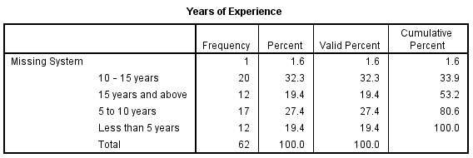
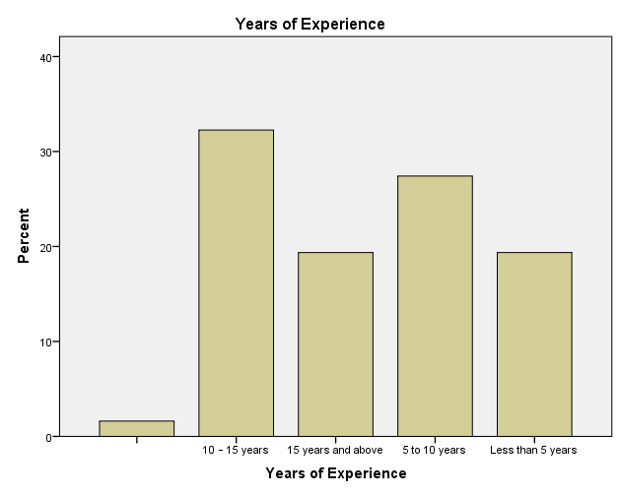
Table 4.2.1 above highlights the distribution of respondents' years of experience in the banking sector. The largest group of respondents (32.3%) have 10–15 years of experience, followed by 27.4% with 5–10 years of experience. A smaller portion (19.4%) have either less than 5 years or more than 15 years of experience, with 19.4% in both categories.
Table 4.2.2: Respondent’s Gender
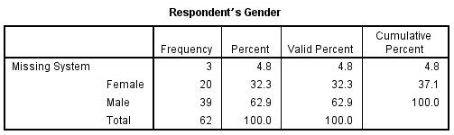
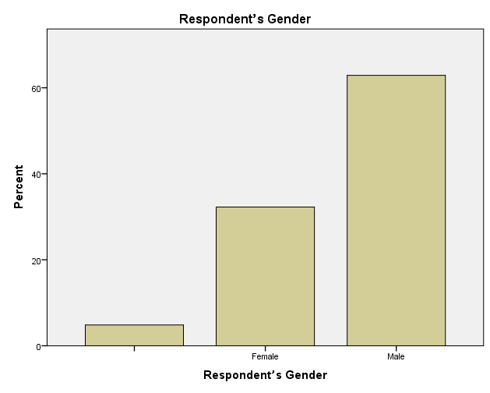
For gender, the majority of respondents (62.9%) are male, while 32.3% are female, with a small number (4.8%) not clearly specified.
Table 4.2.3: Educational Attainment of Respondents
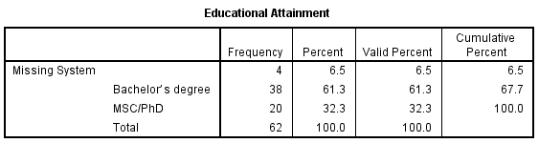
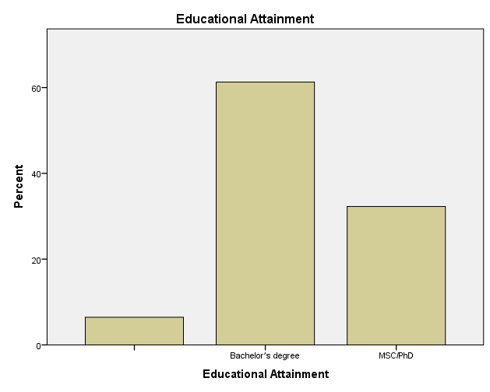
Table 4.2.3 above shows the educational attainment of the respondents. The majority of respondents (61.3%) hold a bachelor's degree, while 32.3% have attained an MSc or PhD. Notably, no respondents reported having only a high school education. This indicates a highly educated sample, with most individuals possessing advanced academic qualifications.
Table 4.2.4: Respondent’s Role
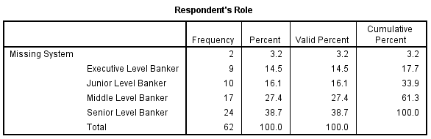
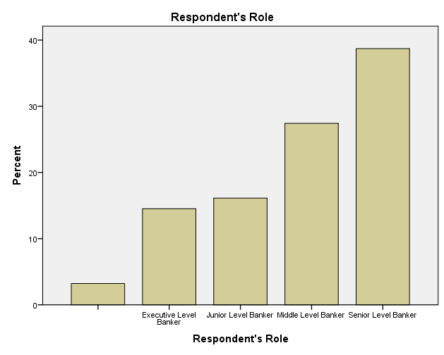
When it comes to the role within the organization, the largest group (38.7%) are senior-level bankers, followed by middle-level bankers (27.4%). Junior-level bankers account for 16.1%, and executive-level bankers represent 14.5%.

4.3: Impact of AI on Operational Efficiency in Banking and Finance.

This section focuses on how artificial intelligence (AI) affects banking operations and efficiency. Respondents were asked a series of Likert scale questions to assess the impact of AI on various aspects of banking. The Likert scale ranged from 1 (Strongly Agree) to 5 (Strongly Disagree). .
Table 4.3.1: Does the adoption of AI in the banking and financial sector support and ease operational efficiency of banks globally?
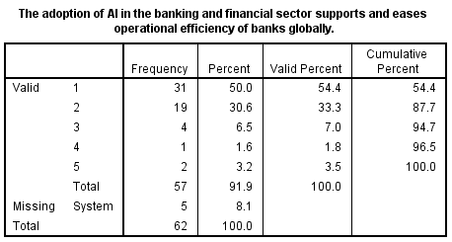
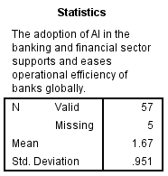
Table 4.3.1 above reveals that, the majority of respondents (87.7%) gave a positive response, with 54.4% strongly agreeing and 33.3% agreeing. A small portion (7.0%) remained neutral, while 5.3% provided negative feedback, with 1.8% disagreeing and 3.5% strongly disagreeing. The mean score of 1.67 and a standard deviation of 0.951 further indicates a strong positive response with some variability in opinions.
Table 4.3.2: Does AI facilitate financial transactions and collaboration between banks and other financial institutions?
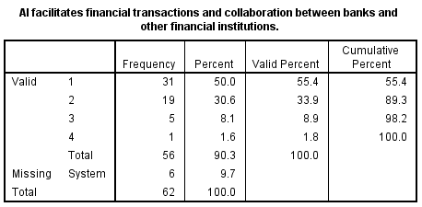
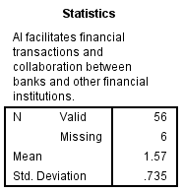
The above table indicates that, in total, 89.3% of respondents expressed a positive sentiment, with 55.4% strongly agreeing and 33.9% agreeing. Only 8.9% of respondents were neutral, while 1.8% disagreed. The overall results demonstrate that most respondents perceive AI as an effective tool for facilitating financial transactions and collaborations between institutions. The mean score was 1.57, with a standard deviation of 0.735, indicates a strong consensus on the effectiveness of AI in enhancing financial transactions and institutional collaboration.
Table 4.3.3: Does AI facilitate data analysis and contribute to making informed decisions in the banking and finance sector globally?
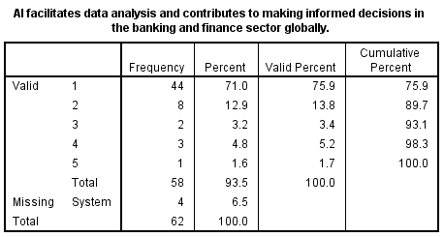
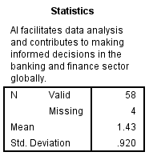
A large majority (89.7%) provided positive feedback, with 75.9% strongly agreeing and 13.8% agreeing. Only 3.4% of respondents were neutral, while 6.9% expressed negative views (5.2% disagreed and 1.7% strongly disagreed). With a mean score of 1.43 and a standard deviation of 0.920, this result suggest a high level of confidence in AI’s ability to enhance data analysis and decision-making processes in the banking sector.
Table 4.3.4: Is AI helping developing third world banks in their daily operations?
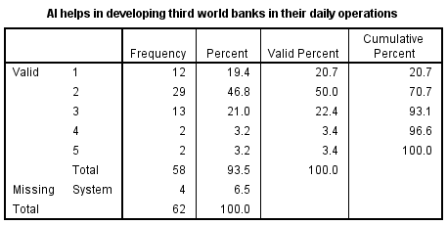
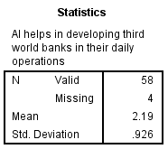
Table 4.3.4 above reveals that majority (70.7%) of respondents expressed positive views, with 20.7% strongly agreeing and 50.0% agreeing. Meanwhile, 22.4% remained neutral, and 6.8% provided negative feedback, with 3.4% disagreeing and 3.4% strongly disagreeing. The mean score was 2.19, with a standard deviation of 0.926, indicates some variation in responses.
Table 4.3.5: Is AI changing the way 21st century banking is being practiced?
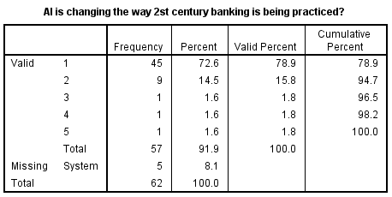
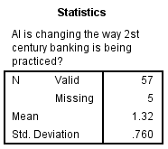
An overwhelming majority (94.7%) of respondents gave positive feedback, with 78.9% strongly agreeing and 15.8% agreeing. Only 1.8% were neutral, and a small 3.5% expressed negative views, with 1.8% disagreeing and 1.8% strongly disagreeing. The mean score was 1.32, with a standard deviation of 0.760, reflects a strong consensus on AI’s significant role in modernizing banking.

4.4: Role of AI in Financial Risk Management and Fraud Detection in the Banking Sector
This section focuses on the impact of artificial intelligence (AI) on financial management and fraud detection. Respondents were asked a series of Likert scale questions, with 1 representing "strongly agree" and 5 representing "strongly disagree.". Also, an open-ended question was posed and qualitative answers by respondents were analyzed using thematic analysis.
Table 4.4.1: Do you believe AI has the potential to significantly improve financial risk management?
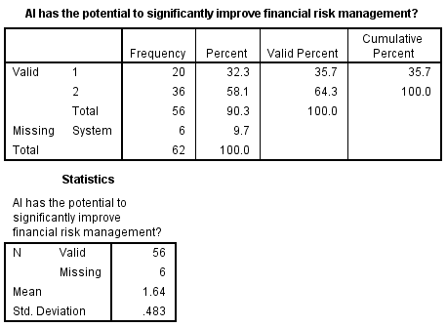

The data in table 4.4.1 reveals that 64.3% of respondents agreed (2) and 35.7% strongly agreed (1) that AI has the potential to improve financial risk management, resulting in 100% positive responses. The mean score of 1.64 indicates a strong consensus in favor of AI's potential, and the standard deviation of 0.483 suggests minimal variability in responses, reflecting a uniform belief in AI’s capabilities in this area.

Table 4.4.2: Are AI models capable of predicting financial risks with greater accuracy than traditional models?
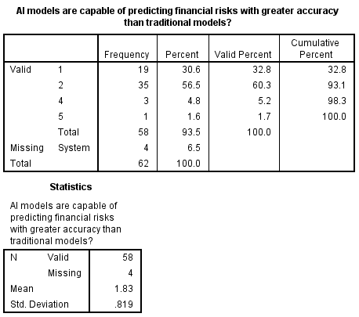

A total of 93.1% of respondents gave positive feedback, with 60.3% agreeing (2) and 32.8% strongly agreeing (1). A small percentage (5.2%) disagreed (4), and 1.7% strongly disagreed (5), showing some skepticism. The mean score of 1.83 points to general agreement, while the standard deviation of 0.819 suggests variability in opinions.

Table 4.4.3: Do you think AI can identify emerging financial risks that human analysts might overlook?
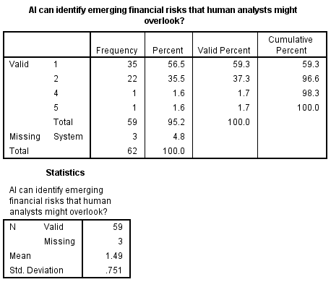

An overwhelming majority (96.6%) of respondents strongly agreed (1) or agreed (2) that AI can identify risks human analysts might miss, with only 3.4% giving negative feedback (4 and 5). The mean score of 1.49 reflects strong agreement, and the standard deviation of 0.751 shows moderate variability, suggesting confidence in AI’s ability to identify overlooked risks but with some variation in opinion.

Table 4.4.4: Are AI-based fraud detection systems able to learn and improve over time?
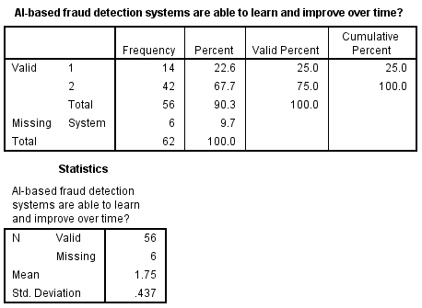

Table 4.4.4 above show that, 75.0% of respondents agreed (2) and 25.0% strongly agreed (1), leading to 100% positive responses. The mean score of 1.75 and a standard deviation of 0.437 indicate that respondents are largely in agreement about the capacity of AI fraud detection systems to improve over time, with little variation in responses.

4.4.5: In a few words, to what extent has the implementation of AI helped with the detection of fraudulent activities in the banking and finance sector?
- CONTINUOUS MONITORING
"AI has greatly enhanced cyber security in finance by continuously monitoring transactions and identifying irregularities that human analysts might overlook." – Respondent 4
"Through advanced algorithms that can detect patterns and anomalies with high accuracy, thus minimizing risks." – Respondent 12
"The use of AI algorithms has provided banks with predictive analytics capabilities, allowing them to anticipate fraudulent activities." – Respondent 24
"While AI has shown promise in fraud detection, its effectiveness heavily relies on the quality of data and continuous refinement of algorithms to stay ahead of sophisticated cybercriminal tactics." – Respondent 32
Here, all relevant answers, as cleaned and prepared by the researcher, fell under the theme of continuous monitoring. Respondents emphasized that AI has significantly enhanced fraud detection through its ability to continuously monitor transactions and identify irregularities that human analysts might miss.

4.5: Impact of AI on Customer Service and Personalisation in the Finance Industry.
This section focuses on the influence of AI on customer service delivery and personalisation in the financial industry. Respondents were asked a series of Likert scale questions, with 1 representing "strongly agree" and 5 representing "strongly disagree.". Thematic analysis was also employed for analysis of the open-ended question in this section.
Table 4.5.1: Is AI widely used in your organization for enhancing customer service?
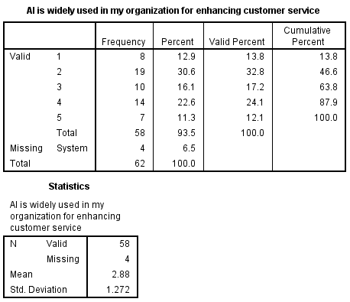
The table above reveals that, a majority of respondents agree that AI is widely used in their organizations for enhancing customer service. The data shows that 46.6% of respondents gave positive feedback, with 13.8% strongly agreeing (1) and 32.8% agreeing (2) to this statement. A notable 17.2% remained neutral (3), while 36.2% gave negative responses, with 24.1% disagreeing (4) and 12.1% strongly disagreeing (5). The mean score of 2.88 indicates a mixed perception, and the standard deviation of 1.272 suggests considerable variation in how respondents view AI’s role in enhancing customer service.

Table 4.5.2: Does your financial institution use chatbots to handle customer inquiries?
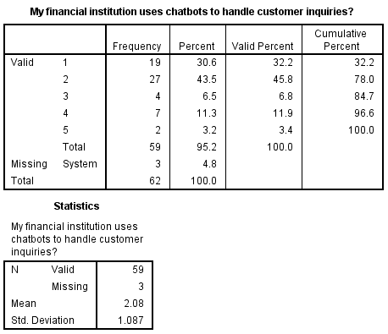

The data shows that 78.0% of respondents provided positive feedback, with 32.2% strongly agreeing (1) and 45.8% agreeing (2). A small portion (6.8%) remained neutral (3), while 15.3% gave negative responses, with 11.9% disagreeing (4) and 3.4% strongly disagreeing (5). The mean score of 2.08 suggests general agreement, and the standard deviation of 1.087 reflects some variability in opinions, with most respondents perceiving chatbots as an integral part of handling customer inquiries..
Table 4.5.3: Has AI reduced the average response time for customer service requests?
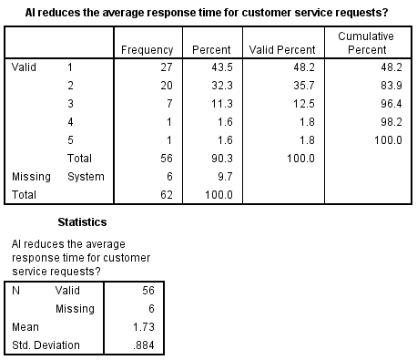

A significant majority (83.9%) of respondents gave positive feedback, with 48.2% strongly agreeing (1) and 35.7% agreeing (2). Only 12.5% remained neutral (3), and a small percentage (3.6%) gave negative responses, with 1.8% disagreeing (4) and 1.8% strongly disagreeing (5). The mean score of 1.73 indicates strong agreement, and the standard deviation of 0.884 shows relatively low variability, reflecting a consistent belief that AI improves response times for customer service.

4.5.4: Can you describe specific AI technologies that have enhanced customer service in your financial institution?
- CHATBOTS
“We've implemented chatbots powered by AI that provide instant responses to customer inquiries, improving efficiency and accessibility."- Respondent 3
"Virtual assistants powered by AI are available 24/7 to assist customers with account inquiries, transactions, and general financial advice." – Respondent 8
"Through AI-powered virtual assistants our bank conducts customer surveys and feedback, gathering valuable insights to enhance our services." – Respondent 27
- ALGORITHMS
"Machine learning algorithms help us anticipate customer needs by analyzing their transaction history and behavior patterns." Respondent 7
"Predictive analytics algorithms help us forecast customer demand and preferences, allowing us to optimize our product offerings." – Respondent 15
- ROBOTIC PROCESS AUTOMATION
"Robotic Process Automation (RPA) automates routine tasks such as account verification and document processing, freeing up time for our staff to focus on more complex customer inquiries." – Respondent 22
- IMAGE RECOGNITION
"AI-driven image recognition technology has enhanced security of customers in our bank” – Respondent 33

4.6: Potential Challenges and Ethical Considerations Associated with the Adoption of AI in Banking and Finance
4.6.1: What are the current challenges of AI with in the banking and finance sector? Make open ended
Here, respondents of this study listed a number of potential challenges as well as ethical considerations; these includes:
"Ensuring data privacy and security." - Respondent 1
"Regulatory compliance." - Respondent 5
"The high cost of AI implementation." - Respondent 7
"Addressing ethical concerns related to AI use." - Respondent 8
"Enhancing transparency in AI-driven decisions." - Respondent 11
"Dealing with the lack of skilled AI professionals." - Respondent 12
"Ensuring the accuracy and reliability of AI models." - Respondent 15
"Keeping up with rapid technological advancements." - Respondent 19
"Adapting to evolving AI regulations." - Respondent 24
"Preventing over-reliance on AI systems." - Respondent 28
"Addressing potential job displacement due to AI." - Respondent 34
"Ensuring AI's adaptability to changing market conditions." - Respondent 36
"Balancing AI innovation with cybersecurity measures." - Respondent 40
"Navigating cross-border regulatory differences." - Respondent 47
4.6.2: How do you ensure compliance with regulatory standards when using AI in financial services?
- STAYING UPDATED
"My bank stays updated on all relevant regulations, and industry-specific guidelines, and collaborate closely with our legal team to interpret and implement these requirements within our AI systems." - Respondent 10
"Regular audits and reviews are part of our process. We conduct frequent checks on our AI systems and their outputs to identify and rectify any compliance issues promptly." - Respondent 12
"Staying proactive is essential. We monitor regulatory changes and adjust our AI systems and policies accordingly to maintain compliance continuously." - Respondent 29
“We conduct regular risk assessments of our AI systems to identify potential compliance issues and take preemptive measures to address them." - Respondent 38
- TRAINING PROGRAMS
"We invest in employee training programs focused on regulatory requirements and best practices for using AI in financial services, ensuring everyone is aware and aligned with compliance goals." - Respondent 18
- COLLABORATION
"Collaboration with various departments, including legal, compliance, and IT, is essential. We work together to ensure that our AI systems are compliant from development through deployment." - Respondent 22
- ADVANCED ANALYTIC TOOLS
"By leveraging advanced analytics and reporting tools, we ensure that our AI systems can provide the necessary transparency and traceability required by regulators." - Respondent 46
4.6.3: What measures are in place to secure AI systems against cyber threats?
- AUDITS
"Regular security audits and vulnerability assessments are conducted to identify and address potential security weaknesses." - Respondent 12
- MULTI-LAYERED AUTHENTICATION AND SECURITY
"We use multi-factor authentication to add an extra layer of security to all access points within our AI systems."- Respondent 4
"Advanced network security measures, such as firewalls and intrusion detection/prevention systems, are in place to protect our infrastructure."- Respondent 15
"Our secure software development lifecycle incorporates security practices from the design phase through deployment." - Respondent 24
"Anomaly detection systems monitor AI system behavior to identify any unusual activities that could indicate a cyber threat." - Respondent 26
"Security considerations are integrated into the design phase of AI systems to build robust defenses from the ground up." - Respondent 33
- DOCUMENTATION
"Detailed logs of all activities within AI systems are maintained and continuously monitored for suspicious behavior." - Respondent 40
- TRAINING PROGRAMS
"We conduct regular training sessions for employees on cybersecurity best practices and specific security protocols for AI systems." - Respondent 44
- ENCRYPTION
"Robust encryption key management practices ensure that keys are stored and used securely." – Respondent 46

4.7: Customer’s Perception over the Integration and use of AI in Financial Operations.
This section focuses on the influence of AI on customer service delivery and personalisation in the financial industry. Respondents were asked a series of Likert scale questions, with 1 representing "strongly agree" and 5 representing "strongly disagree.". Thematic analysis was also employed for analysis of the open-ended question in this section.
Table 4.7.1: Implementation of AI technologies in my bank is beneficial in customer support, fraud detection and giving personalized offers
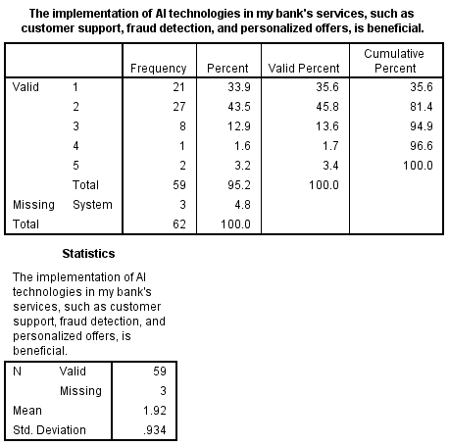
The table above shows that the implementation of AI technologies in banking services, such as customer support, fraud detection, and personalized offers, is seen as beneficial by most respondents. 81.4% provided positive feedback (with 35.6% strongly agreeing and 45.8% agreeing), while 13.6% remained neutral. Only a small percentage (5.1%) expressed disagreement. The mean score of 1.92 indicates a generally positive view, and the standard deviation of 0.934 suggests some variation in responses, but overall agreement that AI is beneficial.
4.7.2: AI has improved overall experience with banking services such as: credit card payments etc.
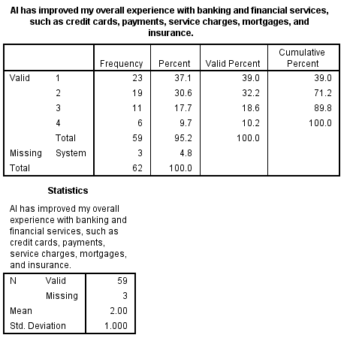
The table above shows that the majority of respondents believe AI has improved their overall experience with banking and financial services, such as credit cards, payments, service charges, mortgages, and insurance. 71.2% of respondents provided positive feedback, with 39.0% strongly agreeing (1) and 32.2% agreeing (2). 18.6% of respondents were neutral (3), while 10.2% disagreed (4). The mean score of 2.00 suggests a generally favorable opinion, and the standard deviation of 1.000 indicates some variability in responses, but overall, the perception of AI’s impact on banking services is positive.
4.7.3: Accuracy and Transparency of AI in determining credit score
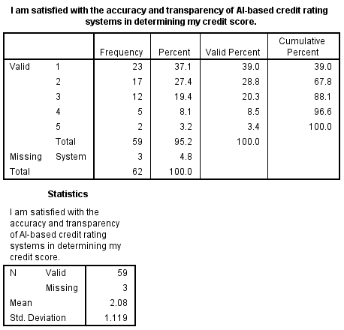
The table above indicates that most respondents are satisfied with the accuracy and transparency of AI-based credit rating systems in determining their credit score. 67.8% of respondents provided positive feedback, with 39.0% strongly agreeing (1) and 28.8% agreeing (2). 20.3% of respondents were neutral (3), while 11.9% expressed dissatisfaction, with 8.5% disagreeing (4) and 3.4% strongly disagreeing (5). The mean score of 2.08 reflects a generally positive perception, while the standard deviation of 1.119 suggests moderate variation in satisfaction levels.
4.7.4: AI improves credit rating understanding
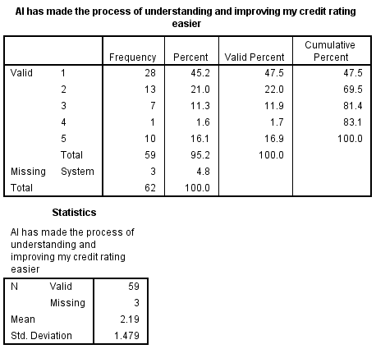
The table above shows that a majority of respondents believe AI has made the process of understanding and improving their credit rating easier. 69.5% of respondents provided positive feedback, with 47.5% strongly agreeing (1) and 22.0% agreeing (2). 11.9% were neutral (3), while 18.6% expressed dissatisfaction, with 1.7% disagreeing (4) and 16.9% strongly disagreeing (5). The mean score of 2.19 reflects a generally favorable perception, while the standard deviation of 1.479 suggests a higher degree of variability in opinions compared to other areas.
4.7.5: AI fraud detection makes me feel secure
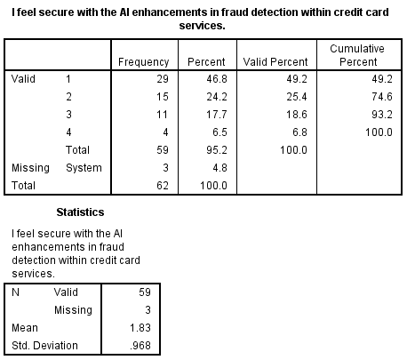
The table above shows that most respondents feel secure with the AI enhancements in fraud detection within credit card services. 74.6% of respondents provided positive feedback, with 49.2% strongly agreeing (1) and 25.4% agreeing (2). 18.6% were neutral (3), and a small percentage (6.8%) expressed disagreement (4). The mean score of 1.83 indicates a strong overall sense of security, while the standard deviation of 0.968 suggests moderate variation in responses.
4.7.6: I am satisfied with AI- generated offers and recommendations for credit card reward and limits.
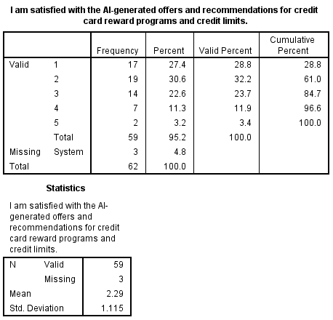
The table above shows that the majority of respondents are satisfied with the AI-generated offers and recommendations for credit card reward programs and credit limits. 61.0% of respondents gave positive feedback, with 28.8% strongly agreeing (1) and 32.2% agreeing (2). 23.7% of respondents were neutral (3), while 15.3% expressed dissatisfaction, with 11.9% disagreeing (4) and 3.4% strongly disagreeing (5). The mean score of 2.29 suggests general satisfaction, while the standard deviation of 1.115 indicates some variability in opinions.
4.7.7: I trust AI tools to assess mortgage eligibility and interest rates
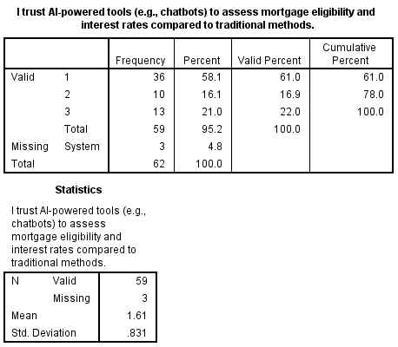
The table above indicates that most respondents trust AI-powered tools, such as chatbots, to assess mortgage eligibility and interest rates compared to traditional methods. 77.9% of respondents expressed trust, with 61.0% strongly agreeing (1) and 16.9% agreeing (2). 22.0% of respondents were neutral (3), and no one expressed disagreement. The mean score of 1.61 reflects strong overall trust in AI-powered tools, and the standard deviation of 0.831 suggests relatively low variability in responses.
4.7.8: AI mortgage applications have simplified the process for me
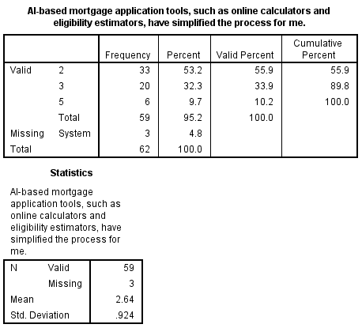
The table above shows that a majority of respondents believe AI-based mortgage application tools, such as online calculators and eligibility estimators, have simplified the process. 55.9% gave positive feedback (2), while 33.9% were neutral (3). A smaller percentage (10.2%) expressed dissatisfaction (5). The mean score of 2.64 suggests a generally favorable opinion but leans toward neutrality, while the standard deviation of 0.924 indicates some variability in responses.
4.7.9: I am satisfied with AI-driven recommendations and offers for insurance products
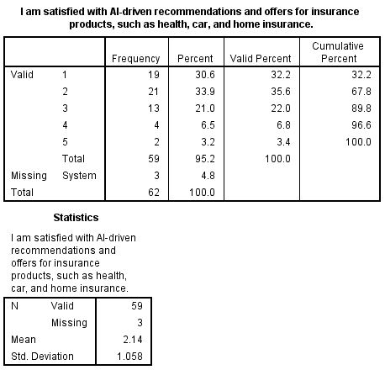
The table above indicates that most respondents are satisfied with AI-driven recommendations and offers for insurance products, such as health, car, and home insurance. 67.8% of respondents provided positive feedback, with 32.2% strongly agreeing (1) and 35.6% agreeing (2). 22.0% of respondents were neutral (3), while 10.2% expressed dissatisfaction, with 6.8% disagreeing (4) and 3.4% strongly disagreeing (5). The mean score of 2.14 reflects a generally positive sentiment, while the standard deviation of 1.058 suggests moderate variability in responses.
4.7.10: AI has improved the process of insurance claims
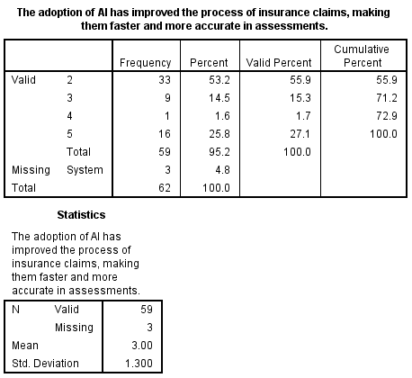
The table above shows mixed opinions regarding whether the adoption of AI has improved the process of insurance claims by making them faster and more accurate. 55.9% of respondents gave positive feedback (2), while 15.3% remained neutral (3). A significant 27.1% expressed dissatisfaction, with 1.7% disagreeing (4) and 25.8% strongly disagreeing (5). The mean score of 3.00 reflects a balanced view between agreement and dissatisfaction, while the standard deviation of 1.300 suggests considerable variability in respondents' opinions.
4.7.11: I am satisfied with AI powered loan application process
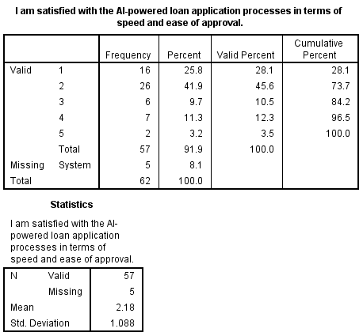
The table above shows that the majority of respondents are satisfied with AI-powered loan application processes in terms of speed and ease of approval. 73.7% of respondents provided positive feedback, with 28.1% strongly agreeing (1) and 45.6% agreeing (2). 10.5% were neutral (3), while 15.8% expressed dissatisfaction, with 12.3% disagreeing (4) and 3.5% strongly disagreeing (5). The mean score of 2.18 suggests a generally positive sentiment, while the standard deviation of 1.088 indicates some variability in responses.
4.7.12: AI loan eligibility assessments are fair and transparent
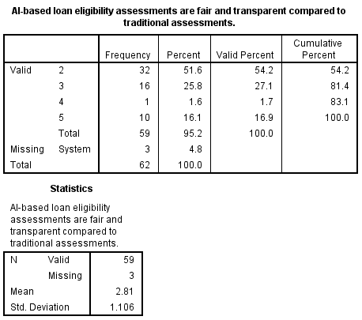
The table above shows that perceptions of fairness and transparency in AI-based loan eligibility assessments are mixed. 54.2% of respondents provided positive feedback (2), while 27.1% were neutral (3). A notable 18.6% expressed dissatisfaction, with 1.7% disagreeing (4) and 16.9% strongly disagreeing (5). The mean score of 2.81 reflects a more neutral stance on the fairness and transparency of AI-based assessments compared to traditional methods, and the standard deviation of 1.106 suggests moderate variability in opinions.
4.7.13: AI payment systems meet my expectation, convenience and security
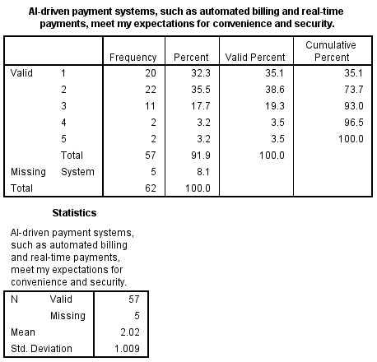
The table above indicates that most respondents feel that AI-driven payment systems, such as automated billing and real-time payments, meet their expectations for convenience and security. 73.7% of respondents provided positive feedback, with 35.1% strongly agreeing (1) and 38.6% agreeing (2). 19.3% were neutral (3), while 7.0% expressed dissatisfaction, with 3.5% disagreeing (4) and 3.5% strongly disagreeing (5). The mean score of 2.02 suggests a generally positive sentiment, and the standard deviation of 1.009 indicates moderate variability in responses.
4.7.14: I am satisfied with AI’s ability to ensure the speed and accuracy of transactions, detect errors and confirm payment authenticity.
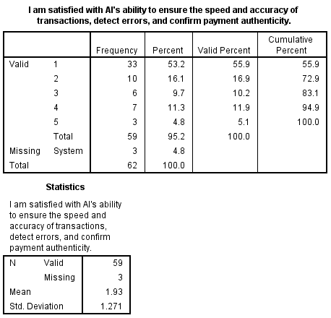
The table above shows that the majority of respondents are satisfied with AI's ability to ensure the speed and accuracy of transactions, detect errors, and confirm payment authenticity. 72.9% of respondents provided positive feedback, with 55.9% strongly agreeing (1) and 16.9% agreeing (2). 10.2% of respondents were neutral (3), while 17.0% expressed dissatisfaction, with 11.9% disagreeing (4) and 5.1% strongly disagreeing (5). The mean score of 1.93 indicates overall satisfaction, while the standard deviation of 1.271 suggests some variability in opinions.
4.7.15: AI will impact the future of banking positively
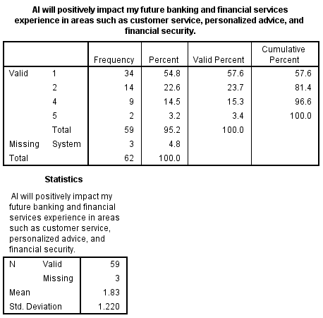
The table above shows that a majority of respondents believe AI will positively impact their future banking and financial services experience in areas such as customer service, personalized advice, and financial security. 81.4% provided positive feedback, with 57.6% strongly agreeing (1) and 23.7% agreeing (2). 15.3% of respondents disagreed (4), and 3.4% strongly disagreed (5), while no respondents were neutral. The mean score of 1.83 reflects overall optimism, while the standard deviation of 1.220 suggests moderate variability in opinions.

4.8 Summary
This chapter gives a comprehensive analysis of the information gathered from respondents. Through analysis of both quantitative and qualitative data using, descriptive stats (frequency, valid percentages, mean scores and standard deviation scores), as well as thematic analysis, this chapter provides an outlook on respondent’s opinions over the subject addressed. This shall serve as basis for further discussions in the subsequent section.

CHAPTER FIVE

DISCUSSION, CONCLUSIONS, RECOMMENDATIONS, AND LIMITATIONS

5.1 Introduction
This section includes important findings from a survey conducted among major players in the banking and finance industries of five third-world nations. The findings provide useful insights into how Artificial Intelligence affects several elements of financial activity, ranging from operational efficiency to fraud detection. The sections that follow will give an in-depth examination of the research findings for each aim, including discussions of policy implications, recommendations for future research, and any limitations noted in the study.

5.2 Discussion of Research Findings
This study investigates how the usage of artificial intelligence affects the banking sector in third-world nations. It explores the impact of AI on operational efficiency in banking and finance, its role in financial risk management and fraud detection in the banking sector, how it affects customer service and personalization, and the challenges and ethical considerations that must be addressed in the finance industry. The sub-sections will go into depth about these aims and how they relate to past academic research to get educated insights on the study's objectives.
5.2.1: Objective one
The first objective of this research was to investigate the impact of AI on operational efficiency in the banking and finance industry. Firstly, the data reveals that a substantial majority of respondents affirm that AI adoption enhances operational efficiency in banks. This is consistent with existing research, which emphasizes AI's role in simplifying banking procedures, lowering operating costs, and increasing service delivery. Romão et al. (2019) found that AI technologies, such as RPA and machine learning, may automate regular processes, leading to faster and more accurate transaction processing and improved operational efficiency. This finding is corroborated by Lal et al. (2023), who argues that AI-driven processes enhance productivity by minimizing human error and optimizing resource allocation. Also, it was revealed that AI facilitates financial transactions and inter-bank collaborations. This finding is similar with Frost et al.'s (2019) research, which shows that AI-powered platforms improve transaction speed and reliability, encouraging increased collaboration across financial institutions. The study also aligns with Yatsenko et al. (2021), who found that AI technologies, such as blockchain and smart contracts, streamline inter-bank transactions by providing secure and transparent processes. However, the notable percentage of respondents who were unsure suggests a gap in understanding or awareness, highlighting the need for further education and dissemination of AI's benefits.
Furthermore, Table 4.3.3 demonstrates that a majority of respondents feel AI helps with data analysis and educated decision-making. This is reinforced by multiple studies that show AI's capacity to analyze massive datasets, detect trends, and produce actionable insights. For instance, Brynjolfsson and McAfee (2017) highlight AI's potential in predictive analytics, which helps banks in risk management, fraud detection, and customer personalization. Similarly, Davenport (2018) discuss how AI enhances decision-making by providing real-time analytics and predictive models that improve strategic planning and operational decisions. Moreover, 70.7% of respondents affirm AI's assistance in the daily operations of developing banks, although a significant 6.8% remain unsure. This dichotomy reflects the variable success of AI implementation in different regions. Research by Chui et al. (2016) indicates that while AI has the potential to transform banking operations in third-world countries, challenges such as limited infrastructure, lack of skilled personnel, and regulatory hurdles often impede its full utilization. Thus, while AI is beneficial, these barriers must be addressed to optimize its impact on daily operations.
Lastly, the data in Table 4.3.5 shows a near-unanimous agreement (94.7%) that AI is transforming 21st-century banking practices. This reflects the broader narrative in existing literature that AI is not just an incremental improvement but a fundamental shift in how banking services are delivered. Maedche et al. (2019) and Arner et al. (2016) studies illustrate that AI is revolutionizing customer interactions through chatbots and virtual assistants, enhancing fraud detection with machine learning algorithms, and providing personalized financial advice through advanced analytics. The high level of agreement among respondents highlights AI's transformational potential for altering the financial industry.
5.2.2: Objective Two
The second objective of this research discusses the role of AI in financial risk management and fraud detection in the banking sector, findings of the research revealed a number of significant insights. Firstly, Table 4.4.1 indicates that an overwhelming 100% of respondents believe AI has the potential to significantly improve financial risk management. This high level of agreement aligns with existing literature that underscores AI's capabilities in this domain. According to a study by Tang (2023), AI-driven risk management systems can perform real-time analysis of market conditions and forecast potential financial disruptions more accurately than traditional methods. This finding is further supported by Kandır and Haseki (2024) who emphasize that AI's predictive analytics enhance the ability to mitigate risks proactively, thus improving overall financial stability. In alignment with the above, table 4.4.2, reveals that 93.1% of respondents believe that AI models predict financial risks more accurately than traditional models. This perception is well-founded in the literature. According to Kanas (2001) and Qi (1999), AI models outperform traditional statistical models in forecasting financial hazards because they can handle non-linear interactions and complicated data structures. Additionally, the adaptive nature of AI models, which allows them to update and refine their predictions continuously, is highlighted by López de Prado (2018) as a key advantage over static traditional models.
Table 4.4.3 reveals that 96.96% of respondents agree that AI can identify emerging financial risks that human analysts might overlook. This finding is consistent with research that demonstrates AI's proficiency in uncovering hidden risks through advanced data analytics. A study by El Hajj and Hammoud (2023) indicates that AI algorithms can identify subtle market trends and emerging risks that are not immediately apparent to human analysts. This capability is crucial for maintaining robust financial risk management frameworks and preventing potential crises. More so, the statistics in Table 4.4.4 reveal that the majority of respondents (100%) believe AI-based fraud detection systems can learn and improve over time. This consensus highlights the adaptive nature of AI, which is a significant advantage in combating evolving fraud tactics. According to Ngai et al. (2011), AI systems utilize machine learning techniques to continuously update their fraud detection algorithms based on new data, thereby enhancing their accuracy and effectiveness. The ability of AI to adapt to new fraud patterns ensures that these systems remain relevant and capable of addressing sophisticated cybercriminal strategies, as supported by a study by Kirkos et al. (2007).
The qualitative responses emphasize the theme of continuous monitoring, illustrating AI's pivotal role in enhancing fraud detection. Respondents noted that AI's continuous transaction monitoring capabilities significantly improve the detection of irregularities that human analysts might miss. This theme is consistent with the literature on AI's application in fraud detection. AI's real-time monitoring and anomaly detection capabilities are crucial for identifying fraudulent activities promptly. According to Hayble-Gomes (2022), AI systems can evaluate massive volumes of transactional data in real time and identify questionable actions for further investigation. This continuous monitoring capabilities, when paired with powerful pattern recognition algorithms, allows financial institutions to detect and respond to fraud more quickly and efficiently.
5.2.3: Objective Three
The findings from the study highlight the significant impact of artificial intelligence (AI) on customer service and personalization in the finance industry. Firstly, Table 4.5.1 demonstrates that 46.6% of respondents support the use of AI in their organizations to improve customer service. This widespread agreement indicates that AI has become an essential component of financial firms' customer service operations. Existing research backs up this result, emphasizing how AI technologies like chatbots and virtual assistants are rapidly being used to simplify customer service operations and boost productivity. According to Daqar and Smoudy (2019), AI can handle enormous quantities of client contacts while giving rapid and accurate replies, therefore dramatically improving the customer experience. Furthermore, AI's capacity to function at any time guarantees that client questions are immediately answered, resulting in improved levels of customer satisfaction and loyalty (Han et al., 2020).
In tandem with the above findings, Table 4.5.2 reveals that 78.0% of respondents reported using chatbots to handle customer inquiries. This aligns with the growing trend in the financial sector where chatbots are deployed to manage routine inquiries and provide immediate assistance. Research by McLean and Osei-Frimpong (2019) shows that chatbots are effective in reducing response times and increasing the availability of customer support services. Chatbots use natural language processing (NLP) to interpret and reply to consumer inquiries, making them a useful tool for financial institutions trying to improve their customer service offerings. Chatbots can give personalized support based on user data, enhancing the overall customer experience (Følstad and Skjuve, 2019). As shown in Table 4.5.3, 83.9% of respondents believe AI has lowered the average response time for customer support queries. This outcome is consistent with previous research that emphasizes the efficiency advantages brought about by AI in customer service. AI technology like chatbots and robotic process automation (RPA) can do mundane tasks quickly and correctly, freeing up human agents to work on more difficult challenges. According to Davenport (2018), AI-driven customer service systems can resolve inquiries faster than traditional methods, significantly reducing wait times and improving customer satisfaction.
The qualitative responses provide further insights into the specific AI technologies employed to enhance customer service in financial institutions. Respondents emphasized the usage of chatbots and virtual assistants powered by AI to give rapid replies, 24-hour availability, and personalized support. These technologies' impact on customer engagement and service efficiency has been thoroughly documented in the literature (Gnewuch et al., 2017). Respondents also recommended using machine learning algorithms to anticipate client requirements and preferences based on transaction history and behavior trends. This is consistent with the findings of Kietzmann et al. (2018), who state that predictive analytics may assist financial institutions deliver personalized goods and services, increasing customer happiness and loyalty. Furthermore, respondents said that RPA is utilized to automate regular processes like account verification and document processing. This technology helps in freeing up staff to focus on more complex customer inquiries, thus improving service quality. Research by Willcocks et al. (2016) supports this, showing that RPA can significantly reduce the time and cost associated with routine administrative tasks, allowing human agents to provide higher-value customer interactions. Lastly, the use of AI-driven image recognition technology to enhance security was also mentioned. This technology can be used for identity verification and fraud detection, contributing to a safer banking environment. According to a study conducted by Venkatesh et al. (2016), picture recognition and other AI-based security solutions can considerably lower the risk of fraud while increasing client trust in financial institutions.
Overall, the strong use of AI by the financial institutions emphasizes the move to digitalization by the financial industry in third world nations which has had a lasting positive impact on customer satisfaction.
5.2.4: Objective Four
Objective four of this research addresses challenges and ethical considerations to be made in utilizing AI in the banking and finance sector of third world countries. A primary challenge noted by respondents is "ensuring data privacy and security." This concern is echoed in the literature, as the handling of sensitive financial data necessitates robust security measures. According to van der Aalst et al. (2017), AI systems must be built with robust encryption and access restrictions to prevent unauthorized access and data breaches. Regulations such as the General Data Protection Regulation (GDPR) emphasize the significance of data privacy by imposing severe restrictions on how personal data is acquired, processed, and kept. Respondents also highlighted "regulatory compliance" as a significant challenge. The financial industry is heavily regulated, and AI systems must adhere to a myriad of standards and regulations. Studies by Arner et al. (2016) emphasize that compliance involves not only adhering to existing regulations but also staying abreast of evolving legal frameworks. Financial institutions often face difficulties in integrating AI with compliance requirements, necessitating continuous updates and modifications to their AI systems. The high cost of AI implementation" is another challenge identified by respondents. Literature by Ahmadi (2023) indicates that the initial investment in AI technology, including hardware, software, and skilled personnel, can be substantial. This financial burden can be particularly challenging for smaller institutions that may lack the resources of larger banks.
Addressing ethical concerns related to AI use and enhancing transparency in AI-driven decisions" are critical issues raised by respondents. AI decision-making processes may be opaque, which makes it challenging to comprehend and justify the methods used to arrive at particular conclusions. According to Mittelstadt et al. (2016), this lack of openness may cause people to lose faith in AI systems. Ensuring that AI systems are transparent and that their decisions can be audited is crucial for maintaining ethical standards and trust. The lack of skilled AI professionals is a significant barrier to AI adoption. According to Makridakis (2017), the demand for AI expertise far exceeds supply, leading to a talent gap in the industry. Financial institutions need to make training and development investments to equip their personnel with the skills that they need. Keeping up with rapid technological advancements is a challenge that requires continuous learning and adaptation. Brynjolfsson and McAfee (2017) note that the fast pace of AI development means that financial institutions must be agile and ready to integrate new technologies quickly to stay competitive. Addressing potential job displacement due to AI is a significant ethical concern. Although AI can automate a lot of processes, it also poses a danger to job displacement. Studies by Acemoglu and Restrepo (2018) suggest that while AI can lead to job losses in certain areas, it can also create new opportunities. Financial institutions need to manage this transition carefully, providing retraining and support for affected employees.
To ensure compliance with regulatory standards when using AI, respondents emphasized the importance of staying updated on regulations, conducting regular audits, and investing in training programs. These practices are supported by literature which underscores the need for proactive compliance strategies (Bailey, 2018). Securing AI systems against cyber threats is crucial. Respondents highlighted measures such as regular audits, multi-layered authentication, advanced network security, and employee training. These measures are aligned with best practices outlined in cybersecurity literature (Buczak and Guven, 2016), which stress the importance of a comprehensive, multi-faceted approach to security.
5.2.5: Objective Five
The findings from this study demonstrate that the majority of bank customers have a positive perception of the integration of AI in financial operations, particularly in areas such as customer service, fraud detection, and personalization. For instance, 81.4% of respondents in this study found AI beneficial in customer support and fraud detection, aligning with the findings of Adeoye et al. (2024), who noted that AI enhances customer engagement by offering personalized services and timely fraud detection. This is further supported by Dhashanamoorthi (2023), who emphasized the operational efficiency AI provides in handling large data volumes and delivering real-time analyses in banking services.
The study also found that 71.2% of respondents felt AI had improved their overall experience with financial services, including credit card payments and mortgages. Accenture (2024) similarly noted that AI enhances the banking experience by automating routine tasks and providing predictive analytics for customer needs. However, concerns about AI's transparency in certain areas, such as credit rating systems, were evident. While 67.8% of respondents were satisfied with the accuracy of AI-based credit ratings, Sadok, Sakka and El Maknouzi (2022) have suggested that AI’s precision in credit assessments may lack the contextual sensitivity found in traditional methods, which can cause apprehensions about bias.
In terms of security, 74.6% of respondents expressed confidence in AI-powered fraud detection within credit card services. Majumder (2024) have highlighted how AI’s ability to detect anomalies and fraudulent patterns significantly enhances banking security. However, a small portion of respondents still expressed concerns, reflecting the ongoing debate about over-reliance on AI without human oversight, which could lead to either missed or false fraud alerts.
Trust in AI-powered tools for assessing loan eligibility was also high, with 77.9% of respondents expressing confidence in AI tools such as chatbots. Rane (2023) discussed the benefits of AI in providing objective decisions based on large datasets, which increases customer trust. Nonetheless, the neutral responses in this area point to lingering concerns about transparency and accountability in AI decision-making, especially in areas as sensitive as loan assessments.
AI-driven payment systems were perceived favorably by 73.7% of respondents, who appreciated the convenience and security provided by automated billing and real-time payments. This finding is consistent with Rahmani (2023), who argued that AI enhances operational efficiency and security in financial transactions. However, the few who expressed dissatisfaction may have concerns about cybersecurity risks or system reliability, as AI-driven systems, while efficient, are not immune to breaches or technical errors.
Finally, the overall optimism about AI’s future in banking is notable, with 81.4% of respondents believing that AI will positively impact customer service, personalized advice, and financial security. This reflects the findings of the S&P global which forecasted that AI will be a central driver in the future transformation of the banking industr (Fernández, 2023). However, some respondents still voiced concerns, suggesting that while AI holds great promise, there are still apprehensions about transparency, fairness, and the ethical use of AI, particularly in decision-making processes.

5.3 Conclusion
The study’s data reveal several insightful conclusions:
- Firstly, it was revealed that AI has significantly enhanced operational efficiency in the banking and finance industry, as evidenced by the overwhelming majority of respondents who acknowledge its benefits. The automation of repetitive jobs using AI technologies, such as robotic process automation and machine learning, has simplified banking operations, cut expenses, and enhanced service quality.
- Second, AI has shown to be an effective tool for detecting fraud and managing financial risk. The majority of respondents believe that AI improves financial stability through real-time market analysis and predictive analytics. AI's ability to identify emerging risks and adapt to new fraud patterns enhances its effectiveness in safeguarding financial systems.
- In addition, customer service and personalization are seeing a positive impact from AI as well. Customers may receive individualized service and round-the-clock assistance via chatbots and virtual assistants that are driven by AI. Furthermore, AI helps reduce response times and frees up staff to handle more complex issues, leading to a more efficient and satisfying customer experience.
- The data also showed that it is difficult to comply with laws pertaining to data security and privacy since AI systems must be upgraded often to be up to speed with changing regulatory frameworks. For smaller organizations, the high cost of integrating AI may be a barrier. Important ethical issues to take into account include addressing the possibility of job displacement from automation and ensuring transparency in AI decision-making. The research suggests that financial institutions should invest in training programs and stay updated on regulations to ensure ethical and compliant use of AI. Additionally, implementing robust security measures like regular audits and multi-layered authentication is essential to protect AI systems from cyber threats.
Overall, while challenges exist, AI holds immense potential to transform the banking sector in developing countries. Banks may use artificial intelligence (AI) to increase operational efficiency, enhance risk management, and offer a more effective and individualized client experience by overcoming these obstacles and guaranteeing ethical implementation.

5.4 Recommendations
- Invest in Training Programs: Financial firms have to provide their staff with thorough AI training courses. This will bridge the knowledge gap and enhance the understanding of AI’s benefits, addressing the uncertainty observed among some respondents (Hafeez and Thomaskutty, 2023).
- Adopt Scalable AI Solutions: As AI is here to stay, it becomes imperative that banks implement scalable AI technologies that can grow with the organization’s needs. This includes investing in advanced RPA and machine learning tools that can automate a wide range of processes and improve transaction speed and accuracy (Biswas et al., 2020).
- Implement Advanced Predictive Analytics: Banks should utilize advanced predictive analytics and AI models to enhance their risk management frameworks. This includes real-time market analysis and forecasting tools that provide more accurate risk assessments (Addy et al., 2024).
- Strengthen Fraud Detection Systems: Financial institutions should deploy adaptive AI-based fraud detection systems that continuously update their algorithms based on new data. Regular audits and updates of these systems are essential to keep pace with evolving fraud tactics (Shoetan and Familoni, 2024).
- Leverage Machine Learning for Personalization: To provide individualized goods and services, banks should employ machine learning algorithms to examine client data and behavior. Higher levels of client satisfaction and loyalty may result from this (Kanan, 2024).

5.5 Research Limitations
The study faced several limitations that may have influenced its outcomes and interpretations. One notable constraint was the reliance on a semi-structured questionnaire for primary data collection. While this method provided valuable insights, it also introduced potential biases, as responses can be influenced by the phrasing of questions and the respondents' interpretations. This might have resulted in heterogeneity in the quality and depth of the data obtained, affecting the study's overall conclusions. Additionally, the sampling process posed challenges. Although efforts were made to ensure a representative sample, limitations in resources and access restricted the ability to obtain a fully diverse participant pool. This might have resulted in certain perspectives being underrepresented, particularly those from more remote or less accessible regions within the third-world countries studied. Consequently, the findings may not fully capture the heterogeneity of experiences and impacts of AI in banking and finance across different demographics and geographies.
Moreover, the dual analysis technique, which employs thematic analysis for qualitative data and descriptive analysis for quantitative data, added a layer of complexity. While this mixed-methods approach enriched the study, integrating and reconciling qualitative and quantitative findings required careful consideration. Discrepancies between the two types of data could have influenced the interpretations, possibly leading to an overemphasis on one type of data over the other. Furthermore, time constraints were a significant limitation. The data gathered may quickly become out of date because to the rapidly growing nature of AI technology, which might have an impact on the conclusions' application and relevancy. This temporal limitation suggests that the study's conclusions should be viewed as a snapshot in time rather than definitive answers.

5.6 Implications for Future Research
The study's findings highlight important directions for further investigation on how to better integrate AI into the banking industry in developing nations. It is important to conduct a thorough examination of the obstacles impeding the adoption of AI in order to identify the problems and devise focused solutions. Analyses that compare various socioeconomic circumstances might yield important insights into the contextual elements affecting AI's influence in banking. In order to comprehend the long-term consequences and sustainability of AI, longitudinal evaluations of its influence are required. To guarantee responsible and ethical AI deployment, research activities should also explore the ethical and societal consequences of AI use in banking. Innovations in AI technology and best practices for regulatory compliance are areas that require further exploration to support the effective integration of AI into banking operations. By addressing these research priorities, academia and industry can collaboratively advance the knowledge and practices surrounding AI adoption in the banking sector of third world countries, ultimately driving positive socioeconomic outcomes.

5.7 Implications for Practice
The research findings highlight the practical steps that financial institutions in third world countries should take to effectively integrate AI into their operations. Strategic investment in AI adoption is paramount, encompassing various aspects such as allocating resources towards implementing AI technologies, upgrading infrastructure, and investing in staff training. Banks can improve customer service, reduce operational costs, and manage financial risk better by making smart investments in AI. Moreover, ensuring regulatory compliance and ethical AI use is essential to build consumer trust and mitigate potential risks associated with AI adoption. Financial institutions must navigate complex regulatory landscapes while prioritizing transparency in AI decision-making processes and implementing robust data privacy measures. Continuous monitoring and adaptation are also critical, requiring institutions to establish mechanisms for ongoing evaluation of AI systems to ensure effectiveness and relevance in dynamic market environments. Financial institutions may use AI's revolutionary potential to boost innovation and competitiveness in the banking industry of developing nations by putting these useful tips into practice.

5.8 Chapter Summary
The chapter meticulously discusses the findings of the research and its relation to prior studies. A meticulous number of recommendations were also provided base off the conclusions derived. This paved way for addressing the studies implication for both practice and future research, Understanding the importance of declaring barriers to a study, the study’s limitations were also addressed in line with ethical practices of research.

REFERENCES
Abduljabbar, R., Dia, H., Liyanage, S. and Bagloee, S.A. (2019) ‘Applications of artificial intelligence in transport: An overview’, Sustainability, 11(1), p. 189. Accesed 15th June 2024.
Accenture (2024). The age of AI: Banking’s new reality. (n.d.). Available at: https://www.accenture.com/content/dam/accenture/final/accenture-com/document-2/Accenture-Age-AI-Banking-New-Reality.pdf. Accessed 10th May 2024.
Acemoglu, D., & Restrepo, P. (2018). Artificial Intelligence, Automation and Work. NBER Working Paper. Accessed 12th June 2024.
Adams, W.C. (2015) ‘Conducting semi-structured interviews’, in Newcomer, K.E., Hatry, H.P. and Wholey, J.S. (eds) Handbook of practical program evaluation. 4th edn. Hoboken, NJ: Jossey-Bass, pp. 492-505. Accessed 21st June 2024.
Addy, W.A., Ugochukwu, C.E., Oyewole, A.T., Ofodile, O.C., Adeoye, O.B., and Okoye, C.C. (2024). Predictive analytics in credit risk management for banks: A comprehensive review. GSC Advanced Research and Reviews, [online] 18(2), pp.434–449. doi:https://doi.org/10.30574/gscarr.2024.18.2.0077. Accessed 27th May 2024.
Adeoye-Olatunde, O.A. and Olenik, N.L. (2021) ‘Research and scholarly methods: Semi-structured interviews’, Journal of the American College of Clinical Pharmacy, 4(10), pp. 1358-1367. Accessed 19th June 2024.
Ahmadi, A. (2023). Implementing Artificial Intelligence in IT Management: Opportunities and Challenges. Asian Journal of Computer Science and Technology. Available at https://doi.org/10.51983/ajcst-2023.12.2.3704. Accessed 25th May 2024.
Aksom, H., Zhylinska, O. and Gaidai, T. (2019) ‘Can institutional theory be refuted, replaced or modified?’, International Journal of Organizational Analysis, 28(1), pp. 135-159. Accessed 9th August 2024.
Al-Araj, R.E.E.M., Haddad, H.O.S.S.A.M., Shehadeh, M.A.H.A., Hasan, E. and Nawaiseh, M.Y. (2022) ‘The effect of artificial intelligence on service quality and customer satisfaction in Jordanian banking sector’, WSEAS Transactions on Business and Economics, 19(12), pp. 1929-1947. Accessed 20th May 2024.
Alase, A. (2017) ‘The interpretative phenomenological analysis (IPA): A guide to a good qualitative research approach’, International Journal of Education and Literacy Studies, 5(2), pp. 9-19. Accessed August 12th 2024.
Alsheibani, S., Cheung, Y. and Messom, C.H. (2018) ‘Artificial Intelligence Adoption: AI-readiness at Firm-Level’, PACIS, 4(2018), pp. 231-245. Accessed 8th June 2024.
Amann, J., Blasimme, A., Vayena, E., Frey, D., Madai, V.I. and Precise4Q Consortium (2020) ‘Explainability for artificial intelligence in healthcare: a multidisciplinary perspective’, BMC Medical Informatics and Decision Making, 20, pp. 1-9. Accessed 3rd June 2024.
Arifin, S.R.M. (2018) ‘Ethical considerations in qualitative study’, International Journal of Care Scholars, 1(2), pp. 30-33. Accessed 6th August 2024.
Arner, D. W., Barberis, J., & Buckley, R. P. (2016). The Evolution of Fintech: A New Post-Crisis Paradigm? Georgetown Journal of International Law. Accessed 2nd August 2024.
Arsic, V.B. (2021) ‘Challenges of financial risk management: AI applications’, Management: Journal of Sustainable Business and Management Solutions in Emerging Economies, 26(3), pp. 27-34. Accessed 4th August 2024.
Ashima Narang, Vashisht, P. and Bajaj, S.B. (2024) ‘Artificial Intelligence in Banking and Finance’, International Journal of Innovative Research in Computer Science and Technology (IJIRCST), 12(2), pp. 130–134. Accessed 16th July 2024.
Ashta, A. and Herrmann, H. (2021) ‘Artificial intelligence and fintech: An overview of opportunities and risks for banking, investments, and microfinance’, Strategic Change, 30(3), pp. 211-222. Accessed 10th July 2024.
Awuzie, B. and McDermott, P. (2017) ‘An adductive approach to qualitative built environment research: Available system methodological exposé’, Qualitative Research Journal, 17(4), pp. 356-372. Accessed 20th July 2024.
Bao, Y., Hilary, G. and Ke, B. (2022) ‘Artificial intelligence and fraud detection’, Innovative Technology at the Interface of Finance and Operations, 1, pp. 223-247. Accessed 12th June 2024.
Biswas, S., Carson, B., Chung, V., Singh, S. and Thomas, R. (2020). AI in banking: Can Banks Meet the challenge? [online] McKinsey. Available at: https://www.mckinsey.com/industries/financial-services/our-insights/ai-bank-of-the-future-can-banks-meet-the-ai-challenge. Accessed 15th August 2024.
Brannen, J. (2017) ‘Combining qualitative and quantitative approaches: an overview’, in Brannen, J. (ed.) Mixing Methods: Qualitative and Quantitative Research, pp. 3-37. Accessed 9th July 2024.
Brynjolfsson, E., & McAfee, A. (2017). The Business of Artificial Intelligence. Harvard Business Review. Accessed 12th June 2024.
Buczak, A.L. and Guven, E. (2016) A Survey of Data Mining and Machine Learning Methods for Cyber Security Intrusion Detection. IEEE Communications Surveys & Tutorials, 18, 1153-1176. Available at https://doi.org/10.1109/COMST.2015.2494502. Accessed 20th July 2024.
Campbell, K.A. et al. (2021) ‘Reflexive thematic analysis for applied qualitative health research’, Qualitative Research Journal. (in press). Accessed 10th August 2024.
Cao, L. (2022) ‘AI in finance: challenges, techniques, and opportunities’, ACM Computing Surveys (CSUR), 55(3), pp. 1-38. Accessed 15th July 2024.
Caron, M.S. (2019) ‘The formatives effect of AI on the banking industry’, Banking & Finance Law Review, 34(2), pp. 169-214. Accessed 19th July 2024.
Castleberry, A. and Nolen, A. (2018) ‘Thematic analysis of qualitative research data: Is it as easy as it sounds?’, Currents in Pharmacy Teaching and Learning, 10(6), pp. 807-815. Accessed 25th July 2024.
Chowdhary, K. and Chowdhary, K.R. (2020) ‘Natural language processing’, in Chowdhary, K.R. (ed.) Fundamentals of Artificial Intelligence, pp. 603-649. Accessed 13th September 2024.
Chui, M., Manyika, J., & Miremadi, M. (2016). Where Machines Could Replace Humans—and Where They Can’t (Yet). McKinsey Quarterly. Accessed 16th June 2024.
Clarke, R. (2019). Regulatory alternatives for AI. Comput. Law Secur. Rev., 35, 398-409. Available at https://doi.org/10.1016/J.CLSR.2019.04.008. Accessed 15th July 2024.
Daqar, M., & Smoudy, A. (2019). The Role of Artificial Intelligence on Enhancing Customer Experience. International Review of Management and Marketing. Available at https://doi.org/10.32479/IRMM.8166. Accessed 25th August 2024.
Davenport, T. (2018). Artificial Intelligence for the Real World. Harvard Business Review. Accessed 15th July 2024.
Davis, F.D. (1989) ‘Technology acceptance model: TAM’, in Al-Suqri, M.N. and Al-Aufi, A.S. (eds) Information Seeking Behavior and Technology Adoption, pp. 205-219. Accessed 10th August 2024.
Dhashanamoorthi, B. (2023). Opportunities and challenges of artificial intelligence in banking and financial services. International Journal of Science and Research Archive. Available at https://doi.org/10.30574/ijsra.2023.10.2.0947. Accessed 12th June 2024.
Dhieb, N., Ghazzai, H., Besbes, H. and Massoud, Y. (2020) ‘A secure AI-driven architecture for automated insurance systems: Fraud detection and risk measurement’, IEEE Access, 8, pp. 58546-58558. Accessed 17th July 2024.
Dibra, M. (2015) ‘Rogers theory on diffusion of innovation-the most appropriate theoretical model in the study of factors influencing the integration of sustainability in tourism businesses’, Procedia-Social and Behavioral Sciences, 195, pp. 1453-1462. Accessed 25th June 2024.
Dougherty, M.R., Slevc, L.R. and Grand, J.A. (2019) ‘Making research evaluation more transparent: Aligning research philosophy, institutional values, and reporting’, Perspectives on Psychological Science, 14(3), pp. 361-375. Accessed 13th August 2024.
Duan, Y., Edwards, J.S. and Dwivedi, Y.K. (2019) ‘Artificial intelligence for decision making in the era of Big Data–evolution, challenges and research agenda’, International Journal of Information Management, 48, pp. 63-71. Accessed 8th August 2024.
Dwivedi, Y.K. et al. (2021) ‘Artificial Intelligence (AI): Multidisciplinary perspectives on emerging challenges, opportunities, and agenda for research, practice and policy’, International Journal of Information Management, 57, p. 101994. Accessed 15th July 2024.
Edson, M.C., Henning, P.B. and Sankaran, S. (eds) (2016) A guide to systems research: Philosophy, processes and practice. Springer. Accessed 19th June 2024.
El Hajj, M. and Hammoud, J. (2023). Unveiling the Influence of Artificial Intelligence and Machine Learning on Financial Markets: A Comprehensive Analysis of AI Applications in Trading, Risk Management, and Financial Operations. Journal of Risk and Financial Management, [online] 16(10), p.434. doi: Available at https://doi.org/10.3390/jrfm16100434. Accessed 22nd June 2024.
Elehunde, A.F. and Osagie, R.O. (2020) ‘Artificial Intelligence Adoption and Employee Performance in Nigeria Banking Industry’, Internatinal journal of management and administration, 4(8), pp. 189–205. Available at: Available at https://doi.org/10.29064/ijma.734734. Accessed 10th July 2024.
‌Farhang Mossavar Rahmani (2023). The Transformative Impact of AI on Financial Institutions, with a Focus on Banking. Journal of engineering and applied sciences technology, pp.1–6. doi: Available at https://doi.org/10.47363/jeast/2023(5)192. Accessed 20th July 2024.
Farzaneh, H. et al. (2021) ‘Artificial intelligence evolution in smart buildings for energy efficiency’, Applied Sciences, 11(2), p. 763. Accessed 4th June 2024.
Fernández, M. (2023). AI in Banking: AI Will Be An Incremental Game Changer. [Online] S&P Global. Available at: https://www.spglobal.com/en/research-insights/special-reports/ai-in-banking-ai-will-be-an-incremental-game-changer. Accessed 20th July 2024.
Fleming, J. and Zegwaard, K.E. (2018) ‘Methodologies, methods and ethical considerations for conducting research in work-integrated learning’, International Journal of Work-Integrated Learning, 19(3), pp. 205-213. Accessed 6rh June 2024.
Følstad, A., & Skjuve, M. (2019). Chatbots for customer service: User experience and motivation. Computers in Human Behavior Reports. Accessed 2nd June 2024.
Frank, M.R., Wang, D., Cebrian, M. and Rahwan, I. (2019) ‘The evolution of citation graphs in artificial intelligence research’, Nature Machine Intelligence, 1(2), pp. 79-85. Accessed 10th June 2024.
Frost, J., Gambacorta, L., Huang, Y., Shin, H. S., & Zbinden, P. (2019). BigTech and the Changing Structure of Financial Intermediation. BIS Working Papers. Accessed 13th August 2024.
Gill, S.S. et al. (2019) ‘Transformative effects of IoT, Blockchain and Artificial Intelligence on cloud computing: Evolution, vision, trends and open challenges’, Internet of Things, 8, p. 100118. Accessed 4th August 2024.
Gnewuch, U., Morana, S., & Maedche, A. (2017). Towards Designing Cooperative and Social Conversational Agents for Customer Service. International Conference on Information Systems. Accessed 22nd July 2024.
Hafeez, M.S., Thomaskutty, M.O (2023). Awareness and Impact of Artificial Intelligence Technology in Banking: A Study Among Bank Employees in Changanacherry Municipality, Kerala, India. International journal of engineering technology and management sciences, 7(4), pp.565–568. doi: Available at https://doi.org/10.46647/ijetms.2023.v07i04.076. Accessed 15th August 2024.
Han, Y., Chen, J., Dou, M., Wang, J., & Feng, K. (2023). The Impact of Artificial Intelligence on the Financial Services Industry. Academic Journal of Management and Social Sciences. Available at https://doi.org/10.54097/ajmss.v2i3.8741. Accessed 1st July 2024.
Harris, L.R. and Brown, G.T. (2019) ‘Mixing interview and questionnaire methods: Practical problems in aligning data’, Practical Assessment, Research, and Evaluation, 15(1), p. 1. Accessed 24th July 2024.
Harrison, R.L., Reilly, T.M. and Creswell, J.W. (2020) ‘Methodological rigor in mixed methods: An application in management studies’, Journal of Mixed Methods Research, 14(4), pp. 473-495. Accessed 23rd June 2024.
Hayble-Gomes, E. (2022). The use of predictive modeling to identify relevant features for suspicious activity reporting. Journal of Money Laundering Control. Available at https://doi.org/10.1108/jmlc-02-2022-0034. Accessed 29th July 2024.
Haydari, A. and Yılmaz, Y. (2020) ‘Deep reinforcement learning for intelligent transportation systems: A survey’, IEEE Transactions on Intelligent Transportation Systems, 23(1), pp. 11-32. Accessed 20th June 2024.
Hothersall, S.J. (2019) ‘Epistemology and social work: enhancing the integration of theory, practice and research through philosophical pragmatism’, European Journal of Social Work, 22(5), pp. 860-870. Accessed 30th August 2024.
Ibrahim, U.A. and Nwobilor, C.J. (2020) ‘Artificial Intelligence as a Tool for Decision Making: A Perspective from the Central Bank of Nigeria’, International Journal of Managerial Studies and Research (IJMSR), 8(1), pp. 76–85. Available at: https://doi.org/http://dx.doi.org/10.20431/2349-0349.0801008. Accessed 3rd August 2024.
Jiang, F. et al. (2017) ‘Artificial intelligence in healthcare: past, present and future’, Stroke and Vascular Neurology, 2(4). Accessed 24th June 2024.
Kallio, H., Pietilä, A.M., Johnson, M. and Kangasniemi, M. (2016) ‘Systematic methodological review: developing a framework for a qualitative semi-structured interview guide’, Journal of Advanced Nursing, 72(12), pp. 2954-2965. Accessed 17th June 2024.
Kanan, N. (2024). The Role of Artificial Intelligence and Machine Learning in Personalizing Financial Services in Banking and Insurance. International Journal of Banking and Insurance Management (IJBIM). Accessed 14th July 2024.
Kanas A (2001) Neural network linear forecasts for stock returns. Int J Financ Econ 6(3):245–254. Available at https://doi.org/10.1002/ijfe.156. Accessed 20th June 2024.
Kandır, S., & Haseki, M. (2024). Predictive Analytics for Financial Risk Management in Dynamic Markets. American Journal of Business and Operations Research. Available at https://doi.org/10.54216/ajbor.110106. Accessed 12th June 2024.
Kaur, P., Stoltzfus, J. and Yellapu, V. (2018) ‘Descriptive statistics’, International Journal of Academic Medicine, 4(1), pp. 60-63. Accessed 13th August 2024.
Kaushik, V. and Walsh, C.A. (2019) ‘Pragmatism as a research paradigm and its implications for social work research’, Social Sciences, 8(9), p. 255. Accessed 4th July 2024
Khan, A.G. (2016) ‘Electronic commerce: A study on benefits and challenges in an emerging economy’, Global Journal of Management and Business Research, 16(B1), pp. 19-22. Accessed 10th June 2024.
Kietzmann, J., Paschen, J., & Treen, E. (2018). Artificial intelligence in advertising: How marketers can leverage artificial intelligence along the consumer journey. Journal of Advertising Research. Accessed 15th July 2024.
Kim, S.W., Kong, J.H., Lee, S.W. and Lee, S. (2022) ‘Recent advances of artificial intelligence in manufacturing industrial sectors: A review’, International Journal of Precision Engineering and Manufacturing, pp. 1-19. Accessed 27th June 2024.
Königstorfer, F. and Thalmann, S. (2020) ‘Applications of Artificial Intelligence in commercial banks–A research agenda for behavioral finance’, Journal of Behavioral and Experimental Finance, 27, p. 100352. Accessed 26th August 2024.
Lal, B., N, V., Kumar, M., Chinthamu, N., & Pokhriyal, S. (2023). Development of Product Quality with Enhanced Productivity in Industry 4.0 with AI Driven Automation and Robotic Technology. 2023 Second International Conference on Augmented Intelligence and Sustainable Systems (ICAISS), 184-189. Available at https://doi.org/10.1109/ICAISS58487.2023.10250736. Accessed 27th June 2024.
Lancaster, K. (2017) ‘Confidentiality, anonymity and power relations in elite interviewing: conducting qualitative policy research in a politicised domain’, International Journal of Social Research Methodology, 20(1), pp. 93-103. Accessed 12th August 2024.
Leo, M., Sharma, S. and Maddulety, K. (2019) ‘Machine learning in banking risk management: A literature review’, Risks, 7(1), p. 29. Accessed 21st July 2024.
López de Prado, M. (2018). Advances in Financial Machine Learning. Wiley Finance. Accessed 11th June 2024.
Lu, Y. (2019) ‘Artificial intelligence: a survey on evolution, models, applications and future trends’, Journal of Management Analytics, 6(1), pp. 1-29. Accessed 7th June 2024.
Lui, A. and Lamb, G.W. (2018) ‘Artificial intelligence and augmented intelligence collaboration: regaining trust and confidence in the financial sector’, Information & Communications Technology Law, 27(3), pp. 267-283. Accessed 3rd June 2024.
Maedche, A., Legner, C., Benlian, A., Berger, B., Gimpel, H., Hess, T., Hinz, O., Morana, S., & Söllner, M. (2019). AI-Based Digital Assistants. Business & Information Systems Engineering, 61, 535-544. Available at https://doi.org/10.1007/s12599-019-00600-8. Accessed 13th August 2024.
‌Majumder, T. (2024). The Evaluating Impact of Artificial Intelligence on Risk Management and Fraud Detection in the Commercial Bank in Bangladesh. International journal of applied and natural sciences, 1(1), pp.67–76. Available at https://doi.org/10.61424/ijans.v1i1.75. Accessed 7th July 2024.
Makridakis, S. (2017). The forthcoming Artificial Intelligence (AI) revolution: Its impact on society and firms. Futures. Accessed 18th July 2024.
Malali, A.B. and Gopalakrishnan, S. (2020) ‘Application of artificial intelligence and its powered technologies in the Indian banking and financial industry: An overview’, IOSR Journal of Humanities and Social Science, 25(4), pp. 55-60. Accessed 6th June 2024.
Manju, K. (2019) Artificial intelligence in finance. Understanding how automation and machine learning is transforming the financial industry. Master’s Degree Thesis, Centria University of Applied Sciences, India. Accessed 5th June 2024.
McLean, G., & Osei-Frimpong, K. (2019). Chat Now... Examining the variables influencing the use of online live chat. Computers in Human Behavior. Accessed 20th June 2024.
Meyer, J.W., Greenwood, R. and Oliver, C. (2017) ‘Reflections on institutional theories of organizations’, in The Sage handbook of organizational institutionalism, pp. 831-852. Accessed 12th July 2024.
Mhlanga, D. (2020) ‘Industry 4.0 in finance: the impact of artificial intelligence (AI) on digital financial inclusion’, International Journal of Financial Studies, 8(3), p. 45. Accessed 6th July 2024.
Mikalef, P., Pappas, I.O., Krogstie, J. and Giannakos, M. (2018) ‘Big data analytics capabilities: a systematic literature review and research agenda’, Information Systems and E-Business Management, 16, pp. 547-578. Accessed 8th June 2024.
Mittelstadt, B. D., Allo, P., Taddeo, M., Wachter, S., & Floridi, L. (2016). The ethics of algorithms: Mapping the debate. Big Data & Society. Accessed 2nd July 2024.
Mohamed Shaffril, H.A., Samsuddin, S.F. and Abu Samah, A. (2021) ‘The ABC of systematic literature review: the basic methodological guidance for beginners’, Quality & Quantity, 55, pp. 1319-1346. Accessed 3rd August 2024.
Munir, K.A. (2015) ‘A loss of power in institutional theory’, Journal of Management Inquiry, 24(1), pp. 90-92. Accessed 20th July 2024
Munoko, I., Brown-Liburd, H.L. and Vasarhelyi, M. (2020) ‘The ethical implications of using artificial intelligence in auditing’, Journal of Business Ethics, 167(2), pp. 209-234. Accessed 17th August 2024.
Nazir, F., Butt, W.H., Anwar, M.W. and Khan Khattak, M.A. (2017) ‘The applications of natural language processing (NLP) for software requirement engineering-a systematic literature review’, Information Science and Applications 2017: ICISA 2017 8, pp. 485-493. Accessed 12th August 2024.
Ngai, E. W. T., Hu, Y., Wong, Y. H., Chen, Y., & Sun, X. (2011). The Application of Data Mining Techniques in Financial Fraud Detection: A Classification Framework and an Academic Review of Literature. Decision Support Systems.Kirkos, E., Spathis, C., & Manolopoulos, Y. (2007). "Data Mining Techniques for the Detection of Fraudulent Financial Statements." Expert Systems with Applications. Accessed 23rd August 2024.
Ngozwana, N. (2018) ‘Ethical dilemmas in qualitative research methodology: Researcher’s reflections’, International Journal of Educational Methodology, 4(1), pp. 19-28. Accessed 28th June 2024.
Nikitas, A., Michalakopoulou, K., Njoya, E.T. and Karampatzakis, D. (2020) ‘Artificial intelligence, transport and the smart city: Definitions and dimensions of a new mobility era’, Sustainability, 12(7), p. 2789. Accessed 10th July 2024.
Noble, H. and Smith, J. (2015) ‘Issues of validity and reliability in qualitative research’, Evidence-based nursing, 18(2), pp. 34-35. Accessed 16th July 2024.
Ntoutsi, E., Fafalios, P., Gadiraju, U., Iosifidis, V., Nejdl, W., Vidal, M.E., ... and Staab, S. (2020) ‘Bias in data‐driven artificial intelligence systems—An introductory survey’, Wiley Interdisciplinary Reviews: Data Mining and Knowledge Discovery, 10(3), e1356. Accessed 3rd July 2024.
Okoli, C. (2023) ‘Inductive, abductive and deductive theorising’, International Journal of Management Concepts and Philosophy, 16(3), pp. 302-316. Accessed 30th July 2024.
Palmer, D., Greenwood, R., Oliver, C., Lawrence, T.B. and Meyer, R.E. (2017) ‘Institutions, institutional theory and organizational wrongdoing’, The SAGE handbook of organizational institutionalism, pp. 737-758. Accessed 29th June 2024.
Pillai, R., Sivathanu, B., Mariani, M., Rana, N.P., Yang, B. and Dwivedi, Y.K. (2022) ‘Adoption of AI-empowered industrial robots in auto component manufacturing companies’, Production Planning & Control, 33(16), pp. 1517-1533. Accessed 9th July 2024.
Plano Clark, V.L. (2017) ‘Mixed methods research’, The Journal of Positive Psychology, 12(3), pp. 305-306. Accessed 15th June 2024.
Prieto, A., Prieto, B., Ortigosa, E.M., Ros, E., Pelayo, F., Ortega, J. and Rojas, I. (2016) ‘Neural networks: An overview of early research, current frameworks and new challenges’, Neurocomputing, 214, pp. 242-268. Accessed 4th July 2024.
Putra, I. D. G. R. D. (2018) ‘The evolution of technology acceptance model (TAM) and recent progress on technology acceptance research in ELT: State of the art article’, Yavana Bhasha: Journal of English Language Education, 1(2). Accessed 16th June 2024.
Qi M (1999) Nonlinear predictability of stock returns using fnancial and economic variables. J Bus Econ Stat 17(4):419Available at. https://doi.org/10.2307/1392399. Accessed 18th June 2024.
Rahi, S. (2017) ‘Research design and methods: A systematic review of research paradigms, sampling issues and instruments development’, International Journal of Economics & Management Sciences, 6(2), pp. 1-5. Accessed 17th August 2024.
Rahman, M., Ming, T. H., Baigh, T. A. and Sarker, M. (2023) ‘Adoption of artificial intelligence in banking services: an empirical analysis’, International Journal of Emerging Markets, 18(10), pp. 4270-4300. Accessed 16th June 2024

Reid, A. M., Brown, J. M., Smith, J. M., Cope, A. C. and Jamieson, S. (2018) ‘Ethical dilemmas and reflexivity in qualitative research’, Perspectives on medical education, 7, pp. 69-75. Accessed 4th August 2024.
Roberts, L. D. (2015) ‘Ethical issues in conducting qualitative research in online communities’, Qualitative Research in Psychology, 12(3), pp. 314-325. Accessd 5th June 2024.
Rogers, E. M., Singhal, A. and Quinlan, M. M. (2014) ‘Diffusion of innovations’, In An integrated approach to communication theory and research (pp. 432-448). Routledge. Accessed 17th August 2024.
Roll, I. and Wylie, R. (2016) ‘Evolution and revolution in artificial intelligence in education’, International Journal of Artificial Intelligence in Education, 26, pp. 582-599. Accessed 21st August 2024
Romão, M., Costa, J., & Costa, C. (2019). Robotic Process Automation: A Case Study in the Banking Industry. 2019 14th Iberian Conference on Information Systems and Technologies (CISTI), 1-6. Available at https://doi.org/10.23919/CISTI.2019.8760733. 3rd July 2024.
Roseline, J. F., Naidu, G. B. S. R., Pandi, V. S., alias Rajasree, S. A. and Mageswari, N. (2022) ‘Autonomous credit card fraud detection using machine learning approach’, Computers and Electrical Engineering, 102, 108132. Accessed 15th June 2024.
Roulston, K. and Choi, M. (2018) ‘Qualitative interviews’, The SAGE handbook of qualitative data collection, pp. 233-249. Accessed 17th July 2024.
Ryman-Tubb, N. F., Krause, P. and Garn, W. (2018) ‘How Artificial Intelligence and machine learning research impacts payment card fraud detection: A survey and industry benchmark’, Engineering Applications of Artificial Intelligence, 76, pp. 130-157. Accessed 9th June 2024.
Sadok, H., Sakka, F. and El Maknouzi, M.E.H. (2022). Artificial intelligence and bank credit analysis: A review. Cogent Economics & Finance, 10(1). Available at https://doi.org/10.1080/23322039.2021.2023262. Accessed 4th July 2024.
Safdar, N. M., Banja, J. D. and Meltzer, C. C. (2020) ‘Ethical considerations in artificial intelligence’, European journal of radiology, 122, 108768. Accessed 3rd July 2024.
Setia, M. S. (2016) ‘Methodology series module 5: Sampling strategies’, Indian journal of dermatology, 61(5), pp. 505-509. Accessed 8th August 2024.
Sharma, G. (2017) ‘Pros and cons of different sampling techniques’, International journal of applied research, 3(7), pp. 749-752. Accessed 6th June 2024.
Shoetan, P.O. & Familoni, B.T. (2024). Transforming Fintech Fraud Detection with Advanced Artificial Intelligence Algorithms. Finance & Accounting Research Journal. Accessed 10th July 2024
Sidel, J. L., Bleibaum, R. N. and Tao, K. C. (2018) ‘Quantitative descriptive analysis’, Descriptive analysis in sensory evaluation, pp. 287-318. Accessed 7th July 2024.
Siedlecki, S. L. (2020) ‘Understanding descriptive research designs and methods’, Clinical Nurse Specialist, 34(1), pp. 8-12. Accessed 5th July 2024.
Simpson, B. (2018) ‘Pragmatism: A philosophy of practice’, The SAGE handbook of qualitative business and management research methods, pp. 54-68. Accessed 14th August 2024.
Stahl, N. A. and King, J. R. (2020) ‘Expanding approaches for research: Understanding and using trustworthiness in qualitative research’, Journal of developmental education, 44(1), pp. 26-28. Accessed 19th July 2024.
Straus, M. A. (2017) ‘The Conflict Tactics Scales and its critics: An evaluation and new data on validity and reliability’, Physical violence in American families, pp. 49-74. Accessed 9th July 2024.
Swedberg, R. (2020) ‘Exploratory research’, The production of knowledge: Enhancing progress in social science, 2(1), pp. 17-41. Accessed 5th June 2024
Tang, D. (2023). Optimization of Financial Market Forecasting Model Based on Machine Learning Algorithm. 2023 International Conference on Networking, Informatics and Computing (ICNETIC), 473-476. Available at https://doi.org/10.1109/ICNETIC59568.2023.00104. Accessed 11th June 2024.
Tang, K. Y. and Hsiao, C. H. (2016) ‘The literature development of technology acceptance model’, International Journal of Conceptions on Management and Social Sciences, 4(1), pp. 1-4. Accessed 18th August 2024.
Tavory, I. and Timmermans, S. (2019) ‘Abductive analysis and grounded theory’, The SAGE handbook of current developments in grounded theory, pp. 532-546. Accessed 29th July 2024.
Ukpong, E.G. (2022) ‘Integration of Artificial Intelligence Applications for Financial Process Innovation by Commercial Banks in Nigeria’, AKSU Journal of Administration and Corporate Governance (AKSUJACOG), 2(1), pp. 125–137. Accessed 2nd June 2024
Umoga, U. J., Sodiya, E. O., Ugwuanyi, E. D., Jacks, B. S., Lottu, O. A., Daraojimba, O. D. and Obaigbena, A. (2024) ‘Exploring the potential of AI-driven optimization in enhancing network performance and efficiency’, Magna Scientia Advanced Research and Reviews, 10(1), pp. 368-378. Accessed 12th July 2024.
van Remmen, J. S., Horber, D., Lungu, A., Chang, F., van Putten, S., Goetz, S. and Wartzack, S. (2023) ‘Natural language processing in requirements engineering and its challenges for requirements modelling in the engineering design domain’, Proceedings of the Design Society, 3, pp. 2765-2774. Accessed 23rd June 2024.
Varian, H. R. (2014). Big Data: New Tricks for Econometrics. Journal of Economic Perspectives. Accessed 5th June 2024.
Venkatesh, V., Brown, S. A., & Sullivan, Y. W. (2016). Guidelines for Conducting Mixed-methods Research: An Extension and Illustration. Journal of the Association for Information Systems. van der Aalst, W. M. (2017). Process Mining: Data Science in Action. Springer. Accessed 3rd August 2024.
Wani, T. A. and Ali, S. W. (2015) ‘Innovation diffusion theory’, Journal of general management research, 3(2), 101-118. Accessed 16th July 2024.
Willcocks, L., Lacity, M. C., & Craig, A. (2016). Robotic Process Automation: The Next Transformation Lever for Shared Services. Journal of Information Technology Teaching Cases. Accessed 11th July 2024.
Yatsenko, V., Kovalov, B., Kubatko, O., Kharchenko, M., Mazin, Y., & Piven, V. (2022). Smart Contract in Banking For Ukraine’s Economy Digitalization. Vìsnik Sumsʹkogo deržavnogo unìversitetu. Available at https://doi.org/10.21272/1817-9215.2022.2-10. Accessed 17th June 2024.
Zeba, G., Dabić, M., Čičak, M., Daim, T. andYalcin, H. (2021) ‘Technology mining: Artificial intelligence in manufacturing’, Technological Forecasting and Social Change, 171, 120971. Accessed 12th June 2024.

