
Strategic Management (LCMB7003)

Strategic Analysis of DELL


Student name: Kiran kalia
Student Number: 2216074

Table of Contents
Introduction 3
Company Background 3
Dell’s Mission and Objectives 4
Macro-Environment Analysis 5
PESTEL Analysis 5
Micro-Environment Analysis 7
Industry Life Cycle 7
Porter’s Industry Five Forces Analysis 8
Internal Analysis 11
Dell’s Strategic Resources and Capabilities 11
Value Chain Analysis 12
Primary Activities 12
Secondary Activities 13
VRIO Analysis of Distinctive Resources and Capabilities 14
SWOT Analysis 15
Strategies to Sustain Competitive Advantage 16
Porter’s Generic Strategy of Dell 16
Growth Strategies 17
Green Strategy and CSR 18
Conclusion 19
Recommendation 19
References 20
Appendix 25
Appendix 1: Porter’s Five Forces of Dell 25

Introduction
The report disscusses about the Dell company. Mission and objectives of the company says what thry wants in ther business. The company one of the top technology firms in the world, and they are making a difference by providing people with access to new and exciting possibilities (Hoyert et al. 2019). A trusted name in laptops, Dell produces everything from lightweight gaming laptops to professional-grade notebooks "Hybrid cloud" "solutions including high-performance computing to" "wide social impact as well as sustainability projects" are all areas where their work has had a "global influence." When it comes to manufacturing and distributing PCs, the firm is unrivalled across the world. Dell's headquarters are located in Round Rock, Texas. In 1984, while a "student at the University of Texas at Austin," American Michael Dell launched PC's Limited. Michael Dell started Dell Computer in his dorm room in 1984. Dell left school that year as his PC engineering company took off and he wanted to focus entirely on it..

Company Background
"Dell Inc. is a worldwide multinational company that designs", develops, but rather produces PCs and certain other computer-related goods (Dell’Osso et al. 2020). The firm was initially known as computer Restricted (“1984–1988”) or Dell Computer Company (“1988–2003”). (“1988–2003”). (“1988–2003”). The organisation is a massive PC maker and supplier and throughout globe. Michael Dell founded the firm that would become a global powerhouse in the PC, server, storage, and software industries in 1984 (Dell et al. 2021). In regards to global shippers in January 2021, Dell was the industry leader in PC monitors and or the third largest PC vendor. With the use of technologies, Dell Technologies helps governments, communities, consumers, especially people everywhere succeed. Their clientele rely on them to supply new technical goods and services that enrich their lives today at work, in school, as well as the community. On March 3, 2023, Dell Technologies Inc. released its quarterly results report. Quarterly sales for the corporation reached "$25,039 million", "down from $27,992 million a year earlier" (dell.com,2023). A year before, "net income was only $2 million", so the rise to $614 million is remarkable. Several different kinds of clients use Dell's services and products, including large multinational organisations, individual countries, educational institutions, healthcare services, law enforcement agencies, as well as individuals. Dell employs just-in-time technology in complement to "JIT factories, direct sales", mass customisation, and build-to-order (Cowgill et al. 2020). Running assembly facilities and procuring all essential parts from partner suppliers enables for online collaboration among vendors, production, as well as consumers. " In addition to being a member of the NASDAQ-100 and S&P 500 indexes", "Dell is also a publicly listed firm". As of January 2021, it ranks as the third largest PC vendor globally (Fattorusso et al. 2021). Dell Technologies is a multinational IT corporation that produces computer hardware, software, but instead provides related support services. According to Cowgill et al. (2020), Alienware, Secureworks, while Virtustream are also a part of Dell Technologies with Dell and Dell EMC. In the last three months of 2022, 23.4% of all personal computers sold in the United States were manufactured by Dell (dell.com,2023). That the very first quarter of 2020 saw Dell's highest quarterly based in the "united States" at 31.7%.The age of the company is 39.

Dell’s Mission and Objectives
Dell designs, manufactures, and offers technical support for a wide variety of hardware and software products in the information technology (IT) industry on a worldwide scale. These are some of Dell's stated objectives:
Mission:
According to Jain et al. (2021), To provide the greatest possible service to their customers in the markets where they operate and become the most leading software business globally as a result.
Objectives:
- Making sure customers are happy with Dell's products and services is the company's top priority.
- Dell spends a lot of money on research and development to invent innovative goods and technologies that will help its consumers.
- Dell's mission is to be an industry leader in operational excellence by continuously improving its business processes, supply chain, as well as cost structure to deliver exceptional value to its customers.
- Dell is committed to minimising its impact on the environment and promoting responsible business practices across the board.
- Long-term financial success for Dell depends on the company's ability to meet the needs of its customers while also generating profits for its owners.

Macro-Environment Analysis
A macro-environment analysis of Dell would consider the political, economic, social, technical, environmental, and legal elements that may have an effect on the business.

PESTEL Analysis
Political: Factors like as trade rules, law, and political stability in the countries where Dell does business have an impact on the company. As per Bainter et al. (2020), The government's regulations on imports and exports, as well as taxes and licencing requirements, may have an impact on business. As Dell operates on a worldwide scale, the corporation must consider the political context in each nation in which it operates. The political atmosphere of the country has a significant impact on the efficiency of the business. According to Peratone et al. (2019), Dell's presence in the European Union and thus the Chinese market is essential. Trump's America is in the midst of a heated trade war. This makes it harder to export and import products. Price increases due to political conflicts. The European Union is no exception.
Economical: The health of the global economy is crucial to Dell's success. Inflation, foreign exchange rates, including interest rates all have an impact on consumer purchasing, which in turn affects Dell's bottom line. As the company's operations reach across several countries, each of which places equal importance on maintaining a stable exchange rate between their currencies, the exchange rate is the most crucial factor. As per O’Dell and Veazey (2022), The Real gdp index is a measure of the speed with which businesses in a country are expanding. The tax systems of the various states and countries are discussed next. Dell's bottom line would suffer if taxes were raised since it would force the corporation to charge more for its goods.
Social: Several different types of people buy Dell products. The demand for and sales of Dell's products may be affected by shifts in society tastes, such as developments in consumer behaviour and lifestyle choices. As per Capobianco et al. (2021), The evolution of computer technology has been phenomenal. Once upon a time, it was standard in all penthouse apartments. It was a sign of authority and achievement to have a desktop computer in one's office. Yet the present is unlike the past. People have grown more tech aware as a result of their recognition that they cannot rise in their chosen professions without doing so. A new demographic to target is tech-savvy and well-equipped young people. Individuals use computers for both fun and education. There has been a rise in the use of tablets and portable computers. Dell has to conduct extensive market research to better target consumers and distribute its products. Learning as much as necessary about a market, especially its economic condition, is essential before designing a product for that market.
Technological: If Dell wants to stay ahead of the competition, it needs to innovate quickly in response to customer demands. As per Aiello (2019), New technological possibilities or disruptions to established goods and services may have an impact on Dell's business strategy. Being a technological firm, Dell will naturally experience the consequences of innovation in the industry. The PC is Dell's most well-known offering. According to Dell (2021), The requirements of society change constantly. There was a time when a mouse and keyboard had to be physically connected to a computer for it to be used. Later on, portable computers that had trackpads and keyboards were all the rage. Touchscreen monitors are now commonplace in both desktop and portable computers. The more visible area there is, the better. Processors are updated at the appropriate times. With the introduction of gaming laptops to Dell's product lineup (due to the purchase of Alienware), the "company's graphics card technology" must advance to compete with its fierce rivals.
Environmental: Dell is committed to sustainability and environmental protection. Manufacturing as well as supply chain management at the organisation might be affected if public opinion or regulation changes regarding environmental issues. Electronic waste is hazardous to the ecosystem as a whole, including plants, animals, especially water sources, because it is not biodegradable. Dell's Research and Development department should prioritise recycling in their new product development. By reducing expenses (due to a drop in the quantity of raw goods imported), this would provide them an advantage over rivals, and it would also help them establish credibility as a socially conscious company in the eyes of its core customers.
Legal: Dell is subject to a wide variety of laws and rules, including those pertaining to data protection and privacy. Regulatory shifts have the potential to impact Dell's commercial operations and the goods and services the company delivers. Dell is bound by the rules of a wide range of nations and regions since it has a global presence. Different countries may have varying base salary, fair employment practices, including employee welfare requirements. Although local tax laws may differ, Dell is required to comply with the laws of every nation in which it operates. If Dell doesn't change its existing strategy, its businesses in India might suffer substantially with the introduction of the good and service tax (GST) in 2019. Due to the increased attention being paid to environmental concerns on a worldwide scale, the company must strictly comply to the environmental regulations that regulate the production of their products. For instance, the company had experienced difficulties with taxes in China because it did not adjust its business methods to comply with local regulations.

Micro-Environment Analysis
The micro-environment analysis primarily assesses the components of the external environment of a company (Bieloborodova and Bessonova, 2020). They are comprised of all the elements and actors of the immediate environment of a company and they are most likely to impact directly to the way an organization is run. The micro-environment of Dell is understood by industry lifecycle, and Porter’s Five Forces analysis.

Industry Life Cycle
The American multinational computer technology corporation, namely Dell is in charge of designing, developing and selling personal computers, data storage devices, serviers, network switches, computer peripherals and software as well as other associated goods and services. the Industry lifecycle of this company can be split into four main stages including introduction, growth, maturity and decline stage (Landoni et al., 2020). The corporation also invested significantly in its research and development for enhancing its products while staing ahead of the competition curve. Dell launched its direct-to-consumer sales strategy and focussed on building particular PCs for every single client during the introduction period. In the growth period, Dell extended the spectrum of goods beyond personal computers and retained its edge in the market thanks to its direct sales approach (Guo et al., 2020). The company also established various production facilities overseas, in Ireland, Malaysia and other countries. Dell additionally kept its supply chain management investments for providing faster deliveries and more affordable costs as compared to its competitors.
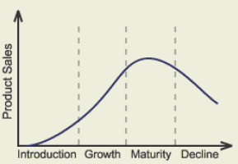
Figure 1: Industry LifeCycle of Dell
(Source: Pham et al., 2022)
Notwithstanding challenges from low-cost competitors throughout the mature period, Dell was capable of retaining revenue through cost-cutting initiatives. In reaction to the ongoing collapse in the computer marketplace, Dell has turned its attention to business solutions and cloud-based computing services (Cautela et al., 2019). The company has diversified its range of goods by acquiring other technological companies. Overall, by changing its business strategy according to volatile markets, Dell has efficiently negotiated every phase of the industry life cycle and can remain competitive. Overall, by changing its plan of action to changing market circumstances, Dell has managed to go across each phase of the industry life cycle. The corporation has been able to sustain its competitiveness and profitability owing to its initiatives in supply chain management, R&D, and strategic acquisitions. Dell has set up itself for potential expansion by shifting its focus to business solutions and cloud computing (Pham et al., 2022).

Porter’s Industry Five Forces Analysis
The entire laptop and PC industry has been in quite a downturn spiral throughout the last five years. Dell is among the significant players in the PC industry and is recignized for its excellent supply chain management, innovative technologies and direct business model (Baxter, 2019). Porter’s five forces analysis can be applied for elaborating how multiple factors are likely to influence the competitive positioning of Dell within the marketplace.
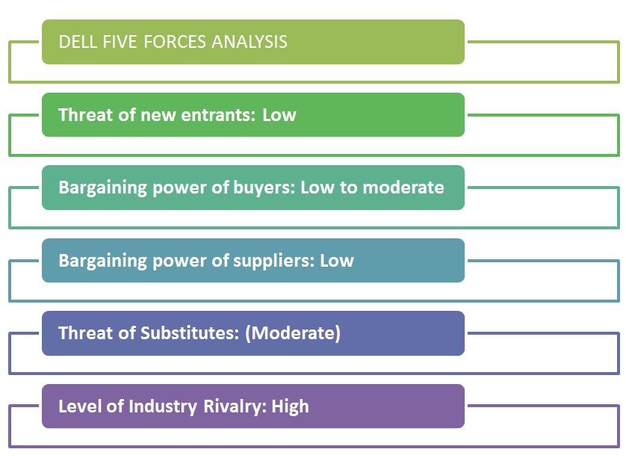
Figure 2: Porter’s Five Forces
(Source: Ragulan, 2021)
Threat of new entrants: Low
There is little risk of new rivals invading the PC industry. It's since accessing this field is so tough. The requirement for technological facilities and highly skilled workers, along with the substantial financial commitment, discourages individuals from approaching this industry (Anastasiu et al., 2020). Also, having an excellent brand image is vital for success in the PC industry. All of these factors collectively illustrate how difficult it is to break into the field of personal computers. Along with funds, competence, and technological infrastructure, Dell has developed to be an important contributor and well-known brand identity (Cheng, 2022). It also requires efficient relationships with clients, human resource management, along with supply chain management. All of these actions will demand effort, time, and cash.
Bargaining power of buyers: Low to moderate
Given a shortage of big companies with well-known brands, buyers have weak to modest bargaining power. The majority of the customers are either individuals or businesses. Consumers are loyal to businesses they recognize as they would buy from them. Given Dell's dedication to excellent client service, consumers have fewer options for negotiating. The ability of buyers to negotiate is greatly affected by elements like brand equity and brand image, and Dell has momentum in both areas (Bani-ata and Consultant–Freelance, 2020). Nevertheless, the market for personal computers has recently dropped and as a result, PC manufacturers like Dell have been driven to implement imaginative tactics to maintain their market share, allowing buyers a little more negotiating leverage.
Bargaining power of suppliers: Low
In the PC industry, suppliers possess minimal bargaining power. The fundamental reason for this is that there are plenty of suppliers in the industry but a few brands to which they sell. Consequently, brands are more equipped to put pressure on suppliers regarding price and level of service owing to their greater negotiation power. The strength of a supplier's bargaining power is contingent upon the standard of its products and services. Organizations like Dell regularly audit their vendors to ensure they comply with the requirements for both durability and quality (Lim et al., 2020). Considering the quality inspection and facility audits of vendors, Dell established stringent policy standards. All Dell audits are performed by authorized third-party auditing firms and conform to the EICC Audit Protocol. Based on all these considerations, Dell’s suppliers are in a weak bargaining position.
Threat of substitutes: Moderate
The PC sector has witnessed a gradual decline over the course of the last five years. But established companies like Dell and Apple witnessed their market share and revenues drop. The growth of substitute goods is the reason for it. There are now better options which provide the same capabilities that a laptop formerly did, like being a machine for experts, a gaming device, and a box of amusement. Individuals are able to explore the web, engage in gaming, listen to songs, and watch videos that stream on tablets and smartphones (Haizoun and GIOVANETTI, 2022). Game consoles also caused damage to the PC sector. In this regard, there are an array of substitutes that, while they are not able to completely substitute the personal computer, deliver comparable features and functions.
Level of industry rivalry: High
In the computer field, competitiveness is severe. Among the leading opponents are HP, Apple, Dell, Lenovo, Asus, and Acer. With the largest market share, HP and Lenovo are at the forefront, promptly followed by Asus, Dell, and Apple. The priority has been shifted to product and price innovation in order to preserve market share owing to the computer sector's relentless decline throughout the past five years (Ding et al., 2021). All of the firms are concentrating on supplying modern products with features that are superior compared to those of other companies. Given the increasing risk presented by mobile technology, an array of other issues, which include cost, mobility, design, and output, have additionally taken on greater importance. Dell presents an enormous obstacle from rivals, and its only chance for it to make up for the loss of market share is via innovative products and processes.

Internal Analysis
The internal analysis helps busiensses in understanding their internal business environment like strengths, weaknesses, opportunities, strengths, resources and capabilities, primary and secondary activities, value chain etc.

Dell’s Strategic Resources and Capabilities
Dell has a wide range of strategic capabilities and resources that have allowed the company in maintaining its competitive edge in a intense competitive computer market. Dell's direct-to-consumer business approach constitutes one of its most important strategic assets. Dell has the capability to reduce middlemen, reduce costs and enhance efficiency by selling directly to clients via its website and call centres (Huang, 2023). Dell additionally is capable to supply specialized items that are tailored to each customer's unique needs due to this business approach. The success of Dell is greatly affected by its experience in supply chain management. In order to effectively handle its supply chain, Dell has built trustworthy connections with suppliers and put technologies into place. As an outcome, Dell is able to ensure an ongoing supply of premium parts to its manufacturing facilities, reducing expenses and boosting efficiency (Ragulan, 2021).
Dell has extremely successful and adaptable manufacturing facilities. The business has made substantial investments in automation technologies while developing manufacturing procedures that aim at decreasing waste and assure quality. Due to this, Dell can rapidly build personalized products, which is an important selling feature for the company. The business's capacity for development and research is an essential force driving Dell's innovation and development (Fernanda and Ellitan, 2023). Dell makes significant R&D investments in order to create novel goods and enhance current ones. A group of scientists and engineers at the company seek out emerging trends and technologies that can be executed into Dell's goods. A vital resource that has aided Dell in maintaining its competitive edge is its brand reputation. Dell is known for creating dependable, high-quality products that are tailored to fulfil every unique customer's request. Due to this, Dell has grown into a well-known name in the computer field. The efficiency of Dell's human resource management methods is a further significant variable (Jiang et al., 2022). The business invests in development and training programs to assist workers in developing their careers, and Dell has a diverse and competent workforce. This makes it easier to ensure that sure Dell has an adequate staff to support the company's continuing expansion.

Value Chain Analysis
While DELL's value chain is quite equivalent to the industry standard, they have created a few unique benefits. They run on an adverse currency exchange cycle, as previously mentioned. They have built an integrated supply chain and a cutting-edge purchasing and manufacturing structure, which distributes value from the supplier to the client and offers DELL a competitive edge (Shanthi, 2019).
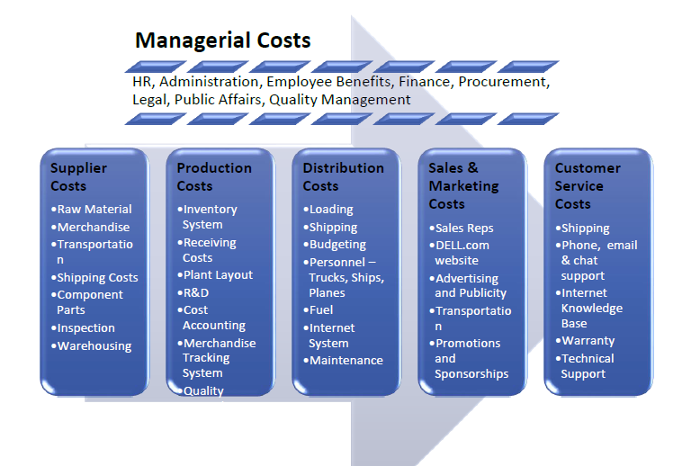
Figure 3: Value Chain Chain Analysis of Dell
(Source: Park, 2021)

Primary Activities
1. Inbound logistics: Internationally distributed suppliers compose Dell's network, and the business has developed close relationships with them. Dell can make certain that superior parts are delivered on schedule to its production plants by cooperating effectively with its suppliers. Through the implementation of a just-in-time inventory system, Dell removes the requirement for costly inventory management expenses by supplying materials as required (Stone et al., 2021).
2. Operations: The manufacturing processes of Dell are exceptionally effective and adaptable. One of Dell's main selling elements is its fast manufacturing of personalized products. Manufacturing procedures are created to reduce waste and assure quality (Fernanda and Ellitan, 2023). Furthermore, the manufacturing process is extremely automated, which promotes productivity.
3. Outbound Logistics: By doing away with dealers and intermediaries, Dell's direct-to-consumer business approach lowers expenses and enhances productivity. A product gets shipped immediately to the customer when it is manufactured. In order to meet customer demands, Dell presents a variety of delivery methods, which include ground delivery and fast shipping (Berenshteyn, 2019).
4. Sales and Marketing: Direct selling via e-commerce and call centres is the primary focus of Dell's advertising efforts. Consumers may modify their goods on Dell's website because of its robust web presence. Furthermore, Dell has a group of sales individuals who work alongside business customers to come up with unique solutions (Ha et al., 2021). The business's advertising strategies promote the positive aspects of its goods, which include customizability, excellence, and reliability.
5. Service: Dell's customer care representatives are available to help clients around the clock (Narayanaswami et al., 2019). Clients are given access to a variety of assistance alternatives, including online tools, telephone, and chat support. The value that Dell focuses on client service assures consumers are happy with their goods and are more prone to buy from them again.

Secondary Activities
1. Procurement: The process of purchasing used by Dell was designed to assure the timely shipment of high-quality parts (Kusumaputri, 2021). The company established lasting relationships with its vendors and interacts effectively with them to raise excellence and lower costs.
2. Technological Development: Dell makes significant expenditures on research and development in order to produce fresh goods and enhance current ones. A group of scientists and engineers at the company seek out new developments and technologies that can be executed into Dell's solutions. This helps ensure that Dell's goods remain cutting-edge and contemporary (Georgios et al., 2019).
3. Human Resource Management: The workforce at Dell is varied and highly competent. To support workers in furthering their professional lives, the corporation sponsors education and growth activities. This makes it easier to ensure that sure Dell has adequate talent that can help the company's continuing growth (Galande et al., 2022).
4. Company Infrastructure: The structures, instruments and resources that back up Dell's operations are incorporated into its infrastructure. This encompasses manufacturing plants, storage facilities, customer service centres, and internet-based sources. The extremely successful and adaptive design of Dell's infrastructure leads to cost savings and higher efficiency.

VRIO Analysis of Distinctive Resources and Capabilities
VIRO analysis is usually a framework which is utilized for evaluating a corporation’s capabilities and resources in order to determine their rarity, values, immitability and organization.
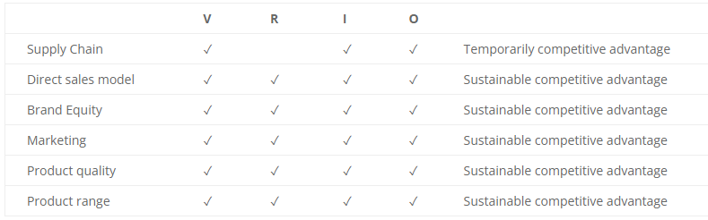
Figure 4: VRIO Analysis of Dell
(Source: Self-constructed)
Based on the above analysis, since the day it was established, Dell has set an important focus on superiority, creativity, and client service. This is an invaluable asset because it assists in a business's capacity to lure in and keep consumers. With the support of its direct sales approach, Dell can circumvent intermediaries and decrease expenditures by selling its goods directly to its consumers (Fernanda and Ellitan, 2023). This is a distinctive and priceless asset that gives Dell an edge over other computer producers. Dell has a highly developed supply chain management system which enables it to deliver goods to its customers fast and efficiently. This is a priceless and uncommon resource that provides Dell with an edge over rivals. Dell makes substantial R&D investments, letting them place cutting-edge products in the marketplace (Dong et al., 2023). Dell has a variety of unique assets as well as abilities that offer it a competitive edge in the field of computing. Its direct sales tactics, SCM, and investment in R&D and innovation are all valuable, unique, and hard-to-replicate capabilities. The company's reputation as a valuable but common brand, on the other hand, allows it to be simple for competitors to imitate.

SWOT Analysis
Strengths | Weaknesses
Strong brand recognition: Dell is a well-known name in the computer enterprise, and its popularity relies on outstanding products, technological advancement, and excellent customer service.  Direct sales model: Dell's direct sales approach permits it to sell products to consumers directly, which lowers costs and increases customer satisfaction (Jiang et al., 2022).  Supply chain Management: Dell employs a highly developed SCM system that allows it to deliver products to customers quickly and efficiently.  Innovation and R&D: Dell makes major investments in R&D, helping it to bring cutting-edge goods on the marketplace. | Dependence on the PC market: Given Dell's dependency on the computer segment for an important percentage of its earnings, its business is susceptible to changes in the market.  Limited presence in developing markets: Dell's potential for growth in these markets is restricted by its restricted footprint there.  Dependency on component suppliers: Given Dell's dependency on suppliers of components, the business is susceptible to supply chain disruptions.
Opportunities | Threats
Growth into developing markets: Dell may expand its market share in these areas in order to capitalize on opportunities for growth.  Diversification into other goods and services: Dell can broaden its selection of goods to decrease its dependency on the PC industry and develop additional forms of revenue.  Investment in cloud computing: Dell can make an investment in cloud computing to benefit from the increasing need for cloud-based services. | Intense competition: Competition is strong in the computer market, and Dell is up against both long-standing rivals and new entrants (Obu and Ukpere, 2022).  Swift technical advancements: The computing business is renowned for its rapid technological improvements, therefore Dell constantly needs to innovate to keep ahead of its rivals.  Economic downturns: Consumer expenditure might be decreased throughout economic downturns, which may negatively impact Dell's income.

Strategies to Sustain Competitive Advantage

Porter’s Generic Strategy of Dell
A framework for investigating an organization's market-competitive approach is Porter's Generic Strategies. Cost leadership, uniqueness, and focus are the three competitive advantage strategies that Michael Porter proposed (Subrahmanyam and Azad, 2019). Porter’s Generic Strategy can be applied to Dell in the following way:
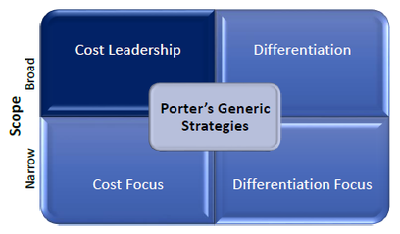
Figure 5: Porter’s Generic Strategy of Dell
(Source: Dai, 2022)
Cost Leadership: Dell has always followed the cost leadership method, which means offering consumers goods or services at the most affordable rate (Ragulan, 2021). By optimizing its manufacturing process and supply chain, Dell has been able to deliver high-quality products at prices that are lower than those of competitors. Dell has grown its market share in the computer company owing to this approach.
Differentiation: By delivering unique advantages, flexible customization possibilities, and high-quality products which set them apart from opponents, Dell additionally uses a differentiation approach (Park, 2021). Examples of things which set Dell apart from other computer makers in terms of layout, achievement, and innovation are the Alienware gaming notebooks and the XPS laptops.
Focus: Dell additionally applies a focus strategy by emphasizing specific industries or niche markets, including workstations and gaming laptops (Mohamed Hashim et al., 2022). By specializing in these industries, Dell can offer specialized services and products that are customized to that customer's needs, creating a following of loyal customers.
Overall, Dell successfully utilized differentiation and cost leadership strategies to develop a competitive edge in the computer market. By concentrating on these methods, Dell has managed to keep costs low, offer consumers restricted features, and offer a wide range of personalization options—all while retaining an excellent market position.

Growth Strategies
The Ansoff matrix is a leading strategic planning tool for assisting corporations in determining their goods as well as the market growth strategy (Jelonek et al., 2022). This framework is founded on four different strategies including market penetration, product development, market development and diversification.
Market penetration: Employing current offerings in current markets, this strategy attempts at expanding market share (Kurdi et al., 2022). In order to grow its market share in current regions including the US and Europe, Dell may need to step up its marketing and sales efforts.
Market Development: This approach involves introducing current goods into new markets. This could involve Dell expanding its operations into previously unexplored regions like South America or Asia, where it now has a less significant presence.
Product Development: In this strategy, novel products are produced for already-existing markets. In order to draw prospective clients while retaining existing ones, Dell might have to create new desktop or notebook models with cutting-edge features.
Diversification: This approach involves putting novel goods into fresh marketplaces. Dell may have to enter markets it does not currently perform, such as tablets or smartphones, in order to accomplish this.

Green Strategy and CSR
Dell's dedication to sustainability is clear in its development and layout of its ecologically conscious goods. They design their products for simple recycling and utilize renewable and recycled components like bamboo and post-consumer reused plastic in their designs. Furthermore, Dell has set ambitious goals to reduce their energy consumption and greenhouse gas emissions, and they regularly inform its audience of its progress (Chou et al., 2023). By employing organic packaging, Dell Technologies lowers its impact on the environment. The recycling of old technology was introduced as well by Dell Technologies as an element of their sustainable concept. Furthermore, Dell engages in local neighbourhoods and aids social causes via an assortment of programs. They have a scheme titled "Legacy of Good," for example, designed to tackle social and environmental problems (Madhu, 2020).
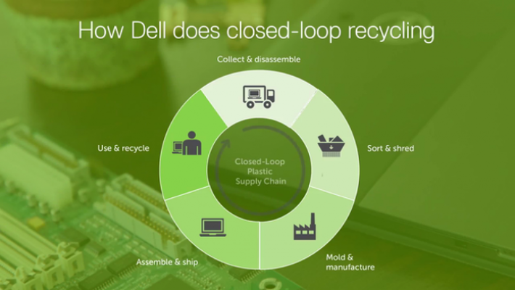
Figure 6: Closed-loop recycling of Dell
(Source: Dell Technologies, 2020)

Conclusion
Thus, to sum up, it can be concluded that Dell has positioned itself in the PC industry. This report has presented various analytical frameworks and tools for gaining a comprehension of the environment, competencies, and resources of Dell’s disciplines in the PC industry. Dell witnessed rapid expansion all over its earliest stages, moving from a start-up to becoming one of the industry's leaders in just a few years' of time. By delivering affordable costs and outstanding service for a long time, their approach to business and sophisticated supply-chain management system allowed them to preserve their edge over their rivals.

Recommendation
According to the current market position and business strategy of Dell, it can be noted that Dell must concentrate on expanding its business into several emerging marketplaces where there are substantial growth opportunities. This may entail countries in South America, Asia and Africa. Dell may attract new consumer groups and enhance its revenue streams by making investments in these markets (Camilleri et al., 2023). Dell needs to look into IoT potential markets. Dell may take benefit of its experience in software, hardware, and data collection to become an expert in this field considering the explosion of connected gadgets and the growing significance of data analytics. Dell may gain from selling IoT services to clients in a variety of financial markets, particularly manufacturing, healthcare, and logistics. Dell's business approach must continue putting a high value on environmental sustainability and responsibility. By doing this, Dell is able to set itself apart from the competition and attract consumers who have grown more conscious about how their technology purchases can impact the environment.

References
Anastasiu, L., Gavriş, O. and Maier, D., 2020. Is human capital ready for change? A strategic approach adapting Porter’s five forces to human resources. Sustainability, 12(6), p.2300.
Bani-ata, B.H.A. and Consultant–Freelance, B., 2020. ACER BECOMES THE TOP IN PC'S WORLD (" With Dell in the Dust Acer chases HP") Competition and Strategy. Revue des Etudes Economiques Approfondies, 5(1), pp.82-94.
Baxter, G., 2019. A strategic analysis of Cargolux Airlines International position in the global air cargo supply chain using Porter’s Five Forces Model. Infrastructures, 4(1), p.6.
Berenshteyn, Y., 2019. Improving customer experience by better predicting revised delivery dates (Doctoral dissertation, Massachusetts Institute of Technology).
Bieloborodova, M. and Bessonova, S., 2020. External environment transformation of Ukraine's tourist enterprises during the crisis. European Journal of Management Issues, 28(3), pp.71-79.
Camilleri, M.A., Troise, C., Strazzullo, S. and Bresciani, S., 2023. Creating shared value through open innovation approaches: Opportunities and challenges for corporate sustainability. Business Strategy and the Environment.
Cautela, C., Mortati, M., Dell'Era, C. and Gastaldi, L., 2019. The impact of artificial intelligence on design thinking practice: Insights from the ecosystem of startups. Strategic Design Research Journal, 12(1), pp.114-134.
Cheng, J., 2022. Sustainable Competitive Advantage Analysis and Recommendations for Dell Company to Achieve Success. Open Journal of Social Sciences, 10(12), pp.486-497.
Chou, D.C., Chen, H.G. and Lin, B., 2023. Green IT and corporate social responsibility for sustainability. Journal of Computer Information Systems, 63(2), pp.322-333.
Cowgill, B., Dell’Acqua, F. and Matz, S., 2020, May. The managerial effects of algorithmic fairness activism. In AEA Papers and Proceedings (Vol. 110, pp. 85-90). 2014 Broadway, Suite 305, Nashville, TN 37203: American Economic Association.
Cowgill, B., Dell'Acqua, F., Deng, S., Hsu, D., Verma, N. and Chaintreau, A., 2020, July. Biased programmers? Or biased data? A field experiment in operationalizing AI ethics. In Proceedings of the 21st ACM Conference on Economics and Computation (pp. 679-681).
Dai, L., 2022. Research on the Differentiated Competition Strategy of Membership-based Retail Stores:--Taking Sam's Club as An Example. Frontiers in Business, Economics and Management, 5(3), pp.38-41.
Dell Technologies, 2020. How to take your corporate social responsibility. Uncategorized. [Online] Available at: https://www.dell.com/nl-be/blog/taking-corporate-social-responsibility/. Accessed on: 20.04.2023.
Dell, C., Williamson, L., McKenzie, H., Carey, B., Cruz, M., Gibson, M. and Pavelich, A., 2021. A commentary about lessons learned: Transitioning a therapy dog program online during the COVID-19 pandemic. Animals, 11(3), p.914.
Dell’Osso, B., Albert, U., Carrà, G., Pompili, M., Nanni, M.G., Pasquini, M., Poloni, N., Raballo, A., Sambataro, F., Serafini, G. and Viganò, C., 2020. How to improve adherence to antidepressant treatments in patients with major depression: a psychoeducational consensus checklist. Annals of General Psychiatry, 19, pp.1-8.
Ding, D., Liu, X. and Xu, H., 2021, October. Sustainable Competitive Advantage: Case Studies of Dell, Ikea and Byte Dance. In 2021 6th International Conference on Modern Management and Education Technology (MMET 2021) (pp. 674-679). Atlantis Press.
Dong, X., Yan, M. and Hu, Y., 2023. Rational and Controlled R&D Innovation System. In Huawei: From Catching Up To Leading (pp. 111-135). Singapore: Springer Nature Singapore.
Fattorusso, A., Matricardi, S., Mencaroni, E., Dell'Isola, G.B., Di Cara, G., Striano, P. and Verrotti, A., 2021. The pharmacoresistant epilepsy: an overview on existant and new emerging therapies. Frontiers in Neurology, 12, p.674483.
Fernanda, N. and Ellitan, L., 2023. The Impact of Raw Material Shortage and Increasing Freight Cost to Dell’s Supply Chain Implementation. ULIL ALBAB: Jurnal Ilmiah Multidisiplin, 2(3), pp.1270-1288.
Galande, A., Solanki, M., Sheth, P. and Thakkar, Y., 2022. A STUDY OF ORGANIZATIONAL CULTURE PRACTICED BY DIFFERENT COMPANIES. Towards Excellence, 14(Special Issue 1).
Georgios, L., Kerstin, S. and Theofylaktos, A., 2019. Internet of things in the context of industry 4.0: An overview.
Guo, D., Ling, S., Li, H., Ao, D., Zhang, T., Rong, Y. and Huang, G.Q., 2020, August. A framework for personalized production based on digital twin, blockchain and additive manufacturing in the context of Industry 4.0. In 2020 IEEE 16th International Conference on Automation Science and Engineering (CASE) (pp. 1181-1186). IEEE.
Ha, H., Loh, H.S., Gay, H.T.E. and Yeap, P.F., 2021. Consumer protection in E-tailing computer sales: a case study of Dell. International Review of Law, Computers & Technology, 35(3), pp.246-269.
Haizoun, A. and GIOVANETTI, E., 2022. Efficient procurement management in an ETO business.
Hoyert, M., Ballard, K. and O'Dell, C., 2019. Increasing student success through a cocktail of cognitive interventions. Journal of the Scholarship of Teaching and Learning, 19(1).
Huang, X., 2023. Logistics Case study---DELL Company. Advances in Engineering Technology Research, 4(1), pp.126-126.
Jelonek, D., Tien, N.H., Dao, M.T.H. and Minh, D.T., 2022. Comparative analysis of business strategy of Vietnamese real estate developers: the use of Hoffer matrix. International journal of multidisciplinary research and growth evaluation, 3(1), pp.197-204.
Jiang, Z., Lin, H., Jiang, M. and Ling, W., 2022. Analysis of Dell’s Marketing Strategy. Law and Economy, 1(1), pp.29-37.
Kurdi, B., Alshurideh, M., Akour, I., Alzoubi, H., Obeidat, B. and Alhamad, A., 2022. The role of digital marketing channels on consumer buying decisions through eWOM in the Jordanian markets. International Journal of Data and Network Science, 6(4), pp.1175-1186.
Kusumaputri, R., 2021. Dell Corporation Strategy in Supply Chain Management in order to Avoid Bullwhip Effect. International Journal of Business and Technology Management, 3(1), pp.21-29.
Landoni, P., Dell’era, C., Frattini, F., Petruzzelli, A.M., Verganti, R. and Manelli, L., 2020. Business model innovation in cultural and creative industries: Insights from three leading mobile gaming firms. Technovation, 92, p.102084.
Lim, K.G.J., Teo, P.C. and Yang, L.Z., 2020, June. The Impact of Innovation on Competitiveness in Smartphone Industry in China. In 8th International Conference of Entrepreneurship and Business Management Untar (ICEBM 2019) (pp. 174-176). Atlantis Press.
Madhu, A., 2020. The impact of CSR activities on the green supply chain of footwear industry. The sustainability comparison of four global brands and life cycle analysis on uppers of Nike Flyknit and Adidas parley shoes.
MARRAS, L., 2022. Competitive analysis in the environmental market: the case of La Lumaca Soc. Coop.
Mohamed Hashim, M.A., Tlemsani, I. and Duncan Matthews, R., 2022. A sustainable University: Digital Transformation and Beyond. Education and Information Technologies, 27(7), pp.8961-8996.
Narayanaswami, C., Nooyi, R., Govindaswamy, S.R. and Viswanathan, R., 2019. Blockchain anchored supply chain automation. IBM Journal of Research and Development, 63(2/3), pp.7-1.
Obu, O.C. and Ukpere, W.I., 2022. Microfoundations of Organizational Growth: Consequences for Entry Strategies and Financing of New Ventures. Available at SSRN 4331442.
Park, S., 2021. Quality Management Practices of Dell and HP.
Pham, C.T.A., Magistretti, S. and Dell’Era, C., 2022. The role of design thinking in big data innovations. Innovation, 24(2), pp.290-314.
Ragulan, B., 2021. Strategic Analysis of Dell Inc.
Shanthi, R., 2019. Customer relationship management. MJP Publisher.
Sheth, J., 2020. Business of business is more than business: Managing during the Covid crisis. Industrial Marketing Management, 88, pp.261-264.
Stone, M., Aravopoulou, E., Stott, R., Parnell, B., Machtynger, J., Machtynger, L. and Foss, B., 2021. Reciprocating business model innovation–how client and supplier models interact. Journal of Business-to-Business Marketing, 28(2), pp.187-202.
Subrahmanyam, S. and Azad, S., 2019. Carrefour’s competitive strategy–Cost leadership and differentiation: A case study. Pacific Business Review International, 11(8), pp.137-145.
ZICCHIERO, I., 2022. Communication in the healthcare industry: development of the marketing plan for a Lombard clinic.

Appendix (if any)

Appendix 1: Porter’s Five Forces of Dell


