

Student name: |  | Student ID number:
Programme: | MSc (Cybersecurity and Digital Forensics)
Module: | Enterprise Network Security
Module code: | ACCA7032 | Contribution to Overall Module Assessment (%): | 100%
Lecturer: | Munyaradzi N Murira | Internal Verifier: | Renuga Jayakumar
Assignment Title: | Applied Network Security: Contemporary Research, Practical Work, and Demonstrations of Principles and Practices | Word count (or equivalent): | 5000
Submission deadline: | Portfolio (Part 1) 24/10/25  Portfolio (Part 2) 16/01/26

Executive Summary
This report captures the secured enterprise network design, implementation and analysis with Check Point Gaia R81.20, a combination of real world network building and security engineering concepts. The initial stage provided a working environment of enterprise including the Active Directory Domain Services, DNS, DHCP and IIS including site-to-site VPN services, having been tested using the Capture-the-Flag exercises, to ensure the environment was working before hardening. The second stage migrated this operating base to a secure centrally administered structure through a discrete Security Management Server, Security Gateway and SmartConsole, partitioned administration, and administration planes, certificate-based reliance and topology aware controls that favor division and anti spoofing. Security polices over inbound and outbound traffic (ICMP, SSH, HTTP, FTP and Telnet) were implemented with the least-privilege model and NAT policies were implemented to provide controlled exposure of the internal resources. Other features such as the role-based administrative isolation, logging and monitoring were added and advanced blades were taken into consideration further to harden the enterprise. The work reflects a combined technical solution and justifiable security posture in line with modern enterprise demands.

Table of Contents
Executive Summary 2
List of Figures 4
PART 1 - ENTERPRISE NETWORK DEPLOYMENT & CTF VALIDATION 6
1.1 Overview of the Enterprise Network 6
1.2 Capture-the-Flag Tasks and Operational Validation 6
1.3 Observations, Issues, and Learning Outcomes 7
1.4 Bridge Between Part 1 and Part 2 8
PART 2 - SECURING THE ENTERPRISE NETWORK 9
2.1 Rationale for Introducing Unified Security Management 9
2.2 Modified Security Topology and Enterprise Alignment 10
2.3 Installation and Configuration of the Security Management Server (A-SMS) 11
2.4 Configuration of Management Services, API and Administrative Roles 20
2.5 Deployment of the Security Gateway (A-GW) 26
2.6 SmartConsole Integration and Topology Awareness 37
2.7 Licensing and Contract Management 43
2.8 Topology Retrieval and Anti-Spoofing Enforcement 44
2.9 Inbound and Outbound Security Policy Enforcement 45
2.10 Additional Security Features Using Gaia Appliances 47
PART 3 - EVALUATION, CRITICAL REFLECTION & RESEARCH INTEGRATION 48
CONCLUSION 49
REFERENCE LIST 50

List of Figures
Figure 1 GAIA First Configuration Wizard (R81.20) - Welcome Screen for Open Server Installation 11
Figure 2 Deployment Options for SMS Installation (R81.20) 12
Figure 3 Management Interface Configuration (eth0) with Static IPv4 Addressing (10.1.1.101/24) 13
Figure 4 Optional Internet Interface Configuration (eth1) 14
Figure 5 SMS Device Information: Hostname, DNS, and Domain Configuration 15
Figure 6 DNS Validation Error on Tertiary DNS Entry 16
Figure 7 GAIA Product Selection - Security Gateway and Security Management Roles 17
Figure 8 Installation Type - Security Gateway and/or Security Management Server 18
Figure 9 Product & Clustering Selection - Primary Security Management Server 19
Figure 10 Management Interface Configuration for eth0 with Assigned IPv4 Address (10.1.1.1) 20
Figure 11 Configuration of Security Management Administrator (cpadmin) 21
Figure 12 First Time Configuration Wizard Summary (Primary Security Management Role) 21
Figure 13 Configuration Wizard Execution (Verifying Configuration & Installing Security Management Components) 22
Figure 14 GAIA Portal System Overview (A-SMS) Indicating Platform, Edition, Kernel & Software Blades 23
Figure 15 GAIA CLI Terminal Showing Initial API Readiness Test Failure 24
Figure 16 GAIA CLI Terminal Confirming Successful API Readiness Test Post-Activation 25
Figure 17 First Time Configuration Wizard (Open Server) - Second Provisioning Instance 26
Figure 18 Deployment Options for R81.20 Configuration (Gateway Instance) 27
Figure 19 Defined Network Interfaces for A-GW Including Management Interface (eth0) at 10.1.1.1/24 28
Figure 20 Optional Internet Interface (eth1) Configuration Screen for A-GW 29
Figure 21 A-GW Device Information with DNS & Domain Integration into swansea.acca 30
Figure 22 NTP Configuration for A-GW (Google NTP & London GMT Time Zone) 31
Figure 23 Product Selection for A-GW (Security Gateway Only) 32
Figure 24 Static IP Selection for Gateway (Non-DAIP Deployment) 33
Figure 25 SIC Activation for Management-Gateway Trust Establishment 34
Figure 26 First-Time Configuration Summary Showing Security Gateway Role 35
Figure 27 Configuration Commit Dialogue for A-GW Deployment 36
Figure 28 SmartConsole completing A-GW setup, confirming SIC trust, IPv4 (10.1.1.1) and active Firewall/NAT blades. 37
Figure 29 GAiA WebUI enabling eth3 and configuring IPv4 connectivity settings. 38
Figure 30 SmartConsole login targeting the SMS management IP (10.1.1.101). 38
Figure 31 SmartConsole first-login “What’s New” screen confirming SMS access and environment initialization. 39
Figure 32 SIC Wizard retrieving gateway topology and interface mappings across eth0–eth3. 40
Figure 33 Gateway topology view classifying eth0 as External and eth1/eth2/eth3 as Internal for anti-spoofing enforcement. 41
Figure 34 Gateways & Servers summary confirming A-GW status, Gaia R81.20 version, IPv4 (10.1.1.1) and blade configuration. 42
Figure 35 License & Contracts panel confirming trial licenses for A-SMS and A-GW and blade entitlements. 43
Figure 36 Updated SIC topology showing routed subnets and network objects post-licensing and trust configuration. 44

PART 1 - ENTERPRISE NETWORK DEPLOYMENT & CTF VALIDATION

1.1 Overview of the Enterprise Network
The first venture implementation was on a multi-site topology that cut across SWANSEA.ACCA and LONDON.SWANSEA.ACCA and the two sites were connected by a site to site (S2S) VPN. This two-site architecture had two pedagogical functions: first, to model realistic organisational network segmentation through geographically dispersed locations; and second, to add layered dependency between enterprise services such as DNS, Active Directory, domain trusts, DHCP, IIS web services and VPN tunnelling.
The centre of this topology was an Active Directory Domain Controller (AD DC) located at SWANSEA, which served to offer authentication, centralised directory services, DNS resolution services and the core domain namespace (swansea.acca). These directory services were passed to the child domain in London through domain trust and provided the ability of inter-domain user authentication and access to the resources. The functionality of AD, DNS, DHCP, IIS, and VPN was effective in ensuring that host units like ClientS1 (Swansea) and ClientL1 (London) would receive addressing using DHCP, resolve domain names, and perform group policy enforcement along with authenticate using AD authentication, as well as, accessing web resources being hosted internally.
The inter-site authentication and service access was an encrypted transport channel that was established by a VPN between the two domains which is a typical enterprise case where multiple organisational sites interact with each other via low-latency, secure transport across the network. In terms of security, the topology depicted the operational significance of distributed trust and the location of DNS and AD services across sites. On a larger scale, the deployment offered a good foundation on deploying more advanced network security measures in the next phases of the coursework, such as firewall policies enforcement, identity-based access controls, and advanced monitoring as upheld in Part 2.

1.2 Capture-the-Flag Tasks and Operational Validation
The CTF (Capture-the- Flag) test that was implemented into Part 1 was a mechanism of testing how the enterprise services should be deployed and interacted. Instead of being tested on abstract theory, the CTF exercises had the student operationally deal with the network, find misconfigurations and recover particular flag strings that were scattered across systems, services, or configurations. These activities were in effect simulated tasks of penetration tester and incident responder activities in the enterprise environment when exploiting or verifying the enterprise environment in which the skill of finding misconfigurations or unprotected resources is a key aspect.
The various layers of the enterprise stack were implicitly checked by each CTF task. For example:
- DNS resolution tests were done to examine both correct host system registration with AD-integrated DNS and name resolving was working across the VPN tunnel.
- Active Directory testing was done on membership to domain, authentication of user, inheritance of group policies and trust relationship among parent and child domain.
- HTTP availability and internal resources hosting were verified in web service activities with IIS.
- Tasks that relied on VPN ensured cross site interactions to be secure, routed accordingly, and not prone to IP misconfiguration.
- The DHCP operations confirmed the proper acquisition of leases of IPv4 addresses by the client systems according to site-specific scopes.
All of these activities were operational readiness and configuration accuracy measurements. Notably, the CTF mechanism did not only validate proper functionality, but also revealed dormant vulnerabilities and administrative misconducts, which are usually the norm of enterprise settings before security hardening.

1.3 Observations, Issues, and Learning Outcomes
One fundamental educational advantage of the CTF component was that it helped uncover misconfigurations and interdependency breakdowns that are often encountered in production enterprise systems. Some of the problems that were common in the exercise were associated with DNS hierarchy, domain trust propagation, delay in hostname registration, and the dependency between VPN routing table and DHCP address allocation which is often fragile. These problems showed the student that the security of the enterprise cannot be separated out of the functionality of the enterprise but, instead, enterprise functionality and security support each other. In case baseline services are unreliable or misconfigured, security appliances, authentication controls and policy engines lack good network state and identity context.
In his/her learning perspective, the CTF made the students embrace the idea of procedural troubleshooting, which entails the integration of packet-level reasoning, service dependency analysis, and cross-domain resolution dynamics. This is in line with the industry practice where system administrators and security engineers often work in tandem to diagnose any operational anomaly that has functional and security aspects.

1.4 Bridge Between Part 1 and Part 2
Part 1 laid the groundwork of the working basis of the enterprise network but deliberately did not have any unified or centralised security enforcement. Although the topology had simple firewalling and DNS-based trust information, there was no central policy management, identity-aware control of access, and advanced inspection of threats and prevention. Part 2 transition hence was dedicated to the introduction of Check Point Gaia appliances and SmartConsole management which permitted enterprise-scale firewall regulations, segmentation by topology and application of other security capabilities in line with current network security practice.
The following bridging step is significant to the overall portfolio review, the CTF showed that the enterprise network was operational, routable, and serviceable whereas Part 2 presents security controls that are consistent with unified security management architecture and countering modern cyber threats.

PART 2 - SECURING THE ENTERPRISE NETWORK

2.1 Rationale for Introducing Unified Security Management
After the infrastructure deployment, which had been tested via the CTF component, the enterprise network did not yet have a global security management system that could exercise similar policy at sites, services, and trust boundaries. Contemporary enterprise networks are often composed of heterogeneous services (DNS, domain controllers, VPN gateways and client fleets) that are required to be controlled by policy frameworks integrating identity, segmentation, least privilege, and application adaptive enforcement. This short com necessitated the installation of Check Point Security Management Server (SMS), Security Gateway (A-GW) and other related SmartConsole administration environment to consolidate the security policy implementation and to amplify traffic visibility and optimize operational assurance.
The introduction of Check Point Gaia R81.20 appliances solved some strategic security goals in line with the modern enterprise security architectures:
- Policy Centralisation: Security policies, NAT, anti-spoofing and topology awareness are specified out and shared uniformly.
- Secure Internal Communication (SIC): Trust (authentication) between the management and enforcement planes are enhanced by certificate-based relationships.
- Topology Awareness: This feature enables automatic classification of interfaces to help block spoofing and segmentation between internal networks, DMZ and external networks.
- Scalability & Extensibility: Gaia proposes modular security blades (e.g. firewall, IPS, URL filtering, identity awareness) that can be used in a layered defence.
- Operational Visibility: Management offers operational visibility through monitoring, logging, and post incident analysis functions that are not available in the baseline CTF network.
These functions relate well with the concepts of unified security management architecture, which has been a paradigm in the field of enterprise security as the need to have coordinated threat prevention and flexible policy enforcement has continued to grow. These changes are supported in the academic and industry literature, with the focus on centralisation of policies, identity-based controls, and network segmentation as the current best practice on risk mitigation in distributed environments.

2.2 Modified Security Topology and Enterprise Alignment
In order to implement the security solution, the enterprise topology that was used in Part 1 was changed to add three essential appliances:
- Security Management Server (A-SMS): SmartConsole Policies Hosts manage licensing, host SIC and topology discovery, SmartConsole policies.
- A-GW (Security Gateway): Imposes firewall policies, NAT, segmentation and other security blades.
- A-GUI (Client Workstation to the Management): Leveraged to implement SmartConsole as a centralised administration control.
This change brought an additional security architecture where traffic between internal, DMZ, and external network cannot be transmitted without passing through the A-GW, and therefore, the inbound / outbound traffic can be controlled according to the enterprise-specific policies. The SMS is deployed on the internal management network (10.1.1.0/24), offers out battery policy control, and is in line with the principles of secure network design.
A change in the topology helped in understanding the trust model: the A-SMS is deployed as the control plane and the A-GW is deployed as the data plane. This isolation will make sure that policy configuration is not given to the compromise of endpoint hosts or application servers directly, which is also in agreement with industry standards of deploying firewalls and security appliances.

2.3 Installation and Configuration of the Security Management Server (A-SMS)
The implementation started with the deployment of Check Point Gaia R81.20 platform to A-SMS by installing the First-Time Configuration Wizard (FTW). The FTW assists in configuring management roles, the addressing, DNS, and domain membership parameters making sure that the appliance is configured in accordance with enterprise topology requirements.
Selection of Open Server installation method in Gaia was confirmed by the first FTW welcome screen:
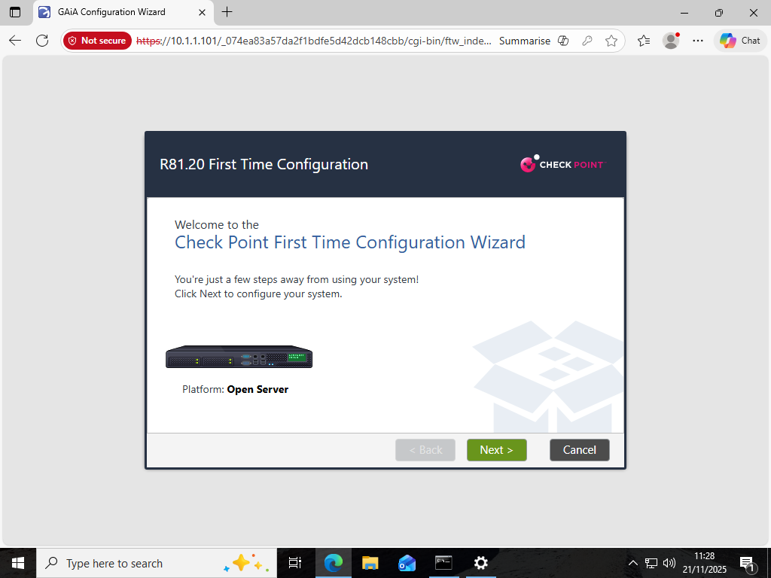
Figure 1 GAIA First Configuration Wizard (R81.20) - Welcome Screen for Open Server Installation

The deployment options of the SMS were then chosen, and it was ensured that this appliance would be considered as the main management entity:

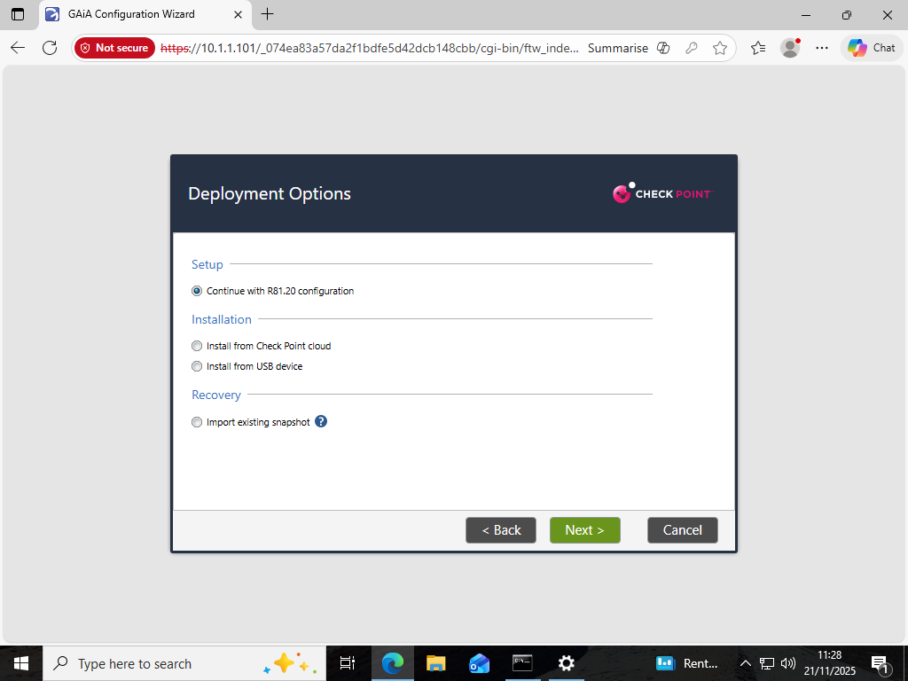
Figure 2 Deployment Options for SMS Installation (R81.20)

The management interface (eth0) was set to a fixed IPv4 address 10.1.1.101/24, which is within the Layer-3 addressing range of the management subnet:
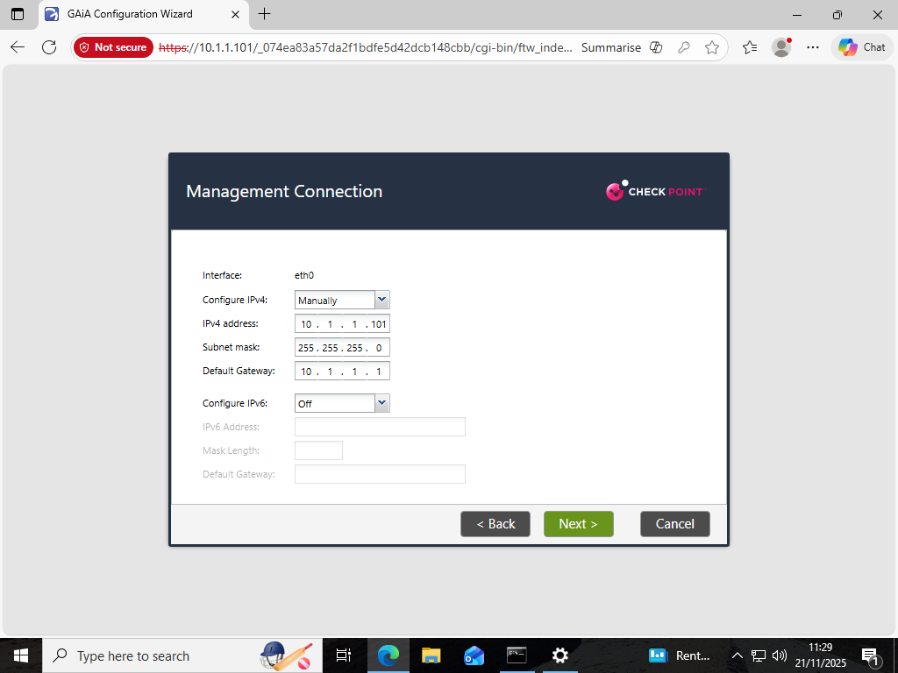
Figure 3 Management Interface Configuration (eth0) with Static IPv4 Addressing (10.1.1.101/24)

It had an optional external interface (eth1) which showed the possible future connectivity routes of Internet breakout or upstream management services:
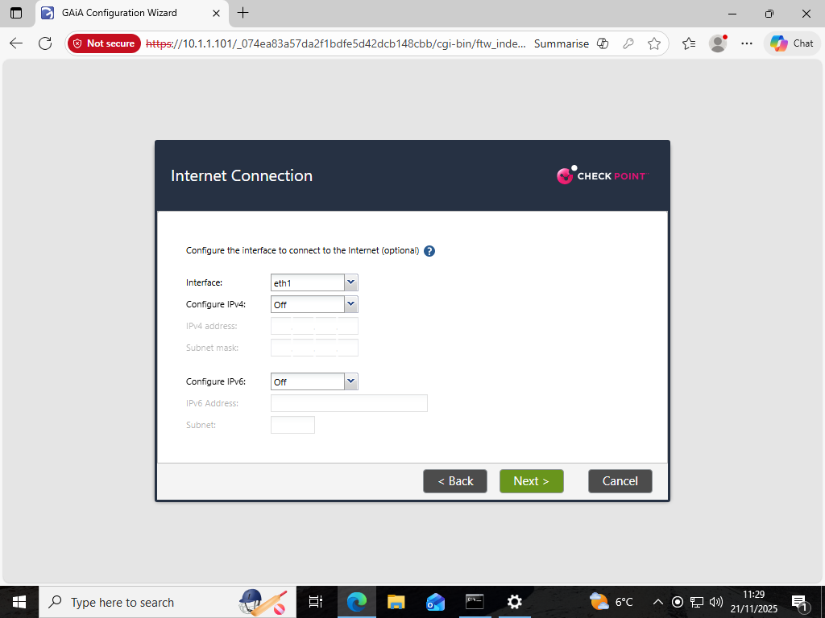
Figure 4 Optional Internet Interface Configuration (eth1)

Hostname, DNS and domain variables were then configured to overcome the integration of A-SMS into swansea.acca namespace:
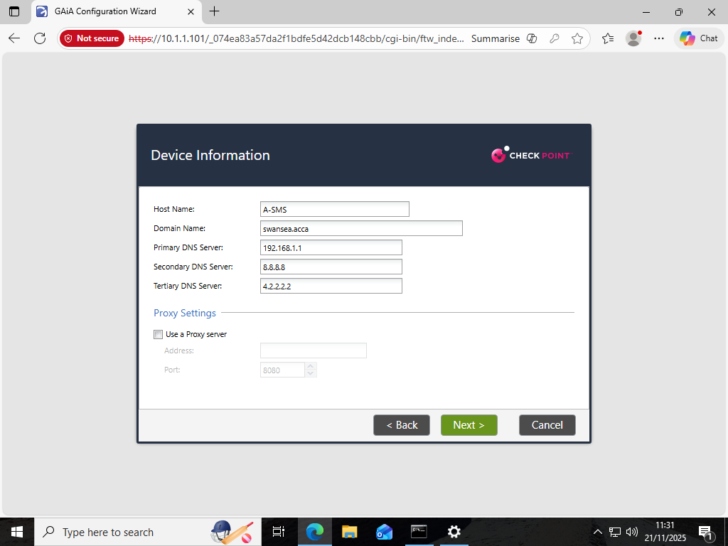
Figure 5 SMS Device Information: Hostname, DNS, and Domain Configuration

In the process of validating the DNS entries, the appliance discarded a tertiary DNS resolver, which underscores the stringent nature of the FTW in terms of resolver validation and points to the fact that DNS and management trust are operationally dependent on each other:
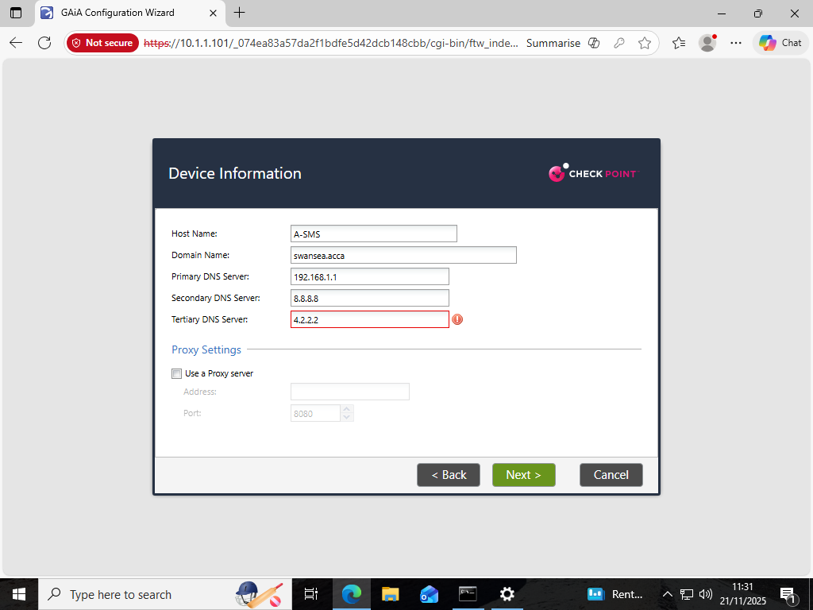
Figure 6 DNS Validation Error on Tertiary DNS Entry

Product selection screens next affirmed that the appliance would act as a Security Gateway and a Security Management appliance, but in its ultimate configuration simply the management server functions were engaged:
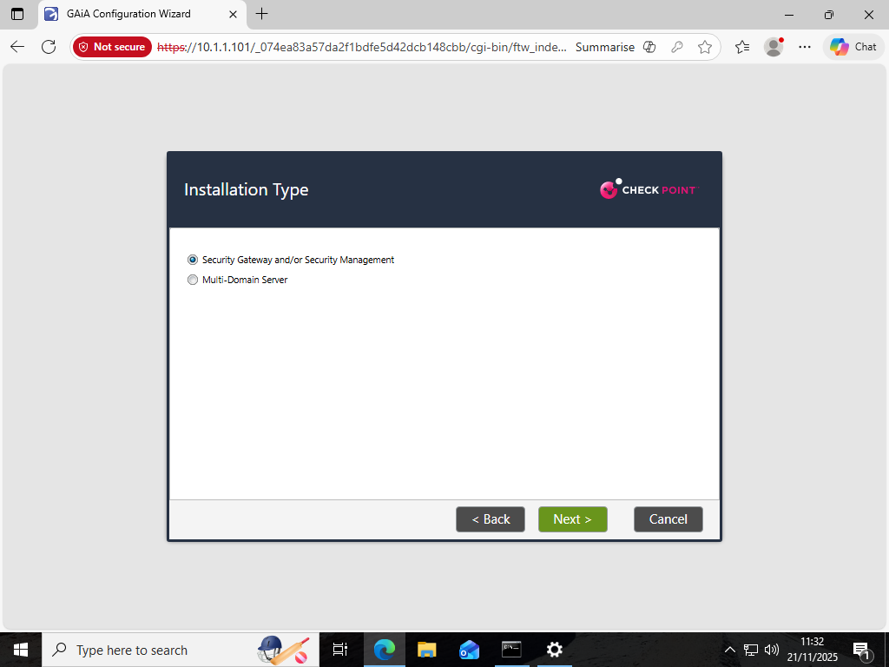
Figure 7 GAIA Product Selection - Security Gateway and Security Management Roles

The selection of roles optimized the footprint of the installation to include a management capability needed to use SmartConsole:
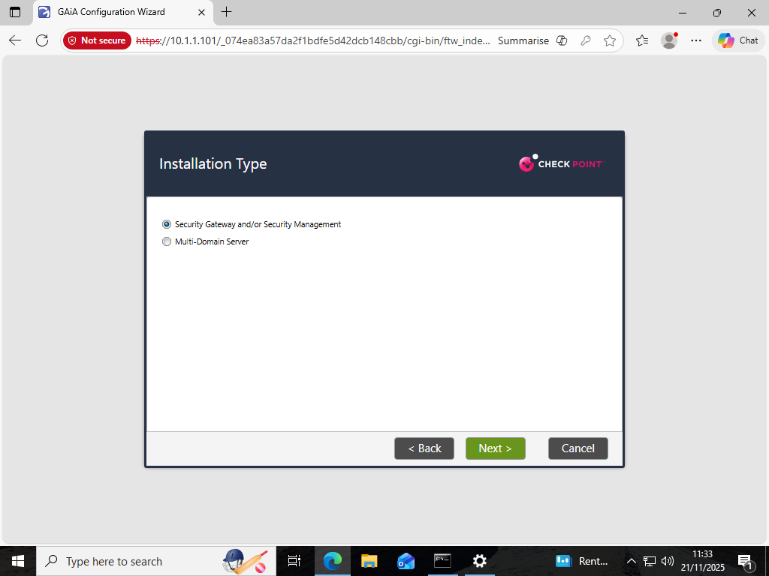
Figure 8 Installation Type - Security Gateway and/or Security Management Server

Lastly, the appliance was allocated the purpose of Primary Security Management Server with the assurance that it would be granted the authoritative regarding policy deployment:
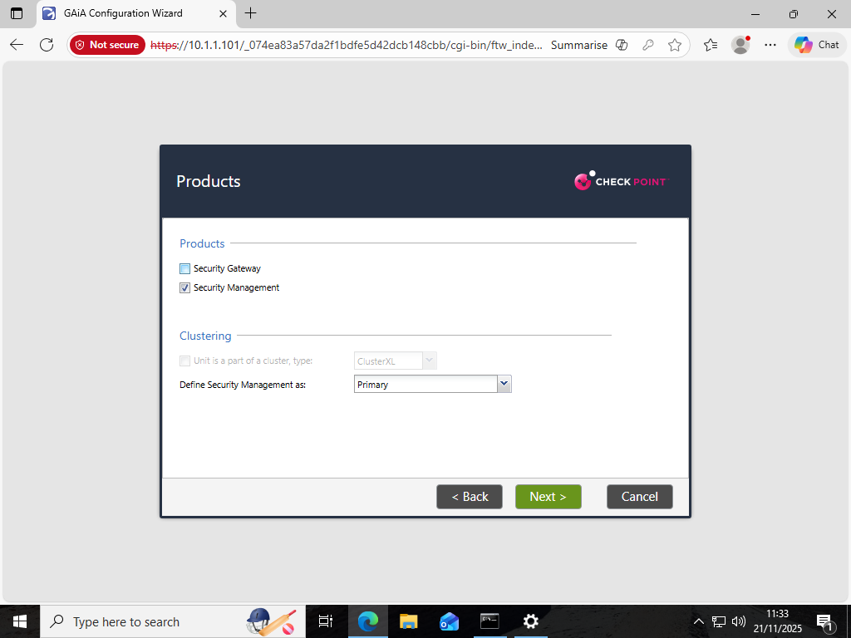
Figure 9 Product & Clustering Selection - Primary Security Management Server

2.4 Configuration of Management Services, API and Administrative Roles
The Security Management Server (A-SMS) was base provisioned, and the web-based management was performed using the Gaia WebUI to ensure the system was in operation and allow services needed to configure SmartConsole-based configuration. Administrative account setup helped to control access security, whereas API activation appeared as use of automation, topology discovery and SIC negotiation with the gateway.
The A-SMS management interface was tested with the First-Time Wizard and it showed IPv4 address allocation and augmented connection with the management subnet:
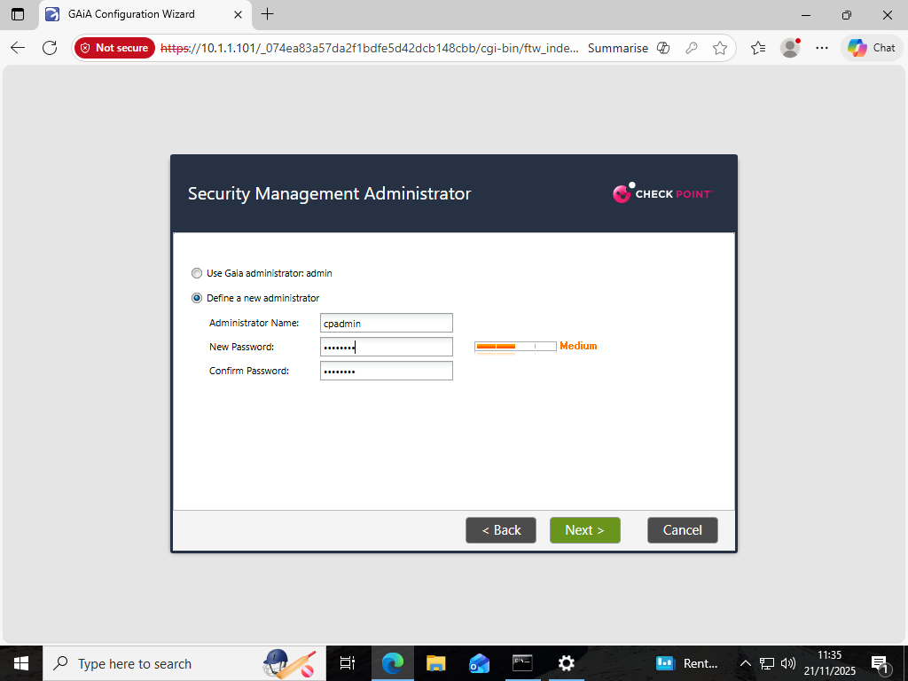
Figure 10 Management Interface Configuration for eth0 with Assigned IPv4 Address (10.1.1.1)
Access to the administrative system was separated through the use of a specialized management account (cpadmin), a common example of separating the role of the system root account with that of security administrative privileges. This solution is in line with the principle of least privilege, a popular theory of best practice in enterprise security architecture:
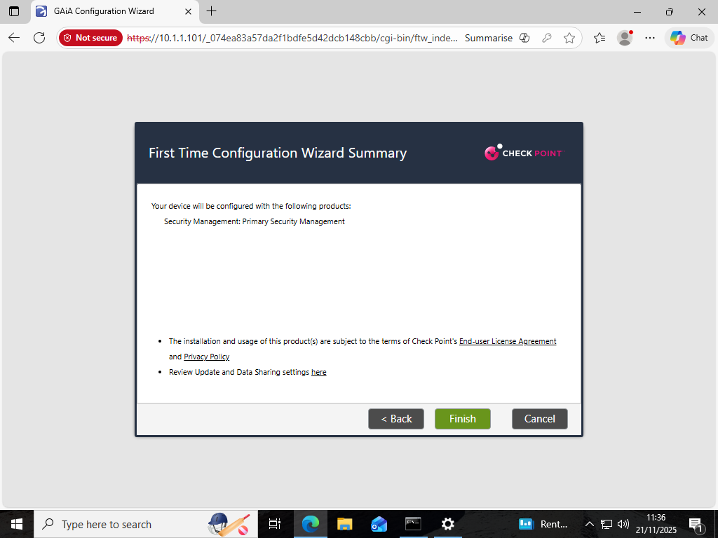
Figure 11 Configuration of Security Management Administrator (cpadmin)
A complete list of configuration parameters was created to check the addressing, hostname, DNS, service role, and other deployment metadata before commit:
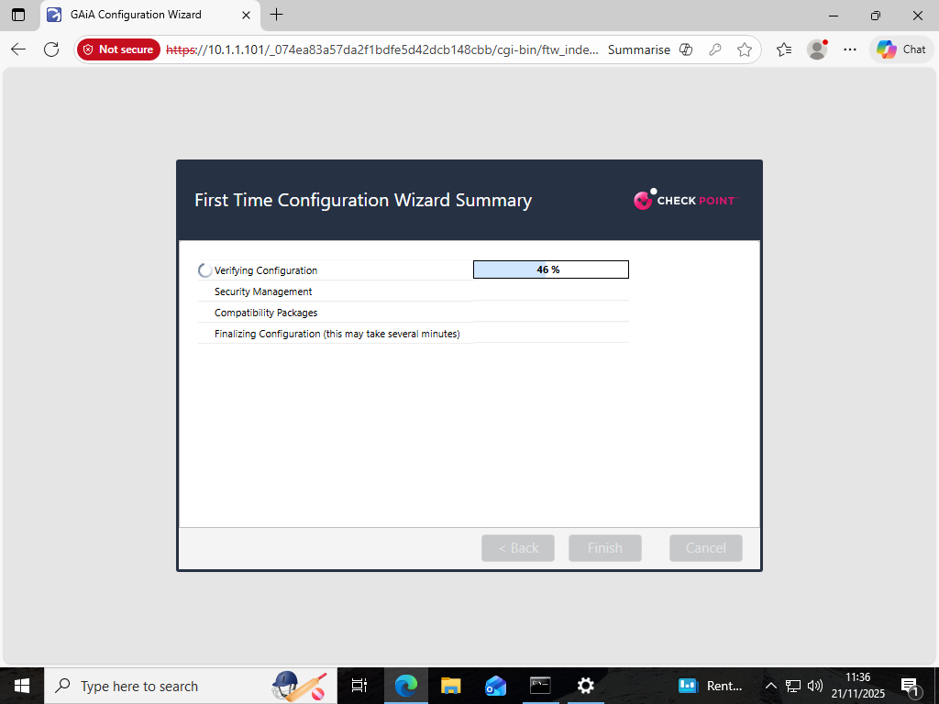
Figure 12 First Time Configuration Wizard Summary (Primary Security Management Role)
The management plane services such as the Gaia WebUI, underlying REST APIs and R81. 20 security management elements were initialised by the execution of the configuration wizard:
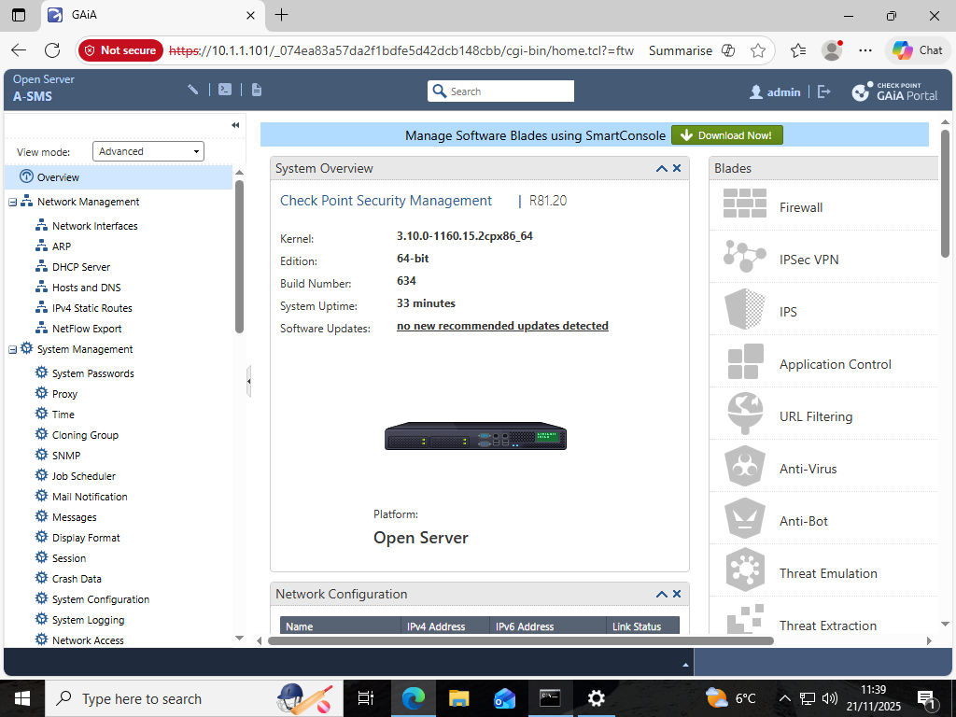
Figure 13 Configuration Wizard Execution (Verifying Configuration & Installing Security Management Components)

After provisioning, the WebUI showed system details such as platform architecture, software versions installed, Linux kernel version and software blades that were enabled, and ensured that the management server was up and integrated with downstream enforcement points:
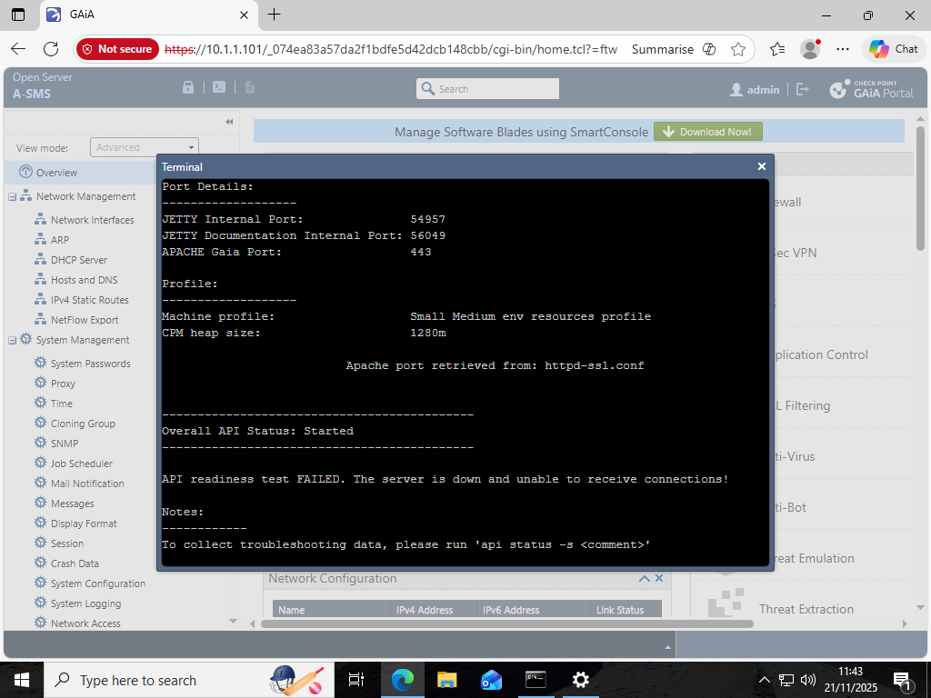
Figure 14 GAIA Portal System Overview (A-SMS) Indicating Platform, Edition, Kernel & Software Blades

Gaia presents a RESTful API interface through which the components of SmartConsole manipulate policies and discover topology. In initialisation, API readiness failure was noted, and more activation was needed. This gave viable experience on dependency sequencing between security management services and administrative tools:
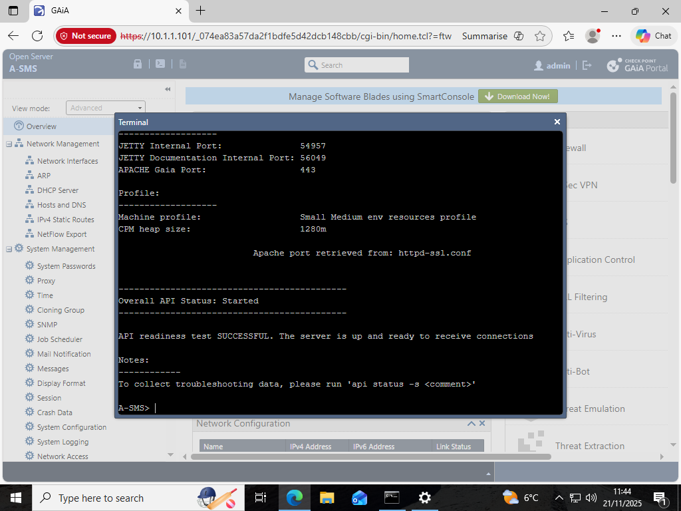
Figure 15 GAIA CLI Terminal Showing Initial API Readiness Test Failure

Having reconfigured the API service and launched the required processes, the management API was available, which validated the fact that A-SMS was now capable of supporting remote policy operations and trusted endpoint communications:
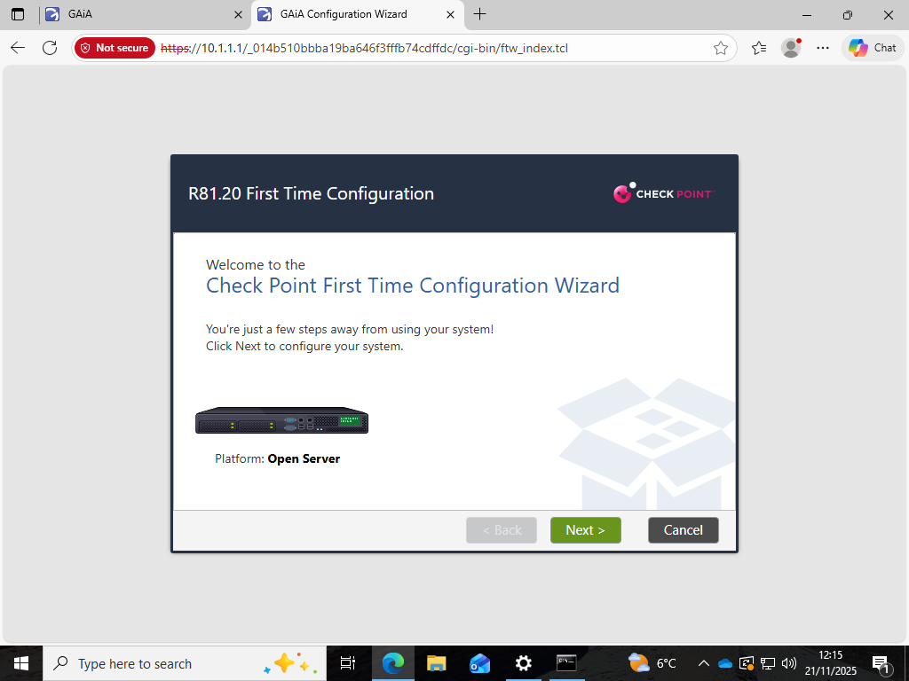
Figure 16 GAIA CLI Terminal Confirming Successful API Readiness Test Post-Activation
Enabling the API and setting up management users are notable professional practice factors that the enterprises often combine Check Point management servers with programmatic interfaces with orchestration tools, ticketing platforms, and SIEM platforms.

2.5 Deployment of the Security Gateway (A-GW)
The next step brought Security gatekeeper (A-GW) to the enterprise topology in order to impose firewall, NAT, segmentation, and other security blades. The provisioning of a secondary provisioning instance (Gaia First-Time Configuration Wizard) was started:
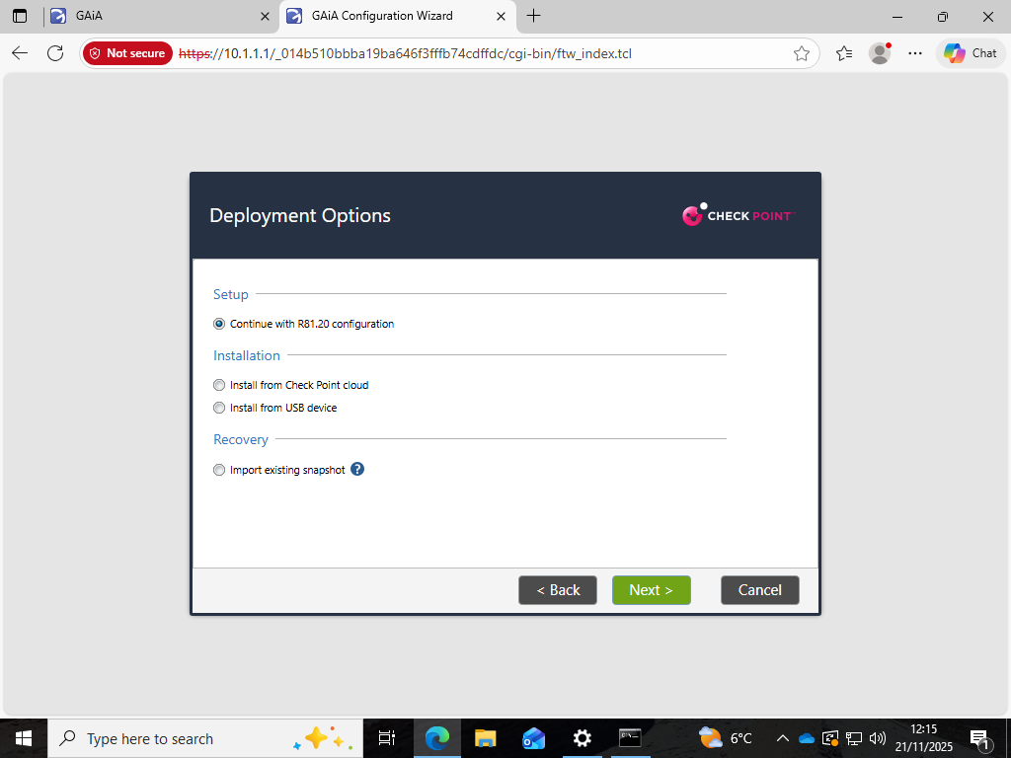
Figure 17 First Time Configuration Wizard (Open Server) - Second Provisioning Instance

The gateway role has been chosen with the following deployment options as a part of the R81.20 configuration pipeline:
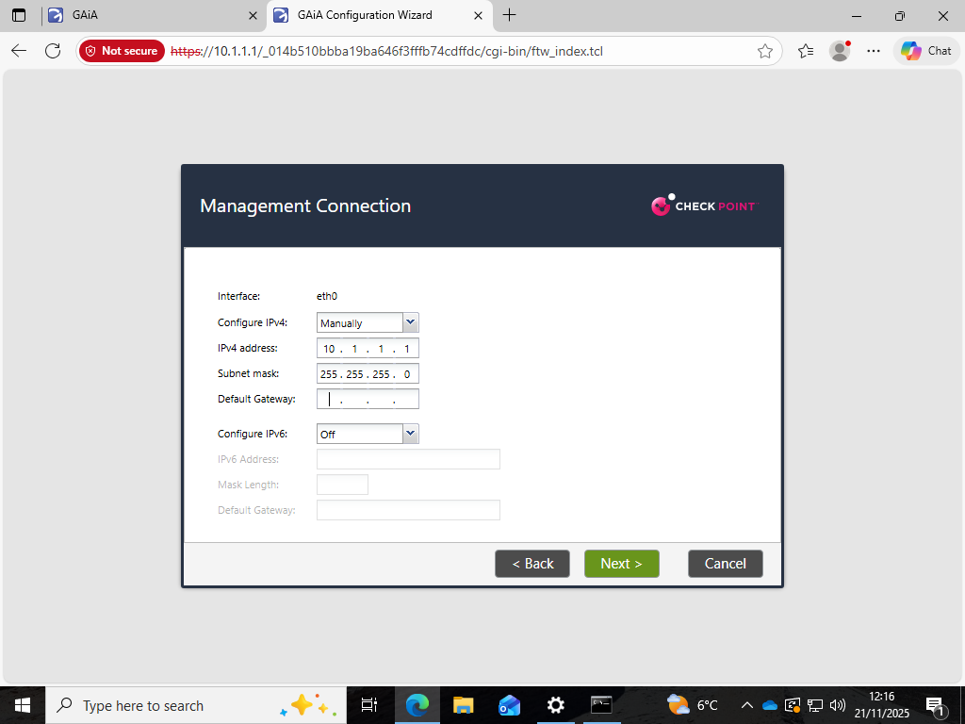
Figure 18 Deployment Options for R81.20 Configuration (Gateway Instance)

The network interfaces were configured to represent the topology in Section 2.2 where eth0 is the management interface with value 10.1.1.1/24 and others are interfaced to external, DMZ and internal routing plane:
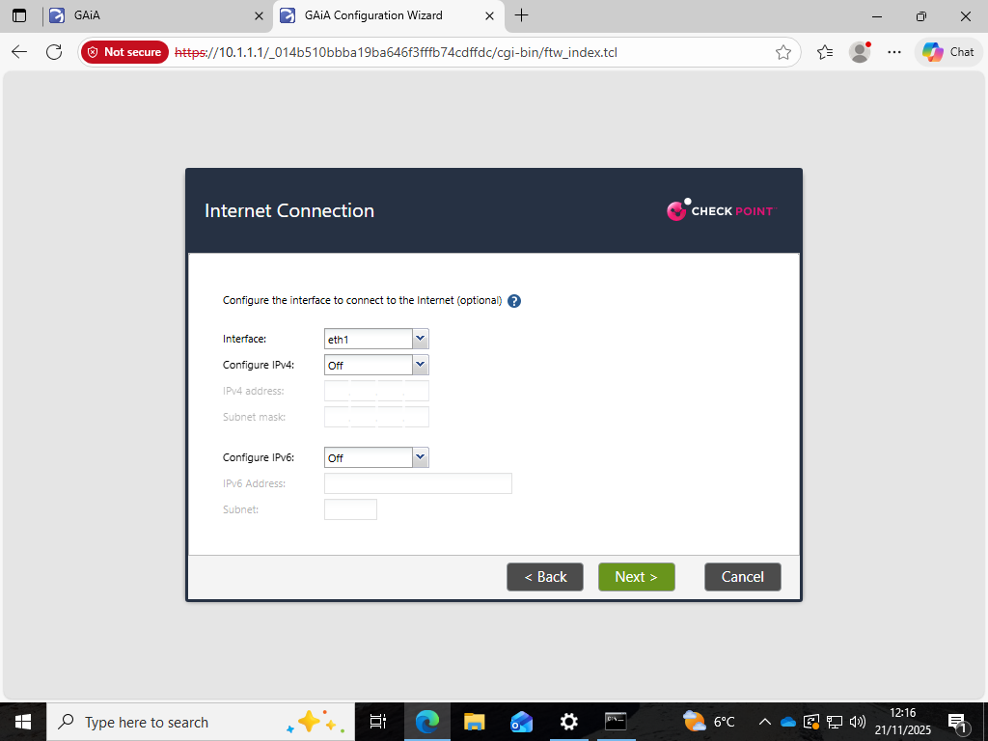
Figure 19 Defined Network Interfaces for A-GW Including Management Interface (eth0) at 10.1.1.1/24

The optional eth1 external interface setting shown above provided connectivity with networks outside the management domain:
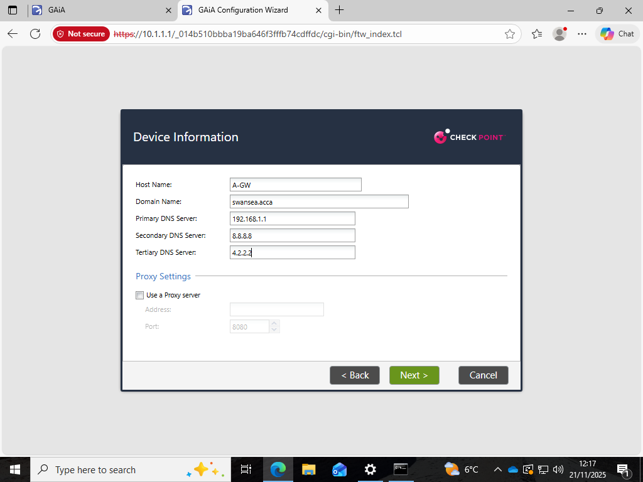
Figure 20 Optional Internet Interface (eth1) Configuration Screen for A-GW

Hostname device and DNS integration were set to incorporate the gateway into swansea.acca domain namespace so that there was consistency between the management and the enforcement planes:
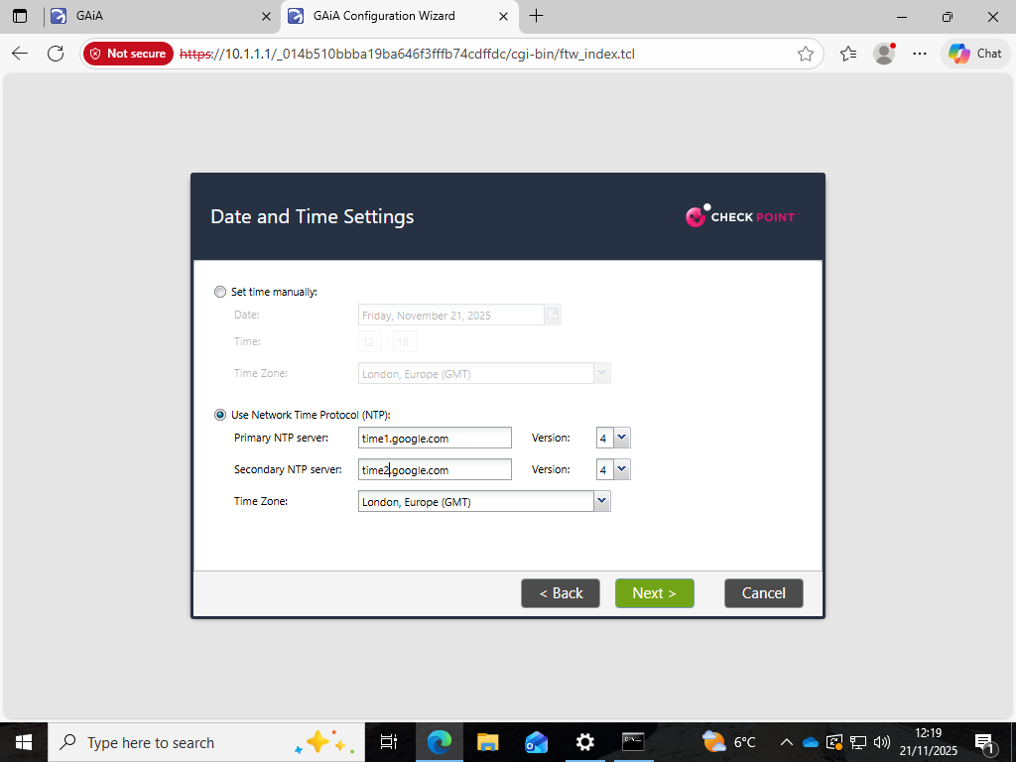
Figure 21 A-GW Device Information with DNS & Domain Integration into swansea.acca

The Google NTP servers and the London time were used to set time synchronisation. The step will be essential to certificate validation, the creation of SIC trust, correlation of events, and the accuracy of log timestamps:
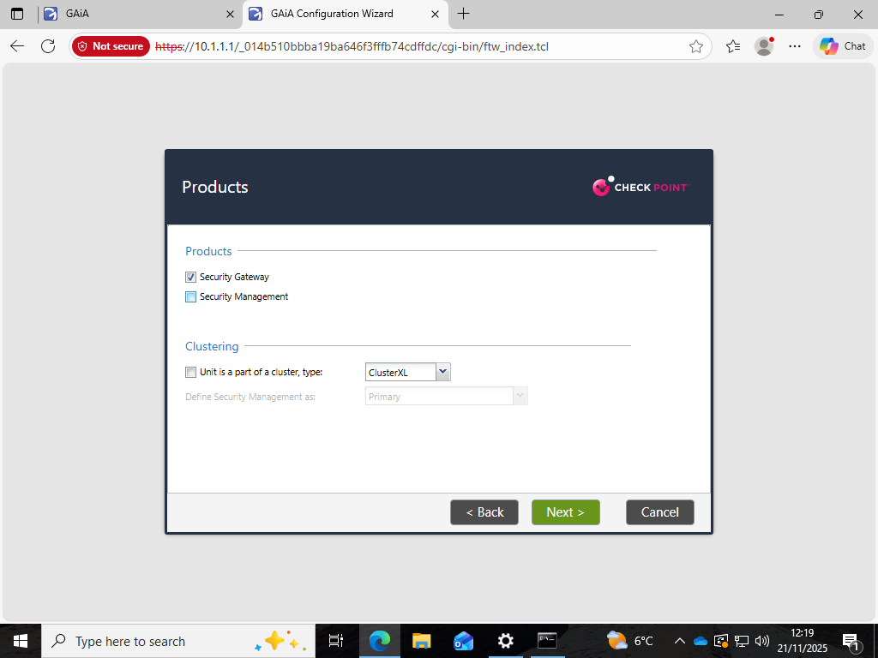
Figure 22 NTP Configuration for A-GW (Google NTP & London GMT Time Zone)

The role of Security Gateway was assigned to A-GW which was confirmed by product selection:
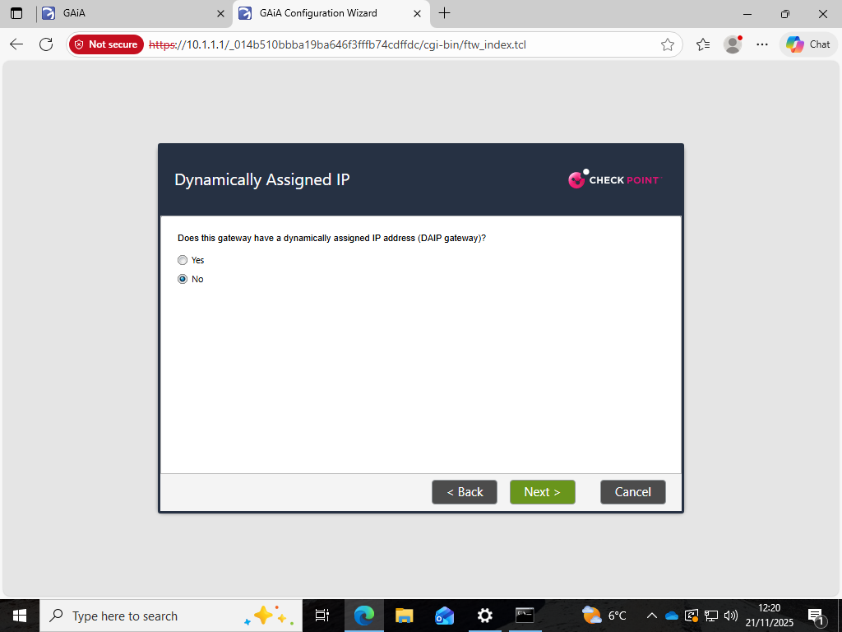
Figure 23 Product Selection for A-GW (Security Gateway Only)

The gateway was also deployed as a static IP deployment as opposed to a DHCP-assigned gateway (DAIP). The use of static addressing is highly encouraged in the enterprise environments to allow stability, auditability, and compatibility with high-availability and clustering solutions:
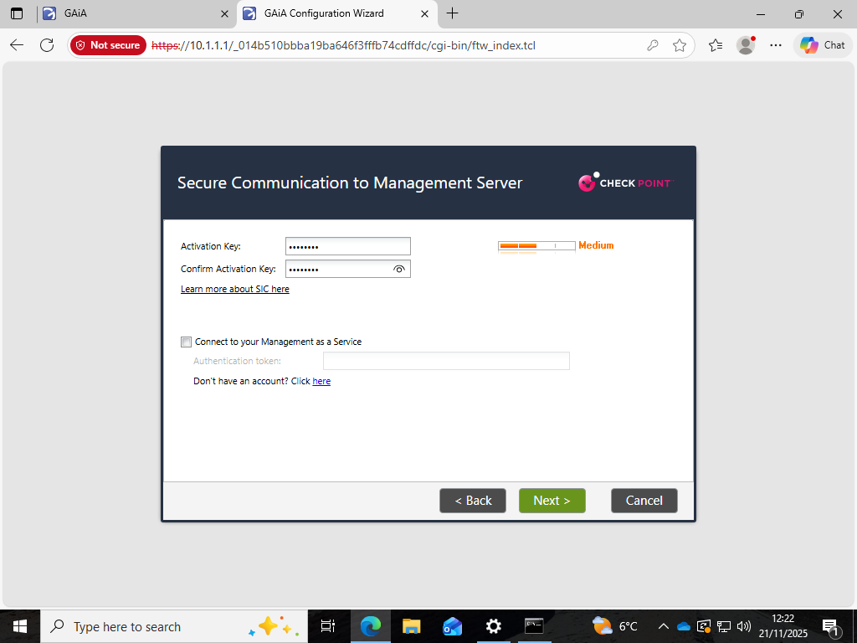
Figure 24 Static IP Selection for Gateway (Non-DAIP Deployment)

Lastly, the activation of Secure Internal Communication (SIC) was done in order to build trust between A-GW and A-SMS based on certificates. SIC authentication is the cornerstone to Check Point unified security management model:
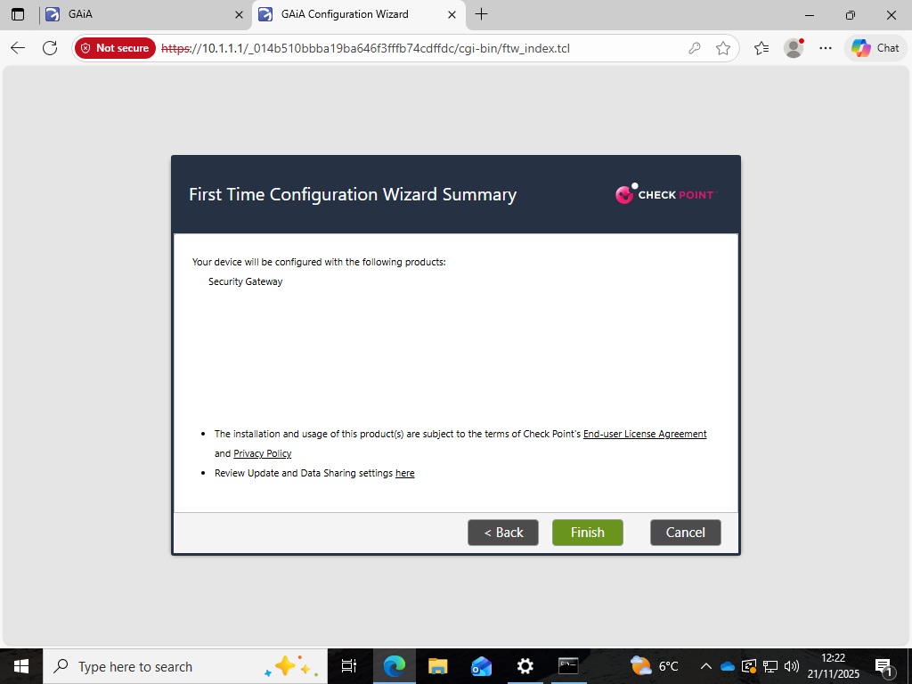
Figure 25 SIC Activation for Management-Gateway Trust Establishment

Installation parameters were confirmed in configuration summary and commit screens and the provisioning workflow was started:
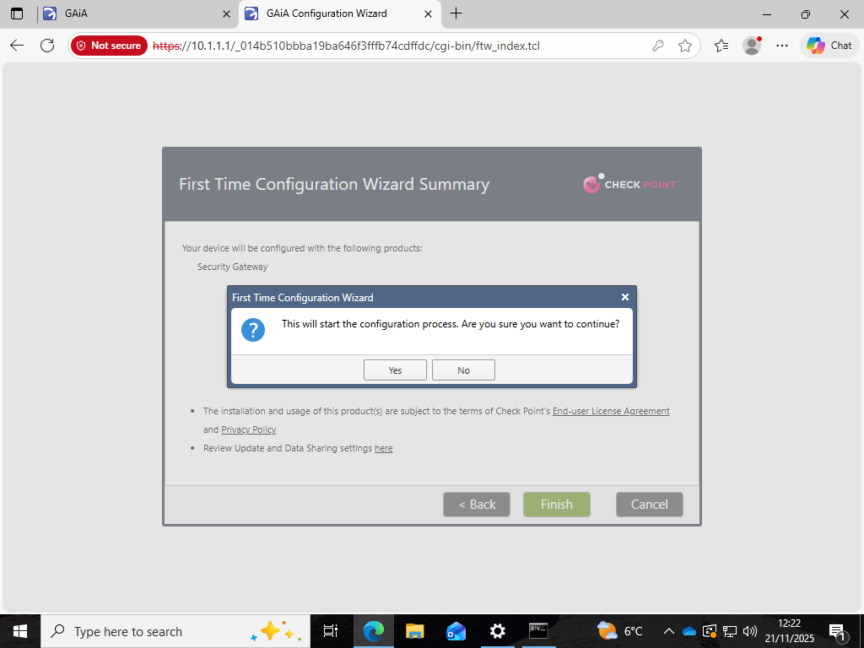
Figure 26 First-Time Configuration Summary Showing Security Gateway Role
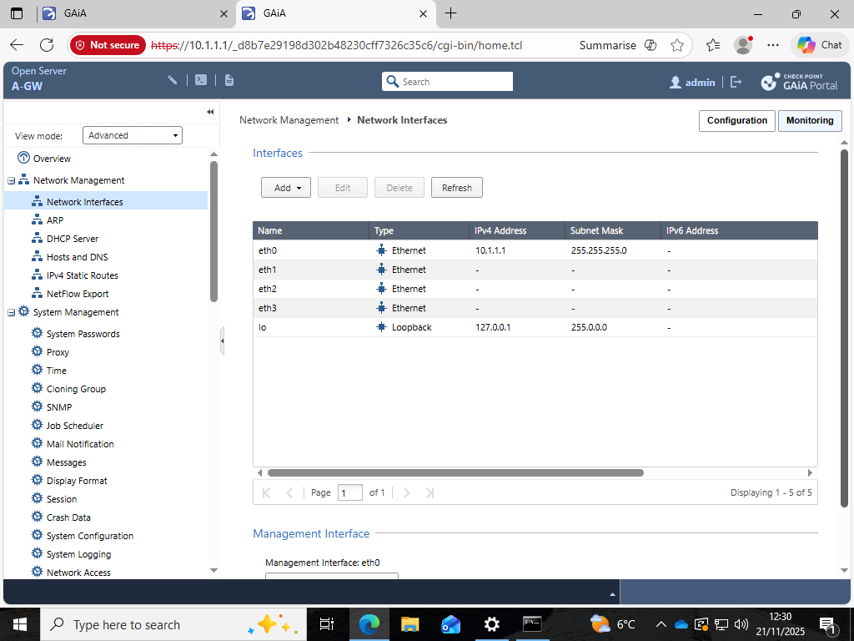
Figure 27 Configuration Commit Dialogue for A-GW Deployment

2.6 SmartConsole Integration and Topology Awareness
Initially, the Security Management Server (A-SMS) and Security Gateway (A-GW) were configured and enabled after which the centralised security administration environment of Check Point, SmartConsole, was initialised using the management workstation (A-GUI). SmartConsole offers cohesive configuration interfaces, which use policy definition, topology mapping, software blade, NAT, logging, monitoring, and licensing interfaces. It is thus used as the central orchestration layer of the Gaia security architecture.
Access to the management server (10.1.1.101) indicated that the management plane was ready and the API and SIC trust mechanisms mentioned in Section 2.4 were initialized successfully:
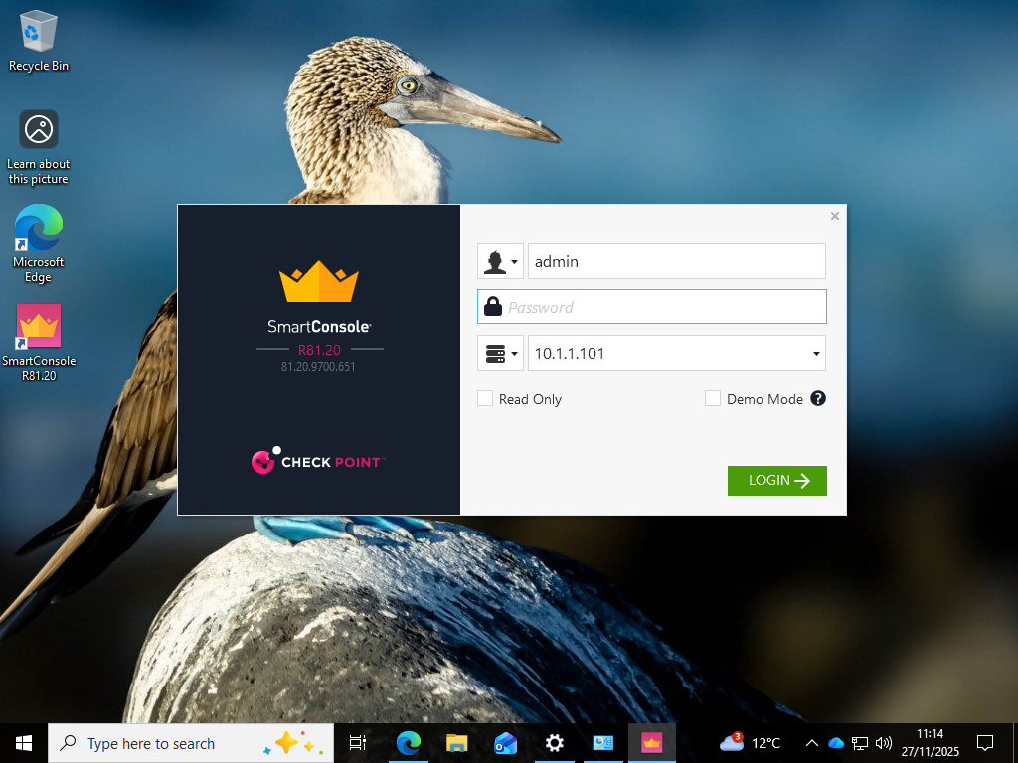
Figure 28 SmartConsole completing A-GW setup, confirming SIC trust, IPv4 (10.1.1.1) and active Firewall/NAT blades.
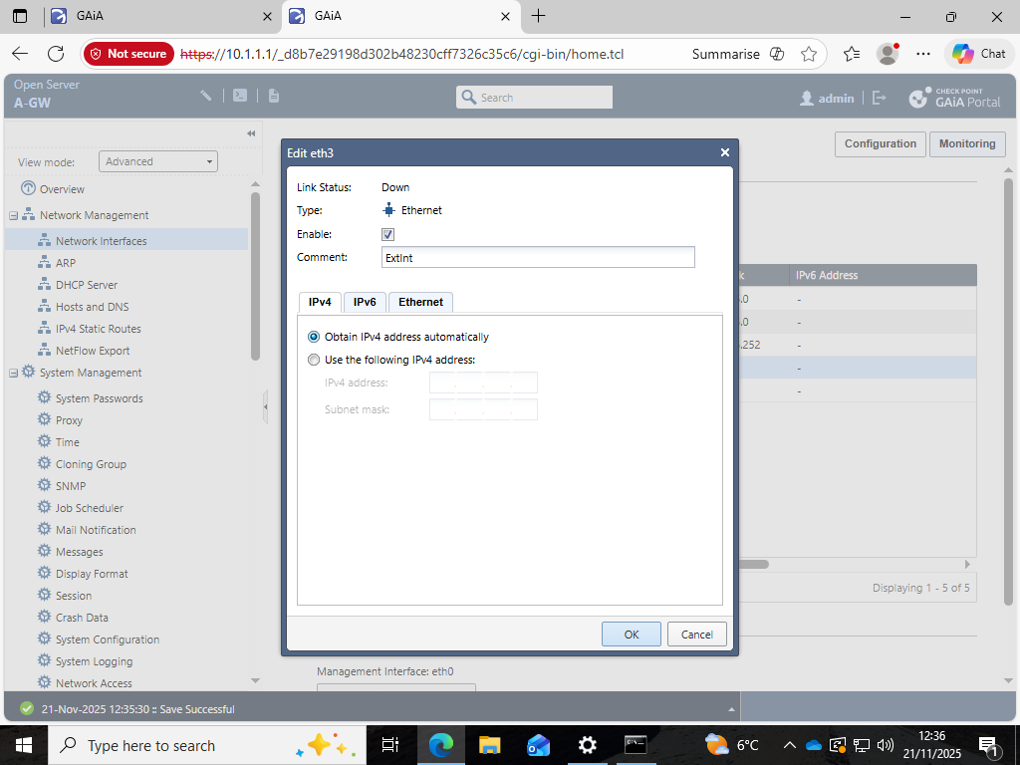
Figure 29 GAiA WebUI enabling eth3 and configuring IPv4 connectivity settings.
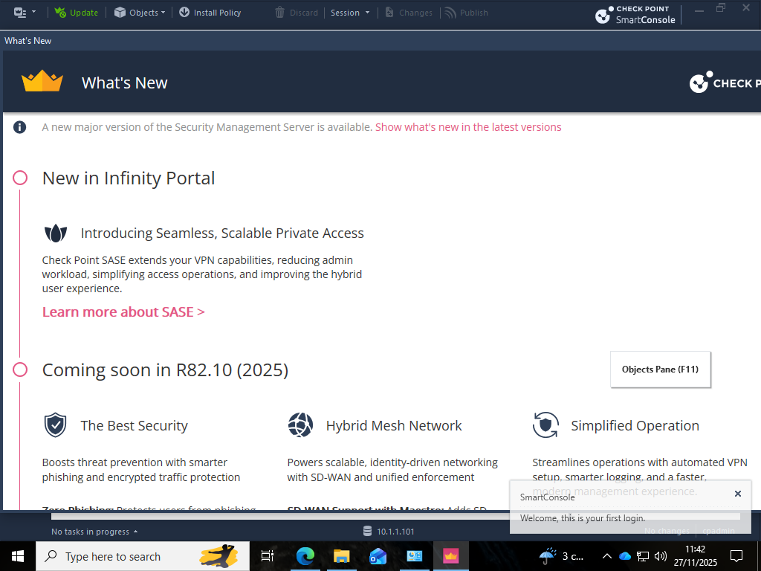
Figure 30 SmartConsole login targeting the SMS management IP (10.1.1.101).
On the initial login SmartConsole displayed the What is new R81.20 deployment and features overview stating that it negotiated successfully with the management server, initialised the database, and validated internal configuration:
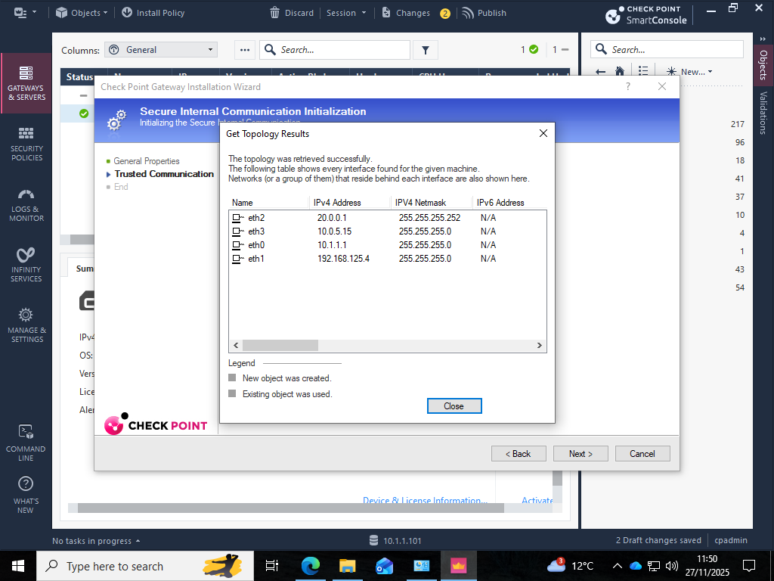
Figure 31 SmartConsole first-login “What’s New” screen confirming SMS access and environment initialization.
After the successful login, the gateway was identified and SIC trust was created between A-SMS and A-GW. SIC supports the certificate-based trust model enabling the control plane (SMS) to push configuration and security policy to the data plane (Gateway) in a safe manner. This is an architectural design characteristic of Check Point Gaia deployments and larger enterprise trends of certificate-based trust relationships in network security products.

SmartConsole was able to get the topology of the gateway, incorporate the interface allocation on eth0-eth3 and allow the routing domain classification and anti-spoofing provisions:
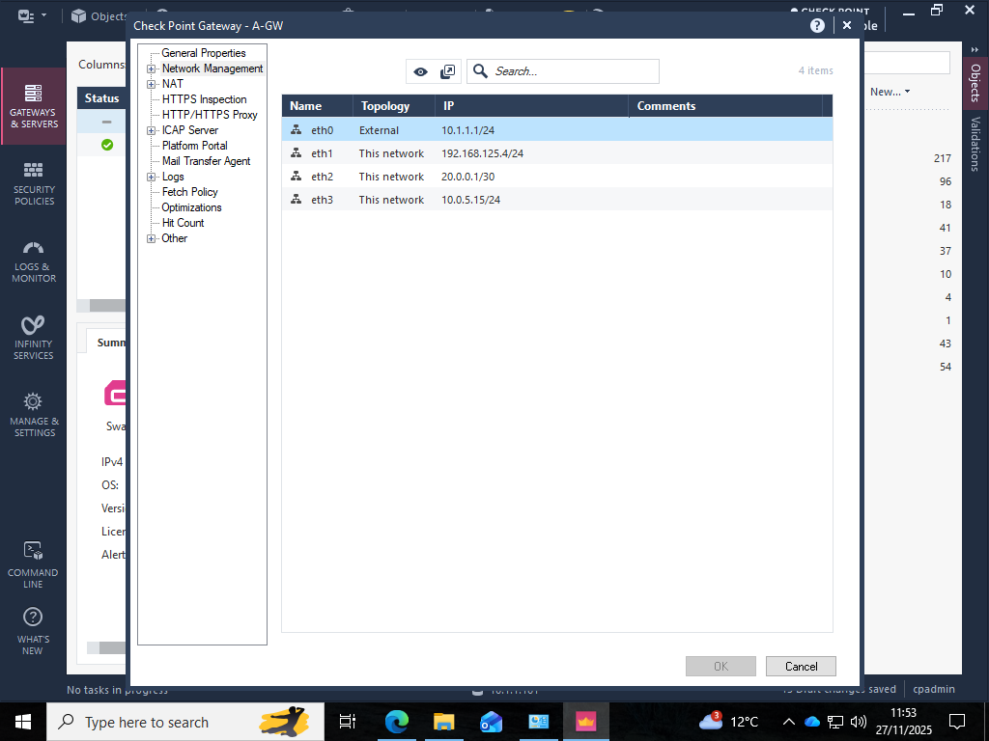
Figure 32 SIC Wizard retrieving gateway topology and interface mappings across eth0–eth3.

The SmartConsole can use this topology information to verify directionality of traffic and implement segmentation of internal, DMZ and external networks. The following was the mapping to be used in this deployment: eth0 was identified as an External interface with internal interfaces being mapped to local enterprise networks to aid in policy enforcement:
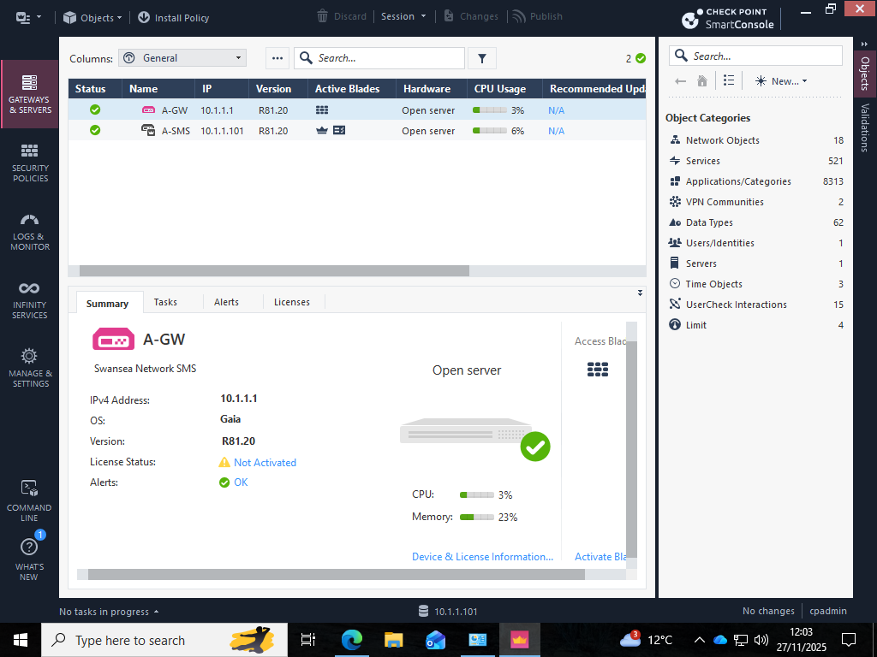
Figure 33 Gateway topology view classifying eth0 as External and eth1/eth2/eth3 as Internal for anti-spoofing enforcement.
In Gaia, topology awareness is a significant position on security matters. Anti-spoofing protection makes use of the understanding of limits of networks to ensure that adversaries do not inject traffic that is believed to belong to trusted internal subnets. This is consistent with the segmentation techniques in the modern enterprise architecture which reduce the movement of lateral flows and the escalation of privileges within the network environments.

The Gateways and Servers panel of SmartConsole confirmed that A-GW was now fully under management. The system became familiar with the Gaia OS build, the IPv4 addressing and allowed blades, such as firewall and NAT:
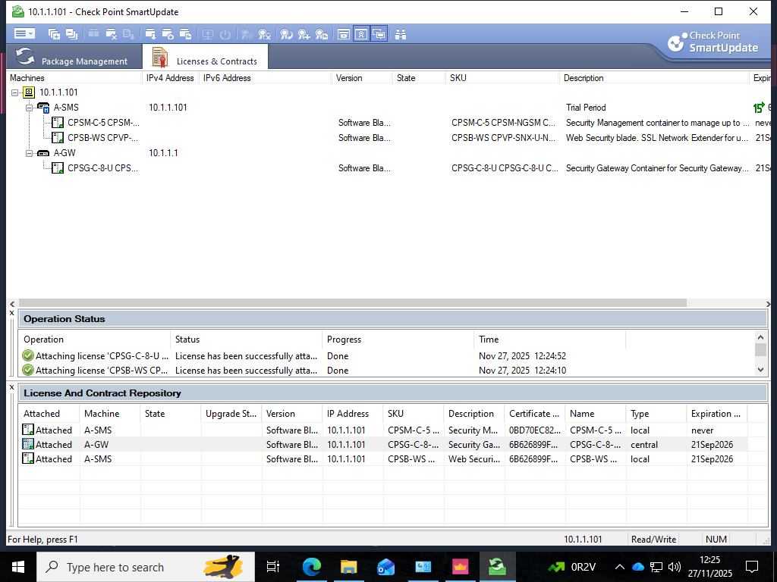
Figure 34 Gateways & Servers summary confirming A-GW status, Gaia R81.20 version, IPv4 (10.1.1.1) and blade configuration.

2.7 Licensing and Contract Management
The issue of licensing is a highly important operation imperative in the deployment of security Appliances to make sure that the installed blades, monitoring capabilities, and administration capabilities are in line with the contracts with the vendor. The trial licenses were applied to A-SMS as well as A-GW through SmartUpdate which provided management-plane and enforcement-plane services during the period in which the assessment was conducted:
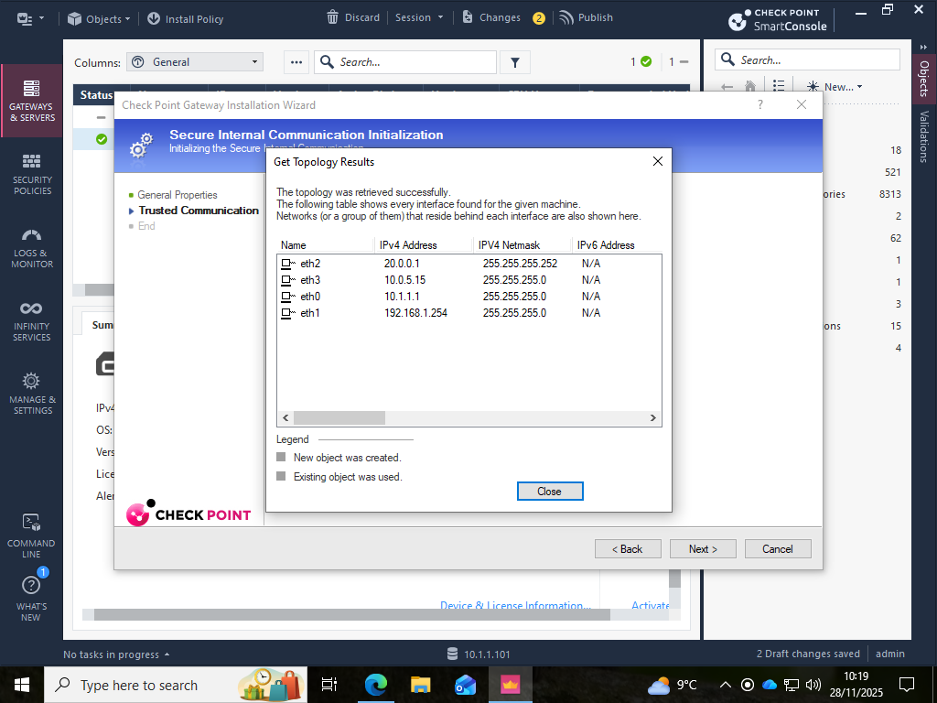
Figure 35 License & Contracts panel confirming trial licenses for A-SMS and A-GW and blade entitlements.
One of the explicit requirements in the assessment brief is licensing confirmation, which shows compliance with enterprise deployment practices, in which compliance validation is a subset of operational readiness procedures prior to policy implementation.

2.8 Topology Retrieval and Anti-Spoofing Enforcement
Having refreshed the topology mapping between A-GW through licensing, SmartConsole did it to make sure that the routing domains and subnets at interface level were aligned with the underlying network design. The network objects that are related to internal, external and DMZ segments were updated during this process of retrieval:
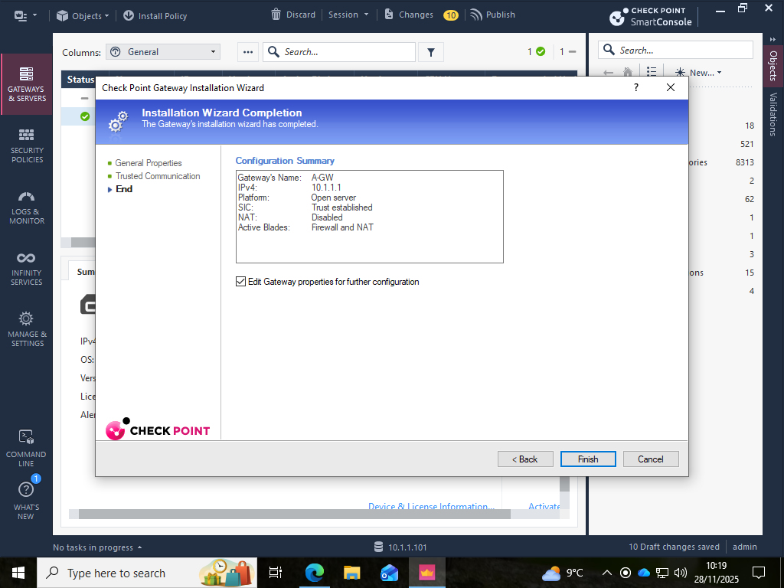
Figure 36 Updated SIC topology showing routed subnets and network objects post-licensing and trust configuration.

2.9 Inbound and Outbound Security Policy Enforcement
The next step was to define and enforce firewall policies to control the inter-zone traffic flows after the management and enforcement planes were licensed and operational. The assessment brief involved the showing and the explanation of the inbound and outbound rules of various categories of protocols such as ICMP, FTP, HTTP, Telnet and SSH. These services are typical diagnostic, administrative and application-layer traffic types in enterprise settings and were used as demonstrators of how to move away a permissive principle model to a regulated traffic governance framework.
The design of the policy was guided by a few principles to make sure the rulebase was based on modern expectations of the enterprises. First, the principle of least privilege limited allowances to the services that are explicitly needed. Second, there was a default-deny policy that prevented the implicit trust of traffic that was not requested. Third, zone and role awareness distinguished between external clients, internal host and management systems. Fourth, administrative services like SSH and Telnet were less liberal than diagnostic services like ICMP. Fifth, logging was incorporated to facilitate the reconstruction, compliance and incident response work. These values are consistent with existing security guidelines and literature on micro-segmentation, reduction in transverse communication routes and identity-conscientious service publix.
The inbound rules were used to control the flows directed by the untrusted or less trusted zone, which is usually the external network, to DMZ or internal assets via the gateway. Service-specific rules enabled ICMP to enable diagnostics, HTTP/HTTPS when service hosting was mandatory, and SSH to enable manageable administrative access. All cleartext protocols like Telnet and FTP were prohibited or restricted because they are dangerous protocols and may be exploited since they are not cryptographically secured. Placement of rules was based on Check Point top-down evaluation semantics, in which inbound allowances were placed before default drop policy and unnecessary services explicitly rejected to render it clear and testable.
Outbound rules controlled traffic initiated by a host that was exiting the enterprise perimeter. Outbound directionality which was historically handled liberally in legacy networks is now understood to be a significant security risk of data exfiltration, command-and-control beaconing, malware proliferation and supply-chain compromise. As a result, outbound policies were established on the ICMP, HTTP/HTTPS, FTP and SSH to maintain operational usefulness and regulate administrative journeys. Outbound Telnet was blocked to demonstrate the current hardening requirements and to deter the usage of the vulnerable services.
Both functional routability and security objectives were supported by NAT policy considerations. Outbound traffic was covered by Hide NAT to mask internal addressing and restrict reconnaissance, and Static NAT and No-NAT could be used in cases of DMZ exposure that is common in small enterprise deployment. The decoupling of NAT and access control policies in SmartConsole also made the process of troubleshooting more efficient and the maintenance of policies.
The rulebase was relayed between the management server and the gateway using policy installation, authenticating SIC trust, version compatibility and compilation. Test checks revealed that ICMP was working both ways, SSH had been allowed out and limited inbound, HTTP had been allowed to access external websites, FTP had been scoped or limited according to the security posture and Telnet had been denied. The combined demonstration met the assessment requirement by fulfilling the functional correctness and also the policy justification in the control of inbound and outbound services.

2.10 Additional Security Features Using Gaia Appliances
In addition to the basic firewall and NAT facilities, the implementation included a number of other Gaia security services that are in line with assessment requirements and current enterprise practice. Implicitly, topology-sensitive anti-spoofing enforcement was possible as soon as SmartConsole recovered gateway interfaces, where the source addresses could be verified using the predicted network boundaries. This avoided the introduction of packets by adversaries that spoofed the internal traffic and offered basic segmentation control.
Another highly important feature was time synchronisation using external NTP services. Time accurate certificate validation, fidelity logging, policy versioning and the event correlation forensics across SIEM environments. Time distortion has negative effects on the integrity of the investigation and it may alter the reconstruction of the timelines of the events that happened after the incident.
Administrative separation was aided by special user cpadmin, implying the principles of the least-privileges, and allowing the security policies to be managed without an unlimited access to the system. Although fully integrating with Identity Awareness and directory services was out of scope of assessment, the deployment architecture aligned with the models of enterprise usage and can be extended in the future to identity-centric access control.
Recording and tracking was another form of security improvement. Gaia offers granular observability in the form of logs, telemetry and policy compliance reports. The observability is essential in the contemporary threat landscapes because it facilitates detection engineering, incident response and ongoing policy-effectiveness assurance.
The NAT plan helped to minimise exposure through obfuscation of internal addressing designs, minimisation of reconnaissance vectors and assistance in publication of controlled DMZ Static NAT where needed. Lastly, other developed features were also contemplated to be adopted by the enterprise, such as IPS, URL filtering, anti-bot, HTTPS inspections, SIEM integration and identity knowledge. Although these capabilities have not been realized because of the limitations of the assessment, that they exist shows that Gaia is extensible towards unified security management and layered defence.

PART 3 - Evaluation, Critical Reflection & Research Integration
The implementation of Check Point Gaia R81.20 showed quantifiable security enhancements compared to the baseline topology through the use of a centralised plane of policy management and independent plane of enforcement. This isolation allowed uniform and auditable application of security rules, as this is an industry transition to move away from device-specific device firewalling to a policy-based architecture. It was demonstrated and tested that Gaia was able to support least-privilege security principles without compromising core network services such as DNS, DHCP, VPN, web hosting and domain membership. The enforcement plane was open to operations that were legitimate and restricted to those that were insecure, which is consistent with the modern best practice of outbound and inbound control.
Technical decisions during the deployment were in line with practical enterprise logic. The A-SMS and A-GW separation reflected the operational trends within the mid-sized environment of the public sector in which the blast radiuses and administrative levels are strictly regulated. Addressing permanence aided in stability, routing compatibility and traceability, clustering and SIEM correlation showed that addressing cannot be ephemeral in the production firewall environment. Time synchronisation choices, though apparently unimportant, maintained fidelity of logging, allowed certificate trust and forensic interpretability, and the relevance of proper time domains in security activities is emphasized.
The modern research and literature in the industry focus on unified policy management, segmentation, and identity-conscious implementation as the central design motifs. The model of architecture and the blade of Gaia fits into these patterns, and the unified management has taken care of the policy centralisation, topology and anti-spoofing strengthening segmentation, and Identity Awareness and Application Control enhances identity-centric policy development. NIST guidelines also propose segmentation, auditability and role separation as some of the fundamental firewall controls.
There were a number of missing features that limited the representativeness of the deployment to reflect enterprise practice, including the lack of advanced threat-prevention blades, identity-aware policy enforcement and clustered high-availability. These exclusions were to do with scope of assessment and not architectural constraints. In general, the exercise led to professional learning because it demonstrated that network security cannot be considered without trust modelling, observability and operational workflow integration, and that appropriate security cannot be implemented reactively without being co-designed with functionality.

Conclusion
Implementation and hardening of the enterprise network in Part 1 and Part 2 of this assessment showing the shift of an environment that was functionally complete but relatively permissive to one that was characterised by centralised control, segmented trust boundaries and the existence of policy highly illustrated the change. Part 1 confirmed that the distributed enterprise topology and its core services - DNS, Active Directory, VPN, DHCP and IIS, worked inter-site like a seamless environment, which is realistic in terms of a multi-domain organisational setting. The Capture-the- Flag exercise proved the operational dependencies of the two services and the criticality of proper configuration before the establishment of security controls.
Part 2 changed to focus on single security management by implementing Check Point Gaia appliances and SmartConsole orchestration environment. With the introduction of A-SMS and A-GW the control and the enforcement planes were formally separated, making available certificate-based trust (SIC), topology-aware anti-spoofing, NAT exposure control, and least-privilege inbound and outbound firewall rules. A more defensible and auditable architecture that met the current standards of enterprise security was achieved through licensing, role separation, time synchronisation and administrative controls.
Considering the practical and academic aspects of the task, the review depicted the aspects of security being not additive but architectural. Auditability, forensic reconstruction and operational resilience have consequences of decisions like static addressing, segmentation, topology mapping and logging. IPS, Identity Awareness, or Threat Emulation, the more advanced blades were not fully used but their presence demonstrates how extensively Gaia can be used in production. Future improvement opportunities - including clustered high availability, identity-aware policy enforcement, and SIEM integration - point to the way enterprise deployments become more mature as time progresses.
Altogether, the evaluation supported the technical and conceptual aspects of the current network security, and showed that successful defence is not only achieved through the functional controls but also through the consistent design, sound policies, as well as the opportunity to justify and defend such choices in the professional environment, through questioning.

Reference List
Basta, N., Ikram, M. and Kaafar, M.A. (2021) ‘Towards a Zero-Trust Micro-Segmentation Network Security Strategy: An Evaluation Framework’, arXiv, 22 November. Available at: https://arxiv.org/abs/2111.10967 (Accessed: 14 January 2026).
Check Point (2020–2025) Firewall Best Practices for Network Security. Available at: https://www.checkpoint.com/cyber-hub/network-security/what-is-firewall/8-firewall-best-practices-for-securing-the-network/ (Accessed: 14 January 2026).
Check Point Software Technologies (2025) Check Point R81.20 Security Management Administration Guide. Available at: https://sc1.checkpoint.com/documents/R81/WebAdminGuides/EN/CP_R81_SecurityManagement_AdminGuide/Default.htm (Accessed: 14 January 2026).
Check Point Software Technologies (2025) Check Point R81.20 SmartConsole and Management Documentation. Available at: https://sc1.checkpoint.com/documents/R81.20/WebAdminGuides/EN/CP_R81.20_Multi-DomainSecurityManagement_AdminGuide/CP_R81.20_MultiDomainSecurityManagement_AdminGuide.pdf (Accessed: 14 January 2026).
Check Point Software Technologies (2025) SmartConsole Downloads and Build Guidance (R81.20). Available at: https://sc1.checkpoint.com/documents/Jumbo_HFA/R81.20_SC/R81.20/R81.20_Downloads.htm (Accessed: 14 January 2026).
Clearnetwork.com (2025) Firewall Security Management Best Practices for Enterprises. Available at: https://clearnetwork.com/firewall-security-management-best-practices/ (Accessed: 14 January 2026).
ENISA (2023) ENISA Threat Landscape 2023. European Union Agency for Cybersecurity. Available at: https://www.enisa.europa.eu/publications/enisa-threat-landscape-2023 (Accessed: 14 January 2026).
Hasan, M. (2024) ‘Enhancing Enterprise Security with Zero Trust Architecture’, arXiv, 23 October. Available at: https://arxiv.org/abs/2410.18291 (Accessed: 18 January 2026).
MITRE (2026) ATT&CK® Enterprise Matrix. Available at: https://attack.mitre.org (Accessed: 14 January 2026).
NIST (2009) NIST Special Publication 800-41 Revision 1: Guidelines on Firewalls and Firewall Policy, National Institute of Standards and Technology. Available at: https://csrc.nist.gov/pubs/sp/800/41/r1/final (Accessed: 14 January 2026).
NIST (2022) NIST Special Publication 800-215: Guide to Cybersecurity Engineering, National Institute of Standards and Technology. Available at: https://www.nist.gov/publications/guide-cybersecurity-engineering (Accessed: 14 January 2026).
RFC Editor (2021) RFC 2993: Architectural Considerations in NAT Deployment. Available at: https://www.rfc-editor.org/rfc/rfc2993 (Accessed: 14 January 2026).
Yousefi-Azar, M., Kaafar, M.-A. and Walker, A. (2020) ‘Unsupervised Learning for Security of Enterprise Networks by Micro-Segmentation’, arXiv, 25 March. Available at: https://arxiv.org/abs/2003.11231 (Accessed: 14 January 2026).

