DS 1 Template

My Screenshots/Photos
- Please add 4–6 screenshots or photos of your digital life.
- You can use your phone or laptop.
- For each screenshot, write one or two sentences explaining what it shows.

Screenshot/Photo 1
Outlook calendar
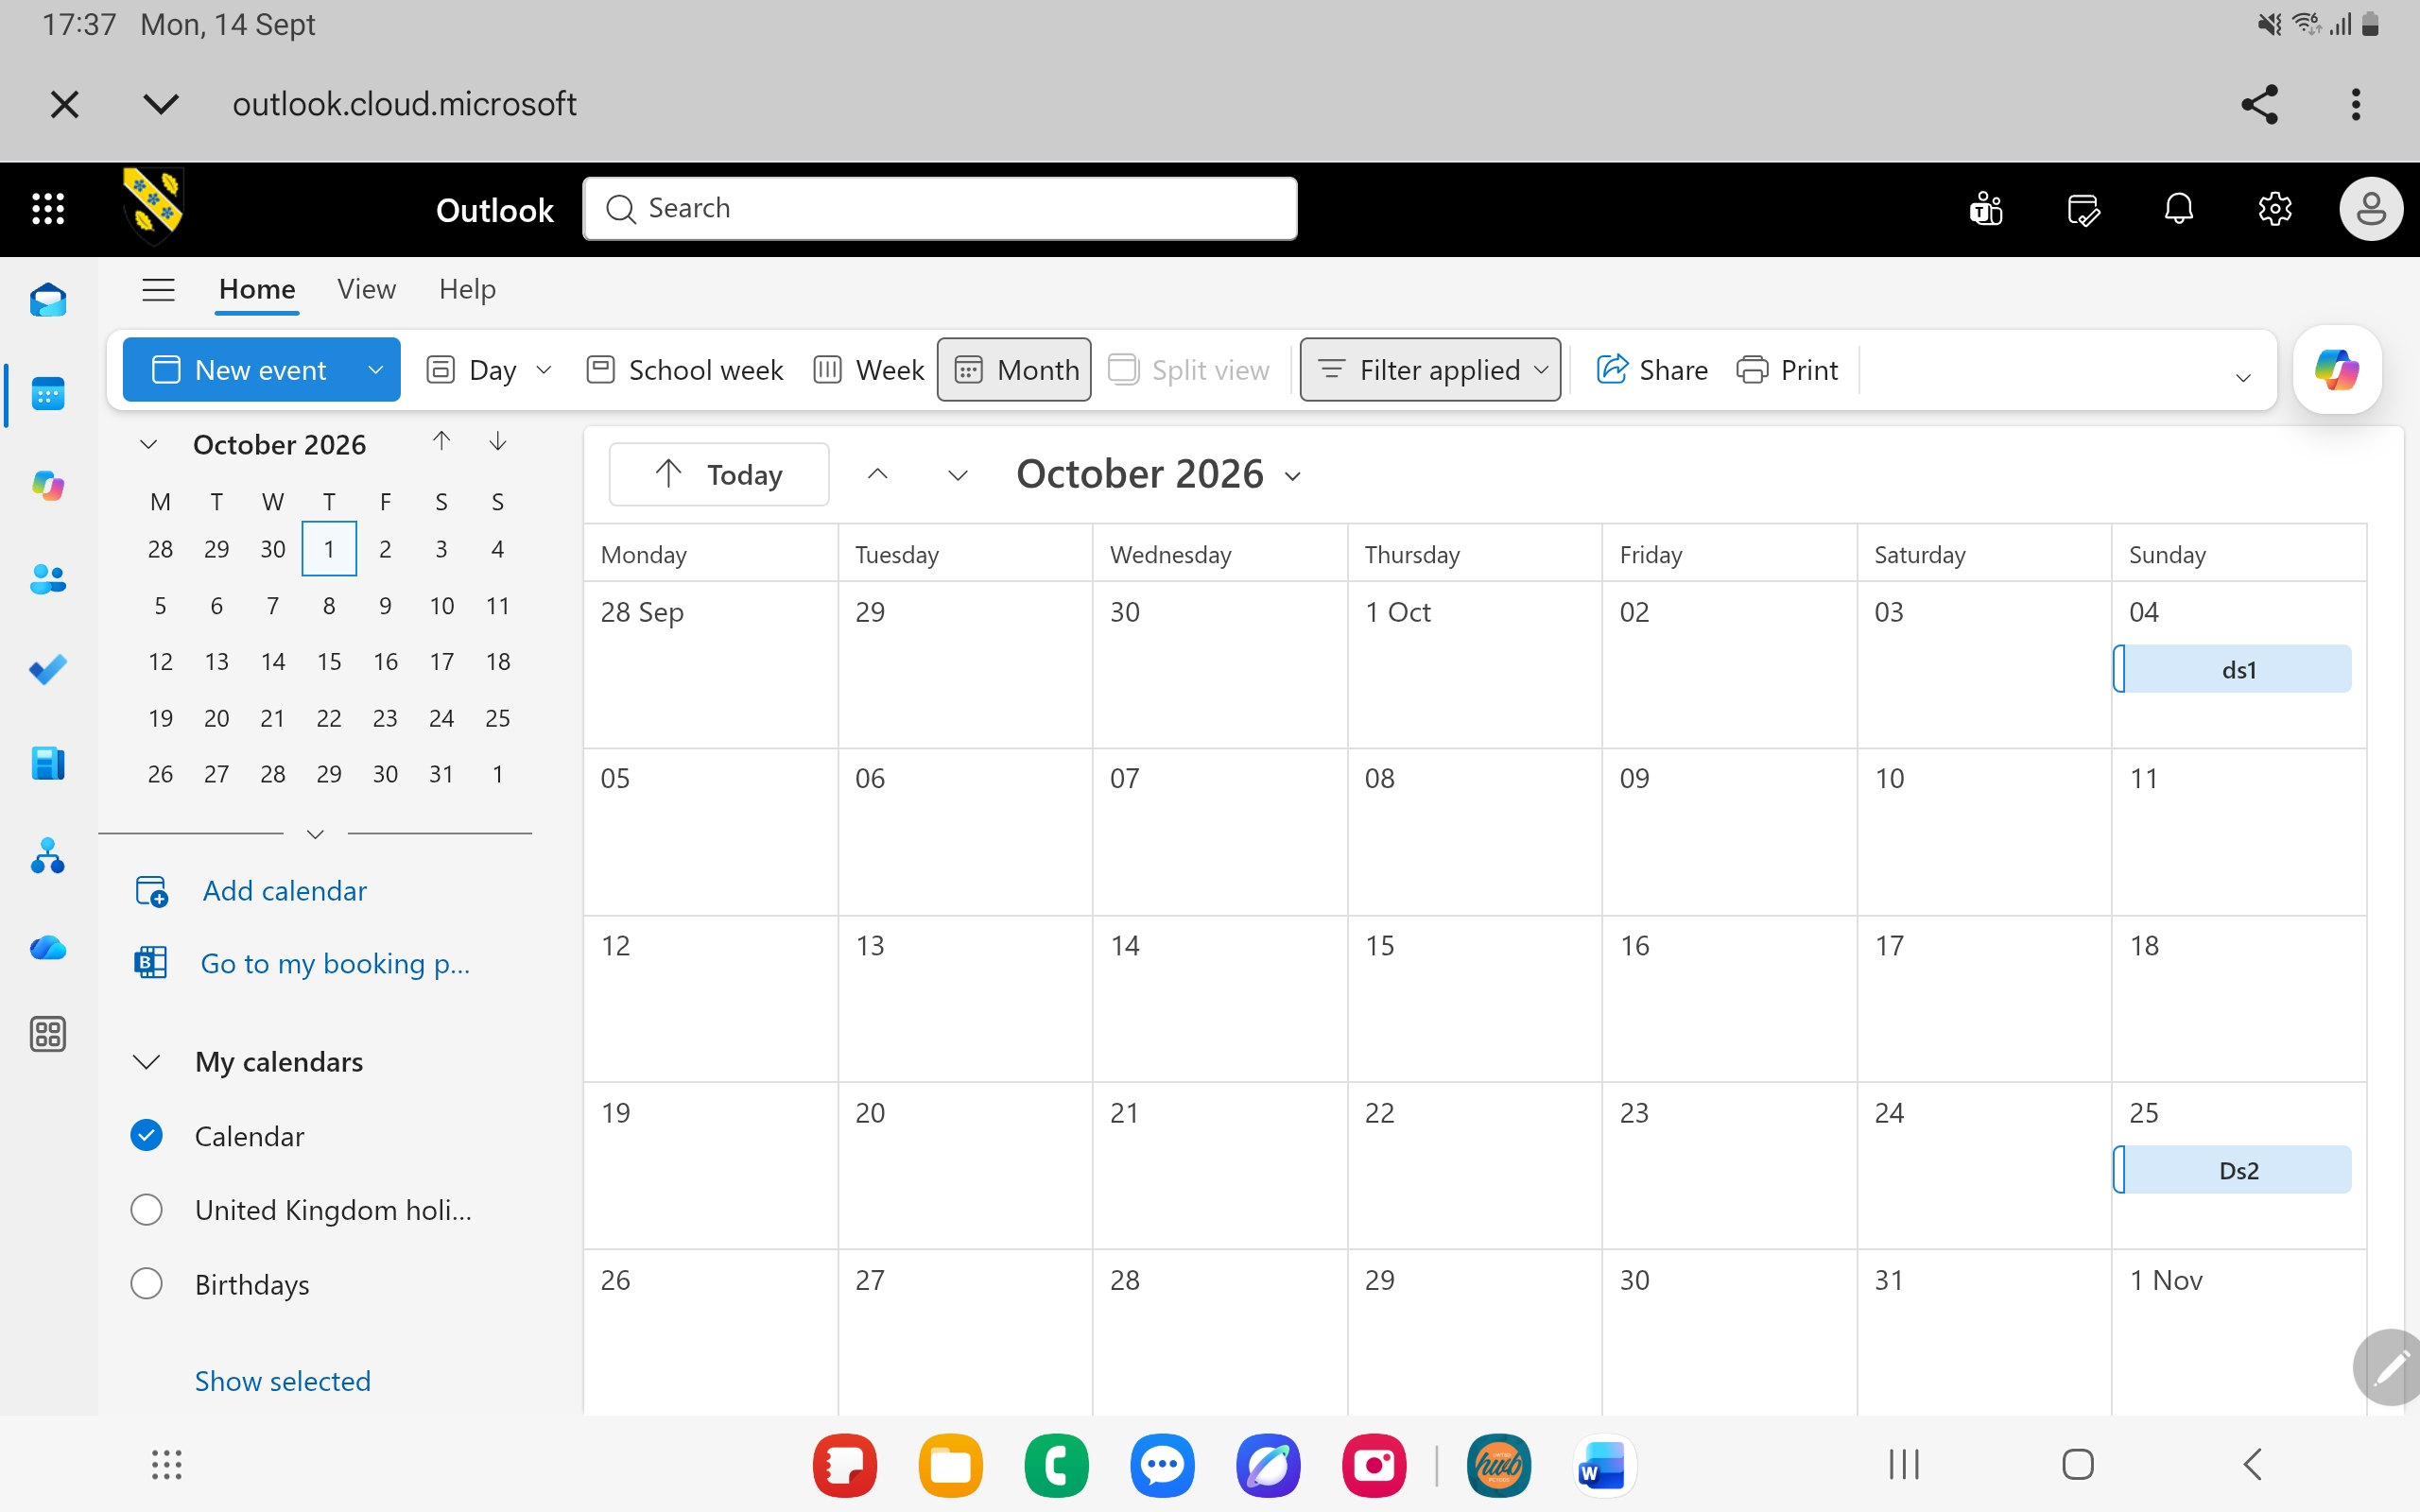
I use Outlook Calendar to organise appointments and bookings for my customers. It helps me manage my schedule efficiently, keep track of important dates and deadlines, and ensure that I do not miss any meetings or commitments.

Screenshot/Photo 2
One drive
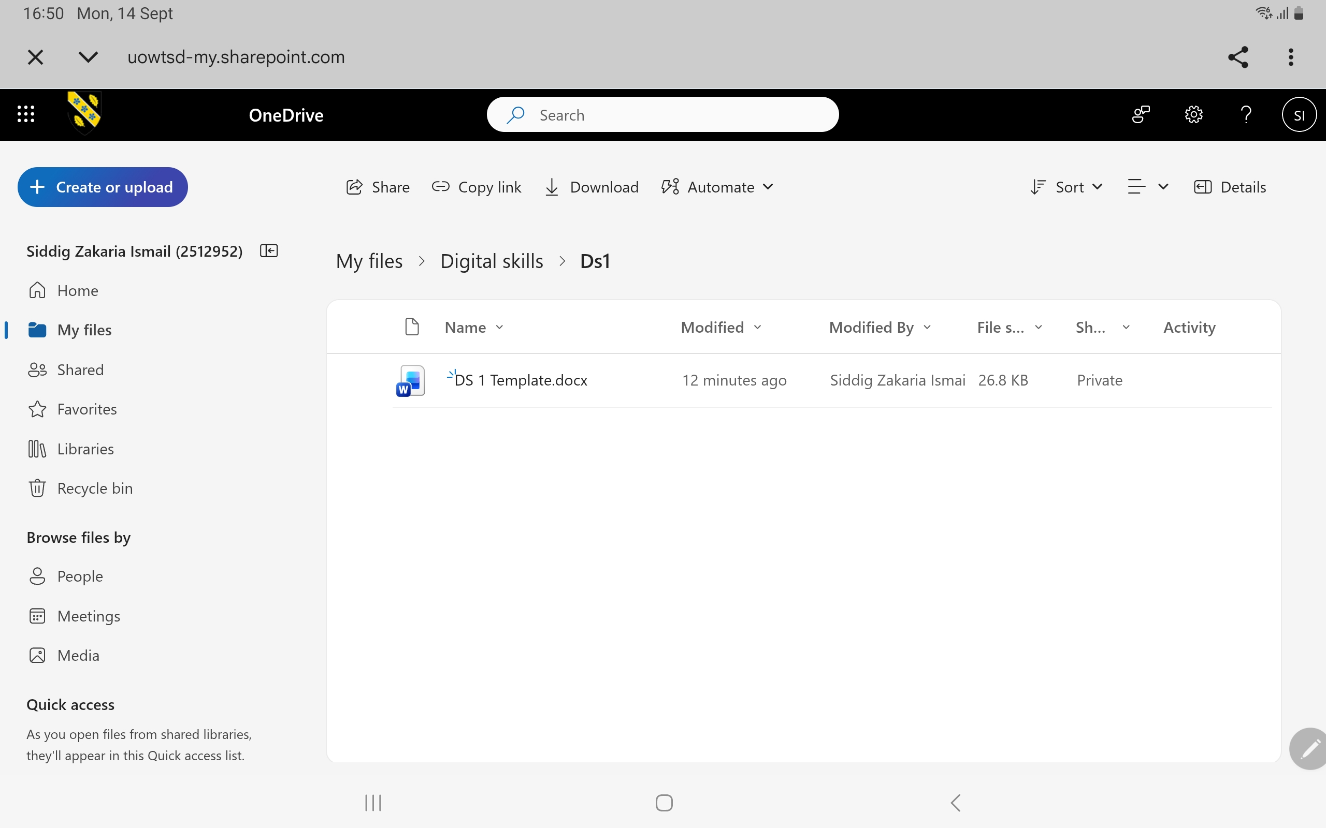
I use OneDrive to save and organize my important documents, university work, and personal files. It allows me to access my files from different devices, keep them secure, and ensure that my work is backed up and available whenever I need it.

Screenshot/Photo 3
LinkedIn
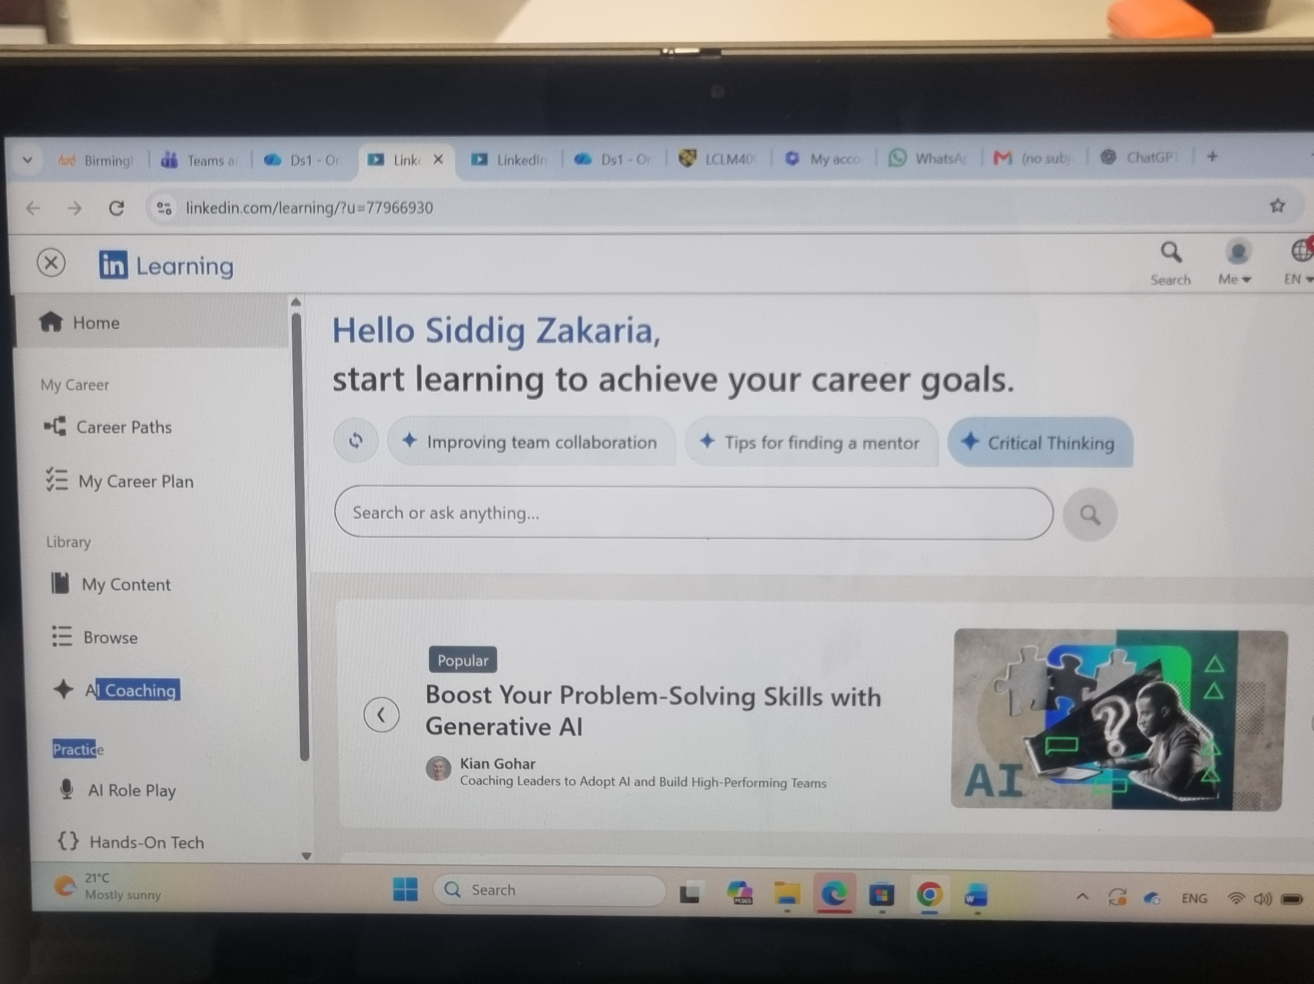
I use LinkedIn to build my professional network, connect with other students and professionals, and learn about career opportunities. It helps me develop my employability skills and stay informed about industry trends.

Screenshot/Photo 4
Just Park
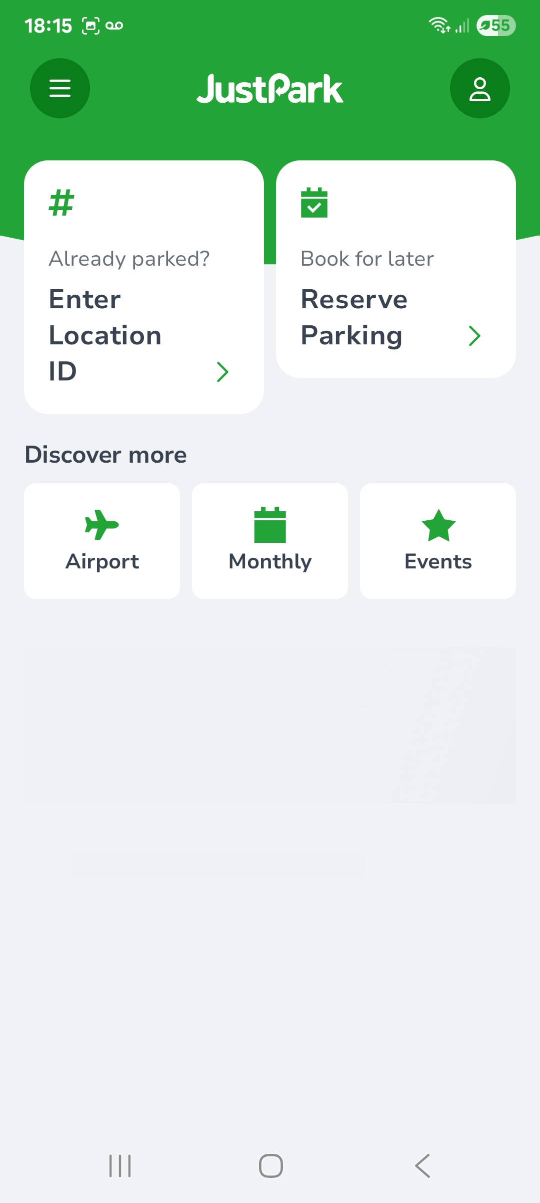
I use Just Park to find the best parking offers and reserve a parking space before arriving at my university. This helps me save time, plan my journey more efficiently, and ensure I have a convenient place to park before attending my classes.

Screenshot/Photo 5
Uber app

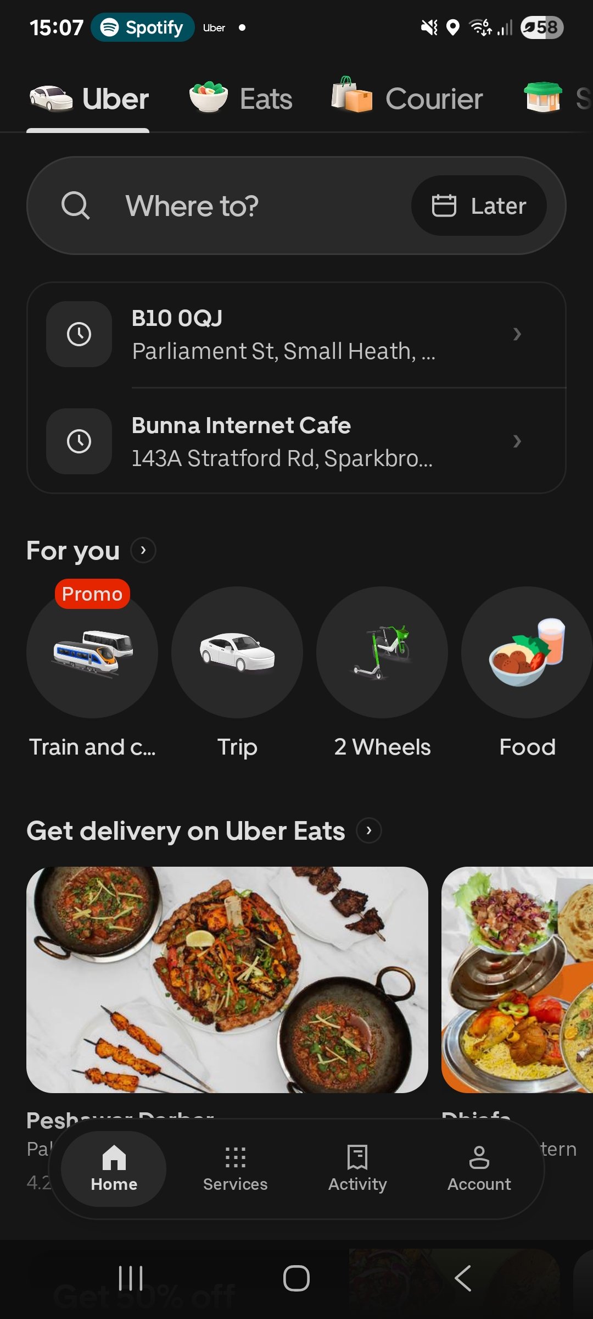
I use the Uber platform to book taxi rides for travel to my university classes. I also work as an Uber driver and use the platform to provide transportation services to customers

Screenshot/Photo 6
Instagram
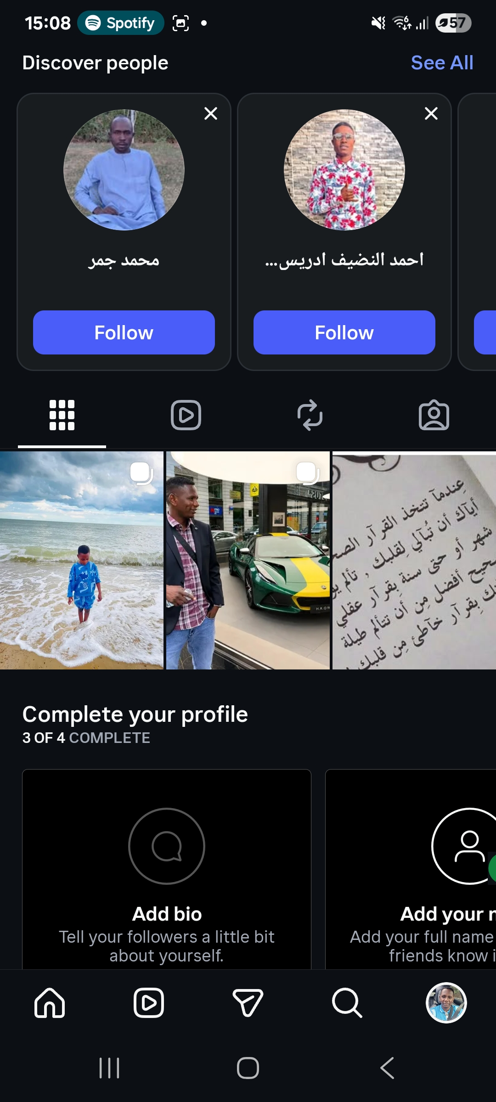
I mainly use Instagram to keep in touch with my friends, stay connected with them, and share aspects of my social life.

My Short Reflection
- Write 5–8 simple sentences about your digital life.
- You can use the sentence starters below if helpful.
- I use digital tools every day for my work. They are used to communicate with customers, to book them and organize my work.
- Digital skills are essential to me because they help me in my studies and work. They also help me manage my business.
- I often use my smartphone for different tasks. I also use Google Maps, email, and online booking systems.
- I feel confident when I use digital tools for my daily activities.
- I want to improve my digital skills and learn more about computers and technology. I also want to learn more about online safety.
- I sometimes feel nervous about using new computer applications. I also need more confidence when completing university assignments.

Submission Checklist
Before you submit, please check:
​​​ ☐ I added 4–6 screenshots
☐ I wrote short sentences for each screenshot
☐ I wrote my short reflection
☐ My work is my own
☐ My file opens correctly
​​☐ My file opens correctly

