Appendix 1
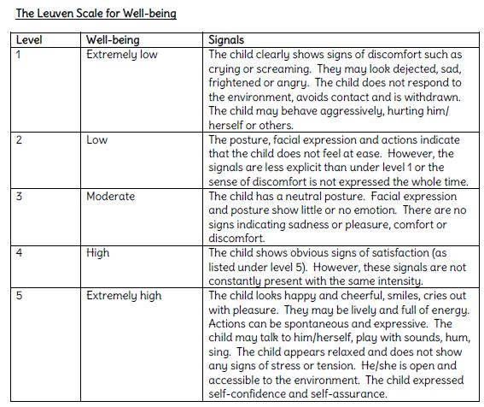

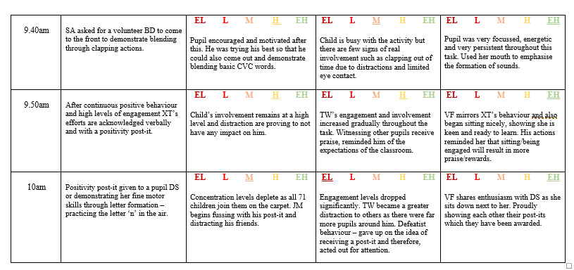
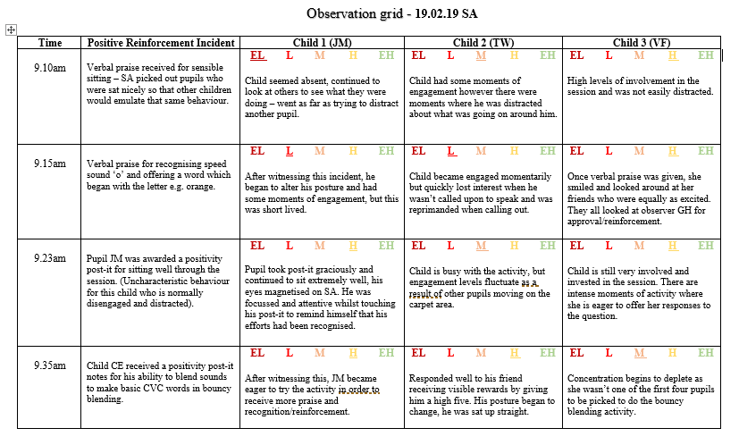
Appendix 2- SA observation notes

Appendix 3- SA interview transcript
Interview 1 transcript
19.02.19 – 9.10-10.10AM

Prior to the interview, pupils were informed that the conversation would be audio recorded, they were asked if they were happy to take part and were told that they could stop at any time.
SA: Right OK, so were just going to have a discussion OK? just about the phonics lesson we’ve just had. Are you okay to do that?

[All three pupils nodded]

SA: Yeah? Do you think you can do that for me?
C1: Yeah!
[C2 and C3 nodded again]

SA: OK. the first question is, did you enjoy the lesson?
C3: Yeah! I did.
SA: Did you have fun in the lesson?
C3: Yeah!
C2: Yes!
C1: YEAH!
SA: Did you have fun doing phonics today?
C3: Yeah I did. I had fun.
SA: What did you like? Tell me what you like?
C2: Ummmmm... [pause]
C1: I liked it with the letters. Doing them.
C2: [pause] I do like the letters too.

C3: I like doing the phonics and making the sounds.
SA: Why do you think I used the post-its?
C3: Because we done really well!
SA: Why do you think I used the post-its? (questions directed to Child 1).
C1: Umm [pause], because we were being good at doing it.
SA: Doing what?
C1: Doing our letters.
SA: OK. How did it make you feel when I used the post-its in the lesson? How did it make you feel when I gave you one?
C1: Happy!
C3: Really really happy!
SA: How did it make you feel? (directed at child number 2). I know you didn’t get one but how did you feel?
C2: Ummmmmmmmm... [pause]
SA: Did you want one?
C2: Umm... [pause] yeah. I wanted a posity post-it.
SA: So what did you think you needed to do to get a post-it? What did you have to do?
C2: Be really good!
C1: Be very good!
C3: And senstible!
SA: And sensible?
SA: What else did you have to do, do you think?
C2: Be dood and be kind.
C1: Be very kind.
C3: You have to cross your legs, arms folded and, and fingers on your nose.
C2: [laughed] No, lips! On your lips not your nose.
SA: On your lips! Ok.

SA: So you know when you saw other people get a post-it, how did it make you feel?
C2: Happy!
SA: You felt happy that other people got a post-it?
C2: Yeah. No. I don’t know (some confusion). It made me happy because I want one.
SA: (directed at child 1) Did you get a post it today?
C1: Yeah! I got one [pointed at post-it on shirt]
SA: How did it make you feel?
C1: Happy. Very happy! Because I did good letters.
SA: What did you have to do for me to give you a post-it?
C1: Sit nicely and put our thumbs on our lips.
SA: Do you think it made you work harder when you got a post-it?
C1: Yes, because I worked hard!
C3: Yeah, because we might get more!

Interview terminated. Pupils were thanked for their participation and were asked to go back to class.

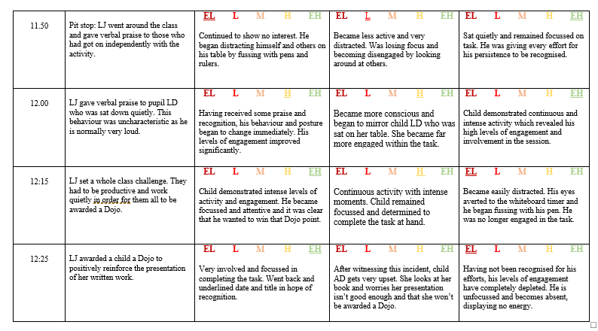
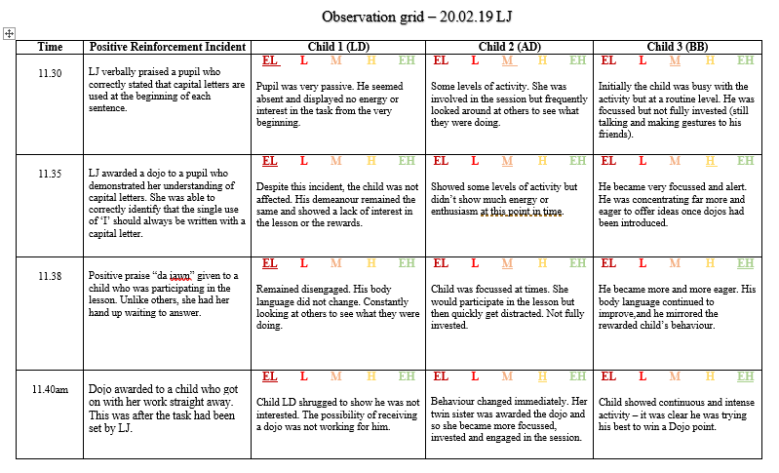
Appendix 4 -LJ observation notes.

Appendix 5- LJ interview transcript
Interview 2 transcript
20.02.19 – 11.30-12.30PM
Prior to the interview, pupils were informed that the conversation would be audio recorded, they were asked if they were happy to take part and were told that they could stop at any time.

LJ: Right, how do you think the lesson went today?
C3: Good.
LJ: Did you enjoy?
C3: Yeah!
LJ: How did you think it went?
C1: Ummm… [pause] it was fun, but it was a bit hard.
LJ: OK. Did you enjoy?
C1: Yeah!
C2: Yeah, it was hard.
LJ: So… [pause] can you answer me this. Why do you think I used dojos in the classroom?
C3: To tell who is working hard and who’s not.
LJ: Well done!
C1: To make us work harder so maybe we can get one.
C2: They’re fun!

[all pupils laughed]

C1: [laughs] That’s why you’ve got 78 of them.
LJ: How do you feel about me using dojos in the classroom?
C3: It’s a reward for what we’ve done.
C1: Good because umm… [pause] makes you feel proud?

C2: I don’t like doing dojos or giving them to my sister.
LJ: OK. But do you like dojos?
C2: Yes!
LJ: So how does it make you feel when you get a dojo?
C2: Good!
C3: Good because I feel like I’ve got rewarded, in a good way.
LJ: What do you think you got rewarded for?
C3: Cause I earned a dojo for working hard.
C1: I feel proud of myself?
C2: It’s amazing!
LJ: Right. How do you feel when other people in the class get dojos and you don’t?
C1: It’s a bit harsh.
C3: I… [pause] feel mad. Because I feel left out.
LJ: Does it make you feel a bit upset or… [pause]
C1: It’s like the same but, I feel the same [pause] but it’s not you getting the reward.
C2: I don’t like it [pause] because it’s not fair!
LJ: It’s not fair? But what if they are working good?
C2: Give them less dojos.
LJ: Why? Because you want to win?
C2: Yeah [laughs]
LJ: What do you think you need to do in order for me to give you a dojo?
C3: Work hard all the time. And make sure you finish your work on time.
C1: Ummmm… [pause] do neat handwriting and do everything correct.
C2: Try hard at everything you do!
LJ: Da iawn!

Interview terminated. Pupils were thanked for their participation and were asked to go back to class.
Appendix 6 – GH observation notes.
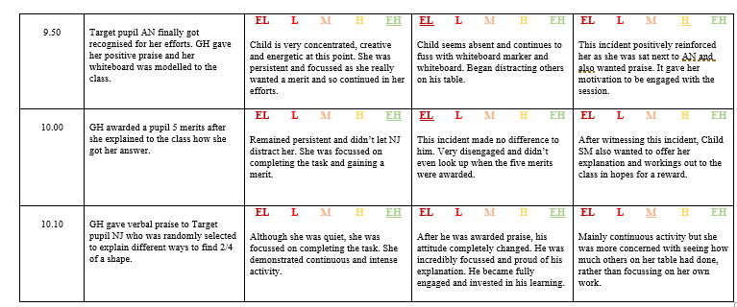
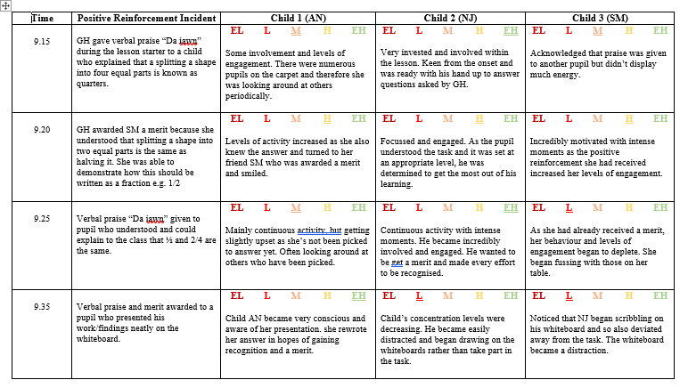

Appendix 7-GH interview transcript.
Interview 3 transcript
21.02.19 - 9.15-10.15AM
Prior to the interview, pupils were informed that the conversation would be audio recorded, they were asked if they were happy to take part and were told that they could stop at any time.

GH: So how do you think the lesson went today?
C3: Good!
C1: Good!
C2: Very well!
GH: OK. So why do you think that I used merits in the lesson?
C2: Because people are being good [pause] and you notice them.
C3: Because people are answering very good things and doing good work.
C1: Because… [long pause] Cause… [pause]
GH: Why, why do you think I used merits in the lesson? Why do you think?
C1: Because [pause] people are listening and being good?
GH: OK. So how does it make you feel when I use merits in the lesson?
C1: Very well!
GH: Makes you feel very well? OK.
C3: It makes me feel happy.
C1: It makes me feel amazed!
GH: OK. So, what do you think you need to do in my lessons to get a merit?
C2: Listen.
C3: Do good work!
C1: [whispered] Listen?
GH: OK! How does it make you feel when you get a merit off me?
C2: Energetic!

C3: Exciting!
C1: [whispers] Happy.
GH: OK. How does it make you feel when others in the class get merits?

[long pause]

C2: It makes me feel jealous.
C3: It makes me feel like I should say well done to them.
GH: OK. What about you?
C1: [shrugged] …
GH: How did it make you feel when I gave [points at C3] a merit?
C1: [long pause] Dunno
GH: Its OK. Its OK. Thank you for answering all of my questions.

Interview terminated. Pupils were thanked for their participation and were asked to go back to class.

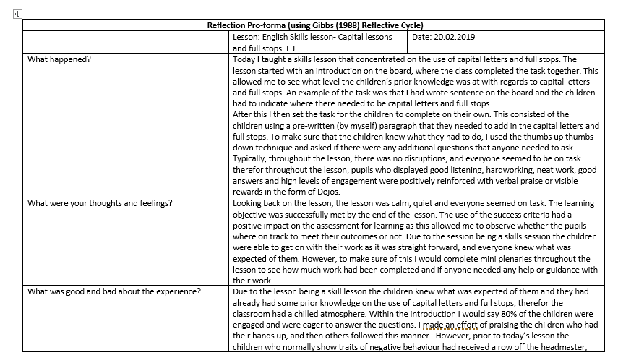
Appendix 8- LJ reflection


