

LEVEL 4 ASSESSMENT SPECIFICATION

Student name: | Anisah hasan | Student ID number: | 2508993
Programme: | Certificate of Higher Education Skills for the Workplace (Health & Social Care)
Module: | Introduction to Health and Social Care
Module code: | LCHS4003 | Contribution to Overall Module Assessment (%): | 50%
Lecturers: | Dr Helen Parsons (Module Lead) | Internal Verifier: | Dr Besty Jose
Assignment Title: | Written Assignment | Word count (or equivalent): | 1,500 words  (+/- 10%)
Submission deadline: | To be submitted via Turnitin by Friday, 24th July 2026, 10 am | Return date of provisional marks & written feedback: | 28th August 2026

Introduction
Safe and effective healthcare and social care require effective communication, record keeping and partnership working. All these are crucial especially when caring for complex patients like older adults. Mrs Thompson is an 84-year-old woman who has been discharged from the hospital following a case of pneumonia. She has mild dementia, does not take her medications as prescribed, experiences confusion spells and there are some safeguarding concerns with her. Mrs Thompson’s case brings out the challenges that have to be navigated in providing safe and person-centred care. This report will assess the importance of effective communication in the care of Mrs Thompson using the provisions of the Equality Act 2010 and Argyle's Communication Cycle. The report will also critically evaluate record keeping and information governance in relation to the Data Protection Act 2018. In addition, the report will analyse multidisciplinary teamwork, ways to improve partnership working and improve health outcomes for Mrs. Thompson.

The Importance of Effective Communication in Mrs Thompson's Care
Communication is crucial in ensuring safety in person-centered health and social care since it is through this that one will be able to evaluate needs effectively and build rapport with individuals as well as involving them in decision-making. According to the Nursing and Midwifery Council (2018), effective communication is among the responsibilities of health practitioners since they have to provide information in understandable ways. This is even more critical in the case of Mrs. Thompson who is an 84 year old lady suffering from dementia whereby issues such as concentration and memory impair her ability to comprehend complicated information. Poor communication may cause issues like medication administration errors, confusion, decreased independence and safeguarding risks.
Mrs Thompson’s communication needs to adhere to a person-centered approach. Even though she is suffering from dementia, Mrs Thompson deserves dignity, respect, and empathy and must be included in any decision-making process about her care as much as possible. Professionals need to tailor their communication by utilizing simple language, speaking slowly, looking at Mrs Thompson in the eyes and giving additional time for answering. Medication aids, medication schedule, and prompt cards are some examples that may prove helpful in teaching and administering medications. As per guidelines set by NICE (2022), the approach for communication should be customized based on the cognitive abilities of the patient.
It is equally critical that family members should be involved because they have knowledge about how Mrs. Thompson usually behaves. At the same time, it is necessary for professionals to respect Mrs. Thompson's consent to address any personal matters related to her. This should be done unless the patient is not capable of making decisions for herself. It follows from the Mental Capacity Act 2005 that all adults are considered mentally capable. This implies that all decisions made are in the best interest of the adult concerned.
The Equality Act 2010 also ensures effective communication through its protection against discrimination on grounds of age and disability. The condition of dementia of Mrs. Thompson does not mean that she cannot be involved in the conversation regarding her care. Reasonable adjustments need to be made including ensuring information is accessible, minimalizing distractions and communicating when she is in her most lucid state.
The Communication Cycle proposed by Argyle serves as an appropriate tool for understanding effective communication. It includes the formation of the idea, encoding and transmission of the message, reception and decoding, and feedback. For instance, while informing a patient about medication, the care worker should use clear language and request Mrs Thompson to repeat the directions in her own words. Any misunderstanding will require further adjustment of the information provided until understanding has been achieved. This is especially important for patients with dementia as it helps avoid medication mistakes and promotes safe practice. Communication between different professionals who provide health and social care services to a particular individual makes multidisciplinary work possible and facilitates early intervention and safeguarding.
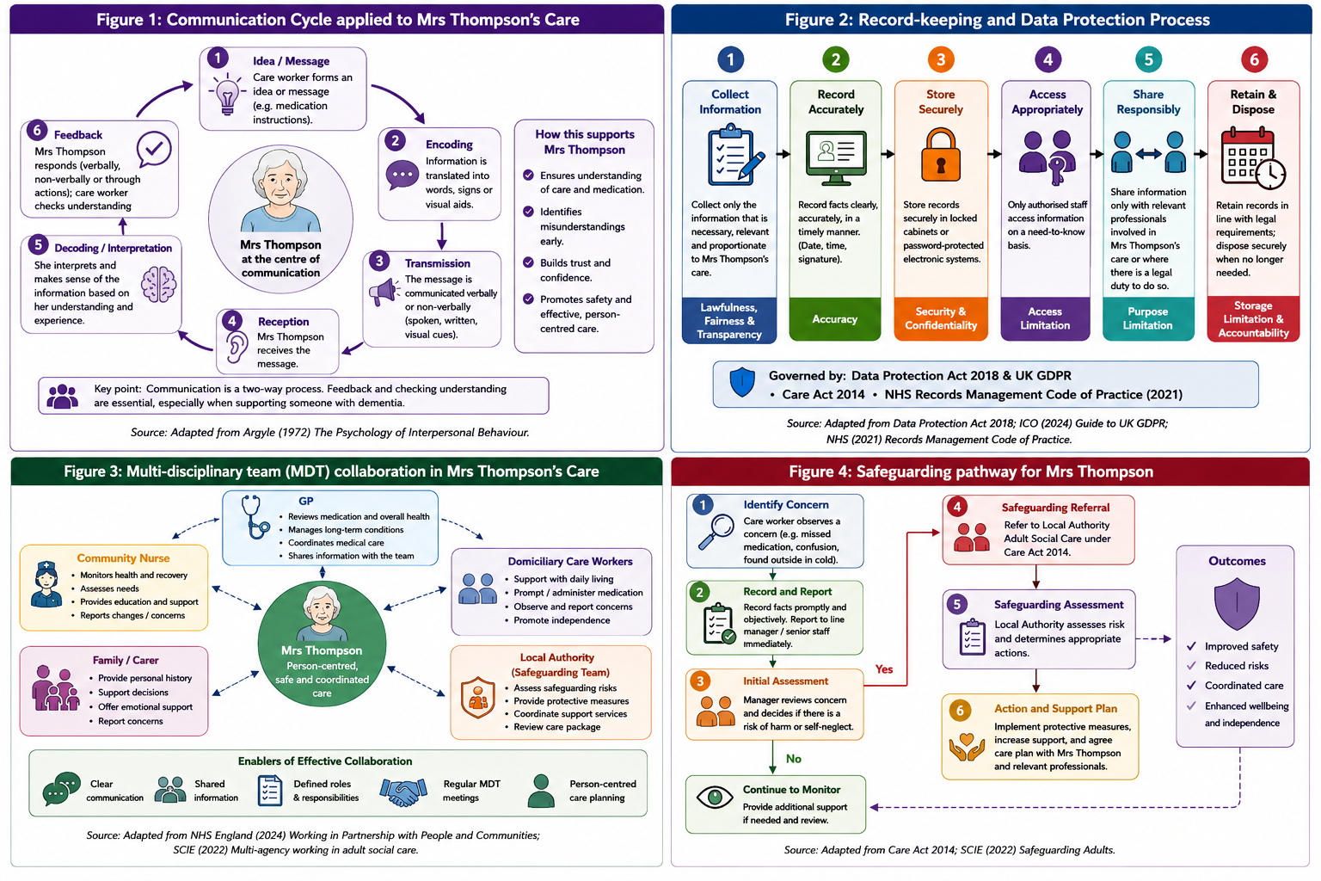
Figure 1: Communication Cycle to Effective Communication in Mrs Thompson's Care.

The Importance of Good Administrative Skills within Professional Practice in Mrs Thompson's Care
Proper administrative skills are vital in providing effective and accountable health and social care that is safe. This entails keeping proper records, confidentiality of information, reporting of incidents and proper exchange of information to facilitate continuity of care. Poor administration leads to medication errors, delay in treatment, failures in safeguarding patients and poor communication between professionals (NMC, 2018). In the case of Mrs Thompson who has missed her medication and is confused with episodes of unsafe behavior, proper administration is important to identify, record and communicate the risks involved.
Record keeping is both a professional duty and a legal one. According to the Nursing and Midwifery Council (2018), records must be clear, factual, accurate, and done immediately after the incident. In relation to Mrs Thompson missing her dose of medication, the domiciliary care worker must record the date when Mrs Thompson missed the medication and how she is feeling, what has been done, whom has been told about the situation, and what has been achieved. In the same way, the incident where Mrs Thompson is found outside in unsuitable attire must be recorded. Proper record keeping will ensure that good decisions are made and prevent future incidences.
The effective management of records becomes necessary because there are different professionals taking part in caring for Mrs Thompson. According to the NHS Record Management Code of Practice (Department of Health and Social Care, 2021), records should be precise, complete, available and managed effectively. Efficient electronic health records help in monitoring the changes in the patient's health status, reviewing the medicine administered to the patient and in delivering good quality of care (Care Quality Commission, 2023). Poorly managed records would lead to fragmentation of care, confusion and risks involved.
Data Protection Act 2018 and UK General Data Protection Regulation (GDPR) provide the legal guidelines for handling personal information. Personal data processing should be lawful and secure (Information Commissioner's Office, 2024). The data concerning Mrs. Thompson, such as medical records, the diagnosis of dementia, and the safeguarding information, are sensitive data and can be processed only by those who work with Mrs. Thompson.
While confidentiality is important, information needs to be shared if there is a need to prevent an individual from getting harmed. Information concerning Mrs Thompson with regard to her being unable to take her medicines and her confused behavior and wandering must be shared with the GP, community nurse and the safeguarding team. The Care Act 2014 also makes it a duty for the organisation to protect adults who are at risk of abuse or neglect. This is because good administrative abilities help enhance safety, compliance, coordination, and improved outcomes while ensuring that Mrs. Thompson receives safe, quality, and personalized care.
Figure 2: Record-Keeping and Data Protection Process within Health and Social Care Practice.

The Importance of Collaborative Working in Mrs Thompson's Care
Effective collaboration among workers is very important for health and social care because patients with complicated physical, psychological and social needs will have to receive help from various experts (Social Care Institute for Excellence, 2022). Collaboration across multiple disciplines ensures patient-centered services since it enables the exchange of information, coordination of actions and decision making leading to successful patient health outcome (NHS England, 2024). The recent discharge from the hospital, mild dementia, lack of adherence to medication administration and safeguarding issues faced by Mrs Thompson demonstrate that collaboration of professionals is required. Collaboration is important in reducing risks and improving her quality of life.
There are many professionals that look after Mrs Thompson. The GP checks her medications, looks after her physical well-being and modifies treatments when needed. The community nurse looks at her recovery from pneumonia, her cognitive function and educates her. The domiciliary care workers notice changes in her behavior and promote adherence to her medications since they have frequent contact with her. After the incident of her wandering, the local authority should conduct a safeguarding assessment under the Care Act 2014 to see if she needs any more help.
Figure 3: Multi-Disciplinary Team (MDT) Collaboration Supporting Mrs Thompson's Care.

Regular MDT meetings and efficient record-keeping and information sharing are required. The use of electronic records ensures that all authorized people have access to the same information. Methods such as SBAR will help in making sure that the information is effectively and accurately shared (Department of Health and Social Care, 2021). Moreover, involving Mrs Thompson and her relatives in care planning is useful for decision-making that is tailored according to her needs and preferences. Despite the presence of barriers, such as ineffective communication, incompatible systems, and unclear roles, it is possible to overcome the barriers and provide safer, coordinated, and high-quality care to Mrs Thompson.
Figure 4: Safeguarding Pathway for Mrs Thompson Following Identified Concerns.

Conclusion
In the case of Mrs Thompson, it is evident that safe and person-centered healthcare and social care services can be provided through effective communication, accurate administration and collaboration across a range of multidisciplinary team members. Effective communication, which is guided by the Equality Act 2010 and the Communication Cycle proposed by Argyle (NMC, 2018; NICE, 2022), allows health professionals to understand the needs of Mrs Thompson, involve her in the decision-making process and lower the risk associated with dementia and medication adherence. Accurate recording and information governance, which are provided in accordance with the Data Protection Act 2018 and the Code of Practice for Records Management in the NHS, will promote continuity of care, accountability and safeguarding (Department of Health and Social Care, 2021). Collaborative relationship among the GP, community nurse, domiciliary care workers, and local authority ensures coordination and timely intervention. All these principles together help to ensure that Mrs. Thompson will live safely and healthily, independently with high quality of life.

Reference List
Care Act 2014. (c.23). London: The Stationery Office. Available at: https://www.legislation.gov.uk/ukpga/2014/23/pdfs/ukpga_20140023_en.pdf (Accessed: 23 July 2026).
Care Quality Commission (2023) Guidance for providers on meeting the regulations. Available at: https://www.cqc.org.uk/sites/default/files/20150324_guidance_providers_meeting_regulations_01.pdf (Accessed: 23 July 2026).
Department of Health and Social Care (2021) Records Management Code of Practice 2021. London: DHSC. Available at: https://transform.england.nhs.uk/media/documents/NHSX_Records_Management_CoP_V7.pdf (Accessed: 23 July 2026).
Equality Act 2010. (c.15). London: The Stationery Office. Available at: https://www.legislation.gov.uk/ukpga/2010/15/contents (Accessed: 23 July 2026).
Information Commissioner's Office (2024) For organisations | ICO. Available at: https://ico.org.uk/for-organisations/ (Accessed: 23 July 2026).
Mental Capacity Act 2005. (c.9). London: The Stationery Office. Available at: https://www.legislation.gov.uk/ukpga/2005/9/body/enacted/data.xht?wrap=true (Accessed: 23 July 2026).
National Institute for Health and Care Excellence (NICE) (2021) Shared decision making (NG197). London: NICE. Available at: https://research.manchester.ac.uk/en/publications/national-institute-of-health-and-care-excellence-nice-2021-shared/ (Accessed: 23 July 2026).
National Institute for Health and Care Excellence (NICE) (2022) Dementia: assessment, management and support for people living with dementia and their carers (NG97). Updated guidance. London: NICE. Available at: https://pubmed.ncbi.nlm.nih.gov/30011160/ (Accessed: 23 July 2026).
NHS England (2024) Working in partnership with people and communities. London: NHS England. Available at https://www.england.nhs.uk/long-read/working-in-partnership-with-people-and-communities-statutory-guidance/ (Accessed: 23 July 2026).
Nursing and Midwifery Council (2018) The Code: Professional standards of practice and behaviour for nurses, midwives and nursing associates. London: NMC. Available at https://www.nmc.org.uk/standards/code/ (Accessed: 23 July 2026).
Social Care Institute for Excellence (2022) Safeguarding adults. London: SCIE. Available at https://www.scie.org.uk/safeguarding/adults/ (Accessed: 23 July 2026).

